Pamella Francis Porto Gomes

Student ID: 2104416

Fine Art: Studio, site, and context

Research in Practice

Paul Duerinckx

Illustrations
Ana Mendieta, Siluetas, (Image from Yagul), (1973) available at: https://blogs.uoregon.edu/anamendieta/2015/02/20/siluetas-series-1973-78/ (20/02/2023)
Ana Mendieta, Untitled (1985), The Estate of Ana Mendieta. Available at: https://d2b8urneelikat.cloudfront.net/media/collectiveaccess/images/9/5/8928_ca_object_representations_media_9558_original.pdf (accessed 20/02/2023)
Akshobhya, the Buddha of the Eastern Pure Land, (16th-17th century), The Met Museum. available at: https://www.metmuseum.org/art/collection/search/38439 (accessed 17/03/2023)
Earthly Paradise, 2022 Available at: https://www.labiennale.org/en/art/2022/milk-dreams/delcy-morelos (accessed 20/03/2023)
Earth-Moon-Earth (Moonlight Sonata Reflected from the Surface of the Moon), 2007 Available at: https://katiepaterson.org/artwork/earth-moon-earth-moonlight/ (accessed 20/03/2023)

Experiences of Nature in Art: exploring and re-thinking our relationship with nature through art.
“Nature: word of manifold senses derived from its original meaning of birth or origin. It may denote the metaphysical principle of life or the forces and processes of the material world, often personified, and regarded as the agency through which the creator works. Again, it may denote the essential constitution or quality of a being or thing, its original uncultivated condition, or its innate character or disposition.”
Alington, C.A.(1932)
Nature has always played an enormous role within the arts, from cave to landscape paintings. This is because “…the history of life on earth has been a history of interaction between living things and their surroundings” (Carson,1962). This relationship with nature has built our sense of place and informed our own development of creations, meaning that “art takes its elements from nature” (Fontana,1946). It is this deep connection between nature and artistic creations that allows us to evolve in harmony with our surroundings. Especially since art is a way of trying to make sense of our experiences of being in the world, as well as challenging and expanding them.
Within my own practice I am interested in exploring nature as the source for materials and tools as well as inspiration and a way of being that is beyond the human. It is important that that the work of art should not be just a representation of nature but a part of nature instead. As Walt Whitman (1855) put it: “you shall no longer take things at second or third hand…” Because unlike the mechanical representations present in the contemporary world, nature itself is organic and unique, so it cannot be reproduced through inorganic methods. Nature is the creative force upon which we, and our creativity depend: “…to the eyes of the man of imagination, nature is imagination itself.” (Kazin, 1979). It is necessary, even to our methods of reproduction, since “It was wood engraving that made graphic art technologically reproducible for the first time…” (Walter, 2008).
There is also a grounding, meditative, mystical, and transformative quality in both natural and artistic experiences which allow for new perspectives that artists such as Ana Mendieta, Delcy Morelos and Katie Paterson explore in their works through various mediums. They allow for a “realization and a rethinking of our place in the world.” (Bridle, 2022) This combats a disembodiment and alienation from nature which could have devastating implications.
To achieve a sense of embodiment in nature and art the body becomes a key instrument. The body originates from nature and returns to nature in death. Ana Mendieta was deeply aware of this and allowed for her body and nature to coexist and merge in the development of her artwork. Mendietas’ experiences of being a part of nature as healing and poetic guided her through her life and artistic practice:
“I have been carrying on a dialogue between the landscape and the female body (based on my own silhouette). I believe this has been a direct result of my having been torn from my homeland (Cuba) during my adolescence. I am overwhelmed by the feeling of having been cast from the womb (nature). My art is the way I re-establish the bonds that unite me to the universe. It is a return to the maternal source.”
Ana Mendieta (1981) in Perreault, J. (1987)
Her works resonate even today because “The image of the human figure is primarily a formal one…” (Selz, 1959) and in a globalized world, people continue to have the experience of having to move away from home. The body is experienced in an unknow place and craves to find familiarity in the earth, the land that is mother to all. As Perreault (1987) points out, her work taps into “…primitive imagery and sources of energy without being exploitive.” This refers to the natural imagery and a personification of nature that we all recognise and feel connected to in one way or another, as well as her use of organic, impermanent materials, that will eventually find their way back to the earth.
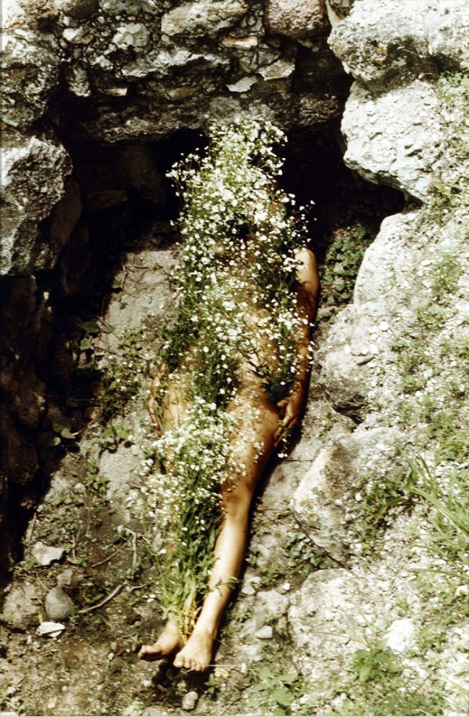
Fig.1 Siluetas (Image from Yagul), 1973
The Siluetas Series (1973–1980), allowed her to expand on a sense of interbeing with nature, and develop the concept of a natural homeland, as a place without borders. A place where organic materials which move and merge through space and time flow through the body, making it clear that the body is one with nature.
From this photograph we can see how the flowers, the rocks, the soil, and the body are brightly lit by the sun contrasting with the shadow under the rock formation that evokes a sense of balance and peace to the viewer. However, the photograph is simply a way “to prove and communicate her ephemeral alterations of the environment.” (Perreault, 1987). And despite the universal themes, it is instead her gestures and personal experience of being part of the land that truly makes up the artwork, as a magical, healing event.
Mendietas’ works are artistic performances in which nature becomes the main witness. Evoking a similar experience to that of The Buddha lowering his right hand towards the earth in Bhumisparsha mudra, “marking the moment when he called upon the earth goddess to witness his resistance of the forces of Mara, prior to experiencing enlightenment.” (Met Museum,unknown)
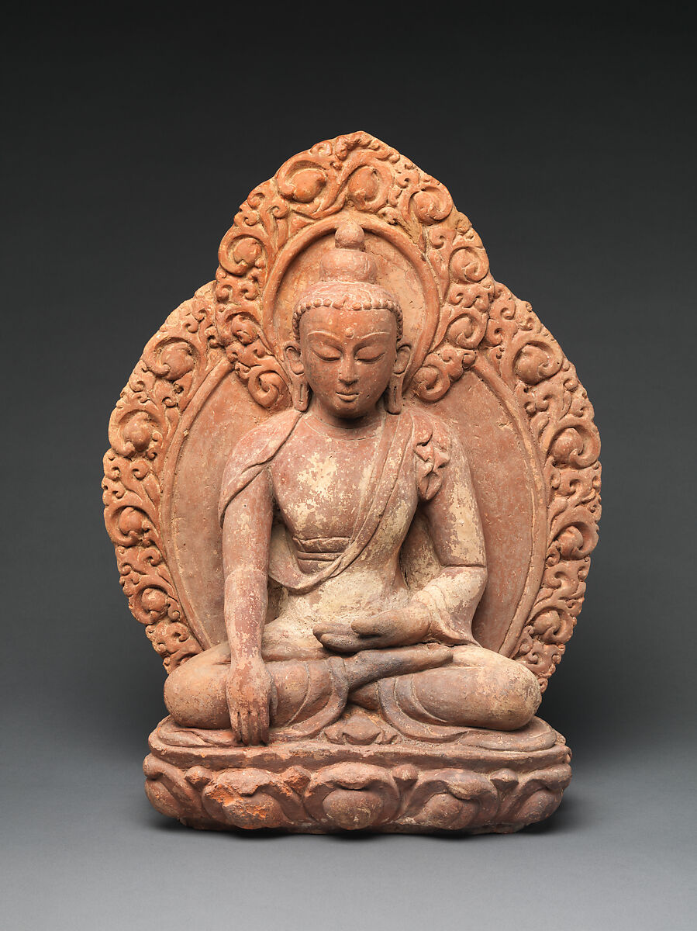
Fig.2 Akshobhya, the Buddha of the Eastern Pure Land (16th–17th century)
This speaks to the meditative benefits and religiosity of becoming one with nature, which were also an important aspect of Mendietas’ works:
“Through my earth/body sculptures I become one with the earth… I become an extension of nature and nature becomes an extension of my body. This obsessive act of reasserting my ties with the earth is really the reactivation of primeval beliefs ... [in] an omnipresent female force, the after-image of being encompassed within the womb, is a manifestation of my thirst for being.”
Ana Mendieta (1981) in Perreault, J. (1987)
The concept of nature becoming a part of her body is explored clearly in other works such as Untitled (1985).
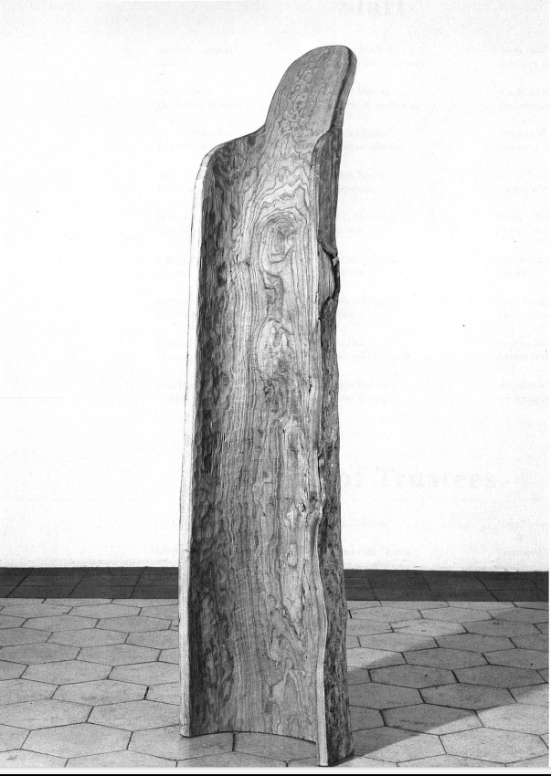
Fig.3: Ana Mendieta, Untitled (1985)
In the act of hollowing out the centre of a tree and leaving it open for the audience to see, Mendieta communicates an incompleteness that is felt when one is severed from their homeland. It is vulnerable yet open to possibilities. This sculpture reminds me of the Buddhist concept of Emptiness, a teaching that “’Emptiness’ means empty of a separate self. It is full of everything, full of life.” (Thich Nhat Hanh, 2022) The emptiness creates space where connections and associations live. This tree sculpture is alive because of its emptiness, and the meanings we can fill it with. For example: through anthropomorphising the tree as a “body”; as an extension of Mendietas’ experience of a body. A human body, pointing to the experience of a body that we can all relate to, making us capable of relating to the tree.
However, becoming a part of nature requires physical presence, an embodiment beyond ocularcentrism. Though visual communication is valuable, especially as a recording of a moment, as seen in Mendietas’ work. It cannot convey a holistic experience of nature to the audience. Jenks (1995) points out that “We daily experience and perpetuate the conflation of the ‘seen’ with the ‘known’.” Seeing a tree and being in the presence of a tree, for example, are two different experiences. The latter encompasses all senses which become active in a quest for knowing that tree, its smell, the shifting shadows under each branch, their varying textures, the sounds of its leaves dancing in the wind, and so on. The same is true for artworks.
Therefore, it is natural that there is a clear expansion taking place in the art world: the purpose of going to exhibitions became “to live an experience from which it would be difficult to maintain a distance.” (Poinsot, 1991) This means an inclusion of all senses in the process of re-thinking of our relationship with nature through art.
Delcy Morelos’ Earthly Paradise at the Venice Biennale 2022 is a successful example of this. As soon as one enters this installation, the organic smell of soil feeds the desire to inspect further, directing the audience through an earthly experience. This was an experience which stood out to me, especially due to its freshness in comparison to other artworks on display. The large accumulations of soil were unexpected and soothing; instead of trying to figure out intellectually (from what I could see) what the artwork was about, I was allowed to simply exist in the artwork and re-connect with my body and my senses as a way of exploring what the artist was trying to communicate.
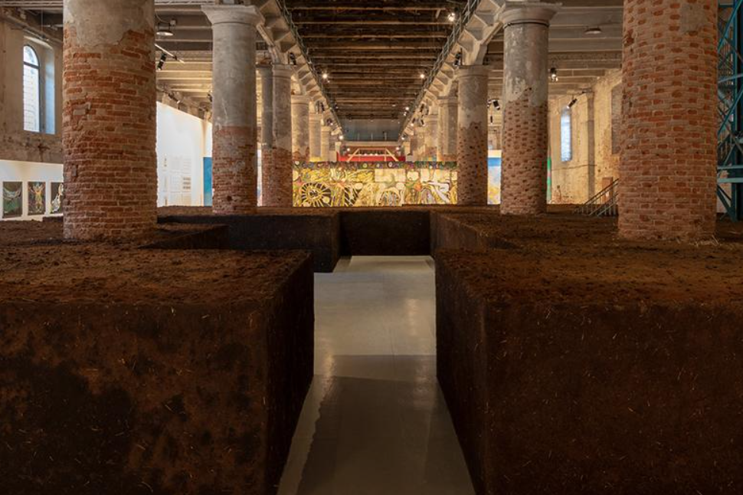
Fig.4 Earthly Paradise (2022).
The soil surroundings create a river of empty space through which the audience flows freely. This places the audience as the performer, there is a sense that the organic rhythm, the pulse of the audience walking through the earth structures gives the space itself life. Therefore, taking into consideration the concept that “art is an activity among all other human activities which is purely based in our presence, our consciousness, to acknowledge the artwork, besides that there is no art” (Bourriaud,2015).
The installation is an active invitation to have a connection with the earth. An opportunity for the audience to potentially have a meditative experience where “…there is no distance between you and your experience” (Harris, 2023) within an art exhibition context. This allows for the audience to become one with the soil. To connect to at least a part of nature and widen their perception of art through that experience.
“Morelos’ use of earth is informed by Andean and Amazonian Amerindian cosmologies and conveys the notion that nature is not something inert that we access and control at our will from an outside and exceptional position, but that we are earthly beings – we become, live, die, and decompose with and as the earth.”
Manuela Hansen in Vicuna,C. (2022) The Milk of Dreams
Similarly to Mendietas’ engagement with land, the soil itself becomes a symbol, expressing “the notion of working with the land” which “has links with a primordial tradition, stretching back to pre-historic stone circles and hill drawings.” (Cork, 2003) In Morelos’ installation, the room is the canvas, and the soil is the paint, but unlike most Exhibiting spaces, here you can feel the medium. Both Earth and audience merge into a performative installation art piece.
Morelos and Mendieta get to know the Earth, as an artistic collaborator, by focusing on the environments within the earth. However, Katie Patterson focuses on Earth, the planet. Paterson explores our relationship with the Earth by making it central to the engineering of the artwork, as well as a poetic concept. Her works tend to focus on the communication between humans, the Earth and the Moon, and how our perceptions of time and space can sometimes limit this communication.
Pattersons’ installation reminds us that the Earth and the Moon are “…active participants in our collective becoming.” (Bridle,2022). And that to live in harmony we need to find an ecology of nature, art, and external forces and technologies that impact the Earth. This is important because it demonstrates a recognition of ecology as “not merely the study of where we find ourselves, but of everything which surrounds us and allows us to live.” (Bridle, 2022) Including the Earths relationship with its surroundings, its orbit, and its Moon.
In Pattersons’ work Earth-Moon-Earth (Moonlight Sonata from the Surface of the Moon):“…Beethovens’ Moonlight Sonata was translated into Morse code and sent to the Moon.”(Patterson, 2007) the code was sent through radio waves which were then reflected back to the Earth. So, the Placement, movement and surface of both the Earth and the Moon impacted the composition, meaning that the making of the work was extended beyond the human and beyond the Earth.
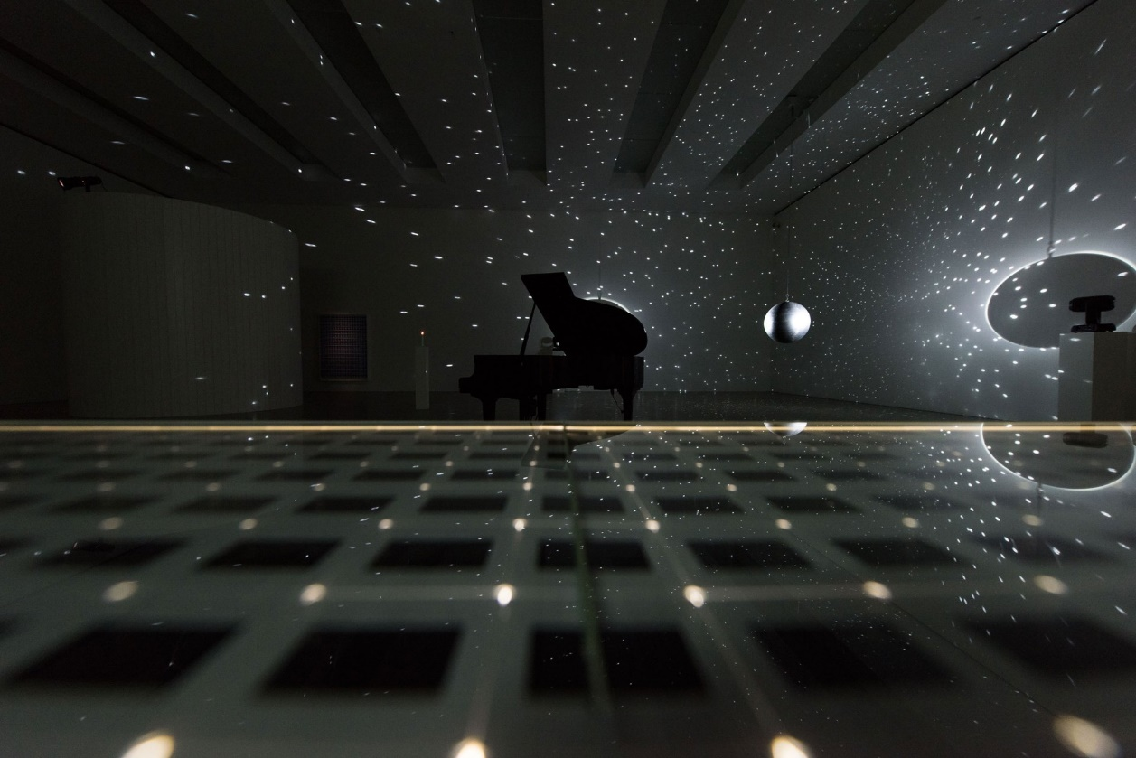
Fig.5: Earth-Moon-Earth (Moonlight Sonata Reflected from the Surface of the Moon), 2007
Beethovens’ sonata was subjected to the Moons’ nature and “…fragmented by the Moons’ surface… then re-translated into a new score…” (Patterson,2007). The composition was transformed, some notes were lost in transmission adding silence to the piece, and these “gaps in the music might represent a sort of sonic negative image of the moon’s topography, with each missing note indicating some lunar crater or gulf in which the original signal was lost.” (Alfrey, 2009)
This is an innovative way of exploring how different landscapes affect artwork because now instead of only being able to look at the moon from a distance or represent the moon, the work of art has had contact with the Moon. So, one can have the immersive experience of listening to the texture of the lunar surface through the medium of sound waves in an art gallery. The work also plays with the familiarity yet distance of the Moon through the choice of Beethovens’ well-known composition: Moonlight Sonata. Both the musical composition and the moon are being experienced by the audience in a new and unusual way; you can hear the moons effect on the music, but you cannot see it since the piano is automated to play it by itself. This illustrates the fact that we can’t touch the moon, but we can listen to it, through the use of radio wave technology.
The work deals with “time, distance and communications technology,” and it brings “the everyday into contact with a remote world…” ( Alfrey, 2009). Sending Beethovens’ Moonlight Sonata to the moon and back contextualizes her work and makes her connections between our sense of artistic creations and the wider natural world clear. Without either the earth or the moon, such a work of art would not be possible. This also suggests that the natural world, even beyond the Earth, not only gives us artistic inspiration but that it is an active creative force to be in contact with and to be collaborated with. The poetic and dramatic way in which Pattersons’ works are staged and perceived provides “new possibilities for the theatricalization and aestheticization of our environment; they partake in the re-enchantment of the world.” (Fischer-Lichte, E. and Jain,S. 2008)
These Innovative ways of experiencing the world through art continue to enable a deeper understanding of nature, as well as exploring our natural origins and cosmos in a way that allows for harmonious and peaceful progress. This is important since in my own practice I am trying to navigate the use of technology as well as organic materials. They are both tools which help the artist explore ideas and sense of place in the contemporary landscape. So, my proposed question might be: How do Nature and Technology encourage the progress of art?

Bibliography
Books
Alington, C.A.(1932) The new standard encyclopaedia and world atlas. London, Odhams Press.
Bridle, J. (2022) Ways of Being: Beyond Human Intelligence. UK, Penguin Random House.
Carson, R. (1962) Silent Spring. New York, Houghton Mifflin
Cork, R. (2003). Everything seemed Possible: Art in the 1970s. New Heaven, and London, Yale University Press.
Danchev,A. (2011) 100 Artits’ Manifestos: From the Futuristics to the Stuckists. UK, Penguin Classics.
Dean, T and Millar, J. (2005), Place. UK, Thames & Hudson.
Fischer-Lichte, E. And Jain,S. (2008) The Transformative Power of Performance: A New Aesthetics. London and New York, Taylor & Francis Group Penguin Classics.
Greenberg, R. Ferguson, B.W and Nairne,S. (1996) Thinking about Exhibitions, London, Routledge.
Hansen, M. (2004) New philosophy for new Media. Cambridge, Massachusetts, The MIT Press.
Heidegger. (1927) Being and Time, Germany, Blackwell.
Jenks, C. (1995), Visual Culture. London, Routledge.
Kazin, A. (1979). The Portable Blake. London, Penguin Classics.
Selz, P.(1959) New Images of Man. New York. The Museum of Modern Art, Arno Press.
Walter, B. (2008) The work of art in the age of mechanical reproduction. UK, Penguin.
Whitman, W. (1855/2017) Leaves of Grass. UK. Penguin Classics.

Essays
Poinsot, J. (1991) Large Exhibitions: A sketch of a typology. Published in Greenberg, R. Ferguson, B.W and Nairne,S. (1996)
Alfrey, N. (2009) RANSMISSION, REFLECTION AND LOSS: KATIE PATERSON, EARTH-MOON-EARTH (MOONLIGHT SONATA REFLECTED FROM THE SURFACE OF THE MOON). London, Djanogly Art Gallery. Available at: https://katiepaterson.org/wp-content/uploads/2022/02/Katie_Paterson_Nicholas_Alfrey_EME_2009.pdf (accessed 02/05/2023)
Manifestos
Fontana, L.(1946) White Manifesto in Danchev,A. (2011) 100 Artits’ Manifestos: From the Futuristics to the Stuckists. UK, Penguin Classics.

Catalogues
Barreras del Rio, P. and Perreault, J. (1987) Ana Mendieta: A Retrospective. New York: New Museum of Contemporary Art. https://d2b8urneelikat.cloudfront.net/media/collectiveaccess/images/9/5/8928_ca_object_representations_media_9558_original.pdf.
Vicuna,C. (2022) The Milk of Dreams, Vennice Bienale Arte 2022 Short Guide. La Biennale di Venezia.

Websites
Ana Mendieta. 1948–1985. MOMA. Available at: https://www.moma.org/artists/3924 (accessed 15/03/2023)
Akshobhya, the Buddha of the Eastern Pure Land, (16th-17th century), The Met Museum. available at: https://www.metmuseum.org/art/collection/search/38439 (accessed 17/03/2023)
Delcy Morelos. La Biennale. Available at: https://www.labiennale.org/en/art/2022/milk-dreams/delcy-morelos (accessed 20/03/2023)
Earth-moon-earth-moonlight. Katie Paterson. Available at: https://katiepaterson.org/artwork/earth-moon-earth-moonlight/ (accessed 15/02/2023)
Katie Paterson. Available at: http://katiepaterson.org/ (accessed 15/02/2023)
“The Heart Sutra: the fullness of emptiness-Thich Nhat Hanh” (2022) Awaken. Available at: https://awaken.com/2022/01/the-heart-sutra-the-fullness-of-emptiness/ (Accessed 05/03/2023)

Videos
Dr. Sam Harris: Using Meditation to Focus, View Consciousness & Expand Your Mind.(02/01/2023) Huberman Lab Ep.105 Available at: https://youtu.be/-wIt_WsJGfw (accessed 14/03/2023)

Modern Connections - Nicolas Bourriaud (02/11/2015) Modern Art Museum of Fort Worth. Available at: https://youtu.be/N_UOa2MS2Dw (Accessed 04/03/2023)

