

MODULE CODE: ECPW5005

ASSESSMENT COMPONENT: A Critical Evaluation of the Role of Digital Innovation in Professional Practice

STUDENT NAME: Lucy Jayne Rees

STUDENT NUMBER: 2512701

Use of Generative AI in Assessment

(Lecturer to indicate Yes or No against each element)

RESEARCH | For this assessment, you can use Generative AI to support you in research, including searching for bibliography, using tools to summarise, compare and interrogate materials. | Yes ☒  No ☐
STRUCTURE | For this assessment, you can use Generative AI to support you in structuring your submission, including creating a draft argument structure, identifying parts and headings, etc. | Yes ☒  No ☐
PROOFREADING | For this assessment, you can use Generative AI to check your own text/creation for grammatical and syntactical mistakes, including rephrasing of your own work within specific standards. | Yes ☒  No ☐
WRITING | For this assessment, you can use Generative AI to create text for submission. | Yes ☐  No ☒
CREATIVE | For this assessment, you can use Generative AI to create creative materials, such as images. | Yes ☒  No ☐
PROGRAMING | For this assessment, you can use Generative AI to create and check code. | Yes ☐  No ☒
NONE | For this assessment, you are not allowed to use any type of Generative AI support. This includes research support, structure support, writing/proofreading support and creative support. | Yes ☐  No ☒

AI Acknowledgement
I confirm that I have not used any AI tools in the research and creation of this assignment.
I confirm that I have not presented any AI generated materials as my own work.
I confirm that I have copies of my drafts, notes, and other resources I used, which I may be asked to provide in evidence.

A Critical Evaluation of the Role of Digital Innovation in Professional Practice
Introduction
For this assignment, I have chosen to focus in depth on the inclusion of a single digital tool in my lessons on my teaching placement at Neath College, rather than offering a overview of many. This approach allows for personal reflection on why I selected the tool, how I used it, the impact it has had on student learning within my classroom, and how established learning theories help explain its successes and its limitations when it comes to the model I think it fits.
The tool I selected is Mentimeter, an online interactive presentation and polling/quizzing platform that enables real-time audience participation via smartphones, tablets, or laptops/computers. Students simply visit a website or scan a QR code and enter a short code, no account or app download is required, which removes many access barriers common in further education settings and saves a lot of time in the classroom.
Throughout my teaching placement, I have used Mentimeter in a lot of my sessions with my Level 2 and Level 3 UAL Creative Media Production groups, keeping the quizzes fun but always relevant to what I’m teaching. These are typically mixed-ability classes of 16-20-year-olds in a FE college, where maintaining engagement can be difficult as they are typical teenagers who can find it hard to concentrate now they’re out of school, especially in theoretically dense topics such as the role and influence of social media platforms, client brief analysis, pre-production planning, and audio production techniques.
Mentimeter allowed me to replace traditional “hands-up” or show-me board questioning with anonymous live polls, word clouds and open-ended responses in fun quizzes. The live view of everyone’s contributions on the shared screen has transformed quiet classrooms: quieter or less confident students participated freely because of the anonymity, their names were not shown on answers, while the competitive element of leaderboards and timed quizzes hyped up the learning with an underlying competitiveness. Feedback was immediate, both for me; I could see misunderstandings or any questions to what I was asking of the students in real time and address them on the spot and for the students; they could compare their understanding against the whole group anonymously, adapting their answers in the word cloud for example. This shift noticeably increased active participation and created a more inclusive atmosphere in which every voice, literally, contributed to the lesson’s direction. I have some non-verbal students in both classes of the level 3 cohort, and I think using this tool let them enjoy an activity at an equal-level to their peers in class.
The role of creativity and Digital Innovation
After describing my own use of Mentimeter and the effects I've observed, I think it’s useful to show how these experiences in the academic sector relate to existing sources in further and higher education.
The use of digital tools doesn’t stop at teaching and learning.
Through placements and life experience it is evident to see that there are multiple resources used to enhance students learning and accessibility at college. Ashwin (2015) discusses that students need space to make meaning suggesting that possibilities such as online resources, blogs could enhance their educational development
This shows that the use of digital tools could be in marking and submitting work, not just teaching within the classroom. Digital tools can come in so many different forms and teachers should really take advantage of that and use them to their capacity in teaching, marking and preparation.
One area for further exploration here is the possibilities offered by online resources, including blogs and wikis, which may allow writing to be a more on-going developmental process of shared reflection. I think this shows that it could be done more and what’s been trial and tested so far has so much more potential.
Research by Ashwin (2015) emphasises that teaching and learning do not need to be restricted to traditional classroom settings, arguing instead for the value of a broader range of learning spaces that can enhance students’ educational experiences.
Temple’s (2008) work supports this view, noting that learning in higher education increasingly occurs across diverse physical and informal spaces, many of which play a critical role in shaping how students engage with their learning. However, both authors highlight that the effectiveness of such expanded learning environments is highly dependent on institutional context. As Ashwin argues, access to varied learning spaces is not guaranteed and often hinges on whether institutions have the resources, infrastructure, and funding to develop and maintain them. Temple (2008) similarly points out that although non-traditional spaces can enhance learning, universities frequently face limitations in designing and supporting them, revealing a gap between pedagogical aspirations and the practical realities of space planning. Together, these perspectives suggest that while learning beyond the classroom holds significant promise, its success is determined by institutional capacity and investment.
I went to a college that was severely underfunded and a Media department that was even more underfunded as it was noted as a ‘non essential’ subject area. When I went to university, the Sports Journalism course had more than enough recourses and was funded by the university correctly.
As much as I think digital tools can be important, I think it’s even more important they don’t replace traditional teacher-to-student teaching. (Race and Pickford, 2007, p. 96) “In the early days of computers it was envisaged that computer-based learning would replace face-to-face tuition, and enthusiastic senior managers rubbed their hands in glee at the twin ideas both of saving on expensive teaching salaries and of taking control of curriculum delivery.” I think in the Covid-19 pandemic, not that we had a choice or say, but teaching and learning needs became a backseat in priorities. I think if you’re going to use a digital tool, it doesn’t become a soul focus and that your teaching includes a tool, your teaching doesn’t become the tool instead. Students can learn a lot from a Menti or a Kahoot! but they won’t learn everything. Especially if I was teaching something on social media, something I am an expert on, then the students will benefit from my knowledge and experience more than a 400-slide quiz, and me just sat there drinking coffee and checking emails for three hours.
Gregson and Hillier (2015) argue that digital tools in a classroom can support students learning. Having these tools in the classroom does not guarantee students will learn. I think this can only apply to certain institutions. As a college, you might find students not wanting to be there and not wanting to do a specific subject but at a university, you will find students motivated and the institution will have plenty of funding, meaning everyone will get access to a PC in a classroom and a well-stocked library resource centre. From experience, I find that students are more eager to learn at a university over a college as it could be a more specialised subject or being away from home and having that independence.
Kerr (2001) explains that funding at universities enables greater results from research and tools available in graduate programs, and knowledge production. I would have to agree with this having studied at a college then a university.
Selection and Justification of appropriate teaching tool(s)/resources
Mentimeter, often shortened to Menti, is an interactive presentation and audience engagement tool for education, training sessions, workshops, conferences, and meetings.
Mentimeter lets a teacher or presenter use real-time interactive slides and lets the class cohort participate using their smartphones, tablets, or laptops/PCs without downloading and app like Kahoot! Participants simply go to the website or scan a QR codr and insert the 5 digit code from the instructions slide then they’re in and can chose a username for the quiz leaderboard. The presenter will then be told how many participants and ready and live.
In a Menti quiz, there are many question types available to use, not just your simple multiple choice, you can also have a word cloud; where everyone submits a word or phrase, then the most popular words and phrases appear bigger - an example of this can be seen below in my in-class image. Other options include, open-ended questions, Ranking and prioritisation, Scales and rating slides (e.g., 1–10 or Likert-style), Image choice questions, Live Q&A/voting and Surveys and feedback forms.
I find this to be really beneficial as a teacher, seeing the instant feedback from the students and helps me understand the needs of the cohort better. It can give you instant feedback and visibility of all of the student responses in your class, this is shown live. So, if you’re ready to move on, you can see 15 out of 17 students have submitted a response to the quiz answer or word cloud. Another great feature is the Anonymity option, I think this encourages honest answers rather than students putting in what they think is right.
I think Menti fits into the TPACK model because it really combines the Content Knowledge, the lesson or topic being social media in my context.
The Pedagogical Knowledge, the formative assessment and active learning strategies, so testing students using the quiz style questions. And finally the Technological Knowledge as I think it’s a reliable cloud-based tool that you can access again and again once the quiz model has been created.
In my lesson, I was teaching the Introduction to Social Media. I used my Menti quiz early on, including a word cloud with the question: “In the morning, what is the first thing you do on your phone?” Students then submitted answers from their phones and a live word cloud was created on the screen. I instantly saw honest answers as it was anonymous – students weren’t ashamed of getting something wrong and having their name to it. Students were reacting to some of the honest answers on the interactive board behind me and I adapted my teaching on the spot, reacting with my own knowledge to what was appearing on screen. I believe that is the TPACK model in action, technology enabling better pedagogy and deeper content understanding.
Why Menti? My rationale for using Mentimeter came after I was going to use Kahoot! But I have 2 classes of around 17 students and there’s a maximum of 10 participants for each quiz when using Kahoot!. The media department at Neath College is severely underfunded and after speaking to my placement mentor, I was advised to use a quiz tool with good benefits on their free version.
The FE sector faces ongoing financial pressures (House of Commons Education Committee, 2025) explains that chronic underfunding has led to overcrowded classrooms, staff shortages, and reduced capacity to meet demand.
When creating my Menti quiz, I took advantage of the question types available and changed one slide to a word cloud instead of a question-and-answer format. This worked well for my lesson on Social Media Content as I was able to give students more freedom for their answers, I also put both word clouds from the two lessons in the PowerPoint for the students to access after the class.
In educational settings, I think the TPACK model offers the best framework for teachers to include digital tools in their teaching strategies.
TPACK, standing for Technological Knowledge, Pedagogical Knowledge, Content Knowledge, highlights the dynamic synchronisation between an instructor's understanding of content, pedagogical approaches, and technological tools, ensuring that digital innovations enhance rather than disrupt learning outcomes according to Mishra & Koehler (2006). By applying TPACK, professionals can evaluate and adopt emerging digital tools like AI-driven platforms, like Grok or ChatGPT, or Quizzes like Kahoot and Mentit, creating more engaging effective learning environments.
Application of the chosen learning tool
I used Menti in one of my first lessons at Neath College to the first year classes of the Level 3 Creative Media course. Both classes have students with mixed abilities and adapt well to a variety of teaching styles. Some have additional learning needs and are better suited to different teaching styles but I still have to be aware of a variety of styles to suit all 17 students in each class.
I used the Menti quiz in both classes I taught, and I think both classes had a similar reaction.
Lesson Evidence:
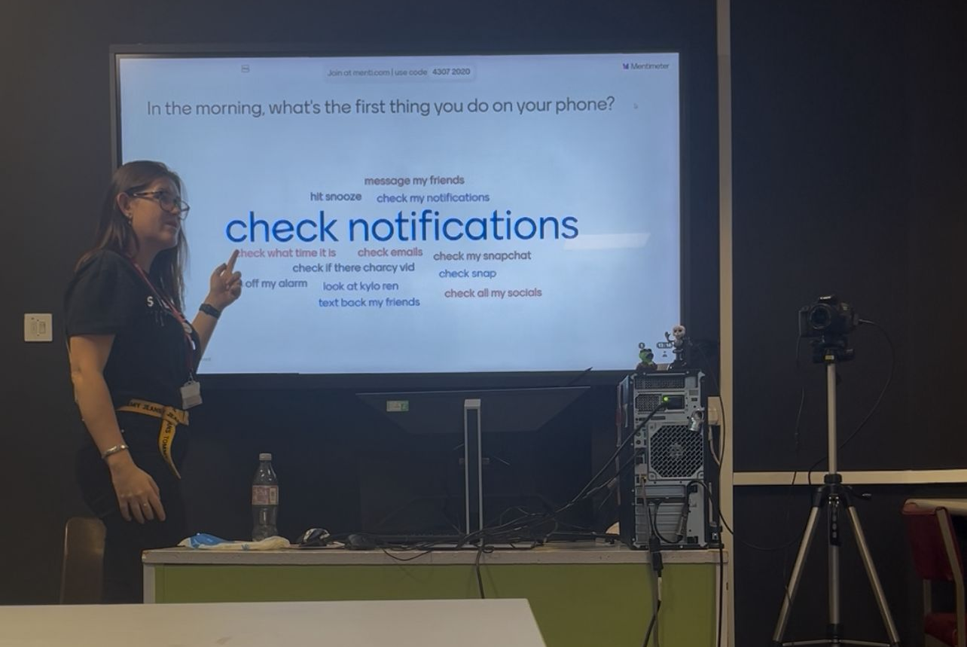
Introduction to Social Media class where my chosen Tool was brought into action.
Lesson Plan:
Topic:  Introduction to social media |  | Class:  Level 3 Media, Year 1
Date:  11 November | Length of lesson:  3 Hours |  | Number of students:  17
Resources required:
A smartphone or laptop/PC, access to existing social media accounts and/or email address to create one, an active blog they would have been working on already to put the tasks from this lesson on.
Aim of Lesson
Introduce the students to Social Media, the uses and how/what/when to post.
Learning Outcomes – The Learners Should Be Able To:
Students will:
- Have a good understanding of social media platforms​
- Have a better idea of what will work well for their content idea
Previous student knowledge required for the session:
None required, it’s a new module.​
Anticipated difficulties (if applicable):
Students not having a social media account or having not heard of any of the platforms I’ll be giving tips on.
Professional Standards (where are these being met within the session)
- I will demonstrate commitment to learners, their learning, safety and well-being by catering to multiple learning preferences by using a mix of teaching styles like a quiz, lecture and Q&A.
- I will demonstrate dignity, courtesy and respect towards others when explaining the usage, pros and cons of each social media platform.
- I have maintained and have knowledge of my subject, by using these social media platforms in my job role and personal life.
- I know how to use evidence and research to improve my practice, by using relevant platforms that use the latest trends.
- I will plan and deliver effective learning, teaching and assessment, by teaching the use of social media thoroughly then assess the understanding by getting the students to do a task.
- I will build positive and collaborative relationships by using a variety of teaching skills like groupwork, positive competitiveness in the quiz, and demonstrations.
- I will enable learners to share responsibility for their own learning and assessment by allowing any students who have previously used social media in a work environment or for personal use.
- I will demonstrate a commitment to sustainability by using my own experience and knowledge like the ideal posting times part.

Lesson Detail:
Stage | Focus | Strategy | Time
Introduction  Development  Plenary/conclusion | Welcome everyone into the lesson, go through objectives.  Establish entry behaviour  Introducing the topic of Social Media content  Address the class to name the social media platforms.  Analyzing task  Group task  BREAK  Presenting task  Feedback  Feedback on objectives, touch on next lesson | Slides 1-2: Objectives.  Slide 3: Menti quiz and word cloud with link  Show results of Menti word cloud, explain what has been found out, share to PowerPoint for students to view again.  Slides 4-5: assignment, blog set up.  Get students to check their blog set up, it should follow the outline set up.  Slide 6: Shows the 6 platforms that will be used for this module.  Slides 7-10: Give a rough run down of each social media platform  Slide 11: Get the students to do this task and put it on their blog  Slide 12: In pairs, get the students to find 4 creators / teams / companies who use social media well. Make sure they are using a variety of the platforms.  BREAK - 20 minutes  Slides 12-14: Get the pairs to present their findings using PowerPoint, each pair taking 5-10 minutes to show the class their findings.  Explain the importance of staying professional, future employers look at these things. Mention interview at The Hundred.  Check with the class who is thinking at this early stage  - What content?  - What platform?  Slide 15: Cover objectives from the start of the lesson. | 1 minute  3 minutes  1 minute  4 minutes  2 minutes  4 minutes  30 minutes  45 minutes  BREAK  1 Hour  5-10 minutes  2 minutes

Assessment Strategies: when and how are they included within the lesson?
For the lesson, I’ll be assessing learning using the quizzes and task that they’ll put on their blog. The assignment will come at the end of the scheme when they are tasked with putting the social media content out there.

Lesson plan from first class of part of the Social Media Content module where students took part in the Menti.

Menti Evidence:
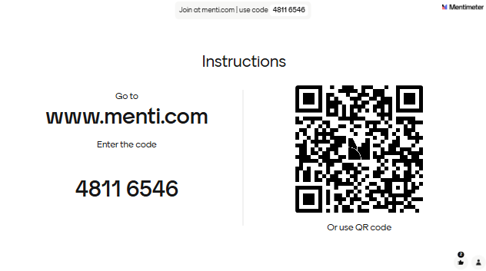
Slide 1: Joining slide for students.
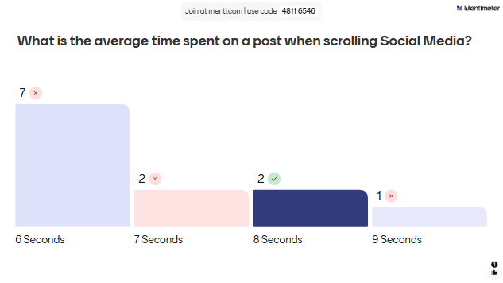
Slide 2: First question of Ice Breaker quiz, This was throwing students straight into the deep end as I hadn’t actually taught anything about social media yet.
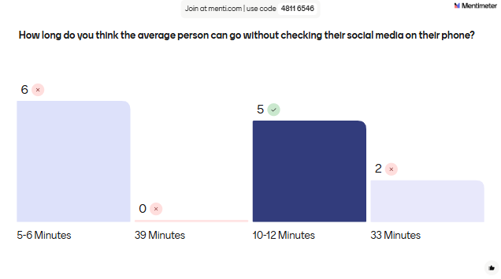
Slide 3: Question 2, this was sort of testing what the students knew already, establishing entry level behaviour in the classroom before startung the new module with the class.
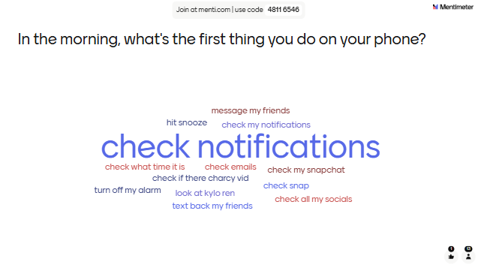
Slide 4: Getting the students to answer this question and as they did, the word cloud was created. The results showed a lot of social media mentions.
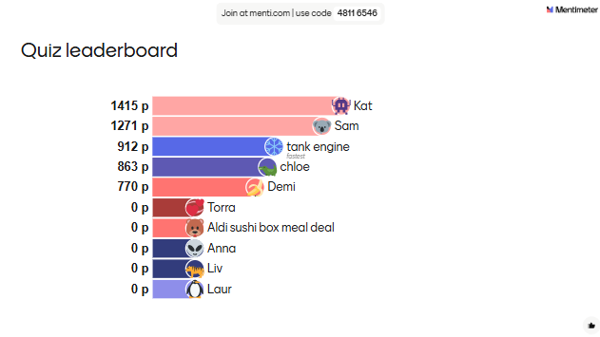
Slide 5: The leaderboard so far.
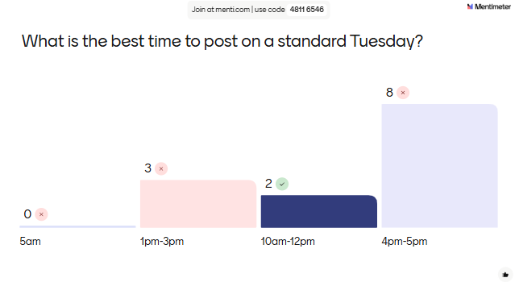
Slide 6: Another question to test existing knowledge.
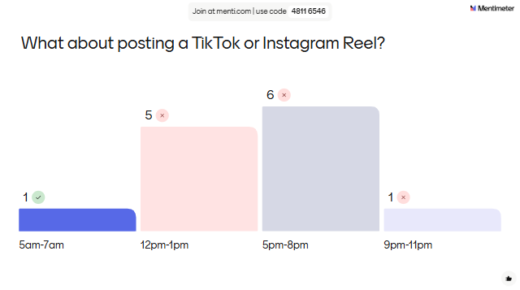
Slide 7: As above.
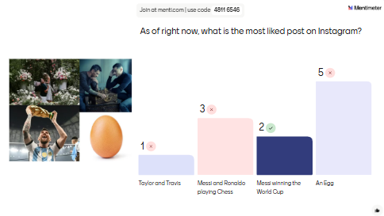
Slide 8: As above.
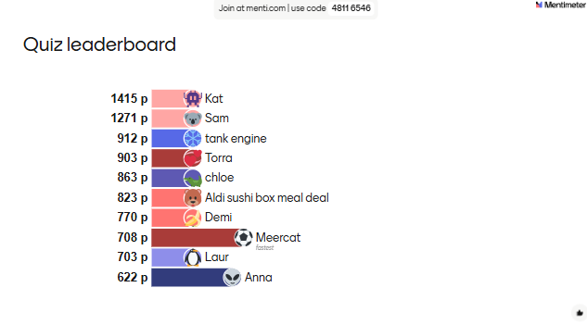
Slide 9: An updated leaderboard, adding the fun and competitive element to the class.
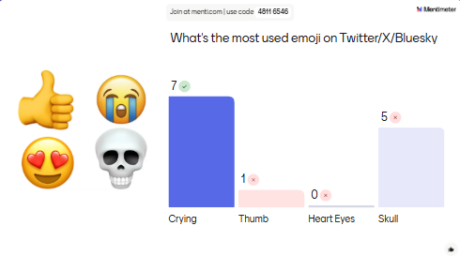
Slide 10: Another question to test existing knowledge.
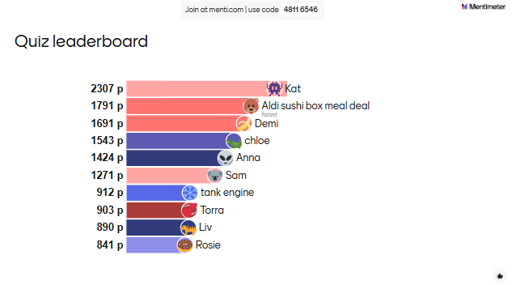
Slide 11: An updated leaderboard, continuing the fun and competitive element to the class
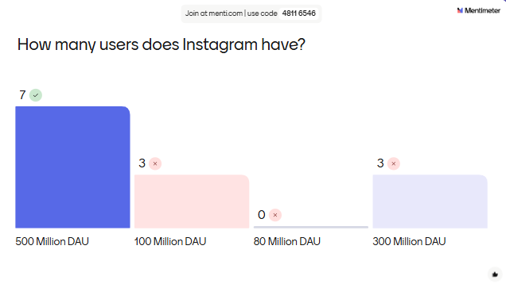
Slide 12: Another question to test existing knowledge.

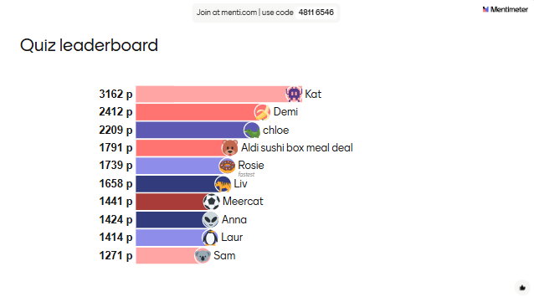
Slide 13: Final leaderboard.

Evaluation and Reflection 1000
I think it's fair to say that digital tools have totally shaken up how we approach teaching, learning, and even broader professional fields, in this day and age.
Throughout this study, I've explored how innovations like AI-driven platforms; Grok and ChatGPT, collaborative software and interactive apps and programmes; Kahoot! Menti, Padlet are reshaping professional practices, particularly in education and even more so in my specialist subject, Media. But as I come to my conclusion, it's time to tie it all together, reflecting on the upsides and downsides, weaving in frameworks like TPACK, and looking at what this means for the future of teaching and learning.
As someone who's grown up with technology always growing and changing, I see digital innovation as a double-edged sword: super empowering but also fraught with failures if not handled the correct way.
Firstly, I’m going to look at the benefits of integrating digital tools into the classroom, using a digital competency such as Mentimeter as my prime example.
Menti, is this real-time polling and interactive presentation tool that's become a popular in modern teaching, and something that I have used many times in the placement classes I’ve presented at Neath College.
One advantage is how the tool boosts engagement. I have found that in a traditional lecture, you'd have students zoning out, scrolling on their phones, or just passively taking notes and the quieter students might fall behind and not feel comfortable contributing to the lecture. But with Menti, teachers can include quizzes, word clouds, or open-ended questions mid-session, turning the class into an interactive digital discussion encouraging participation.
I think tools like Menti, Kahoot!, and Padlet can increase student participation and even attention spans because they make learning feel more dynamic and inclusive and this might be huge for neurodivergent students. From a professional practice view, this aligns with shifting pedagogies toward student-cantered learning, which I just think is so important, especially in 2025 where students might not learn the old-fashioned and boring ways.
Imagine a history class where instead of droning on about World War II, the teacher uses Menti to poll opinions on key events, sparking debates and real-time feedback. As a GCSE History student, I would have much rather learnt like this!
It's not just fun; it helps with retention too, as active involvement reinforces concepts better than rote memorization, I have included several student-made word clouds in the learning resources I’ve then shared with the students.
Another benefit is accessibility and inclusivity. Digital tools like Menti can bridge gaps for diverse learners. For instance, students with social anxiety might hesitate to speak up in a crowded room, but with responses being anonymous and teachers being able to see the number of responses, this is a barrier that can be broken down.
Another bonus I think it has it that it features support and is easier for non-verbal or those with disabilities to join in. In professional practice, this means teachers can cater to a wider audience, promoting equity in education and meet those relevant professional standards. I've seen this firsthand in my own university experiences during online classes post-Covid-19, tools like Menti could have kept everyone connected. I think it also is a huge time-saver in the classroom, teachers can instantly view responses and look at the level of understanding the students have had and adjust their lesson content or question styles where need be within the software.
I do think that there are some serious cons to using digital tools in the classroom that we can't ignore as teachers. The digital divide is a big one, not every student has equal access to devices or reliable internet. I know at university, not all my class could access remote learning during the pandemic due to lack of technology when we were all sent home for the remainer of the academic year.
Menti might seem like a brilliant tool to use in class and online, it might be something to think more about should you find yourself in a similar situation to 2020. Students without smartphones or stable Wi-Fi end up feeling left out, turning what should be a inclusive tool into one of exclusion.
To avoid this, I would ensure I’d have backups, like paper alternatives, but that defeats the purpose of doing something digital.
Privacy and data security can be another issue. Tools like Menti collect a pile of user data like, responses, IP addresses, even behavioural patterns you can access in the post-presentation area. I think this raises red flags. Teachers might unintentionally expose student info, leading to misuse or cyber problems and risks. In professional practice, educators need to be vigilant about GDPR, which adds another layer of concern to using tools in a classroom. I've personally felt this unease in my first lesson using Menti; during a group project, our Menti session glitched, and responses got mixed up it was totally harmless, but it made me question how secure these tools really are.
Another con might be teachers becoming overly reliant on digital tools. For professionals, this means balancing tech with traditional methods to avoid deskilling the workforce and the impact that will have on the students. If teachers lean too hard on digital tools, they might lose the art of reading a room or improvising without screens. My interactive whiteboard lost power the other lesson but I still knew what I was saying and could go on without a panic.
This is where the TPACK framework comes in handy as a framework to evaluate this all together. It shows how effective teaching with technology requires overlapping knowledge in three areas; content (what you're teaching), pedagogy (how you teach it), and technology (the tools you use). It's not just about slapping a gadget into a lesson; it's about integrating them seamlessly so they enhance each other, so you can teach the old fashioned way and whack out a shiny new Menti or Kahoot! properly in class.
TPACK helps us critically assess tools like Menti. But TPACK also highlights the cons. If a teacher's technological knowledge is weak, they might misuse tools, leading to ineffective practice.
Personally, as a 25-year-old navigating this technology-evolving world, I'm optimistic but can remain cautious when using digital tools in the classroom. I definitely think there’s a time and a place for them. Growing up with Facebook being brand new and then seeing apps today like TikTok, I've seen the power technology has to connect and innovate within the classroom, but also its potential to isolate or overwhelm students and even teachers or student-support staff.
In education, tools like Menti can make learning exciting if used wisely, but they shouldn't replace human elements like empathy and the ability to read body language in a classroom, looking at the attention of students. Ultimately, digital innovation isn't about replacing professional practice, it's about enhancing it positively in a classroom for the benefit of the learners.

Reference List
Ashwin, P., Boud, D., Coate, K., Hallett, F., Keane, E., Krause, K.-L., Leibowitz, B., MacLaren, I., McArthur, J., McCune, V. and Tooher, M. (2015) Reflective teaching in higher education. London: Bloomsbury Academic, pp. 30.
Temple, B. (2008) 'Overeducation and the skills of UK graduates', Journal of the Royal Statistical Society: Series A (Statistics in Society), 172(2), pp. 307–337. Available at: https://doi.org/10.1111/j.1467-985X.2008.00578.x (Accessed: 8 December 2025)
Race, P. and Pickford, R. (2007) Making teaching work: ‘teaching smarter’ in post-compulsory education. London: SAGE Publications, pp. 96-97.
Gregson, M. and Hillier, Y. with Biesta, G., Duncan, S., Nixon, L., Spedding, T. and Wakeling, P. (2015) Reflective teaching in further, adult and vocational education. 4th edn. London: Bloomsbury Academic, pp. 183-184.
Kerr, C. (2001) The uses of the university. 5th edn. Cambridge, MA: Harvard University Press.
Mishra, P. and Koehler, M. J. (2006) 'Technological pedagogical content knowledge: A framework for integrating technology in teachers' knowledge', Teachers College Record, 108(6), pp. 1017-1054.
House of Commons Education Committee (2025) Power growth and boost young people’s life chances with investment and reforms to further education. London: UK Parliament. Available at: https://committees.parliament.uk/committee/203/education-committee/news/209364/power-growth-and-boost-young-peoples-life-chances-with-investment-and-reforms-to-further-education-mps-tell-govt/ (Accessed: 3 December 2025).

