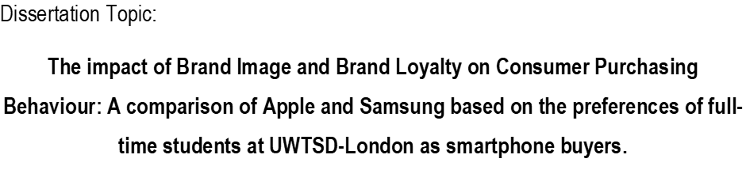



Module Title: Dissertation
Module Code: LCMB7020
Course: MBA Marketing
Supervisor: Mrs Tushara Balandran
Student Name: Anastasiya Petrova
Student Number: 1816952


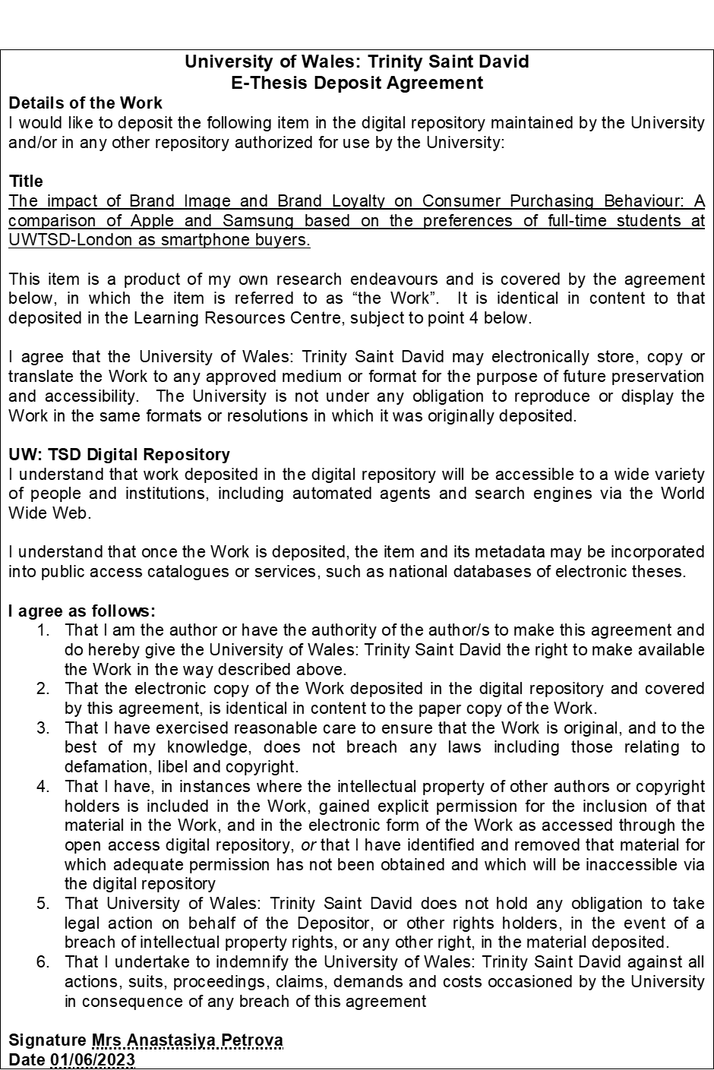
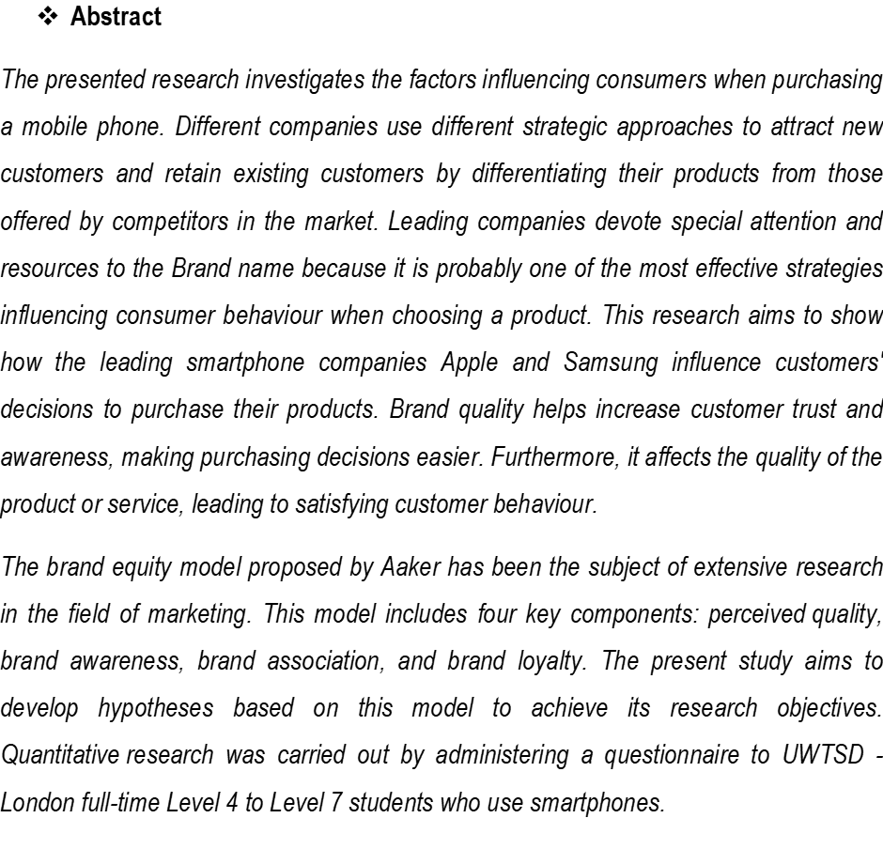



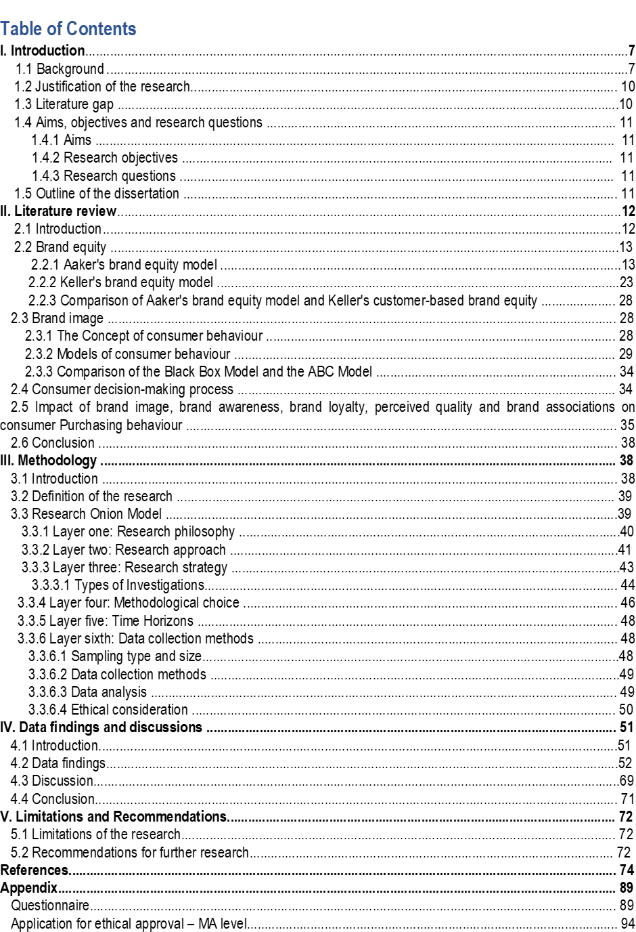

I. INTRODUCTION
1.1 Background
Sometimes people don't differentiate between a product and a brand. A product is produced for use, can be copied by competitors and quickly become obsolete. The brand is unique and unrepeatable, it is what customers buy, and when it is successful, it is eternal. The brand is a critical factor for companies and their products that influences buyers' decisions. According to Song et al. (2019), ensuring a good brand image is essential because it influences customer perceptions and awareness. The information we receive as customers is through the logo, the text and the message that affect our senses. Therefore, an effective strategy in terms of consumer behaviour when purchasing a product is to use the brand for the products offered.
According to Cecere et al. (2015), the telecommunications industry's mobile phone segment is experiencing rapid growth and development. According to the data of Fortune Business Insights (2022), the worldwide market share of the smartphone industry is projected to increase from USD 484.81 billion in 2022 to USD 792.51 billion in 2029, with a compound annual growth rate (CAGR) of 7.3%. The observed expansion can be ascribed to a multitude of factors, such as the escalating acceptance of the Internet of Things, the rising rate of homeownership, the augmenting flexible incomes in developed nations, the intensified marketing endeavours by smartphone vendors, and the burgeoning subscriptions to social media. Persistence Market Research (2023) claims that the onset of the Covid 19 pandemic has led to an economic slowdown that has affected the industry immensely. The coming years will increase disposable income, increasing the likelihood that people will spend more on mobile communications and media. This, in turn, will lead to an increase in smartphone sales worldwide. The research then identifies North America, followed by the Asia Pacific regions, as the leading smartphone markets in the world. Persistence Market Research (2023) notes that North America is strongly supported by advanced telecommunications infrastructure, increased 5G deployment and significant smartphone manufacturers in the region.
Statcounter's data (2023) illustrates the worldwide mobile phone market share distribution. Apple and Samsung are prominent market leaders who engage in competition with each other, as well as with other brands.

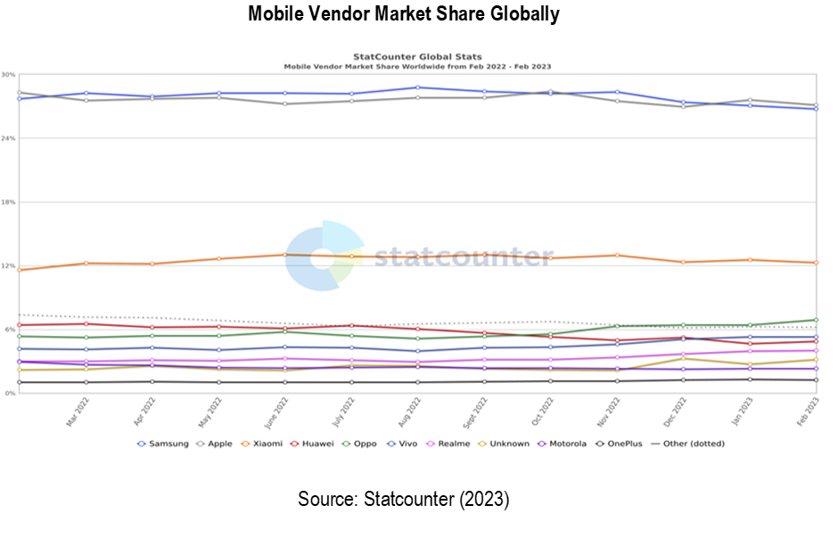

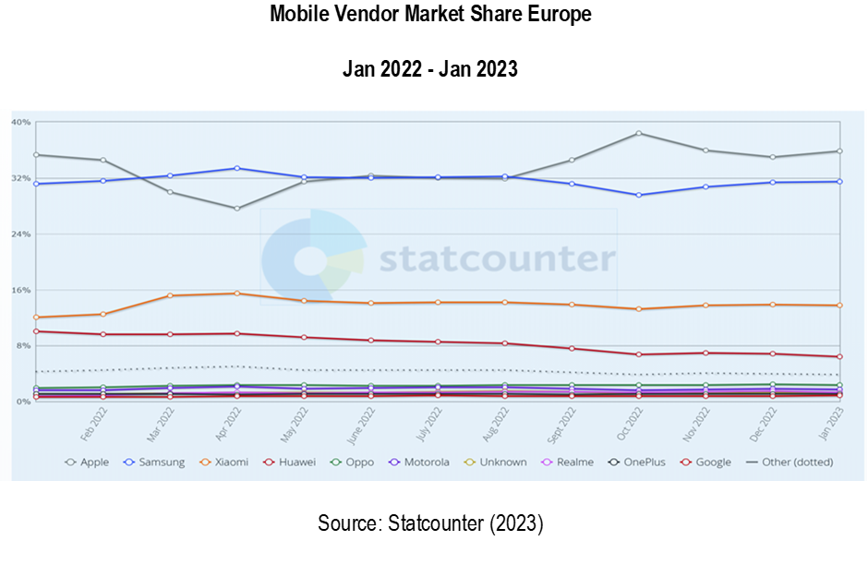
In Europe, Apple dominates the smartphone market with a market share of 34.82%, Samsung falls in second place with a market share of 31.61%, and Xiaomi falls in third place with a market share of 14.06%. The significant percentage difference indicates that Apple and Samsung are Europe's two dominant smartphone vendors.
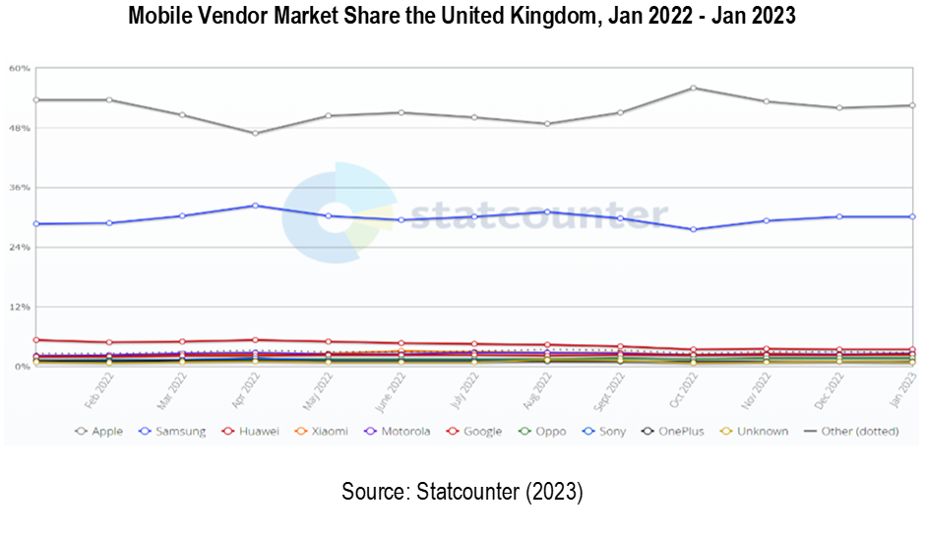
The UK has been regarded as the leading market for smartphones in Europe. The region is reported to have registered tremendous growth in the smartphone sector, which is projected to continue. The existence of key manufacturing companies coupled with substantial investment in Android and iOS smartphones has enabled the region to scale the smartphone market's growth effectively (Persistence Market Research, 2023). From the figure above, it can be noted that Apple dominates the market, with Samsung following closely. Although present in the region, the other brands occupy a smaller market share.
Companies use various techniques to acquire new consumers, maintain existing ones, and differentiate their products from their rivals. Emphasising items' "brand name" is the most important and feasible method for influencing consumer product selection behaviour. The research centred on the impact of smartphone branding on customer purchase decisions. Brand equity refers to the overall value of a product (service) derived from the perception of the brand name and symbol. This value is influenced by both positive and negative factors associated with the brand, which can impact the consumer's willingness to pay for the product (service). It affects how satisfied a buyer is after making a purchase, how well they understand the product, and how confident they are in their choice.
Businesses employ several strategies to attract new clients, retain existing ones, and set themselves apart from rivals' offerings. Using a product's brand name is a potentially powerful tool for influencing consumer behaviour. Brands are significant to customers because they facilitate risk avoidance and reduce the time and energy spent deciding (Aghdaie SFA and Honari R, 2014). Even Keller and Lehmann (2006) take it for granted that consumers will appreciate companies that simplify their decision-making, guarantee quality, and inspire confidence. They also believe that brands help consumers recall positive feelings associated with a product. According to Aaker (1991), one of the primary functions of brands is to increase brand recognition. Consumers now have more options in terms of brands but less time to decide. The brand's unique selling proposition reduces uncertainty and ensures that consumers always receive what they expect from their purchases. That is why a company's brand is its most valuable asset, next to its consumers. According to Aaker (1991), the brand is the most valuable asset for any business.
1.2 Justification of the Research
Comprehending customers' purchasing behaviour is crucial in assessing their inclination towards a particular brand compared to others. According to prior research findings, identification traits such as a customer's self-identity, social identity, and brand identity all contribute to the customer's intention to purchase. Additional study has shown that aspects of a brand, such as its image, behaviour, and communication, can affect a consumer's intent to purchase. Nonetheless, another purpose of the study is to enhance the understanding of brand equity through a more comprehensive analysis. The study aims to provide theoretical and empirical evidence regarding the correlations among brand awareness, brand image, brand behaviour, and purchase intentions (Stankevich A, 2017; Rather RA et al., 2019). The research investigates the attributes connected to the brand to analyse consumers' purchasing patterns and determine their preferences for future purchases. The findings will demonstrate whether a brand's image, communication, and loyalty directly or indirectly impact consumers' intentions to purchase. This study's topic is the consequences of a business strategy that arises from effectively managing a brand's many facets. The insights derived from this can help marketers formulate branding strategies that are both adaptive and effective, and that influence customer buying behaviour.
1.3 Literature gap
Based on a review of previous research, the current study further investigates the influence of brand image on customer loyalty and commitment and their mobile phone purchase decision behaviour, as well as the possible relationship between brand image and these variables. The findings of the brand influence study are helpful for mobile phone marketers. In addition, the research intends to remind the mobile phone industry that its target customers have opinions and perceptions about the branding tactics offered. This will help them determine the most effective method of gaining the loyalty of branded mobile phone users to influence their purchasing decisions. In addition, the study provides a significant result for manufacturers: understanding how branding influences customer purchasing behaviour is critical to developing powerful brands and gaining a market advantage. The findings of this research expect to contribute to the literature on smartphone branding in corporate settings by offering valuable insights into branding from the perspective of smartphone users. Its primary purpose is as a resource for researchers hoping to build on the work done here.
1.4 Aims, objectives and research questions
1.4.1 Aims
Wood (2000) has observed that the marketing literature encompasses the notion of "brand equity," which concerns the relationship between consumers and brands. This study aims to demonstrate the impact of Apple and Samsung smartphone brands on the buying patterns of their respective target audiences through an analysis of their interdependent relationship. The hypothesis has been derived from Aaker's brand equity model, which assesses the worth of a brand from the consumer's perspective. The present conceptual framework encompasses four key components: perceived quality, brand awareness, brand association, and brand loyalty.
1.4.2 Research objectives:
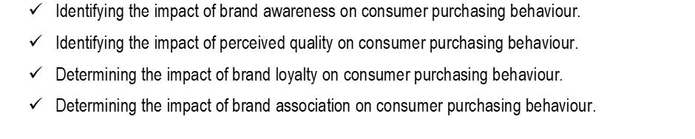
1.4.3 Research questions:
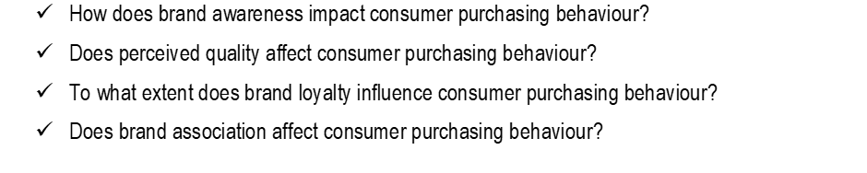
1.5 Outline of the dissertation
The dissertation is structured into five chapters.
The first chapter provides an overview of the research, encompassing the research background, rationale, and objectives. The study examines the correlation between consumers and brands and the impact of these relationships on purchase decisions for Apple and Samsung products. Furthermore, this chapter outlines the research aims and questions that identify the influence of brand awareness and perceived brand quality on consumer purchasing behaviour. The remaining research objectives and questions are about assessing brand loyalty and the impact of associations on consumer buying behaviour.
The second chapter comprehensively analyses the current literature on brand image, familiarity, loyalty, quality, and associated theories. This review aims to thoroughly comprehend these concepts by examining various studies. Furthermore, this section presents consumer behaviour, decision-making procedures, the influence of brand image on consumer acquisition, and related models.
The third chapter of the manuscript outlines the research methodology employed in the investigation. The present section examines diverse research methodologies utilising the Research Onion Diagram Model proposed by Saunders et al. (2019). The primary objective of this is to identify a suitable research methodology. Selecting optimal philosophy, process, and strategic approaches for conducting a comprehensive investigation involves gathering primary and secondary data.
Chapter four of the document provides an in-depth examination of the analysis of data, the interpretation of outcomes, and the discussion of findings. This section presents the primary outcomes of the research, which are derived from the feedback of participants from UWTSD - London, chosen as smartphone users. The study examines the influence of brand image and loyalty on consumer purchasing behaviour. The presentation of data in statistical tables and pie charts are essential for supporting the analysis and discussion, which is crucial for deriving valid conclusions and providing actionable recommendations. Additionally, the conclusions drawn from the results and findings are presented in this section.
In Chapter Five, the study's limitations are expounded upon, and recommendations for future research are provided.
II. LITERATURE REVIEW
2.1 Introduction
This section of the study presents a comprehensive analysis of the current literature on the impact of brand image and loyalty on consumer behaviour. This review aims to thoroughly understand the historical context of the multiple studies on this subject matter. This section provides an overview of brand equity and its associated theories, as well as an examination of brand image, brand awareness, perceived quality, brand association, and brand loyalty. Additionally, it explores the concept of consumer behaviour and its models, the consumer decision-making process, and the influence of brand image on consumer purchasing behaviour.
2.2 Brand Equity
Two significant models are widely employed to explain the concept of brand equity. They include Aaker's brand Equity Model and Keller's Customer-Based Brand Equity model.
2.2.1 Aaker's brand equity model
The model proposed by David Aaker in 1991 is considered the most comprehensive and widely accepted definition of brand equity. According to the model, brand equity encompasses the amalgamation of brand assets and liabilities linked with a brand's name and symbol. These factors can enhance or diminish the value provided to the firm and its customers. According to Aaker's (1991) proposition, brand equity generates customer value and influences the quality of user experience, comprehension of information, and confidence in purchase decisions among customers. Aaker has classified brand equity into five categories: perceived quality, brand loyalty, brand recognition, brand association, and other brand assets such as patents, trademarks, and channel partnerships. The first four dimensions of brand equity concern the assessments and reactions of customers towards the brand, which are readily understandable to consumers. Therefore, they are commonly chosen to evaluate brand equity (Vinh, 2017). According to Indeed (2022), integrating these dimensions can improve the value of a company's products, resulting in various customer benefits. According to Aaker's model, brand equity can facilitate brand recall, impact consumer buying behaviour, and enhance customer satisfaction. The figure below depicts Aaker's brand equity concept, demonstrating how each component contributes value to customers and the organisation.
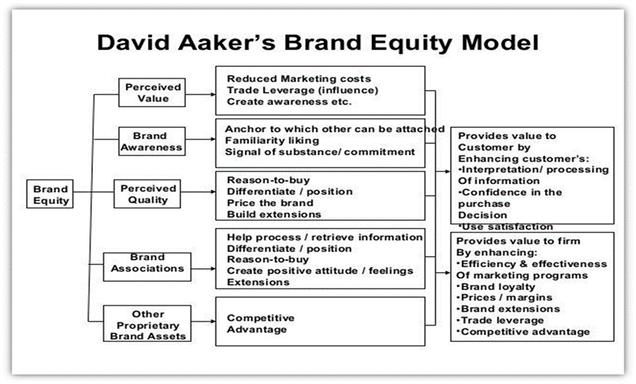
Source: Aaker (1991, p. 270)
Brand Awareness
According to Aaker's (1991) perspective, brand awareness refers to a customer's capacity to remember and acknowledge that a brand belongs to a specific product category. Aaker posits that brand awareness can be viewed as a spectrum, spanning from a fundamental recognition of the brand to a more advanced perception that it is exclusive to a particular product category. Aaker observes that the level and context of awareness achieved are the primary factors determining brand awareness within the brand equity framework. Aaker's brand equity model emphasises the importance of businesses having a broad customer base and proficiently operating beyond traditional media channels to achieve optimal brand recognition. Brand awareness measurement is based on various factors determining how well customers can recall a brand. These factors include brand recognition, recall, top of the mind, and dominant brand, as stated by Aaker in 1996.
The study conducted by Kunst A, a member of the Consumer and Business Insights and published in Statista (2022), employed the method of assisted brand recognition by presenting the brand logo and written brand name to the participants. The research indicates that Samsung has a brand awareness of 96% in the UK. Of the UK respondents familiar with Samsung, 55% have a positive attitude towards the brand, while 41% utilise its smartphones. The data shows that a significant percentage of brand users, precisely 87%, are inclined to use the brand again, which suggests a strong sense of brand loyalty. Based on the survey, among the 95% of brand-aware respondents, only 31% reported being exposed to Samsung through media, social media, or advertising. This suggests that Samsung has created some level of interest and attention for itself in the UK during the survey period. The company is one of the most recognisable names in technology, which invested in aggressive brand recognition campaigns, enabling it to earn colossal brand awareness among its consumers. Also, the company employs various strategies, including social media ads, sponsorships and online advertisements, to promote its awareness effectively. Samsung sponsored the Olympic Games, an additional positive contribution and part of the brand recognition strategy.
Regarding Apple, brand awareness in the UK is 94%, according to a study based on the same assisted brand recognition concept by Kunst A (2022). 47% of them (from 94%) say they like Apple, 31% use it, and 79% of customers show brand loyalty. During the survey, 32% of brand-aware respondents had heard of Apple in the media, social media or advertising, indicating that Apple is generating some buzz in the UK. The company can keep its branding simple and aesthetically pleasing and employs exciting and informative marketing strategies to enhance recognition. Apple creates brand awareness through various marketing strategies, including promotions, personal selling and public relations. Further, the company does not expose much information about its products, which triggers excitation and anticipation. Apple is highly recognised through its brand name and logo, keeping the company in the mind of customers as dominant.
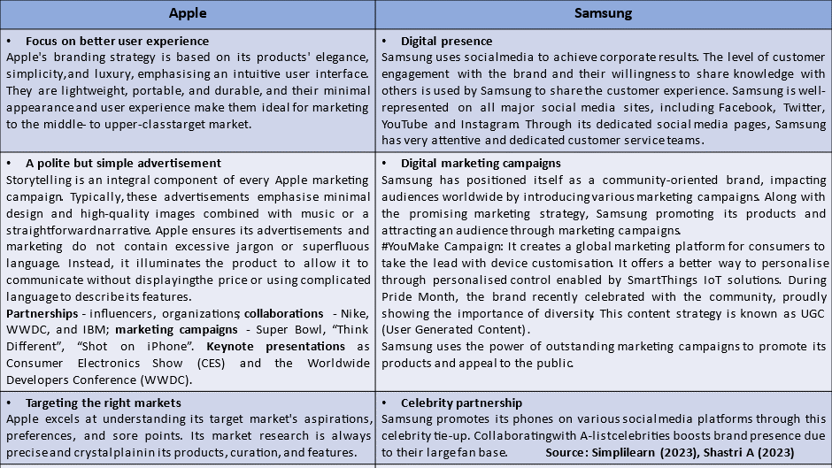
(Created by the researcher)
On the other hand, Bornmark, Göransson and Svensson (2006) argue that brand awareness pertains to an individual's perception and cognitive response towards a specific situation. The concept of awareness is abstract and does not necessarily imply implicit understanding. According to Pappu and Quester (2006), brand awareness significantly influences consumers to remember and remain loyal to a specific brand. According to Gwinner (1997), a positive correlation exists between the number of customers a business gains quickly and the spread of brand awareness. According to Langaro et al. (2018), brand awareness is the capacity and potency of a consumer's recollection to identify a brand in specific situations. Brand awareness involves establishing a clear product identity by linking its various elements to a particular product category.
Kotler and Keller assert that brand equity is built upon customers' brand awareness. According to Kotler and Keller (2006, p.278), brand awareness enables customers to distinguish between various brands and influences their perception and reaction to marketing efforts. According to Keller (2008, p. 373), brand awareness is essential for any brand but cannot solely generate and propel sales within a company. Per Aaker's (1991) perspective, brand name awareness is vital in consumer decision-making. Customers' familiarity with a brand positively influences their purchasing behaviour, as they tend to feel more at ease when buying from a brand they are already familiar with. A company's entire brand name is significant because it influences customers to opt for a familiar brand instead of an unfamiliar one. According to Shahid et al. (2017), the impact of brand awareness on consumers' purchase intention is significant. The user has identified two key elements that contribute to the measurement of brand awareness: the brand name and the brand logo.
While evaluating the literature, a gap is identified in previous studies regarding the requirement to quantify the appropriate form of brand awareness. According to Rossiter J.R. (2014), the right choice of brand awareness can be made through the researchers' understanding of consumer behaviour or qualitative one-on-one interviews in which the consumer is prompted to think about and frame their last purchase in a specific target context. In their model of brand positioning, Rossiter and Percy (1997) refer to this as constructing a behavioural sequence model in which brand awareness and attitude are unified. This concept is in the marketing literature's CUB Branding Model of Positioning.

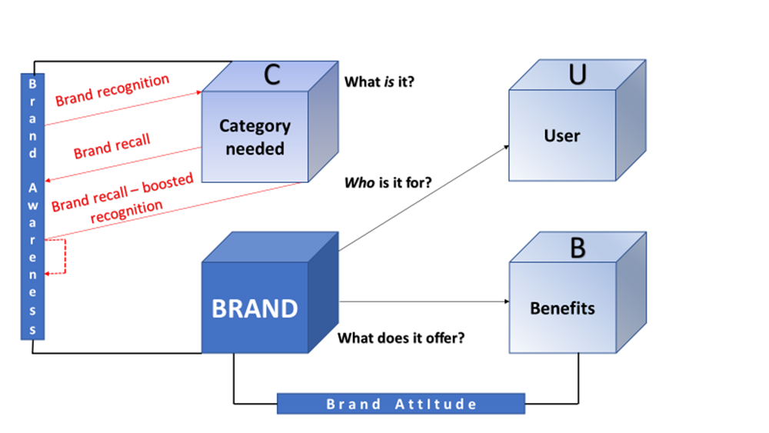
(Created by the researcher)
According to identifying the behavioural sequence model of the majority choice process, the image depicts three different types of brand awareness tested differently. Additionally, the chart includes all three different ways to achieve brand recognition.
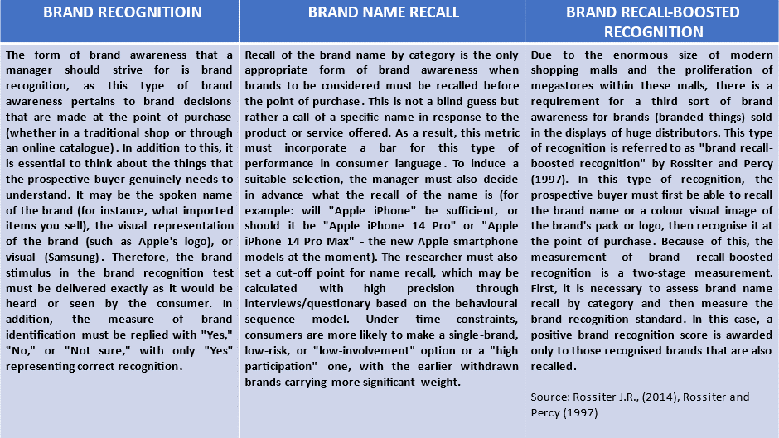
(Created by the researcher)
Perceived Quality
Quality perception, as defined by Calvo-Porral and Lévy-Mangin (2017), is "the customer's all-encompassing perception of a product's (service's) quality or superiority about its intended use relative to other options available in the market." Customers' perceptions of a product's quality are essential because they give them a reason to choose one brand over another. Consumers' purchasing decisions and commitment to a brand are profoundly influenced by their impressions of its quality. Aaker (1996) argues that a consumer's last impression of a product or service can impact their current opinion of its quality. The customer's trust in a product (service) may be challenging to regain despite any improvements in quality due to a negative experience in the past. Aaker's conceptual framework delineates the quintet of values that illustrate the perception of quality. The values encompass rationale for purchase, differentiation or position, premium pricing, interest in the distribution channels, and brand extension.
Apple and Samsung are perceived as high-quality brands by their customers. When a brand makes a promise and meets or exceeds consumer expectations based on that promise, it is perceived as high quality. For example, Apple promises a simple and elegant smartphone, and most believe it delivers. Therefore, their products are regarded as superior. People also have a high opinion of Samsung but are slightly behind Apple in this indicator. The difference between the two companies is due to Apple's differentiation and marketing strategy (Finkle, 2023).
Apple uses a technique called "differentiation" to reach a specific group of consumers by clarifying that its products differ from those of other electronics companies. Apple's goods stand out from the competition because their designs have different looks and functions or do different things. Apple does a great job of living up to its "Think Different" motto by making goods and services that are unique and special. A company's pricing tactics are also a part of its plans to stand out from the competition. Apple's pricing approach considers how it stands out in the market for selling electronics. Apple sells small amounts to big stores and puts most of its retail efforts into its Apple Stores. Apple Inc. tries to make high-quality products at prices that match their level of quality while keeping their profit margins high (Kopp CM, 2021).
Through its strategy of low prices and product differentiation, Samsung has effectively expanded its product line thanks to the ecosystem it has created around itself. Samsung is a multinational conglomerate and the largest chip manufacturer in the globe. It manufactures many of the components that go into its smartphones, giving it a price advantage and allowing it to be more flexible regarding what and when it produces. Samsung's ability to offer a broader range of products than its competitors can be attributed to its substantial investments in innovative research and development. The price blend is a critical component of Samsung's marketing strategy, and the company offers two pricing options to ensure customer satisfaction. The company implements a price-skimming reduction strategy when launching a new smartphone with advanced technology. The introduction of identical products by competitors results in a decrease in the product's price. According to Simplilearn (2023), Samsung utilises highly effective sales promotion strategies in its advertisements to appeal to consumers.
Brand association
Establishing a connection between the brand and specific attributes or individuals can generate a sense of reliability and assurance among consumers. Furthermore, certain brands utilise alternative characteristics, such as exceptional customer service. Aaker (1991) suggests that there is a strong correlation between brand association and brand equity, as a brand association can improve the ability to remember a specific brand. According to Kotler and Keller (2006), a correlation exists between brand association and attitudes, benefits, and attributes. The concept of brand association pertains to the intangible qualities of a brand, including its uniqueness concerning other brands, level of innovation, market share, and prestige. Brand associations can be categorised into three distinct types: emotional attribute associations, functional product attribute associations, and attitudinal associations. According to Foroudi et al. (2018), brand loyalty is influenced by establishing brand associations and the quality of brand relationships.
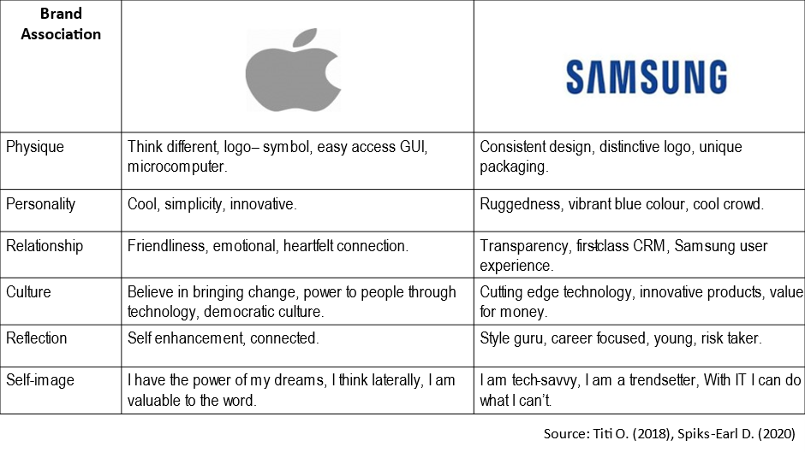
(Created by the researcher)
Both companies prioritise the development of brand associations as a means of achieving success and standing out from competitors.
Samsung has been linked to various things throughout the years. The brand is widely recognised and has a reputation for durability, fashionability, ease of use, innovation, intelligence, relevance, productivity, style, and refinement.
The branding strategy Apple places a high emphasis on evoking emotional responses. The brand personality of Apple emphasises various traits such as lifestyle, imagination, reclaimed freedom, innovation, passion, hope, ambition, aspiration, and the use of technology to empower individuals. The establishment of a genuine human connection with customers has a direct impact on their loyalty to the brand. Apple's focus on design and user experience will likely foster customer loyalty among those who appreciate their products' streamlined and user-friendly nature.

Brand loyalty
According to Aaker's (1991) definition, brand loyalty is a quantifiable indicator of the level of emotional connection that a consumer feels towards a particular brand. As per his statement, brand equity indicates the probability of a customer shifting to an alternative brand, particularly in cases where the new brand offers distinct product attributes or pricing. Customers who exhibit brand loyalty tend to maintain their preference for a specific product from a particular brand, despite the availability of cheaper alternatives. According to Ahmad et al. (2021), the degree of customer loyalty towards a brand indicates its commitment level. The level of brand loyalty is a crucial factor in determining a brand's equity; when customers prioritise product features, price, and convenience over brand identity, the likelihood of low brand loyalty increases. According to Shariq's (2018) assertion, an increase in brand loyalty results in a decrease in the customer base's vulnerability to competitive actions.
According to Gennene's (2020) perspective, brand loyalty indicates a brand's significant market presence. It suggests that customers are less likely to switch to other brands and are willing to purchase the same brand repeatedly. Keller (2003) challenges the notion that customers who often buy from a single brand are genuinely loyal to that brand. Consumers may have multiple motives for their actions, such as maintaining consistent daily routines, being enticed by persuasive marketing messages, and taking advantage of attractive discounts and offers. Keller (2003) challenges the notion that customers who repeatedly purchase from a particular brand are necessarily loyal to that brand. Consumers may have multiple motives for their actions, such as maintaining consistent daily routines or being enticed by appealing marketing messages and special offers.
In 1991, David Aaker developed a brand loyalty pyramid to communicate the concept of brand loyalty effectively. The pyramid highlights five steps of brand loyalty development, with customers/ prospects entering the base and progressing to the final step. The first step in the pyramid is switchers. According to Aaker (1991), brand loyalty is not sought at this step. At this stage, customers have not decided which brand to dedicate their loyalty to – they don't seem to care about the brand they purchase from. Typically, customers at this level tend to grab anything from the shelves as much as it meets their needs and most probably, they won't remember the brand they bought in their next purchase. Wachtel (2020) asserts that customers at this stage are not bothered with switching brands.
The pyramid model includes a second tier consisting of customers who are either satisfied or habitual buyers. Per Aaker's (1991) analysis, customers at this level tend to concentrate on procuring a single brand. However, they do not display any intense emotional attachment towards it. The consumer's purchasing behaviour suggests that they have developed a habitual preference for the brand, which may indicate a level of satisfaction with the product and a lack of motivation to explore alternative options. Customers who encounter problems with a brand will likely switch to a different brand rather than attempt to resolve the issue with their current brand.
In the third step, some buyers are satisfied, and the costs are subject to change. Customer satisfaction with the brand offering may be influenced by the presence of barriers that reduce the attractiveness of switching. Aaker (1991) has identified several obstacles, including quality, monetary costs, and time. Assuming the obstacles are removed, consumers in this stage will likely switch brands due to their lack of emotional attachment to their current brand.
The fourth step is comprised of brand likers. The stage is regarded as a transition point for a customer- the customer is passionate and enthusiastic about the brand. Emotions drive customers at this stage into liking a brand. They don't know why they want the brand but feel the urge to do so. The liking is natural, and they tend to feel attached to the brand. The last step is comprised of committed buyers. At this stage, Aaker (1991) asserts that a brand plays a significant role in the customer's day-to-day life and consumers at this level tend to feel proud to be associated with a given brand. Notably, the brand's identity fits effectively in the customer's values; innovative brands reward customers with loyalty perks to promote mutually beneficial relationships. Wachtel (2020) postulates that business organisations should authentically engage with their customers and invest immensely in customer service to move them up the ladder. Notably, rewarding loyalty, paying attention to customer reviews and feedback, and maintaining a positive presence on social media are some strategies businesses can embrace to move customers up the ladder effectively.
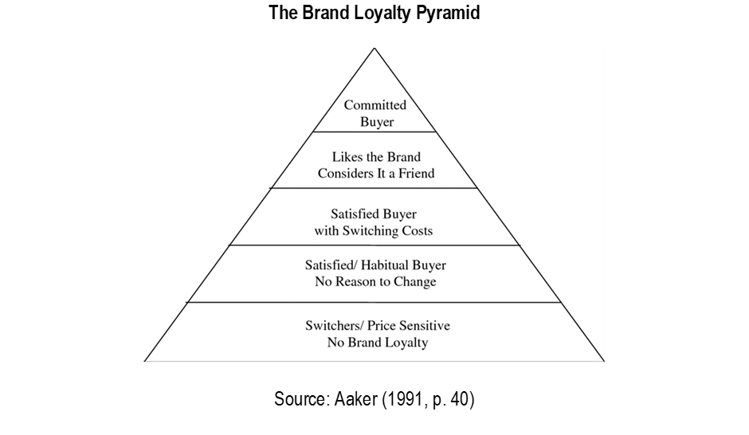
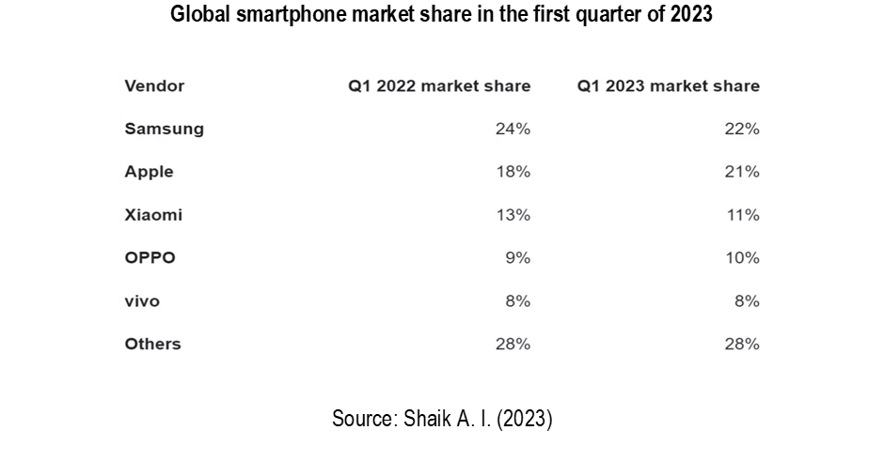
After building a customer base, providing consistent experiences that maintain loyalty is necessary. Consistency builds trust, which keeps customers coming back. In this way, companies increase their revenue. Apple is committed to consistency in design and user experience. According to Moorman C.'s article, published by Forbes (2018), all touchpoints, such as products, websites, ads, app store and retail store, provide a consistent Apple experience. From design to functionality, this experience is all about simplicity.
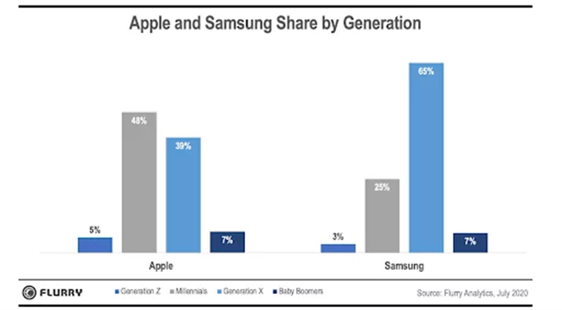
According to Tom's Guide (2019), Samsung is the leader in Android phone brand loyalty with 63.9%, while only 10.8% of Android consumers use other devices. After adopting Samsung products, consumers are likely to remain brand loyal. Samsung's marketing campaigns are geared towards consumers who will remain loyal over time. Advertising on Samsung devices allows advertisers to reach brand-loyal consumers unlikely to switch allegiances once established. The objective is to get the generation most likely to remain brand loyal, namely Generation X, which has the highest brand loyalty percentage of all ages. By contacting these consumers early in the new device's lifecycle, the company secures their loyalty for the long term.
Similarities and Differences between Apple and Samsung Concerning Aaker’s Brand Equity Model
Samsung and Apple are global leaders in consumer electronics with devoted customers. Substantial brand equity for both companies results from both companies' positive brand awareness, high brand loyalty, positive brand associations, and high product quality. Both businesses have employed various strategies contributing to their high brand equity. As previously stated, Samsung's brand equity presently has a slight edge over Apple's in several areas. Apple has marginally lower brand loyalty than Samsung, and the business has more engaged customers. Despite the higher price of Apple products, their consumers demonstrate high dedication by being willing to pay any fee for them. The difference between the two companies lies in their differentiation and positioning strategies. Samsung's business model emphasises vertical supply chain integration and increased production volume, and Apple has adopted a business strategy emphasising design and the user experience while outsourcing manufacturing.
2.2.2 Keller's Brand Equity Model
The brand equity model developed by Kevin Lane Keller in 1993, known as customer-based brand equity, is commonly referenced in brand management. This model is outlined in Keller's book 'Strategic Brand Management'. The model was developed to assist business organisations in establishing solid brands that can draw in a large customer base. According to Keller (1993), to establish a strong brand, an organisation must influence the perceptions and emotions of its customers towards its products. Creating a positive brand image is crucial for a company to shape customers' thoughts, beliefs, and perceptions about the brand. Keller suggests that companies with robust brand equity experience increased customer loyalty and advocacy, resulting in higher purchase frequency and a greater likelihood of customer referrals (Keller, 1993). Increasing brand loyalty can provide a competitive advantage for a company.
Keller's work delves into the explanation of the existence of brand equity and provides insights into how marketers can cultivate it. The user states that customer-based brand equity is achieved when customers are intensely familiar with a brand and maintain positive and unique associations with the brand in their memory. Keller introduces the customer-based brand equity (CBBE) concept and devises a "brand resonance pyramid." The text outlines a series of steps that a company can follow to establish a robust brand presence in the market. The figure below provides a visual representation of the steps.

Brand Resonance Pyramid
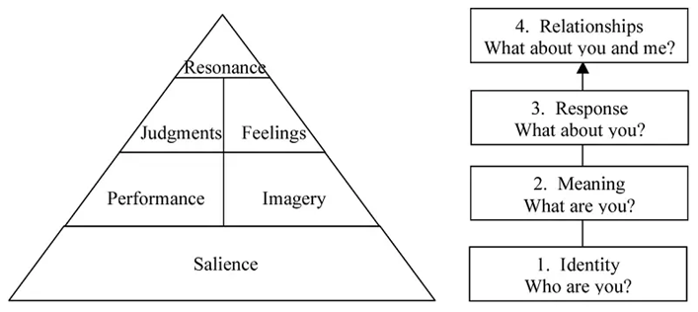
Source: Keller, (2003)
Keller outlines that the initial stage involves establishing brand identity and utilising brand salience to gauge brand recognition within the marketplace. According to Keller's (2008) definition, brand awareness pertains to a customer's capacity to recollect and identify a brand efficiently. Comprehending a brand involves establishing a correlation between attributes such as emblem, appellation, and icon, with distinct recollections in mind. According to Keller (2001), it is crucial for businesses to effectively communicate the categories of their products and services to customers to establish brand awareness. Farjam and Hongyi (2015) argue that in Keller's model, the initial step towards establishing a solid brand is to guarantee real brand identity. Brand salience is crucial as it encompasses various aspects of brand awareness and the ability to recall a brand in a wide range of buying and consumption scenarios. Regarding this matter, the concept of brand salience serves as the foundation and consists of identification and satisfaction.
As illustrated above, the second step establishes meaning by linking concrete and abstract brand associations. Keller categorises brand meaning into two types: functional associations, which refer to brand performance, and conceptual associations, which are related to the brand's image (Farjam and Hongyi, 2015). The following recommended action for organisations is to develop a brand response strategy once they have established their brand's meaning. Keller's perspective on brand response involves assessing and judging brand viewpoints and appraisals. At this stage, businesses evaluate the response of customers towards their brands. Their emotions and thoughts influence the feedback provided by customers towards a particular product. At this point, the fundamental components of brand response are emotions and evaluations. Keller posits that a brand's overall quality, credibility, and superiority are reflected in its conclusions, while customers' emotional responses and reactions to a brand are encapsulated in their feelings (Farjam and Hongyi, 2015). The final stage of the pyramid is comprised of brand resonance. At this stage, the focus is on converting brand responses into active loyalty relationships between the brand and its customers. According to Farjam and Hongyi (2015), Keller has identified four critical components of brand resonance: a feeling of belonging to a community, active participation, emotional attachment, and consistent loyalty towards the brand. From the analysis, it can be noted that there is a sequence in Keller's branding ladder. Keller contends that one stage must be achieved before moving to the next. For instance, brand meaning cannot be completed before brand identity, and brand resonance cannot be reached before brand response (Farjam and Hongyi, 2015).
Apple and Samsung established successful brand identities through distinct approaches, enabling them to thrive in the market. The user states Apple is a sophisticated, innovative, and imaginative corporation. According to Westervelt (2021), a company's brand identity highlights several attributes, such as simplicity, exclusivity, innovation, and memorability, which are aimed at appealing to consumers. As per Fisovee's (2019) analysis, Apple's robust brand identity enables the company to retain its existing customers and attract new ones. Samsung's brand identity is characterised by simplicity and flexibility, as pointed out by Samsung SDI (2016). The user suggests that the oval shape of the logo represents qualities such as dynamism and innovation.
At the performance and imagery level, Apple tends to pay attention to the experience of its customers. To achieve this, the company ensures high-quality products and effectively meets customers' expectations. This provides its users with a comfortable zone, making it difficult for them to shift to another brand (Ana, 2020). In the case of Samsung, the company has invested in unique features and assured its customers of simplicity, reliability, serviceability, and value for money. According to Panicker and Mathew (2017), customers feel the brand thrives and effectively meets their needs, enabling the company to develop a strong brand performance and imagery.
With brand resonance, Apple works by incorporating emotional content in its advertisements. Further, the company delivers what its adverts are saying and makes use of colours that are appealing to customers. These strategies have enabled the company to earn credibility and customer trust in the market (Ana, 2020). In contrast, Samsung advertises itself as a high-quality, superior, credible and considerate brand. The company also assures its customers of excitement, fun, and social approval, which it delivers effectively.
Upon developing a high brand response, Apple strives to create long-term associations with its customers. Here, the company achieves this through organizing events and overnight sales events where customers stand in lines at night, partying with friends to acquire the latest Apple products. Majorly the company organizes frequent events where they get to interact with customers and create positive relationships (Ana, 2020). Like Apple, Samsung also strives to retain customers by building effective relationships. The company does this by investing in customer experience and undertaking advertisements.
Similarities and Differences between Apple and Samsung regarding Keller’s Model
Both companies strive to build brands from brand identity to brand resonance. With brand identity, both companies have been able to develop well-known brands in the world using different strategies. In addition, both companies have invested in offering an exceptional customer experience by producing high-quality, simple and innovative products. Also, both companies have invested in long-term customer relationships, although the metrics used differ. While the two companies are similar in many ways, they differ in their model.
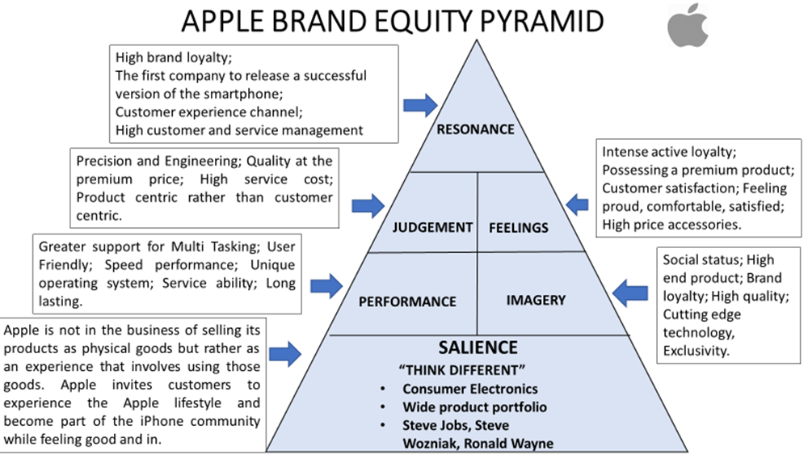
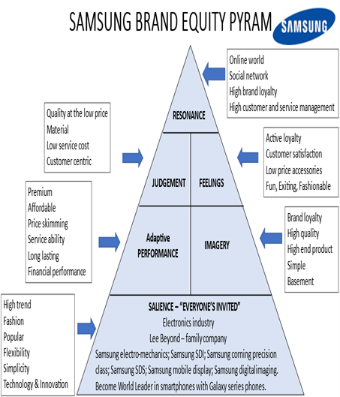
Source: Titi O. (2018), Spiks-Earl D. (2020), Panicker and Mathew (2017), Westervelt B. (2021)
(Created by the researcher)
2.2.3 Comparison of Aaker's Brand Equity Model and Keller's Customer-Based Brand Equity
Both models are widely known and have been used over the years. Secondly, both models have been extensively used to explain the concept of brand equity, providing ample guidance concerning branding and marketing strategies. Further, both models offer a holistic approach to brand building, including the inner understanding of a brand and customers' perceptions of it.
However, Keller's model relies more on customers' emotional responses. In contrast, Aaker's model pays attention to recognition, how well a brand is known, and in what way the brand is well known. Keller's model is more suitable for B2B customers as it involves fewer customers with solid relationships beyond a single purchase (Kuhn, Alpert and Pope, 2008). However, Aaker's model is more suitable for the mass production of products in that a company can emerge as a strong brand amidst solid competition.
2.3 Brand Image
According to Keller's (1993) assertion, the brand image refers to a collection of associations linked to a particular brand and typically retained in customers' memory. In marketing, a brand image refers to the cognitive representations of a brand formed through the brand associations stored in a consumer's memory. According to Keller (1993), brand associations are mental constructs linked to the brand node in memory, which provide buyers with brand significance. Keller (1993) argues that in a decision-making environment where consumers are highly involved, the favorability, uniqueness, and strengths of brand associations are crucial dimensions that differentiate brand knowledge. This differentiation plays a significant role in eliciting various responses that establish brand quality.
2.3.1 The Concept of Consumer Behaviour
According to Suelin (2019), a consumer is an individual with the ability and the willingness to purchase goods and services available for sale in the market to fulfil personal or household requirements. He highlights that consumer behaviour involves examining how individuals, groups, or organisations choose, buy, utilise, and discard goods and services to fulfil their requirements (Szmigin and Piacentini, 2018). Contextually, consumer behaviour refers to the observable actions exhibited by customers in the marketplace and their underlying intentions for engaging in these actions. According to Horner and Swarbrooke (2020), consumer behaviour pertains to the activities and decision-making processes involved in purchasing goods and services to fulfil individual needs. According to Kardes, Cronley, and Cline's (2014) definition, consumer behaviour pertains to the actions exhibited by an individual while searching for, purchasing, utilising, evaluating, and discarding goods and concepts. According to Schiffman et al. (2013), consumer behaviour examines individuals' actions when allocating their available resources, such as time and money, towards consumption-related products. Consumer behaviour is a field of study that examines individuals' actions and thought processes when making choices about buying, utilising, and discarding goods and services.
2.3.2 Models of Consumer Behaviour
Black box Model
The black box model, also known as the stimulus-response model, suggests that consumers will react in specific manners to various stimuli after mentally processing them (Theintactone, 2023). Additionally, the model views consumers as individuals who engage in cognitive processes and analytical reasoning to evaluate and resolve problems when making purchasing decisions. According to the model, consumers are influenced by intrinsic and extrinsic factors when deciding whether or not to buy a product. The term "black box" represents the consumer's cognitive processes and decision-making mechanisms in this model. As per Theintactone's (2023) analysis, a buyer's decision-making process is influenced by a company's marketing strategies and external stimuli. These factors enter buyers' minds, producing specific choices or buying responses. Jisana (2014) posits that marketing stimuli comprise the four Ps of the marketing mix: price, promotions, place, and product.
Furthermore, external stimuli encompass events in a customer's environment, such as technological, economic, cultural, and political inputs. The triggers a buyer is exposed to are processed in their black box, resulting in observable responses such as brand type, time, amount, and product choice (Jisana, 2014). The model suggests that their features influence the perception and response of a buyer to stimuli. The behaviour of a consumer is influenced by their decision-making process when making a purchase.
For example, Apple uses marketing mix elements to evoke stimulus in the minds of its customers. With the product element, the company offers many innovative, simple, style and luxurious products that exceed customers' needs. Notably, the company has invested in customer experience, where it delivers what it promises, and this has evoked positive stimuli in its customers' minds. Further, the company uses various promotional techniques, including print media, advertisements, price-based offers, and social media, among others, to stir positive emotions among its customers (EdrawMind, 2023). In the case of Apple, products are sold at convenient locations, including at Apple stores, online stores, retailers, and value-added resellers. Apple uses three primary pricing techniques: skimming, premium and geographical pricing (EdrawMind, 2023). The company's prices are fair since the products match what the company has promised. The company's strategies have enabled it to evoke positive stimuli in its customers' minds, resulting in brand loyalty.
On the other hand, Samsung also uses the marketing mix to influence the purchasing behaviours of its customers. To begin with, Samsung also offers innovative and up-to-date products that meet customers' needs effectively. Like Apple, the company also offers a wide range of products that allow customers to select the best. In the case of pricing, the company uses competitive and skimming pricing techniques to provide its products to buyers. The company sells directly to retailers and service providers and uses various promotional strategies to influence its buyers' black box positively. These strategies include sponsorship, print media, celebrities, and social media platforms (Shastri, 2023). Like Apple, the company has positively influenced its customers' minds, which has triggered brand loyalty over the years.
Although the model has widespread application, it has also been subject to criticism from various sources. According to Fintech's analysis in 2022, this model exhibits inconsistencies, and over-reliance on it may only sometimes result in favourable outcomes in the marketing sector. The model's limitations in its applicability to certain products pose a challenge for marketers, who may need help to rely solely on the fundamental strategies of the model. According to Fintech (2022), the dynamic nature of consumer interests poses a challenge for marketers to adhere to a single course of action, thereby restricting the model's applicability. The model solely focuses on the process of new purchases and does not consider the circumstances where a customer has already made a purchase.
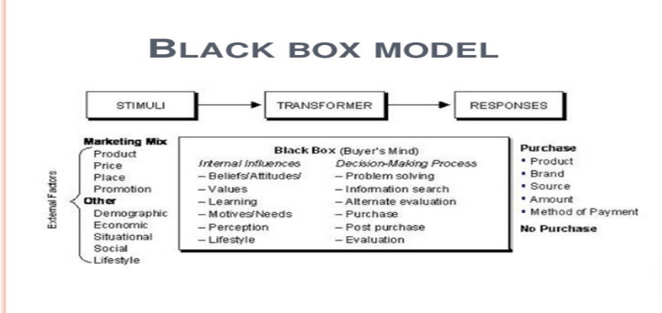
Source: Kotler et al. (2004)
Brand Attitude and ABC Model of Attitudes
The study of G. W. Allport (1935) is based on various authors' understanding of attitude. There he summarises the opinions regarding the definition of attitude, ultimately concluding that it is a state of readiness for mental and physical activity that reflects an individual's attitude toward value. Attitudes can be influenced by either positive or negative behaviour towards the subject it pertains to. Responses to these attitudes can be either implicit or explicit, conscious or unconscious, rational or irrational. G. W. Allport (1935) highlights the connection between attitudes and actions and the inclination to act or behave in a certain way towards specific objects. However, he mentions the presence of both mental and physical readiness to work towards things perceived as valuable.
Bem et al. (1972) define attitude as an individual's emotional reaction and assessment of an object. Various authors in marketing and psychology, such as Lott B. and Lott A. (1985), Chaiken S. and Stangar Ch. (1987), Ajzen I. (2001), Hogg M. and Vaughan G. (2021), and Pratkanis A.R., Breckler S.J., and Greenwald A.G. (2014), have analysed the concept of attitude from an evaluative standpoint. The definitions provided by the authors characterise attitude as a mental construct that conveys a positive or negative assessment of an object. The concept is denoted by various expressions, including "cumulative rating," "rating accumulated over a period," and "positive and negative rating."
Eagly and Chaiken (2007) thoroughly explain attitude from an analytical perspective, as they state that attitude is a broad expression that includes an individual's psychological traits. The authors' analysis of attitude centres on three key components: the evaluation, the target of the attitude, and the inclination to act in a preconceived way towards the evaluated object. The components of attitude consist of cognitive elements, which are ideas and thoughts related to the objective of the attitude, and behavioural elements, which are intentions to act or behave in a particular manner. The presence of certain factors can suggest whether an individual is inclined towards a positive or negative viewpoint regarding an object. The evaluation process considers beliefs, thoughts, and intentions as essential factors. As a result, emotions and experiences are considered integral components of this process.
The authors Bakanauskas et al. (2020) thoroughly explain the concept of attitude. Per their statement, the information is obtained and gathered within the person's memory. The idea is intangible and serves as a comprehensive evaluation of specific items. It reflects an individual's psychological makeup and is influenced by emotions, behaviour, and cognitive processes. It conveys a particular belief and response to the evaluated object but does not necessarily translate into action in real-life scenarios. The researchers broadened the definition to encompass behavioural, cognitive, and emotional aspects that prompt a specific action.
The ABC Model of Attitudes suggests that consumer attitudes play a significant role in their decision to purchase a product or service.
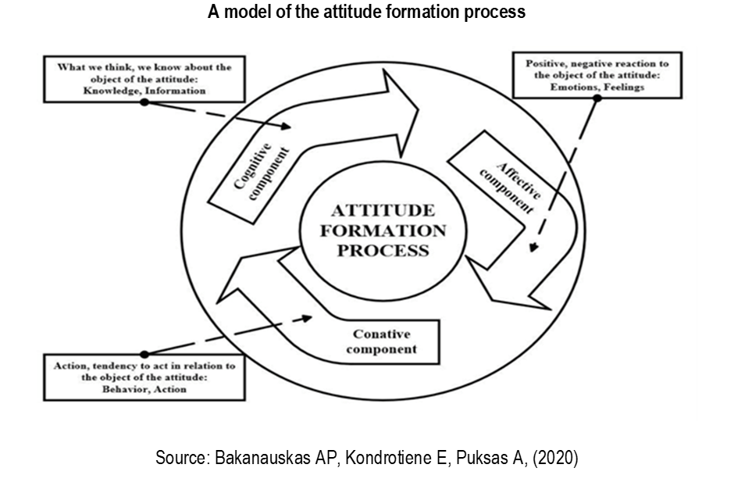
According to Drew (2023), attitudes are divided into three components: affective, behavioural, and cognitive. The affective component of consumer behaviour pertains to consumers' emotional response towards a product or service. This response can be positive or negative and is typically the consumer's initial reaction. According to Drew's (2023) argument, consumers' emotional responses towards a brand are influenced by fundamental memories or past encounters that have moulded their brand perception. Individuals may hold varying sentiments towards Apple and Samsung in the smartphone industry. Consumers' preferences for Apple or Samsung may vary based on their priorities. Some may be drawn to Apple's latest features, while others may value Samsung's long-lasting battery and power-sharing capabilities.
On the other hand, Drew (2023) highlights the behavioural component of consumer behaviour, which pertains to consumers' actions based on their feelings and intentions. Consumers who prefer Apple or Samsung products are likely to make a purchasing decision based on their respective brand loyalties. The cognitive component refers to a customer's mental processes related to a product or service, including their beliefs, thoughts, and associations with the product. According to Nimble Foundation (2019), cognitive detail refers to the division of opinions or ideas associated with a particular attitude. For instance, consumers choose between Apple and Samsung based on brand reputation, product features, and personal experiences. Based on the ABC model, consumer purchasing behaviour is influenced by their affective, behavioural, and cognitive responses to a brand. It can help marketers implement viable strategies that will help target customers effectively.
Similarities and differences.
In both companies, customers purchase products based on their feelings about the brands. Also, customers will tend to buy from either of the companies based on how they like the brand, the reputation of the brand as well as personal experiences. The difference between the two companies lies in the strategies they have put in place to meet customers' needs. For instance, Apple is more reputable due to its ever-innovative, simple and luxurious products, giving the company an upper hand over Samsung.
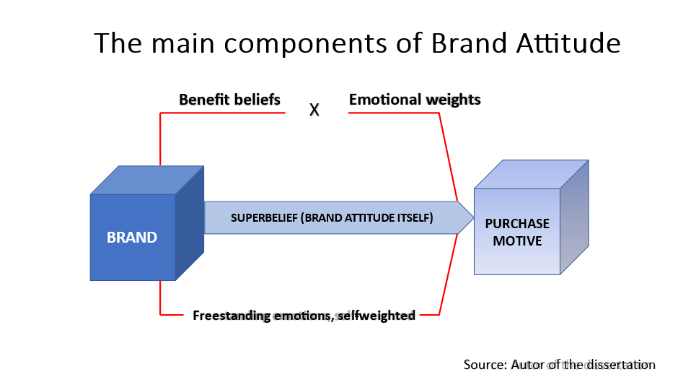
The most difficult challenge for marketers to overcome is changing consumer perceptions of their brands. It usually involves persuading favourable brand switches to rank the product as one of the customers' preferred brands and become loyal to the brand (Foroudi P., 2019). The result is that such consumers will consider that brand their preferred brand.
Following are some strategies used to increase the buyer's attitude towards the brand:
1. Increase the level of importance consumers attribute to brand benefits. According to a study of the desirability of smartphones and their operating systems conducted by Taute et al. (2014), the competition between Apple's iPhone and Samsung's Galaxy is mainly about securing the advantage of ever-larger screen size.
2. Encouraging a greater appreciation of or emphasis on the unique value offered by the brand. For example, the CEO of ConAgra, who suffered a heart attack, was used dramatically to promote healthy eating. They are establishing themselves as a market leader due to the success of their Healthy Choice brand of frozen foods that are lower in fat, cholesterol and sodium.
3. Inclusion of a new benefit that holds high value and is perceived to be distinct from the benefits offered by rival brands. For example, introducing sodium fluoride by Crest toothpaste allowed the brand to gain a competitive advantage in the US market, leading to a rapid rise in popularity due to its cost-effectiveness.
4. Including a robust and good sense of self. When selling these "experiential" brands, as Rossiter and Percy call them, the key is to find a powerful and positive emotion that stands on its own and can be associated with the product in a way that is independent of privilege. Campaigns like "I'm lovin' it" for McDonald's and "Pure thrills" for Smirnoff Vodka are two examples of this strategy.
5. Correcting the selection rule favouring a particular brand, a strategy presenting the most significant difficulty. Examples of such phrases include "Ask about generics" for prescription or over-the-counter medications and "Five a Day," which refers to eating five servings of fruits and vegetables daily (Rossiter J.R., 2014).
2.3.3 Comparison of the Black Box Model and the ABC Model
Both models provide in-depth insights into consumers' behaviour when purchasing products and services. Both models regard consumers as being rational, and they tend to buy after considering different factors/alternatives and selecting the best that matches their needs.
However, the black box model is based on the fact that consumer behaviour results from internal and external stimuli entering a consumer's mind (black box) and processing, making a consumer behave in a particular manner towards a given brand. In contrast, the ABC model is based on attitudes- consumer behaviour results from their perspectives, including feelings, intentions and what they think about a brand.
2.4 Consumer Decision-Making Process.
Ahmed (2021) states that marketers must comprehensively understand consumers' decision-making process when making purchasing decisions. This knowledge serves as a fundamental basis for developing effective marketing strategies. According to Suelin's (2019) assertion, the comprehensive comprehension of every component of a decision-making process can enable marketers to provide products and services that possess more excellent utility than their rivals. The hierarchical consumer decision-making model delineates a series of sequential steps consumers undergo when purchasing a product or service. Suelin (2019) classified the model in question as sequential. The underlying premise of this model is that individuals progress through a sequence of cognitive and affective stages that ultimately result in a particular behaviour. Keller's model delineates a series of steps consumers typically undergo when purchasing, including recognising a need, gathering information, evaluating alternatives, making a purchase decision, and reflecting on the post-purchase experience. The process description is as follows:
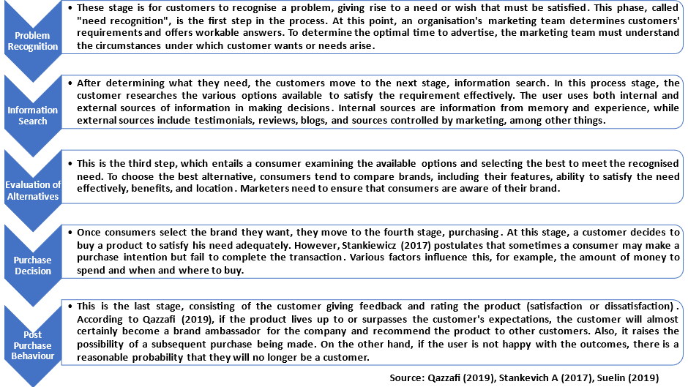
(Created by the researcher)
2.5 Impact of brand image, brand awareness, brand loyalty, perceived quality, and brand associations on consumer purchasing behaviour
Impact of Brand Image
Zhang (2015) posits that a robust brand image that aligns with the preferences of the intended consumer demographic can yield favourable outcomes for both the brand and its offerings, as evidenced by consumer purchasing behaviour. According to Martín, Faraoni, Díaz, and Ranfagni's (2018) study conducted by Deloitte, a significant proportion of consumers, precisely 69% in the retail sector, tend to consider a brand's image before purchasing. On the other hand, Zhang (2015) posited that due to the proliferation of brands in the market, consumers are inclined to base their purchase decisions primarily on the brand image as opposed to the product per se. He asserts that congruence between a brand's image and its self-concept results in a higher likelihood of consumer preference. According to Zhang (2015), Self-esteem theory pertains to an individual's self-perceptions, encompassing various aspects such as personality traits, imperfections, physical attributes, and other relevant factors (Zhang, 2015). The scrutiny of the correlation between brand image and consumer self-esteem is a crucial task for marketers, as individuals tend to exhibit varying perceptions in diverse contexts. Notwithstanding the context, consumers tend to hold a more favourable perception of a brand when its image aligns with their self-concepts (Wang and Tsai, 2014).
Arora S (2018) confirms the above and claims that brand image strongly influences purchasing behaviour. Furthermore, it notes that customer behaviour is also positive with a positive brand image. Moreover, he notes that customers become loyal when satisfied with a brand. Therefore, companies should seriously consider their societal role and provide quality products/services that enhance their brand image.
The influence of brand awareness on consumer purchasing behaviour
According to Aaker (1991), the awareness of brand names holds significant importance in consumer decision-making. Consumers with prior knowledge and familiarity with a brand tend to experience greater ease when purchasing. Hence, the significance of a robust brand identity for customers to opt for a recognisable brand instead of an obscure one cannot be overstated. According to Shahid et al. (2017), brand awareness is a crucial determinant that affects consumers' purchase intention. Hoyer and Brown (1990) have observed that brand awareness tends to increase the likelihood of consumers associating with a reputable brand. Brand awareness enables consumers to recognise a brand and make informed decisions regarding purchasing products or services. According to Shahid, Hussain, and Zafar (2017), the impact of brand awareness on consumer decision-making has been substantiated. Specifically, consumers tend to take into account the brand when contemplating the purchase of a product. According to Shahid, Hussain, and Zafar (2017), consumers who thoroughly understand a specific brand will likely have increased purchasing options and consistently engage in logical economic decision-making. Lin and Chang's (2003) research revealed that brand awareness significantly influences consumer purchasing. The study's results are consistent with the outcomes of an investigation conducted by Hoyer and Brown (1990).
Impact of brand loyalty on consumer purchasing behaviour
According to Bornmark, Göransson, and Svensson's (2006) findings, brand loyalty is a crucial determinant that affects a consumer's selection of a particular brand. In consumer behaviour, brand loyalty is characterised by a consumer's consistent tendency to purchase a specific brand repeatedly. According to Foster and Cadogan's (2000) argument, consumers are inclined to place greater trust in brands to which they exhibit loyalty despite numerous substitute brands in the market. These prompts elicit repetitive purchasing behaviours irrespective of the price of the product. Yoon and Kim (2000) corroborate the above assertions by contending that brand-loyal consumers are more likely to pay a premium price for their favoured brand than to switch to an alternative brand.
Consequently, the purchasing intentions of such consumers concerning a particular brand are relatively impervious to fluctuations in the brand's price. Hameed and Kanwal (2018) conducted an empirical investigation to examine the impact of brand loyalty on purchase intention within the cosmetics sector. The study's results suggest a significant favourable influence of brand loyalty on purchase intention.
Impact of perceived quality on consumer purchasing behaviour
Idealogic (2022) states that the perception of quality is a potent psychological factor significantly impacting consumer purchasing decisions. The crucial element is the consumer's perception of a product, which ultimately influences their decision to purchase the brand and fosters a propensity to exhibit brand loyalty. Perceived quality has been identified by Martins et al. (2019) as a cognitive response that exerts an influence on consumer product purchase decisions. Asshidin, Abidin, and Borhan (2016) assert that perceived quality significantly influences consumer purchasing behaviour within the marketing domain. The research results align with the outcomes reported by Dogerlioglu-Demir and Tansuhaj (2011) and Martins et al. (2019). The research indicates that perceived quality is a highly significant factor that can be utilised to elucidate a brand's fluctuation and consumer purchasing intentions. The results validate the favourable correlation between store brands and consumers' purchase preferences.
Impact of brand associations on consumer purchasing behaviour
As previously stated, brand associations pertain to any aspect directly or indirectly associated with a brand within a consumer's memory and are typically correlated with brand characteristics, attitudes, and advantages. The associations that a brand evokes are a crucial determinant of a consumer's purchasing behaviour. According to Phong et al. (2020), brand associations provide consumers with justifications for purchasing a brand's products, serving as a foundation for buying decisions and brand allegiance. The results of a study by Pasha and Hadibrata (2019) demonstrated a favourable association between brand associations and consumer purchasing behaviour. Grigaliūnaitė and Pilelienė (2017) have conducted research confirming a positive and significant correlation between brand associations and consumer purchase behaviour.
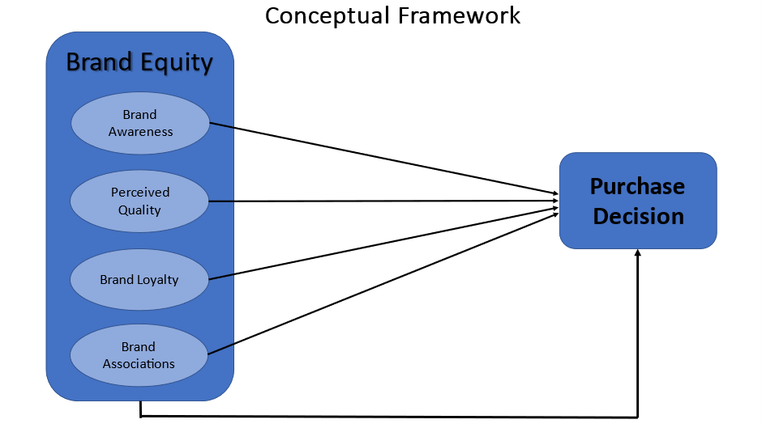
(Created by the researcher)
2.6 Conclusion
Diverse perspectives exist among authors regarding the impact of brand image and loyalty on consumer purchasing behaviour. Following a comprehensive analysis outlined earlier, most scholars concur that a favourable correlation is evident between brand image, brand awareness, brand loyalty, perceived quality, brand associations, and consumer purchasing behaviour. Nevertheless, most research endeavours concentrate on a singular facet of brand equity and its impact on consumer conduct. Moreover, certain studies need more empirical substantiation, resulting in a cavity within the extant body of literature. This research aims to address the identified deficiencies by integrating the components of brand equity, such as perceived quality, brand associations, brand awareness, and brand quality, in evaluating their influence on consumers' buying behaviour. Furthermore, the research provides theoretical and empirical support for the abovementioned variables.
III. METHODOLOGY
  - Introduction
The present chapter expounds upon the methodology, approaches, and steps employed in the investigation to accomplish its stated objectives. This document presents the justification for the selected method, the preparatory phases, and the timetable for the study. The research questions are an integral component of the research strategy employed for primary research. Alturki (2021) posits that the collection and analysis of data to present novel and valuable findings varies depending on the type of research conducted. The selection of an appropriate methodology is influenced by various factors such as the researcher's beliefs, interests, and objectives, the study's purpose, and the nature of the data to be gathered and analysed. Selecting a research methodology impacts the research design and, consequently, the findings.
  - Definition of research
According to Kothari's (2004) definition, research is a systematic and rational exploration to obtain relevant information on a particular subject—the type of inquiry in question endeavours to resolve scientific and societal predicaments using impartial and methodical examination. Pandey P. and Pandey M.M. (2021) define research as an intellectual pursuit that seeks to uncover novel insights and knowledge. According to Askarzai and colleagues (2017), research generates novel insights, rectifies prevailing errors, dispels misunderstandings, and supplements the current reservoir of knowledge. Per the definition provided in the Advanced Learner's Dictionary of Current English, research is a meticulous examination or exploration, mainly through the pursuit of novel information in any field of expertise. Lastly, Askarzai W. et al. (2017) postulate that research is a systematic process that entails an in-depth search or study of any particular subject supported by collecting, computing and interpreting pertinent data. Based on a thorough literature review, they discuss the three primary research methodologies and their attributes – qualitative, quantitative or a combination of both.
  - Research Onion Model
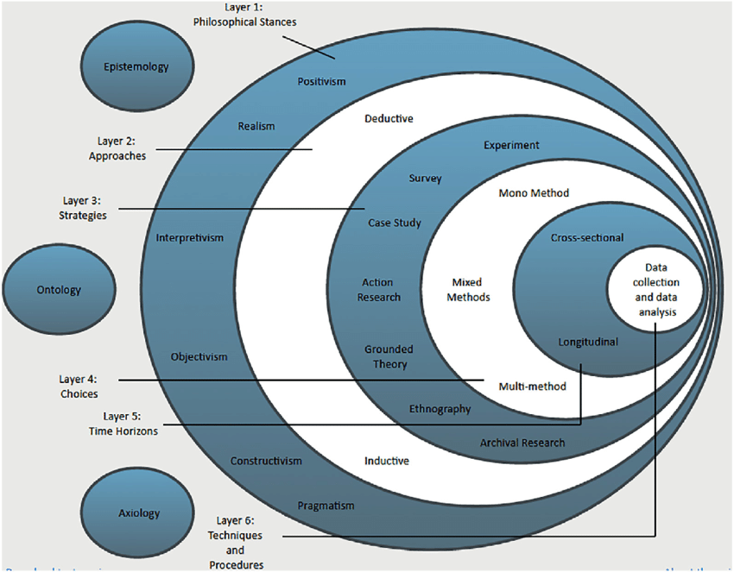
Source: Ahmadzai S., McKinna A. (2018)
The model was developed by Saunder et al. in 2007 and outlined the stages a researcher should go through when designing a research strategy. According to Melnikovas A (2018), the Research Onion offers a relatively extensive depiction of the fundamental layers or phases that must be fulfilled to develop a proficient methodology. The tool mentioned above facilitates the efficient organisation and development of research by adhering to six model layers, as depicted in the figure. The utilisation of this particular model facilitates the researcher's comprehension of how the execution of the research will effectively address the research inquiries. Therefore, the researcher is assisted in determining the most suitable methodology for analysing the collected findings based on their research concepts and domains.
3.3.1 Layer one: Research philosophy
According to Saunder et al. (2019), the research philosophy constitutes the outermost layer of the research onion, encompassing the beliefs and assumptions about knowledge development. In contrast, Kirongo and Odoyo (2020) contend that selecting a research philosophy is contingent upon the area of expertise under investigation. The diagram above illustrates that scholars employ six distinct research philosophies: positivism, interpretivism, realism, objectivism, constructivism, and pragmatism. According to positivist philosophy, scientific methodologies are the leading means of establishing reality. According to Collins, H. (2010), positivism is compatible with the empirical notion that knowledge is based on the human experience. Positivism takes an atomistic, ontological view of the world, with all phenomena separate from each other and interacting predictably and consistently. Crowther and Lancaster (2008) state that phenomenological theories are linked to inductive research methods, while positivist research uses a deductive approach. Positivism is the idea that the researcher should focus on facts, while phenomenology is about the meaning of things and how they affect people. The positivist researcher's only responsibility is impartial data collection and analysis. To be objective analysers, researchers must put aside their values during the research process, and these investigations produce observable and quantitative findings.
The interpretive philosophy entails interpreting data from the perspective of the integrated human interest within the study. The interpretive paradigm is founded on the naturalistic methodology of gathering data, encompassing interviews and making observations. Moreover, the interpretivism philosophy contains secondary data, emphasising qualitative analysis over quantitative analysis. In addition, research in the interpretive paradigm emphasises the interpretation of the meaning and employs diverse methodologies to capture various facets of a given issue (Saunders et al., 2019). Acquiring profound expertise entails many perspectives and methods for studying that are comprehensive, heterogeneous, and multifaceted. However, every such study must be solid, distinguished by honesty and reliability, and enhance knowledge and understanding (Leitch et al., 2010).
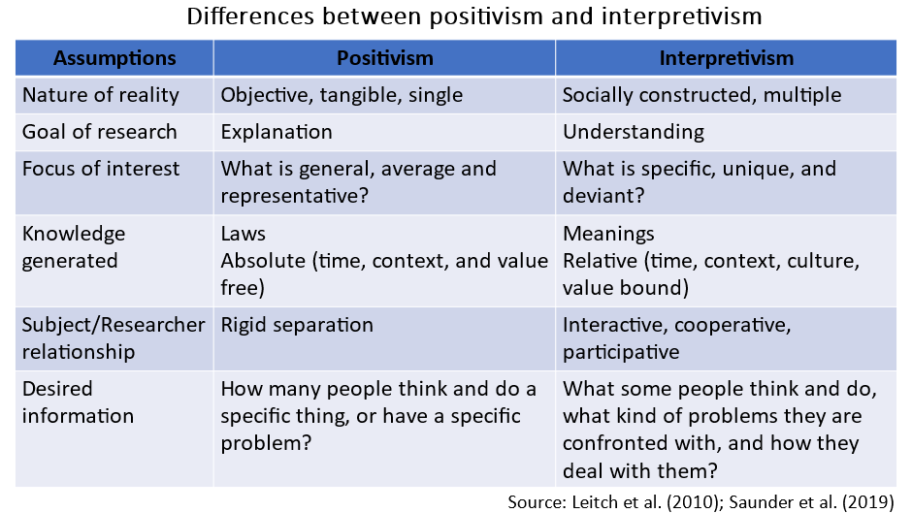
(Created by the researcher)
The interpretive research methodology is associated with certain disadvantages, including the inherent subjectivity of the approach and the increased likelihood of researcher bias. Furthermore, primary data will likely be subject to the researcher's perspective and values. Consequently, the dependability and inclusiveness of the data could be better. One of the advantages of interpretivism lies in its ability to establish a link between qualitative and quantitative research. The validity of primary data can be significant due to the potential for reliability and honesty in the data collected through interpretive studies.
In line with the abovementioned, the present study adopts the interpretive research philosophy, as this research paradigm posits that individual observers possess the capacity to comprehend and apprehend reality—the current investigation endeavours to understand the phenomenon by construing the constituents of the inquiry. The application of positivism is deemed unsuitable in this context due to its philosophical tenet that posits the existence of knowledge as independent from the object of investigation.
    - Layer two: Research approach
The second layer of the research onion model pertains to the research approach. Saunders, Lewis and Thornhill (2019) have identified three principal methods for developing theories, namely the deductive, inductive, and abductive approaches. The reasoned approach involves drawing conclusions from a broad perspective and applying them to a specific law-like inference. This method is primarily employed in the process of testing theories. Conversely, the inductive methodology is antithetical to deductive reasoning as it commences with a particular perspective to formulate broader generalisations. According to Kuosa's (2011) assertion, inductive reasoning relies on intuitive methods, whereas deductive reasoning employs logical argumentation to regulate operations and guide knowledge. Paavola, Hakkarainen, and Sintonen (2006) have defined the abductive approach as a type of inference that commences with the observation of clue-like signs, which serve as the fundamental concept for subsequent research. Inductive reasoning starts with specific comments and conclusions, whereas deductive reasoning begins with available premises and derives particular findings. Inductive reasoning is characterised by a progression from detailed observations to generalisations, while deductive reasoning involves deriving certain conclusions from given premises.
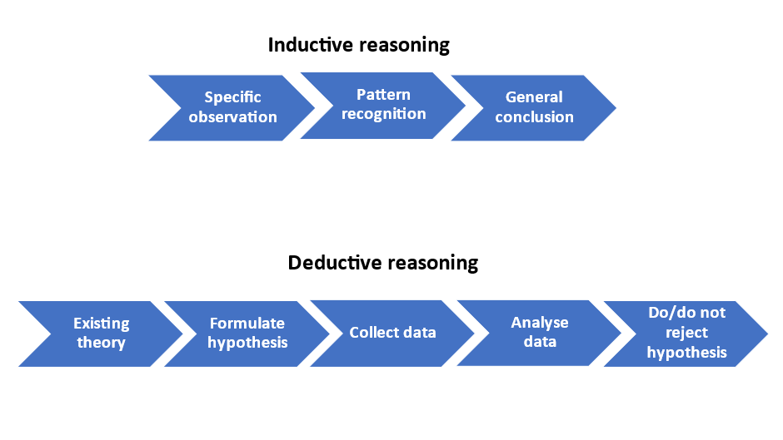
(Created by the researcher)
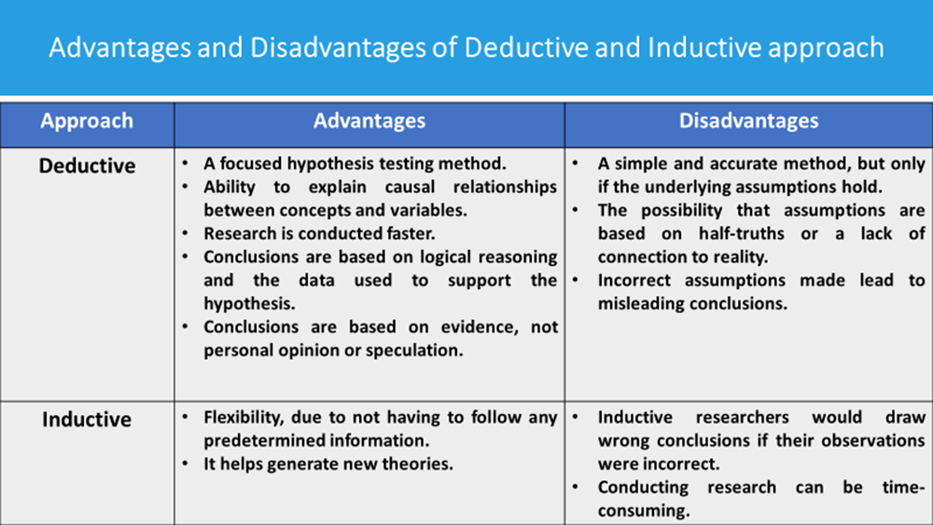
Source: Saunders M, Lewis P, Thornhill A, (2012, p.144), (Created by the researcher)
The investigation employs a deductive methodology to elucidate the relationships between brand image, customer loyalty, and purchase behaviour. Deductive reasoning allows for reaching specific conclusions based on hypotheses. In addition, this approach enables understanding of data, generalisation of research results and better decision-making. Using inductive reasoning allows the researcher to extrapolate from little data, making it unsuitable for this study.
    - Layer three: Research Strategy
According to the definition of Bryman (2008), research strategy encompasses a comprehensive methodology for conducting research. Remenyi et al. (2003) have proposed an extension of the idea of research strategy, which contains the study's general direction and the specific methodology employed to carry out the investigation. Saunders et al. (2012) assert that the selection of a research strategy should be contingent upon various factors, including the research questions and objectives, the level of pre-existing knowledge in the subject area under investigation, the availability of time and resources, and the philosophical foundations of the researcher. Yin (2003) proposes an alternative methodology that involves selecting a research strategy based on three factors: the nature of the research question, the extent of control the researcher can exert over the actual behavioural phenomena, and the degree of emphasis placed on contemporary or historical events. A plethora of research strategies exhibits distinct characteristics, which a researcher may opt for based on the criteria above. Yin (2003) and Saunders et al. (2019) have recognised that, despite utilising distinct research methodologies, there is considerable overlap between their respective approaches. Thus, selecting the most suitable system for a given research is paramount. Various research methods are commonly employed in business and management, including but not limited to experiments, surveys, case studies, action research, grounded theory, ethnography, archival research, cross-sectional studies, longitudinal studies, and participatory studies (Easterby-Smith et al.,2008; Collis and Hussey, 2009; Saunders et al., 2019). The research endeavoured to employ the survey methodology as a suitable approach to attain the study aims instead of alternative methodologies.
Advantages and Disadvantages of Survey Research Strategy (Created by the researcher)
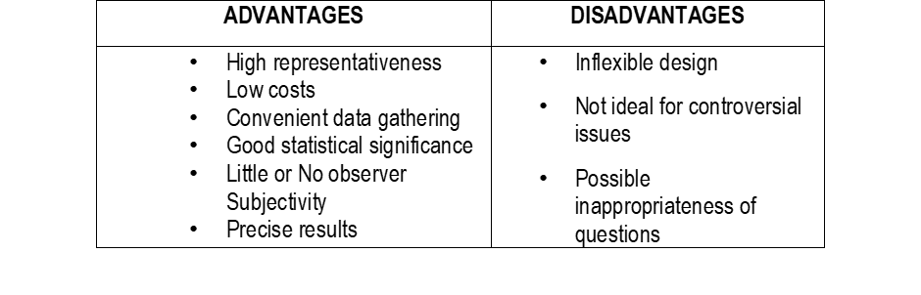
The study adopted the research strategy where Apple and Samsung are selected as case companies as a suitable research strategy to achieve the research objectives. Van Thiel (2014) argues that the survey is one of the most used forms of research because it can easily reach many people and collect important information. It can also be adapted to almost any form of the research question. In addition, the survey may be extensive in scope, with many variables and respondents. Using a research methodology facilitates gathering quantitative data, which can subsequently undergo examination by applying both descriptive and inferential statistical techniques. Furthermore, the data that has been collected is utilised to propose potential factors that may contribute to specific correlations between variables and to construct models that depict these correlations. The survey strategy is preferred because it offers enhanced control over the research process.
3.3.3.1 Types of investigations
Primary research
According to Gratton and Jones (2010), primary research is a form of research that entails the gathering of first-hand information about a particular research undertaking. Primary research involves collecting original data through surveys, experiments, and observations instead of relying solely on pre-existing information from databases and publications. According to Pandey P and Pandey MM (2021), this inquiry form typically generates novel insights. As such, it is referred to as original research. By implementing initial investigations, scholars aim to address questions not previously posed or deliberated upon. The difficulty of this investigation mandated the adoption of a primary research approach due to the need for more available information about the subject matter. The utilisation of questionnaires is a requisite for the observational methodology, wherein the research participants furnish the pertinent information by the prescribed research framework. A survey instrument comprising 13 structured questions is distributed to a sample of 150 participants, with a request for candid feedback within a predetermined timeframe. The interrogatives have been formulated to elicit answers that pertain to fundamental elements of the research's objectives. Collecting numerical data from participants constitutes the fundamental basis of primary research data, commonly called quantitative information.
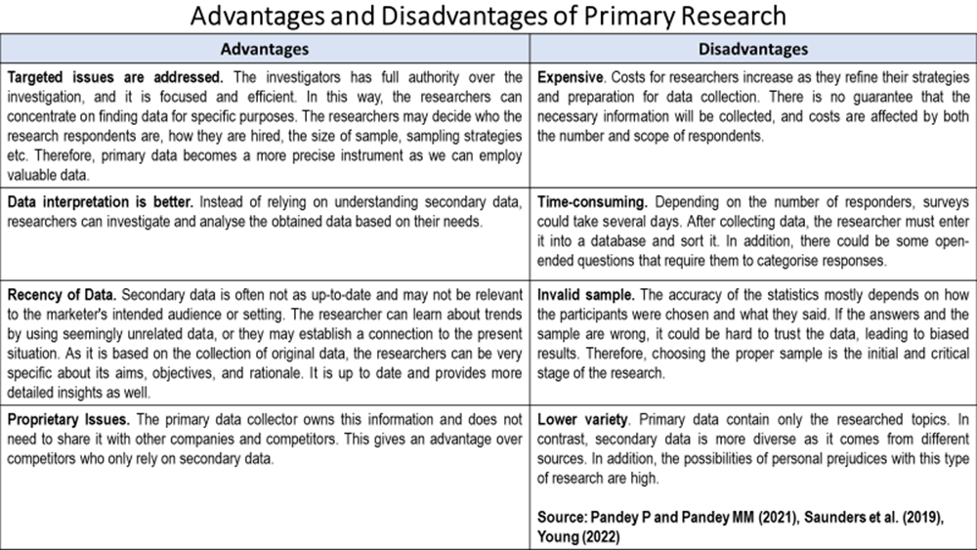
(Created by the researcher)
Secondary research
Secondary research, in contrast to primary research, requires synthesising pre-existing data rather than the researcher's engagement. To be more specific, in secondary analysis, a researcher uses data that has previously been gathered and made public by other researchers. Bouchrika (2023) states that academic peer-reviewed journals, published books and papers, government organisations, educational institutions, and so on are some of the many places researchers might find secondary data. According to him, primary research cannot be compared to secondary research due to the latter's lack of novelty. Existing findings from secondary research are used as supporting evidence for the proposed hypothesis. The hypothesis is then tested using newly collected data from ongoing primary research.
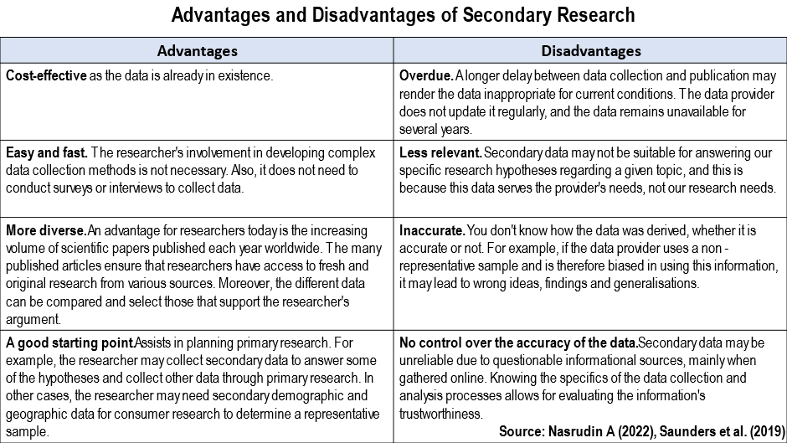
(Created by the researcher)
    - Layer four: Methodological choice.
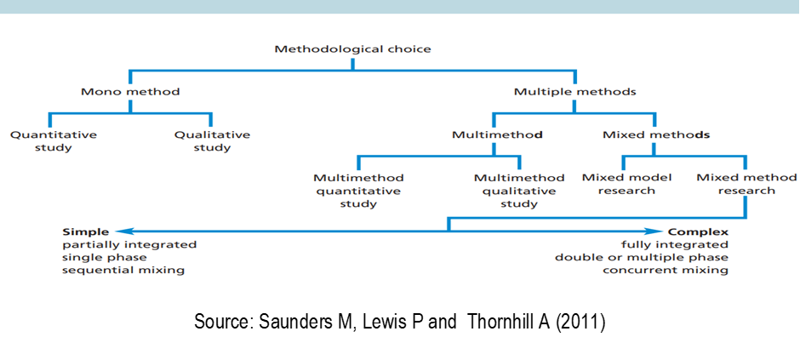
According to Saunders, Lewis, and Thornhill (2012), selecting a research methodology is a fundamental yet crucial decision that researchers must make during the design phase of their research. Per their assertion, the primary research options encompass three distinct categories, namely quantitative, qualitative, and mixed methods. Quantitative research is a methodology that employs empirical techniques and propositions, per the definition provided by Cohen et al. (2017). Collis and Hussey (2009) describe quantitative research as a research approach that seeks to elucidate phenomena by gathering numerical data and subjecting it to statistical analysis. Melnikovas (2018) defines quantitative research as research involving numerical and mathematical operations.
In contrast to quantitative research, qualitative research does not entail using numerical and mathematical procedures but rather entails gathering comprehensive descriptive information. According to Abuhamda and Ismail (2021), qualitative research is an explanatory approach typically employed to identify patterns in ideas and perspectives. Regarding this matter, qualitative research is inclined to address research inquiries that necessitate gathering qualitative data instead of quantitative data. According to Yilmaz K (2013), qualitative researchers commonly employ participant observation, in-depth interviews, focus groups, and document analysis to gather and analyse data.
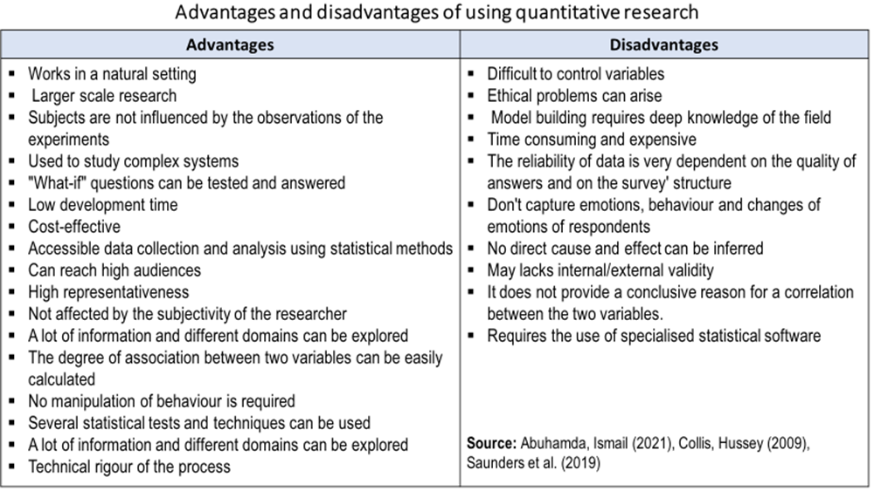
(Created by the researcher)
The current study used a quantitative research strategy. Relationships between variables uncovered by the quantitative approach can be better understood using the qualitative approach. The mono method quantitative facilitated the development of research questions, survey questions, and sample and participant selection (Patten L and Newhart M, 2018).
    - Layer five: Time Horizons
Within the research context, the term "time horizon" is primarily utilised to denote the temporal scope of a given research endeavour. According to Saunders, Lewis, and Thornhill (2019), research can be conducted over significant time horizons, either cross-sectional or longitudinal. Cross-sectional analysis involves the collection of data on a phenomenon at a specific point in time. In contrast, longitudinal research involves the repeated accumulation of data from a particular population over an extended period. A brief duration characterises a cross-sectional study, whereas a protracted course distinguishes longitudinal research. The present research employed a cross-sectional data time frame because the quantitative investigation and data analysis could be completed within a brief 16-week period.
    - Layer sixth: Data Collection and Analysis
      - Sampling type and size
Singh and Masuku (2014) define sampling as the method of selecting subsets from a larger population to determine the characteristics of the entire population. According to Patten and Newhart (2018), sampling is choosing a subset of individuals from a larger population to conduct research. In other words, the sample is a representation of the people that are involved in the study. According to Saunders et al. (2019), sampling can be classified into two distinct categories: probability and non-probability. Probability sampling entails using random selection, thereby enabling the derivation of statistically valid inferences about the entire population while minimising the likelihood of selection bias. Non-probability sampling is a method of selecting participants that do not involve randomisation but is based on convenience or other predetermined criteria. This approach enables researchers to collect data promptly.
The study randomly selected 150 participants from the population of full-time students at the University of Wales Trinity St David London. Thus, the sampling and clustering process ensures that every member of the student body is afforded a fair chance of being chosen, with no preference given to undergraduates or postgraduates beyond the MBA level. The cluster sampling method is employed to determine the appropriate sample size. According to Sedgwick's (2014) definition, cluster sampling is a method of probability sampling that entails the division of a target population into clusters, followed by the random selection of a subset of these clusters to serve as the sample population. The sampling method employed involves including all units within a group in the sample—the cluster samples comprised of male and female university students aged between 18 to over 50 years. The students are required to expeditiously accomplish and submit the questionnaire within three weeks, as previously indicated, owing to the constrained time constraints.
Advantages and Disadvantages of cluster sampling method
Regarding cost, cluster sampling is a cheaper and faster method of determining sample size to observe groups of units in a population rather than randomly selecting scattered units. Also, cluster sampling helps avoid any unintended bias in the collected data. However, if a varying size of subgroups is determined, then sampling errors will occur. The clusters may contain similar units, thus causing sampling error and reducing the representativeness of the large population. Finally, with cluster sampling, the researcher cannot apply the findings to another area population.
      - Data Collection Methods
To address the research questions, establish conjectures, and assess the findings, the investigator must gather data encompassing methodical and structured details about pertinent variables (Saunders M et al. 2012). The prevalent techniques for gathering information encompass the utilisation of schedules, surveys, questionnaires, and interviews. As previously stated, quantitative research employs numerical and statistical methodologies to quantify variables and evaluate research inquiries methodically.
The acquisition of precise data from diverse sources facilitates accurate data analysis and the identification of productive solutions to research inquiries. The utilisation of primary data assists in identifying factors that influence consumer purchasing behaviour. The survey instrument comprises a set of thirteen items in the form of multiple-choice questions, and it is estimated to require a time frame of up to five minutes for completion. The survey questionnaire (see Appendix 1) was disseminated and tracked through an online platform utilising Google Forms. Before the commencement of the preliminary study, a pilot study was executed to assess the credibility and consistency of the research tool. Primary data collection in the study did not entail the use of interviews. The secondary data utilised in this study was derived from peer-reviewed literature, including scholarly articles, academic journals, and books containing pertinent information about the research subject. The text expounds on diverse theoretical facets of branding strategies that enhance customer contentment and stimulate buying decisions. The combination of primary and secondary data aligns with the intended goals and objectives of the research.
      - Data analysis
The data analysis generally entails various activities, including collecting, refining, and arranging data. The procedures above necessitate using software for data analysis to appropriately format the data for its intended purpose. According to Patten and Newhart (2018), data analytics involves examining unprocessed data to derive informed insights. Data analysis strategies and techniques are used to maximise the potential of data to help overcome challenges such as:
- System problems, human error and outdated data cause poor data quality
- An effective data strategy ensures the security, high quality and value of data that can be used for business purposes.
- Sufficient qualifications in terms of technical skills and adequate data analysis skills
Using algorithms, mathematical analysis tools, and software is commonly necessary to apply quantitative data analysis techniques to effectively manipulate and extract insights from data. The present investigation utilised descriptive statistical analysis to examine the quantitative data obtained from participants. Regression analysis is necessary to use specialised software such as Microsoft Excel and the Statistical Package for the Social Sciences (SPSS) owing to the intricate formulas involved. The completed surveys underwent analysis and coding procedures to ensure the accuracy of the data. The study's findings were conveyed through distribution tables, standard deviations, means, and percentages, allowing for a more accurate assessment of fundamental patterns and detecting potential correlations between various study variables. The thematic and textual analysis process was employed to categorise qualitative data into predetermined and recurrent logical groupings, as described by Ott and Longnecker (2016).
      - Ethical consideration
Preserving confidentiality and anonymity safeguards against any potential harm from participating in this study. Participation in the event is entirely optional, and any individual who chooses not to partake is not obligated to do so and may withdraw from the event at their discretion. The information gathered for this study will be handled by the Data Protection Act 1998, which guarantees the privacy and confidentiality of all personal data and restricts its use to the specific objectives for which it was initially obtained. Their voluntary participation was solicited before administering the research instruments to the participants. The questionnaire was accompanied by an informational document that introduced the researcher, outlined the research project objectives, and included the supervisor's name and contact information for the university.
Furthermore, the participants were guaranteed that the research was solely being carried out for educational objectives and that their answers to each questionnaire would only be accessed and utilised by the study's author. The questionnaire will not solicit the names of the respondents but will instead request a restricted set of personal details, namely gender and age bracket. Research tools are provided through a hyperlink directing users to Google Forms. Upon receipt of the data, it underwent a process of entry and subsequent verification to ensure its accuracy. The data shall be deleted upon the project's conclusion.
IV. DATA ANALYSIS AND DISCUSSION
4.1 Introduction
The following section provides an analysis and assessment of the survey outcomes after completing the questionnaire. The statistical data presented in this study were collected by administering an electronic survey to a selected group of students enrolled at the University of Wales Trinity St David, London Campus. The results and discussions demonstrate the variations in the impact of brand image and loyalty on consumer purchasing behaviour. The systematic organisation, analysis, and interpretation of quantitative data were conducted. The data analysis findings are presented lucidly and succinctly, substantiated by tabular and graphical representations, facilitating their comprehension and discourse. The validation of the conclusions was accomplished through the utilisation of the literature review support.
A structured and standardised questionnaire was utilised to verify the legitimacy of survey participants, which included targeted inquiries about demographic factors such as age, gender, and educational attainment. Furthermore, the study included matrix statements about the critical variables. The anticipated duration required to accomplish the questionnaire was under five minutes to avoid causing annoyance or inefficiency for the participants. The participants were requested to choose the most suitable information alternative from a given list to assess their emotional state and mitigate potential bias concerns.
One hundred fifty respondents who participated in the survey were accessed through diverse online channels. The survey instrument was distributed to the participants via electronic mail, with a portion of the sample receiving it through the messaging platform (WhatsApp)utilised by the course group. The survey was conducted during the student assessment period and summer vacation, with the expectation that a more significant number of responses would be obtained if the questionnaire was distributed to a broader student population. The study received 66 responses, all of which were accurately completed and contained 100% of the necessary information. The factors mentioned above led to a sufficient sample size that is representative.

4.2 Data findings
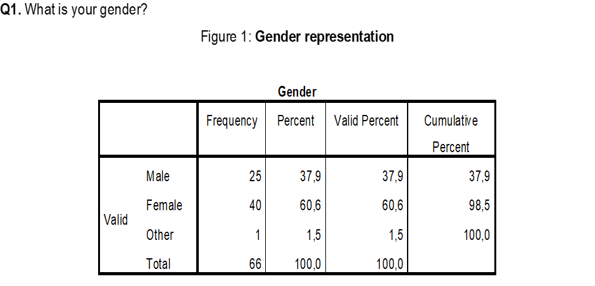
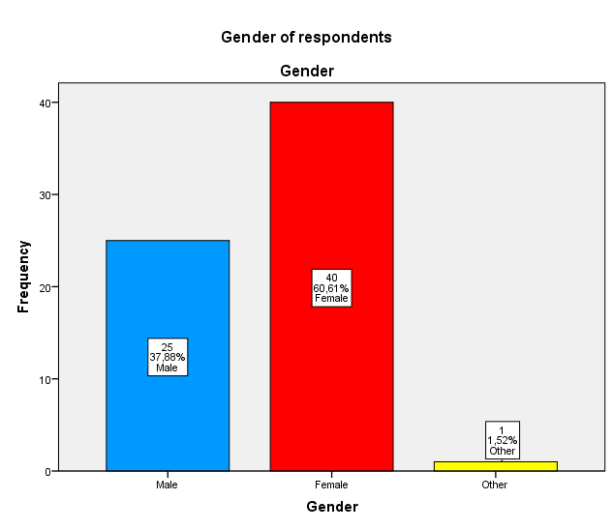
The sample consisted of 25 (38%) Males, 40 (61%) Females, and 1 (1%) “Other” respondents (N=66).
It should be noted that more females were available to complete the questionnaire, which reflects the demographic distribution in the London Campus division of the UWTSD. Even though this can be regarded as an almost evenly split response rate, it is essential to highlight that more females than males completed the questionnaire.
Q2: What is your age group?
Figure 2: Age group representation
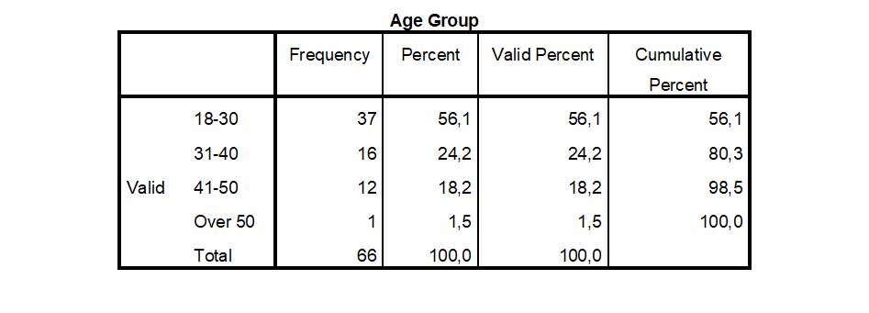
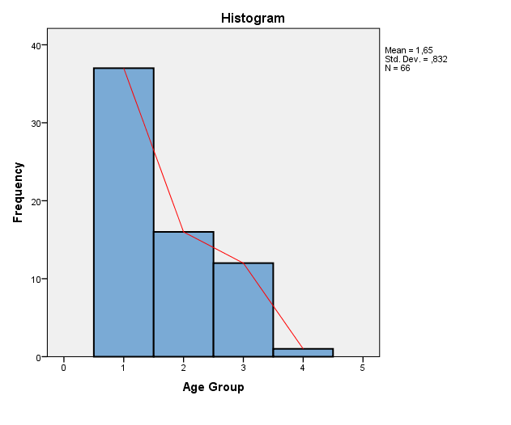
Figure 2 illustrates the distribution of participants by age category, a crucial piece of demographic data. The sample of 66 participants was divided by age, with the largest group consisting of those aged 18-30 (56.1%), followed by those aged 31-40 (24.2%), 41-50 (18.2%), and over 50 (1.5%). The proportion of 18 to 30-year-olds (56.1%) represents a representative consumer age group, making it suitable for the study and bolstering the business case for this research.
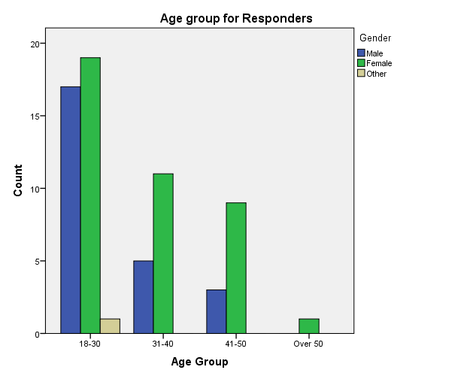
In addition, the female presence is stronger than the male presence, both organically and in the sample by age group, due to gender-representative analysis. In the 18-30 age group, male and female representation is nearly equal, whereas, in the other age groups, female model predominates.
Q3: What level of study are you in the current year at UWTSD?
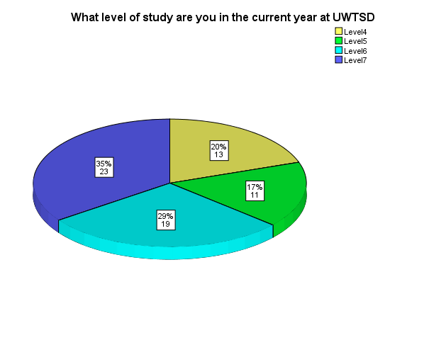
Figure 3 reveals that 35% of students are at level 7, followed by 29% at level 6, 20% at level 4, and 17% at level 5. The response rates demonstrate a decent distribution in the study sample, with a 25% median indicating a good split among the student population.

Q4: What brand of smartphone do you have?
Figure 4: Smartphone brands used by participants
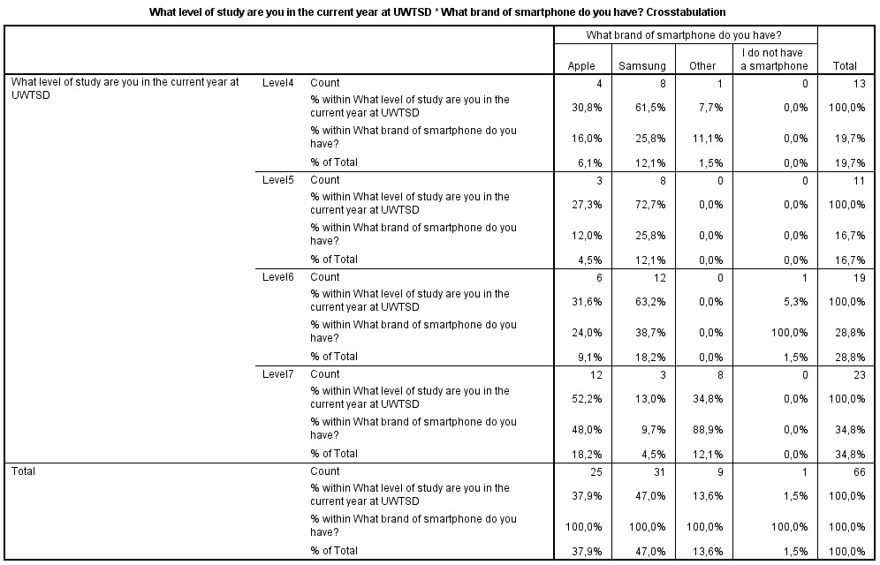
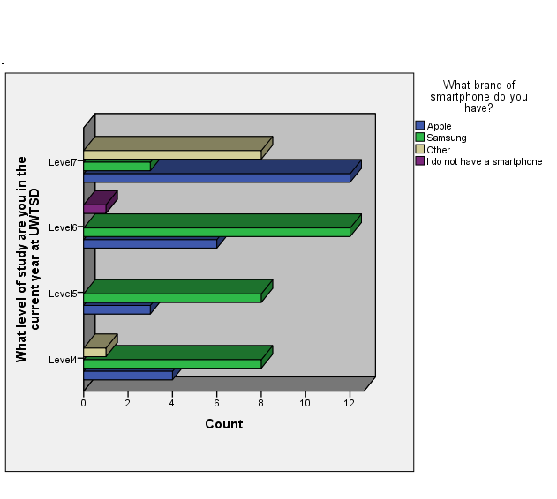
The title and purpose of the study necessitate the inclusion of an analysis of smartphone brands used, which shows that out of a total of 66 participants, 47% use Samsung smartphones, 38% Apple, 14% use other brands, and 1% do not use a smartphone. The crosstab presents the breakdown of the smartphone brands operated by students' academic level. 52% of Level 7 use Apple, 13% Samsung, and 35% other brands, indicating that Apple is a preferred brand in the Level 7 group compared to the others. 32% of Level 6 use Apple, 63% Samsung, and 5% do not use smartphones. 27% of Level 5 use Apple and 73% Samsung. 31% of Level 4 use Apple, 61% Samsung, and 8% other brands. According to the results, Levels 6, 5, and 4 preferred the Samsung brand.
Q5: On a scale of 1 - 5, how satisfied are you with your smartphone?
Figure 5: Participant satisfaction by brand and type of smartphone owned.
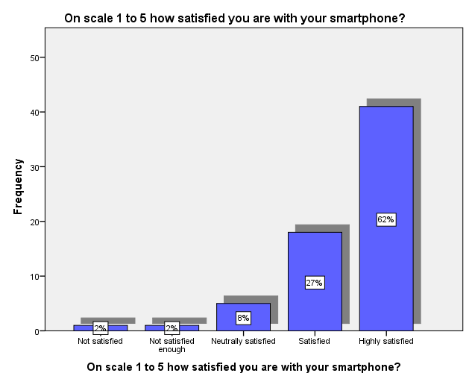
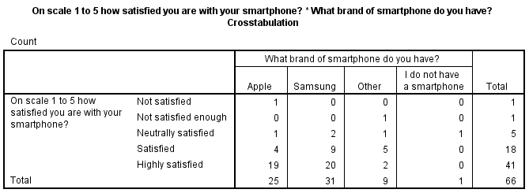
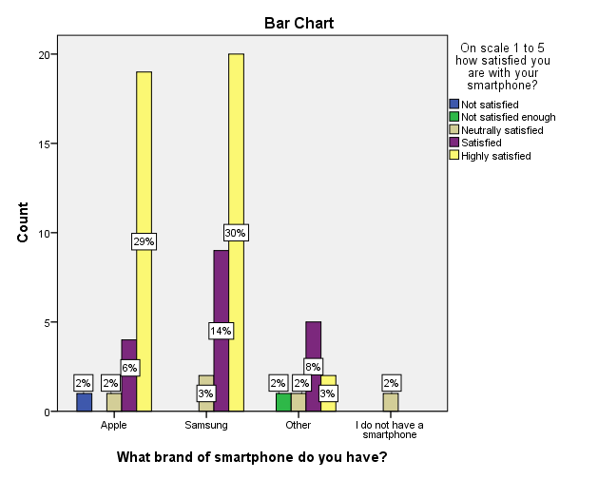
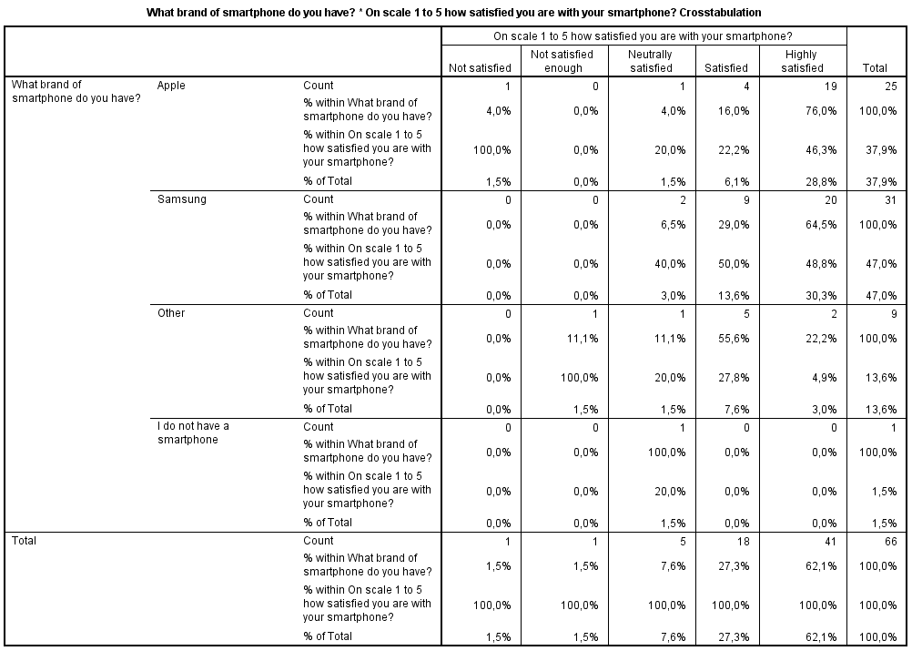
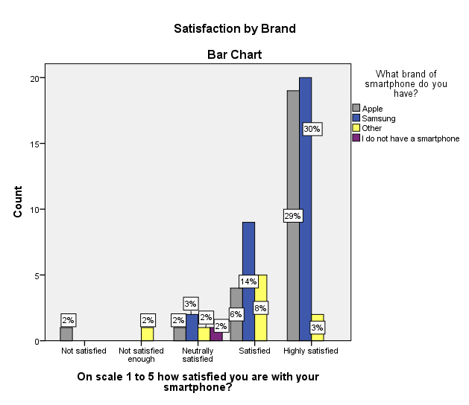
Figure 5 illustrates a high level of satisfaction among survey participants (66) with the results as follows 62% (41) were Highly Satisfied, 27% (18) were Satisfied, 8% (5) were Neutrally Satisfied, 2% (1) Not Satisfied Enough, and 2% (1) Not Satisfied. In addition, the results show that the level of satisfaction among Samsung customers is higher than that of Apple. Regarding Samsung, £30% were Highly Satisfied, 14% were Satisfied, only 3% answered Neutrally Satisfied, and 0% were Not Satisfied. Compared to Apple, the data shows that 29% of participants using this brand are Highly Satisfied, 6% Satisfied, 2% Neutrally Satisfied, 0% Not Satisfied Enough, and 2% Not Satisfied.
The crosstab presents other important information. 37.9% (25) of the participants are Apple customers, of which 76% are Highly Satisfied, 16% Satisfied, 4% Neutrally Satisfied, and 4% Not Satisfied. For comparison, the data regarding Samsung is as follows: 40% (31) of the survey questionnaire participants are Samsung customers, of which 64.5% are Highly Satisfied, 29% Satisfied, 6.5% Neutrally Satisfied, 0% Not Satisfied Enough, and 0% Not Satisfied.

Q6: Is the brand name essential when buying a smartphone?
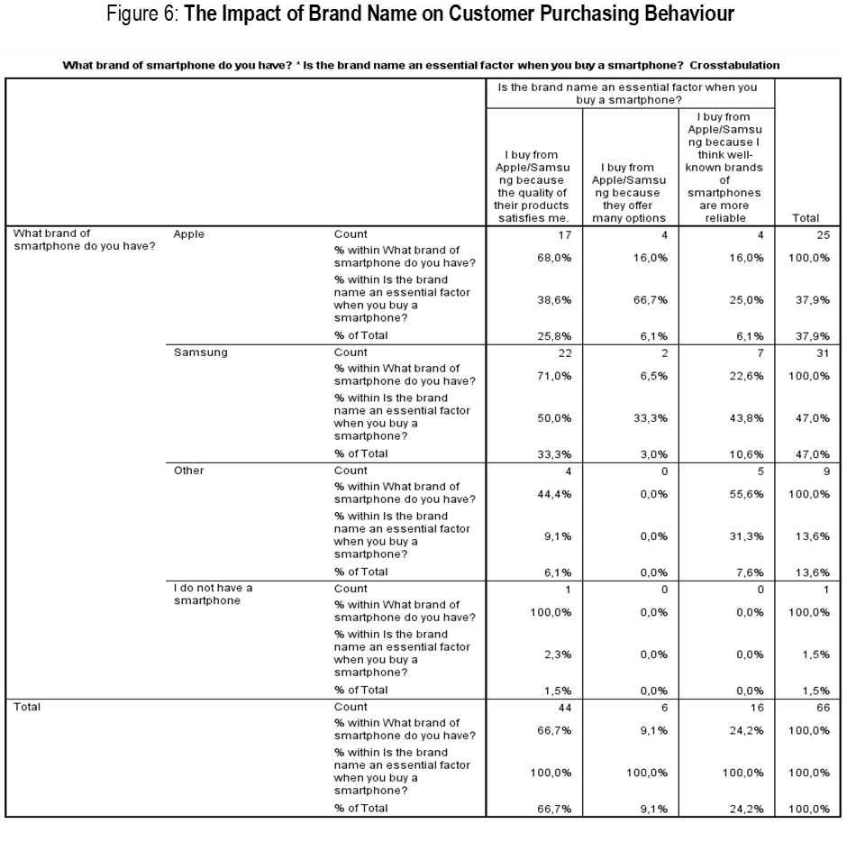
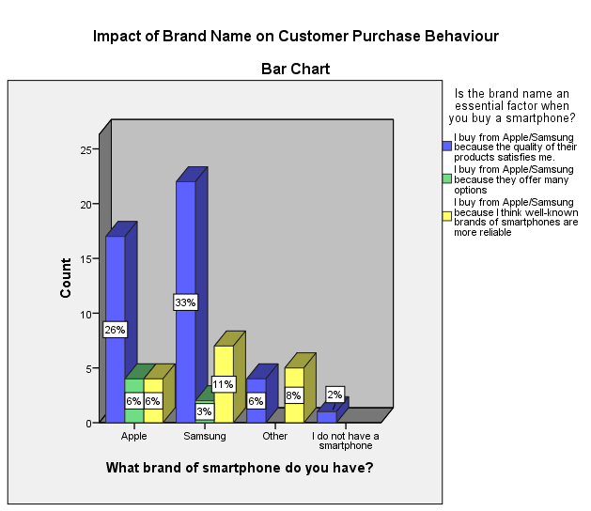
The data presented in Figure 6 illustrate the influence of brand names on customer purchasing behaviour. 66.7% (44) of the total number of participants (66) indicated, "I buy from Apple/Samsung because the quality of their products satisfy me", 9.1% "I buy from Apple/Samsung because they offer many options", 24.2% "I buy from Apple/Samsung because I think famous smartphone brands are more reliable", and no one indicated the option "I buy from Apple/Samsung because I like to share my satisfaction with their products with my friends". The option "I buy from Apple/Samsung because I am satisfied with the quality of their products" is indicated by 33% (22) of Samsung users and 26% (17) of Apple users. The option "I buy from Apple/Samsung because they offer a lot of options" was indicated by 3% (2) of Samsung users and 6% (4) of Apple users. Relative to Apple, 68% (17) indicate, "I buy from Apple/Samsung because the quality of their products satisfies me", 16% (4) "I buy from Apple/Samsung because they offer many options", and 16% (4 ) "I buy from Apple/Samsung because I think the famous smartphone brands are more reliable". Regarding Samsung, the data is 71% (22) "I buy from Apple/Samsung because the quality of their products satisfies me", 6.5% (2) "I buy from Apple/Samsung because they offer many options", 22.5 % (7) "I buy from Apple/Samsung because I think famous smartphone brands are more reliable."
Q7: Is the brand name on your smartphone indicator for the social class?
Figure 7: How brand name indicates the social class
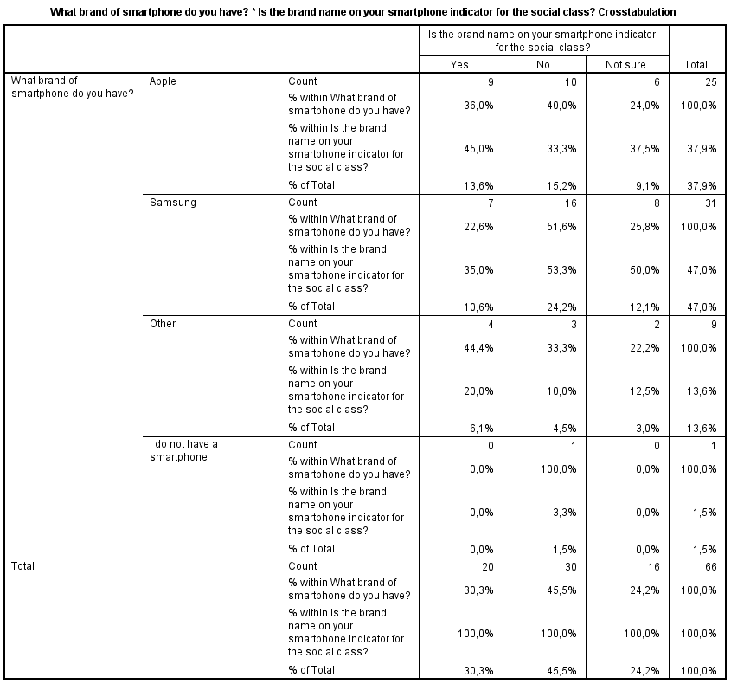
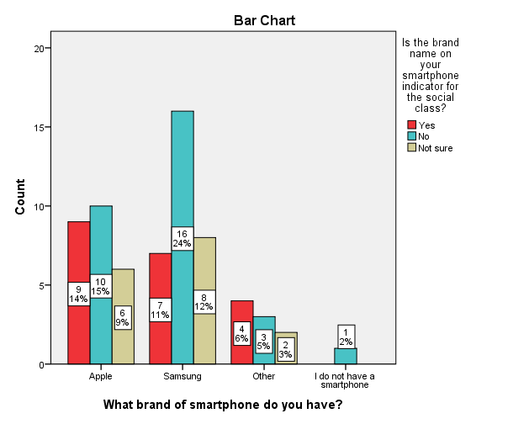
The data in Figure 7 gives us the following information, 20 (30.3%) out of 66 (100%) agreed that the brand name of their smartphone indicates social class, 30 (45.5%) said no, and 16 (24 .2%) were not sure. Another essential piece of information that the crosstab provides is almost a tie between positive 9 (36%) and negative 10 (40%) responses for Apple owners. On the other hand, among Samsung owners, the negative 16 (52%) responses significantly outweighed the positive 7 (11%). Since most of the participants said "No", it can be noted that the brand name of the smartphone does not indicate social class within the target group.
Q8: Does your smartphone's brand logo help you feel more confident?
Figure 8: Cross tabulation of smartphone brand and brand logo
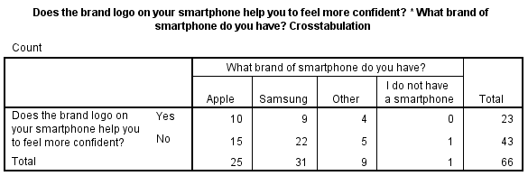
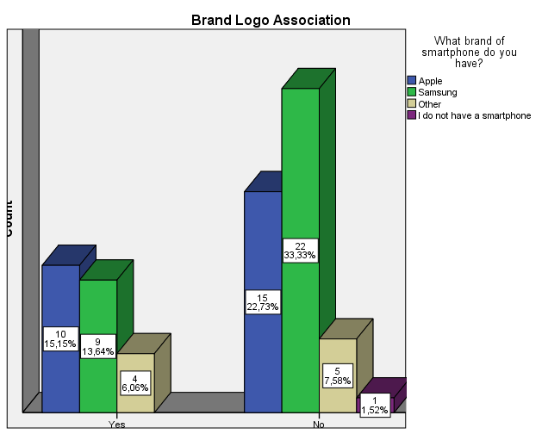
Figure 8 illustrates that 15.15% (10) of Apple smartphone owners indicated that the brand logo on their smartphones helped them feel more confident, while 22.73% (15) demonstrated a "No" option. 13.64% (9) of those who own a Samsung smartphone noted that the brand logo helps them feel more confident, while 33.33% (22) disagreed. 6.06% (4) of those who own other brands of smartphones answered positively, and 7.58% (5) countered that the brand logo on their smartphones helps them feel more confident, and the participant who does not own a smartphone 1.52% (1) also answered negatively. The total number of participants who noted that the brand logo on their smartphones helped them feel more confident was 34.85% (23), while those who said no were 65.15% (43). In addition, the illustration represents that Apple owners feel more confident than Samsung owners.
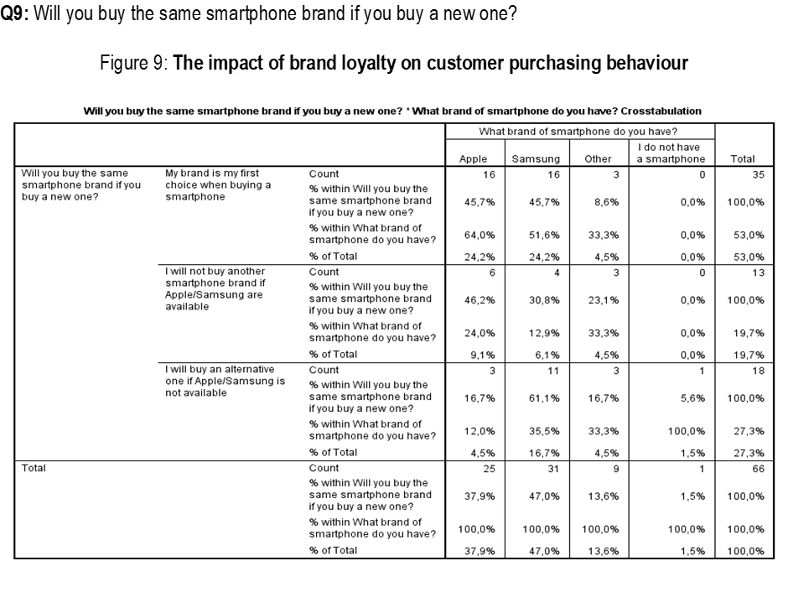
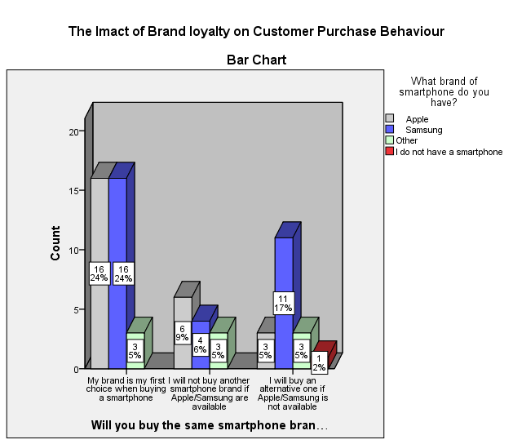
Figure 9 shows that more than half of the participants, 53% (35), would consider their brand the first choice when buying a new smartphone. Apple 24% (16) and Samsung 24% (16) note an identical result, and the owners of other brands mark the result as 5% (3). 20% (13) report that they will not buy another brand if theirs is available - Apple, 9% (6), Samsung 6% (4), and Other 5% (3). 27% (18) are willing to buy an alternative smartphone, or in other words, join one of the other competing brands, and the distribution is as follows: Apple 5% (3), Samsung 17% (11), Other 5% (3).
Based on the information presented in the crosstab showing customer loyalty by brand, 64% (16) of Apple owners (25) indicated that they would consider their brand as their first choice when purchasing a new smartphone, 24% (6) said, that they will not buy another brand if Apple is available. In comparison, 12% (3) indicate they will accept an alternative smartphone if Apple is unavailable. In summary, 88% (22) are customers loyal to the brand, and 12% (3) are willing to join other competing brands.
Regarding Samsung, 52% (16) of the total number of participants (31) using this brand indicated that when buying a new smartphone, their brand would be the first choice, and 13% (4) indicated that they would not buy another brand if Samsung were available. In comparison, 35% (11) would accept an alternative if Samsung is unavailable.
The presented data give grounds for claiming that customer loyalty is high and directly impacts purchasing behaviour. Moreover, Apple customers' loyalty is more elevated than Samsung customers'. In addition, the data presented also provides other information regarding the level of switching to competitors. For example, Samsung customers are more likely to switch to competitors (11) than Apple customers (3).
Q10: On a scale of 1 - 5, how do the technical characteristics of the smartphone influence the decision to purchase the product?
Figure 10: Cross tabulation of smartphone brand and the influence of technical characteristics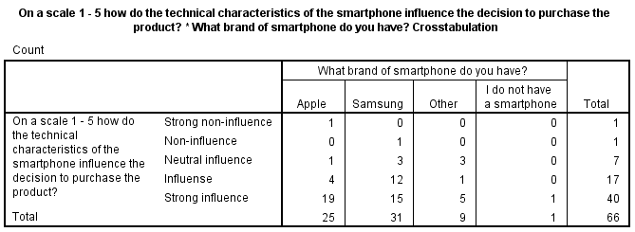
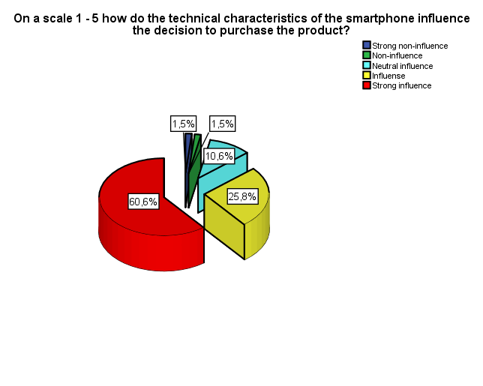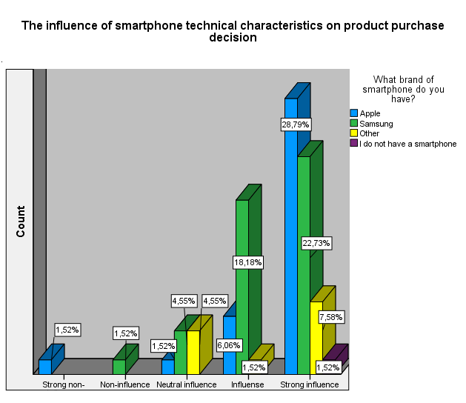
According to the information presented in Figure 10, 60.6% (40) of the participants who completed the survey questionnaire (66) were strongly influenced by the technical characteristics when deciding to purchase a smartphone. 25.8% (17) answered that the technical characteristics influenced their purchase decision, 10.6% (7) indicated a neutral influence, 1.5% (1) registered “Non-influence, and 1.5 % (1) that it had a “Strong Non-influence”.
The results by brands provide information that 1 (1.5%) participant with an Apple smartphone noted that the technical characteristics of the smartphone did not have a strong influence on the decision to purchase the product, none registered a lack of influence, 1 (1.5%) noted that it had a neutral influence, 4 (6.1%) indicated that the features influenced purchase decisions, and 19 (28.8%) claimed that the technical characteristics had a strong impact on purchase decisions. In the case of Samsung, none rated a strong lack of influence, while only 1 (1.5%) said features did not influence purchase decisions. In addition, 3 (4.5%) noted that the characteristics had a neutral influence, 12 (18.2%) indicated that the traits influenced the decisions, and in 15 (22.7%), the technical aspects strongly influenced the purchase decision. For participants using brands other than Apple and Samsung, none of them indicated strong non-influence and non-influence. However, 3 (4.5%) noted that features had a neutral influence, 1 (1.5%) agreed that features influenced decisions, and 5 (7.6%) strongly influenced purchase decisions. Finally, 1 (1.5%) non-smartphone participant shared that technical characteristics can strongly influence purchase decisions.
Based on the findings, we can say that more Apple customers note that technical characteristics have a "Strong influence" compared to Samsung customers. On the other hand, most Samsung users say that the technical features of a product usually affect their decision to buy it. This is especially true since no one mentions the "Strong Non-Influence" or "Non-Influence" options. The sample of people who filled out the study questionnaire showed that technical features are more important to Samsung than Apple customers.
Q11: Is buying Apple/Samsung smartphones safe, as they always come with better features?
Figure 11: Brand Extension
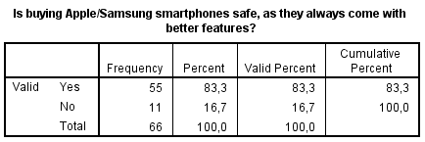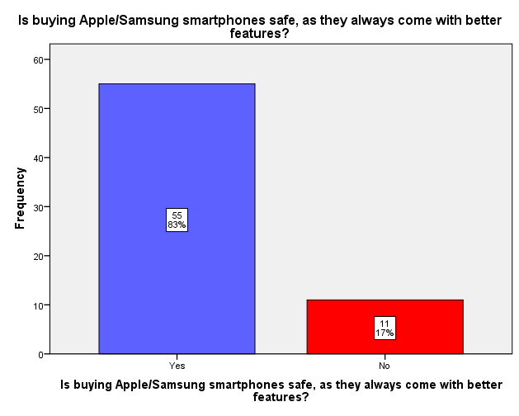
Out of 66 participants, 55 (83%) are convinced that their chosen brands continuously improve their products' safety and security features, positively influencing their purchasing behaviour. The remaining eleven (17%) answered negatively.
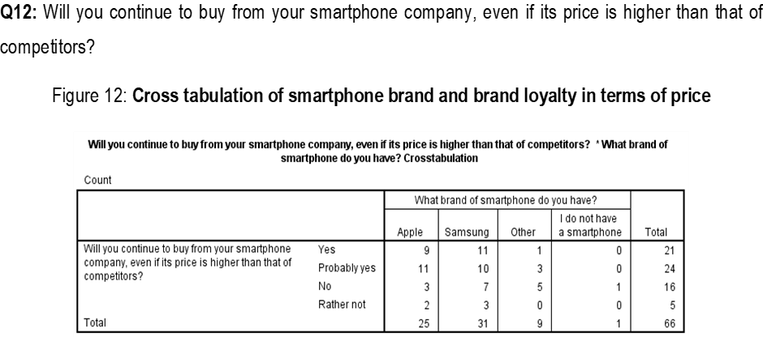
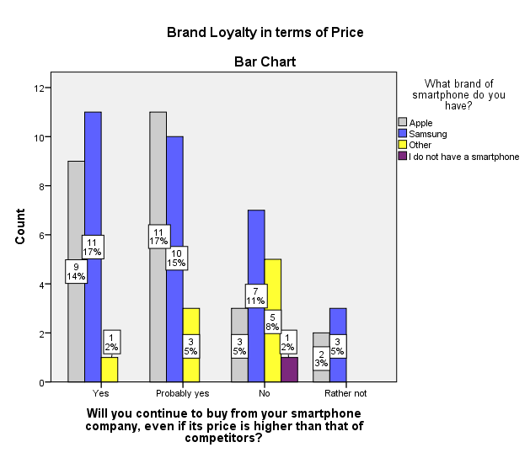
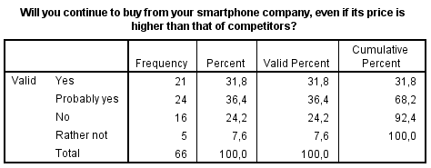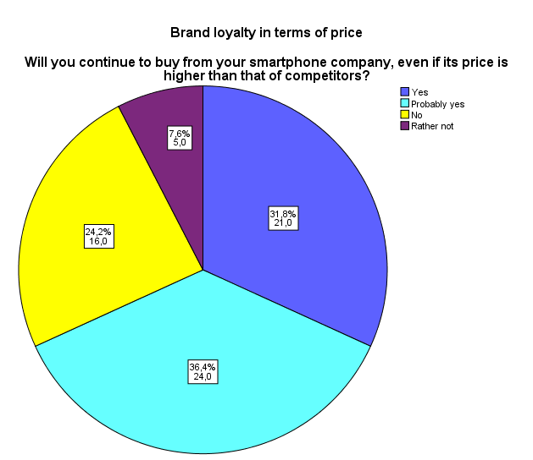
9 (14%) Apple smartphone owners indicated they would continue to purchase from the company even if the price increased. 11 (17%) said "Probably yes", 3 (5%) said "No", and 2 (3%) said they would prefer not to purchase from Apple if its prices were higher than those of competitors.
Eleven participants (17%) indicated they would continue purchasing from Samsung even if the price was higher than the competition. 10 (15%) said "Probably yes", 7 (11%) said "No", and 3% said they would instead not purchase from Samsung if the price is higher than its competitors. Regarding smartphone manufacturers other than Apple and Samsung, 1(2%) respondents indicated they would continue to purchase from the company even if the price was higher than the competitors. 3 (5% of respondents) said they were likely to continue purchasing, 5 (8% of respondents) said they would not, and none selected "Rather not." The participant without a smartphone gives the "No" option.
Regarding brand loyalty as a function of price increase, the presented data demonstrate that Apple and Samsung customers report nearly identical levels of high commitment (31% for Apple and 32% for Samsung, respectively), which is directly related to trust and loyalty of customers to the brand, regardless of the price increase of the product.
Out of a total of 66 participants, 21 (32%) responded affirmatively, "Yes", 24 (36%) responded ", Probably yes", 16 (24%) answered "No", and 5 (8%) responded "Rather no", indicating that the majority of participants, 45 (68%), selected "Yes" or "Probably yes" as their brand loyalty response. The remainder of the sample, 21 individuals (32%) who chose "No" and "Rather not" in the event of a price increase, are more likely to transfer to competing brands, thereby altering their purchase behaviour.
Q13: On a scale of 1 - 5, what influences the after-sales services the respective smartphone manufacturer provides you in purchasing decisions?
Figure 13: Influence of after-sales services on purchasing decisions
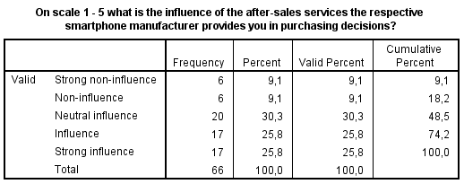
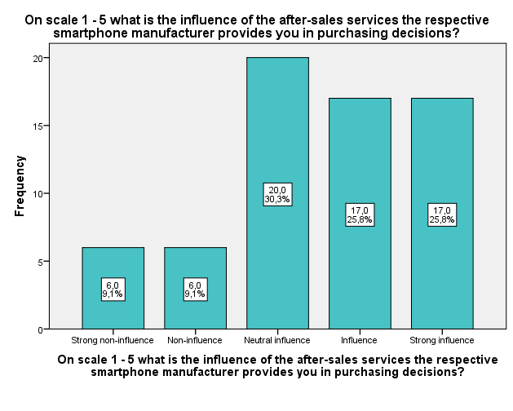
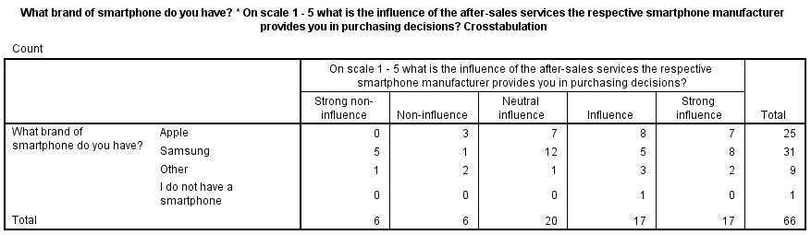
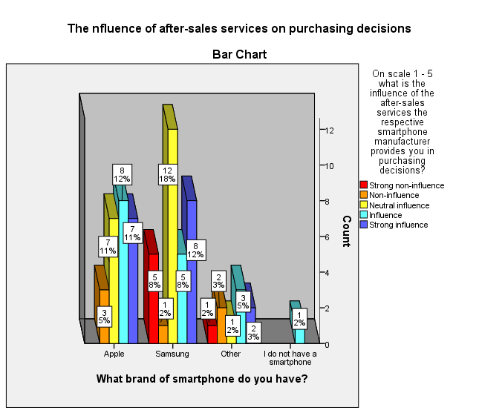
According to Figure 13, out of a total of 66 participants, 17 (26.6%) were highly influenced by after-sales service, 17 (26.6%) indicated that they were influenced by this service, 20 (30.3%) maintained a neutral influence, 6 (9.1%) are not affected, and 6 (9.1%) indicate "Strongly not influenced" by after-sales service. In summary, the presented data suggest that after-sales service influences the purchasing decisions of 34 (52%) participants. 20 (30%) respondents who answered neutrally are probably not indifferent, but it does not significantly influence their purchase decision. However, for 12 (18%) participants, after-sales service would not affect their purchasing behaviour.
The crosstab presents the impact of after-sales service on the respondents according to their smartphone brands. 3 (5%) Apple smartphone owners indicated that the company's after-sales services had no impact on their purchase decision, 7 (11%) said they had a neutral impact, and 8 (12%) said they had an impact. In contrast, 7 (11%) respondents indicated they influenced the purchase decision considerably.
In contrast, 8% of Samsung smartphone owners reported that the company's after-sales service did not significantly impact their purchase decision, 2% said it did not, 18% reported neutral influence, and 8% said they were influenced. In contrast, eight (12%) reported that the services had a significant impact.
In addition, 1 (2%) of other smartphone owners indicated that after-sales services did not have a strong influence, 2 (3%) stated that they had no impact, 1 (2%) said that they had a neutral impact, 3 (5%) reported that they influenced the purchase decision, and 2 (3%) stated that they had a strong influence. One per cent of non-smartphone owners indicate that after-sales service would influence their purchase decision.
The collected data indicate that after-sales service has a more significant impact on the consumer purchase behaviour of Apple smartphone owners (23%) than Samsung users (20%).
4.3 Discussion
Summary of the findings
The study focused on assessing the impact of Apple and Samsung on the purchasing choices of their respective target audiences. The study analysed the effect of brand equity's four key components, which are brand awareness, brand association, perceived quality, and brand loyalty, on the purchasing decisions of Apple and Samsung customers. Based on the analysis, most participants support this conclusion, Samsung is the preferred smartphone brand among the target population. Based on the findings, most respondents expressed contentment with the smartphone brands they use, specifically Apple and Samsung.
The data suggests that a significant number of the intended audience is inclined to buy from Apple and Samsung because of their superior quality of merchandise. According to the findings, there is no significant impact of brand logos or brand association on the level of confidence exhibited by the target population. Most participants were inclined to prioritise their preferred brands while contemplating a replacement purchase. The study reveals that most respondents are strongly willing towards brand loyalty, as they say, a willingness to purchase from their preferred brands, even in cases where the cost is higher than that of rival brands.
The findings also indicate that the technical characteristics of smartphone brands significantly impact the purchasing decisions of the target population. In conclusion, the after-sales services provided by various smartphone manufacturers have a moderate to substantial impact on purchase decisions.
Interpretation of findings related to the research questions
Question 1: How does brand awareness impact consumer purchasing behaviour?
The study results indicate that Samsung has greater brand recognition than Apple. Thirty-one participants owned a Samsung smartphone, and twenty-five owned an Apple smartphone. The findings confirm those from Statista (2022), which indicate that Samsung's brand awareness in the United Kingdom is 96% and Apple's is 94%.
In addition, the results show a relationship between brand awareness and consumer purchasing decisions. According to the analysis section, Apple and Samsung consumers are inclined to purchase from their respective brands primarily because of the brand name, which is a crucial aspect of brand awareness. Aaker (1991) identifies two fundamental components of brand awareness: the brand name and logo. According to Aaker's (1991) argument, brand awareness is crucial in consumers' decision-making because familiarity and understanding of the brand positively influence the purchasing confidence of customers. A company must possess a strong brand identity for consumers to select a recognisable brand over an unknown one. Most participants said they choose to buy from either Apple or Samsung because they perceive these brands to be associated with high-quality products. The statement implies that the perception of Apple and Samsung as high-end brands impacts the choices made by consumers when purchasing products.
The user's statement highlights that the results obtained are in line with previous studies conducted by Shahid et al. (2017), Hoyer and Brown (1990), Shahid, Hussain, Zafar (2017), and Lin, Chang (2003). These studies have found that brand awareness positively impacts consumer purchase decisions.
Question 2: Does perceived quality affect consumer purchasing behaviour?
The results indicate a correlation between perceived quality and Apple and Samsung consumer purchase decisions. Most respondents indicated they purchase either Samsung or Apple products due to their high quality. The findings align with those of Finkle (2023), who asserted that Apple and Samsung are perceived as high-quality brands by their customers. With high-quality products, consumers are compelled to choose between the two companies effectively. Furthermore, participants concurred that they are pleased with their smartphone brands (Apple/Samsung). Apple's satisfaction level was significantly lower than Samsung's. According to the data, there is a direct relationship between the perceived quality of Apple/Samsung products and the purchase decisions made by consumers, which is consistent with Yu's (2005) claim that perceived quality directly and positively affects consumer satisfaction, a component of brand equity. Furthermore, the findings are consistent with those presented by DogerliogluDemir and Tansuhaj (2011), Martins et al. (2019) and Abidin, Borhan (2016), which confirms that perceived quality is one of the most critical factors that can be used to explain brand variability and consumer purchase intentions. The results demonstrate that there is a direct relationship between consumers' purchase intentions and brands, which is positive.
Question 3: To what extent does brand loyalty influence consumer purchasing behaviour?
It is evident from the results of the analysis section that brand loyalty influences consumer purchasing decisions. Most respondents (35) (16 for Apple, 16 for Samsung, and 3 for others) indicated they would contemplate purchasing a new smartphone from their current brand. In addition, most respondents (45) (20 for Apple, 21 for Samsung, and 4 for others) stated that they would continue to purchase from their respective smartphone manufacturers even if their prices were higher than those of the competition. This indicates that Apple and Samsung enjoy strong brand loyalty, positively influencing their customers' purchasing decisions. Bornmark, Goransson, and Svensson (2006) suggest that brand loyalty significantly shapes a consumer's brand preference. Consumers who exhibit brand loyalty tend to purchase a specific brand frequently. The study's results align with their statement and Yoon and Kim's (2000) statement, indicating that brand-loyal consumers are more inclined to pay a higher price for their preferred brand rather than switch to a different one. This suggests that the brand's price does not easily sway a consumer's purchasing decision for a particular brand.
Question 4: Does brand association affect consumer purchasing behaviour?
According to the study results, brand associations do not affect consumer purchasing behaviour. Most respondents (43) said the brand logo on their smartphones does not make them feel more confident, whereas 23 said it does. The Apple and Samsung brand logos have a negligible effect on consumer confidence. In this study, the findings contradict those of Phong et al. (2020), Pasha and Hadibrata (2019), and Grigalinait and Pilelien (2017), who found a positive relationship between brand associations and consumer purchasing behaviours.
4.4 Conclusion
This research aims to evaluate the impact of brands on the purchasing behaviour of consumers who use Apple and Samsung smartphones.
This study's assessment is predicated on diverse brand dimensions, including brand awareness, brand image, brand loyalty, perceived quality, and brand association. The survey comprehensively addresses various dimensions of brand-based consumer purchasing behaviour.
Most participants know the designated smartphone logos regarding customer brand conceptions, and the users recognise that branding encompasses the name, title, logo, slogan or motto, design, and quality. The phenomenon above suggests that individuals form an affective bond with their chosen brand.
The study has identified a significant correlation between branding and customer purchase behaviour based on the analysed data. The research revealed a significant association between brand awareness, loyalty, and the probability of a customer engaging in a purchase. The study's findings indicate a positive correlation between customer purchase behaviour and brand image and association, albeit not statistically significant. The investigation employed correlation analysis to ascertain the relationship between brand and consumer buying behaviour within the framework of smartphone users. As per the survey, the dimensions above of the brand impact customers' purchasing behaviour.
V. LIMITATIONS and RECOMMENDATIONS
5.1 Limitations
Notwithstanding the findings and knowledge acquired, this investigation is susceptible to various constraints, encompassing but not restricted to the following variables:
- The study's limited sample size may constrain the generalizability of the findings to the broader demographic of smartphone users.
- The study used a convenience sample due to the limited time frame set for the start and end of the study. The study exhibited a limited scope as it concentrated solely on respondents from UWTSD-London, prompting apprehensions regarding the sample's representational validity. The absence of a randomised selection process for participants may introduce bias into the study. The study's generalizability may be compromised due to the limited sample size of university students, as it fails to represent the broader population of smartphone users.
- The research employed a cross-sectional methodology, which entails gathering information from participants at a particular time to capture a momentary representation of their opinions and experiences. The method may need to be revised to accommodate changes in customer buying behaviour and tendencies.
- Using only quantitative survey data could limit insights into a more comprehensive and in-depth understanding of customer experiences, behaviours and preferences. Excessive dependence on quantitative data can impede capturing the nuances of customer feedback. Exploring the impact of brand image and loyalty on customer purchasing behaviour holds promise for a more profound comprehension of the subject.
5.2 Recommendations
The concepts of brand image and brand loyalty are essential for organisations to prioritise and work towards. Based on empirical research, it has been found that a favourable brand image can directly impact the level of brand association and the likelihood of repeat purchase intentions for the brand. Affective commitment from customers is crucial in achieving brand loyalty, as it is the foundation for establishing the initial relationship that eventually leads to attitudinal and behavioural brand loyalty. The need for additional investigation into developing comprehensive or compelling consumer loyalty is crucial, and this could enhance the effectiveness of new product development and communication strategies. The possibility of Apple and Samsung expanding their customer engagement programmes, specifically targeting consumers with a full-time university education, could be a strategic move to shape future attitudes and behaviours towards their brands. This approach may involve offering various engaging and attractive incentives to this demographic.
Empirical evidence suggests that enhancing brand image positively impacts consumer satisfaction regarding perceived quality, ultimately leading to brand loyalty among the student population. To further their efforts to influence the perceptions and actions of prospective consumers towards the Apple and Samsung brands, they may endeavour to enhance their operational frameworks and communication approaches by leveraging diverse social media channels to foster a symbiotic relationship between the consumer and the brand, using gaining deeper insights into the user experience and its potential implementation. The objective is to determine the optimal approach for cultivating customer loyalty among consumers of branded mobile phones, enhancing customer satisfaction, and fulfilling customer demands. Implementing this approach can improve the recognition and perception of a brand, as customers will actively endorse the brand through their interactions, leading to a more profound affiliation with the brand and an elevation in brand allegiance. Furthermore, adopting this approach is expected to result in revenue expansion, enhanced product development, and increased competitive edge for both Apple and Samsung.
Further research
- The study could benefit from a broader and more varied group of students to improve the results' accuracy and enhance the findings' applicability.
- A probability sampling method, precisely a random sampling method, would mitigate potential biases in selecting participants and yield a more comprehensive sample of smartphone users.
- Integrating qualitative research methodology can facilitate a more comprehensive understanding of customer experiences and purchasing behaviour. Doing so can provide a lucid depiction of prospective consumers' primary needs and assist organisations in formulating marketing strategies and producing advanced technological products.

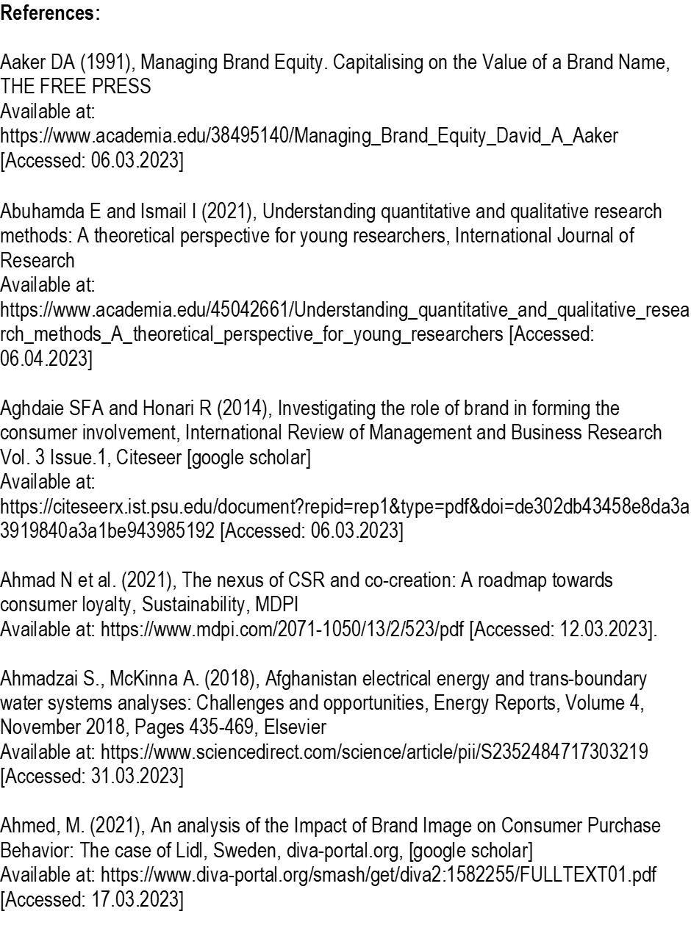

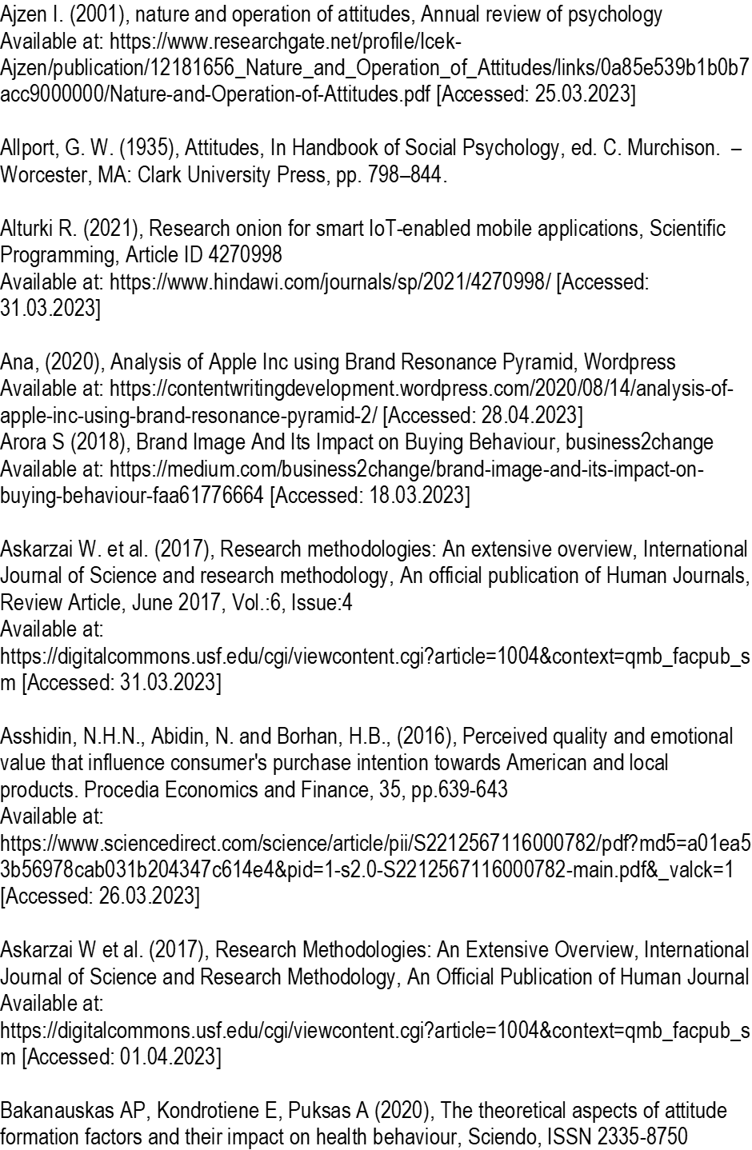

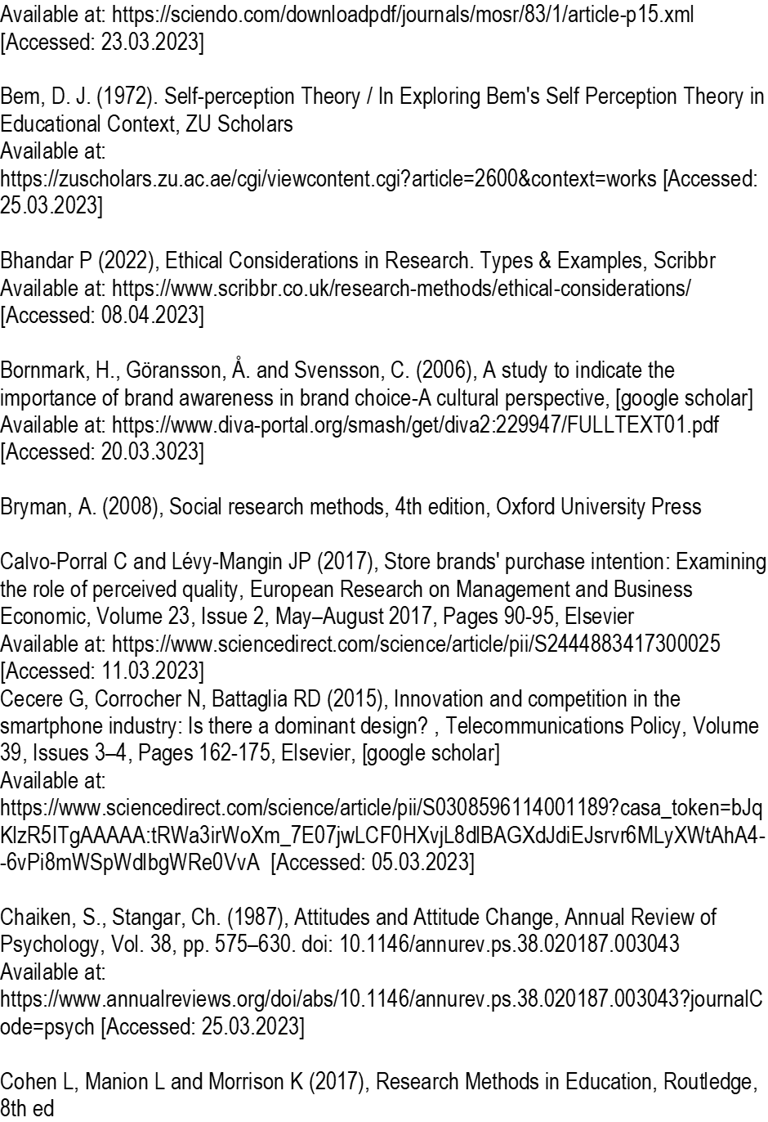
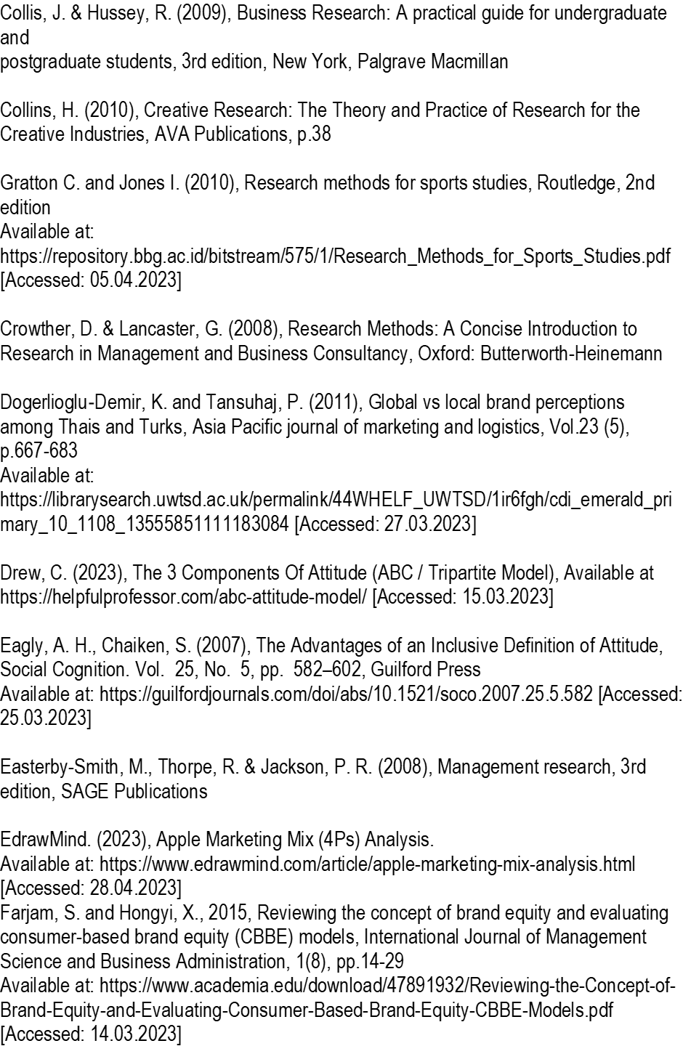
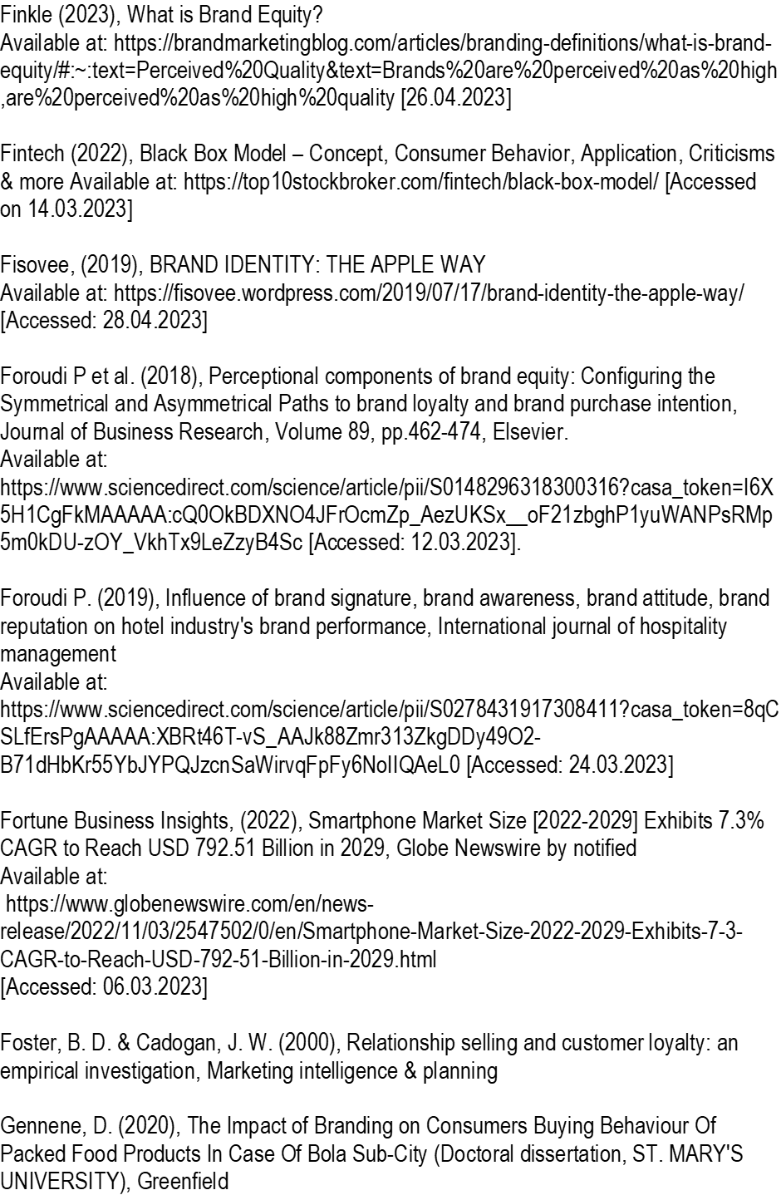
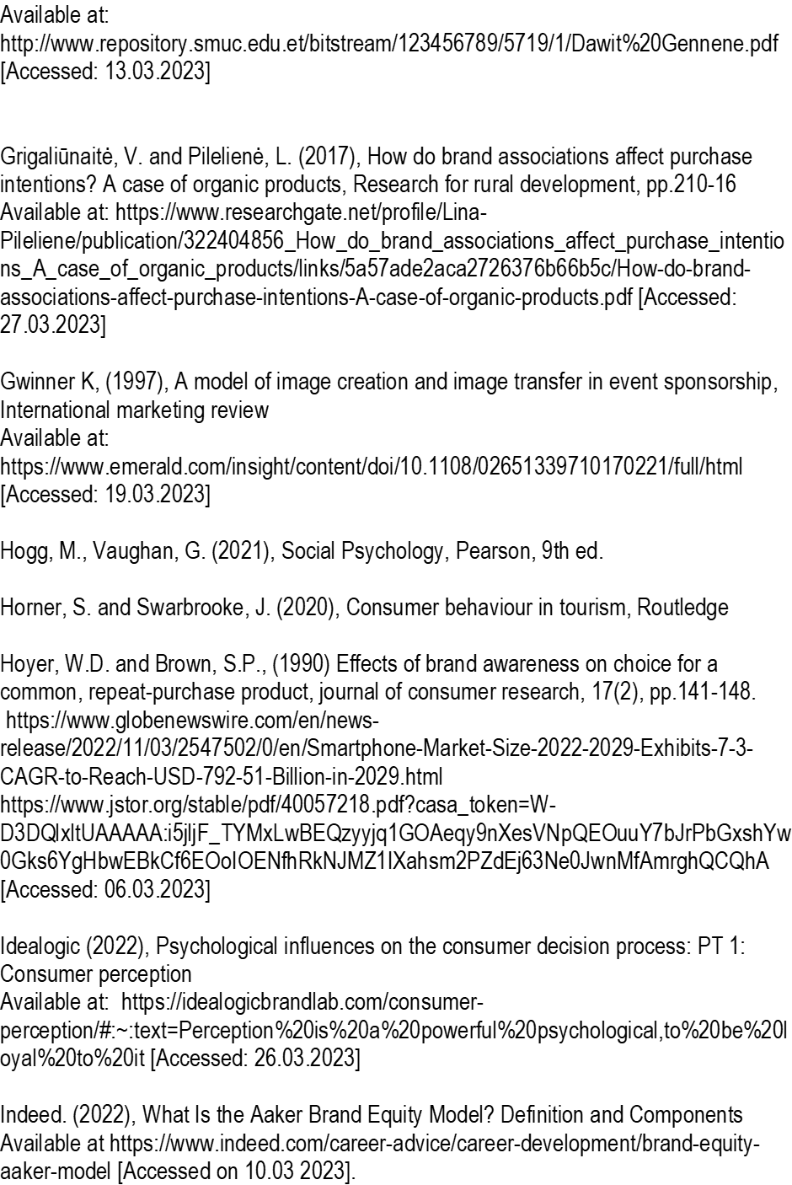
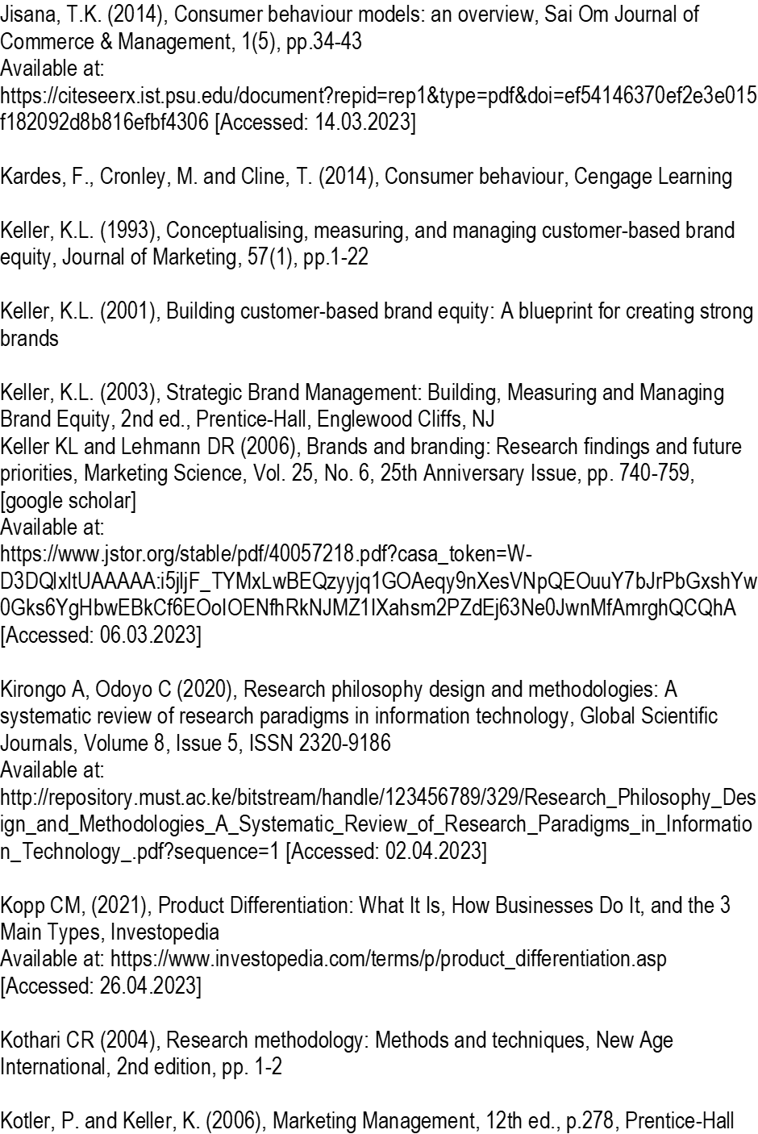
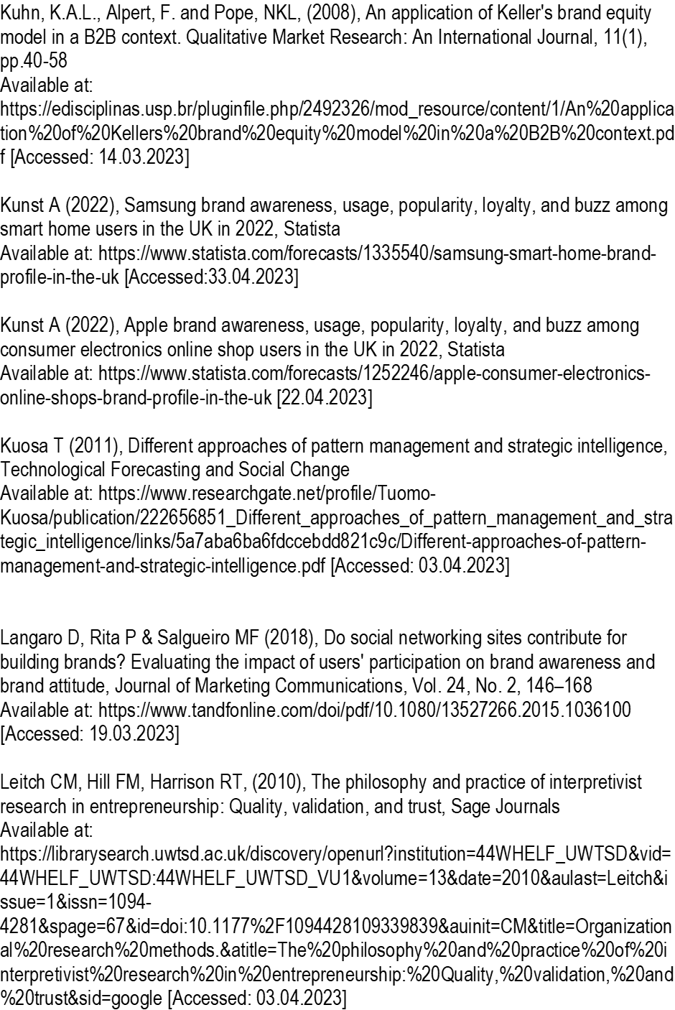
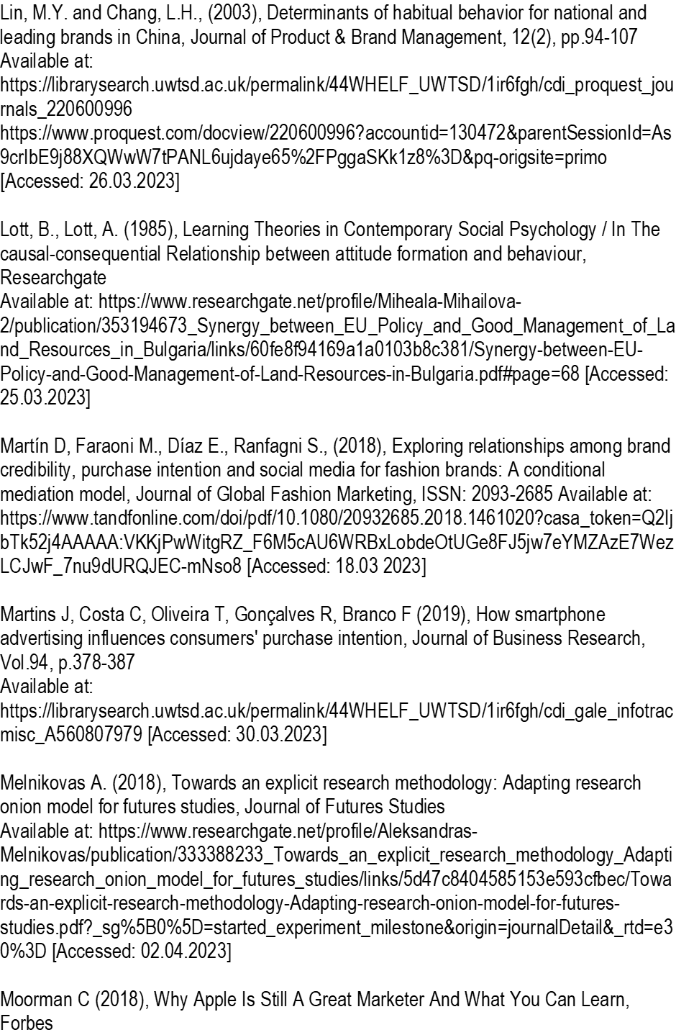
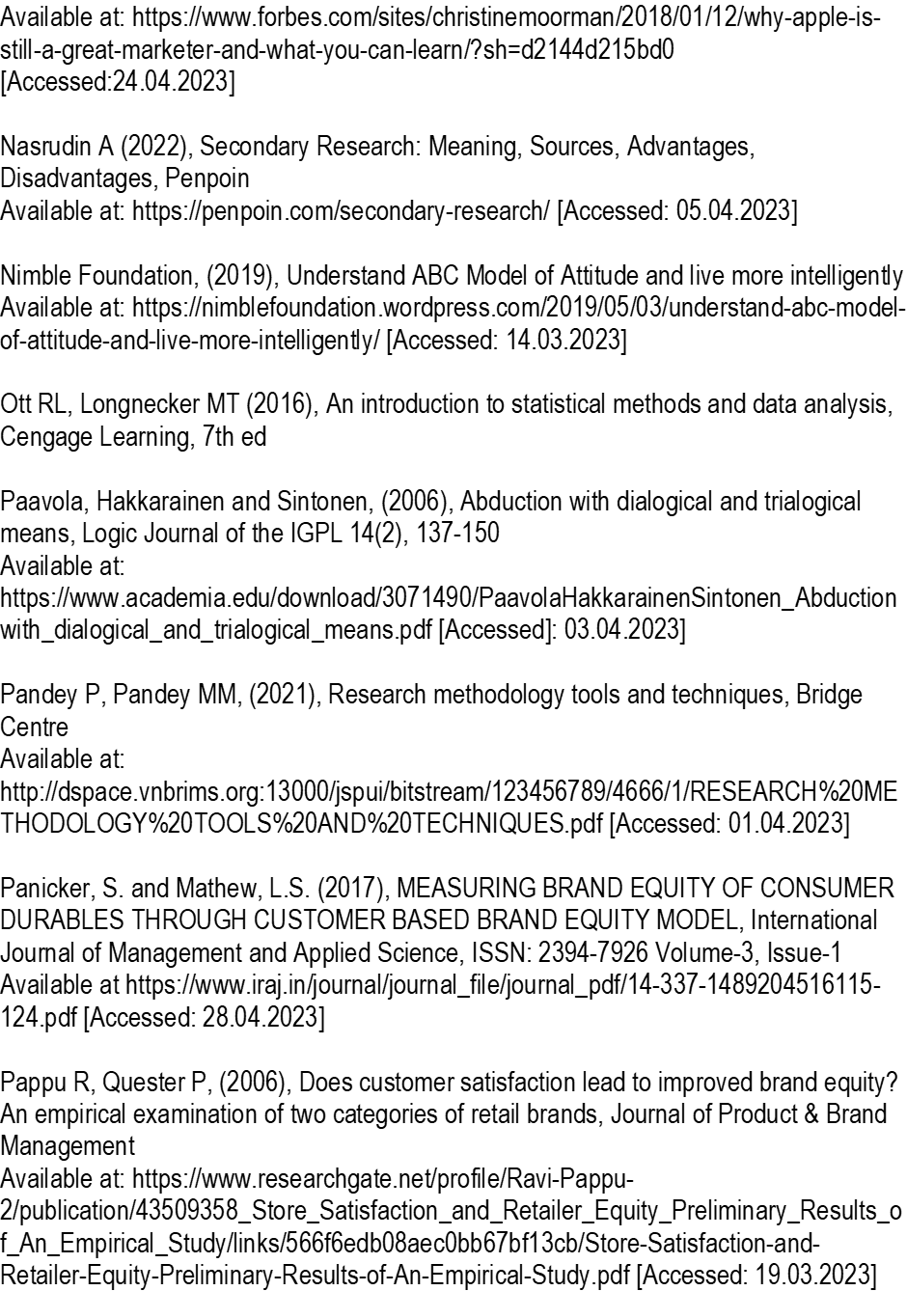

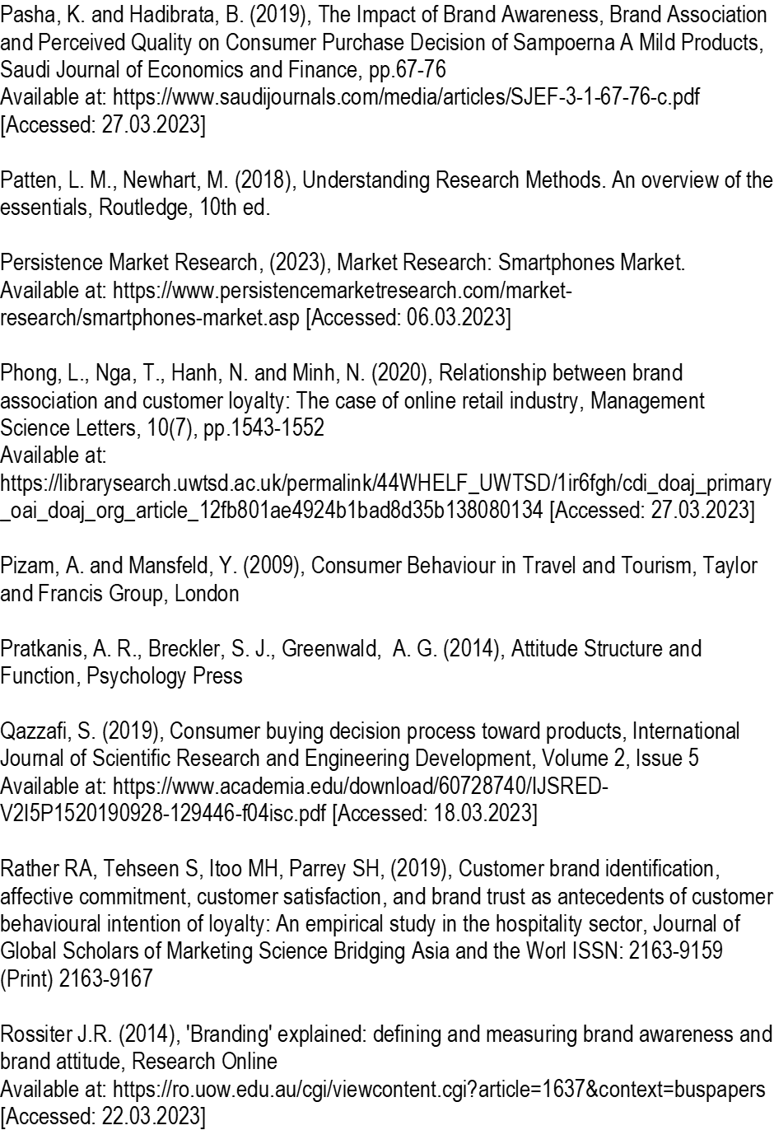
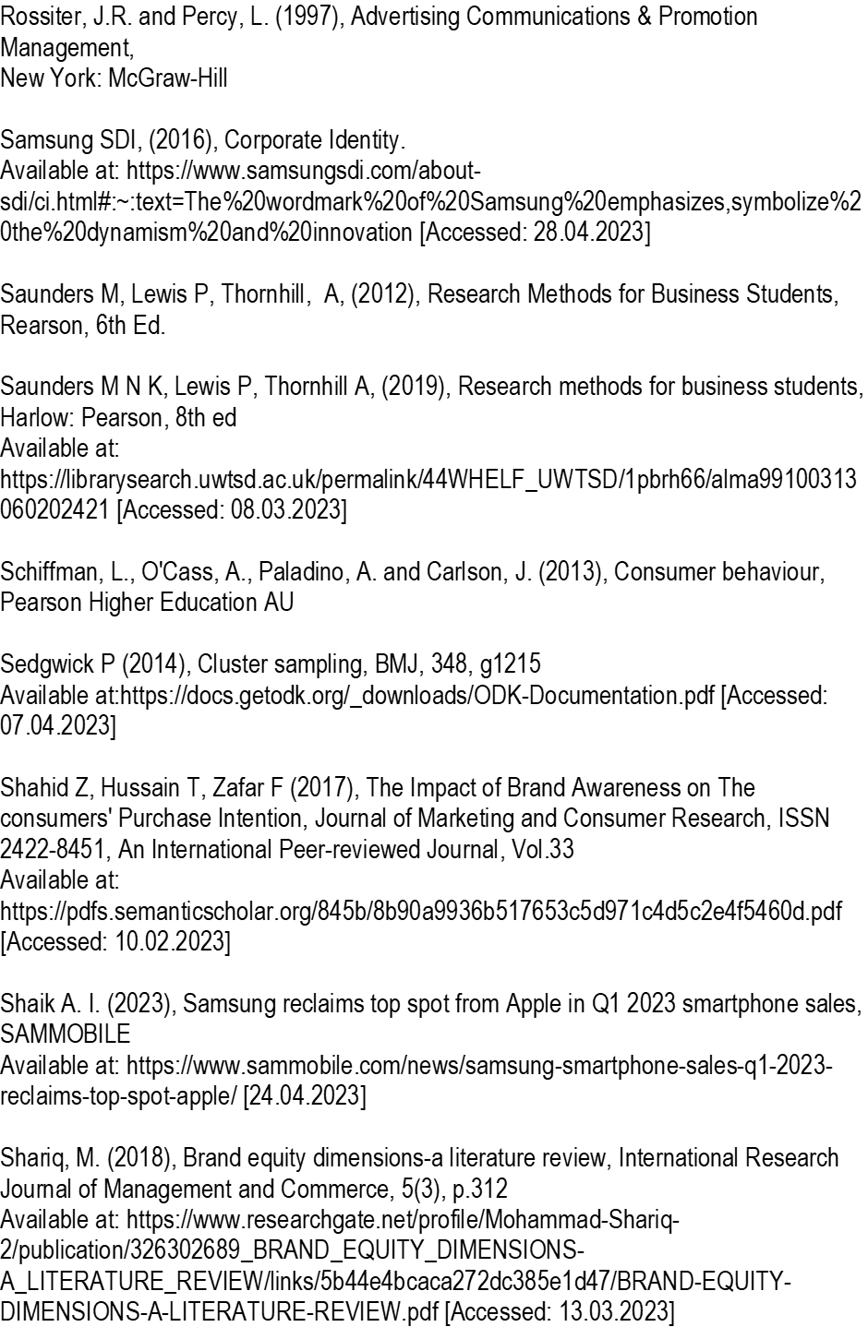

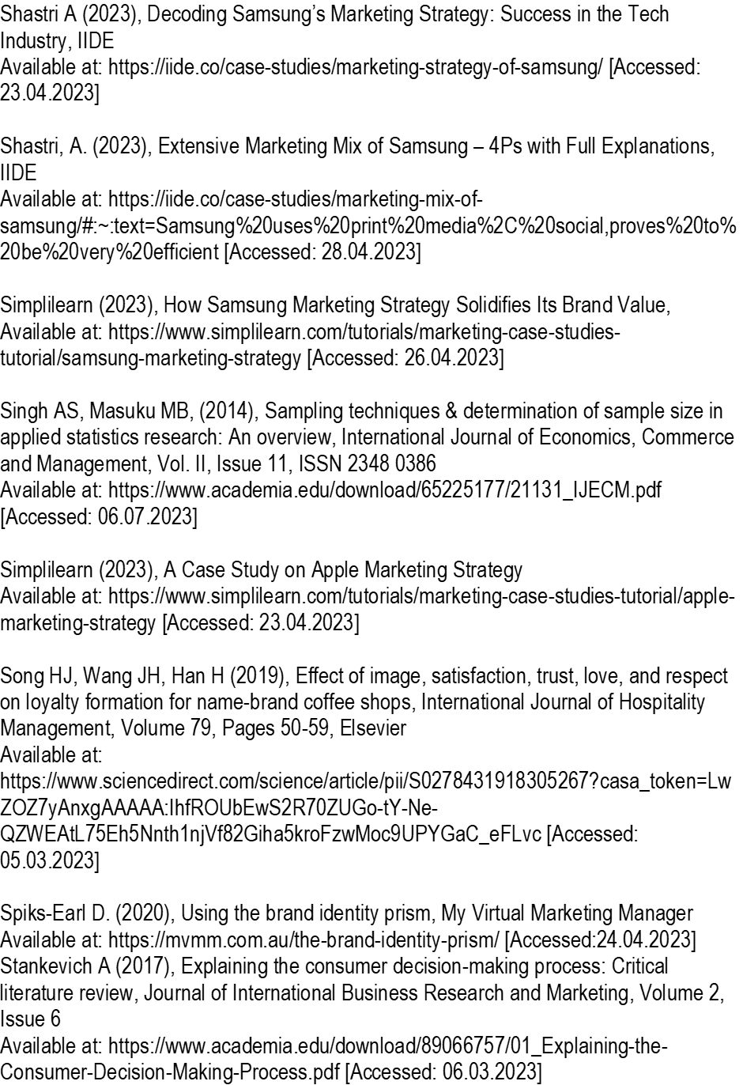
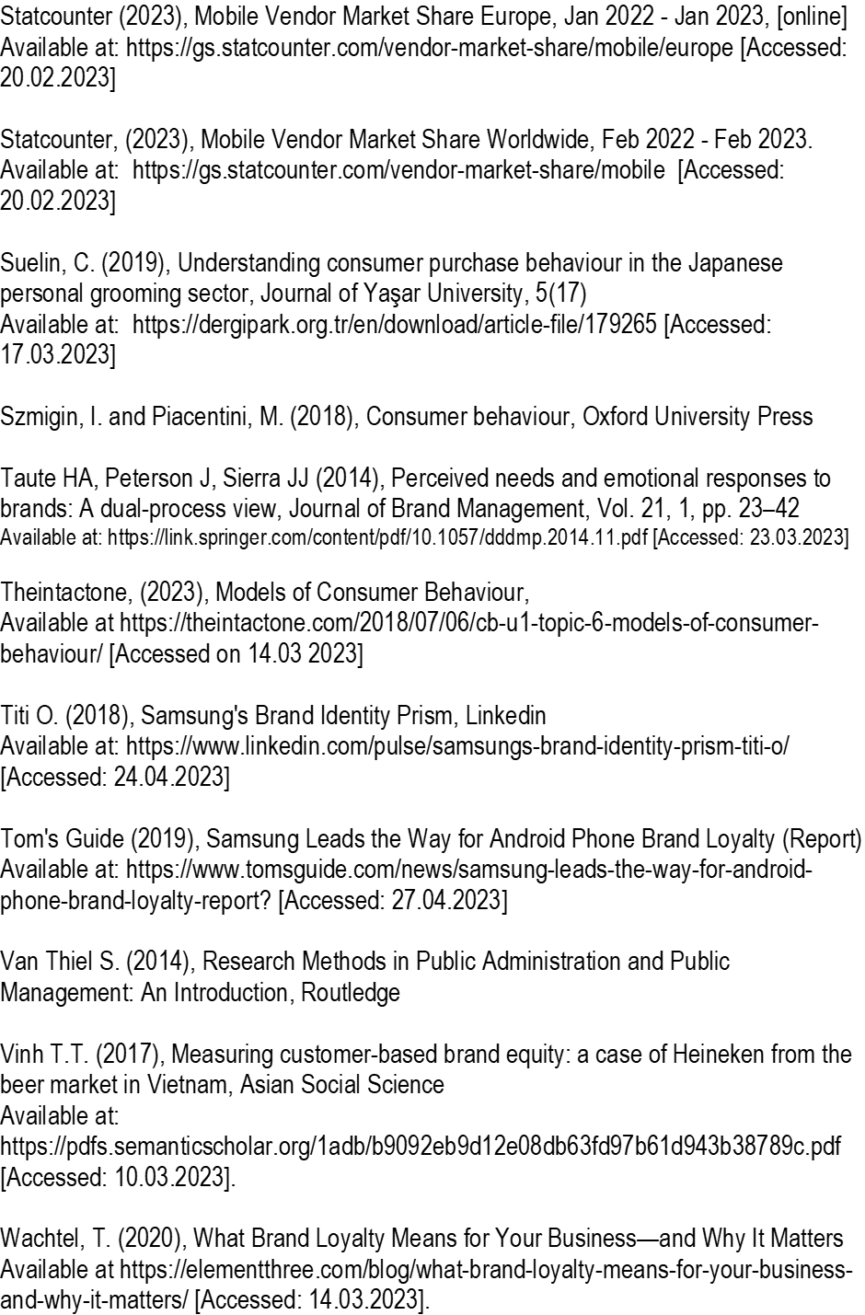
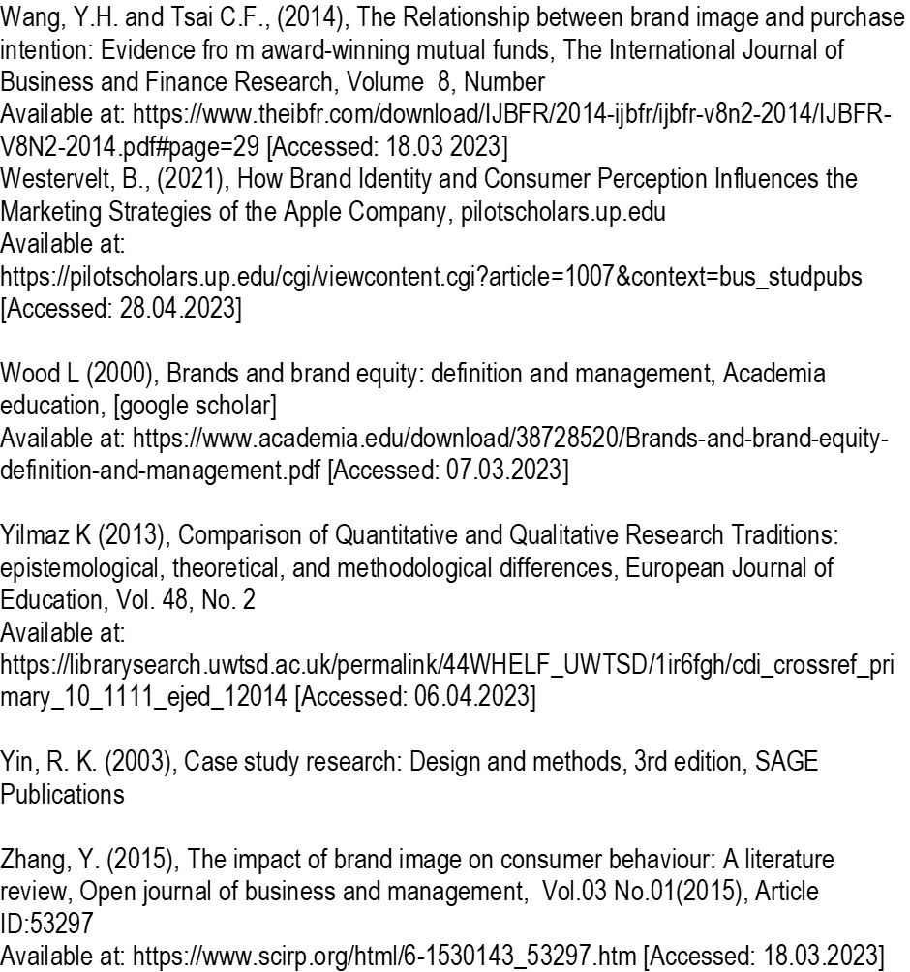

Appendix 1:


