

International Marketing (LCMB7006)


Student name: Alexandra Kazandjieva
Student Number: 2235019
Lecturer: Tushara Balendran
Submission Date: 21/08/2023

Table of Contents
1. Introduction 4
2. Company Background 4
3. Analysis of Allianz Macro Environment 4
Table1: Macro Environment 4
4. Pestel Analysis 4
4.1. Political Factors 5
UK. 5
Bulgaria 6
4.2. Economic Factors 7
UK 8
Table 2: GDP UK 2013-2022 8
Bulgaria 8
4.3. Social Factors 9
UK 9
Bulgaria 10
Hofstede Method of Cultural Dimension 10
Table 3: Country comparison of the UK and Bulgaria 11
Power Distance 11
Bulgaria 11
UK 11
Individualism 12
Masculinity 12
UK 12
Bulgaria 12
Uncertainty Avoidance 13
UK 13
Bulgaria 13
Long-term orientation 13
UK 13
Bulgaria 13
Indulgence 14
UK 14
Bulgaria 14
Advantages of Hofstede's Cultural Model 14
5. Technological Factors 15
The UK 15
Bulgaria 16
Legal Factors 16
UK 16
Bulgaria 17
Environmental Factors 17
UK 17
Bulgaria 18
Similarities and differences in the Macro analysis of Allianz 18
6. Insurance Industry Attractiveness for Allianz 18
Porters Five Forces 18
Table 4: Porter's Five Forces 19
6.1. Threats of new entrants 19
6.2. The Bargaining power of suppliers 20
UK 20
Bulgaria 20
6.3. The bargaining power of buyers 20
UK 20
Table 5: Allianz's performance in the UK for 2021-2022 20
Bulgaria 21
6.4. Threats of new substitutes 21
6.5. Competitive rivalry 21
Table: 6 Some Competitors of Allianz in the UK 22
Source: Author of the report 22
UK 22
Bulgaria 23
Table: 7 Allianz competitors in Bulgaria 23
7. Similarities and differences between the UK and Bulgaria based on Porter's Five Forces Model 23
Similarities: 23
Differences: 23
8. SWOT analysis 24
Table8.SWOT Analysis of Allianz compare the UK and Bulgaria 24
8.1. Similarities and differences in SWOT for Allianz in the UK and Bulgaria market 26
9. Segmentation, Targeting and Positioning in Allianz 27
Table: 9 Segmentation, Targeting, Positioning 27
9.1. Segmentation 28
9.2. Targeting 29
9.3. Positioning 29
Table: 10 Customer Perception Map for Allianz Competitors 30
10. Similarities and differences of STP 30
11. Marketing mix- 7s P 30
TABLE:11 The 7Ps of Marketing 31
11.1. Product 31
UK 31
Bulgaria 32
Similarities and differences in product offering in the UK and Bulgaria 32
11.2. Price 32
11.3. Place 32
11.4. Market Entry Methods 33
Bulgaria 33
Advantages of the entry model of Allianz 34
Disadvantages 34
11.5. Promotion 34
11.6. People 35
11.7. Process 35
11.8. Physical evidence 35
12. Similarity and differences in 7Ps Model 36
13. Definition of: Directional development strategy 36
14. BCG Matrix 36
Table 12: BCG Growth-Share Matrix 37
Source: https://managementconsulted.com/bcg-matrix/ 37
Stars 38
Cash Cows 38
Question Marks 38
Dog 38
Limitation of BCG Matrix of Allianz 39
15. Conclusion and recommendations 39
Bulgaria 39
Table 13: TOWS Matrix 40
Table 14: TOWS Matrix 41
References 42

- Introduction
International marketing is vital in any organisational strategy, including all activities and strategies involved in selling and promoting products or services worldwide. International marketing involves understanding and adapting to the unique characteristics of a market entry country's culture, economic, political, and social environment that influence market and consumer buying behaviour.
The aims of the following reports are to:
- Analise and briefly explain the Macro environment with the Hofstede Cultural Dimensions model in the case of Allianz AG by comparing two countries- the UK and Bulgaria.
- To evaluate and relate Porter's Five Factors, SWOT analyses and Segmentation, Targeting and Positioning to Allianz AG in the UK and Bulgaria.
- To critically analyse and compare the similarity and differences in 7Ps Marketing mix elements in the UK and Bulgaria using BCG Matrix, including conclusion and recommendations.
- Company Background
Allianz AG is a German financial service company founded in 1890 by Wilhelm von Finck and Carl von Thieme, mainly operating in the insurance and assets management sectors around the globe, with headquarters in Munich, Germany. According to Statista, in 20202, Allianz was ranked as the fourth largest insurance company worldwide (Rudden, 2023). According to Allianz's website, their value proposition is to "secure the future" to protect and grow people's assets. Like any non-tangible brand, Allianz focuses on establishing an emotional connection with all stakeholders, customers, brokers, agents, and the most asset for organisations-Allianz employees.
- Analysis of Allianz Macro Environment
Protecting individuals and companies from everyday risk, insurers generate positive value for their customers, helping them live better lives.
Allianz Insurance is a global insurance organisation operating in a very dynamic environment. To analyse the macro environment, one needs to consider some factors that are external to the company but substantially impact its operations, growth, and overall performance. Here is a PESTEL analysis affecting Allianz Insurance in the UK and Bulgaria.

Table1: Macro Environment
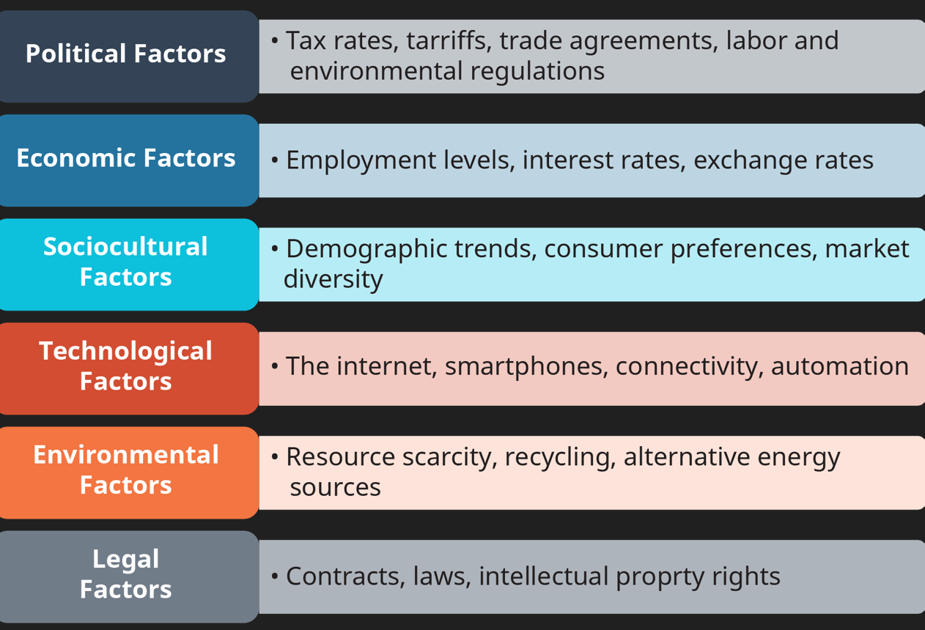
Source: https://ecampusontario.pressbooks.pub/globalmarketing/chapter/5-3-a-firms-external-macro-environment-pestel/
- Pestel Analysis
PESTEL analysis is an essential tool that helps companies understand their external macro environment as they play a crucial role in any individual organisation. PESTEL is a starting point that provides a framework that senior managers can use to identify how future political, economic, cultural, environmental, technological, and legal trends may impact organisational performance. These factors differ from country to country and sector to sector, impacting one organisation differently. PESTLE analysis helps managers to understand and consider how to change their strategy depending on the changing business environment.
Some of the main reasons why organisations should do PESTEL analysis are:
- Strategic decision-making helps organisations to align their strategies to mitigate risks and adapt to emerging trends.
- Risk management helps with uncertainties that may affect company operations.
- Stakeholder engagement is more effective when the company understand the macro environment. Considering social and environmental factors helps organisations to demonstrate corporate responsibility, address concerns and tailor their practices to social expectations.
- PESTEL analysis helps to identify both opportunities and threats in the macro environment. By analysing factors such as changing consumer demographics, emerging technologies and regulations, organisations can identify potential partnerships, new markets or areas of potential risk that can affect their performance and strategy.
  - Political Factors
The first component of PESTEL analysis is the Political Factors that play a significant role in business long-term performance and sustainability. Taxation policies, government trade regulations and political stabilities are examples of political factors that influence companies' survival.
For investors' confidence and customer trust, political stability is vital for any business organisation and seriously impacts the economy. Political factors do not always directly impact businesses but can impact other factors, affecting the overall business and business environment. Allianz operates in geographical areas experiencing political instability due to internal and external conflicts such as South African riots, anti-government protests in Columbia, BLM protests worldwide, and the Ukraine conflict, meaning the insurance industry is entering a challenging market.

UK.
The UK is a constitutional monarchy with a parliamentary system and strong traditions of rule. The Conservative Party and Labour Party are two major political parties in a multi-party-political system. The political stabilities in the UK are influenced by different factors, including economic conditions, global events, and public opinion, and are characterised by its governance system of law, where the law is consistently enforced, and the judiciary operates independently. UK governments have strong regulations covering labour laws, consumer protection, health and safety standards, taxation and competition policy that directly impact businesses.
Companies involved in import/export activities are significantly affected after Brexit establishing new trade agreements that lead to market access, changes in customs duties and import/export procedures. After Brexit, companies must adjust their strategies, investment plans, and supply chain accordingly.
All banking and financial organisations or individual is determined by government regulatory bodies such as Prudential Regulation Authority (PRA) and Financial Conduct Authority (FCA) (BakerMcKenzie, 2023). The changes in those two regulatory bodies can significantly impact Allianz AG, including consumer protection, data privacy, market conduct and capital adequacy.
Brexit affects many insurance companies operating in the cross-border market with the ability to underwrite policies across EU member countries pushing them to establish new entries or partnerships within the EU as Allianz's headquarter is in Germany Allianz is authorised under EU/EEA legislation (Allianz, 2018).
Changes in government policies in social welfare programs and retirement pensions can impact the demand for and profitability of certain insurance products such as health care coverage, life insurance and annuities.
Data protection and cybersecurity new policies required insurance companies to enhance data protection measures, increase cybersecurity investments, and comply with General Data Regulatory (GDPR). However, political factors in the UK are a mix of favourable and unfavourable aspects-the, the leading party is seeing a lot of criticism, including the situation with migration, the NHS waiting list, scandals, and Brexit chaos.
Some political factors are favourable such as the Covid-19 crisis government-supported businesses, strong intellectual property law, and favourable corporation tax rate.

Bulgaria
Bulgaria's insurance industry is subject to EUU regulations and directives as the country is part of the EU. Any changes in EU regulations can impact insurance companies operating in Bulgaria, including the requirement for risk management, capital adequacy and market conduct.
The difference between the UK and Bulgaria is that Bulgaria as an EU member, benefited from funding and programs for economic development and social cohesion. The insurance industry in Bulgaria may be badly affected by political decisions regarding EU implementation of programs and fund relocations as the government may choose to support other sectors such as renewable energy, agriculture, or infrastructure.
According to Fitch Rating, Political instability in Bulgaria is also a reason for delaying the country's access to the EURO zone by 2024 (Fitch Ratings, 203). Bulgaria's political future is unclear after two years of politically unstable government, five elections, and many corruption scandals. Business confidence and investment in the insurance sector are related to a politically stable environment in the country. Corruption and bureaucracy levels in Bulgaria are incredibly high, which is one of the main barriers to attracting foreign investments and together with an unstable political system, political factors are unfavourable for investment and businesses.
The changes in government regulations and policies affect business performance, and Allianz should closely monitor the political environment, engage with industry associations and regulatory bodies to quickly adapt to changing procedures and leverage new opportunities that may arise.
  - Economic Factors
In the context of shaping the business environment, the macro environment is one of the main factors affecting all business activities. Population consumption, monetary policies, Gross Domestic Product (GDP), employment and unemployment rates and access to internal finance are some drivers of successful business performance (Cepel, 2019).
A stable global economy, including international trade, geopolitical factors, and financial markets, can significantly impact country economies. Recessions, trade disputes or financial crises in leading economies can create ripple effects around the globe.
Inflation and interest rates set by central banks affect the cost of spending, investment and borrowing. High inflation and high-interest rates can erode purchasing power and destabilise the economy. Some examples are the covid-19 pandemic and the sharp rise in oil and gas prices, showing that these economic factors are interconnected and often influence each other. Allianz AG needs to understand the economy's direction and analyse these factors for better-informed future decisions.

UK
Gross Domestic Product (GDP) measures the total value of all services and goods produced in the country over a specific period. That is one of the significant indicators of economic growth and development.
Potential implications, unstable political and economic worldwide can be seen in the following graft shows the UK's Gross Domestic Product from 2013 -2022.

Table 2: GDP UK 2013-2022
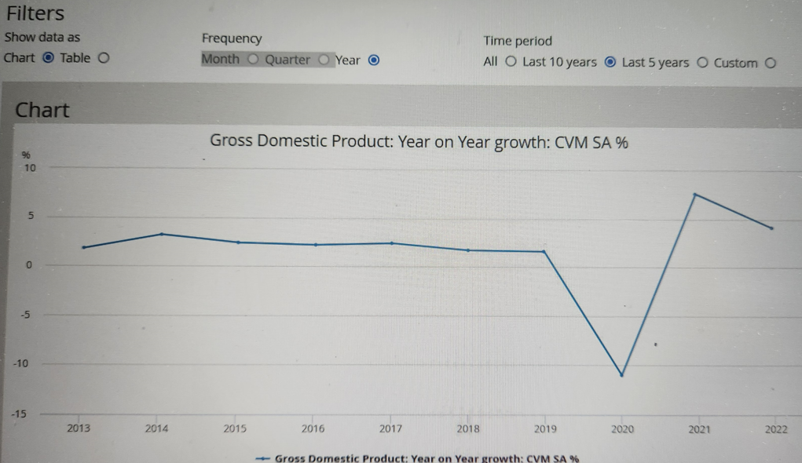
Sources: https://www.ons.gov.uk/economy/grossdomesticproductgdp/timeseries/ihyp/qna
Statista states, "For 2020, the UK has the second large life insurance investment portfolio in Europe after France with 133 billion Euro gross written premiums." (Statista, 2022).
The UK still attracts foreign investments but faces supply chain problems, inflation, and increasing living costs, and it is a mix of unfavourable and favourable factors for business investment opportunities.

Bulgaria
Bulgaria is a country in the Eastern European region with a small open economy with a population of 6.8 million and a GDP of $89 billion in 2021, driven by various sectors such as manufacturing, tourism, agriculture, and services, according to Worl Bank (Bank, 2023). The Covid-19 pandemic, the Global financial crises and conflict in Ukraine, and opposing governance weaknesses influence economic trends in Bulgaria. Changing the interest rate affects business investment; for example, new machinery, new technology or plant directly reduce total spending in the economy, affecting the profitability of many investment projects. In Bulgaria, the annual inflation rate for May fell to 15.8%, with consumer prices falling.14% in May, according to Focus Economics (FocusEconomics, 2023).
Economic conditions can be seen as unfavourable as Bulgaria's unemployment, inflation and living costs continue increasing.
  - Social Factors
Social factors, including consumer behaviour, social values, norms, and demographic characteristics, are some of the critical factors Allianz should consider for successful business operations. Failure to adapt to the sociocultural environment can void failure in business performance. Social factors in both countries are favourable. For example, the insurance market increased in Bulgaria, and Allianz Bulgaria is a well-positioned and trustworthy company. Allianz UK has a strong reputation and well-established brand with a range of products that UK citizens like and buy.

UK
Insurance has a long and long history in the UK, from the Great Fire of London in 1666 and developing insurance trading in 1688 from Lloyds in his coffee shop. Insurance provides peace of mind to the public, benefiting the economy and society and encouraging innovation and competition by freeing businesses from everyday risk (Institute, 2017).
Changes in the demographics landscape, such as the ageing population, population growth and shifting household structure, can affect insurance businesses. For example, the ageing population may increase the demand for long-term care coverage and life insurance, while changing household structure may affect the demand for home and contents insurance. Cultural and social norms play a significant role in shaping insurance preferences and behaviour. Personal responsibilities, attitude toward risk, and the importance of protecting assets can influence and motivate the demand for different insurance, including property insurance, motor insurance and Liability coverage.
A purchasing decision, customer loyalty and market competitiveness can be impacted by consumer trust and perception driven by customer experience, brand reputation, policy terms, and price transparency.

Bulgaria
Social factors in the Bulgarian insurance business can have a significant impact on the industry, and here are some vital social factors to consider:
- Insurance businesses should influence the importance of insurance awareness and financial education among the Bulgarian population to boost demand for insurance products and increase insurance penetration.
- Building trust and maintaining strong customer relationships are essential for Bulgaria insurers. Cultural attitudes towards risk, personal responsibilities and trust in financial institutions can influence buying behaviour. The gross written premium for Insurance in Bulgaria was BGN 3.3 billion ($2 billion) in 2021, and Allianz Bulgaria Life was the largest life insurer in 2021 (Data, 2022).
- Technological advancements, including mobile apps, digital platforms, and data analysis, can potentially transform the insurance industry in Bulgaria. Allianz needs to adapt to these challenges and offer innovative insurance solutions.
- Insurers should increase awareness of climate change and sustainability, which may influence insurance offerings and risk assessments. Insurance companies must assess and respond to emerging environmental risks, such as natural disasters and environmental Liability, through appropriate insurance coverage and affordable price.

Hofstede Method of Cultural Dimension
Geert Hofstede, a Dutch social psychologist, describes six entirely different parameters in organisational culture and the position of countries they may still bring. Careful consideration should be given to Hofstede's model as the cultural dimension is a key element of social factors that impacts consumer behaviour. Having a high level of knowledge of different cultural variations is critical for management and can make business more effective when dealing with colleagues, subordinates or negotiating with partners from other countries. In the 21st century, managers must understand cultural differences to avoid cross-cultural misunderstandings.

Table 3: Country comparison of the UK and Bulgaria
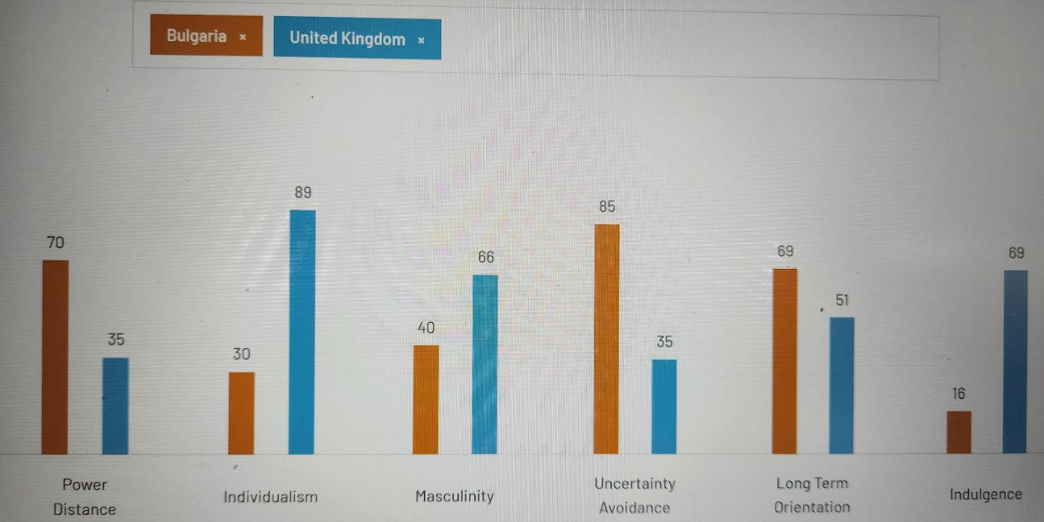
Source: https://www.hofstede-insights.com/country-comparison tool? Countries=bulgaria%2Cunited+kingdom

Power Distance
The Hofstede Power Distance dimension refers to the extent to which less powerful members of a society accept the power to be distributed unequally. It measures the level of hierarchy and inequality within a society. However, it is essential to understand that cultural dimensions are generalisations and may not accurately represent every individual within a country.

Bulgaria
A high score of 70 showed that in Bulgaria, everyone except the hierarchical order, where the autocratic boss tells subordinates what to do and proper titles with respectful language are used when addressing individuals in higher positions, emphasising the hierarchical structure. Symbols of power, wealth and social status may hold significance in Bulgarian society as they are associated with higher social standing.

UK
According to Hofstede's cultural dimensions, the United Kingdom has a low Power Distance Index (PDI) score of 35, meaning that British society is equal and relatively flat in a hierarchical structure. In British culture, is a main expectation that all individuals have equal opportunities, and there is a great willingness to challenge authority and engage in open discussion and debate. Individuals are often addressed by their first names, regardless of their positions or authority and that reduces the emphasis on status and titles.

Individualism
With a relatively low score of 30m, Bulgaria is considered a more collective and group harmony society than an individual. Bulgarian culture values solid social bonds, and individuals often can prioritise the interest of their family, community, or social group over personal desires. Bulgarian society value collaboration and cooperation as people often rely on others for support and decision-making, and there is a sense of shared responsibility within social groups.

Masculinity
Another fundamental issue in society is how to distribute values between genders- Masculinity versus Femininity. According to Hofstede, masculine counties have tabu around those dimensions (Press, 2011).

UK
With a score of 66 on Hofstede's scale, British culture balanced both masculinity and femininity values. British society values a healthy work balance and recognises the importance of personal well-being, family time and leisure activities. Gender equality and equal opportunities play an important role in British culture. There is fairness and non-discrimination in the workplace. Achievement and success are valued in British society, with an emphasis on personal accomplishment and recognition.

Bulgaria
Bulgaria has a low masculinity score of 40 and is considered a Feminine society where negotiations and compromises resolve conflicts. Many women are elected to political positions, both father and mother can deal with facts and feelings, and balance between work and family are some differences that distinguish Bulgarian Feminine society from masculinity in the UK.

Uncertainty Avoidance
Uncertainty is "the extent to which the members of a culture feel threatened by the uncertain or unknown situation" (Library, 2023) . Society should deal with the fact that the future cannot be predicted: do we need to let it happen, or should we try to control the future?

UK
With a score of 35, the British nation proved they are happy in uncertain situations, as British culture values adaptability, flexibility, and a willingness to embrace change. Another indicator is that British society encourages direct and open communication, even when discussing sensitive or uncertain topics. British society is more willing to take risks and engage in entrepreneurial activities.

Bulgaria
A relatively high Uncertainty Avoidance of 85 on the Hofstede scale shows that Bulgarian society strongly prefers rules, structure, and certainty. Bulgarian culture value stability and predictability with a desire for clear regulations and guidelines to minimise uncertainty and maintain order. Bulgarians prefer to avoid significant risk or uncertainty, prioritising security, and stability over potential rewards. One of the most values is respect for tradition, which means there is a preference for preserving established traditions and norms to provide stability and reduce uncertainty.

Long-term orientation
This dimension considers the value given to the past and the value given to the future.

UK
The UK is known for its historical perspectives, long-standing institutions, and focus on planning for the future, which often demonstrates a balance between balancing short-term needs with long-term goals. A score of 51 indicates that the UK is in the middle and that the dominant culture cannot be determined. There is a recognition of the importance of stability, continuity and adapting to change over time.

Bulgaria
With a score of 69 on Hofstede's dimension Bulgaria showed her pragmatic culture where society exhibits some characteristics of traditional values and practices with a growing acceptance of modernity. Bulgarian society demonstrates flexibility and adaptability in response to changing circumstances, which may influence the country's historical experience and need to adjust to different economic, political, and social changes.

Indulgence
According to Hofstede cultural dimensions, indulgence refers to the extent to which a society allows and encourages the gratification of basic human desires and enjoyment of life.

UK
The United Kingdom have a very high score of 69 on indulgence on Hofstede's scale, indicating that British people in society are open to pleasure, leisure, and enjoyment of life, including individual expression of identity. British culture allowed individuals to pursue their desire and happiness.

Bulgaria
With a lower score of 16 on Hofstede's cultural dimensions, Bulgaria seems to be a Restrained society with a more self-disciplined approach to desires and enjoyment of life. Traditional values like barriers stop individuals from controlling their desires and putting duties and obligations before personal pleasure.

Advantages of Hofstede's Cultural Model
Some of the advantages of the Hofstede Cultural model:
- The framework for contrasting and comparing different cultures in different regions and countries comprises six cultural dimensions.
- A Hofstede cultural model can be applied to education, business, and international relations.
- Businesses can benefit from understanding cultural preferences, norms, and values.
- Improving intercultural communication, management, and negotiation leads to booming international business success in a multicultural environment.
- Can be used in human resources, marketing, and intercultural training, as the Hofstede cultural model prove that culture is not fixed or static and can change over time (Hofstede Insights, 2023).
Disadvantages of Hofstede's cultural model
- The sample is small as it is based only on one company (IBM), which cannot represent all countries' cultures and involves only middle-class workers.
- The model is focused on business-related values and cannot provide a complete understanding of other vital things such as social relationships, religions, and family.
- The model does not explain the reason why certain cultures interact with each other.
- The model does not explain specific actions of behaviour based on personal education, experience, or individual differences.
- The Hofstede cultural model is old for a rapidly changing environment in our globalisation world, and the Hofstede model needs to be reviewed (Usmani, 2022).
Uniting with other cultural frameworks, Hofstede cultural model helps business managers understand cultural differences when entering a new international market.

Technological Factors
We live in the technology era, and any business organisation investing in emerging technologies has opportunities to overtake competition. Technology is a primary driver for change and innovation, enabling companies to gain significant competitive advantages that lead to higher profitability and business sustainability.

The UK
The United Kingdom has a well-developed technological infrastructure where it is easy to innovate and reduce costs, giving businesses opportunities to take competitive advantages in the global marketplace. The UK needs to implement new technology to bring more benefits to improve Co operational efficiency, change the customer experience, and make a more accurate risk assessment alliance. For example, Allianz can use artificial intelligence and machine for underwriting processes and can use chatbots and virtual assistants to provide instant customer support, guide customers through the claim process and offer personalised recommendations. All new technologies must be reconciled under the UK's General Data Protection Regulation (GDPR). Allianz must educate and train all employees on new technologies to maximise their effectiveness within the organisation. Technological factors are favourable in the UK.

Bulgaria
The level of business progress is closely linked and dependent on technology and innovation. Bulgaria is trying to be up to date with other countries in implementing new technology, training people to benefit through technological change to meet the market's needs better.
" Nearly 70 per cent of business enterprises in Bulgaria took green action through information and communication technology with a medium or high intensity in 2021. Furthermore, one-quarter of small and medium-sized enterprises (SMEs) in the country were found to possess at least a basic level of digital intensity" (Department, 2023). Technological factors are favourable and unfavourable as there is still room for investment and implementation of innovations and technology.

Legal Factors
All legal factors connected under the law affect how organisations operate and customers behave, including health and safety, advertising standards, product labelling and product safety and consumer rights. For Allianz to trade globally, this is a tricky area, as organisations need to be up to date -because each country has a set of laws, rules and regulations that must be followed.

UK
UK insurance companies must follow all regulations of different regulatory bodies, including the Prudential Regulation Authority (PRA) and the Financial Conduct Authority (FCA). Allianz must ensure fair and transparent business practices, financial stability, and consumer protection. Allianz holds many sensitive and personal data, so they must comply with data protection laws, Protection Act 2018, and the General Data Protection Regulation (GDPR). Another crucial moment in Allianz's operations is to prevent their services from being misused for money laundering, terrorist financing or other criminal activities following Money Laundering Regulation 2017. Insurance companies must prevent anti-competitive practices - including avoiding all activities that may constitute market share or abuse dominant market positions (James C. Scoville, 2022).
It can be said that the UK Legal factors are favourable for businesses with solid copyright law, import/export law, intellectual property law, etc.

Bulgaria
Bulgaria has a well-developed insurance market with long years of history. New insurance CODE was adopted and entered into force implementing all EU directive solvency and other fundamental EU regulation and directives at the beginning of 2016. The regulatory authority responsible for regulating and supervising the insurance sector in Bulgaria is the Financial Supervision Commission (FSC), and Allianz AG must comply with FSC regulations, including financial reporting, internal control, licencing, and solvency. (Nevena Radlova, 2023). Allianz must comply with the Personal Data Protection Act (PDPA) in Bulgaria implementing data protection measures ensuring all policyholders and other individual data is secured and protected. Under Bulgarian law, all vehicle owners must have mandatory motor third-party liability insurance (MTPL). "For 2020, the gross written premium income for MTPL insurance is 45% of the insurance premium total for non-life insurance according to data published by the FSC" (Stoeva, 2022).
Legal factors are unfavourable in Bulgaria, following concerns about corruption everywhere in the country, including the judicial system.

Environmental Factors
Environmental factors play a significant role for businesses, including insurance companies, due to the increased vigilance of stakeholders towards environmental protection and sustainability.

UK
At the beginning of 2023, the UK government published and 25 years environmental improvement plan to protect nature from pollution, waste management, and emissions, focusing on green initiatives and sustainability (HM Government , 2023). UK governments are working hard to protect the environment expecting individuals and businesses to demonstrate environmental responsibility. Allianz must demonstrate a commitment to those green initiatives to keep companies' reputation and brand image and differentiate them in the market. In the last few years, we witnessed many natural disasters, including earthquakes, floods, wildfires, and hurricanes all around the globe. Insurance companies must adjust and evaluate their risk models and underwriting practices to the potential impact of natural disasters that can impact their portfolios. Environmental factors are favourable for businesses in the UK.

Bulgaria
Air pollution is one of the main problems in Bulgaria, and the government and other organisations are working to improve air quality. Bulgaria is famous for its various water resources, including lakes, natural mineral waters, rivers, and diverse ecosystems. Bulgarian has many national parks, nature reserves and different protected areas. Like other countries, Bulgaria faces the risk and impact of climate change, including the intensity of extreme hot or cold weather events. Insurance companies must include in their policies and adopt their underwriting practises to protect Bulgarian individuals and businesses from potential climate change risk.
Environmental factors are unfavourable for businesses, and government need to put more effort into addressing environmental issues and helping businesses.

Similarities and differences in the Macro analysis of Allianz
Allianz, one of the world's leading insurance companies, should consider the following similarities and differences in macro analysis for the UK and Bulgaria that may affect its operations.
- The UK has well-established laws and institutions, while Bulgaria still suffers from high governance issues and corruption.
- The UK received a high level of foreign investment instead of Bulgaria, directly affecting consumer behaviour, social norms and lifestyle.
- Regarding technology, huge differences between both countries can be seen - the UK holds a strong tech sector and innovation hubs, while Bulgaria does not.
- The UK has a higher level of GPD compared to Bulgaria. Bulgaria has the potential to increase growth opportunities.
- The UK has well established and mature insurance sector.
- Insurance Industry Attractiveness for Allianz

Porters Five Forces
The Five Forces framework was developed by Harvard Business School professor Michael Porter and published for the first time in 1979. This robust framework helps businesses understand their industry dynamics, accordingly, take strategic decisions, boost their profitability, and gain an advantage over their competitors. Porter's Five Forces strongly depend on each other, as pressures from one direction can quickly reflect and affect another in a dynamic to shift competitors' source.

Table 4: Porter's Five Forces

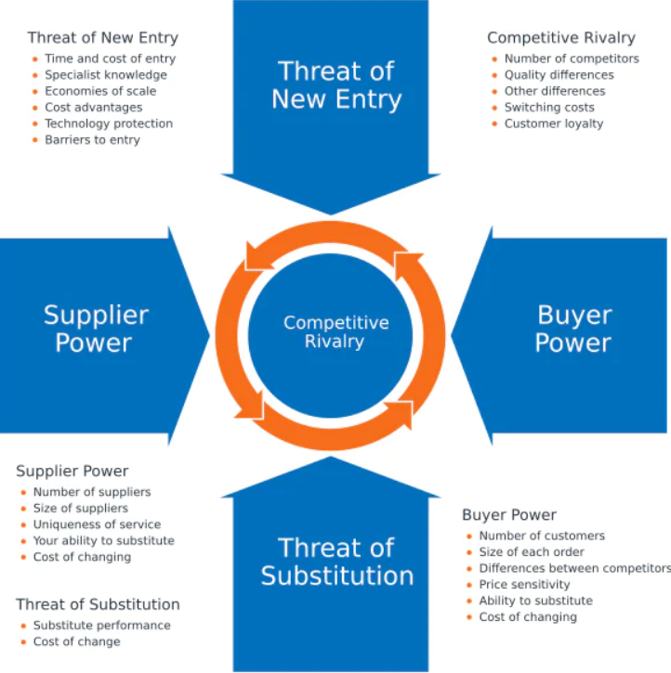
Sources: https://www.mindtools.com/at7k8my/porter-s-five-forces
  - Threats of new entrants
Substantial regulatory requirements, well-established regulations, procedures, and some of the world's biggest insurance companies on the market pose high barriers for new UK insurance entrants.
Compared to the UK, the Bulgarian insurance market still has a place and low barriers for new players and potential for market growth.
  - The Bargaining power of suppliers

UK
Reinsurers and service providers in the insurance industry are suppliers that may have moderate to high power over Allianz. However, with a well-established name brand and good market share, Allianz can benefit from power because of good negotiation positions over suppliers.

Bulgaria
Allianz can have high power over local suppliers because of the cheap labour market and content market. Compared to international suppliers, things are like the UK – suppliers have moderate to high power over Allianz.
  - The bargaining power of buyers

UK
Due to many insurance companies and available options, buyers have moderate power, but they can easily switch between insurers if they are not happy with service, coverage, or price.

Table 5: Allianz's performance in the UK for 2021-2022
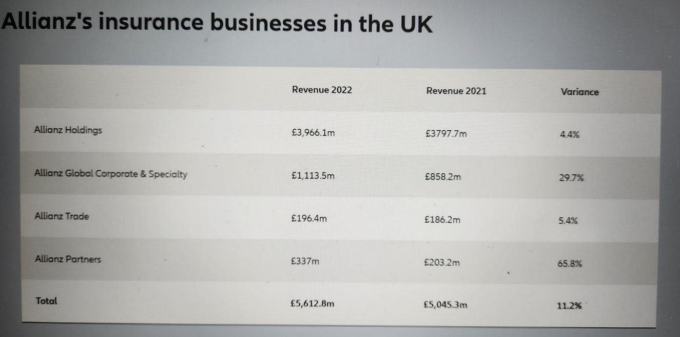
Sources: https://www.allianz.co.uk/news-and-insight/news/allianz-trading-roundup-2022.html

Bulgaria
Compared to the UK, consumers in Bulgaria have low bargaining power due to limited choice in many insurance segments and limited choice of insurers.
According to a Statista report from 2022, Allianz Bulgaria Jivot holds the largest market share in gross written premiums of almost 30 percent in the Bulgarian market (Rudden, 2022).
  - Threats of new substitutes
In the UK insurance market, Allianz may face a moderate threat from substitute services or products due to the high level of new technologies that can replace traditional insurance, and customers may choose alternative insurance options.
Threats of new substitutes for Allianz in Bulgaria are moderate as the market is evolving, and implementing new technologies or creating new insurance products may affect Allianz's performance.

  - Competitive rivalry
Compared to the UK insurance market, the Bulgarian insurance market for Allianz is low as the market is less saturated. Advantages can gain any insurance company that establishes a good reputation, a strong brand name, and a strong relationship with a loyal customer by providing low insurance prices for their products/services.

Table: 6 Some Competitors of Allianz in the UK

Source: Author of the report

UK
Insurance companies operating in the UK insurance market are one of the biggest names in the industry, focusing on customer loyalty, market share and innovative technologies that make the insurance market highly competitive.

Bulgaria

Table: 7 Allianz competitors in Bulgaria
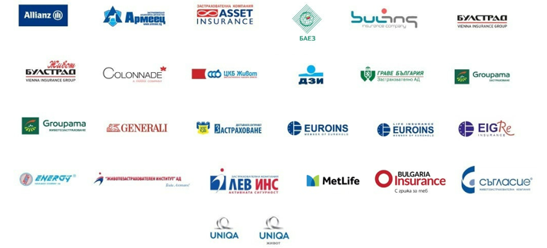
Sources: https://www.abz.bg/en
- Similarities and differences between the UK and Bulgaria based on Porter's Five Forces Model
The UK and Bulgarian insurance businesses have many differences and similarities between both countries based on the five forces framework.

Similarities:
- Strong regulations, procedures, and barriers are challenging for new companies to enter the insurance industry.
- In both countries, suppliers have moderate bargaining power.
- Both countries encourage international investment as they have good regulatory systems and legal frameworks.
- Because of the new digital era and competitive market, customers of both countries have access to many different services and products.
- In the UK and Bulgaria are many substitutes in the insurance business.

Differences:
- The UK has a more diverse economy, a high population, and better quality of life.
- The UK has more substitutes because of the largest market compared to the Bulgarian insurance market.
- Because of the largest consumer market in the UK, buyers may have more power than in Bulgaria.
- In the UK, the number and size of suppliers are more significant than the Bulgarian market.
- In the UK, economies of scale, time and cost entry are higher than in Bulgaria (Worl Data , 2023).
Managers of Allianz should always consider all those factors when entering a new international market to predict the future, as Porter's Five Factors give a detailed picture of the competitive landscape in which insurance companies operate.
- SWOT analysis
Like Porter's Five Forces, SWOT analysis benefits business organisations in analysing a company's position compared to its competitors in its business environment. SWOT stand for – strengths, weaknesses, opportunity, and threats and is used for making strategic business decisions. To be up-to-date and specific, Allianz must take coordination between all company departments, such as human resources, finance, marketing, logistics, strategic planning, and operations.

Table8.SWOT Analysis of Allianz compare the UK and Bulgaria
STRENGTHS |  |  | WEAKNESSES
UK | BULGARIA |  | UK |  | BULGARIA
- Strong brand reputation and equity with £5.6bn for 2022.  - Increasing revenue by 4.4% (Allianz, 2023) | - Substantial brand equity with a turnover of 180m BGN. For 2021.  - First place in gross written premium for 2021 (Rudden, 2022) |  | - Rented property.  - Very highly competitive market with local well-established insurance companies like AXA, Admiral, and Aviva |  | - Rented property.  - Research and development  - Not very good portfolio of products
OPPORTUNITY |  |  |  | THREATS
UK |  | BULGARIA |  | UK |  | BULGARIA
- Adopting a new market under a government-free agreement  - Market growth because of the growing population  - Partnership and Acquisition  - New technology for better customer service and cyber security |  | - New trends in customer preferences  - Digital transformation for better customer experience  - Social media for awareness of a brand |  | - Brexit  - Rising raw materials may decrease profitability.  - Rising pay level.  - Changing customer needs and wants.  - Tight labour market (British Chambers of Commerce , 2023) |  | - Brexit  - Shortage of skilled employees  - Economic conditions such as increasing inflation  - Technology development from competitors  - Sustainable insurance and net zero (Kimberley Nanson, 2023)

Allianz should consider that SWOT Analysis has some limitations. SWOT Analysis does not recommend how a company should achieve better competitive advantage and does not consider the factors of the dynamic change environment where Allianz operate. For example, changing the environment can be seen as an opportunity and a threat. The following are recommendations for Allianz – to use digital marketing in both countries to reach more customers and increase brand awareness. Allianz has an excellent financial position and must invest in innovative products/services and expand distribution channels for long-term competitive advantage, as in the insurance industry are some of the best financial sharks in the world.
  - Similarities and differences in SWOT for Allianz in the UK and Bulgaria market
Comparing similarities and differences between the UK and Bulgaria need to be considered that Allianz is a multi-national financial and insurance organisation that offers personal and business insurance products, including life insurance, car insurance, cargo insurance, home insurance, contractor insurance, property owner insurance, legal protection insurance etc. Allianz is a provider of inspection and claim services. Allianz has a well-established network operating through agencies and brokers around the world.
There are some similarities and differences between both countries:
Similarities:
- Global brand recognition name, good reputation, various portfolios of products and services, and good risk management are Allianz's strengths that are similar in the UK and Bulgaria.
- Competitions from local insurance suppliers in both countries and changing customer preferences and wants are other similarities for Allianz in the UK and Bulgaria.
- Potential partnerships, growing insurance markets, and implementing digital technology in both countries can be seen as opportunities for Allianz.
- Changes in government regulations, cybersecurity risk, fraud claims or legal disputes threaten similarities between countries.
Differences:
- Market growth potential and the highly intensive insurance market in the UK are some differences from the insurance market in Bulgaria.
- Allianz must manage two different compliance requirements and specific regulations in both countries.
- Consumer behaviour, buying habits and insurance awareness may vary between Bulgaria and the UK.
- Economic factors are other huge differences between the UK and Bulgaria. The UK has a bigger GDP than Bulgaria, directly affecting Allianz's market size, consumer spending and business environment.
"A SWOT analysis summarises the key issues from the business environment and the strategic capability of an organisation that is most likely to impact strategy development" (Gerry Johnson, 2005).
- Segmentation, Targeting and Positioning in Allianz
Marketing guru Philip Kotler states One way to achieve a company's goal is to know the needs and desires of consumers or target markets and provide expected satisfaction effectively and efficiently compared to competitors" (Muhammad Yusuf1, 2022). Behind marketing segmentation, targeting and positioning (STP), the idea is to define the target market's needs, wants and preferences and offer the best to them. When deciding about companies' marketing processes, those three concepts go hand in hand, as these steps are vital for an organisation's marketing strategy.

Table: 9 Segmentation, Targeting, Positioning

Sources: Autor of report
  - Segmentation
"Breaking down a market into sub-groups with similar characteristics is known as marketing segmentation" (Dave Hall, 2008). These are the most essential ways to segment customers:
- Demographic segmentation is the most used method because it divides customers into groups considering their characteristics: age, family size, occupation, sex, income, etc. Allianz offers different health insurance in both countries depending on customers' income and age.
- Geographical segmentation is the method that divides the market base into geographical aspects such as country, city, neighbourhood, etc. Allianz UK and Allianz Bulgaria have different segmentation of regions, as Bulgaria is at high risk of earthquakes.
- Psychographic segmentation looks at customers based on internal characteristics, including their lifestyle, attitudes, interest, personality, values, beliefs, and social class. In both countries, Allianz divides potential customers into their personal characteristics, leisure activities, etc., understanding that psychographic characteristics are based on individual life experience and growing up environment.
- Behavioural segmentation includes customer purchasing behaviour, customer loyalty, attitude toward the product/service, website activities, etc. Allianz UK and Allianz Bulgaria offer various life insurance with tax benefits for customers looking for financial protection.
In both countries, Allianz should use cross-marketing segmentation with businesses with the same values, philosophy, and vision. That will help to build more loyalty and credibility in customers. Cross-marketing can benefit Allianz with advertising cost reduction, increasing brand awareness and recognition that can lead to sales growth.
  - Targeting
Philip Kotler stated," There is only one winning strategy. It is to carefully define the target market and direct a superior offering to that target market" (Muhammad Yusuf1, 2022). How we see market targeting is different from market segmentation. Target marketing focuses on selecting one or more market segments and developing products/services that benefit each segment. After identifying the segment, management's role is to evaluate each segment's opportunity offer.
Because of Allianz's products/services specifications and characteristics, Allianz uses a mix of undifferentiated, differentiated, and concentrated strategies in the UK and Bulgaria to reach more customers and gain a high market share percentage. For example, Allianz uses an undifferentiated strategy in car, home, and even life insurance- the exact product/service to all customers, depending on their income, gender, or age.
Allianz UK and Allianz Bulgaria are using differentiated strategies offering different products/services to different market segmentation—for example, some investment products and life insurance for families, older adults or people willing to invest and give benefits of the products.
Concentrate strategy, known as niche marketing, focuses on serving customers with unique preferences and needs like cargo and Marine insurance is a strategy Allianz use in both countries.
Allianz's targeting strategy is based on a combination of the company's overall objectives and each target market's specific needs, preferences and wants.
  - Positioning
When people hear "positioning", most think about products, places, or themselves, but positioning is what marketing people do with the consumer mind, how they position the product/service in the prospect's mind. Positioning can be seen as an empty place in the consumer's mind where, under the right circumstances, the company can position their brand product or service at the right moment. To overcome their competitors, companies must create a position in the prospect's mind, using their brand name like a hook, as positioning can affect the price of the product/service.

Table: 10 Customer Perception Map for Allianz Competitors

Sources: Autor of report and https://www.consumerintelligence.com/articles/the-insurance-brands-delivering-the-best-customer-service

Similarities and differences of STP
There are not many similarities between Allianz UK and Allianz Bulgaria, as the UK insurance market is well organised and very old regarding the Bulgarian insurance market. Similarities include a focus on the same age groups, lifestyle preferences, behaviour, and psychographic characteristics of the target market. In both countries, Allianz focuses on growth market potential and company capabilities to serve as much as possible at best customer needs and preferences.
Differences between Allianz UK and Allianz Bulgaria are based on economic factors; for example, UK GPD is higher than Bulgaria's. The population in the UK is higher than in Bulgaria, with more cultural and diverse backgrounds, directly impacting target and segmentation groups. The cultural values differ in the UK and Bulgaria, directly affecting consumer buying behaviour and motives. The UK offers a more competitive environment than Bulgaria, as the UK is one of the leading insurance markets in the world (Rudden, 2023).
- Marketing mix- 7s P
The marketing mix is a managerial approach to leading business and successful product promotion to the target market. Businesses can use any 7Ps elements in their daily decision-making process to seduce the right audience through marketing campaigns.

TABLE:11 The 7Ps of Marketing
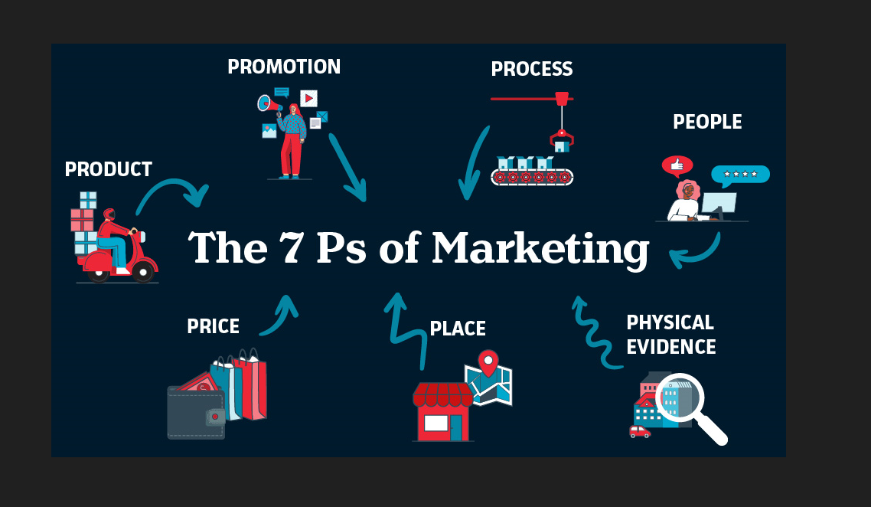
Source: https://assemblo.com/guides/what-are-the-7-ps-of-marketing/

  - Product
The main purpose of insurance is to collect premia to protect the customer from possible risk and pay the cost if there are any damages or losses during the insured period. Allianz offers various products in its portfolio under the service sector, grouped into personal and business insurance and underwriting services. Allianz products are "clearly explained and honestly marketed" to customers (Allianz, 2023).

UK
Allianz offers various insurance products tailored to UK customers' wants and needs, including Renewable energy instalments, Retirement Planning, Health insurance, Pet insurance, Cargo, Trade Credit Insurance, Liability, etc.

Bulgaria
Allianz is tailoring its product depending on Bulgarian market preferences and regulatory requirements. The products are property insurance, health insurance, life insurance, liability insurance, travel insurance, etc.
To capture target groups' attention, businesses must create a brand that stands out from competitors. Allianz UK and Allianz Bulgaria fulfilled brand loyalty and brand awareness of their customers by delivering what they promised. In both countries, Allianz is using Brand extensions -introducing new products/services under the same name as customers already know and trust Allianz.

Similarities and differences in product offering in the UK and Bulgaria
There may be some similarities between Allianz products in both countries:
- Property insurance
- Health Insurance
- Underwriting
- Cargo insurance, etc.
Due to many PESTEL and SWOT analysis factors, such as country preferences, government finance laws, requirements, and market demand, there are many differences in policy types, covered risks offered, premiums and payout between both countries.
  - Price
Price is another essential element of the Marketing mix connected with how much money customers need to spend for an offered service/product. Insurance companies are trying to offer friendly and affordable premiums for their products/services. Allianz's product/service price depends upon regulatory bodies and competitors. Allianz is trying to provide high-quality products/services at the best premium price based on the competitive landscape, market conditions and customer preferences.
  - Place
Place is another crucial segment of the Marketing mix, as the right product should be sold at the right price in the right place, and the product /service needs to be available for customers where they are willing to buy. Availability and distribution of the product are essential for any insurance company around the globe, and Allianz has access to different distribution channels in many countries it operates. One of the largest distribution channels for Allian is in Germany (Moody's Investors Service, 2018). Allianz is working to develop a "Building Block Platform" "where all customers can buy insurance products/services like they are buying soap" (Allianz, 2019).
  - Market Entry Methods
For international companies selecting the proper entry mode is part of the decision-making process and vital for business survival. Different entry mode decision-making directly implements companies' abilities to adjust their entry modes after entry. According to Katsikas, Samiee, and Theodosiou (2006), " Decision-making is one of the essential parts of management work. Moreover, in international marketing, effective decision-making is becoming increasingly critical to success." (Ali Ahi, 2017).
UK
The UK insurance market is one of the world's most highly competitive and mature, with a long history of providing insurance products/services. It offers different insurance products and services tailored to the needs, values and wants of individuals, businesses, and various organisations. UK Allianz UK sells their products through selected partners, banks, and brokers across the UK. Allianz also uses its website-direct channel to reach customers. The choice of those channels depends on the diverse products offered, high level of insurance awareness, high level of competitors and size and maturity of the market.
The choice of distribution market depends upon various factors such as Legal factors, control, cost, and distribution.

Bulgaria
Entering a new market country is always a risky business that may lead to success and have massive potential for failure. Due to globalisation, companies are trying to operate worldwide and expand their portfolio to gain more revenue and market shares, and the Bulgarian market seems to be a n attractive for insurance businesses as have much potential.
Allianz Bulgaria Holding was founded in 1998 by seven companies offering banking and insurance products/services (Allianz Bulgaria Holding, 2023). Allianz Bulgaria offers its products/services using banks, brokers, direct channels, and franchises.

Advantages of the entry model of Allianz
- Franchising is one of the advantages of the entry model as they can control how products and services will be distributed to their customers.
- Established reputation is another advantage of alliance strategy as that can help to build trust and attract new clients.
- Using customer relationships and networks, a strategic alliance helps gain a solid competitive advantage.
- Bulgaria is an EU member whit a regulated and stable insurance environment; Allianz can provide its products and services across the region.
- An extensive network of agents, brokers, and other distribution channels can cut operational costs.
- Direct marketing is affordable and cost-effective (Invest Northern Ireland, 2023)

Disadvantages
- Brokers or franchising agents can ruin brand image and reputation through their actions.
- Direct investment and vertical integration can occur as risks that can increase costs.
- Increasing product prices can lead customers to switch to other competitors (Harward Business Review, 2021).
  - Promotion
Promotion is when companies increase customer attention to products/services. The following are some of the promotional goals:
- Existing customers may switch the product/service.
- Can attract new customers.
- To promote better quality or price than competitors.
Some of Allianz's digital and traditional marketings promotions are the followings:
- Sponsorship. Allianz used sponsorships with many organisations around the globe and supported global championships like Formula E in New York, Para Olympics, and Golf. Many stadiums worldwide are named Allianz- Juventus and Bayer München stadiums. In 2018 Allianz became a worldwide Olympic Insurance Partner (Allianz, 2023).
- Allianz UK proved that people are their priority, encouraging individuals in their carrier and establishing an agreement with Irish sprinter Rashida Adeleke (Sport for Business, 2023).
- Allianz uses social media like Facebook, Twitter, and Instagram to promote its brand and products/services. Digital promotion is cost-effective, measurable and can quickly reach many target audiences.
- In the UK, Allianz uses partnerships to "promote safer driving" that can help target new audiences and keep existing customers happy (Pangilinan, 2023).
- Mobile App where customers can have easy access to their insurance policies.
Allianz Bulgaria uses more outdoor advertising like billboards, direct mail, and phone calls from financial agents to promote their products/services.
  - People
People's elements in the marketing mix play a leading role in the insurance industry. Alliance has a diverse environment with employees from different backgrounds, races, nationalities, cultures, ages, and genders. Allianz's top priority is their employees' health and mental well-being; Allianz has been ranked "number 1 in insurance in the global Refinitiv Diversity Inclusion Index 2022 and number one in the German Diversity Index 2022" (Allianz, 2023). In Bulgaria and the UK, Allianz is training and motivating their staff and employees, positively impacting people's productivity, and performance. The UK and Bulgarian Allianz employees are benefited from flexible and autonomous work environments, team building, and mental and well-being support.
  - Process
Allianz customers can use the smartphone Allianz App or the Allianz website for quick and easy access to any questions about policy, price, inquiries, claims, company products or services. Allianz is trying to improve customer satisfaction and support its customers in all situations, giving customers an easy and convenient way to solve them.
  - Physical evidence
In the UK and Bulgaria, Allianz offices are situated at convenient locations with easy access in many cities and towns worldwide. The offices are equipped with the latest technology in a friendly environment for providing professional service without delay. All offices have a waiting area where customers can be offered magazines, hot or cold beverages. The brand logo can easily recognise Allianz offices -three vertical lines symbolising their three business areas.

Similarity and differences in 7Ps Model
The similarities between both countries are in the product portfolio Allianz offers, like life insurance, non-life insurance, etc. Promotion is another similarity, as Allianz use marketing promotions to target its customers.
The differences between the two insurance markets are enormous- starting with people. Language barriers between customers and employees and sales interaction; for example, in Bulgaria, customers still prefer a financial advisor to visit them, as online sales are not preferred. Distribution channels, promotion and prices also vary in both countries.
- Definition of: Directional development strategy
According to Sydney Finkelstein, Professor of Tuck School of Business at Dartmouth," Directional Strategy is the driving force behind all businesses decisions: it is the only way to accomplish a strategic and state" (Welp Magazine, 2023). The difference between directional and operational strategies is that the directional strategy shows how a company will grow or grow instead of the steps taken and the decisions made.
Advantages of Directional strategy:
- Geographic strategy: Applying a business or marketing concept in a new geographical region.
- All departments in the company work toward corporate goals.
- Stability, growth, and retrenchment are the main components of a company's directional strategy.
- The united effect of the company mission, value and vision statements can significantly impact performance and growth.
- BCG Matrix
Bruce Henderson 1968 created a chart called BCG Growth-Share Matrix. BCG Matrix categorises company portfolios into four groups depending on their market share and growth rates, which helps management make better strategic decisions about which product/service to keep.to sell or to invest more in. The picture below shows Four groups of BCG Matrix.

Table 12: BCG Growth-Share Matrix
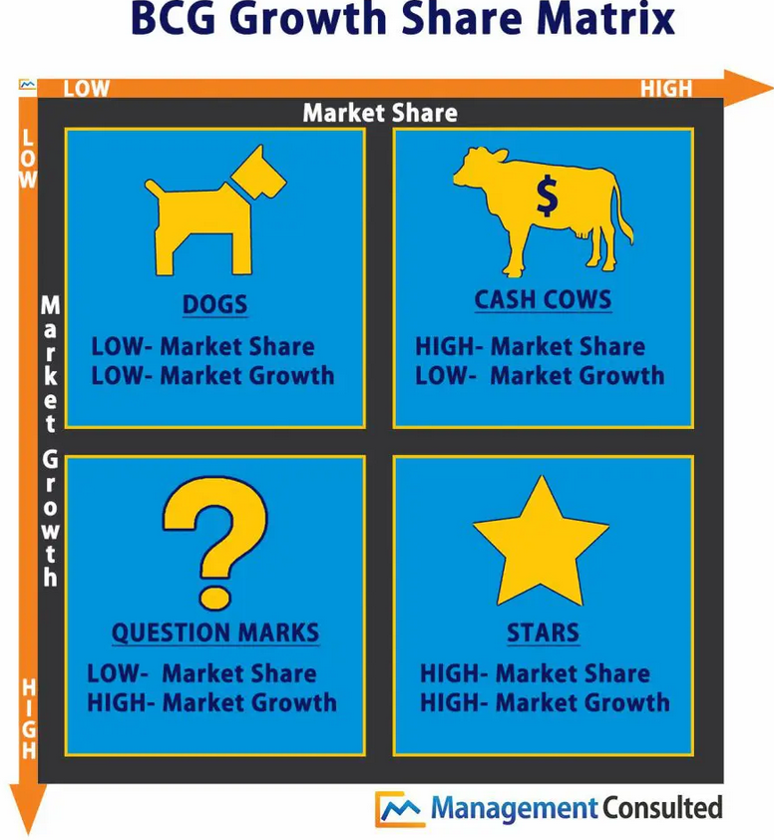

Source: https://managementconsulted.com/bcg-matrix/

Allianz is managing various portfolios, including a diverse range of products/services, and using BCG Matrix is strongly recommended to help the company decide to invest or divest in its strategy business units. To better understand and evaluate BCG Matrix, consider Allianz's market share, market growth, and Allianz portfolio, and assess industry growth rates.
Below is what each category represents Allianz product/service:

Stars
Allianz is operating in an industry that is still growing and has future potential, and Allianz earns a massive amount of its income from this SBU. Allianz's Strategic business unit is ranked STARS in BCG Matrix as Allianz is one of the market leaders with its product/service that generates significant sales of £ 5.6 bn in the UK (Allianz, 2023). The potential for this market is to make high effectiveness and high Return on Investment (ROI).
Allianz can acquire or integrate with other companies in developing new products/services in life insurance, pension, or business insurance to earn more profit and take more market share, as this Strategic business unit has colossal potential as the population growth, businesses growth and always will be needed for risk protection and insurance products/services.

Cash Cows
Allianz Cash Cows can be any products/services with a high market share and limited investment effort that generate stable revenue. Some of Allianz Cash Caws products/services include liability insurance, home insurance and term life insurance, as those insurances contribute well and provide a good income for the company.

Question Marks
These are products/services that consume enormous resources, hide risk potential because of growing faster and need to be very carefully observed as they are in a very early stage and have the risk of uncertainty. The company should keep an eye on climate change insurance, Cyber insurance, and Drone insurance, which are part of the Allianz Question Marks group, as they exceptionally quickly grow but still do not dominate the market. Some of those products have real possibilities to become Stars – high-profit products, high growth. Need to bear in mind that everything is specific and depends on company strategy and market environment.

Dog
Any product/service that generated negative profit or low growth required Allianz's attention to evaluate product viability, as those products/services should be liquidated or repositioned. Allianz should regularly review those products/services to respond to market trends and satisfy customers. For example, Traditional Annuities is one of the Allianz portfolio products that are not too popular because of many other alternatives and low-interest rates.

Limitation of BCG Matrix of Allianz
Allianz should consider some BCG Matrix limitations, such as:
- There are no middle business or mixed classifications of the products/services.
- Competitors are not considered.
- Micro and Macro environments are not t.
- PESTEL must be analysed for better decision-making.
- Conclusion and recommendations
Based on the evidence, there are excellent macroeconomic environments for the insurance business but still many obstacles preventing massive market penetration, such as demographic crises, inflation, and destructive political and economic situation.
UK
Allianz UK is one of the leading Insurance providers with their stable finance position and good market share, offering various insurance products/services for businesses, corporate clients, and individuals.
To stay competitive, Allianz should diversify products/services and explore niche markets to attract more customers build trust and maintain a firm brand name. Focusing on customer experience across all customer touchpoints is vital for company growth and sustainability.

Bulgaria
There are some applicable recommendations: Allianz must stay updated with the macro environment focusing on factors like GDP, inflation rising living rates and government laws and regulations, as those factors are crucial for the growth of insurance products/services. Allianz must focus on customer preferences and market trends and clearly define its potential customer group. Allianz should think about how to market its products/services, giving customers the best experience and creating value for the Allianz brand.

TOWS Matrix is one step ahead of SWOT analysis and another recommendation for Allianz to use from management strategic decisions and planning for future success. TOWS Matrix can directly balance positive and negative external and internal factors with essential action points.
After completing the SWOT analysis, Allianz must follow the TOWS matrix below to identify and consider four potential business strategies.

Table 13: TOWS Matrix
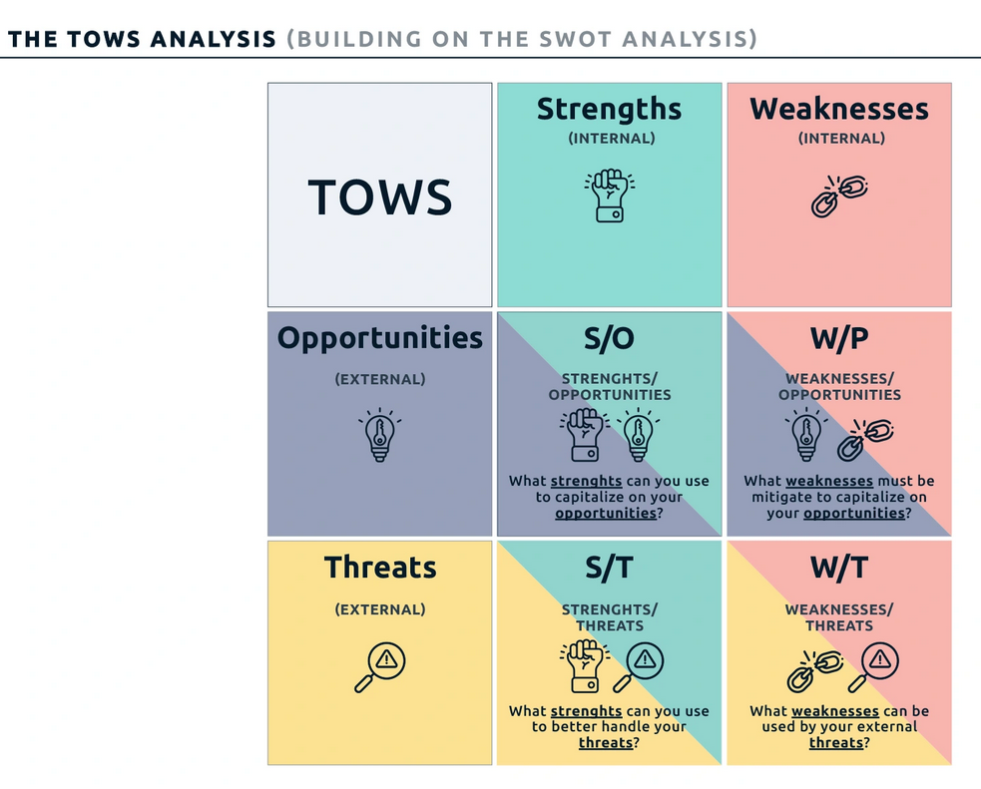
Source: https://digitalleadership.com/unite-articles/tows-matrix/
After analysing and considering more of the external and internal factors that may affect Allianz's performance and revenue, the other recommendation for Allianz is to use the Maxi-Maxi strategy from TOWS Matrix to achieve sustainable advantage and take incredible ideas to fulfil business marketing strategy. The maxi-Maxi strategy is helpful for Allianz as it can use external opportunities and internal company strengths. For example, Allianz, in both the UK and Bulgaria, has a well-established brand name and reputation that successfully can introduce new products or services for its existing customers or explore new emerging markets.

Table 14: TOWS Matrix
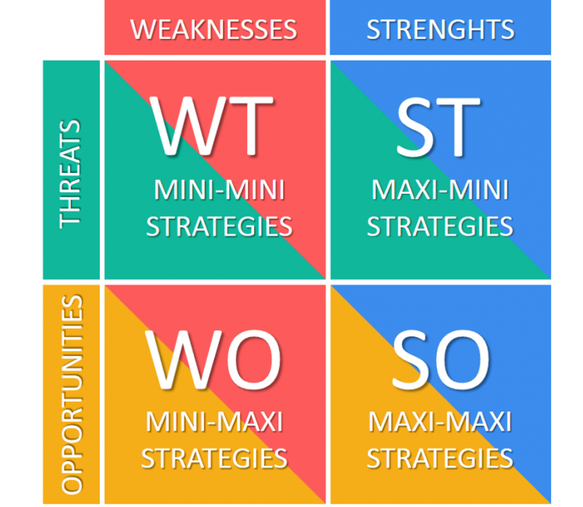
Source: https://tradebrains.in/tows-matrix/

References
Ahmedova, S., 2020. Digital Transformation of the Bulgarian Industry. Varna, IOP Conference Series: Materials Science and Engineering, pp. 1-6.
Al Ries, J., 2001. Positioning; The battle for your mind. First ed. New York, Toronto, San Francisco: McGraw-Hill.
Ali Ahi, G. B. O. K. a. M. P., 2017. International Market Entry: How Do Small and Medium-Sized Enterprises Make Decisions?. Journal of International marketing, 25(1), pp. 1-21.
Allianz Bulgaria Holding, 2023. Insurance Company Allianz Bulgaria Holding. [Online]
Available at: https://www.nit.bg/en/portfolio/learning-management-systems/allianz
[Accessed 18 July 2023].
Allianz, 2018. Allianz Legal Forms. [Online]
Available at: https://www.allianz.com/en/about-us/corporate-management/corporate-governance/legal-form.html
[Accessed 20 July 2023].
Allianz, 2019. Sell insurance as sample as soap. [Online]
Available at: https://globaldigitalfactory.allianz.com/blog/new-joiner-s-experience-at-dixd---data-scientist-1.html
[Accessed 19 July 2023].
Allianz, 2023. Allianz Group announces revenue of £5.6bn in UK. [Online]
Available at: https://www.allianz.co.uk/news-and-insight/news/allianz-trading-roundup-2022.html
[Accessed 22 July 2023].
Allianz, 2023. Fostering a culture of diversity, inclusion, and innovation. [Online]
Available at: https://www.allianz.com/en/press/news/company/human_resources/230405_Allianz-People-Fact-Book-2022-Fostering-a-culture-of-diversity-inclusion-and-innovation.html
[Accessed 18 JULY 2023].
Allianz, 2023. Press. [Online]
Available at: https://www.allianz.com/en/press/news/commitment/sponsorship.result.html/2.html
[Accessed 17 July 2023].
Allianz, 2023. Responsible Products and Services. [Online]
Available at: https://www.allianz.co.uk/about-allianz/social-responsibility/products-and-services.html
[Accessed 19 July 2023].
BakerMcKenzie, 2023. Who regulates banking and financial services in your jurisdiction?. [Online]
Available at: https://resourcehub.bakermckenzie.com/en/resources/global-financial-services-regulatory-guide/europe-middle-east-and-africa/united-kingdom/topics/who-regulates-banking-and-financial-services-in-your-jurisdiction
[Accessed 30 July 2023].
Bank, W., 2023. The world bank in Bulgaria. [Online]
Available at: https://www.worldbank.org/en/country/bulgaria/overview
[Accessed 8 July 2023].
Cepel, M. B. J. R. Z. &. S. Z., 2019. Selected economic factors of the quality of business environment. Journal of International Studies, 12-2(14), pp. 228-240.
Data, G., 2022. Bulgaria Insurance Industry: Key Trends and Opportunities to 2026. [Online]
Available at: https://www.globaldata.com/store/report/bulgaria-insurance-industry-market-analysis/
[Accessed 7 July 2023].
Dave Hall, R. J. C. R. A. A., 2008. Business Studies. Fourth ed. Harlow: Pearson Education.
Department, S. R., 2023. Digital technology integration in Bulgaria 2021, by indicator. [Online]
Available at: https://www.statista.com/statistics/1385337/digital-tech-integration-bulgaria/
[Accessed 10 July 2023].
Fitch Ratings, 203. Fitch Affirms Bulgaria at 'BBB'; Outlook Positive. [Online]
Available at: https://www.fitchratings.com/research/sovereigns/fitch-affirms-bulgaria-at-bbb-outlook-positive-12-05-2023
[Accessed 28 July 2023].
FocusEconomics, 2023. Bulgaria Inflation May 2023. 14 June, pp. 1-2.
Gerry Johnson, K. S. R. W., 2005. Exploring Corporate Strategy. 7th Edition ed. Harlow: Pearson Education Limited .
Harward Business Review, 2021. If You're Going to Raise Prices,Tell Customers Why. [Online]
Available at: https://hbr.org/2021/06/if-youre-going-to-raise-prices-tell-customers-why
[Accessed 13 July 2023].
HM Government , 2023. Environmental Improvement Plan 2023, London: Department for Environment, Food and Rural Affairs.
Hofstede Insights, 2023. Organistaional Culture. What you need to know. [Online]
Available at: https://www.hofstede-insights.com/organisational-culture
[Accessed 15 July 2023].
Institute, C. I., 2017. THE SOCIAL VALUE OF INSURANCE. [Online]
Available at: https://www.cii.co.uk/32307
[Accessed 9 jULY 2023].
Insurance, A., 2023. Allianz Group announces revenue of £5.6 bn in UK. [Online]
Available at: https://www.allianz.co.uk/news-and-insight/news/allianz-trading-roundup-2022.html
[Accessed 9 July 2023].
Invest Northern Ireland, 2023. Direct Marketing. [Online]
Available at: https://www.nibusinessinfo.co.uk/content/advantages-and-disadvantages-direct-marketing
[Accessed 12 July 2023].
James C. Scoville, C. S. a. B. L., 2022. Insurance and Reinsurance in the United Kingdom: Overview. [Online]
Available at: https://uk.practicallaw.thomsonreuters.com/0-501-2031?transitionType=Default&contextData=(sc.Default)&firstPage=true
[Accessed 2023 July 2023].
Library, B., 2023. Geert Hofstede. [Online]
Available at: https://www.bl.uk/people/geert-hofstede
[Accessed 8 July 2023].
McAuley, N., 2023. Gross Domestic Product: Year on Year growth: CVM SA %. [Online]
Available at: https://www.ons.gov.uk/economy/grossdomesticproductgdp/timeseries/ihyp/qna
[Accessed 9 July 2023].
Moody's Investors Service, 2018. Allianz SE Semi -annual update, s.l.: Finnancial Institution.
Muhammad Yusuf1, T. Y. S. P. S., 2022. Analysis of Segmenting, Targeting, Positioning and Marketing .Mix Strategies on the Yonly Glass Processor and Application.GlassBusiness Plan. American International Journal of Business Management (AIJBM), 5(01), pp. 77-83.
Mullakhmetov, K., 2018. Technological Factors and Management Transformation in Social and Economic System. European Research Studies Journal , XXI(3), pp. 230-241.
Nevena Radlova, A. K., 2023. Ten things every insurer should know in Bulgaria. [Online]
Available at: https://cms.law/en/int/expert-guides/cms-expert-guide-to-insurance/bulgaria
[Accessed 4 July 2023].
OECD, 2023. Global Insurance market trends , s.l.: OECD.
Pangilinan, M., 2023. Allianz Commercial enters partnership to promote safer driving. [Online]
Available at: https://www.insurancebusinessmag.com/uk/news/auto-motor/allianz-commercial-enters-partnership-to-promote-safer-driving-449362.aspx
[Accessed 17 July 2023].
Press, B. E., 2011. Dimensionalizing Cultures: The Hofstede Model in Context. Online Readings in Psychology and Culture (ORPC), 2(1), pp. 1-26.
Rice University , 2019. Principles of Management. Houston: OpenStax.
Rudden, J., 2022. Leading life insurance companies in Bulgaria Q4 2021, by gross written premiums. [Online]
Available at: https://www.statista.com/statistics/882000/leading-life-insurance-companies-in-bulgaria-by-gross-written-premiums/
[Accessed 22 July 2023].
Rudden, J., 2022. Market share of leading life insurance companies in Bulgaria December 2021. [Online]
Available at: https://www.statista.com/statistics/881951/market-share-of-life-insurance-companies-in-bulgaria/#statisticContainer
[Accessed 8 July 023].
Rudden, J., 2023. Allianz Group statistics and facts. [Online]
Available at: https://www.statista.com/topics/1628/allianz-group/
[Accessed 29 July 2023].
Sport for Business, 2023. Allianz and Adeleke. Strike Three Year Ambassador Deal. [Online]
Available at: https://sportforbusiness.com/allianz-and-adeleke-strike-three-year-ambassador-deal/
[Accessed 16 July 2023].
Statista, 2022. Life insurance industry in the United Kingdom (UK) - statistics & facts. [Online]
Available at: https://www.statista.com/topics/6688/life-insurance-industry-uk/#topicOverview
[Accessed 28 July 2023].
Stephen Bungay, R. H. a. A. F., 2020. How to Make Good Decisions When You Cannot Make Good Predictions. Agile Strategy, pp. 1-7.
Stoeva, I., 2022. The Insurance and Reinsurance Law Review: Bulgaria. [Online]
Available at: https://thelawreviews.co.uk/title/the-insurance-and-reinsurance-law-review/bulgaria
[Accessed 2 July 2023].
The Chartered Institute of Marketing, 2009. Marketing and the 7PMs, s.l.: The Chartered Institute of Marketing.
Usmani, F., 2022. Hofstede's Cultural Dimensions: Explanation, Limitation, and Examples. [Online]
Available at: https://parsadi.com/hofstedes-cultural-dimensions/
[Accessed 4 July 2023].
Welp Magazine, 2023. A Complete Guide to Directional Strategy. [Online]
Available at: A Complete Guide to Directional Strategy
[Accessed 6 July 2023].
Worl Data , 2023. Country comparison Bulgaria and UK. [Online]
Available at: https://www.worlddata.info/country-comparison.php?country1=BGR&country2=GBR
[Accessed 12 July 2023].

