

Student name: Abosede Dehinbo
Student ID: 2313077

Module name: Empowering the Older Person
Module code: BMHP6027_LON
Lecturer’s name: Dr. Laila Surani

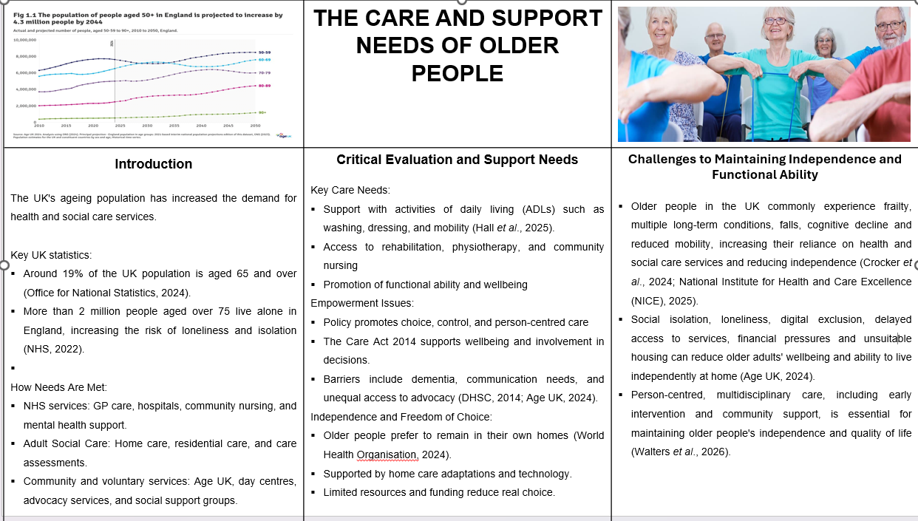
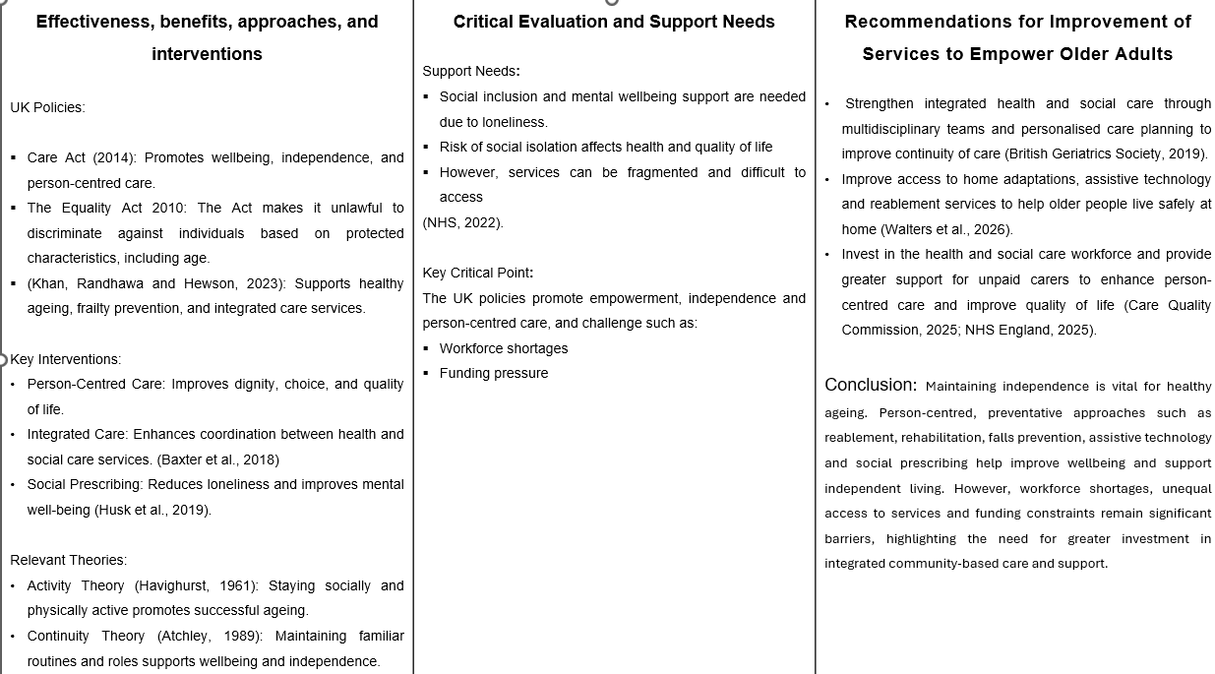

References

Abdi, S., Spann, A., Borilovic, J., de Witte, L. and Hawley, M. (2019) Understanding the care and support needs of older people: a scoping review and categorisation using the WHO International Classification of Functioning, Disability and Health Framework (ICF)’, BMC Geriatrics, 19, p. 195. Available at: https://doi.org/10.1186/s12877-019-1189-9 (Accessed: 22 June 2026).
Age UK (2024) Later life in the United Kingdom. London: Age UK. Available at: https://www.ageuk.org.uk/siteassets/documents/reports-and-publications/later_life_uk_factsheet.pdf (Accessed: 22 June 2026).
Age UK (2024) State of health and care of older people in England 2024. Available at: https://www.ageuk.org.uk/discover/2024/september/state-of-health-and-care-of-older-people-in-england-2024/ (Accessed: 28 June 2026).
Baxter, S., Johnson, M., Chambers, D., Sutton, A., Goyder, E. and Booth, A. (2018) The effects of integrated care: a systematic review of UK and international evidence’, BMC Health Services Research, 18, article 350. Available at: https://doi.org/10.1186/s12913-018-3161-3 (Accessed: 22 June 2026).
British Geriatrics Society (2019) 8. CGA in primary care settings: care and support planning. Available at: https://www.bgs.org.uk/8-cga-in-primary-care-settings-care-and-support-planning (Accessed: 28 June 2026).
Care Quality Commission (2025) The state of health care and adult social care in England 2024/25. Available at: https://www.cqc.org.uk/publications/major-report/state-care/2024-2025 (Accessed: 28 June 2026).
Crocker, T.F., Ensor, J., Lam, N., Jordão, M., Bajpai, R., Bond, M., Forster, A., Riley, R.D. and Clegg, A. (2024) ‘Community based complex interventions to sustain independence in older people: systematic review and network meta-analysis’, BMJ, 384, e077764. Available at: https://doi.org/10.1136/bmj-2023-077764 (Accessed: 28 June 2026).
Department of Health and Social Care (2014) Care Act 2014: statutory guidance. London: Department of Health and Social Care. Available at: https://www.gov.uk/government/publications/care-act-statutory-guidance/care-and-support-statutory-guidance (Accessed: 22 June 2026).
Hall, A., Davey, V., McGarrigle, L., Astbury, J., Lazo Green, K., Ahmed, N. et al. (2025) OPFPRU HAPRU Homecare Quality Project – Full Report 29.10.24. Manchester: University of Manchester. Available at: https://doi.org/10.5281/zenodo.16895867 (Accessed: 23 June 2026).
Husk, K., Elston, J., Gradinger, F., Callaghan, L. and Asthana, S. (2019) ‘Social prescribing: where is the evidence?’, British Journal of General Practice, 69(678), pp. 6–7. Available at: https://doi.org/10.3399/bjgp19X700325 (Accessed: 27 June 2026).
Khan, N., Randhawa, G. and Hewson, D. (2023) ‘Integrated care for older people with different frailty levels: a qualitative study of local implementation of a national policy in Luton, England’, International Journal of Integrated Care, 23(1), 15, pp. 1–13. Available at: https://doi.org/10.5334/ijic.6537 (Accessed: 22 June 2026).
National Institute for Health and Care Excellence (NICE) (2025) Falls: assessment and prevention in older people and in people 50 and over at higher risk (NG249). Available at: https://www.nice.org.uk/guidance/ng249 (Accessed: 28 June 2026).
NHS (2022) Loneliness in older people. Available at: https://www.nhs.uk/mental-health/feelings-symptoms-behaviours/feelings-and-symptoms/loneliness-in-older-people/ (Accessed: 22 June 2026).
Office for National Statistics (2024) Living longer: older people and ageing in the UK. Available at: https://www.ons.gov.uk/peoplepopulationandcommunity/birthsdeathsandmarriages/ageing (Accessed: 22 June 2026).
Walters, K., Frost, R., Barrado-Martín, Y., Kalwarowsky, S., Marston, L., Pan, S. et al. (2026) ‘Enabling health and maintaining independence for older people at home: the “Home Health” randomised controlled trial’, Health Technology Assessment, 30(43), pp. 1–22. Available at: https://doi.org/10.3310/GJKW1909 (Accessed: 28 June 2026).
World Health Organisation (2024) Ageing and health. Available at: https://www.who.int/news-room/fact-sheets/detail/ageing-and-health (Accessed: 22 June 2026).

