

Dissertation Proposal
Title: Impact of Social Media Marketing on a Business’s Success: a case of Dior
Student Name: Cristina Miloiu
Student ID: 2008582
Table of Contents
Introduction 3
The Rationale of the Study 3
Aim 4
Objectives 4
Questions 4
Literature Review 5
Research Methodology 7
Research Strategy 7
Research Techniques 8
Sampling Methods and Types 8
Data collection methods 8
Analysis of the Data 9
Research Ethics and Privacy 9
Research Expenditure 9
Resources and Planning 10
References and Bibliography 11

Topic: Impact of Social Media Marketing on a Business’s Success: A Case of Dior

Introduction
Social media marketing is a process through which an organisation utilises various social media platforms to interact with several customers to effectively build brands, enhance their sales figures and thereby drive website traffics (Jacobson, Gruzd and Hernández-García, 2020). It helps in developing the brand image in the perceptions of customers and thereby executing effective promotions. The study will be outlining the aims, objectives, aims literature review and methodology that will be adopted in the completion of the study. Additionally, it will also evaluate a relevant theory that helps to analyse the topic in more depth.

The Rationale of the Study
There have been instances in which various brands have not used social media platforms in an appropriate way and resulted in major issues in its operation. This has also occurred for Dior when it faced major amounts of backlash for cultural appropriation. the company shared a picture of a dark-skinned Chinese model wearing a traditional outfit while holding a Dior bag (Manjur, 2021). This was much against normal cultural norms relating to beauty as it is considered to be fair-skinned having large eyes. Due to the social media post of the brand, it was targeted by various consumers as it tarnished the image of Chinese women. This issue rose in popularity as the typical standards of beauty in the Chinese markets are highly different from what has been portrayed in the post. This issue is highly important as it degrades the brand image of Dior by significant margins.
Additionally, it affects the desirability of the Dior in global markets and the controversy has reached global markets. The intensity of the decline in demand for Dior products has majorly reduced. This is because customers across the globe have been demanding a global apology for the blatant disregard for improper cultural social media marketing initiatives undertaken by the company (Wang, 2023). Moreover, this issue is important for the business organisation, as it creates a scenario in which it faces reduced demand in the global markets and lower forecasted sales figures effectively. Moreover, this can also reduce the comprehensive market share of the global fashion and apparel markets effectively. Due to this controversy, there has been a decline in the entire image and thereby a lower brand attractiveness. It has a significant impact on profitability and comprehensive revenue generation potential. In all, this controversy has a veritable impact on the demand and overall brand equity that it had.

Aim
The aim of the study is to evaluate the impact of social media marketing on the organisational performance of Dior.

Objectives
- To analyse the concept and significance of social media marketing
- To evaluate the impact of social media marketing on the business success and organisational performance of Dior
- To identify the mitigation strategies through which challenges faced by Dior can be addressed

Questions
- What is social media marketing?
- What is the impact of social media marketing on the business success and organisational performance of Dior?
- What are the mitigation strategies that can be applied to address the issues faced by Dior?

Literature Review
Concept and Significance of social media marketing
According to Mason, Narcum and Mason (2021), social media marketing is the execution of various social media platforms such as Instagram, Facebook and Twitter to effectively promote a business organisation and build an appropriate amount of brand loyalty. It helps in effectively engaging customers, reaching out to a large base of operations and thereby creating a proper amount of trust among customers. Additionally, it also ensures that the various businesses can have a large base of customers to which services and products can be offered. As identified by Zollo et al. (2020), social media significantly supports an organisation in the course of targeting customers in a better way and thereby facilitates an enhancement of the demand for the products that are being sold and thereby increasing its overall revenue generation potential.
Impact of social media marketing on organisational performance
Social media marketing plays a veritable role in improving the links and relationships that customers have with business organisations. As opined by Wibowo et al. (2020), social media marketing ensures that customers can be properly engaged in organisational operations. This aids business organisations in the generation of effective and long-lasting relationships between them. It can be inferred that through better relationships, word-of-mouth marketing also increases, which in turn increases the comprehensive revenue generated and profitability recorded. This has been contradicted by Savitri et al. (2022), stating that bad reviews on social media posts can also damage the brand image of a company.
Strategies for addressing issues in social media marketing
Since social media has innumerable users, it is significantly difficult for an organisation to be visible to customers. Here, are various strategies that a business can implement to effectively address the issues that have been identified. As per Gkikas et al. (2022), the primary strategy that an organisation can implement is the utilisation of various hashtags that are in trend. This can majorly help an organisation in being visible to the intended users. In contrast, Mehta (2020), states that a company can also use various linguistic features that can essentially help it in targeting the customers that fall in its selected demographic.
AIDA model of marketing
AIDA model is a framework that outlines four stages through which an organisation can persuade customers through the utilisation of persuasive communication strategies (Mumtaz, 2019). Social media platforms can be utilised in the course of persuading customers effectively.

Figure 1: AIDA model
(Source: Inspired by Mumtaz, 2019)
The Attention stage involves getting the attention of the customer relating to the existence of customers in the markets. As opined by Vasconcellos-Silva (2023), this can be executed by implementing social media posts that have an element of shock through provocative pictures. It can also be completed through intensely targeted messages through various story posts, timeline posts and various others. This can majorly help an organisation in making the customer aware. This is followed by the interest stage which is characterised as the most difficult part of the business marketing procedure that is included in the social media marketing process. Herein, an organisation needs to effectively ensure that the advertisements and posts that are offered through social media platforms. Additionally, an organisation can implement a social media activity in which the message that is to be conveyed to the customer needs to be clear and precise. This can effectively aid a customer in realising the attractiveness of the products and services that are sold and thereby create interest in customer perceptions.
The desire stage closely follows the interest stage as they are highly similar and need to be often completed together. After the interest has been generated in the consumer mind relating to the products that have been offered. According to Trisnayanti, Sudiarta and Puspita (2022), desire can be created by creating social media posts and reels which provide interesting information relating to the products and thereby create desire among customers. This information needs to effectively highlight the information that can encourage the customers to effectively acquire the products and services of a company. The action stage includes converting the desire of the customer into the act of purchasing products that have been promoted. Content that requires immediate action can be shared by an organisation to execute this stage under the model.
Literature gap
Previous studies have not discussed the theory of social media in veritable detail. The study has effectively analysed the topic of social media marketing through the use of the AIDA model which helps in better comprehension of the topic. Thus, this outlines the various processes through which it can ensure a wider and more in-depth understanding of social media marketing initiatives effectively. However, there has been a lack of establishing a proper relationship between social media marketing and success of brand.

Research approach and philosophy
The research can use approaches namely, deductive, inductive and abductive approaches. In this case, deductive research approach will be included as it involves the creation of hypotheses based on an existing concept and thereby creating a strategy through which it can be properly tested (Casula, Rangarajan and Shields, 2021). This will be selected, as it helps in properly establishing a proper relationship between the variables that have been developed. Moreover, the positivism philosophy will be followed in completing the study. This entails a concept that only factual knowledge gained through observation is trustworthy and genuine. It will be utilised in this study as it helps in making accurate forecasts and predictions quantitatively.
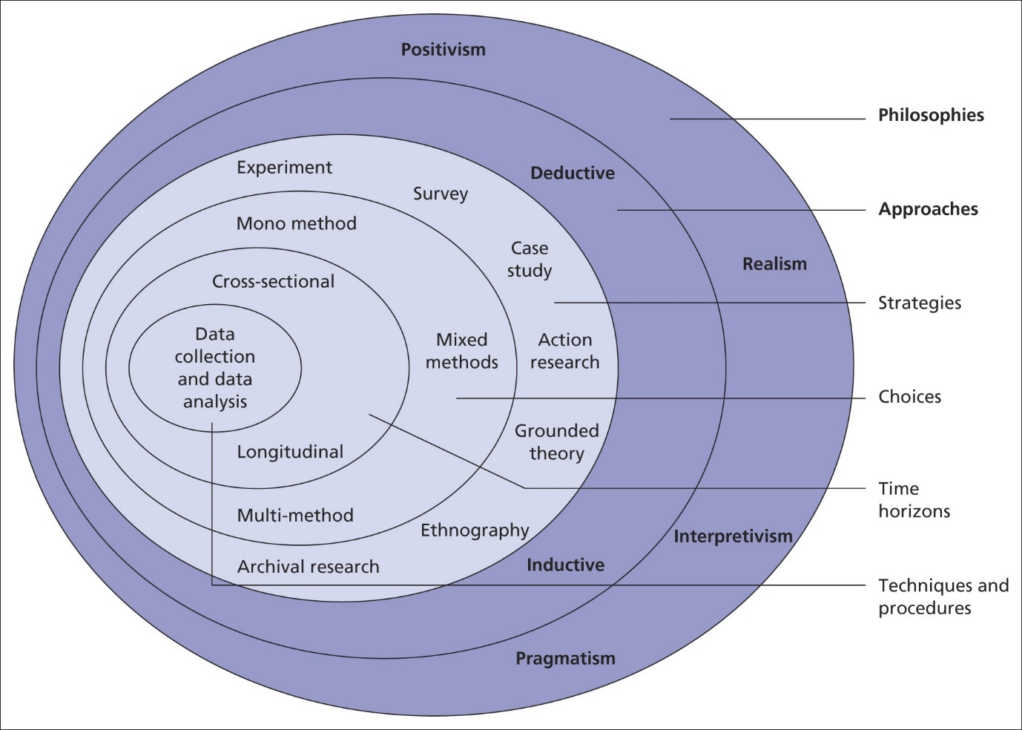
Figure 2: Research Onion
(Source: Saunders et al., 2007)

Research Strategy
A survey strategy will be utilised in the study to effectively analyse information that will be collected directly from primary sources. This will be adopted as the research strategy as it will help in acquiring information that is authentic and reliable (Morgan et al., 2019). Furthermore, a case study strategy will be adopted in evaluating secondary information gathered through subsidiary sources. It helps in the formulation of a proper relationship between the phenomena and context. Moreover, it also facilitates the gathering of data from a wide range of data.

Research Techniques
Two techniques can be followed while completing a research study namely, qualitative and quantitative. Qualitative techniques refer to market research techniques that involve various open-ended conversations and communication methods (Mezmir, 2020). This will be adopted to evaluate secondary data that will be collected through case studies and other subsidiary sources. Moreover, quantitative techniques are research methods that include gathering and evaluating numerical and statistical data (Sürücü and MASLAKÇI, 2020). This will be utilised in analysing primary data acquired through surveys in an objective, clear and transparent way.

Sampling Methods and Types
Sampling is a method that is included in the research process by selecting a subset of the larger population in the interest of the study (Campbell et al., 2020). Herein, various sampling techniques are present namely, simple random sampling, clustered sampling, systematic sampling and others. The study will be completed suiting utilising probability-based simple random sampling method. This reduces any bias in the selection of participants and aids in implementing fair and transparent results. Moreover, the study will consider a sample size of 20 customers at Dior.

Data collection methods
Primary and Secondary methods are the two most common procedures adopted in gathering information on various topics. Primary data collection refers to the collection of data from the original source of the information directly (Ruggiano and Perry, 2019). This can be collected through various methods such as surveys, interviews and others. Questionnaire will be included in this study as it has greater potential in collecting data from large number of participants. Secondary data collection includes acquiring data and information from sources that are not the original source or actual users of the information. It majorly includes subsidiary sources such as articles, books, reputed websites and others (Ruggiano and Perry, 2019). Google scholar, company website and social media page can be the idea sources to collect such data. This will help in evaluating a broad topic such as the effect of social media marketing.

Analysis of the Data
The primary data will be analysed through the usage of frequency distribution tables and pie charts. Additionally, secondary data will be analysed through the creation of a thematic analysis table. This will be done by utilising Excel and Microsoft Word respectively. Frequency distribution tables and pie charts will be utilised as it helps in properly visualising the opinions of various consumers and thematic analysis will be executed as it will help in gathering different perspectives of different authors on the connection between social media marketing and organisational success.

Research Ethics and Privacy
To maintain the ethical aspects of the study, certain measures will be included, some of which have been elaborated in this section. Primarily, it will be ensured that the participants of the study are not harmed in any way. Additionally, the study will aim to protect the data that has been acquired from the participants while ensuring that all the provisions of the Data Protection Act 2018 are followed in acquiring the data. To ensure ethicality in secondary data, factual information will be provided which are updated. All the information from scholarly articles will have open access to pdfs.

Research Expenditure
Activities | Allocated Budget (£)
Identification of an area of interest and selection of topic for evaluation. | 4
Accessing secondary sources | 10
Indirect costs for conducting primary research | 10
Data analysis process and data management involving soft and hard copies | 6
Total | 30
Table 1: Budgetary Forecasts
(Source: Created by the learner)

Resources and Planning
Name | Start Date | Duration | End Date
Choosing a topic | 9/5/23 | 10 | 19/5/23
Preliminary, reading literature | 19/5/23 | 5 | 24/5/23
Writing Proposal | 24/5/23 | 15 | 8/6/23
Literature Review | 8/6/23 | 17 | 25/6/23
Selecting methodology | 25/6/23 | 12 | 7/7/23
Executing Secondary research | 7/7/23 | 10 | 17/7/23
Completing Data Analysis | 17/7/23 | 16 | 2/8/23
Findings and interpretation | 2/8/23 | 10 | 12/8/23
Providing conclusions and recommendations | 12/8/23 | 3 | 15/8/23
Submitting the dissertation | 15/8/23 | 1 | 16/8/23
Figure 3: Work breakdown structure

Figure 4: Timeline
(Source: Created by the learner)

References and Bibliography
Campbell, S., Greenwood, M., Prior, S., Shearer, T., Walkem, K., Young, S., Bywaters, D. and Walker, K. (2020) Purposive sampling: complex or simple? Research case examples. Journal of research in Nursing, 25(8), pp.652-661.
Casula, M., Rangarajan, N. and Shields, P. (2021) The potential of working hypotheses for deductive exploratory research. Quality & Quantity, 55(5), pp.1703-1725.
Gkikas, D.C., Tzafilkou, K., Theodoridis, P.K., Garmpis, A. and Gkikas, M.C. (2022) How do text characteristics impact user engagement in social media posts: Modeling content readability, length, and hashtags number in Facebook. International Journal of Information Management Data Insights, 2(1), p.100067.
Jacobson, J., Gruzd, A. and Hernández-García, Á. (2020) Social media marketing: Who is watching the watchers?. Journal of retailing and consumer services, 53, p.101774.
Manjur, R. (2021) Dior faces criticism in China for 'smear' of Chinese women and culture Available at: https://www.marketing-interactive.com/dior-faces-criticism-in-china-for-smear-of-chinese-women-and-culture (Accessed: 9 May 2023)
Mason, A.N., Narcum, J. and Mason, K. (2021) Social media marketing gains importance after Covid-19. Cogent Business & Management, 8(1), p.1870797.
Mehta, S. (2020) Localization, diversification and heterogeneity: Understanding the linguistic and cultural logics of Indian new media. International Journal of Cultural Studies, 23(1), pp.102-120.
Mezmir, E.A. (2020) Qualitative data analysis: An overview of data reduction, data display, and interpretation. Research on humanities and social sciences, 10(21), pp.15-27.
Morgan, N.A., Whitler, K.A., Feng, H. and Chari, S. (2019) Research in marketing strategy. Journal of the Academy of Marketing Science, 47, pp.4-29.
Mumtaz, R. (2019) Awareness and perspectives social media as new strategic marketing approach in minor industries; notion grounded on AIDA model. Journal of Content, Community Communication, 10.
Ruggiano, N. and Perry, T.E. (2019) Conducting secondary analysis of qualitative data: Should we, can we, and how?. Qualitative Social Work, 18(1), pp.81-97.
Saunders, M., Lewis, P.H.I.L.I.P. and Thornhill, A.D.R.I.A.N. (2007) Research methods. Business Students 4th edition Pearson Education Limited, England, 6(3), pp.1-268.
Savitri, C., Hurriyati, R., Wibowo, L. and Hendrayati, H. (2022) The role of social media marketing and brand image on smartphone purchase intention. International Journal of Data and Network Science, 6(1), pp.185-192.
Sürücü, L. and MASLAKÇI, A. (2020) Validity and reliability in quantitative research. Business & Management Studies: An International Journal, 8(3), pp.2694-2726.
Trisnayanti, N.M.A., Sudiarta, M. and Puspita, N.P.L.A. (2022) Application of Digital Marketing in Increasing Brand Awareness With The Concept of Aida at Movenpick Resort & Spa Jimbaran Bali. Repositori Politeknik Negeri Bali.
Vasconcellos-Silva, P.R. (2023) The consumerism of misinformation in health: the abject objects of desire. Ciência & Saúde Coletiva, 28, pp.1125-1130.
Wang, F. (2023) China: Dior accused of racism over 'pulled eye' advertisement Available at: https://www.bbc.com/news/world-asia-china-65229901 (Accessed: 9 May 2023)
Wibowo, A., Chen, S.C., Wiangin, U., Ma, Y. and Ruangkanjanases, A. (2020) Customer behavior as an outcome of social media marketing: The role of social media marketing activity and customer experience. Sustainability, 13(1), p.189.
Zollo, L., Filieri, R., Rialti, R. and Yoon, S. (2020) Unpacking the relationship between social media marketing and brand equity: The mediating role of consumers’ benefits and experience. Journal of Business research, 117, pp.256-267.

