
Skills for the Workplace
Module Assignment Submission
Student Name: | Yahea Hassan
Student Number: | 1811554
Module No: | BMSK 6001
Module Title: | BMSK6001 Emergent Leadership Skills  for the Workplace

Statement of Confirmation of Authenticity
By the act of making this submission, the student declares that this is the work of the student named above. The work has not, in whole or in part, been knowingly presented elsewhere for assessment, or where assessment has been built on a previous assessment, this has been identified. Where materials have been used from other sources it has been properly acknowledged. If this statement is untrue, the student acknowledges that an assessment offence has been committed.
Attention is drawn to the plagiarism and unfair practice policies of both the University and of ILM.

Executive Summary
To be successful in the market, every organization must satisfy a set of shared aims and objectives. And leaders are the pioneers who encourage and motivate workers to accomplish such organizational goals. To achieve the greatest leadership practice, a leader must employ a variety of leadership styles dependent on the scenario and individuals targeted. An effective leader may foster a good work atmosphere in which every employee has the same team spirit in order to work for the company's benefit. Moreover, leaders are the foundation of an organization, creating a motivated work environment in which all employees share the same values and collaborate to achieve the overall organizational goals. In this case, the situational leadership model is most suited for leaders who must interact with diverse groups of individuals in a variety of settings.

Table of Contents
Question 1: 4
Evaluate own ability to use a range of leadership styles in different situations and with different types of people, to fulfil the leadership role. 4
Question 2: 8
Critically assess a recognised leadership model or theory in relation to its ability to impact on individual’s workplace performance. 8
Question 3: 14
Assess your own ability to set direction, motivate, delegate and empower others to bring about a workplace change. 14
Reference 20
Appendices 23
Appendix A – Situational Leadership Model 23
Appendix B – Motivation model 25
Appendix C – Delegation model 26

Introduction
This assignment composes of certain areas related to emergent leadership skills. The writing has been separated in accordance with three separate tasks or questions. The first question addresses the personal abilities and characteristics that need to be exhibited to fulfil the roles of leadership styles, bases upon expected circumstances and situation one can find himself in. The application of these styles has also been included. Following on from this a recognised model of leadership known as the situational leadership model has been critically assessed for the purpose of identifying the implication practicing this model would have on the overall workplace performance of individuals. Finally, before concluding this assignment, my own personal ability of executing certain skills and elements of leadership such as direction, motivation, empowerment and delegations have been addressed in relation to how such actions could ensure a positive workplace change.

Question 1:

Evaluate own ability to use a range of leadership styles in different situations and with different types of people, to fulfil the leadership role.

Every organisation has a set of common goals and objectives to meet to be successful in the market. And leaders are the pioneers who empower the employees and motivate them to achieve such organisational goals (Botting, 2021). However, Hyperlink InfoSystem is currently the number one app developing IT company in the United Kingdom. The company was first founded in 2011 by Harnil Oza who had the courage and passion to make this company the number one leading IT company in the market. Through his motivated and determined effort his was able to establish the company into the market and ensure that he was successfully progressing towards reaching his goal of becoming a renowned app developer in the United Kingdom. Since then, he was the owner and the leader of a three men’s team. He successfully motivated them being the best version of themselves and soon started to flourish in the market. Now Hyperlink InfoSystem has over 350 motivated employees working for them. The leaders of Hyperlink InfoSystem still follows the best leadership styles and theories to fulfil their leadership roles and responsibilities (Paal et al., 2018). This leadership quality of Hyperlink InfoSystem has created a motivated work environment for the employees where they can give their best performance to successfully achieve the organisational goals. From this it can be identified how vital the leaders are and the styles that they adopt on the overall productivity and performance of a workplace as well as the work ethic displayed by the employees. Determined and motivated employees are often driven by the influence gained by the leadership role models. So, to ensure the best leadership practice, I must apply different leadership styles based on the situation and targeted people. These leadership styles define how the core roles and responsibilities of an efficient leader will be achieved.
Roles of an efficient leader
An efficient leader can create a positive environment in the workplace where every employee has the same team spirit to work for the betterment of the company. A leader is the role model for the employees in an organisation (Botting, 2021). For this the leader should be a self-motivated person with an optimistic mindset who inspire their followers and shares the same value with them. A leader does not order around the employees, rather leaders build up their confidence and empower them to bring the best out of the employees. Also, a leader maintains transparency, follows the team approach, and leads them through examples. A leader is always there to listen, help and support his or her followers. In Hyperlink InfoSystem, the founder Harnil Oza maintained his roles and responsibilities as a great leader from the beginning. He started this company with 3 other talented employees. Because of the leadership quality of Harnil Oza, he managed to keep motivating his three employees and shared his vision with them. So, the employees always worked as its their company which helped them boost up their self-confidence and eventually, they managed to shine brighter in the long run. So, because of the successful leadership style and approach of Harnil Oza, Hyperlink InfoSystem is now the number one IT company in the United Kingdom (Paal et al., 2018). I have to play a key role in the overall success of the company, providing the direction and pathway which employees need to take. By demonstrating and showing a positive pathway for employees and providing them with the guidance that they need to follow a certain pathway, is what enables employees to be successful and achieve the desired outcomes and objectives a company anticipate on achieving.
Different Leadership styles to fulfil the leadership role
Different leadership styles determine the behaviour pattern of a leader. According to Blanchard and Hersey’s Situational leadership model, efficient leaders use two types of behaviour. One “Directive” and another one is “Supportive” (Alvehus, 2018). These two types are further categorised into four distinct leadership styles that varies according to the situation and people related to it. How I apply these leadership styles in different situations are as follows.
- Directing
Directing leadership style follows a one-way communication between the leader and the employees. In this type only I will have the authority to make decisions and setting goals for the company (Peck, 2018). So, as a Leader, I will give full instructions and direction to the employees about the details of the task. In this style, the employees do not have any freedom to make decisions, they only must follow what I will say as their leader. Then I have to monitor their performance and ensure the success of the task. Directing leaders are in control of everything that takes place in the workplace, and deviations from the expectations and objectives of the leader is seen as failure or incompletion of tasks. Satisfaction or completion of tasks can only be understood from the approval of the leader after monitoring and assessing the actions of the workers.
Application in an organisation
Directing leadership style is important in a crucial situation where the decisions are sensitive and extremely delicate. Also, this style is ideal when I need to make an ethical and moral decisions in the company. In case of Hyperlink InfoSystem, the leader and founder Harnil Oza, followed this style when the company was in the development stage. As an efficient leader, he instructed his three men’s team to ensure the success rate of primary tasks (Cardno, 2015). Because, in the early stage of a company, the decision-making process is delicate as it determines how the company can survive in the market and grow in the long run, making this type of leadership style appropriate and applicable. Therefore, even though this type of leadership may seem strict and stern and not appropriate towards motivating staff and developing trusting relationships with them, this leadership is effective as seen in the case of Hyperlink InfoSystem as the decision – making process being very sensitive means that the impact on the entire company is great. Therefore, this type of leadership was most effective in this case and suitable.
- Coaching
Coaching leadership style is slightly more flexible than the directing leadership style. It allows the employee to participate and be involved in determining the process of the task to be done. In this style, I will describe the task details and give employees the instructions of successfully doing the task. Although the final decision will be made by me as their leader, the employee can also actively participate in the process (Nicholls, 2015). So, it develops a two-way communication between me and the employees in a company. As a result, this leadership style reflects both directive and supportive behaviour about how the tasks will be done.
Application in an organisation
Coaching leadership style is the most effective when a company is in the development stage. In this stage, its very crucial for me to continuously motivate their employees to keep focused on the goals. By efficiently coaching the workforce, I can bring out the best performance of them (McFarland, 2014). For example, in Hyperlink InfoSystem, the organisation follows a two-way communication system. I will make sure that their talented workforce is actively participating in the planning process. This ensures a confident work environment where employees and leaders trust each other and have the same objectives to achieve.
- Supporting
Supporting leadership style appreciates a two-way communication so that the employees feel comfortable and valued as a part of the company. In this leadership style, I will state the final goals that they need to meet. Then the employees will have the right to develop an action plan under the supervision of the leader (Covey, 1999). Here, I will encourage them to be confident in themselves and take the best decision to achieve the goals. This way I can act more friendly and supportive in this leadership style.
Application in an organisation
Supporting leadership style is the best when I have already created a great work environment where people are self-motivated to work, they are valued, confident and consider the company as their own so they give their best effort to make it better. On the other hand, if the work environment is not pre organised and the employees do not share the same values, then a supporting leadership style will create an imbalance situation in the workplace (Carroll, 2015). For example, the leader and owner of the Hyperlink InfoSystem has ensured a well-trained workforce first, then created a great working environment so that their employees are always motivated to innovate new technologies and ideas. By supporting leadership style, the leader transfers authority to their valued and trusted employees because he believes that they are well efficient with necessary information and genuinely care about the betterment of the company. So, they give their best performance under such efficient supporting leadership style.
- Delegating
Delegating leadership style is when I delegate decision-making to the employees. This style is typically utilized when workers are much more knowledgeable about the issue than the leader. So, they can evaluate the problem and devise a strategy for what needs to be changed. In this method, I must still assign duties. This method is only recommended when I have total faith in his employees' abilities.
Application in an organisation
Delegating leadership style is the most suitable for highly successful businesses where the foundation is strong and the employees are well trained about their tasks (Stenmark and Mumford, 2011). Only in this situation I can fully trust them and assign them tasks. I will have the total authority to make decisions and innovate the best possible way to do the task. But they also will be responsible for their work. For example, after Hyperlink InfoSystem had become the market leader in the UK’s IT industry, the company started following the delegating leadership style. Their leader believed in his employees’ efficiency to innovate new technologies according to the company’s overall goals.

Question 2:

Critically assess a recognised leadership model or theory in relation to its ability to impact on individual’s workplace performance.

Leaders are the pillar of an organisation who creates a motivated work environment where all the employees share the same values and work together to achieve the overall organisational goals (Gill, 2009). To ensure the best outcome, the leader should be a self-motivated enthusiastic person with an optimistic mentality who inspires his followers and has the same values as them. A leader does not order around the employees; rather, leaders develop their confidence and empower them to bring out the best in the workforce. A leader also preserves openness, commits to the team approach, and leads by example. A leader is constantly there to listen, assist, and support his or her people. These are the common characteristics and behaviour of a great leader. Different leadership models explain the specific leadership traits according to the situation and the people. Among various models, Situational Leadership Model is one of the most used models for organisations like Hyperlink InfoSystem that need to manage a motivated workforce.
Situational Leadership Model
Situational leadership model is the most suitable for leaders who need to work with different group of people in any kind of situations. This model was developed by Paul Hersey and Ken Blanchard in 1969. After some more research, Hersey and Blanchard developed their own version of this model (Jackson and Parry, 2011). The Hersey version is called Situational Leadership Model and the Blanchard version is called Situational Leadership II Model. According to this model, there are four different leadership styles which are – Delegating, Supporting, Coaching and Directing. And four different level of maturity which indicates a particular situation and the ideal style for that situation (Kippenberger, 2002). This model is highly recommended in organisational leadership training and development. The leaders use this model after evaluating their employees and then decide the right person for the right task. The model includes two types of behavioural pattern, directive and supportive. Directive pattern supports the one-way communication method where supportive patterns work on a two-way communication method. However, a good example of Situational leadership model is portrayed in Hyperlink InfoSystem as they grew from a SME to the number one leading IT company in UK. Here, the situational model is explained as follows.
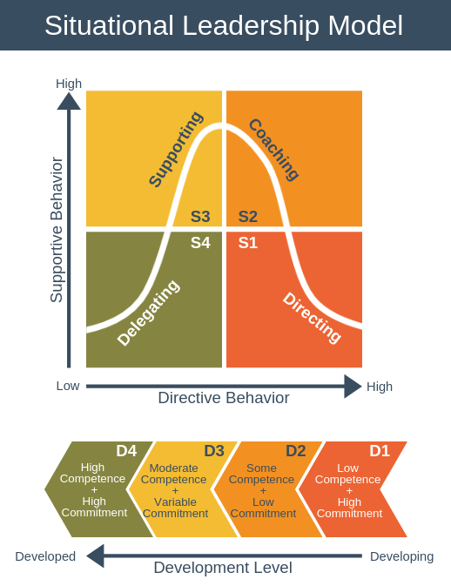
Figure 1 - Situational Leadership Model; (Blanchard, 2012)
- The following Situational Leadership Model demonstrate the framework that helps the leader to understand the situation and then determine the most suitable leadership style according to the situation.
- Here, the X axis designates the level of “Directive behaviour”. This indicates how the leader passes directions and instructions to their employees. Before doing this, the leaders first evaluate their employees’ capabilities and performance and then access the details of the task to determine the right employee for the right job. The greater the direction, the less capable the employees are of making independent judgments about the task (Alvesson, 2017).
- And, the y-axis represents the leader's level of supporting conduct. That is, the quantity of assistance they provide to their employees. The higher the level of support, and the more the leader assists their team in making decisions and doing their duties.
- Development level indicates how skilled or motivated the employees are. This shows their competency and commitment level in the company. From D1 to D4 the flow chart indicates a developing workforce as D1, to the most developed workforce as D4 (Mewton, 2015, pp.14).
The four types of Leadership style according to Situational approach
According to the Situational Leadership Model, there are four type of leadership styles. As the Figure – 1 show, S1 Directing Style, S2 Coaching Style, S3 Supporting Style and S4 Delegating Style. Here is the analysis of these four-leadership style and how it is applied in different situations.
S1 – Directing Style
A directive leadership style is characterized by one-way communication between the leader and the workforce. Only leaders of this kind have the authority to make decisions and define goals for the organization (EL-Annan, 2015, pp.8). The leader will provide detailed instructions and direction to the staff on the intricacies of the assignment. Employees in this manner have no decision-making authority and must just obey what their supervisor says. The task's success is ensured by the leader's monitoring of their work. In a critical scenario where judgments are sensitive and highly delicate, a commanding leadership style is essential. This method is also appropriate when the leader must make an ethical and moral judgment of the company.
S2 – Coaching Style
Coaching leadership is more adaptable than commanding leadership. It enables the employee to participate in determining the method of the work to be completed. In this method, the leader will discuss the work details and provide employees with guidance on how to do the assignment properly (Fernandez and Vecchio, 2017, pp.67). Although the leader will make the final choice, the employee can actively engage in the process. As a result, it fosters a two-way interaction between a company's CEO and its workforce. As a result, this leadership style exhibits both directive and supporting behaviour over how responsibilities will be completed. When a firm is in its early stages, a coaching leadership style is most successful (Grossman and Sharf, 2018, pp.114). It is critical for leaders to continually inspire their staff to remain motivated on the targets at this level. True leaders can play a huge part in bringing the best out of their employees by effectively mentoring them.
S3 – Supporting Style
A supportive leadership style values a two-way communication so that employees feel at ease and appreciated as members of the organization. The leader will outline the end targets that they must accomplish in this leadership style. The workers will then have the authority to create an action plan under the supervision of the leader (Grossman and Sharf, 2018, pp.114). The leader will inspire people to believe in themselves and make the best decisions possible to attain the goals. In this leadership style, leaders act friendlier and supportively. When a leader has already built a fantastic work atmosphere where employees are self-motivated to work, they are respected, confident, and believe the firm to be their own, they will give their all to make it better.
S4 – Delegating Style
When a leader uses a delegating leadership style, he or she delegated decision-making to staff. This technique is often used when employees are far more informed about the subject than the boss. As a result, they can assess the issue and create a strategy for what has to be addressed. Even if the worker makes the decision, this is still the leader's responsibility to supervise their every move. The leader must still allocate duties in this way. This technique is only suggested when the leader has complete trust in the skills of his staff. Delegating leadership is best suited for extremely successful organizations with a stable platform and workers who are well-trained in their roles (McFarland, 2014). They have complete authority to make judgments and devise the best approach to complete the assignment. They will, however, be held accountable for their job.
The Four Level of Employee Development
The four level of Employee development reflects how skilled or motivated they are. This demonstrates their competence and devotion to the organization, Hyperlink InfoSystem. Here are the Description of four level of development.
D1 – Enthusiastic beginner
When the employees are not properly skilled but they are highly committed to the company. Although they lack the required skills, they are the most enthusiastic and eager to grow. So, this approach is most suitable when a company needs to get the work done at development stage. For example, Hyperlink InfoSystem’s initial three employees were at this level (Yan, 2011, pp.18).
D2 - Disillusioned learner
When the employees have the primary skills but lack the commitment to the company, they are considered as disillusioned learner. The employees may have the necessary abilities but are hesitant or lack confidence to do the work. They might be unfamiliar with the work or circumstance (Alvehus, 2018, pp.535). For example, as Hyperlink InfoSystem grew in some years, they have reached their employees at level 2.
D3 - Capable but cautious worker
When the employees are more capable and more skilled than level D2, but they are not motivated enough to be dedicated to the company. To get the best result out of them, a leader should play the supportive role to understand their psychology and works on their motivation factors.
D4 - self-reliant achiever
When the employees are highly skilled and efficient and at the same time, they are fully committed to the company, they are considered as self-reliant achievers. They are highly confident and capable of doing a task on their own. They are also responsible for any outcomes (McFarland, 2014). This is the developed stage and delegating style is the most appropriate leadership style for this type of people. For example, as Hyperlink InfoSystem became the market leader and number one IT company in UK, they follow the delegating leadership style for their level D4 employees.
Connecting Leadership Style to Development Level
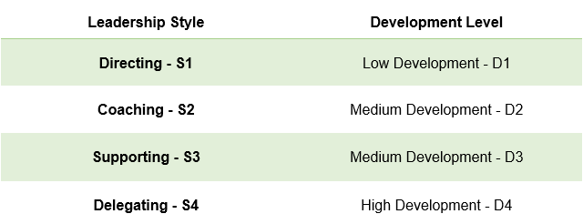
Figure 2 - Connecting leadership style to development level; (Self-made)

Advantage and Disadvantages of Situational Model Leadership in an organisation
The main advantages of Situational Model Leadership in an organisation like Hyperlink InfoSystem is that this model is very easy to apply. It connects with the people according to the situation. It delivers four type of leadership style for the leaders to use which one they feel appropriate to get the highest possible outcome (Yan, 2011, pp.18). But it also has some disadvantages. This model is ideal for short term situation analysis, it is not suitable for long term leadership style. To apply this model the given situation should be analysed in details, otherwise the model may fail to provide successful outcomes.

Question 3:

Assess your own ability to set direction, motivate, delegate and empower others to bring about a workplace change.
The ability to set a positive change in a workplace depends on the key aspects of setting direction, motivating others, delegating and empowering others. However, it is easier said than done. All of these topics are interconnected. Only setting the direction and not motivating rightly or not empowering others seldom shows expected result of a positive change in the workplace. Assessing the ability to motivate others can be biased for a lot of reasons for me. The ability of truly setting direction and motivating others is a powerful characteristic trait for me to master. Empowering others can truly empower me and also help the organisation overall.
Setting Direction
Research shows that human resource always follows the direction set by the leader figure, not the direction written in the papers (Grossman and Sharf, 2018, pp.114). The information from Hyperlink InfoSystem positively corelates with the research. Harnil Oza set the direction for the organisation in every turn. The workplace change can be derived from the direction of a leader. I try to portray a positive direction to being more workaholic, and focus on deadline. To bring change to the workplace the direction could be set with different tools.
The written directions are the seen indicators for setting the direction for me. For example, mission, vision and goal statement of the organisation. Such as, Hyperlink’s mission is to believe in what the client believes in. Doing so Hyperlink tries to deliver the best tech solution. However, this behaviour also resembles the characteristics of Harnil Oza. Peers suggest that whenever Harnil Oza is in a meeting with a client he always shows utmost respect towards the views of the client. And tries to provide the best tech solution in his power. This portrays the role of a leader in setting and maintaining the direction for any organisation. I always try to focus on the work ethic and time management when doing, or delivering my own work.
Identity, values, beliefs and process of completion could be identified as unseen indicators to set direction. Research suggests that the identity, values and beliefs of the leader always affects the overall culture and individual action of any employee (Fernandez and Vecchio, 2017, pp.67). The employees’ beliefs and values go on to represent the beliefs and values of the leader. I believe loving what you do is the first and most important part of doing a good job. I try to portray this belief on my team and this bought a positive change among the overall team. As a result, my team is known to do the job from their heart, not only with their brain. However, setting the perfect direction can be crucial.
Motivation
Extrinsic motivation comes from outside. Example of extrinsic motivation is the outcome of any job. For example, salary is an extrinsic motivation. This is a reward driven behaviour (Kouzes and Posner, 2012). However, to truly motivate someone extrinsic motivation needs to turn to intrinsic motivation. Intrinsic motivation comes from within the individual. Intrinsic motivation helps to do specific acts without any obvious external incentive (Stenmark and Mumford, 2011). Intrinsic motivation can be love towards the doing the task or enjoyment felt while doing the job. Another example of intrinsic motivation can be reading a book because someone enjoys reading. As a leader, I need to be aware of these motivational differences and have a clear knowledge about how individuals perceive intrinsic and extrinsic motivation. The model of high performance shows that extrinsic and intrinsic motivation results in a better performance.
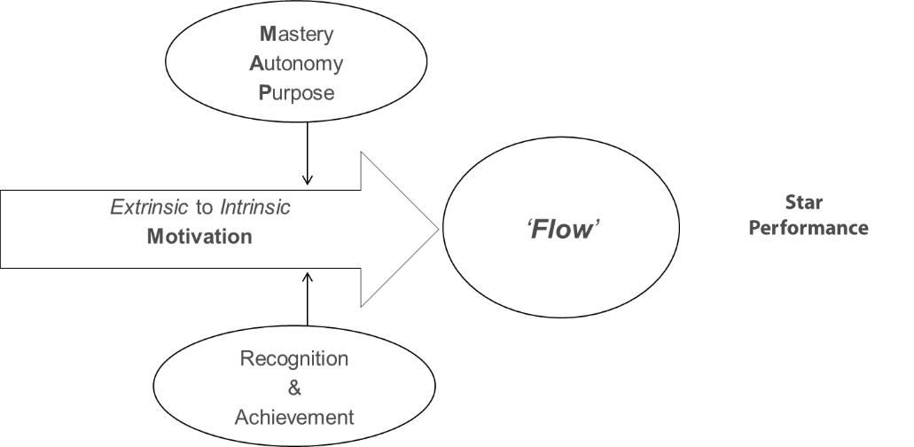
Figure 3: High performance model; (AH Raymondson, 2018).
The role design for motivation on the other hand, helps me to show an automatic way to motivate employees. The systematic and deliberate distribution of work to groups and people within an organization is characterized as Job Design (Cardno, 2015, pp.117). Moreover, this is considered to be a psychological theory of motivation. The role design suggests that role engagement, role enrichment and role rotation ultimately aid the empowerment of the employee. This overall motivates the individual to perform better and stay motivated for a longer time period.

Figure 4: Role design for motivation; (AH Raymondson, 2018).
Overall, to increase my own ability to motivate others in the workplace I tried to implement these theories into practice. A significant change that I faced in the workplace was when my team was motivated to work on off days. This was the result of intrinsic motivation, role enrichment and empowerment (Yan, 2011, pp.18). They felt the development of the organisation was their development. This thought process helped them consider the opportunity cost of working in a holiday.
Empowerment
Empowering the workforce is a core quality of an efficient leader. A true leader doesn’t order his employees around, rather he gives them the opportunity to learn skills and new techniques. Empowering employees motivates them to be better in every task given. Empowerment makes the employees feel valued and pushes their morals (Grossman and Sharf, 2018, pp.114). So, the employees perform better by developing their skills for the betterment of the company. Empowerment is also linked to delegation and development which can be followed by an efficient leader.
In a workplace, employee empowerment can provide such trust and sense of responsibility in the whole workforce. When the employees are given power and being valued, they feel they are not the employees but they are the part of the company. So, they become more responsible doing what will be the best for the company. In an organisation that empowers its employees are more likely to the extra mile than the other companies cannot (Fernandez and Vecchio, 2017, pp.67). Also, the productivity and efficiency level will rise as they will work as a team with good communication.
So, to empower the employees in an organisation, I have to transfer the authority and dividing responsibility among the employees. Then, I should train them with best practices and guide them all the way. This way the employees will feel more supported and they can plan their own development with the company (Cardno, 2015, pp.117). By, encouraging communication and providing them all the opportunity for their growth will ensure best empowerment in the workplace. For example, the front leaders of Hyperlink InfoSystem follow delegating leadership style where the leaders completely trust their employees and gives them the power to make decisions of how the task will be done.
Delegation
Great leaders always create a motivated work environment where the employees are empowered to make their own decisions to complete a task successfully. The leaders understand how to empower their employees to complete tasks. But it's not only about getting the work done or understanding what to do to delegate duties effectively (Nicholls, 2015, pp.5). It is also about establishing an environment where employees are satisfied with the job and can claim ownership of it. These are the essential components of understanding how to properly distribute tasks.
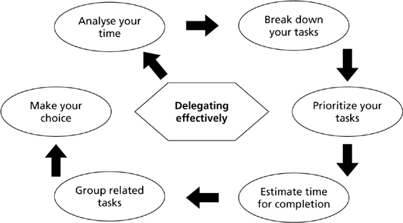
Figure 5 - Delegating effectively; (Management Skills, 2020)
In an organisation like Hyperlink InfoSystem, the best practice of delegation is “Stewardship Delegation” which focuses on the outcome. By following the 5 aspects of Stewardship delegation, a company can boost up the efficiency level of the employees.

Figure 6 - Stewardship Delegation; (Self-made)

Desired results – This delegation is concerned with outcomes rather than procedures.
Guidelines – Guidelines are accurate ideas that are frequently summarized in the form of standardised processes.
Resources – Identify the available resources that can be used to achieve the goals.
Accountability – Accountability is essential for delegation of stewardship. People are set free and feel a sense of duty to do whatever is necessary to achieve the goals.
Consequences – Consequences might be expressed in terms of monetary or psychological incentives, such as recognition, admiration, advancement, new tasks, or new chances for training and growth (West, 2015, p.25).
By ensuring the best practice of delegation I can lead the employees toward their best performance in the organisation.

Conclusion
To conclude, the overall assignment has addressed the three tasks and questions in relation to emergent leadership skills. Initially the leadership styles that could be demonstrated in a workplace environment, have been analysed with considerations of what situation such a style may be exhibited. The chosen organisation for this task was Hyperlink InfoSystem, for the purpose of showing which situations the type of leadership style was used by the leader of this organisation. The chosen leadership model for the next task was the situational leadership model. This model was analysed in respect to the impact it would have on the behaviour of individuals in the workplace. A personal view of abilities to perform leadership skills such as motivating, delegation, setting direction and empowerment was analysed.

Reference
“I Have a Dream Speech” Martin Luther King 1963 . https://youtu.be/yXyr95yfL3M
“The Blind Side” 2009 Sandra Bullock.
Alvehus, J., 2018. Emergent, distributed, and orchestrated: Understanding leadership through frame analysis. Leadership, 15(5), pp.535-554.
Alvesson, M., Blom, M. and Sveningsson, S., 2017. Reflexive Leadership. Los Angeles: Sage
Bennis, W. and Thomas, R., 2002. Geeks & Geezers: How Era, Values, And Defining Moments Shape Leaders. Harvard Business School Press.
Botting, R., Ribbe Jr., R. and Robinson, G., 2021. Assessing the Impact of Summer Camp Employment on the Development of Workplace Skills. Journal of Outdoor Recreation, Education, and Leadership,.
Bush, T., 2008. Leadership And Management Development In Education. Los Angeles, CA: SAGE Publication.
Cardno, C., 2015. Diversity, Dilemmas and Defensiveness: leadership challenges in staff appraisal contexts. School Organisation, 15(2), pp.117-131.
Carroll, B., Ford, J. and Taylor, S., 2015. Leadership. Los Angeles. SAGE Publications
Covey, S. (1999) The seven habits of highly effective people. London, UK; Simon & Schuster UK Ltd
Dymock, D., 2016. Identifying emergent challenges. Journal of Workplace Learning, 18(2).
EL-Annan, S., 2015. The Relationship between Project Manager Skills and Leadership Skills in the Workplace. British Journal of Economics, Management & Trade, 8(1), pp.8-18.
Fernandez, C. and Vecchio, R., 2017. Situational leadership theory revisited: A test of an across-jobs perspective. The Leadership Quarterly, 8(1), pp.67-84.
Gill, R., 2009. Theory And Practice Of Leadership. London: Sage publications.
Grossman, G. and Sharf, R., 2018. Situational Judgment Tests and Transformational Leadership: An Examination of the Decisions, Leadership, and Experience in Undergraduate Leadership Development. Journal of Leadership Education, 17(1), pp.114-131.
Jackson, B. and Parry, K., 2011. A Very Short, Fairly Interesting And Reasonably Cheap Book About Studying Leadership. Los Angeles: SAGE
Journal of Leadership, Accountability and Ethics, 2020. Situational Leadership and Leader Versatility. 17(3).
Kippenberger, T. 2002. Leadership Styles. Oxford. Capstone. (eBook dawsonera)
Kouzes, J. and Posner, B., 2012. The Leadership Challenge. San Francisco: The Leadership Challenge.
Maund, A. 2018. BA in Leadership & Management SfWP. Final Year. P.513-586
McFarland, V., 2014. Situational Leadership. SSRN Electronic Journal,.
Mewton, L., Ware, J. and Grantham, C., 2015. A question of leadership: Which skills and competencies will be most critical for leaders as the workplace continues to evolve?. Leadership in Action, 24(6), pp.14-15.
Mumford, M., Todd, E., Higgs, C. and McIntosh, T., 2017. Cognitive skills and leadership performance: The nine critical skills. The Leadership Quarterly, 28(1), pp.24-39.
Nicholls, J., 2015. A New Approach to Situational Leadership. Leadership & Organization Development Journal, 6(4), pp.2-7.
Paal, P., Neenan, K., Muldowney, Y., Brady, V. and Timmins, F., 2018. Spiritual leadership as an emergent solution to transform the healthcare workplace. Journal of Nursing Management, 26(4), pp.335-337.
Peck, A., 2018. Mapping Career-Ready Skills Through Student Leadership Programs. New Directions for Student Leadership, 2018(157), pp.71-83.
Sowcik, M., Wert, J. and Niewoehner-Green, J., 2018. The Leadership Skills Series: Utilizing Videos to Address Leadership Skills. EDIS, 2018(5).
Stenmark, C. and Mumford, M., 2011. Situational impacts on leader ethical decision-making. The Leadership Quarterly, 22(5), pp.942-955.
Twelve O' Clock High. 1990. [DVD, & VIDEO] Pinewood Studio's London: 20th Century Fox
West, M., Armit, K., Loewenthal, L., Eckert, R., West, T. and Lee, A. (2015) Leadership and Leadership Development in Healthcare: The Evidence Base. London, Faculty of Medical Leadership and Management, P.25
Yan, J., Rothwell, W. and Webster, L., 2011. Transferring the soft-skills technology of workplace learning and performance to China. Performance Improvement, 40(10), pp.18-23.

Appendices

Appendix A – Situational Leadership Model

Figure 5 - Situational Leadership Model; (Blanchard, 2012)

Figure 6 - Connecting leadership style to development level; (Self-made)

Appendix B – Motivation model

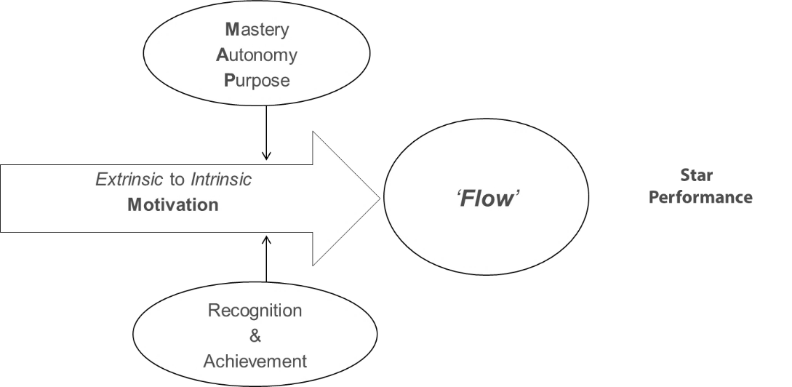
Figure 3: High performance model; (AH Raymondson, 2018).

Figure 4: Role design for motivation; (AH Raymondson, 2018).

Appendix C – Delegation model

Figure 5 - Delegating effectively; (Management Skills, 2020)

Figure 6 - Stewardship Delegation; (Self-made)
Appendix D- Leadership style questionnaire


