Shefa Rahman
1714270
Problem Solving and Decision Making
BMSK4004
Richard Small

Executive Summary
AMT Coffee is a UK based coffee chain that has operations in the UK and Ireland of the Europe. Recently the company has been facing a problem of declining market share and profitability due to the rising competition level among the competitors and the weak economic condition around the Europe. With the help of PESTEL and SWOT analysis, the mangers of AMT Coffee ltd. have come up with certain alternatives solutions of the problem such as increasing the investment in the R&D department, focus on the merger and acquisition with other companies in the industry, broadening the target audience in the market, and expanding the business in the foreign countries. The fishbone diagram of the company has been depicted to find out the sub problems of the major problem because the problem seems to sustain for a long period of time. The business of AMT Coffee Ltd. has been facing challenges in the market due to high level of competition and the marketing managers of the business are solving those problems.
Table of Contents
Introduction 4
Case summary and background of the company 4
Impacts and scope of the problem 4
Analysis of information regarding the problems for decision making process 5
Decreasing employee motivation 5
Lower budget in R&D 5
Weak strategies 6
Alternative solutions to the problem 6
Increasing investment in research and development 6
Vertical and horizontal integration 6
Increasing economies of scale and scope 7
Employees training program 7
Techniques for decision making 7
PESTEL analysis 7
SWOT analysis 9
Fishbone diagram and brainstorming for decision making 11
Implementation of the solutions 13
Communicating the solutions to stakeholders 14
To shareholders 15
To employees 15
To suppliers 15
To regulators 15
Monitoring and Review 15
Conclusion 17
References 18

Introduction
The business environment of competitive markets presents so many challenges for companies like AMT Coffee to do their day to the business in that particular environment. The following report is based on the case study about the problems and challenges that have been faced by AMT Coffee shop recently and the probable solutions of alternatives will be given in this report so that the company can come up with the best performance within the business regime in England and Ireland. AMT Coffee shop has been facing declining market share and revenue base from England and Ireland business operations because of the high competition in the market with major rivals like Starbucks and Costa coffee (Peeters and Blake, 2016).

Case summary and background of the company
AMT Coffee limited is a London based coffee chain which operates in England and Ireland. The company was founded in 1992 by Alistair McCallum and his two brothers. A empty coffee is a chain of coffee houses which are mainly diversified on airports, hospitals and railway stations. AMT Coffee shop is the first coffee House in the UK to use 100% bio-compostable lids and cups, 100 percent organic milk and 100 percent fair trade coffee (Sooktip and Wattanapongsakorn, 2015). The company is also accredited with fair tax payer and the ethical consumer named it the most ethical coffee shop in the UK. But recently the company has been facing the declining market share and declining revenue which are mainly triggered by high level of competition in the market from the biggest rivals in the UK. The company had an annual revenue of 26 million pounds in 2017 but the revenue decreased to 22 million pounds in 2018 which made the company tensed about that serious problem. So, the higher-level managers of AMT Coffee shop is trying to find the optimum solutions that will benefit the company to overcome the problems in a short period of time (Webster, 2002).

Impacts and scope of the problem
AMT Coffee limited is a very small size company which has only 50 bars and outlets around England and Ireland. As the declining market share and declining revenue are impeding the company to grow in the longer period of time. So, it is very problematic for the company because of the lower size and capital base (Peeters and Blake, 2016). The first and foremost impact of declining market share is declining the profit margin in future which makes the company very concerned about the long-term profitability and the preservation of capital. When a company is losing money to the competitors, it essentially signals that the company is giving the market share away to the competitors like Starbucks, Costa coffee and other Giants coffee chain in the world (von Hippel and von Krogh, 2013). As the capital base and asset base of the company are very low which are indicated by the size of the company, the declining revenue and profit margin are creating a big problem for the company because the stakeholders of the company are getting tensed and concerned day by day with the performance of the company in the market. So, the higher-level managers of AMT Coffee shop must layout some strategies that attract the customers to the company away from the rival companies in the market. The problem that AMT Coffee is as facing is really huge specially for small company like AMT Coffee LTD (Sooktip and Wattanapongsakorn, 2015).

Analysis of information regarding the problems for decision making process
There are certain issues that are obviously acting behind this major problem of AMT Coffee shop. The main issues that are creating the problem for AMT Coffee shop are discussed below shortly.

Decreasing employee motivation
It has been found that the employees of the company are so much demotivated because the environment of AMT Coffee shop is not that much good which makes the employees satisfied and motivated in the organization. Employee motivation and satisfaction are the main factors for a business to become a leader in the market because employees and managers are in the functioning region of the company which means that the overall business performance is basically dependent on the productivity and performance of the employees of AMT Coffee shop (Greenblum and Rowe, 2012).

Lower budget in R&D
Research and development department of a company is the key factor that triggers Innovation in the business. So, having a decent investment in research and development department is much needed for a company operating in business environment like beverages industries (von Hippel and von Krogh, 2013).

Weak strategies
To survive in the long run in any kind of business environment, the strategies that are taken by the businesses are the main factors in helping the businesses to survive in that competitive business environment for a longer period of time. AMT Coffee shop is proven to have weak strategies to attract the customers and beat the rivals in the market in an effective and efficient way which are causing the company to lose market share to the rivals (Greenblum and Rowe, 2012).

Alternative solutions to the problem
Every problem has some sort of solutions, so does the declining market share and revenue. AMT Coffee LTD. should consider the following alternative solutions of the problems to resolve the problem in a short period of time (Sooktip and Wattanapongsakorn, 2015).

Increasing investment in research and development
Every business needs to innovate something to offer to the market and attract new customers from the market so that they can survive and flourish in the long run otherwise no business can survive in the competitive business environment (Konigsberg, 2012). So, innovation can be driven by investing decent amount of money in research and development department so that the researchers and analysts of the department can use that extra money to bring innovations to the company which will ultimately set the company apart from the competitors and gain the market share from the competitors. If the competitors in the market are more innovative than the company itself, then it will be very difficult to survive in that kind of environment because the competitors will attract so many customers from the markets because of their innovative products and services. So, in that position being innovative is the only way to survive (Peeters and Blake, 2016).

Vertical and horizontal integration
Vertical integration means acquiring suppliers in the industry so that the continuous supply of raw materials can be and shield for AMT Coffee shop. If the suppliers have much bargaining power over the company itself then the vertical integration would be very helpful to boost the market share and revenue base by acquiring that supplier with the vertical integration mechanism. Horizontal integration means acquiring the same kind of business as in the market in a purpose to maximize the market share in the work environment of business so that the company can boost the revenue and profitability for the stockholders of the company and survive in the long run in that competitive business environment. For example, if AMT Coffee can take over some of the same businesses in the UK, they can be more powerful in the market to regain the market share and profitability (Greenblum and Rowe, 2012).

Increasing economies of scale and scope
Increasing economies of scale means increasing the production level to minimise the per unit cost of the products and services that are being offered to the market which will eventually reduce the production cost of the company and increases the profitability. Increasing the economies of scope means that the company is efficiently using the capacities of production in variant geographical locations so that the production cost of the overall production level can be reduced (Konigsberg, 2012).

Employees training program
Launching employee training program can be very helpful to resolve the problem by increasing the productivity of the employees so that they can understand the nature of the problems and bring solutions to the problems in a very efficient way. AMT Coffee should place the employees in a very high priority range to make them motivated and feel that they are the main reasons why the companies are getting so much success in the market (Peeters and Blake, 2016).

Techniques for decision making
When a company's managers are trying to solve a problem, they use different types of techniques to draw the decisions of how they will solve the specific problems that are bothering the business. Different techniques of solving problems and decision making are discussed below:

PESTEL analysis
PESEL analysis helps businesses to find the core factors of external environment that impact the businesses in them of doing business. PESTEL analysis considers the political, economic, social, technological, environment and legal and factors in the analysis which impact a business (Kampanje, 2012). The PESTEL analysis of empty coffee limited is given below:

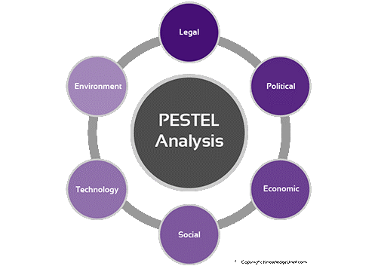
Figure: PESTEL analysis
Source: (Kbmanage, 2019)

Political Factors | Economic Factors
The income tax of UK from 2017 to 2018 was very high which made AMT Coffee limited increase the price of their offerings to the market. This increment in the sales price of the offerings caused the company to lose the market share as the customers purchase less with the increased price level. The stability of the rules and regulations for the business in the UK, political stability and other political issues impact the business of AMT Coffee (Yüksel, 2012). | The weak economy all around Europe caused the sales of the company to decrease and this condition continued all around Europe. The inflation rate and the unemployment rate all over the European countries increased over the last few decades which caused the customers in that continent to lower the purchasing power and which in turn caused the business sales to decline and market share also went down.
Social Factors | Technological Factors
The attitude of the people and the living standard of the people are increasing day by day. This trend is making the people not only desire for high quality coffee but also desiring for an environment that provides them relaxation and pleasure. The social thinking and culture also have impacts on the business of AMT Coffee. | With the advancement of technology, the business of AMT Coffee has been redefined and the operations of the business has been changed to cope up with the new technologies. Now the company is having the customer base by developing an app in iOS and Android operating system which makes the customers able to locate the outlets of AMT Coffee shops in the UK (Abdeldjebar, 2017).
Environmental Factors | Legal Factors
AMT Coffee has been using 100 percent environment friendly packaging and cups so that the environment remains green. Environmental factors make a company to define business in way that prevents the business from pollution and degrading. The extra focus on the environmental issues come out of extra cost of the company (Abdeldjebar, 2017). | The rules and regulations set by the government of the UK have to be strictly followed by AMT Coffee shop otherwise the company will be hugely penalized for violating the rules and regulations. The rules and regulations set by government indicate that the company has to provide an environment which is healthy and good for the employees. The company signed a contract with Food Standard Agency to make sure that the goods and services provided are healthy (Yüksel, 2012).

SWOT analysis
SWOT analysis is a very powerful tool for analysing the businesses’ internal and external factors that facilitate the business and the hamper the way of doing business in the context of that particular organization (Vaněk, Mikoláš and Žváková, 2012). The SWOT analysis of AMT Coffee LTD. is given below:

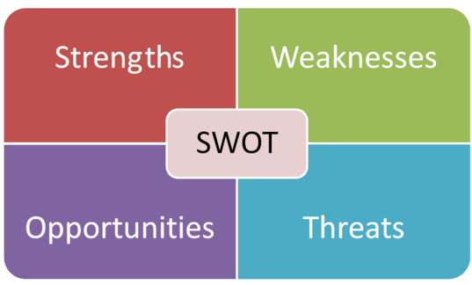
Figure: SWOT analysis
Source: (Kbmanage, 2019)
Strengths | Weaknesses
- The business of empty coffee is highly reputed for its quality coffee and services offered to the customers in the market  - The company has a strong brand name and brand visibility e across the UK and Ireland  - The company has white variant of products and services for the customers in the UK and Ireland  - The experience that a customer has with AMT Coffee is very high which makes the company able to retain the customers for a longer period of time (Mohammad Arabzad an, 2012) | - The marketing department of AMT Coffee has very inefficient marketing strategies  - The products and services of AMT Coffee is relatively costly compared to the competitors like Starbucks and Costa coffee.  - The competitive advantages that the company has over the competitors can be easily imitated by the new competitors in the market  - The revenue and sales of the company had been declining recently  - The company has operations only in two countries around the world (Kumar and M.S. Nain, 2011)
Opportunities | Threats
- The company has immense opportunities for broadening the target market by decreasing the price of the offerings of the company  - The company also has opportunities for merging with other coffee companies and also have opportunities for acquiring other small size companies in the same industry to have larger market share in the market  - the company also has the opportunities for continuous expansion of their operations in many countries in the Europe and America  - The company can develop more caffeine products in the market to attract new customer base for maximizing the revenue and market share (Kawai, 2017) | - The price of raw materials has been increasing day by day  - The competition among the competitors in the industry is getting stiff day by day  - As the people are getting concerned about their health day by day, drinking coffee is being perceived an unhealthy beverage continuously  - The flow of raw materials by the suppliers can be distracted easily if the production of coffee beans is disrupted in the exporting countries (Kawai, 2017)

Fishbone diagram and brainstorming for decision making
The fishbone diagram is a very powerful mechanism and to for identifying the core roots of a problem and what are the causes that attribute to the problem. Running a brainstorming session can be easily done with the help of fishbone diagram to find the reasons behind a problem for a longer period of time. The problem that has been faced by AMT Coffee limited is analysed with the help of fishbone diagram in the following discussion.

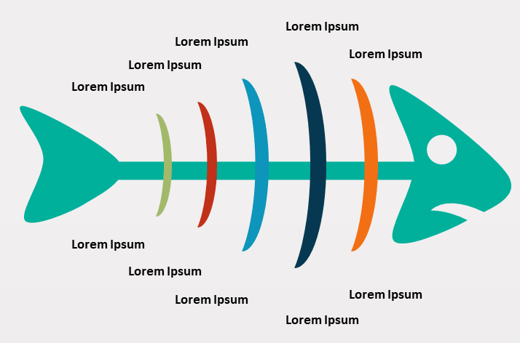
Figure: Fishbone Diagram
Source: (SlideShare, 2018)
The major problem that AMT Coffee limited has been facing since the last year is the declining sales level and the declining revenue in the UK and Ireland. The core issues that cause the problem to happen in the business of AMT Coffee limited can be divided into certain issues that have the problem lasted for a longer period of time. The first sub problem that can be attributed to the final problem of AMT Coffee limited is the losing demands in the market because of the poor economic condition across the UK and Ireland. The second sub problem that can be attributed for long lasting problem of decreasing the sales revenue of empty coffee limited is is the competition that is getting stiff day by day from the rivals like Starbucks and Costa coffee. The third most important sub problem of empty coffee limited is the scarcity of raw materials. The scarcity of raw materials is happening because the production of coffee beans in the exporting countries has been frequently disrupted by the too much rainfall and droughts (Mortazavizadeh, 2014). That is why the company cannot always avail the needed raw materials to meet the demand of the market smoothly which in turn makes it quite difficult for the company to keep the customers satisfied all the time with the quality service and products. Another sub problem is the concern of the people about the health issues that are coming from the beverages like caffeine. Day by day people are getting concerned about their health issues which make the company suffer in the long run because people are not eager to drink coffee on a regular basis anymore when they go to office and come back home in the evening. People are frequently switching their demands to other healthy beverages like health drinks, fruit juices, and green tea offered by other companies in the indirect industry in the UK and Ireland.
The fishbone diagram is also very helpful for running a brainstorming session to find out the major causes of the problem that is happening very frequently in the organization. When the higher level managers run a brainstorming session they usually invite the front line managers and other low level managers into the session so that the managers of all the departments of the organization can have opinion on the problems that are occurring in the company right now which will in turn help the company to find the roots of the problems and eradicate the problems in a very efficient and effective way. In the brainstorming session, an open-ended question has been asked to the managers of all level and the answers from the managers of all level together into one formation so that the roots of the problem can be easily identified and can be attributed to the problems very easily (Mortazavizadeh, 2014).

Implementation of the solutions


Figure: Implementing Solutions
Source: (Bloomberg, 2018)
Now it is the time for the implementation of the solutions to problems of declining sales revenue of AMT Coffee limited in the UK and Ireland. To implement the solutions of the problems that have been clearly sort out by the fishbone diagram and the brainstorming session, the managers have to follow certain rules and regulations to implement the solutions resolve the problem. Creating an overall plan that will be followed throughout the session of the implementation level can be the first step of the implementation stage by the higher-level managers of the organization. For example, to increase the market share and revenue ways the company can focus on the broadening of the target audience by expanding their business in other foreign countries like Italy, France, Germany, Belgium etc. and merging with other companies or acquiring other potential companies with huge potential in the implementation process (Karan Singh, Satish Singh and Swapnil Patil, 2015).

Communicating the solutions to stakeholders
In this stage of the solution of the problem the managers of the company have to communicate the probable solutions to the major stakeholders. To whom the solutions can be communicated is discussed below:

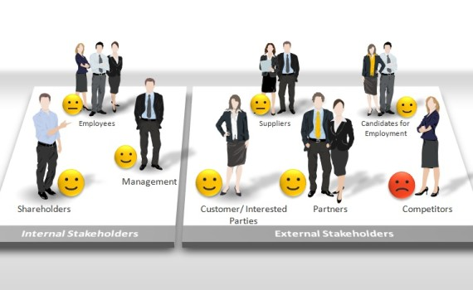
Figure: Stakeholder of AMT Coffee
Source: (SlideShare, 2018)

To shareholders
At first what will be the outcomes of the proposed solution to the problem must be communicated to the shareholders of the company because the shareholders of the company have the first priority in the claim of the company in time of liquidation. The group of people that will be benefited most if the solution of the problem works best is the shareholders because the share price of theirs will be increasing if the performance of the overall business is increasing that's why it is the most important task for the managers to communicate the probable solutions to the shareholders at first.

To employees
Employees are the second most important stakeholder of a company because the employees are the main players for the success and failure of a business. The employees of all level should be well aware of the probable solutions to the problem of AMT Coffee limited so that the employees can easily contribute to the implementation of the solutions to the problem by knowing the solutions accurately from the higher-level managers (RKA and SS, 2016).

To suppliers
Suppliers are the third most important stakeholder of the company. So, the probable solutions to the problem of declining sales revenue in the UK and Ireland should be communicated to the suppliers. The suppliers supply the needed raw materials to the company which makes them able to participate in the decision-making process of the company.

To regulators
The regulators of a country are the fourth most important stakeholder of a company because what will be the consequences if the solutions of the problem are implemented in the business on the society is a major concern for the regulators of a company. So, the probable solutions and their consequences must be effectively communicated to the regulators of that particular company if you want to do their business in a very smooth and frequent manner.

Monitoring and Review
In this stage, the monitoring of the entire process of implementation of the solutions and finding the problems has to be ensured so that if any discrepancy is occurring in the process can be easily sort out by the managers and implement the solutions to the problem very easily instantly. For example, it is observed that the implementation of solution to a specific problem is not working good according to what is expected from the implementation process. In this stage, the managers of the company review and monitor the process and correct the process according to what is expected by the managers (RKA and SS, 2016).

Conclusion
To draw the conclusion, it can be said that the business of AMT Coffee limited is very volatile in nature because there are so many competitors in the market are competing each other to retain the market share for them. The supply chain management of the company has to be very smooth and fast so that the company can avail the needed raw materials to meet the demands from the market instantly otherwise the customers of the market will switch to competitors and the company will be suffering hard in the future. The SWOT analysis and the PESTEL analysis of the company provided us the insights of the external and internal factors that have influence on the business of the company in the long run which makes the managers of the company able to draw the necessary strategies to bring the profitability in the company (Karan Singh, Satish Singh and Swapnil Patil, 2015).

References
Abdeldjebar, S. (2017). Analyse Stratégique Du Secteur Du Transport Aérien Par Les Modèles PESTEL Et SWOT ( Etude De Cas Portant Sur Un Echantillon Des Compagnies Aériennes ) Strategic Analysis Of The Air Transport Sector By The PESTEL And SWOT Models :, Case Study Of A Sample Of Airlines. p.280.
Greenblum, C. and Rowe, M. (2012). Nighttime Activity in Individuals with Dementia: Understanding the Problem and Identifying Solutions. Journal of Gerontological Nursing, 38(5), pp.8-11.
Kampanje, B. (2012). Pestel Analysis of Malawi's Non-Life Insurance Industry. SSRN Electronic Journal.
Karan Singh, Satish Singh and Swapnil Patil (2015). Construction Planning, Monitoring Controlling Techniques Review. International Journal of Engineering Research and, V4(03).
Kawai, T. (2017). The historicity and potential of Jungian analysis: another view of ‘SWOT’. Journal of Analytical Psychology, 62(5), pp.650-657.
Konigsberg, A. (2012). The Problem with Uniform Solutions to Peer Disagreement. Theoria, 79(2), pp.96-126.
Kumar, P. and M.S. Nain, M. (2011). Agriculture in India: A SWOT analysis. Indian Journal of Applied Research, 3(7), pp.4-6.
Mohammad Arabzad an, S. (2012). Improving Project Management Process in Municipality Based on SWOT Analysis. International Journal of Engineering and Technology, 4(5), pp.607-612.
Mortazavizadeh, S. (2014). A Review on Condition Monitoring and Diagnostic Techniques of Rotating Electrical Machines. Physical Science International Journal, 4(3), pp.310-338.
Peeters, A. and Blake, M. (2016). Socioeconomic Inequalities in Diet Quality: from Identifying the Problem to Implementing Solutions. Current Nutrition Reports, 5(3), pp.150-159.
RKA, P. and SS, B. (2016). A Review on Techniques for Diagnosing and Monitoring Patients with Parkinson’s Disease. Journal of Biosensors & Bioelectronics, 7(2).
Sooktip, T. and Wattanapongsakorn, N. (2015). Identifying preferred solutions for multi-objective optimization: application to capacitated vehicle routing problem. Cluster Computing, 18(4), pp.1435-1448.
Vaněk, M., Mikoláš, M. and Žváková, K. (2012). Evaluation Methods of Swot Analysis / Metody Vyhodnocení Swot Analýzy. GeoScience Engineering, 58(2), pp.23-31.
von Hippel, E. and von Krogh, G. (2013). Identifying Viable Need-Solution Pairss: Problem Solving Without Problem Formulation. SSRN Electronic Journal.
Webster, A. (2002). Grasping the nettle with employers: defining the problem, identifying solutions. A Life in the Day, 6(2), pp.26-32.
Yüksel, I. (2012). Developing a Multi-Criteria Decision Making Model for PESTEL Analysis. International Journal of Business and Management, 7(24).

