Anita Nan 1908930

I will be producing a portfolio on my understanding of communication, why it is crucial to have it in a workplace and how it can be improved in my work environment. Communication is important because without communication the needs of many people can not be met.

Most of our day is spent communicating and we don’t even notice we are doing it, this could be eye contact, hand gestures, facial expressions or body language, it is not all about words! ‘People spend between 70 and 80% of their day engaged in some form of communication’ (Lake, 2015). Communication is used in many places such as shops, school and work, and as I work in a nursery, communication is one of the key factors of our day to day work routine.

What is communication?
‘Communication is the act of conveying meanings from one entity or group to another through the use of mutually understood signs, symbols, and semiotic rules’ (Wikipedia). Communication is something that is needed wherever we go, even when at home, people can use their phone to communicate with other people, send emails, or receive letters. Television channels such as bbc and itv spread important news around the world by using their platform to project business plans, car crashes, traffic delays, the weather and situations currently going on in the world.

Communication is used to help understand people for both yours and their benefit. ‘Emotional awareness, or the ability to understand feelings, will help you succeed when communicating with other people.’ (Conover, 2016). By being able to identify someone’s emotional state, you will be able to understand how that person works and if the are trying to communicate something specific to you but don’t know how. ‘Sometimes, understanding how a person is communicating with you is more important than what is actually being said.’ (Conover, 2016). It is important that you know and understand how your colleagues work and you will be working alongside them, and their work can affect yours, especially in a childcare setting as each member of staff has a specific role to play, and the children rely on staff at all times.

There are different types of communication, verbal, non verbal and written. Each form of communication that is listed are vital when working with young children.
Verbal communication is based around speech, what can be said, what noises can be made to gain attention or make a gesture. It is based around what we hear or what we make heard. There are different types of verbal communication, one being intrapersonal and the other being interpersonal.

‘Intrapersonal communication is an internal process of communicating with the self. It may be more commonly recognized as the "little voice in your head" or "self-talk.’ (Questia). Another way of explaining intrapersonal is the voice you can hear right now in your head, talking to you right this second, can you hear it? This voice is only for you, no one else can hear it, it is your brain giving you a chance to think or process what you just encountered, by yourself.

Interpersonal communication is the process by which people exchange information, feelings, and meaning through verbal and non-verbal messages: it is face-to-face communication. (Skillsyouneed). Interpersonal is the opposite to intrapersonal communication as its about projecting the thoughts you would have in your head, it also consists of ‘non-verbal messages sent through tone of voice, facial expressions, gestures and body language.’ (Skillsyouneed).
This form of communication is used more frequently as it is done without consent. Two people in a room, constastanly looking at each other and making different facial expressions at each other is a form of interpersonal communication as they are communicating non verbally, in a negative or positive way.

‘Non verbal communication (also referred to as body language) includes all the ways we communicate without words’ (Quintanilla, K.M & Wahl, S.T, 2017). Meaning the way we look at eachother, our body language, how we are sitting, are we giving the speaker eye contact to let them know we are concentrating on the information being provided? It’s a guessing game with non verbal communication as it can be interpreted wrong, ‘facial expressions, gestures, and other bodily expressions may be intended as one kind of signal but received as other’(H.N,K.C,2001). This is not always the case but for people who find it hard to be verbal this can be difficult. Some examples are Sign language, braille and makaton.

Written communication however can be an email, letter, text or postcard. ‘A 'Written Communication' means the sending of messages, orders or instructions in writing’ (Sharma, P) In my workplace written communication is used to inform parents with events coming up, written notes if an accident occurs and to efficiently send emails between staff. Following up a recent in class exercise where we had to produce a brief business email, I learnt that although we all have basic verbal and non verbal skills, depending on your area of work it is best to check if you have the full communication requirements as you might have to do an extra course.

In my email, I was acting as the director of communications and I had to advise a supervisor to take a training course on non verbal skills, I was to tell her that I had observed her non verbal skills and I realised that some of them had been interpreted wrong also known as a kinesic slip. This had to be emailed to my colleague as if it has been verbally transmitted, my colleague could have then taken a different understanding which could have caused more issues than necessary. Written communication can make difficult situations easier to resolve within the workplace as you can not see people’s non verbal behaviour, which can affect outcomes and resolutions. ‘If such a kinesic slip occurs nonverbal cues are mostly given greater weight then what was said verbally.’(Krueger, J,2005).

Although there are positives in communication there is also negatives or barriers to effective communication. Some of them being physical, psychological and language barriers.
Physical barriers can be things like inadequate equipment, when a workplace lacks equipment it makes everyone’s job harder, the equipment could be technology related meaning all the systems shut down, if the company is an IT company, they might have to close down for the day to reboot their systems.

‘The psychological state of the receiver will influence how the message is received. For example, if someone has personal worries and is stressed, they may be preoccupied by personal concerns and not as receptive to the message as if they were not stressed’.(Phicare)
This being the psychological barrier, can have a massive effect on your everyday life. This includes work, home and social life. By having a negative energy you’re creating a negative environment, if in work that means you’re bringing people down with your actions, body language, timing, making other people and their jobs harder and more frustrating.
This can cause issues in the workplace as you were not performing to the best of your ability. Although this is a topic that can sometimes be controlled, when unfortunate circumstances tend to arise, it is best that you know how to deal with them in an appropriate manner which will help you and your colleagues day flow more smoothly.

‘Language barriers are the most common communication barriers which cause misunderstandings and misinterpretations between people.’ (B.T,2018). This refers to people who can not speak the language of the country that they are living in, or people who have problems speaking verbally. This then means certain people will not be accepted for certain roles as they are not fluent enough and will not be able to provide the right information. It is not to say these people are wrong or any less smart it just means they have a harder time relaying the correct information. ‘Not using the words that other person understands makes the communication ineffective and prevents message from being conveyed.’(B.T,2018)

‘The Osgood-Schramm model is built on the theory that communication is a two-way street, with a sender and a receiver. Charles Egerton Osgood popularized the notion that communication was circular rather than linear, meaning that it required two participants taking turns sending and receiving a message.’(study.com) A graph is demonstrated below.

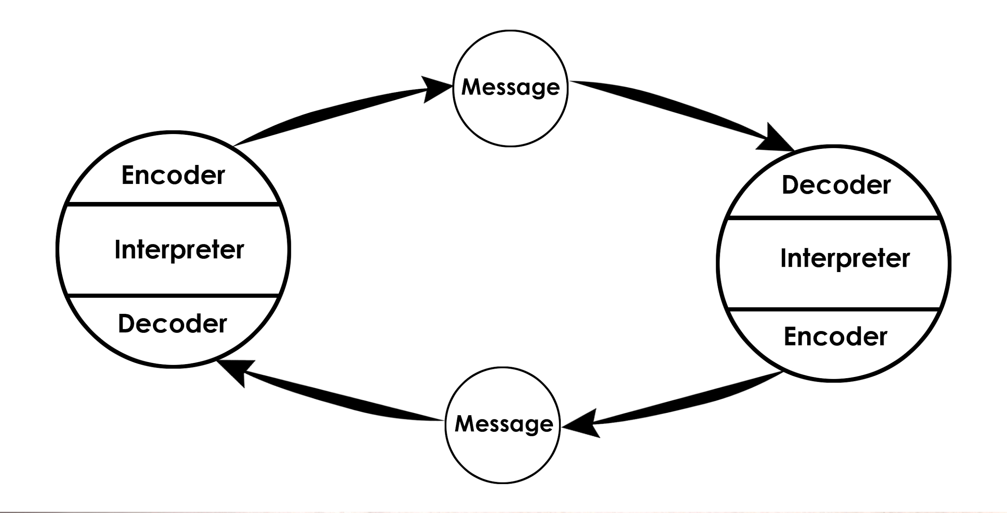
(Communication Theory.org)

This theory is trying to say that we can explain the act of communication in a very simplistic way. From person A to B, “In fact it is misleading to think of the communication process as starting somewhere and ending somewhere. It is really endless. We are really switchboard centers handling and re-routing the great endless current of information.” (Schramm, 1955). This communication model starts with the encoder and it makes both the receivers senders, making it easy to communicate. ‘Each person is both a sender and a receiver. They are therefore able to communicate to one another, rather than only in one direction.’ (Drew, 2020)

Communication in the workplace starts from the very second you walk into the facility, in the morning the staff members greet the children and parents at the door of the classroom. Once the children are in the classroom and have been greeted the parents will then give information on any problems that may have occurred with the child overnight, following up with medication or advice. The children are then formed into groups and each staff member is assigned a task and group, each hour the groups will change and it is our responsibility to make sure we are all communicating efficiently to keep the groups together and in the right order. This helps keep track of children's learning. In a childcare setting the main form of communication used in a childcare facility is verbal. This form of communication is used when we need to inform a parent of an incident which has happened, to inform each other of any changes in routine such as sleep times being cancelled or doctors coming in. Chef’s also have to be informed of any allergies the children may have to make amendments.

Although visual communication is needed, some children may have learning difficulties and need extra assistance to get through their day. In a childcare setting this form of communication is important because it can also help predict and prevent future incidents from occurring, such as injuries, bullying and visible illness’.
Listening is also vital because it can help pick up the signs of bullying, when working in a busy environment you learn to multitask, listening is important as you can over hear other children and the language they are using to communicate with each other, this means that even if you can not see, you will be able to distinguish child a from b and act appropriately.
Often some staff members tend to overload themselves with tasks and forget certain tasks at hand this can be frustrating for the people who have stayed on top of their tasks as it works as a domino effect, one job links to the other, discrimination between staff members and staff members coming in moody and barely communicating these are all ongoing problems in workplaces.

In my workplace I feel we could improve our communication skills by encouraging group meetings this will help staff members engage and build relationships, making a set schedule that everyone has to follow will encourage people to be on time and to help divide tasks equally so everything can be done efficiently. Everyone has a job to do and we can not keep letting other people affect our duty.
‘Possessing strong communication skills will help you in every phase of your life. This is especially true in the workplace’. (Apodaca, 2019)
References:
Lake R, 17 Sep. 2015, "Listening Statistics: 23 Facts You Need to Hear - CreditDonkey." https://www.creditdonkey.com/listening-statistics.html

"What is Communication? Verbal, Non-Verbal & Written ...." https://www.skillsyouneed.com/ips/what-is-communication.html

3 June 2016 "The Importance of Emotional Awareness in ...." https://www.conovercompany.com/the-importance-of-emotional-awareness-in-communication/

"Intrapersonal Communication - Questia." https://www.questia.com/library/communication/human-communication/intrapersonal-communication

"Interpersonal Communication Skills | SkillsYouNeed." https://www.skillsyouneed.com/ips/interpersonal-communication.html

Maund, A., Schriek, M. and Tinkler, P. (2017). Certificate in higher education: skills for the workplace student yearbook P.69.

Henley, N., Kramarae, C. (2001) Feminism in the study of religion. P.34.

Sharma, P. "Written Communication: Meaning, Advantages and Limitations." http://www.yourarticlelibrary.com/business-communication/written-communication/written-communication-meaning-advantages-and-limitations/70195

Juliane Krueger (Author), 2005, Nonverbal Communication, Munich, GRIN Verlag, https://www.grin.com/document/54811

Phicare "Communication Barriers - PhiCare." http://phicare.com/competencies/communicationbarriers.php

Businesstopia(B.T), 2018. "Language Barriers to Communication - Businesstopia." https://www.businesstopia.net/communication/language-barriers

Study.com Chapter 5, lesson 2, 2018 "Osgood-Schramm Model of Communication: Definition ...." https://study.com/academy/lesson/osgood-schramm-model-of-communication-definition-application.html

Schramm, W. (1955). How communication works. In: Schramm, W. (Ed.). Process and Effects of Mass Communication. Illinois: University of Illinois Press.
https://helpfulprofessor.com/osgood-schramm/

Drew. C, 2020. "Osgood-Schramm Model of Communication - Helpful Professor." https://helpfulprofessor.com/osgood-schramm/

Apodaca, M. 2019. "How to Improve Communication Skills for ... - Lifehack." https://www.lifehack.org/articles/communication/9-tips-to-improve-communication-skills.html



