
ACDB5007 – L5 – Instrumentation and control
Student: Stephen McAngus (2113123)

Contents:

Introduction: 3
Method: (300-400 words) 5
Figure 1 displays the Step input of the Simulink circuit, a negative feedback loops returns to the start of the PID controller post transfer function. The oscilloscope measured the step input, negative feedback, response after the PID controller, and the output of the system. 5
Figure 2: displays the mathematical equation that was input into the Transfer function and this was throughout all of the simulation. This number derived from the Student ID number: 2113123. 6
Results: 6
7
Figure 3: displays the PID amplitude response in relation to tuning effects, Top Left displays the PID prior to any tuning, Top Right displays the PID response to initial tuning, Bottom middle displays the PID response in relation to refined tuning in relation to the transfer function. 7
Figure 4: displays the PID tuning values, Left displays the PID response from initial tuning, whereas the left shows the PID response, after tuning in response to the transfer function. 7
Figure 5: Displays the amplitude response in relation to time, measurements were taken from the input source, after the PID controller, after transfer function, the negative feedback loop. Top left displays the effects on the circuit after initial and final tuning, Top right displays the effects after making adjustments to the PID controller without tuning, bottom left shows the effect on the circuit without any tuning or alterations to the PID controller. Bottom right displays the effect on the circuit by just tuning the PID without solving the transfer function. 8
Discussion: 800 – 1000 words.. Need a very good interpretation of the results. 9
Conclusions and recommendations: 10
References: 11

Introduction:

Instrumentation and control is a field of engineering that analyses the performance of a system through the observation, measurement and control of quantities and parameters of a system. Typically, this requires various instruments, sensors, and control systems to ensure the precise and reliable operation of a system or circuit. To achieve this it is common to find both sensors and transducers within a system to achieve an accurate response. A sensor is typically a component that identifies an input source, and feeds this information to a transducer. The transducer’s role is to implement change, in the example of a fire detector; the sensor would be a thermostatic relay, which would send feedback to a transducer that converts the energy to noise by the actuation of a speaker/ tweeter, this is an example of a direct feedback operation [1]. This approach is scalable, and applicable to highly complex systems such as weapons systems. Many modern complex weapons systems designed by the west are renowned for high accuracy in both terms of delivery and function [2] [3]. This is due to the complex design and circuitry involved with these systems, to achieve this many systems need a means of accurately responding to stimuli in situ, a cost effective means of achieving this, is through the implementation of a PID controller [4].
PID controller circuits are used in a variety of applications, these include industrial processes such as dispensing lines for filling munitions, where weight, pressure, flow are all monitored, and negative feedback from each arm of this system returns to a PID controller, which in turn regulates the downstream effects on the next cycle [5]. PID controllers provide a means of dynamically controlling a system from a feedback loop. This control system allows for error correction through the continuous monitoring between a desired set point and the actual output of the system, by active monitoring input signals. The aim of the PID controller is to align the output to the desired set point. Inherently this aids in the stability of a system, by reducing oscillations and instability of the input, reducing erratic behaviours [6].
This is achieved by the proportional, integral and derivative terms of the PID controller. The proportional aspect of the component scales the output of the system based on the magnitude of error received by the input as part of a negative feedback loop, this reduces error by directly responding to the immediate deviation from the set point [7]. Whereas the integral control aspect of this system accumulates the error of the system over time, which is integrated into a response through the output of the controller, downstream stabilising the intensity of the effect. It is important to note that due to the mathematical behaviour of integration, considerable effort must be made to tuning as the integration in-it-self could cause a rise in the instability of the system triggering overshooting, and eventually undesired oscillations [7] [8]. Finally, the derivative aspect of this unit provides a means of controlling the output proportionally to the rate of change in error, this behaviour is somewhat predictive of events to come. This contributes towards the damping properties of a PID controller, this level of control within a system assists in the anticipation of rapid changes reducing overshoot and instability from other aspects of the controller unit. All three aspects of a PID controller work in harmony to provide a comprehensive regulation of system response [8] [7] [9] [10].
The MatLab Simulink software package was chosen to design and create a circuit where outputs and inputs of a PID controller could be assessed in relation to a transfer function. Simulink is a renowned software known for its ease of use whilst being a highly flexible platform to run simulations on electronic circuits.
The general dynamics CWIS/ Phalanx platform is a highly capable short range anti air defence system, the system is equipped with the M61 Vulcan 6 barrelled cannon. This armament is designed to fire the 20x102mm round at a high cyclic rate of 3000 rounds/minute. CWIS/ Phalanx is driven by a Ku-band radar system that tracks targets within a nine-kilometre sphere of influence [11]. An electronic arming and firing system is used to control the actuation of the firing mechanism within the gun, to properly arm and function a series of preprogramed prerequisites must be achieved [12]. There are several instances on the CIWS/ phalanx platform where PID’s could be implemented to improve the effectiveness and efficiency of the platform [13]. Furthermore, PID controllers could be exploited to regulate the fed-rate of munitions in response to the load upon the motor or actuator of the cannon. With the overall objective of a damping, PID controllers prove beneficial to many aspects of an automated weapon system.
The aim of this study is to assess the effect of a PID controller in response to a transfer function of known values and to tune a circuit in response to this feedback input. With the objectives of using Matlab Simulink to illustrate and simulate the negative feedback, and to take measurements from a digitalised oscilloscope.

Method:

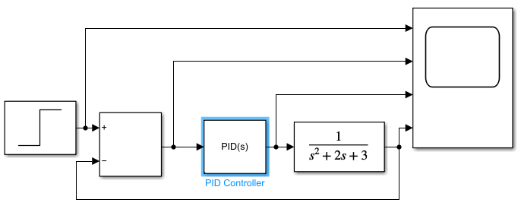

Figure 1 displays the Step input of the Simulink circuit, a negative feedback loops returns to the start of the PID controller post transfer function. The oscilloscope measured the step input, negative feedback, response after the PID controller, and the output of the system.

Using the MatLab plug in Simulink, a circuit was created in order to analyse the function of a PID controller, refer to figure one above. The transfer function was modified to the equasion that can be seen in figure 2 under the instruction of the class tutor.


Figure 2: displays the mathematical equation that was input into the Transfer function and this was throughout all of the simulation. This number derived from the Student ID number: 2113123.

Results:
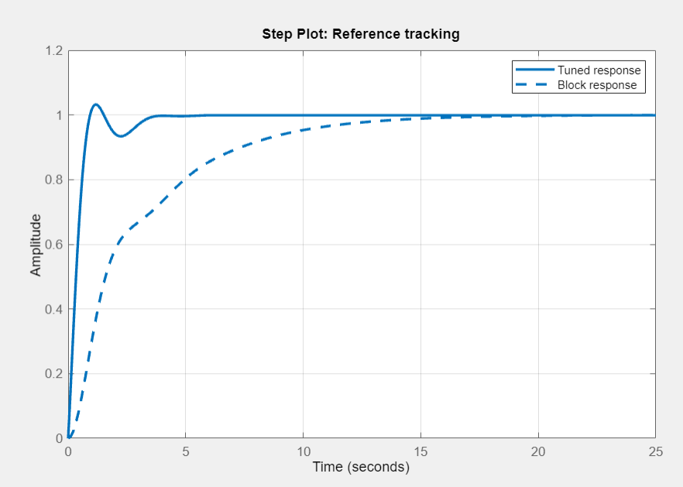 |  | 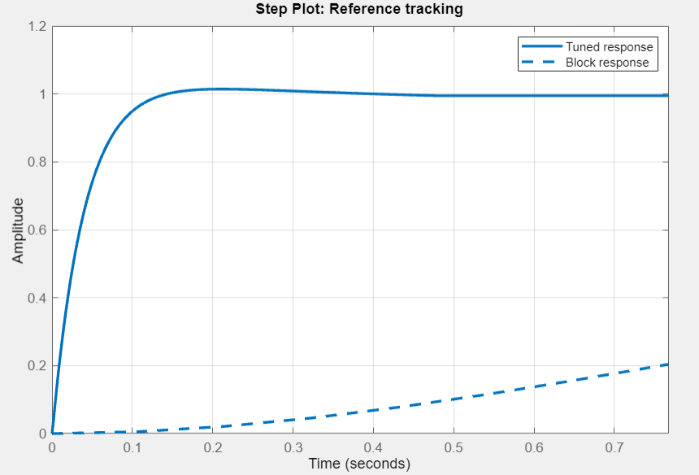

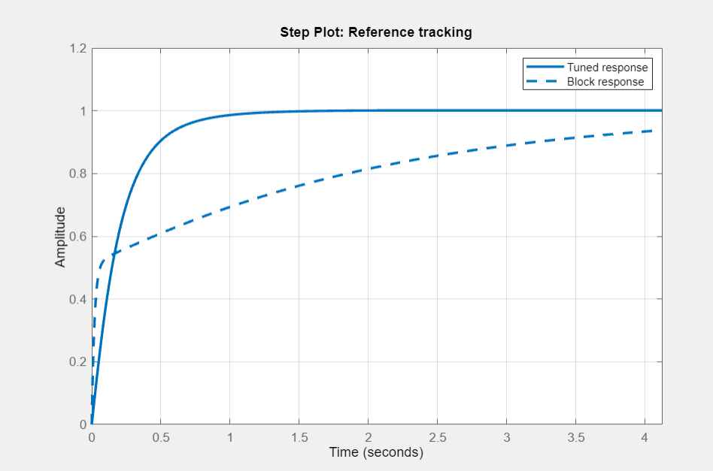

Figure 3: displays the PID amplitude response in relation to tuning effects, Top Left displays the PID prior to any tuning, Top Right displays the PID response to initial tuning, Bottom middle displays the PID response in relation to refined tuning in relation to the transfer function.
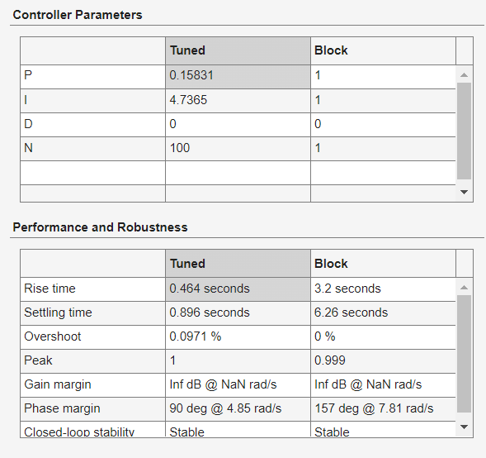 | 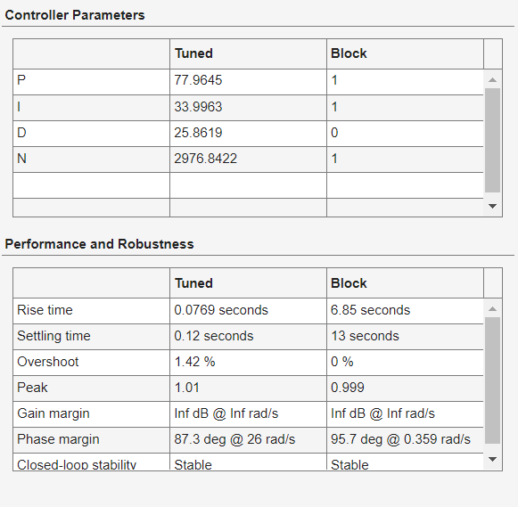

Figure 4: displays the PID tuning values, Left displays the PID response from initial tuning, whereas the left shows the PID response, after tuning in response to the transfer function.

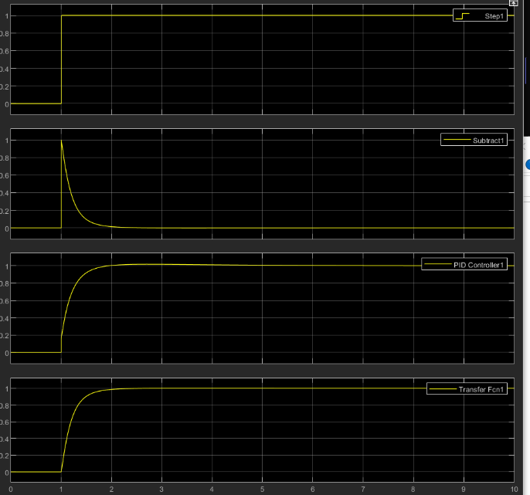 | 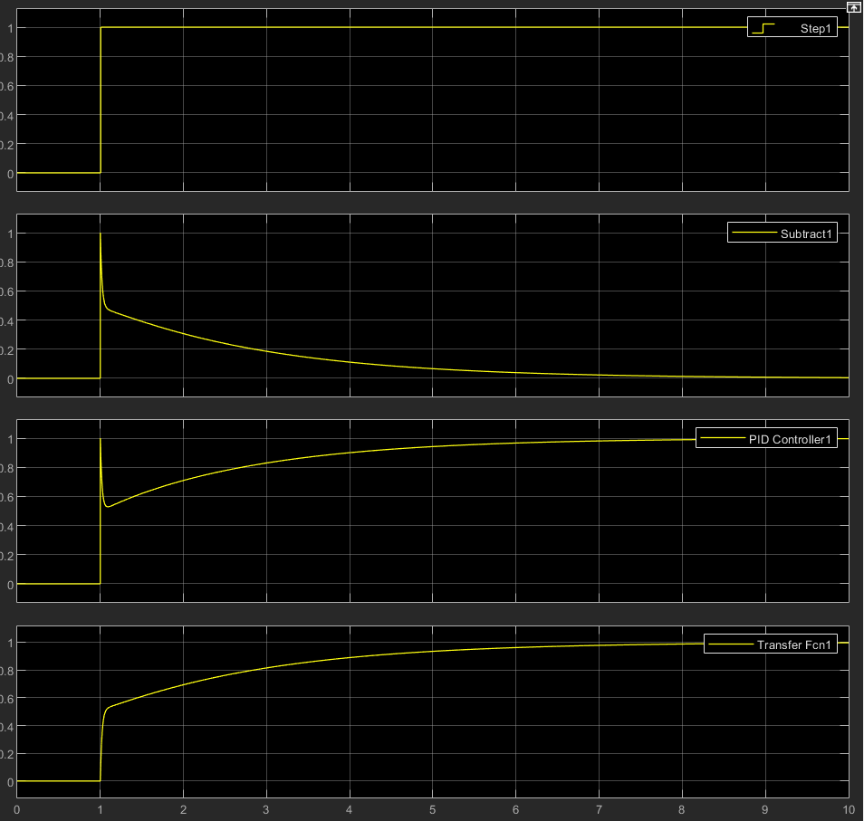
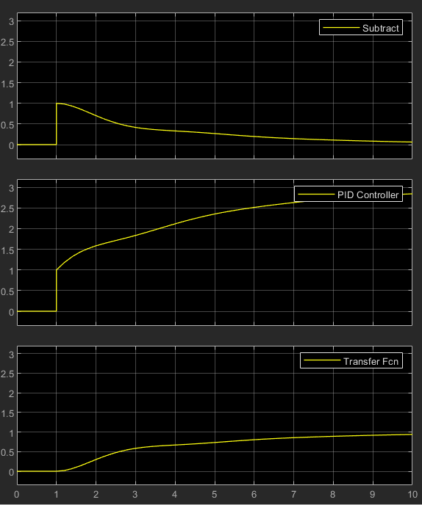 | 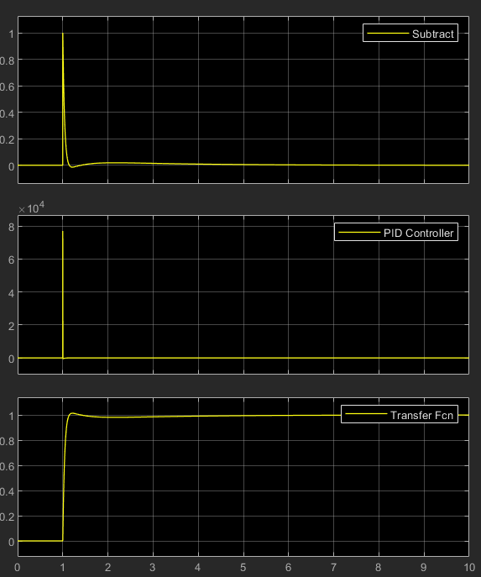

Figure 5: Displays the amplitude response in relation to time, measurements were taken from the input source, after the PID controller, after transfer function, the negative feedback loop. Top left displays the effects on the circuit after initial and final tuning, Top right displays the effects after making adjustments to the PID controller without tuning, bottom left shows the effect on the circuit without any tuning or alterations to the PID controller. Bottom right displays the effect on the circuit by just tuning the PID without solving the transfer function.

Discussion:

Results shows that this circuit has been tuned to a certain optimum, as can be seen in figure three, the response time in relation to amplitude reduced significantly, producing a smoother transition to a ramped state. As a result of tuning the PID it can be seen that interference was removed from the circuit, further refinements to tuning better increased the block response in relation to amplitude and time. This indicates that there will be smoother actuation of downstream components within this system. Furthermore, by smoothening the response of the PID much more accurate actuations can be achieved as this becomes predictable [14]. When comparing this to the response measured by the oscilloscope it can be seen that tuning the PID greatly reduces sharpness generated by interference from the feedback loop. By removing this interference, it can be established that finer and more accurate actuations can be achieved [15]. By introducing the transfer function into this circuit it can be established how the system would perform under load, as a result filters can be tailor designed and inserted into this circuit to reduce interference, and noise, creating a much more stable system response [16].
For the requirements of this report, a transfer function was implemented to simulate the load of a system, whilst also serving as a means of tuning the PID controller in response the negative feedback. The provision of a mathematical representation of the relationship between the input and the output signal, the dynamics of the system and associated behaviours from feedback can be assessed [17] [18]. Furthermore by introducing a transfer function into the scope of this study an understanding of the systems stability could be assessed through the analysis of poles and zeros [19]. It is important to note that further studies of this nature should also include Bode and Nynquist plots, as this would give greater insight into the systems stability, frequency response, gain and resonant frequencies. Understanding these key elements also allows for the significant reductions to external noise factors [20]. Despite transfer functions providing a very effective means of estimating the tuning parameters of a PID controller there are practical considerations to be made, such as sensor noise, actuator limitations, or system tolerance variation with the effect of age [18].
Utilisation of a PID controller within this circuit ensures that undesired factors are removed from play from within this circuit. The PID removes uncertainties through the implementation of proportional integral and derivative actions. A PID’s ability to respond to dynamic situations also allows for the maintenance of a highly stable system, whilst also benefitting the overall performance of the circuit [21]. To that end, it is imperative that PIDs are tuned accurately to achieve the desired effect within a circuit, by adjusting the proportionality, integral, and derivative a control systems response can be tuned to achieve certain highly accurate responses. What observed from this study is that a trial by error approach was used to tune the frequency response. However, what might improve upon this route, would be a mathematical approach such as the Ziger-Nichols tuning response function [22]. The Ziger Nichols approach would allow for a very simplistic tuning of a non-dynamic PID system, utilising the hierarchal structure of this method would also lead to rapid initial tuning, with fine manual adjustments to stabilise the frequency output [23]. Alternatively, to this machine learning algorithms could be implemented to dynamically tune a PID. This approach could allow for the rapid adaptability of a systems dynamics, thus adjusting PID parameters on specific characteristics and requirements [24]. Additionally to this, neural network control systems may be better suited to large platforms that utilise air defence weapons such as CIWS. However these latter approaches make systems increasingly more complicated, and justify for PEDs to remain on modern weapons systems.
Results from this study have shown that the use of a PID controller to regulate the output to an actuator may lead to a greater performing system. There are several features upon the CIWS platform that could use PID controllers to accurately actuate physical motion. Utilising a PID controller could stabilised transverse and traverse motion of the cannon [25]. Furthermore, the used to regulate the feed of the weapons system, and feedback loop from a sensor could assist in the functioning of the loading of the gun.

Conclusions and recommendations:
In conclusion, this exercise has demonstrated that PIDs remain a cost effective means of implementing refinements that improve the accuracy and reliability of implementing a desired effect from an actuator. PIDs provide a real time solution to stabilise the output and response of a system, however literature has highlighted that there are other approaches such as fuzzy logic with the advent of machine learning, or alternatively an artificial intelligence driven model predictive control may also be control routes to consider for control circuitry. Additionally, by the removal of PIDs from a system could lead to the advent of ‘hot-swappable’ systems aboard a system increasing interoperability by following a brainstem approach to design.

References:

[1] | S. Vidhatri, “Design of an innovative smoke sensot and fire alarm panel,” in Third International Conference on Intelligent Computing Instrumentation and Control Technologies, 2022.
[2] | S. Maio, “Portable maintenance aid instrument pack-improved weapon system diagnostics,” in IEEE AutoTestCon, 2002.
[3] | J. Rogers, Applications of internal translatinf mass technologies to smart weapons systems, Atlanta: Georgia Institue of technology, 2009.
[4] | A. Vicioli, Practical PID control, New York: Springer Science & busieness media, 2006.
[5] | G. Matticari, “Use of a "wide dynamic range" electronic flow regulator to increase the flexibility and versatility of electric and cold gas small propulsion systems,” in 32nd international Electric Propulsion systems, Wiesbaden, 2011.
[6] | V. Zheng, “A review of PID control, tuning methods and applications,” International Journal of Dynamics and Control, vol. 9, pp. 818-827, 2021.
[7] | S. Bennett, “Development of the PID controller,” IEEE Control Systems Magazine, vol. 13, no. 6, pp. 58-62, 1993.
[8] | J. Han, “From PID active distrubance rejection control,” IEEE Transactions on Industrial Electronics, vol. 56, no. 3, pp. 900-906, 2009.
[9] | A. Isaksson, “Derivative filter is an integral part of PID design,” IEE Proceedings-Control Theory and Applications, vol. 149, no. 1, pp. 41-45, 2002.
[10] | W. Luyben, “Effect of derivative algorithm and tuning selection on the PID control of dead time processes,” Industrial & engineering chemistry research, vol. 40, no. 16, pp. 3605-3611, 2001.
[11] | Joint Counter Air, Joint counterair and theatre missle defense doctrine to defend against unmanned areial systems and cruise missles in asymmetric warfare, Ft Brag: Air War College, US Air Force, 2009.
[12] | S. Kaya, “Evaluating effectiveness of a frigate in an anti-air warfare (AAW) environment,” Naval postgraduate school, Monterey, 2016.
[13] | E. Serris, “Design and prototyping of a portable naval weapon control system for heavy machine guns,” Naval Postgraduate School, Monterey, 2018.
[14] | K. Elgeneidy, “Bending angle prediction and control of soft pneumatic actuators with embedded flex sensors-A-data-driven approach,” Mechatronics, vol. 50, no. 1, pp. 234-247, 2018.
[15] | Q. Xu, “Design and development of a flexure-based dual-stage nanopositioning system with minimum interfereance behaviour,” IEEE Transactions on Automation Science and Engineering, vol. 9, no. 3, pp. 554-563, 2012.
[16] | B. Maundy, “On the practical realization of higher-order filters with fractional stepping,” Signal processing, vol. 91, no. 3, pp. 484-491, 2011.
[17] | R. Barbosa, “Tuning of PID controllers based on Bode's ideal transfer function,” Nonlinear Dynamics, vol. 38, no. 1, pp. 305-321, 2004.
[18] | S. Schei, “Automatic Tuning of PID controllers based on transfer function estimation,” Automatica, vol. 30, no. 12, pp. 1983-9189, 1994.
[19] | M. Amin, “Small-Signal stability assessment of power electronics based power systems: A discussion of impedance and eigenvalue-based methods,” IEEE Transactions on Industry Applications, vol. 53, no. 5, pp. 5014-5030, 2017.
[20] | D. Rife, “Transfer functions measurement with maximum-lenth sequences,” Journal of Audio Engineering society, vol. 37, no. 6, pp. 419-444, 1989.
[21] | Y. Mitsutake, “Dynamic response analysis of a linear solenoid actuator,” IEEE Transactions on magnetics, vol. 33, no. 2, pp. 1634-1637, 1997.
[22] | A. Pomerleau, “A survey of Grinding circuit control methods: from decentralized PID controllers to multivariable predictive controllers,” Powder Technology, vol. 108, no. 3, pp. 103-115, 2000.
[23] | K. Åström, “Revisiting the Ziegler-Nichols Step response method for PID control,” Journal of process control, vol. 14, no. 6, pp. 635-650, 2004.
[24] | K. Rohit, “Tuning of PID controller using Zieger-Nichols method for speed control of DC motor,” in IEEE-International conderence on adavances in engineering, science and management, Unknown, 2012.
[25] | W. Longherst, “Investigation of force controlled friction stir welding for manufacturing and automation,” Journal of engineering manufacture, vol. 224, no. 6, pp. 937-949, 2010.

