Re
School of Applied Computing
Submitted 1st May 2022
Donna Kennett
1908067@student.uwtsd.ac.uk
Abstract
An exploration of how the field of computer networks has moved towards a greater emphasis on software
Report
Network Programmability
Declaration

I declare that this report is the product of my own work and is not being submitted for any other degree etc.

D M R Kennett

Table of Contents
1 Introduction 1
2 Cloud Computing 1
3 Application Programming Interfaces (APIs) 3
4 Software Defined Networking (SDN) 4
5 REST 5
5.1 RESTful APIs 6
5.2 RESTful Web Services 6
5.3 JSON and REST interoperability 6
5.3.1 JSON 6
5.3.2 JSON and REST 6
6 Changing role of network professionals 7
7 Conclusion 8
8 Future work 8
9 References 9
10 Bibliography 11

Introduction
A computer network is simply two or more devices connected to share data or resources [1].
In 1969 ARPANET (Advanced Research Projects Agency Network) became the first connected computer network [2] [3]. This used the TCP/IP protocol suite [4], which later became the Internet [3].
Originally a four-node network between university computers at Stanford, Utah, California (ULCA and UCSB) it expanded to 40 machines in 1972 [2].
Cisco forecasts the number of connected devices to be more than three times the global population by 2023 [5].

Cloud Computing
The National Institute of Standards and Technology (NIST) defines cloud computing as the fast and easy configurable provision of computer resources [6].
Although cloud computing may seem like a new concept it has been around since the 1960’s when IBM virtualised operating systems offering users timeshares to the same resource [3].
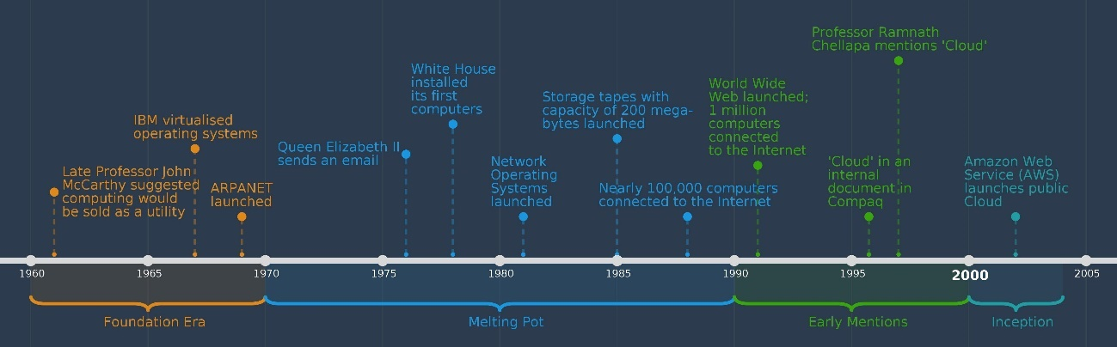
Fig 1: History of cloud computing timeline (1960-2005) [3]
Current cloud computing is available “as-a-service” where service models are chosen to meet the needs of the organisation. The most common of these are Infrastructure as a Service (IaaS), Platform as a Service (PaaS) and Software as a Service (SaaS):
Service Models | Description
IaaS | - The cloud provider manages the hardware.  - The customer manages the Operating System and applications.  - Use case: Amazon Web Services
PaaS | - The cloud provider manages the hardware and the Operating System.  - The customer manages the applications.  - Use case: AWS Elastic Beanstalk
SaaS | - The cloud provider manages all levels of the computing environment.  - The customer accesses application software from the cloud.  - Use case: Microsoft O365
Table 1: Cloud computing service models

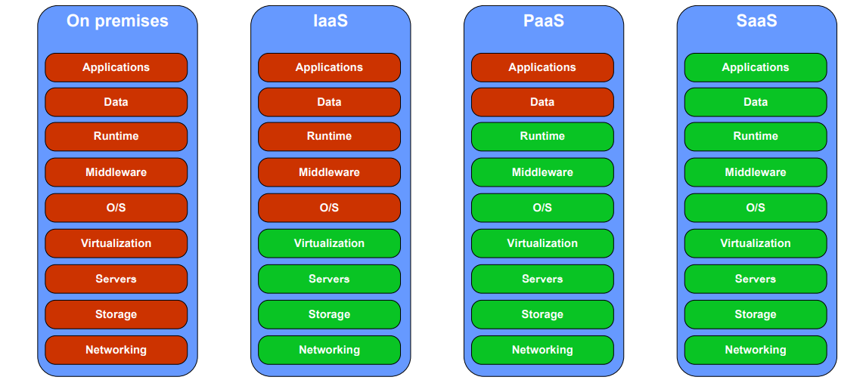
Fig 2: Comparison of Cloud Service Models and on-premises computing [7]

The above figure shows how the responsibility changes between each service model. The items in red are the responsibility of the consumer whereas green is the responsibility of the cloud provider.
Advantages and disadvantages for cloud computing includes:
Advantages | Disadvantages
Scalable | Network engineers required different training
Increased flexibility | Security concerns
Availability | Vendor lock in
Pay per use services | Needs internet connection
Storage capacity | Reduced control
Mobility | Data loss of theft
Reduced infrastructure costs | Denial of Service Attacks
Resource utilisation | Data sovereignty
Table 2: Advantages and disadvantages of cloud computing
The different service models allow an organisation greater control over their cloud provisioning, choosing exactly what they need and when. This flexible approach has seen a continued increase in deployment. A recent report by GMI [8] estimates the European Cloud Computing market will be worth over $140 billion USD by 2028, up 15% from $35 billion in 2020:

Fig 3: Estimated European cloud usage growth from 2020-2028 [8]

Application Programming Interfaces (APIs)
An API allows organisations to offer their applications’ data and functionality easily and securely. Developers do not need to know how the API is implemented they can simply use the interface to communicate with other products and services.
APIs sit between and application and the web server. They act as a go-between that deals with data transfer between the systems.
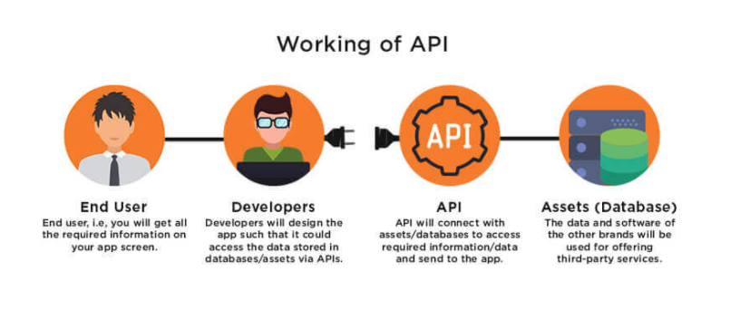
Fig 4: Working of API [9]

APIs offer security by design because of their position between the two systems. The API endpoint separates the application from the service. API calls usually include authorisation credentials, HTTP header and cookies to provide additional security.

Benefits | Disadvantages
Simple to manage existing or design new tools | Primary target for hackers. If compromised the entire system is compromised
Improved collaboration | Vulnerable to man-in-the-middle attacks, CSRF attacks, XSS attacks, SQL injection, and DDoS attacks.
Automate workflows
Flexibility
Enables safe connections
Added security
Easier innovation
Table 3: Advantages and disadvantages of using APIs
The most common data formats found in modern APIs are JSON and XML.
Most current web applications would not be able to function as they currently do without using an API.

Software Defined Networking (SDN)
The SDN concept was created in 2007 and developed by Stanford University in 2008 [10].
SDN is an approach to networking that uses software-based controllers or APIs to communicate with underlying hardware infrastructure and direct traffic on a network [1].
Differences between traditional networking and SDN includes:
Traditional Networking | Software Defined Networking
Single Tenancy | Multitenant
Dedicated infrastructure | Shared infrastructure
Hardware restricted | Software defined
Pre-provisioned | On demand provisioning
Manual administration | Automation
Isolated | Centralised environment
 | Improved visibility
Table 4: Comparison of traditional and Software Defined Networking
In traditional network services, all three planes (Application, Control and Infrastructure) are implemented in the firmware of network devices located in the physical data centre. In SDN, the control and data planes are separated (as shown below). The Data plane is still applied on the network infrastructure devices, but the network control plane is software hosted on a server.
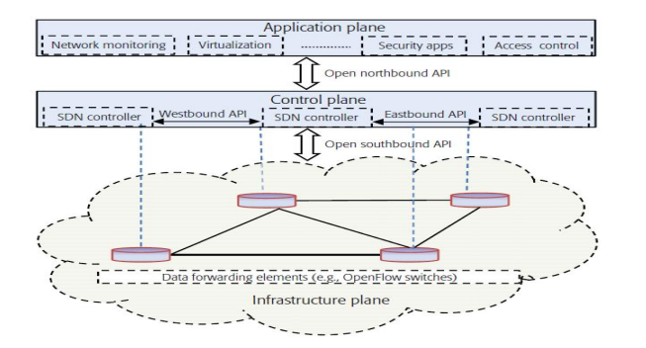
Fig 5: SDN functions [11]

SDN has many advantages over a traditional network and is likely to solve many security issues of a legacy network [12]:
Advantages | Disadvantages
Flexibility, able respond rapidly to changing business, end-user and market needs | Single point of failure
Scalability | Staff retraining
Efficiency | Unique security considerations for application and control planes
No vendor dependencies | Current network will need to be reconfigured and new management tools procured
Centralised management of networking devices
Allows automation of networking devices
Increased network reliability
More granular network control
Improved end user experience
Overall cost savings
Future proof
Table 5: Advantages and disadvantages of SDN
As shown above, the advantages of SDN far out way the disadvantages. In 2020, the global SDN market size was nearly $9.2 billion USD, with network customisation options and further technological advances this is forecast to grow by a staggering 25.4% to over $35.6 billion USD by 2028 [13].

REST
Representation State Transfer (REST) is an architectural style and communication method presented by Roy Fielding in 2000 for his dissertation [14].
Communication between the client and server occurs through HTTP requests and responses. The server does not store application state information. Instead, each client request contains all the information needed to service the request.
There are five principles of REST Architecture:
- REST – based on HTTP
- Resources – organised around data, slice resources represent the data for a particular user: name, age etc.
- Stateless – each request stands alone
- Uniform – standard HTTP actions and errors: GET, PUT, POST, DELETE
- Discoverable – only accessible from a few specified entry points.

RESTful APIs
A RESTful API conforms to the restraints of REST architecture and uses HTTP requests to access and use data known as resources. These principles allow RESTful applications to be lightweight, simple and fast
The state of the resource at any time is called resource representation which includes the data, metadata and hypermedia links.
Users can access the contents of these resources in various formats including HTML, JSON, XML, JPEG, PDF and plain text.
SDN uses RESTful APIs for applications to request resources from the network.

RESTful Web Services
A web service is a collection of open protocols and standards used for exchanging data between applications or systems over a network.
RESTful web Services follows RESTful principles [15] and usually defines a URI (Uniform Resource Identifier), resource representation and HTTP Methods.

JSON and REST interoperability
    - JSON
Originally created by Douglas Crockford in 2001 [16] JavaScript Object Notation (JSON) is a lightweight date-exchange format that is readable by humans and computers.
JSON is built on two structures:
- Key value pairs
- Ordered list of values.
This structure is very useful when sending or receiving data thought an API.
    - JSON and REST
JSON works well with REST because:
- It is language independent and can be used with any programming language.
- It is easy to generate.
- It can be read and understood without help.
- Easy to parse.
All modern programming languages and application platforms can produce and consume JSON data.

Changing role of network professionals
SDN is a favourable solution for IT, cloud providers and organisations. This means that the role of network professionals is changing.
As shown in the figure below Data Centres now take up nearly 50% of end users. The network professional must adapt to a new way of working to manage their infrastructure effectively.
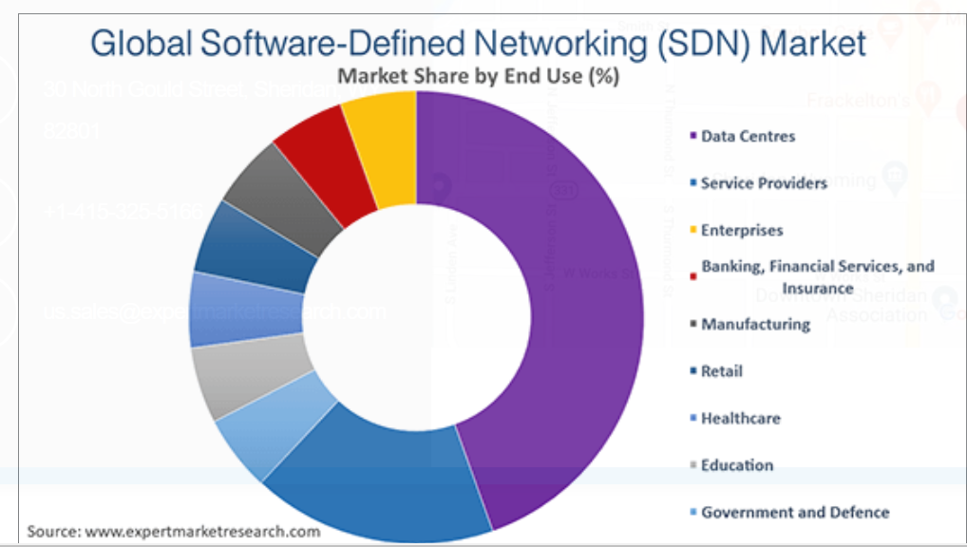
Fig 6: SDN Market Share by End User [13]
Network engineers have had to learn new skillsets [17]. They now need to use code to support SDN networks but there are also many other benefits:
Advantages | Disadvantages
Learn new skills | Learn new skills
Respond quickly to changing business needs | Possible job loses
Centralised control
Efficient administration
Better control of virtualisation and automation
Improves server utilisation
Reduced configuration errors
Easier device management
Highly sort after skill set
Improved job satisfaction
Increased salary
Table 6: Advantages and disadvantages for SDN for network engineer

Conclusion
SDN is an evolutionary step for networks, but it will not take away the need for traditional networking for larger enterprises. Although small and medium size organisations may be able to adapt to SDN relatively easily the complexity of many legacy networks will pose an issue for the larger organisations. In these cases SDN should be used to enhance and work alongside their current legacy networks.
COVID19 has accelerated the need for organisations to become more flexible with their ways of working.
User expectations have encouraged the technological advances needed to make SDN available and desirable to many organisations. The pandemic has expedited this even further.
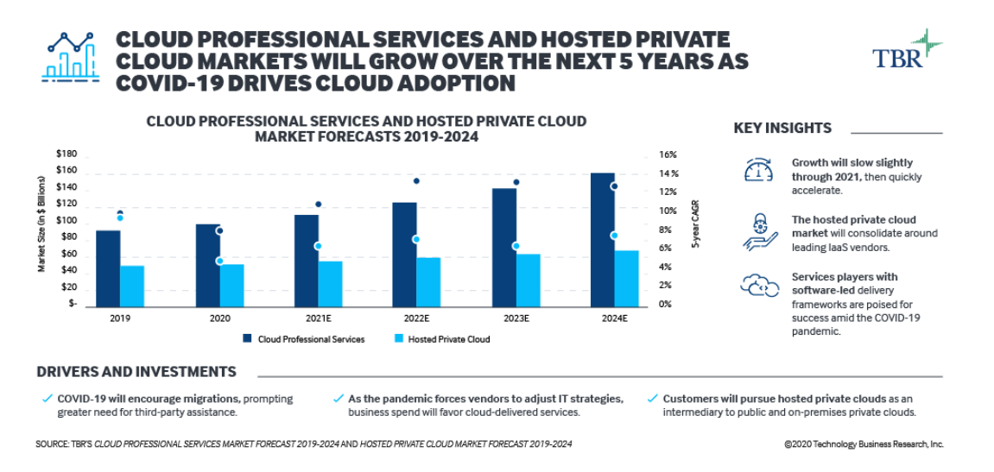
Fig 7: Cloud adoption growth forecast after pandemic [18]
SDN and Cloud Computing have helped many companies not only survive the unprecedented issues caused by the pandemic, but have used the opportunity for growth with:
- Flexibility, allowing companies to adjust to changing environments, business and customer needs
- Reduced operational costs
- Deploy and launch programs and applications quickly and seamlessly.
During a period where many things are outside of our control, cloud computing and SDN provides a granular control of networks that was previously difficult if not impossible to achieve.

Future work
Further research into serverless computing (Function as a Service), Function Platform as a service (fPaaS) and security best practice.
Gartner predicts that half of global enterprises will have deployed fPaaS by 2025, up from 20% today [19].

References

[1] |  | “What is Computer Networking?,” Cisco, [Online]. Available: https://www.  cisco.com/c/en/us/solutions/enterprise-networks/what-is-computer-  networking.html#:~:text=-%20Cisco%20What%20is%20Computer%20  Networking%3F%20  Computer%20networking,and%20various%20sensors%29%20that%20c  ommunicate%20with%20one%20another.?msclkid=0. [Accessed 1 April 2022].
[2] |  | J. Guice, “Looking Backward and Forward at the Internet,” The Information Society, vol. 14:3, no. 3, pp. 201-211, 1998.
[3] |  | B. VARGHESE, “History of the cloud,” bcs The Chartered Institute for IT, 19 March 2019. [Online]. Available: https://www.bcs.org/articles-opinion-and-research/history-of-the-cloud. [Accessed 1 April 2022].
[4] |  | W. R. S. Kevin R. Fall, “1.3 The Architecuture and Protocols of the TCP/IP Suite,” in TCP/IP Illustrated, Volume 1: The Protocols Second Edition, Addison-Wesley, 2012, pp. 13-15.
[5] |  | Cisco, “Cisco Annual Internet Report (2018–2023) White Paper,” Cisco, Updated 9 March 2020.
[6] |  | T. G. Peter Mell, “The NIST Definition of Cloud Computing,” NIST Special Publication 800-145 , Gaithersburg, 2011.
[7] |  | M. S. S. R. M. G. Velkoski Goran, “BUSINESS CASE: FROM IAAS TO SAAS,” in SMEs DEVELOPMENT AND INNOVATION, Ohrid, 2014.
[8] |  | “Global Market Insights,” June 2021. [Online]. Available: https://www.gminsights.com/industry-analysis/europe-cloud-computing-market?msclkid=516749d2b1bd11ec8150077c3cd4f1e8. [Accessed 1 April 2022].
[9] |  | A. Mehta, “A Complete Guide to API Development – Importance, Working, Tools, Terminology and best Practices,” appinventiv, 8 March 2022. [Online]. Available: https://appinventiv.com/blog/complete-guide-to-api-development/. [Accessed 1 April 2022].
[10] |  | B. N. A. K. O. T. T. Marc Mendonca, “Software Defined Networking for Heterogeneous Networks,” IEEE Communications Society Multimedia Communications Society Multimedia Communications Technical Committee E-Letter, vol. 8, no. 3, pp. 36-39, 2013.
[11] |  | S. R. M. Z. R. H. S. e. a. Saad H. Haji, “Comparison of Software Defined Networking with Traditional Networking,” Asian Journal of Research in Computer Science, vol. 9, no. 2, pp. 1-18, 2021.
[12] |  | R. K. M. C. Antoine Feghali, “SDN security problems and solutions analysis,” A. Feghali, R. Kilany and M. Chamoun, "SDN security problems and solutions analysis," 2015 International Conference on Protocol Engineering (ICPE) and International Conference on New Technologies of Distributed Systems (NTDS), pp. 1-5, 2015.
[13] |  | “Global Software-Defined Networking (SDN) Market Report and Forecast 2022-2027,” EMR, 2020. [Online]. Available: https://www.expertmarketresearch.com/reports/software-defined-networking-market. [Accessed 1 April 2022].
[14] |  | R. T. Fielding, “Architectural Styles and the Design of Network-based Software Architectures,” 2000. [Online]. Available: https://www.ics.uci.edu/~fielding/pubs/dissertation/rest_arch_style.htm. [Accessed 1 March 2022].
[15] |  | C. Pautasso, “RESTful Web Services: Principles, Patterns, Emerging Technologies,” in Web Services Foundations, New York, Springer, 2014, pp. 31-51.
[16] |  | C. Severance, “Discovering JavaScript Object Notation,” Computer, vol. 45, no. 4, pp. 6-8, 2012.
[17] |  | G. C. Gary Pfitzer, “Demystifying SDN for the Network Engineer,” 2017. [Online]. Available: https://mkto.cisco.com/rs/564-WHV-323/images/DemystifyingSDN_Whitepaper.pdf. [Accessed 21 March 2022].
[18] |  | F. M. V. R. P. V. e. a. Diego Kreutz, “Software-Defined Networking:,” 2014.
[19] |  | “Top 7 Most Common Uses of Cloud Computing,” IBM, 20 July 2020. [Online]. Available: https://www.ibm.com/cloud/blog/top-7-most-common-uses-of-cloud-computing. [Accessed 1 March 2022].

Bibliography
Snehal Mumbaikar and Puja Padiya. "Web services based on soap and rest principles." International Journal of Scientific and Research Publications 3.5 (2013): 1-4
Mark Masse, REST API Design Rulebook: Designing Consistent RESTful Web Service Interfaces, O’Reilly (2012)
Brian Mulloy, WEB API Design, apigee
Qiao Yan et al. "Software-defined networking (SDN) and distributed denial of service (DDoS) attacks in cloud computing environments: A survey, some research issues, and challenges." IEEE communications surveys & tutorials 18.1 (2015): 602-622.
Evangelos Haleplidis et al. "Software-defined networking (SDN): Layers and architecture terminology." RFC 7426 (2015).
MK Shin, Nam Ki-Hyuk, Kim Hyoung-Jun "Software-defined networking (SDN): A reference architecture and open APIs." 2012 International Conference on ICT Convergence (ICTC). IEEE, 2012.
S. Sezer et al. "Are we ready for SDN? Implementation challenges for software-defined networks," in IEEE Communications Magazine, vol. 51, no. 7, pp. 36-43, July 2013.
S Shin et al. "Enhancing network security through software defined networking (SDN)." 2016 25th international conference on computer communication and networks (ICCCN). IEEE, 2016.

