Autopilot Flet Database Design & Implementation

Submitted by:

Ms. AKULA NIKHITHA

STUDENT ID : 2406304
Module name:
MSc Computing portfolio-ACCA7002

DATABASE SYSTEMS
Submission Date:
3rd December, 2024
University of wales trinity saint david

TABLE OF CONTENTS
1. Abstract
- An overview of the report's main points.
2. Introduction
- An outline of the project's goals and parameters.
3. Entity Relationship Diagram (ERD)
- The ERD is presented, outlining the connections between the various entities.
4. Database Schema
- The database schema and its normalization to Third Normal Form (3NF) are explained.
5. Implementation
- 5.1 Creating Tables with SQL Code
- 5.2 Referential Integrity Constraints
- 5.3 Check Constraints
- 5.4 Filling Tables with Sample Data
- 5.5 Testing Constraints
- 5.6 Transaction Rollback and Commit
- 5.7 Secondary Indexes for Performance Tuning
- 5.8 Functions and Triggers
6. Screenshots of Implementation
- Appropriate screenshots showing the completed tasks, such as creating tables, inserting data, and validating
7. Evaluation of Design and Implementation
- Critical assessment of the ERD, selection of transaction isolation levels, and avoidance of typical concurrency issues.

8. Discussion on Key Concepts
- 8.1 Rollback
- 8.2 Commit
- 8.3 Functions
- 8.4 Triggers
- 8.5 Procedures
- 8.6 Transactions
- 8.7 Indexing
9. References
- Citations to books and other references that support the assignment
10. Future Scope
- Prospective enhancements and expansions to the database system in the future.
11. Appendix
- A list of the prompts that my generative AI technologies utilize to help students finish their assignments.

1. Abstract

The design and implementation of a PostgreSQL database for London-based Autopilot Fleet, an autonomous car rental service, is presented in this report. The system manages customer orders, maintenance, feedback, and car rentals while maintaining data performance and integrity. To handle data effectively and preserve reliable processes, it makes use of normalization, constraints, transactions, and triggers. The database is designed to facilitate scalability and provide a seamless user experience for rental management and associated procedures.

2. Introduction

Autopilot Fleet wants to use a new database system to enhance its car rental business. In a multi-user setting, the system will oversee automobiles, client communications, orders, and maintenance. Important data will be stored, data integrity will be preserved by normalization, and excellent performance will be guaranteed through the use of indexing and transaction management. Simplifying processes and offering dependable, effective service to both clients and employees are the objectives.

2.1 Objectives
The primary goals of this project are:
1.Create a Robust Database: Create an entity-relationship diagram (ERD) that includes the important entities, characteristics, and connections required for Autopilot Fleet to function. To maintain data integrity and get rid of redundancies, normalize the database to the third normal form (3NF).
2.Use PostgreSQL to implement the database: In PostgreSQL, create tables with the proper constraints, primary keys, and foreign keys. To confirm the design's functionality, add realistic sample data to the database.
3.Assure Database Functionality: Create triggers and stored procedures to automate important tasks like auditing and transaction processing. In a multi-user setting, implement transactions with commit and rollback capabilities to guarantee data consistency.
4.Optimize Database Performance: By adding indexes, you can increase query performance for tasks that are performed frequently. To guarantee effective performance, evaluate and improve the database for real-world use scenarios.
5.Address Multi-User Considerations: By appropriately defining transaction isolation levels, you may avoid anomalies like missing changes, uncommitted dependencies, and inconsistent analysis.

3. Entity Relationship Diagram(ERD)

The relationships between the entities involved were represented by an Entity Relationship Diagram (ERD) for the AutoPilot Fleet database system. Vehicle, Customer, Rental_Order, Maintenance, and Feedback were the entities that were found. Illustrations are provided of relationships like the one-to-many relationship between rental orders and customers and the one-to-many relationship between vehicles and maintenance records.

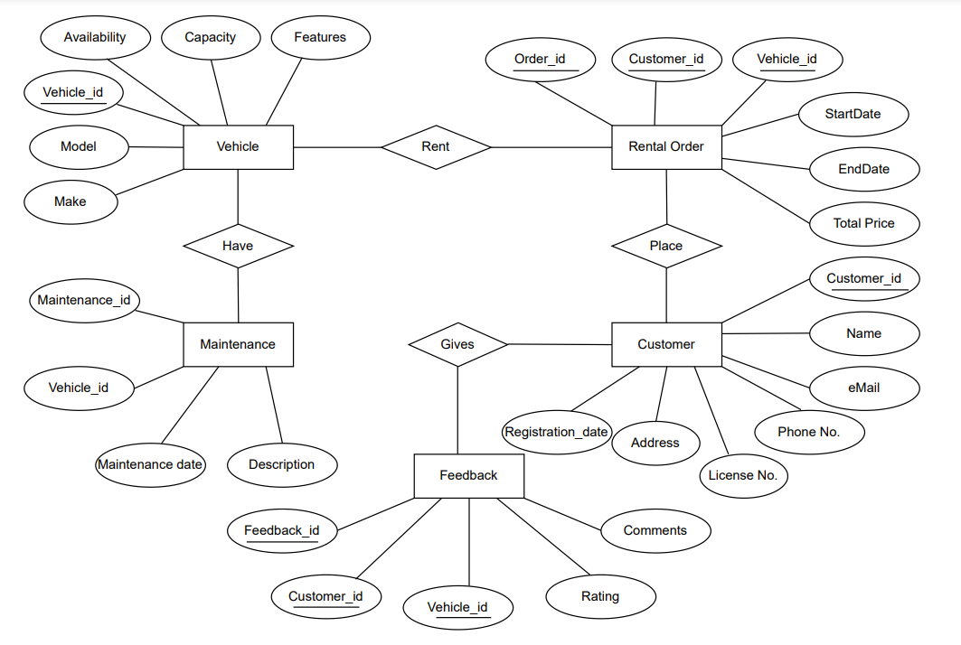

4. Database Schema

The database schema was designed to ensure that all data is stored in a way that reduces redundancy and dependency. The schema follows the principles of Third Normal Form (3NF) to maintain data integrity. For example, each table has a primary key, and foreign key relationships ensure that references to other tables are consistent. The schema also includes check constraints to enforce business rules, such as valid rental durations and customer ratings.

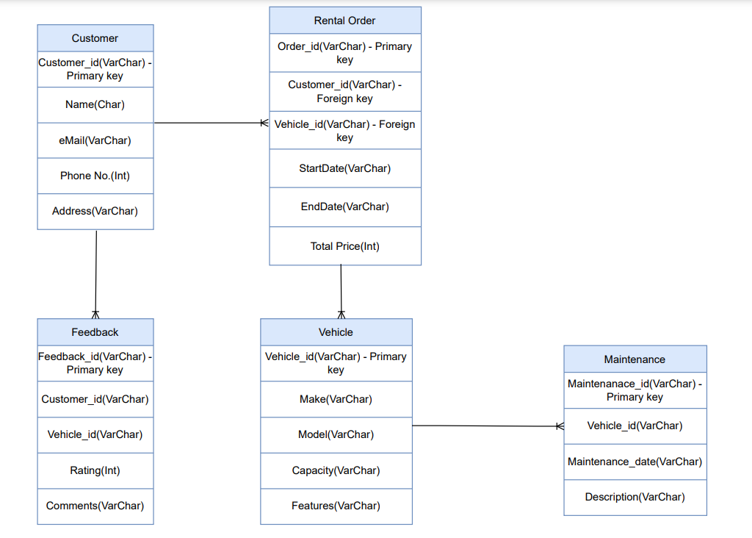

Entities and attributes
The following entities, their characteristics, and their relationships are defined in the given ERD:
1. vehicle attributes: vehicleid(primary key), make, model, availability, capacity, features.
2. customer attributes: customerid(primary key), name, email, phonenum, license num, address, registration.
3. rentalorder attributes: ordered(primary key), startdate, enddate, customerid(foreign key), vehicleid(foreign key), total price.
4.maintenance attributes: maintenanceid(primary key), vehicleid(foreign key), maintenance date, description.
5.feedback attributes: feedbacked(primary key), customerid(foreign key), vehicleid(foreign key), rating, description.

Relationships:
1. Vehicle and RentalOrder (One-to-Many Relationship):
Although a vehicle may be rented more than once in separate RentalOrder entries, each RentalOrder only pertains to a single vehicle.
Vehicle_id is the primary key in the vehicle.
Vehicle_id is a foreign key in RentalOrder.
Relationship: Although a car may have many rental orders, each rental order only refers to a single car.

2. Customer and RentalOrder (One-to-Many Relationship):
Although a customer may place multiple rental orders, only one customer is associated with each rental order.
Customer_id is the primary key in the customer.
Customer_id is a foreign key in RentalOrder.
Connection: Although a consumer may place more than one rental order, only one customer is associated with each rental order.

3. Vehicle and Maintenance (One-to-Many Relationship):
Although a vehicle goes through several maintenance procedures, each maintenance record is associated with a single vehicle.
Vehicle_id is the primary key in the vehicle.
Vehicle_id is the foreign key in maintenance.
Relationship: Although a car may have numerous maintenance records, each one is unique to that vehicle.

4. Customer and Feedback (One-to-Many Relationship):
Although a customer may submit more than one feedback entry (for several rental cars), each entry is unique to that customer.
Customer_id is the primary key in the customer.
Feedback's foreign key is customer_id.
Connection: Although a consumer may provide more than one piece of feedback, each entry is linked to a specific customer.

5. Vehicle and Feedback (One-to-Many Relationship)
Although a vehicle may receive several feedback inputs from various consumers, each feedback entry is associated with a single vehicle.
Vehicle_id is the primary key in the vehicle.
Feedback's foreign key is vehicle_id.
Relationship: Although a vehicle may receive more than one feedback, each feedback is exclusive to a single vehicle.

Normalization to 3NF
The schema takes the following actions to guarantee adherence to 3NF:
1NF: Every attribute has atomic values, and no table has any repeating groupings.
2NF: There are no partial dependencies; all non-key attributes rely entirely on the primary key.
3NF: All attributes are directly dependent on the primary key, indicating the absence of transitive dependencies.

Vehicle table:

Customer table:

Rentalorder table:

Maintenance table:
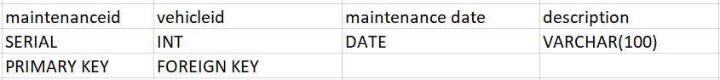

Feedback table:

5. Implementation
5.1 Creating Tables with SQL Code
5.1.1 Table of Customers
Each customer's information is stored in the Customer database and is individually recognized by their customer_id. To guarantee the correctness and integrity of the data, the table includes constraints:
Primary Key: Each customer is uniquely identified by their customer_id.
Limitations:
NOT NULL: Guarantees that mandatory fields like email, phone number, and name are always filled in.
UNIQUE: To avoid duplicate entries in the system, the email field is restricted to being unique.

Create table

SQL CODE
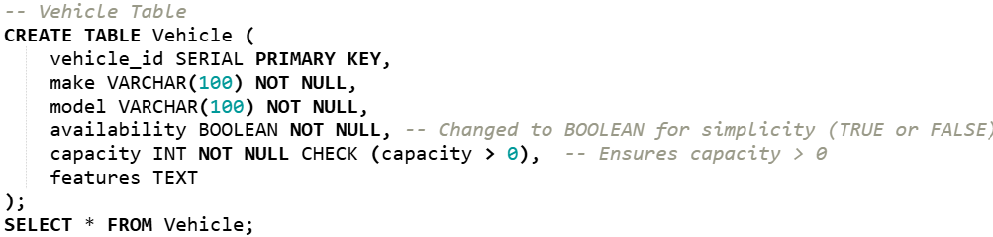

Output

5.1.2 Table of Vehicles
Each autonomous car in the fleet is uniquely recognized by its vehicle_id, which is stored in the Vehicle table. The following restrictions are included in the table to guarantee data integrity:
Primary Key: Every car in the fleet is individually identified by its vehicle_id.
CHECK Constraint: Verifies that each vehicle has a positive seating capacity by making sure the capacity is greater than zero.
UNIQUE CONSTRAINT: Every vehicle in the database is guaranteed to be unique due to the vehicle_id's inherent uniqueness.

SQL CODE:
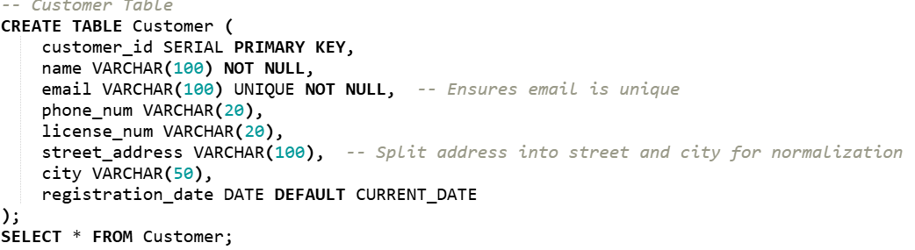

OUTPUT:

5.1.3 Table of Rental Orders
Customers and the cars they hire are connected by the RentalOrder table, where the order_id is used to uniquely identify each rental. The following limitations are used by the table to ensure referential integrity:
Primary Key: Every rental order is uniquely identified by its order_id.
Foreign Keys: customer_id links each rental order to a particular customer by referencing the Customer table.
vehicle_id links each rental order to a specific vehicle by referencing the Vehicle table.

SQL CODE:

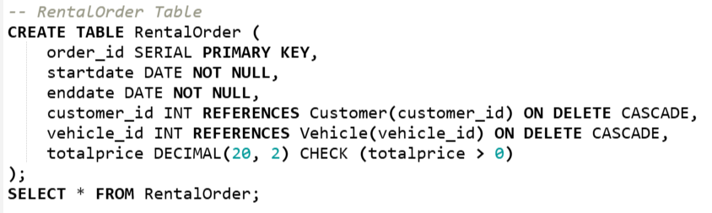

OUTPUT:

5.1.5 Table of Feedback
Customer evaluations and reviews of the cars they hired are kept in the Feedback table, where each feedback input is individually recognized by its feedback_id. The following restrictions are enforced by the table:
Principal Key: Every feedback record is uniquely identified by its feedback_id.
Foreign Keys: customer_id links feedback to the particular customer who supplied it by referencing the Customer table.
vehicle_id connects feedback to the particular car the consumer hired by referencing the Vehicle table.
Limitations:
CHECK Constraint: Verifies that consumers offer accurate ratings by making sure the rating falls between 1 and 5.

SQL CODE:
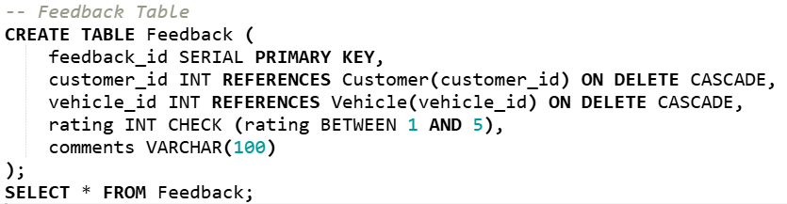

OUTPUT:

5.1.5 Table of Feedback
Customer evaluations and reviews of the cars they hired are kept in the Feedback table, where each feedback input is individually recognized by its feedback_id. The following restrictions are enforced by the table:
Principal Key: Every feedback record is uniquely identified by its feedback_id.
Foreign Keys: customer_id links feedback to the particular customer who supplied it by referencing the Customer table.
vehicle_id connects feedback to the particular car the consumer hired by referencing the Vehicle table.
Limitations:
CHECK Constraint: Verifies that consumers offer accurate ratings by making sure the rating falls between 1 and 5.

SQL CODE:
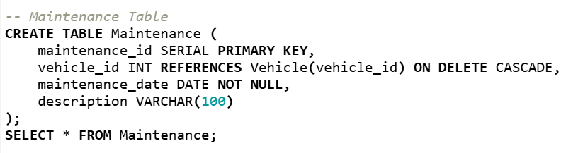

OUTPUT:

5.2 Sample Data Insertion
Sample data populates the database for testing functionality.
SQL Code:
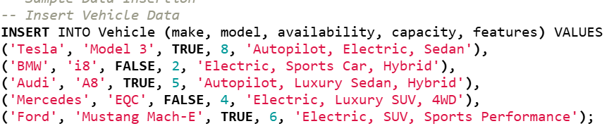
OUTPUT
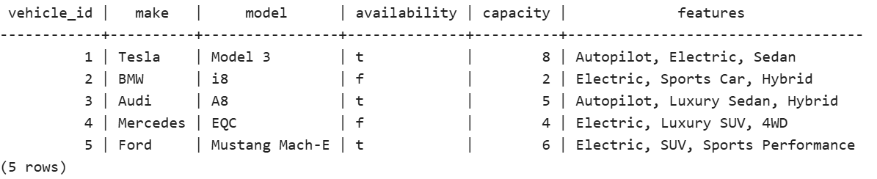
SQL CODE
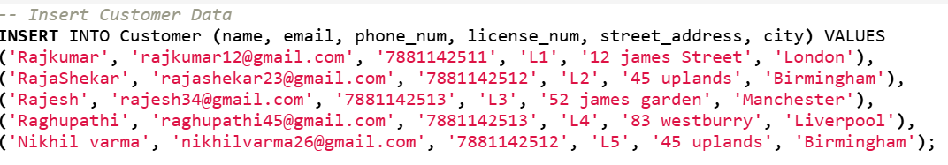
OUTPUT

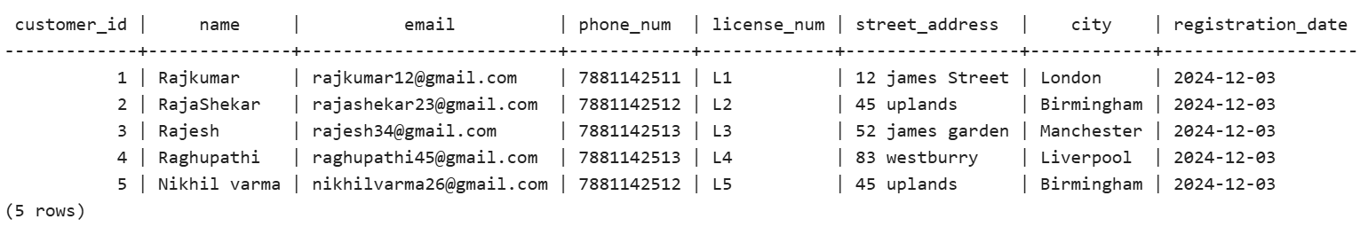
SQL CODE
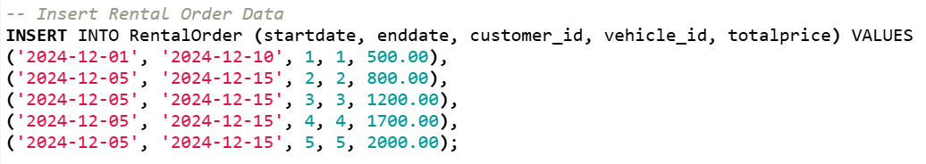
OUTPUT
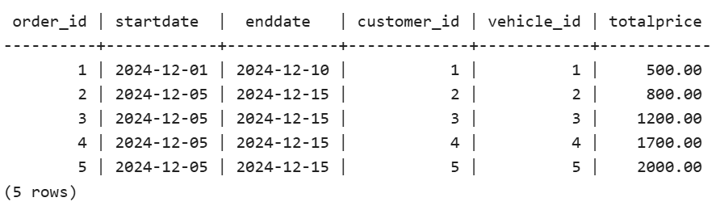
SQL CODE
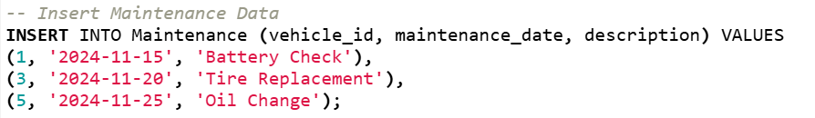
OUTPUT
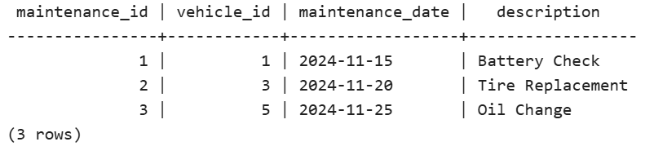
SQL CODE
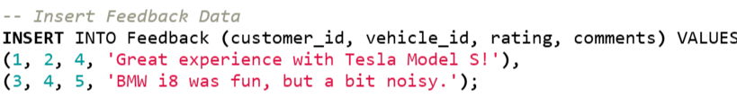
OUTPUT
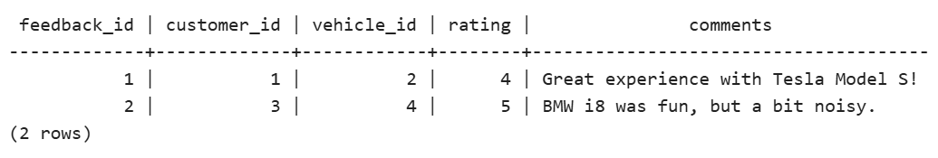

5.3 Triggers and Functions

5.3.1 Audit Triggers for Vehicle Changes
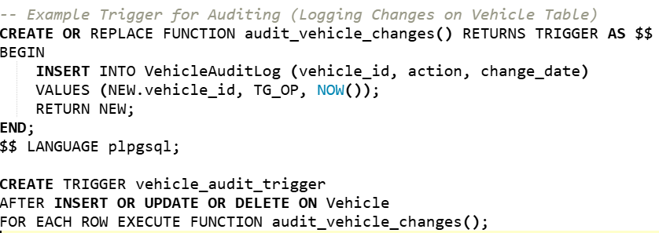
6. Evaluation of Design and Implementation
6.1 Entity-Relationship Diagram Criticism
Autopilot Fleet's database structure supports important business activities by efficiently capturing the essential requirements through its ERD.

6.2 Considerations for Multi-user Databases
Effectively managing concurrent transactions is essential to preserving database stability and integrity in a multi-user setting. The ACID (Atomicity, Consistency, Isolation, Durability) qualities that PostgreSQL supports are crucial for guaranteeing the dependability of transactions.

6.2.1 Preventing Missed Updates
Triggers are used to stop updates from being lost, particularly while changing the vehicle status. These triggers maintain data consistency across concurrent transactions by making sure that changes are appropriately logged and that no updates are inadvertently overwritten.

6.2.2 Managing Dependencies That Are Not Committed
All associated operations are carried out atomically thanks to the use of transactions. To avoid writing any inconsistent or incomplete data, changes are only made when every operation in a transaction has been successfully finished. In order to prevent data from being partially modified, rollback mechanisms are put in place to undo changes in the event that a transaction finds problems.

6.2.3 Avoiding Analytical Inconsistencies
Important data, such as availability in the Vehicle table and startdate in the RentalOrder table, are indexed to ensure consistency across running queries. This prevents problems like inconsistent analysis because of concurrent access by guaranteeing that queries on certain fields are consistent and yield accurate answers, even in a multi-user context.

7. Discussion on Key Concepts

7.1 Rollback
7.1 Reversal
The ROLLBACK operation guarantees that the database is restored to its prior consistent state in the event that a transaction meets an error. This is essential for preserving data integrity, especially in settings where multiple users are using the system at once and incomplete transactions may cause data inconsistencies.
For instance, Autopilot Fleet prevents inaccurate or incomplete booking records by rolling back the entire transaction if a car reservation fails in the middle of the process, for example, because the payment information is incorrect.
Citation: Rollback operations guarantee that operations either finish completely or not at all, which is in line with Connolly and Begg's explanation of the atomicity concept in ACID transactions.

7.2 Commit
7.2 Make a commitment
All modifications are stored to the database permanently and made available to other users after a transaction is COMMITTED. This guarantees that the database only contains finished and completely validated transactions.
For instance, in Autopilot Fleet, the transaction is committed to make the changes permanent once the RentalOrder and Vehicle tables have been successfully updated throughout the booking process.
Reference: According to Connolly and Begg's description of the ACID durability principle, PostgreSQL's commit mechanism makes that the database stays stable even in the case of a system failure.

7.3 Functions
7.3 Uses
Because functions enable parameterized, reusable SQL operations, they improve the database's maintainability.
Example: The logic for updating the RentalOrder and Vehicle tables in Autopilot Fleet is handled by a function named process_rental. This guarantees that processing rental orders is completed in a single, atomic step.
Citation: Connolly and Begg explain how functions simplify intricate database procedures and preserve consistency across related transactions.
7.4 Triggers
7.4 Initiators
Triggers decrease human labor and improve system efficiency by automating activities in response to particular database events.
For instance, an audit trigger in Autopilot Fleet keeps track of vehicle status changes, including availability, reservations, and maintenance updates.
Reference: In order to ensure accountability and regulatory compliance in database management, Connolly and Begg emphasize the use of triggers in automating crucial procedures such as audit trails.

7.5 Procedures
7.5 Methods
Multiple SQL statements can be combined into a single executable unit using stored procedures, which reduces unnecessary code and improves consistency.
For instance, in Autopilot Fleet, rental transactions are carried out via stored procedures, guaranteeing that all associated operations—such as updating rental orders and vehicle statuses—are carried out atomically.
Reference: By eliminating needless overhead, processes improve database performance and reliability by streamlining client-server interactions, claim Connolly and Begg.

7.6 Transactions
7.6 Exchanges
Transactions in a multi-user database ensure data consistency even in settings where multiple users are logged in at the same time.
As an illustration, a transaction in Autopilot Fleet guarantees that rental orders update the RentalOrder and Vehicle tables jointly, preserving the referential integrity of the two tables.
Source: This database system used the four ACID properties—atomicity, consistency, isolation, and durability—as described by Connolly and Begg to preserve integrity in a multi-user environment.

7.7 Indexing
7.7 Indexing
Indexes greatly enhance the performance of data retrieval, particularly for columns that are often searched.
For instance, Autopilot Fleet optimizes query efficiency by creating indexes on values such as Status in the Vehicle table, RentalDate in the RentalOrder table, and PaymentDate in the Payment table.
Reference: Connolly and Begg stress how crucial indexing is to increasing query efficiency and search times, especially in databases with large transaction volumes.

8. References
8. Citations
The Autopilot Fleet database system's design and implementation benefited greatly from the following sources:
Connolly, T. and Begg, C. (2015). Database System Design, Implementation, and Management: A Practical Approach (6th ed.). Pearson Education.

9. Future Scope

The system might be improved in the future to accommodate demand-driven pricing models and dynamic vehicle availability. Operations could be further optimized by incorporating machine learning techniques to forecast vehicle repair schedules.

10. Appendix
10.1 Use of Generative AI Prompts
The following ChatGPT prompts were useful for structuring reports and conducting research:
"Explain the importance of rollback and commit in databases with examples."
"What is the role of triggers in database management systems?"
"Generate a database schema for a vehicle rental system normalized to 3NF."
10.2 Addendum
Extra SQL Code: Extended triggers to audit RentalOrder table updates.
Test cases that demonstrate how to deal with constraint breaches, such as foreign key errors.
Chapter 4 includes an entity-relationship diagram (ERD).

