Name:
Student Number:
Module Title:
ASSIGNMENT TITLE: MARKETING MANAGEMENT – ASSESSMENT 1

MODULE LECTURER’S NAME:

Executive summary
Marketing management influences an organisation to focus on customer satisfaction, promote services and products. This report shed light on marketing management that had been discussed in context of GSK, UK. Communication model had been explained with a diagram and IMC had been described with special emphasis of GSK. Current offline and online promotional strategies of GSK had been described for increasing brand awareness. With help of customer journey map, customer touch points had been analysed.

Table of Contents
Introduction 5
Communication definition 5
Explanation of communication model 5
Integrated Marketing Communications 6
Current promotions 8
Promotional strategies for rising brand awareness 9
Brand equity and branding definition 11
Keller's model of Brand Equity 12
Discussing customer touch-points and journey 14
Model of Total Engagement 15
Conclusion 17
Reference List 18

Introduction
Marketing management works as an organisational discipline, focusing on marketing methods, techniques and orientation. This report has focused on marketing management that is discussed in context of GlaxoSmithKline (GSK), UK. In this report, definitions of communication, "Integrated Marketing Communications" (IMC), brand equity have been provided. After explaining communication model, current promotional strategies of selected company has been analysed. Keller's model of Brand Equity and Total Engagement has been taken into consideration. Furthermore, customer touch-points, along with their journey, have been discussed.

Communication definition
As stated by Datta et al. (2017), communication refers to a process of exchanging and imparting information in a written or verbal format. In marketing management context, multiple tools and channels are used to communicate with different stakeholders. Examples of communication system types are radio, optical, half-duplex, tactical and duplex system.

Explanation of communication model
In purpose of effective communication, nine major contributors are present-
- 2 Major parties- these involve receiver and sender
- Two major tools- Media and message
- Four major functions of communication- Feedback, response, encoding and decoding
- 1 factor in system involves noise that can interfere with intended interaction (Armaniads.com. 2020)
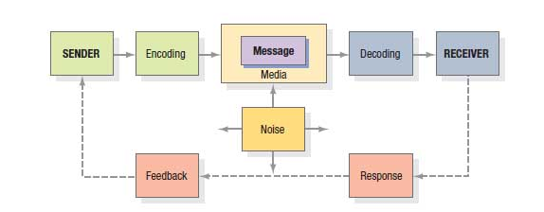
Figure 1: Communication process macro-model
(Source: Armaniads.com. 2020)
According to this model, senders have to know type of audiences that have been selected for interaction and type of responses. Hence, it is necessary to transfer message through any media that can reach target audience as well as construct feedback channels for response monitoring. A greater level of senders' and receivers' experience makes more effective message delivery.

Integrated Marketing Communications
As propounded by Mintzes et al. (2020), IMC works as a concept where an organisation carefully coordinates along with integrates multiple channels of interaction for delivering a consistent and clear message. Hence, IMC facilitates to ensure message consistency and complementary media usage.
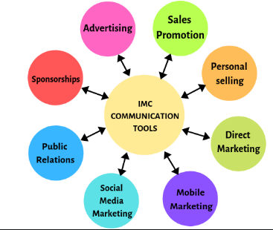
Figure 2: IMC
(Source: Armaniads.com, 2020)
Different IMC tools include advertising, direct marketing, personal selling, marketing through social media, sponsorships, sales promotion, public relations and mobile marketing. Promotional tools work effectively while they work in collaboration in comparison to isolation. Strategies behind IMC include creating customer-friendly experiences while delivering services. Hence, brand promotion is important for companies in gaining a competitive edge and increasing market share. In GSK, apart from online and offline communication with customers, this company has developed an IMC framework by interacting with investors, HCPs, and R&D partners.
Interacting with investors
Management maintains constructive and regular dialogue with its investors for communicating performance and strategy in purpose of promoting confidence of investors along with ensuring continuous access to the capital.
HCPs
This company communicates with medical experts and HCPs for understanding patient requirements and ensuring products.
R&D partners
A collaborative and communicative framework has been built with national systems of health, scientific institutions, and academia and business partners for development of differentiated products of healthcare.
Regulators and government
Interaction of management takes place with regulators and government for advocating policies that can encourage innovation, provide patient support and promote efficient healthcare spending management.

Current promotions
- Currently, GSK is emphasising product promotion through television commercials that work as ways o brand recalling as brands are working for a long time. Apart from TV advertisements, this company uses electronic media as well as commercials to promote its nutritional products of healthcare. For product promotion, this brand has engaged different celebrities such as Sachin Tendulkar, Virendra Sehwag, and Kapil Dev (Gsk.com. 2020).
- As a result, this brand has been successful in maintaining high-quality service delivery. In addition to that, GSK utilises its website for creating brand awareness and driving customer loyalty.
- In special occasions, GSK provides attractive discounts to customers and discounts in sales to its retailers.
- Participating in activities regarding social responsibility works as an instrumental strategy for brand promotion for this company. Through these activities, GSK supports multiple forums, in support of healthcare, education, water facilities, lighting facilities and disaster support.
- Furthermore, management is focusing on adjusting "Selling, general and administration" or SG&A costs in form of a turnover percentage. As a result, adjusted costs have become 31.7% that seems to be 0.8% high in "Cost Estimation Relationship" (CER). Presently, this company is able to enhance its investment in promotional activities (Gsk.com. 2020). Hence, improvement has been seen in recent product launches in respiratory diseases, vaccines and HIV treatments. Besides, this brand has reduced operating profit in Pro-forma adjustment. This initiative has facilitated promotional support of products.
- Prioritising underserved people of developing nations in product promotion is working as a resilient strategy as it is creating an image of "socially responsible" brand before customers. Within financial year 2025, management has aimed to reach around 800 million people that are still neglected. In this mission, this brand has considered various factors such as product donations, tiered pricing and agreements of voluntary licensing. In this way, GSK can reach thousands of generic manufacturers. As in 2018, GSK set its target; this brand has already reached around 192 million patients with help of access strategies (Gsk.com. 2018).
- As stated by Mishra and Sanghvi (2020), using digital tools facilitate to promote services and products to a large number of Digital audience transformation has become a stepping stone for this company to promote its services to global customers. From financial year 2019, management set a framework to enrich technology for driving performance and increasing ability in medicine delivery. Data have been leveraged for unlocking fast and smart interactions with customers. In this way, management can understand whether their commercial activities are impacting. In this context, piloting recommendations, driven by artificial intelligence, is working successfully to promote its HCP or healthcare professional engagement.
- This company maintains a section of "RSS feeds" or "Rich Site Summary" that works efficiently for staying updated with new content on the official website (Gsk.com, 2020). This section also acts as an effective promotional strategy of GSK as updates of new services and products are easily available to people.

Promotional strategies for rising brand awareness
In order to raise potential brand awareness, GSK can apply following strategies-
Presence in social media
In every social media site, GSK needs to promote its new program so that customers can be aware of activities of this company. In early stage of 2020, this brand initiated a program of two years for preparing GSK into two major companies-
- New GSK-It represents a bio-pharma organisation with innovative "Research and Development" (R&D) approach, prioritising immune system science and using genetics (Gsk.com, 2020).
- A new firm for consumer healthcare with category-leading brands along with technological innovation.
Documenting such information on social media platforms can make customers confident to purchase their services.
Building relationships
As stated by Sanober et al. (2018), relationships with physicians have to be strengthened for a pharmaceutical company to perform as a successful marker. Physicians prefer prescribing pharmaceutical products and drugs from trustworthy sales reps so that responsibility can be perceived with patients. Hence, GSK can expand their networks to interact with physicians for knowing patient requirements and get physicians about GSK's cost-effective and high-quality services.
Offering free samples
Special offers, such as delivering free samples or samples at a discounted rate, work as an efficient strategy for promotion (Tripathi and SGI, 2018). In this condition, GSK can adopt strategies of offering free samples certainly attract physicians for prescribing as patients can use these products at free-of-cost and without any risk of harmful effects.
Having quality content in official websites
In marketing management, quality content in websites plays a vital role to attract global customers (Datta, Ailawadi and Van Heerde, 2017). In this context, GSK management needs to monitor regularly, so that updated information is available, required by a patient or a physician. This content has to include drug benefits, data of clinical trial, recommended dosage, risks, and safety information. Besides, website design needs to be easy for navigation, and a system has to be placed to capture email address of an individual.
Making emotional connections with customers
Reaching clients gets easy while a firm is able to build an emotional connection with its customers (Mishra and Sanghvi, 2020). This emotional connection building can work in a great way for GSK while promoting any drug or vaccine. For example- one among twenty individuals dies due to COPD ("Chronic Obstructive Pulmonary Disease") globally. Under these circumstances, COPD candidate of GSK works as an effective therapeutic vaccine to reduce acute exacerbations frequency. Hence, while promoting this vaccine, GSK can run a campaign on mobile application that can encourage people to share their harmful habits such as smoking or tobacco consumption that can increase COPD risks.
Creating visual advertisements for physicians
GSK can use attractive educational posters so that this organisation can create value for presenting to offices of physicians. As a result of this strategy, potential customers can get acquainted with brand value.
Participating in events and conferences
Physicians tend to gain a large amount of knowledge; under these circumstances, management of SK can reach individuals at conferences (Linchpinseo.com, 2020). In this way, GSK authority can get an excellent opportunity for interacting with the physicians and getting feedback.
Utilising search engines
As most of people utilises Google for finding answers, hence, content marketing team of GSK can be recommended to conduct pharma SEO or Search Engine Optimisation.

Brand equity and branding definition
As propounded by Yasa et al. (2020), branding refers to a marketing practice that includes creation of designs, symbol and name for identification and differentiation of services along with products. For example techniques of branding involve taglines, logos, mascots or jingles. On other hand, Tripathi and SGI (2018) stated that brand equity works as a value, generated by a company from services and products with help of a recognisable identity while it is in comparison with generic equivalent.
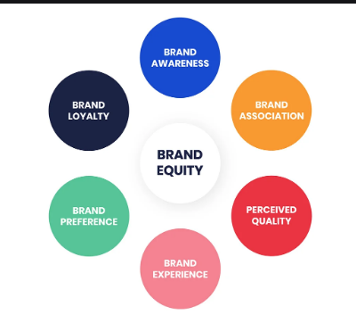
Figure 3: Process of building brand equity
(Source: Linchpinseo.com, 2020)
Organisations create brand equity in order to make services superior in reliability, quality, easily recognisable, and memorable. Four major elements of brand equity are brand attributes awareness, brand loyalty and perceived quality (Linchpinseo.com, 2020). For example- to secure brand loyalty, GSK is focusing on contributing to society, besides securing financial returns. In financial year 2019, GSK has made good progress within every Trust commitments. Additionally, this company has found to be well-positioned in responses to increase investors' interests in ESG or "environmental, social and governance" performance. In this way, secured position in brand equity of GSK has been proved as it has been regarded as top pharma organisation in the Sustainability Index of Dow Jones.

Keller's model of Brand Equity
According to Keller's model, in purpose of building a strong brand, customers have to be shaped in a way so that they can feel and think about products. As propounded by Vasileva and Vasileva (2017), in order to achieve this objective, building right customer experiences is essential around the brand. In this way, customers can generate positive and specific thoughts, feelings, perceptions and beliefs. While having resilient brand equity, customers not only buy products, however, they recommend others. As a result, a loyal customer-base can be created and a competitive edge can be gained.
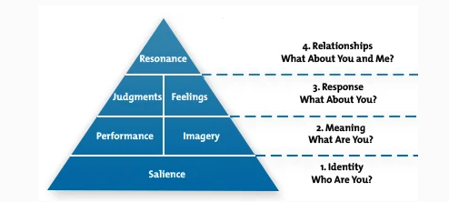
Figure 4: Keller's model of Brand Equity
(Source: Vasileva and Vasileva, 2017)
This model illustrates that four steps are required to build brand equity-
- Brand identity-This step concentrates on "brand salience" creation; here, a marketer needs to ensure that perceptions regarding brand are working correctly at important buying process stages.
- Brand meaning- Two major factors of this step are "imagery" and "performance" for interacting and identifying correct meaning of a brand.
- Brand responses- In this step, responses of customers are categorised into two sections- feelings and judgements.
- Brand resonance- Achieving this step is difficult as, at this stage, a brand needs to create a psychological and deep bond with customers. This step is further categorised into four sections attitudinal attachment, behaviour loyalty, active engagement and community sense.
According to Keller, six main factors and four levels are helpful in purpose of brand development (Yasa et al. 2020). These six factors are resonance, salience, feelings, judgements, imagery, and performance.
Taking example of GSK, this company prioritises customer experiences to achieve every aspect of brand equity. Based on a statement of the lead in Global insights of denture care team in UK, it has been revealed that consumers have been placed at "heart" of every activity of GSK. Whether it is a gel of pain relief or any denture care product, this brand is in track of continuous evolution and innovation according to responses collected from customers.

Discussing customer touch-points and journey
As stated by Datta, Ailawadi and Van Heerde (2017), customer touch points refer to customer contact points of a brand from starting to finish. It can be illustrated with an example that customers can find a business in advertisements, online, and see reviews and ratings, visit website, and contact customer services.
For this purpose, engagement with HCPs plays a vital role in securing customer touch points in GSK. Hence, management has revised incentive program of sales representatives so that they can be encouraged to make better connections with customers. In this way, best salespersons can be attracted and retained and dialogue with HCPs can be enhanced. As a result, HCPs can serve patients ina better way. Furthermore, management has upheld a values-led and ethical approach regarding HCP engagement while supporting strong performance delivery. This approach has already been applied in Canada, UK and United States with proper training, monitoring and controls.
On other hand, in specific countries, modifications have been brought in engagement processes with HCPs for improvement of clinical experience and new data understanding with innovative products for patients. Additionally, for better communication purposes, GSK engage with their concerned HCPs by introducing scientific workshops that can enable interactive debates among HCPs. In addition to that, management has enhanced digital interaction channels for supporting scientific engagement by educational activities (like webinars) boards of virtual advisory. This initiative seems to be effective to get feedback and reviews from HCPs.
Programs of patient assistance at Response Centre of GSK
GSK is offering these programs to communicate directly with eligible patients that need help to pay for vaccines or medicines, prescribed by GSK. This interactive service is served at free-of-cost (Gsk.com, 2018). In the website of "GSKForYou.com", patients can get full details of special offers regarding product savings and covered products. Furthermore, calling services are available at this centre to get complaints at earliest convenience with help of a given phone number. The facilities of having assistance from an expert representative and return calls are available. Besides, additional services are available at this centre to interact with HCPs for solving inquiry related to medical information, coding and billing as well as medications of "over-the-counter".
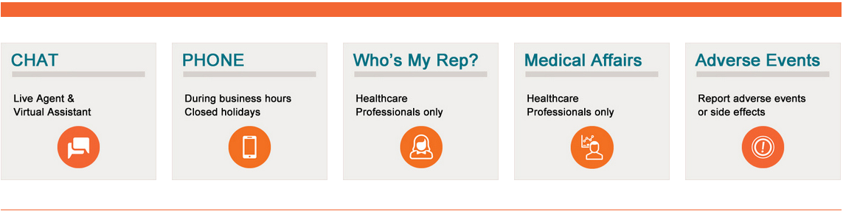
Figure 5: Customer journey with touch points
(Source: Gsk.com, 2018)
As customer touch points, multiple ways are available such as-
- chatting with a virtual assistant and live agents
- Connecting through phone calls at time of business hours
- Interacting with expert HCPs
- Providing scientific, evidence-dependent and balanced answers to the unsolicited medical queries.
- Receiving reports regarding possible side effects as such effects can negatively impact consumers' safety

Model of Total Engagement
Based on this model, it can be illustrated that engaged customers refer to people that are loyal to a specific brand and recommend services along with products of that particular brand. As stated by Sanober et al. (2018), this model is effective for creating customer engagement. This moel initiates with proposition regarding business-oriented major strategic elements that are required to be aligned and designed in customer engagement purposes. These elements involve-
- CVP or "Customer Value Proposition"- Value that has been offered to customers. (Emerald.com, 2020) In order to secure value proposition, management of this company focuses on Transparency, Patient Focus, Integrity and Respect. Additional three building blocks have been given importance such as Trust, Performance and Innovation, driven by performance-dependent culture. On other hand, this organisation is investing in technical along with scientific excellence in order to introduce and develop new product pipeline that can meet requirements of consumers, payers and patients.
- Effective branding- Value proposition has to form a major part. In purpose of effective branding, GSK is strengthening "Research and Development" or R&D pipeline by prioritising advanced technologies, human genetics as well as immunology. Through this way, effective branding has been successfully established for patients' delivering transformational medicines.

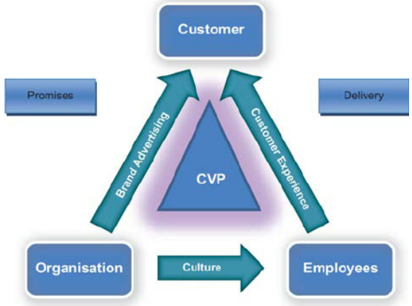
Figure 6: Model of Total Engagement
(Source: Emerald.com, 2020)
- Culture-This factor represents organisational internal aspects, including internal behaviours, values and goals. In GSK, a performance-based culture is encouraged that is aligned to expectations and values of this company. In context of expectations, accountability, courage and teamwork are major components in this organisational culture. This culture has been established in such a way so that GSK can become one of most innovative, trusted and best-performing healthcare companies.
- Customer Experience- It works as an amalgamation of emotional along with physical elements. In purpose of ensuring physical conditions of patients, innovation has been driven in this company n treatment of HIV, Oncology, immuno-inflammation, infectious and respiratory diseases. On other hand, for securing emotional well-being, expert assistants of this company directly interacts with its patients for resolving issues.

Conclusion
From this report, it can be concluded that communication plays a vital role in marketing management that becomes influenced by efficiency of senders along with receivers. GSK prioritises both online as well as offline communication channels to interact with customers, HCPs and employees. A coordinated communication network has been developed in GSK with efficient IMC management. In context of current promotions, it has been summarised that both traditional ways, involving TV commercials and modern ways, including social media platforms are used to promote services.
However, building relationships, offering free samples and having quality content can be beneficial for product promotion of this company. In context of brand equity, a customer-centric approach has been proven to be effective for GSK. Live chats, connecting through phone calls and interacting with expert HCPs have been proven to be effective touch points of customers.

Reference List
Journals
Datta, H., Ailawadi, K.L. and Van Heerde, H.J., 2017. How well does consumer-based brand equity align with sales-based brand equity and marketing-mix response?. Journal of Marketing, 81(3), pp.1-20.
Mintzes, B., Fabbri, A., Grundy, Q., Spurling, G.K., Lexchin, J., McKenzie, J.E. and Bero, L., 2020. Information and promotional strategies by pharmaceutical companies for clinicians. Cochrane Database of Systematic Reviews, (3).
Mishra, R. and Sanghvi, D., 2020. Promotional Strategies of Pharmaceutical Organizations through Online and Social Media. A journal of composition theory, 13(1).
Sanober, N., Adnan, A., Alam, D. and Alam, A., 2018. Impact of Marketing Mix Strategies on Consumer Purchase Intention. Page| i, p.52.
Tripathi, P.K. and SGI, S., 2018. A study on Promotional Strategies for e-marketing. International Journal of Business & Engineering Research, 11.
Vasileva, I.V. and Vasileva, T.N., 2017. KELLER''S BRAND EQUITY MODEL. Modern Science, (6-1), pp.93-98.
Yasa, N., Giantari, I.G.A.K., Setini, M. and Rahmayanti, P., 2020. The role of competitive advantage in mediating the effect of promotional strategy on marketing performance. Management Science Letters, 10(12), pp.2845-2848.
Websites
Armaniads.com. 2020. Marketing Communications (MARCOM) Process. Viewed on: 8/12/2020<http://armaniads.com/en/marketing-communications-marcom-process/>
Emerald.com. 2020. Total customer engagement: designing and aligning key strategic elements to achieve growth. Viewed on: 8/12/2020<https://www.emerald.com/insight/content/doi/10.1108/10610421011046175/full/html?skipTracking=true>
Gsk.com. 2018. How do consumer insights fuel our innovation? Viewed on: 8/12/2020<https://www.gsk.com/en-gb/behind-the-science/innovation/how-do-consumer-insights-fuel-our-innovation/>
Gsk.com. 2020. RSS feeds. Viewed on: 8/12/2020<https://www.gsk.com/en-gb/media/rss-feeds/>
Gsk.com. 2020. Strategic Report. Viewed on: 8/12/2020<https://www.gsk.com/media/5892/strategic-report-2019.pdf>
Linchpinseo.com. 2020. Guide To Pharmaceutical Marketing Strategies and Tactics. Viewed on: 8/12/2020<https://linchpinseo.com/pharmaceutical-marketing-strategies-and-tactics/>

