
Program: CERTHE Business Skills for the Workplace Level 4
Module Title: Enterprise & Entrepreneurship
Module Code: LCLM 4006
Assessment: Individual Written Business Plan
Student Name: Asam Rashid
Student Number: 2441027
Lecturer’s Name: Dr Ejike Udeogu

- Executive Summary
AR Mobile Tech is a mobile phone and laptop repair service offering fast, convenient, and on‑site technical support across Birmingham and nearby areas. The business responds to the growing national dependence on digital devices for work, education, and communication, which has created strong demand for repair solutions that minimise disruption to daily routines. Fast. Reliable. At your door.
The business will initially operate as a sole trader to minimise setup costs and maintain full operational control. Core services include screen and battery replacements, diagnostics, software troubleshooting, and data transfer. Most repairs can be completed on‑site within an hour, supporting high customer satisfaction and strong daily job capacity. More complex repairs will be managed through a 24–48‑hour collection and return service.
Market research highlights strong demand for affordable and convenient repair services, driven by rising device costs, increased digital dependency, and cost‑of‑living pressures that encourage consumers to repair rather than replace (ONS, 2023; Mintel, 2023). AR Mobile Tech’s unique selling point (USP) combines on‑site repairs, transparent pricing, rapid response times, and professional branding, positioning the business competitively against high‑street shops, manufacturer repair services, and informal freelance technicians.
The business requires £8,500 in startup funding, consisting of £3,500 personal investment and a £5,000 Start Up Loan. With projected monthly revenues of £4,000–£5,000 and estimated monthly operating costs of around £2,000, the business is expected to reach break‑even within six months. Medium‑term plans include expanding technician capacity, adding additional mobile repair vehicles, and securing repeat contracts with small businesses.
Key risks include supply delays and fluctuating parts costs, mitigated through multi‑supplier sourcing and a £1,000 parts buffer.

Table of Contents

1. Executive Summary 2
2. Overview of the Business Idea 4
3. Legal Format and Management Structure 6
4. Market Research 7
5. Marketing Communications 9
6. Financials 10
7. References 11

- Overview of the Business Idea
AR Mobile Tech is a mobile device repair service offering fast, convenient, and on‑site support for smartphones and laptops across Birmingham. The business responds to growing consumer expectations for services that fit around busy lifestyles, particularly as digital devices have become essential for work, education, and communication. With over 90% of UK adults using smartphones daily, demand for repair services that minimise downtime continues to rise (Office for National Statistics, 2023).
Entrepreneurship theory supports the idea that new ventures emerge when individuals identify unmet customer needs or inefficiencies in the market. Shane (2003) argues that entrepreneurial opportunities arise when technological change or shifts in consumer behaviour create gaps that can be exploited by innovative business models. AR Mobile Tech aligns with this view by addressing the growing demand for fast, convenient, and on‑site device repairs in a digitally dependent society.
The business provides a mobile alternative to traditional high‑street repair shops by delivering repairs directly to customers’ homes, workplaces, or public locations. This model aligns with the wider growth of on‑demand services such as mobile car washing, home‑visit healthcare, and food delivery, which have reshaped expectations around convenience. Most common repairs, such as screen and battery replacements, can be completed on‑site within an hour, enabling customers to resume their activities quickly.
AR Mobile Tech’s USP is its combination of professional on‑site repairs, transparent pricing, and rapid response times. While high‑street shops require customers to travel and wait, and manufacturer repairs are often expensive and slow, AR Mobile Tech offers a flexible, customer‑centred alternative that reduces friction in the repair process and enhances the overall service experience.
The business model is strong from an entrepreneurial perspective because it operates with low overheads, requires no fixed premises, and leverages the owner’s existing technical expertise. The mobile approach also supports scalable growth, as additional technicians or vehicles can be added as demand increases. Optional add‑on services such as protective accessories and device cleaning further increase revenue potential.

- Legal Format and Management Structure
AR Mobile Tech will operate as a sole trader, a legal structure commonly chosen by new UK ventures due to its simplicity and low administrative burden. A sole trader is defined as an individual who owns and controls the business, assumes full responsibility for decision‑making, and is personally liable for all debts and obligations (Carter and Jones‑Evans, 2012).
The management structure will be simple and owner‑led during the initial phase. I will handle repairs, customer service, and administrative tasks initially, and I expect to work long hours during the first three months while building a client base. The owner will oversee all core functions, including repairs, customer service, marketing, procurement, and financial administration. This approach is feasible due to the owner’s existing technical skills and experience with mobile and laptop repairs.
As demand increases, the business has a clear pathway for scalable growth. Future expansion may involve hiring part‑time or full‑time technicians, subcontracting work during peak periods, or adding additional mobile repair vehicles. In the longer term, transitioning to a limited company may offer tax efficiencies, enhanced credibility, and limited liability protection as the business grows. A transition to a limited company after year one would support tax efficiency, credibility, and the ability to secure business contracts.
- Market Research
An informal campus survey of 20 respondents was conducted in February 2026 using convenience sampling; results (65% willing to pay extra for same‑day on‑site repairs) are indicative but not statistically representative of the wider Birmingham market. However, the results align with national trends showing increased demand for repair services due to rising device costs (PwC, 2023).
PESTEL Analysis
Political | Government support for entrepreneurship, including Start Up Loans and small business grants, creates favourable conditions for new startups (GOV.UK, 2024). Regulations relating to data protection, electronic waste disposal, and consumer rights also influence operational practices. Compliance with GDPR and environmental standards is essential.
Economic | Rising living costs and economic uncertainty have encouraged consumers to repair rather than replace devices (The Guardian, 2023). With new smartphones often costing more than £800 or more, repair becomes a cost‑effective alternative (PwC, 2023). The mobile repair model also benefits from low overheads, enabling competitive pricing.
Social | Smartphones and laptops are essential for communication, work, education, and entertainment. Consumers increasingly expect fast, convenient services that minimise disruption to their routines. Remote and hybrid working has further increased reliance on personal devices.
Technological | Rapid technological advancements create ongoing demand for skilled repair services. New device models require updated tools and technical knowledge, but affordable diagnostic equipment supports the viability of mobile repair businesses.
Environmental | Repairing devices reduces electronic waste and supports sustainability goals (TechUK, 2023). Environmentally conscious consumers increasingly prefer repair over replacement, and government initiatives encourage circular economy practices.
Legal | The business must comply with GDPR when handling customer data and follow environmental regulations for disposing of electronic components. Public liability and professional indemnity insurance are essential.
Overall, the PESTEL environment is favourable, particularly due to economic pressures encouraging repair over replacement and strong social demand for convenience. The main challenges relate to legal compliance and keeping pace with rapid technological change.

Competition Analysis
The mobile repair market in Birmingham is competitive, with several types of providers offering overlapping services.
High-street repair shops
These offer walk‑in services but require customers to travel, queue, or leave devices for several hours. Service quality and pricing transparency vary, creating an opportunity for a more convenient, customer‑centred alternative.
Manufacturer repair services
Brands such as Apple and Samsung provide trusted but often expensive repairs. Customers may wait several days for appointments or device returns, and repairs are usually carried out off‑site. Mintel (2023) reports that consumers increasingly seek faster, more flexible options.
Freelance or informal technicians
These operators often provide low‑cost repairs but may lack formal branding, insurance, or consistent service quality. Customers may perceive them as less reliable due to limited accountability.

Competitive Advantage
A comparison of these competitor groups shows clear differentiation opportunities for AR Mobile Tech. High‑street repair shops benefit from established locations but often involve long waiting times and require customers to travel, reducing overall convenience. Manufacturer repair services offer trusted, high‑quality repairs but are typically expensive and involve multi‑day turnaround times, making them less suitable for customers needing rapid support. Freelance technicians provide low‑cost services but lack insurance, branding, and consistent quality, which can reduce customer confidence. This competitive landscape highlights a clear gap for a service that combines professional reliability with fast, on‑site convenience — a position that AR Mobile Tech is uniquely placed to occupy.

Marketing Communications

The marketing strategy focuses on building strong local visibility, attracting customers through digital channels, and developing long‑term relationships with individuals and small businesses. As the business operates without a physical shopfront, online presence and trust‑building are essential.
Target Market
• Professionals needing fast repairs
• University students
• Families preferring home visits
• Small businesses dependent on functioning devices
Brand Positioning
AR Mobile Tech will position itself as a friendly, reliable, and professional mobile repair service. The brand identity will emphasise trust, transparency, convenience, and customer satisfaction. A key objective is to achieve 50 Google reviews with an average rating of 4.8 or higher within the first six months to build early trust and strengthen local visibility
Digital Marketing Strategy
• Google My Business: Improve visibility for local searches.
• SEO: Optimise website for local keywords and reviews.
• Social media advertising: Use Facebook, Instagram, and TikTok for repair videos and testimonials.
• Short‑form content: Share device care tips and quick repair demonstrations.
• Partnerships: Collaborate with universities and small businesses.
• Customer retention: Use follow‑up messages, loyalty discounts, and newsletters.
The customer journey will follow a simple pathway: Awareness → Search → Booking → On‑site repair → Follow‑up message → Loyalty discount.

Financials

AR Mobile Tech requires an initial investment of £8,500 to launch operations. This will be funded through £3,500 personal investment and a £5,000 Start Up Loan.
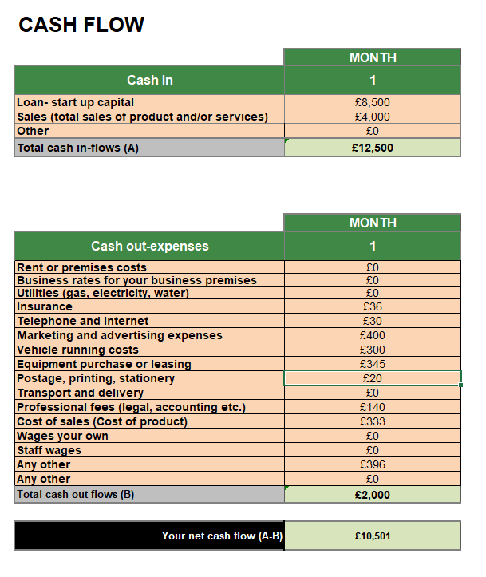

Revenue Model and Viability
Repair fees range from £25 to £120. Completing 3–4 repairs per day could generate monthly revenues of £4,000–£5,000. With monthly operating costs of around £2,000, the business is expected to reach break-even within six months.
Break‑even requires approximately 70–80 repairs per month, based on an average repair value of £55 and monthly operating costs of £2,000.
Risk: Supply delays for replacement parts could reduce monthly revenue by up to 20% for a month.
Contingency: Maintain a £1,000 parts buffer and two alternative suppliers to reduce downtime. If repair volume drops by 20%, the business remains viable due to low fixed costs, though profit margins tighten temporarily.

References

Carter, S. and Jones‑Evans, D. (2012) Enterprise and Small Business: Principles, Practice and Policy. 3rd edn. Harlow: Pearson Education.
Department for Business, Energy & Industrial Strategy (2023) UK business: activity, size and location 2023. London: BEIS.
GOV.UK (2024) Start Up Loans: eligibility and how to apply. Available at: https://www.gov.uk/start-up-loans (Accessed: 1 February 2026).
Mintel (2023) Mobile Phone Repair and Insurance – UK. London: Mintel Group Ltd.
Office for National Statistics (2023) Internet access and device usage in the UK. Available at: https://www.ons.gov.uk (Accessed: 1 February 2026).
PwC (2023) The UK mobile device market outlook. London: PricewaterhouseCoopers.
Shane, S. (2003) ‘A general theory of entrepreneurship: The individual–opportunity nexus’, Entrepreneurship Theory and Practice, 27(3), pp. 219–231.
Statista (2024) Smartphone usage in the United Kingdom. Available at: https://www.statista.com (Accessed: 1 February 2026).
TechUK (2023) Electronic waste and repair trends in the UK. London: TechUK.
The Guardian (2023) ‘Cost‑of‑living pressures drive rise in device repairs’, The Guardian, 14 September. Available at: https://www.theguardian.com (Accessed: 1 February 2026).

