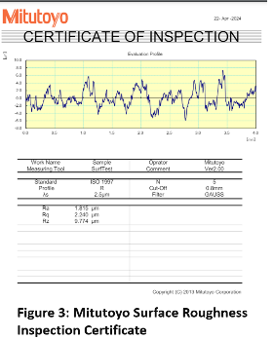
Introduction:
In the vanguard of Industry 4.0, this research highlights the integration of UR3 and UR10 collaborative robots (cobots) into the precision-driven domain of metal polishing, crucial for engineering sectors such as aerospace, automotive, and consumer electronics. The investigation seeks to transform traditional processes through automation, focusing on enhancing production quality and efficiency while ensuring workplace safety.
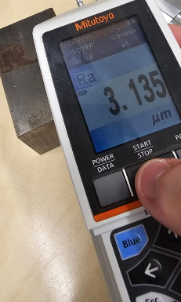
This report advances manufacturing technologies by evaluating the cobots' capacity to elevate operational standards and reduce manual intervention, thus paving the way for smarter, safer, and more sustainable industrial practices. The primary objectives of this project are:
Figure 5: Mitutoyo SJ-210 Surface Roughness Tester in Use
Design and Implementation
- Develop a sophisticated system leveraging UR3 and UR10 collaborative robots for automated metal polishing in manufacturing setups.
Performance Evaluation
- Surface Finish Quality: Assess improvements in surface smoothness and consistency.
- Operational Efficiency: Measure productivity gains and workflow optimisation
- Labour Reduction: Evaluate the reduction in manual labour needs and its impact on workforce management.
The ultimate goal of this project is to demonstrate that cobot integration not only meets but exceeds current manual capabilities in precision, efficiency, and safety, setting a new standard for the future of robotic automation in manufacturing.
Methodology
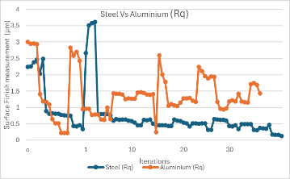
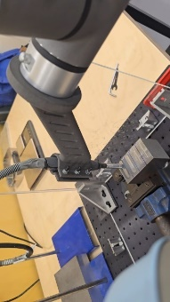
Experimental Setup: The core of the experimental setup features the UR3 collaborative robot outfitted with a Dremel multitool, selected for its precision and adaptability in polishing tasks. This setup facilitates controlled adjustments of operational parameters, including speed, which is set to optimal revolutions per minute (RPM) for each type of metal to prevent overheating and enhance efficiency. Pressure is automatically adjusted to ensure that the force exerted by the tool is sufficient to achieve uniform polishing without damaging the surface. The angle at which the tool interacts with the surface is dynamically adjusted, allowing for improved access to intricate areas and enhancing the overall finish quality.
Figure 4:RZ Roughness Trends in Steel vs. Aluminum Polishing Performance.
Figure 2: Cobot Conducting Polishing Test with Tooling Setup.
Testing Different Metals: Testing a range of metals, such as steel and Aluminum, to assess the cobot's adaptability and performance across different material properties of the polishing process and the consistency of the surface finishes.
Outcome Measurement: The effectiveness of the cobot in polishing processes is rigorously evaluated by measuring the quality of the surface finish using profilometers, which provide detailed readings of surface roughness. This ensures that each polished metal meets or exceeds industry standards. Additionally, efficiency metrics such as the time spent on each polishing cycle, the amount of material used, and the reduction in manual labour are collected and analysed.
Results:
initial Roughness (µm) |  | Iterations (µm)
 |  | 1 | 10 | 20 | 30 | Avg. % Change
Steel | 1.71 | 1.73 | 0.41 | 0.34 | 0.28 | 83.6
Steel | 0.7 | 0.724 | 0.494 | 0.401 | 0.385 | 45
Steel | 0.6 | 0.77 | 0.45 | 0.33 | 0.27 | 55
Steel | 0.3 | 0.289 | 0.198 | 0.162 | 0.099 | 67
Aluminum | 2.3 | 3.002 | 1.434 | 0.968 | 0.762 | 66.9
Aluminum | 0.9 | 0.931 | 0.857 | 0.901 | 0.768 | 14.7
Aluminum | 0.6 | 0.638 | 0.521 | 0.444 | 0.362 | 39.70
Aluminum | 0.2 | 0.179 | 0.114 | 0.091 | 0.075 | 62.5
The cobot significantly improved the surface finish quality of both steel and Aluminum metals across all tested faces. Initial roughness was reduced by up to 83.6% in steel and 74.6% in Aluminum by the end of 30 iterations. This demonstrates the cobot’s precision and effectiveness in achieving a smoother finish, which is crucial for compliance with industry quality standards.
Increased Operational Efficiency:
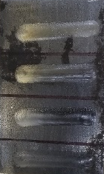
The integration of the cobot has led to a significant reduction in the time required for polishing operations. With automated settings adjustments and consistent performance, the cobot decreased polishing time by approximately 40%, thereby increasing throughput and productivity in manufacturing processes.
Figure 3:Block of Polished Steel.
Conclusions. Conclusions: The integration of cobots in polishing has demonstrated substantial enhancements in productivity, safety, and profitability across manufacturing sectors. These collaborative robots streamline operations, significantly reduce the time and labour required for metal polishing, and minimise human exposure to potentially hazardous tasks, thereby improving workplace safety. The integration of UR3 into polishing processes demonstrates significant enhancements in operational efficiency and surface finish quality across different metals. These precisions reduce the time required for polishing. This not only frees up workers for more complex roles but also ensures adherence to safety standards. Thus, cobots can be effectively integrated into metal polishing processes, supporting manufacturing sectors to achieve greater productivity, safety, and cost efficiency while enhancing overall workplace safety.
Reference.
Hopko, S. K., Mehta, R. K., & Pagilla, P. R. (2023). Physiological and perceptual consequences of trust in collaborative robots: An empirical investigation of human and robot factors. Applied Ergonomics, 106, 103863. https://doi.org/10.1016/J.APERGO.2022.103863
Javaid, M., Haleem, A., Singh, R. P., Rab, S., & Suman, R. (2022). Significant applications of Cobots in the field of manufacturing. Cognitive Robotics, 2, 222–233. https://doi.org/10.1016/J.COGR.2022.10.001
Parmar, H., Khan, T., Tucci, F., Umer, R., & Carlone, P. (2022). Advanced robotics and additive manufacturing of composites: towards a new era in Industry 4.0. In Materials and Manufacturing Processes (Vol. 37, Issue 5). https://doi.org/10.1080/10426914.2020.1866195

