Six Sigma Green Belt
Designing and executing a Six Sigma Green Belt project.

Contents
Introduction 2
Define 2
Problem statement 2
Process Mapping 2
Voice of the customer/critical to quality 3
Project Scope 3
Measure 4
Identify Measurement Variation 4
Determine Data Type 4
Develop Data Collection Plan 4
Analyse 4
Process analyse Methods 4
Review Analysis Methods 5
Graphical Analysis Tool 5
Identify Sources of variation 5
Improve 6
Generate Improvement Alternatives 6
Improve FMEA Phase 6
Perform Cost/Benefit analysis 7
Validate Improvements 7
Control 7
References 9

Figure 1- Flow Chart for DENCO lubrication system 2
Figure 2- Project scope for Lubrication system. 3
Figure 3- Run Time Chart from lubrication system 5
Figure 4- FMEA DENCO Lubrication system. 7

Introduction
Big Pit is a real coal mine and one of the UK's premier mining museums (Explore South Wales , 2022). Originally Big Pit was an iron mine that was initially started in 1810 (Johnson, 2021). The name was first recorded during the late 1800’s and got the name from the shafts peculiar dimensions being 18 by 13 ft (Johnson, 2021). The mine was crucial to providing production to the Blaenavon area. Now in the 21st century Big Pit has become one of the UK’s most noticeable tourist attraction site whist at the same time maintaining that crucial part of Welsh mining history.
Six Sigma is a technique used for improving a process. The process of six sigma includes steps to ensure you are identifying and removing cause of defects or causes of errors within mechanical systems. The process can also help increase performances and to improve the quality of life within the system.
This Green Belt project it will discuss the found issues with the recently installed lubrication system for Big Pits winding system. The report will go through the process and show evidence on how it was completed. Using green belt in situations like this can really benefit a project to become very successful (Grey Campus , 2023). The use of green belt in a project also allows to find ways to reduce waste and to improve processes (Grey Campus, n.d.). In this report it will show the data used to give reasoning behind this report. It will display the fundamental elements to improve the lubrication system along with what can be done in the future.

Define

Problem statement
Big Pit recently had a lubrication system installed for the mines winder system. The winders shaft requires oil bearings to keep the shaft lube whilst in motion. After carrying out inspection and gathering data it was found that the original lubrication system wasn’t providing adequate lubrication. Upon installation, it was found that on when the oil was applied onto the shaft, it wasn’t returning to tank which was putting strain on the oil pumps. This project will be going through the process of solving the issue with the lubrication system.

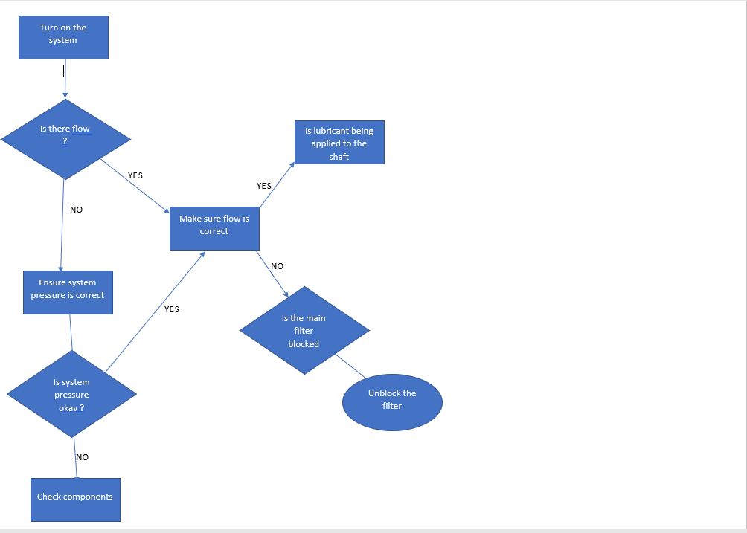
Process Mapping
Figure 1- Flow Chart for DENCO lubrication system

Voice of the customer/critical to quality
The voice of the customer is crucial when carrying out project work. For this project the customer is Big Pit National Coal Museum (National Museum Wales , 2023). The winding system is crucial to the company as it’s a fundamental part of the site. The company needs the machine running as it is what brings the public to the mine and helps determine what is crucial (Gaussian Team, 2022). Having the voice of the customer also make available the sense of importance that is has the organisation (Gaussian Team, 2022). Data collection is also key to allow for a successful project to be accomplished. It allows for a project that can personalised to customers’ needs (Bresteckaya, 2021). By doing this you are showing your customer that you really do care and want to ensure the best options for them.

Project Scope
Below can be found the scope for this project. (Template Lab , 2023)

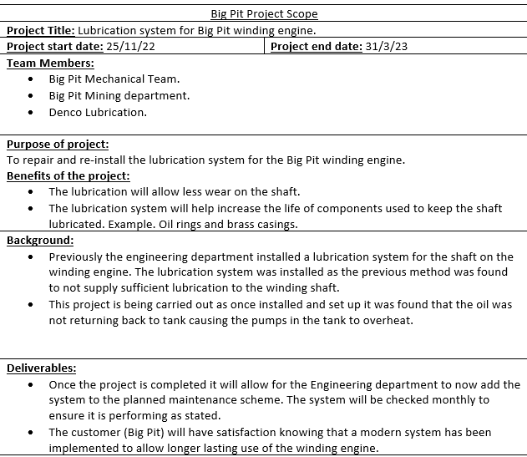
Figure 2- Project scope for Lubrication system.

Measure

Identify Measurement Variation
During the measure stage of the project it is important to identify your measure type to allow for good quality data to be utilized and can allow for areas to be improved upon (Hessing, 2023). When selecting your measurement type it is also key to make certain that the data you are collecting is relevant to your research (Hessing, 2023). When recording and measuring your data it is key that there is some linearity across the research. When big differences can be noted, this could cause false statistics (SixSigma Institute , 2023). Variation must be minimised as much as possible to ensure the statistics are as reliable as possible. On the other hand, some errors are human, there may be physical factors that could cause unstable results which are uncontrollable and cannot be helped (SixSigma Institute , 2023).

Determine Data Type
The data type that has been determined is variable. The reason why variable data is being used is because it allows for good accurate readings of data (PQ Systems , 2023). Variable data also allows to collect data over a period of time to gain a consistent recording (PQ Systems , 2023). The oiling system on the Big Pit winding engine has flow control valves. By using these valves, it allows to adjust the flow of oil and get recordings of different rates. By doing this it will allow to get good readings which can then be used to examine (Feldman, 2018).

Develop Data Collection Plan
In order to analyse the data that will be collected, a data collection plan must be used. A data collection plan must be used as it allows you to follow a set criteria in order to understand your aims and goals and what you want to understand (Aransiola, 2023). A collection plan also ensures that all your work is being documented as you proceed to collect your records (Aransiola, 2023). At the same time it also allows for good time keeping. In a plan, you can set dates that you would like to achieve by that safeguards your overall deadline (Aransiola, 2023).
The data that is needed will be collected by physically examining the lubrication system of the course of a day. The team included will be the Big Pit mechanical team as the winder is part of the mechanical statutory exams. The plan will be to activate the lubrication system ensuring that the tank has enough oil for application and return. By adjusting the flow control valves it will allow for data to be recorded at different times to see what setting is best used for the system.

Analyse

Process analyse Methods
Due to the characteristics of the job, observation analysis was carried out to visually inspection the lubrication system. By using the observation analysis, it allowed for the fitting department to have a good visual inspection on the system. Observation seemed the most efficient way as there is componentry on the system such as flow control flows which allows for the team to adjust the valves and experiment with different flows and visualise the different outcomes. The team went into the observation with open minds as it could’ve been multiple issues causing the problem that needed addressing. By observing the issue with a clear head also allows for the fitters to think of multiple reasons why and communicate with others.

Review Analysis Methods
It was decided for an observation analysis type inspection to be used as it seemed the best fitting analysis method. The observation method conducted of simply powering on the pump and conducting visual inspections to the system and see where potential problems could arise. By waiting and inspecting certain points of the oiling system it allowed the fitters to see the system work visually. As previously mentioned, an observation analysis is the only type of tailored methods to the job. Due to the fact Big Pit isn’t a production mine it allows for us to have downtime and to really look into the cause of the problem. The observation was carried out safely as it meant we could lock out the winder system to just concentrate on the lubrication system itself.

Graphical Analysis Tool
Below is a run time chart created by collecting the data from running the lubrication pump over the course of 15 minutes. The chart displays a clear but slow start up of the pump when first started.
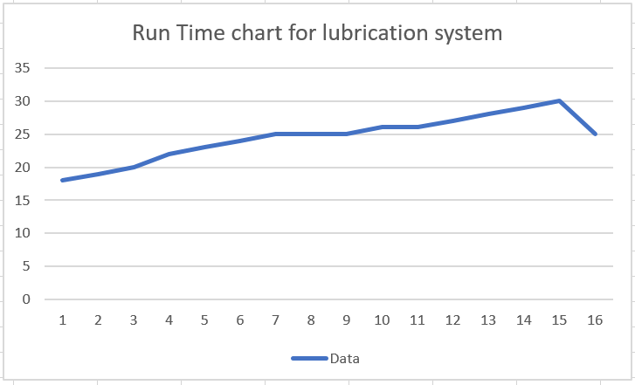
Figure 3- Run Time Chart from lubrication system

From the graph above it is shown the flow of the oil when the pump it turned it. It’s clearly visible that it’s a very slow start to the flow of oil along with some dips where the oil may not have enough force behind it to provide clear flow through the pipes. Although when it reaches the 15 minute of run time, there is a very obvious drop off. This where it was found that the oil would start to clog in in the pipe to cause the blockage of the pipe work. By using the run time chart, it allowed the fitting team to see how long the pump would run before running into issues.

Identify Sources of variation
There was little variation when it came to running the pumps and recording them. Due to the simple fact that it was only pumps that were being recorded. Although there was variation noticed during testing when the weather would differ. On the hotter days and when the winder was running-due to the heat from the system, it was found that the oil would run much smoother and causes less blockages. Whereas when the winder wasn’t running and it was a colder day where the temperature would drop, the oil would really affect the overall flow of the system.

Improve

Generate Improvement Alternatives
After going through the collected data, it allowed for improvements to be made regarding how to system will perform. The measure phase granted enough information to determine what the new course of action would be. The phase also allows to make informed decisions which backs up any valuable points made (The council on leadership and quality , 2023). Data also allows for you to become strategic when going through your improvement stages. It allows to narrow out any unwanted costs to allow for any extra budgeting further down the line (The council on leadership and quality , 2023). Generating improvement alternatives is crucial when coming to a close in the project. By generating alternative ideas allow for multiple directions to attack the issue in hand (Structured Decision Making, 2023). It is also beneficial to determine and discuss multiple alternatives and label each of the pros and cons to narrow it down to the best alternative (Structured Decision Making, 2023).

Improve FMEA Phase
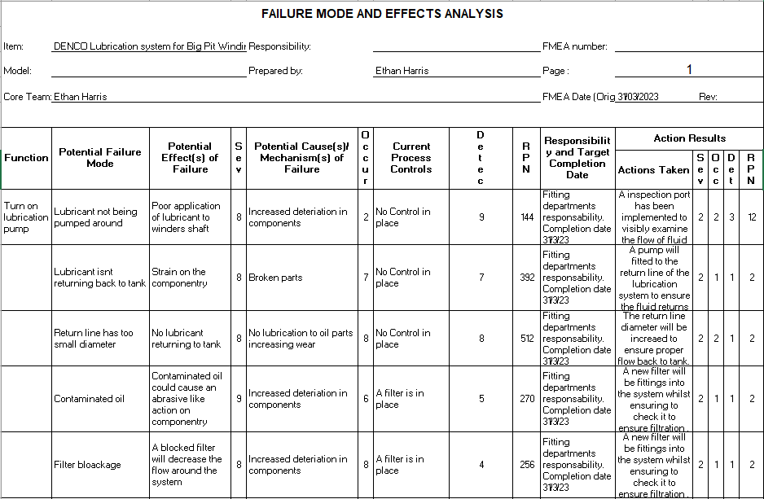
Below can be found a FMEA carried out on the lubrication pump. FMEA tables are very important to prevent any future issues from triggering difficulties. The process can also be used to improve existing procedures that are currently in place (ASQ, 2023). By carrying out FMEA you are also increasing a healthier team performance. FMEA is usually carried out within a team which allows for multiple options and ideas (Thorn, 2023).
Figure 4- FMEA DENCO Lubrication system.

Perform Cost/Benefit analysis
The reason behind the installation of the lubrication system was to help increase longevity of the winding system. Due to its age and the characteristics of it, its very unlikely to find parts. By installing this system, it will increase life on the components to allow a good working order. Overall, the project cost £5,000 with the aid of a grant that the mechanical department was given.
As mentioned above the cost for the system alone with £5,000. This isn’t taking into considering the cost of labour, extra materials, and indirect costs. With the labour of the DENCO team and the Big Pit Mechanical team, and extra £5,000 was added due to labour from the workers creating a total of £10,000. Although sounding like a huge amount of money, the first £5,000 was a grant given by the organisation.
All in all, with the cost and other factors to take into consideration, the project was very beneficial to the site to ensure that the winding system can stay functional. As mentioned earlier, the componentry of the winder is becoming extremely rare due to its demand in the 21st century. The project has massively benefitted the system to increase its overall life and running time. Its now crucial that the fitting team keeps on top of maintenance of not only the winder but now the newly installed lubrication system.
A cost benefit equation was carried out to see if financially the project was worth it. Even though above it was mentioned that physically it was beneficial for componentry and the winding engine itself,

Validate Improvements
To improve the lubrication system controls were put in place such as the increased bore size of the return line for the system. This was found during the finished installing of the lubrication system. Once operated it was found that oil was seeping through the seals into the bearing housing. When the pump was turned off and the system was inspection it was clear that there was a blockage in the return line due to the smaller pipe. Once this problem was found, the return line bore was increased to ensure better return to tank. Once the job was carried out it was returning back to tank correctly but was still rather slow. By having the slow return, it meant for a lot of stress on the lubrication pump as it was trying to push around very little oil when the system was in high demand. There were flow control valves close to the input of oil which were adjusted to try and improve the flow to the bearings. Although slight improvement was noticed, it still wasn’t enough to supply adequate lubricant to the winder shaft. It was finally decided to input a small suction pump within the return line. By having this final improvement, it was finally recognised that the oil was returning back to tank with ease and satisfied the fitting team.

Control
To control and eliminate the issue at hand, the fitting department decided to carry out two methods to control the issue from happening again. Firstly it was decided to bore the diameter to a larger bore on the return line of the lubrication system. By carrying out the data collection of the system it was found that the bore size was too small and causing series blockages for the oil the return. This was found to cause very serious issues with the system and was also found that it was putting strain on the systems componentry.

Secondly it was decided by the mechanical engineer to install a small suction pump on the return line on the system. This was a big call as by talking to the technicians from DENCO, they mentioned that it would benefit the system during the winter when the oil becomes thicker due to the environment. By having two positive opinions on the decision the pump was installed on the return line of the system.
To ensure the issues becomes less of the threat to the system the lubrication system has now been added the fitting departments planned maintenance preventative scheme. This was decided as it means that the pump will be checked weekly and daily. By having these checks in place are the minimising the risk of experiencing the problem again. It also means that’s by visually checking the system allows for the fitter to examine components such as filters (to clean and unblock if necessary), check pump conditions, (ensure that all seals are holding fluid well and that they aren’t making any unusual noises) and lastly to ensure the oil is being applied the winders shaft efficiently. Lastly there has been inspection ports fitted to the overall system itself. By having these inspection points around the system, it allows for the fitters to inspect certain parts of the line and to see if there are any problems in a specific place. The pipework on the return line has also been adjusted to allow for the oil to have more of a fall back to tank rather than the almost horizontal profile they originally had.
Lastly, to ensure full competence of the of the fitting department, training will be carried out amongst the fitters to guarantee their full understanding of the system to allow competence. If the fitters have a full understanding of the system then it means if a breakdown occurs, then they will be able to solve the issue with ease.

References
Adobe Communications Team, 2022. Project scope — definition, best practices, examples, and more. [Online]
Available at: https://business.adobe.com/blog/basics/project-scope-definition-best-practices-examples-and-more#what-is-project-scope
[Accessed 8 March 2023].
Aransiola, J., 2023. Data Collection Plan: Definition + Steps to Do It. [Online]
Available at: https://www.formpl.us/blog/data-collection-plan-definition-steps-to-do-it#:~:text=A%20data%20collection%20plan%20is%20a%20detailed%20outline,and%20what%20format%20it%20will%20be%20displayed%20in.
[Accessed 14 March 2023].
ASQ, 2023. Failiure Mode and Effective Analysis (FMEA). [Online]
Available at: https://asq.org/quality-resources/fmea
[Accessed 24 March 2023].
Bresteckaya, O., 2021. A Guide to Customer Data Collection Methods. [Online]
Available at: https://sendpulse.com/blog/customer-data-collection-methods#:~:text=Why%20is%20it%20crucial%20to%20collect%20customer%20data%3F,communication%20...%204%20Increased%20customer%20lifetime%20value%20
[Accessed 11 March 2023].
Explore South Wales , 2022. Big Pit. [Online]
Available at: https://exploresouthwales.com/explore/big-pit/
[Accessed 1 February 2022].
Feldman, K., 2018. Variable Data. [Online]
Available at: https://www.isixsigma.com/dictionary/variable-data/
[Accessed 14 March 2023].
Gaussian Team, 2022. Why Customer Needs Are Important. [Online]
Available at: https://gaussianco.com/insights/why-customer-needs-are-important
[Accessed 11 March 2023].
Grey Campus , 2023. What is Six Sigma Green Belt?. [Online]
Available at: https://www.greycampus.com/opencampus/six-sigma-green-belt/what-is-six-sigma-green-belt#:~:text=Green%20belts%20are%20skilled%20team%20players%20and%20their,improving%20the%20process%2C%20data%20inspection%20or%20Project%20Management.
[Accessed 8 March 2023].
Grey Campus, n.d. What is Green Sigam. [Online].
Hessing, T., 2023. Measurement Systems Analysis (MSA). [Online]
Available at: https://sixsigmastudyguide.com/measurement-systems-analysis/#:~:text=In%20Six%20Sigma%2C%20we%20want%20to%20base%20as,the%20equipment%20by%20people%20and%20by%20the%20environment.
[Accessed 12 March 2023].
Johnson, L., 2021. Big Pit National Coal Museum. [Online]
Available at: https://www.historyhit.com/locations/big-pit-national-coal-museum/
[Accessed 1 February 2022].
National Museum Wales , 2023. Big Pit. [Online]
Available at: https://museum.wales/bigpit/
[Accessed 11 March 2023].
PQ Systems , 2023. Variables data (measurements). [Online]
Available at: https://www.pqsystems.com/qualityadvisor/DataAnalysisTools/variables_data.php
[Accessed 14 March 2023].
SixSigma Institute , 2023. Six Sigma DMAIC Process - Measure Phase - Measurement System. [Online]
Available at: https://www.sixsigma-institute.org/Six_Sigma_DMAIC_Process_Measure_Phase_Measurement_System.php
[Accessed 12 March 2023].
Structured Decision Making, 2023. Alternatives. [Online]
Available at: http://www.structureddecisionmaking.org/steps/step3alternatives/
[Accessed 24 March 2023].
Template Lab , 2023. Project Scope Statement Templates & Examples. [Online]
Available at: https://templatelab.com/project-scope/
[Accessed 12 March 2023].
The council on leadership and quality , 2023. 12 Reasons Why Data Is Important. [Online]
Available at: https://www.c-q-l.org/resources/guides/12-reasons-why-data-is-important/
[Accessed 24 March 2023].
Thorn, A., 2023. Failiure Mode and Effective Analysis. s.l.:Andrew Thorn .
Wales, N. M., 2022. Big Pit National Coal Museum. [Online]
Available at: https://museum.wales/bigpit/about/
[Accessed 19 April 2022].

