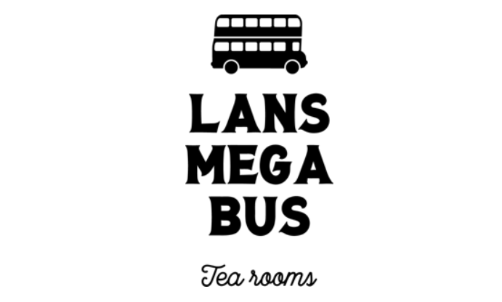

Business Plan
By Leanna Jenkins 1712164,
April Fuge 1712455,
Natalie Thomas 1712163
& Sarah Rees 1712165.

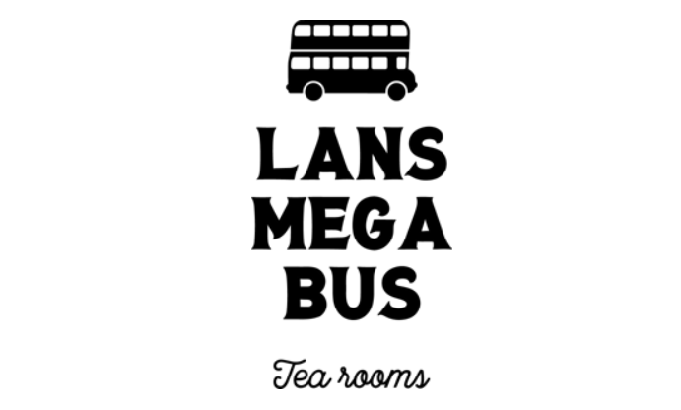

Contents
- Executive Summary
- Company Description
- Product & Services
- Market Analysis
- Market Strategy
- Human Resources & Management
- Financial Plan
- Conclusion

1.0 Executive Summary
LANS Mega Bus is committed to becoming the next unique social enterprise, offering a relaxing atmosphere, while enjoying a traditional afternoon tea.
Operating at various venues with secure on-site parking areas in and around South Wales, we have already secured agreements with 6 residential homes in the Llanelli area.
The partners have invested £84,671.14 of the start-up costs, from their own personal savings, to keep expenses as low as possible during the first financial year.
Combining the shared roles and responsibilities they have taken upon, within the management team and day to day operating of the business to accommodate the profit margins.
The tearooms offers a simple to use website for all marketing needs, connects with customers through social media and uses the more conventional form of advertising via newspapers, to ensure we reach people of all ages.
With a tight marketing campaign and financial schedules, LANS Mega Bus estimates an annual net profit margin of between £90,000.00 and £115,000.00 during their first financial year.

2.0 Company Description

2.1 Business Aims & Objectives
Lans mega bus aims to achieve a net profit margin of £114.370 in their first Financial Year (FY) – 2019. Investing all profits back into the business, to improve further returns in year two and three.

2.2 Mission
‘Driving Local Communities Together’.
By bringing a unique experience where customers can socialise in a relaxing atmosphere, while enjoying a traditional afternoon tea with delicious hot beverages, sandwiches and cakes.

2.3 Company Ownership
Lans Mega Bus trades as a partnership company, owned by four partners, Leanna Jenkins, April Fuge, Natalie Thomas and Sarah Rees.

2.4 Location
Situated in the south of Wales, one of the greatest benefits is that it can operate at various venues with secure on-site parking areas, maximising its potential where and when needed.

2.5 Start-up Summary
The total start-up costs for the mega bus is £84,671.14.
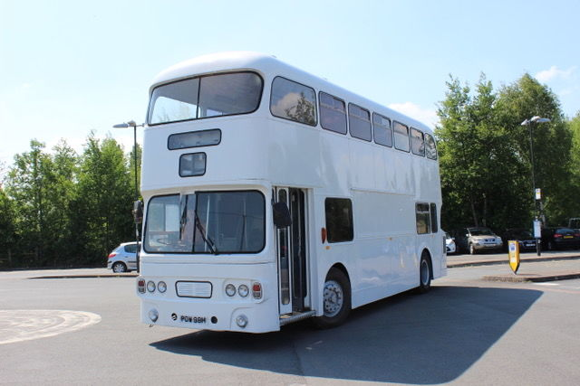
Included in these are fixed costs such as, conversion costs, legal expenses, marketing costs, insurance premiums and utility costs. Variable costs consisting of salaries and stock. Capital costs include premises (pic on left), kitchen equipment (coffee machines, fridges, kettle, etc), power supplies and serving/book keeping equipment. These items are necessary for our business to function, along with renovation costs, they also incorporate pacific power supplies, for which we have found GEL DEEP CYCLIC Batteries.
Break down can be seen below.
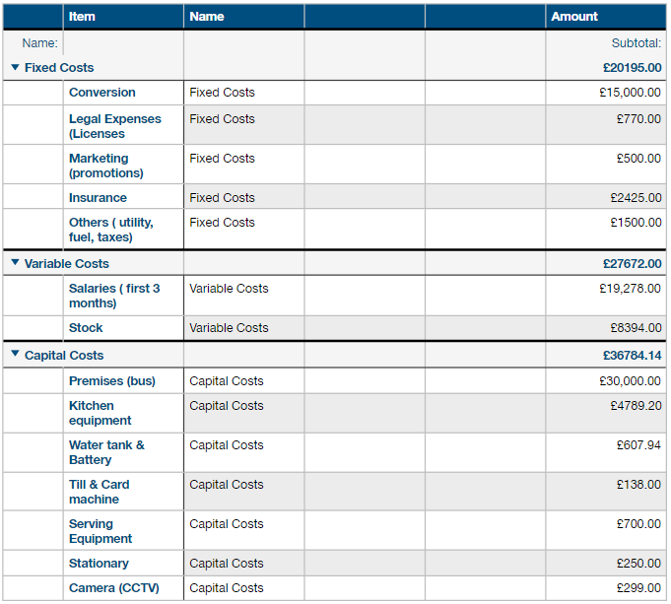

3.0 Products & Services

3.1 Services
We aim to bring people together, whether it may be to flee those every day stresses or purely meet with friends/family , our tea rooms offers the tranquillity of a good old-fashioned cuppa. Our differentiated services prides itself on being in the heart of the local areas, where people can come and enjoy our delicious hot beverages, complimented by freshly made sandwiches, cakes and ambience in our friendly environment.

3.2 Products
LANS Mega Bus will offer the finest quality and freshly made traditional afternoon tea, accompanied by preferred hot beverage.
Our hot beverages include all varieties of tea, ranging from white, green or fruity and luxury hot chocolate, served with cream and marshmallows.
The coffee menu includes a vast arrangement for different required tastes, such as Cappuccino, latte, milky or americano.
Full menus also include the option of light bites and snacks, from sandwiches or wraps, filled with various fillings (vegan/veggie option available), to the warming hot toastie or panini. Our daily speciality of sweet treats comprises of delicious cakes or smooth fresh milkshakes. We will also serve soft drink which include, sparkling/still water, fizzy drinks, milk or juices.

3.3 Sourcing our Products
We aim support other local businesses by sourcing our products locally. The welsh coffee company will supply our coffee beans, with all other required stock purchases being made within our home and surrounding area. Helping us to cut out delivery costs, it builds a relationship with supporting companies and ensure our stock is fresh daily.

3.3 Future of our business

Once our business has progressed, we will then expand our services by offering a hire service such festivals, community events, hen parties, children’s parties or any other event required. Also, we will upgrade our afternoon teas by offering an alcoholic option as part of our beverages range.

4.0 Market Analysis

4.1 Strategy
To concentrate on getting to know new customers and creating a loyal customer portfolio. Ensuring our business is known, to help it grow and ensure that customers have an excellent experience, so they will keep returning.

4.2 Target Market
Our aim is to provide service for a customer base of all ages. With the initial start-up base during the first financial year aimed at –
- The elderly in Residential homes,
- Teenagers at youth clubs,
- Weekend hire.

4.3 Competition

We have conducted research in our local and surrounding areas and although we found that there is a wide range of businesses offering afternoon teas, we found that ours is the only mobile one.
Conducting this intense research ensures it does not become a threat or our prices are under cut and has helped us create our pricing strategy/promotional offers.

4.4 Marketing Techniques

Our marketing techniques have been based around our products (menus), place (location), price (competition based ), promotion (advertising), processes (services) and physical (premises).

4.4.1 Questionnaire
We distributed questionnaires out to new potential customers to establish a variety of opinions on products and services.

4.4.2 Market Trends
The questionnaires identified 54.5 % of people asked have a high interest in our tearoom services, with the remaining 45.5% slightly interested. No customers responded with a not interested response. The majority said they would use our services weekly and over 80% replied the £15 price bracket was reasonable.

5.0 Marketing Strategy

5.1 Advertising
To get our business, products and services known we have created our own website and social media pages. Social media has become a necessary time investment for all businesses, with that in mind we will use these resources such as Facebook, Twitter and Instagram to advertise our business.

5.1.1 Website

Our website is simple to use, with all the relevant information about our company, the services we offer, location, contact details and menus. It also includes links to our Facebook page, Twitter and Instagram.

5.1.2 Online – Social Media

We will use the online social media resources such as Facebook, Twitter and Instagram to advertise our business. This is an excellent way to start our advertising as social media is very popular, but it is also free.
These pages will be updates daily, promoting any special offers and informing customers of our timetable and location.

5.1.3 Flyers & Business Cards

Evident from our marketing questionnaires, social media does not attract all target markets. So, to further promote our business we will make flyers and business cards to distributed out in public and ask local businesses for their permission to leave some for them to hand out and in return we will offer to advertise their business on our bus. We have found a reputable business online to make our flyers and business cards, starting off with a 1000 of each, for a fraction of the price. But inevitably with our business growth we will need more flyers and cards, so we will set up a subscription with this company, so we can take advantage of the discount it offers.

5.1.4 Newspaper & Radio

We will also advertise in the local paper for the first year to help encourage getting our business known for a small price each week. After our first year, we will investigate bigger advertisements such as radio advertising.

5.2 Unique Selling Point
We will pride ourselves on being the heart of the community where ever located. A relaxed environment consisting of unique décor and dining suites, encouraging customers to flee their everyday stresses.

5.3 Competitive Edge
With the ability to travel to various destinations, we can easily adapt to suit our customer’s needs. As we are a small private partnership, we have no set working hours, allowing us to adjust business hours when needed – such as private hire. There is no other business like ours offering our services in the area.

5.4 Promotions

Promotional offers will include, hot drink & cake or Any drink & sandwich deals and Loyalty cards. These will be available at off peak times, weekends and during our youth evenings, can be seen on our website/social media pages.

5.5 Pricing Strategy
Our prices are based on marketing, competition and cost, supporting a market-based pricing strategy. These can be seen on financial plan.

5.6 Sales Forecast
Based on our weekly sales schedule at Residential homes, selling 25 afternoon teas per sitting, twice a day, five days a week up until 8th September. Then in the following months of the year progressing to three sitting per day, selling 20 for five days a week. They also include youth clubs estimate sales of £86.60.

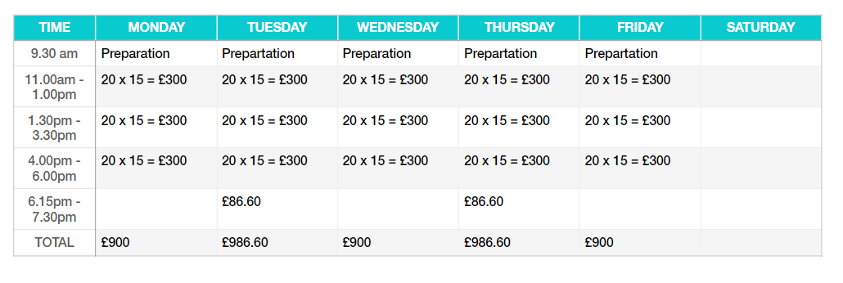
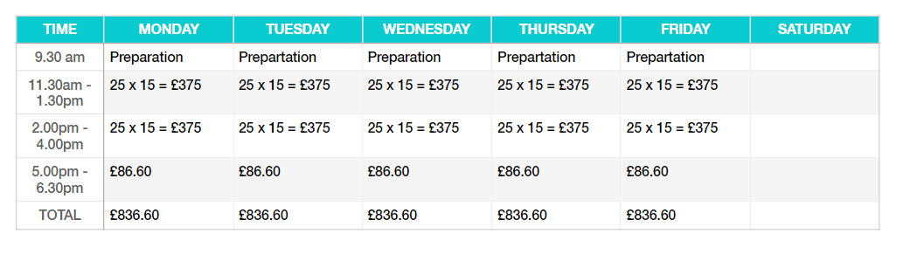

There are 16 care and assisted living homes in Llanelli alone without including surrounding areas. We have secured agreements with 6 of the care homes already on a 6-week basis.

6.0 Human Resources
6.1 Employee’s
Lans Mega bus will employee four members of staff during the first financial year. With the intend to keep expenses low and profit margins high, the partners have decided to take on the following job descriptions/management roles, based on their experience and specifications.

6.2 Roles & Responsibilities
Leanna’s specifications include, a Food Hygiene Level 2 and CIM Foundation Certificate in Marketing. Allowing her to take responsibility of the service of food/beverages and the marketing side of the management team.
April’s specifications include, PCV Category D + E Licence, a Diploma Level 3 in Customer Service, CIPD Level 3 Certificate in HR and First AID Certificate. She will drive the bus to various venues, while taking care of any maintenance the bus will require, her expertise’s in HR and customer care will ensure our Human Resources team is fully equipped to deal with any issues it may face.
Natalie specifications to the team include, ATHE Level 5 in IT, AAT Foundation Certificate in Accounting Level 2 and Diploma Level 3 in Customer Service. Her responsibilities will include taking care finance management along with the bookkeeping and day to day responsibilities of customer service.
Stock control and auditing stock turnover will be Sarah’s Responsibility, with her specifications including, Food Hygiene Certificate Level 3 and First AID Certificate, she will also keep the day to day preparation and baking in the kitchen area.

6.3 Gap in Training
We understand there are areas of our team which will require training, to strengthen our company. All of which have been accounted for in our start-up cost and schedule, we intend to complete all training prior to our start trading date.

6.4 Contracts
All contracts will be drawn is writing and include roles/responsibilities, wage structure, holiday pay and pension contributions. Our policies also include agency cover, in the event of sickness/leave, allowing staff to be available at short notice is required.

6.5 Licenses
A street licence is needed to trade on streets and council car parks.
The business requires a premises licence to sell alcohol. There are also strict stipulations regarding the sale of alcohol, we must abide to.
Food hygiene inspections are carried out by law by the council. Our business is then given a food rating certificate that by law in Wales must be clearly displayed.

7.0 Financial Plan

7.1 Financial Basis

Our calculated net profit for Year 1 is £114,370, sales figures are based on a cash basis. Salaries are set above the national minimum wage, averaged at £20,884, per annum. Depreciation has not been considered within the first-year calculations, as we have renovated our premises and do not expect to see a decrease in these figures during this time. However, it will be deducted at 25% in following years, to accompany wear and tear costs.

7.2 Start-Up Costs

The total start-up costs for the company is £84671.14.
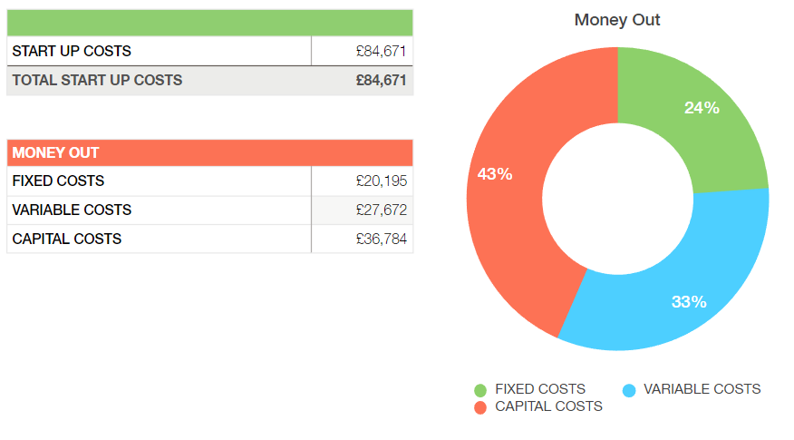

Our total start-up costs consist of three areas, as the graph above identifies, the largest amount of capital will be utilised for capital costs. These include all major costs we face during the first financial year, which are necessary requirements to get the mega bus up and running. Budgeted within these costs are what we will also require for our first 3 months of operating.

7.3 Source of Start-Up Costs

The capital to fund these costs will be obtained from the four partners/owners personal saving. As follows: Leanna Jenkins £21,250 April Fuge £21,250 Natalie Thomas £21,250 Sarah Rees £21,250

7.4 Financial Statement
LANS Mega Bus is expected to see a gross annual income of £212,895, during the first FY-2019 (first) and a net profit margin of between £90,000 - £115,000.

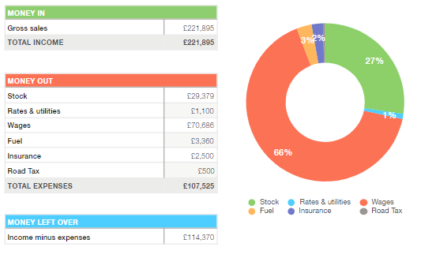

7.5 Contingency Plan

With constant changes in economic and social demands, we understand that there may be need to adjust the above schedules. In the event of this we have an alternative schedule in place consisting of two sittings a day, serving just twenty seats of the possible thirty and no evening youth club meets. With these schedules in place we will still see an estimate net profit after all expenses of £25,272.

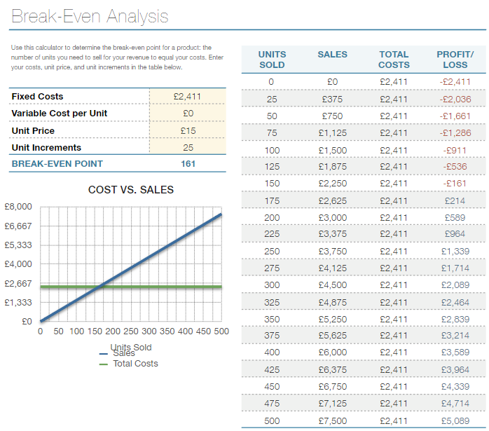
7.6 Break Even

All the above sales and costs have allowed us to create a breakeven point based on the afternoon tea sales. The table below identifies our weekly average operating expenses are £2411, which is made up from- wages, utility, fuel and stock. When sold at £15 per head, our afternoon tea breakeven point is 161 units, out of the 250 we schedule for weekly.

7.7 Production Costs & Pricing
The break down costs based on products to produce each item are as follows –
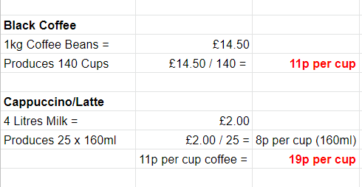

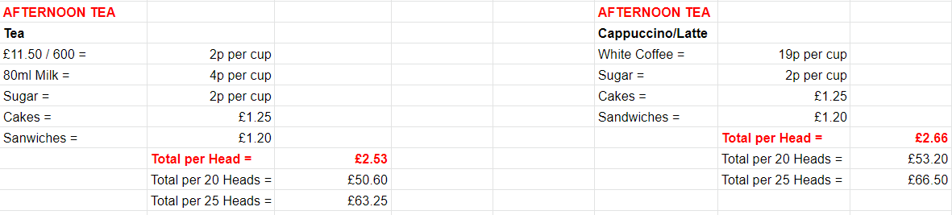
Together with the costs to purchase the stock required to produce the above items and our marketing/pricing strategy, using questionnaires we distributed to our potential customers, we have set the following competitive prices in the table below.

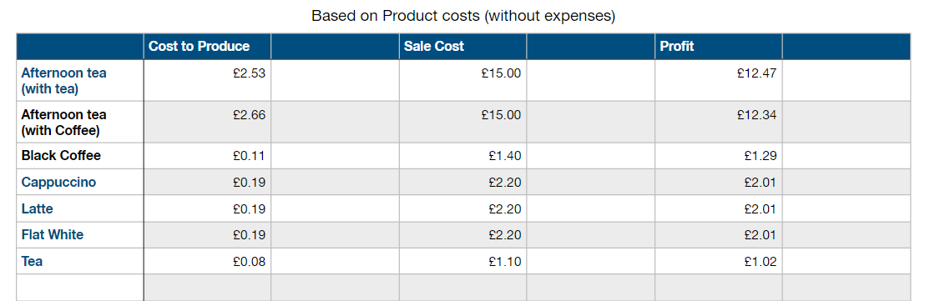

7.8 Cash Flow Forecast FY2019
Our cash flow forecast (below) for FY2019, includes sales based on the schedule above, it considers the pre-paid expenses accounted for during our set up costs, makes amendments for the seasonable holidays, and covers the following FY insurance and road tax.

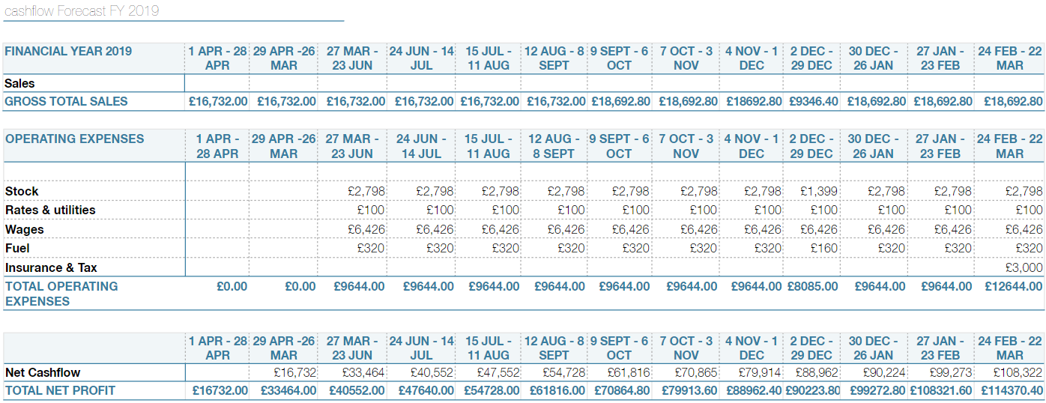

8.0 Conclusion

A swot analysis to give stakeholders an evaluation of business plan.

STRENGTHS  Staff have strong combined skills, qualifications and experience.  Innovative and original menu.  Strong marketing strategy.  Only mobile tea-room in Wales.  Consumer convenience.  Strong community ethics. | WEAKNESSES  Start- up costs.  Limited funds.  No current customer- base.  Short notice cancellations.  Predictability of bookings for parties.
OPPORTUNITIES  Unique physical location – bus.  Ability to move business to any desired  location.  Only business in Wales with this operation.  Register our trademark logo.  Target other demographic groups and introduce other services.  Profit from mobile tearoom, funds start- up costs for parties.  Well planned and realistic financial model. | THREATS  Changes in regulations may put restrictions on our business.  Future competition.

The SWOT analysis identifies a strong position in todays competitive market, our unique mobile business gives us the extra competitive edge, creating convenience for our customers, which will be our biggest selling point. It also allows for us to acces future competition or changes in regulations that may become threats and apply contingency plans to overcome our weaknesses.
Lans business plan has been devised by conducting through research into every element surrounding our business. Highlighting the main outcome from our questionnaire identifies a high interest for our services.
Required Laws, regulations and licences have been applied to our business.
Human resources management have ensured all taxes, pensions, insurances and wages have also been correctly applied within the stated law.
The financial model has a detailed and methodical analysis of the mobile tearoom, showing a healthy profit. This profit will be used to build on the party and events side of the business.
Expansion will consist of a deluxe, top of the range bus adapted specifically for first-class parties. This means we can charge more for this enhanced, luxurious experience and give our stakeholders a higher return on their investment in our company.

Speaker Notes
Sarah 1712165
Introduction
Mission Statement
“ Driving Local Communities Together”
As a group we have decided to set up business as a mobile Tea Rooms on a converted Double Decker Bus. We have named the Business “Lans Megabus” which we will be trading as a Partnership. The owners will be:-
Leanna Jenkins
April Fuge
Natalie Thomas
Sarah Rees
We will be operating at various venues in and around the South Wales Area.

Our main start-up Customer Base will be aimed at:-
- The Elderly in Residential Homes
- Teenagers at Youth Clubs
- Weekend Hire
All these Venues will have Secure On-site Parking Areas. Customers can enjoy the Relaxed Atmosphere of our Tea Rooms while enjoying a traditional Afternoon Tea with Delicious Hot Beverages, Sandwiches and Cakes Our Business Will offer a unique service being the only one in our Local area and we Believe our business can draw a lot of customer interest.
There are 16 Care and assisted living homes in Llanelli alone without including surrounding areas we have secured bookings with 6 of the Care Homes already before starting our business.

Physical Resources
Every Business needs resources, whether its people, money, suppliers, or time. The Physical resources include tangible items that are necessary and available for a business to function. Physical resources include raw materials, Buildings, vehicles, machinery and supplies. Schofield, T. (2018).
DOUBLE DECKER BUS
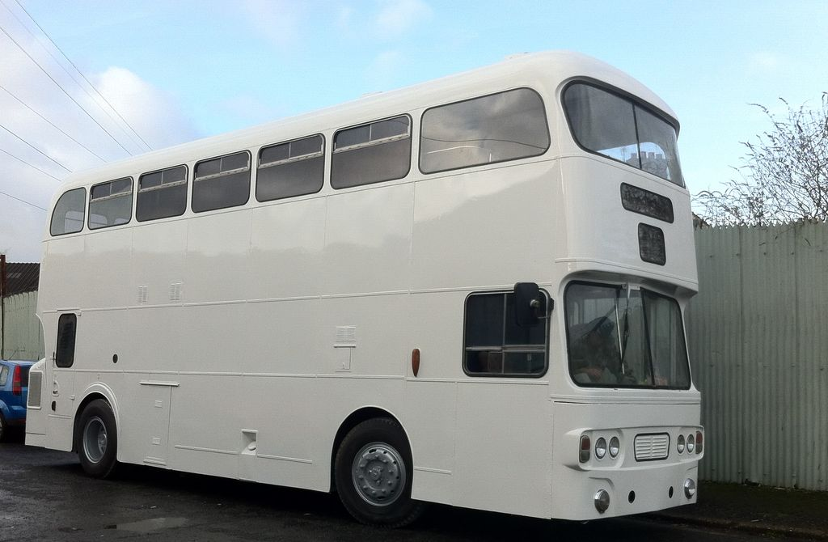
POWER SUPPLY

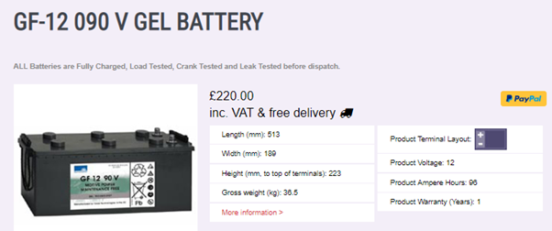

Gel Deep Cyclic Batteries
The Pros - Gel Leisure Batteries are pure deep cyclic. These can be drained almost completely flat and still recover. Suitable for deep discharge applications such as catering equipment, security cameras etc.

The Cons - Sadly Gel batteries are very expensive, we only supply the best product brand of Gel which is Sonnenschein. Advanced battery Supplies, (2018).

RENOVATIONS

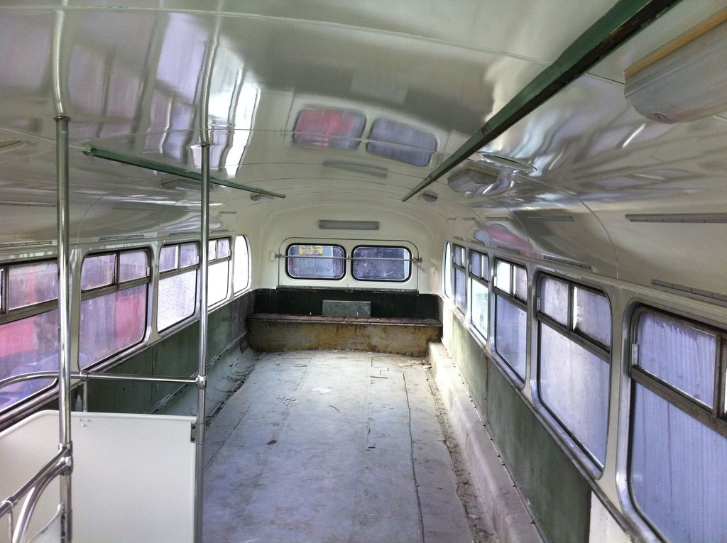

The bus has been fully gutted ready for renovating and the following pictures will show our target look on completion.
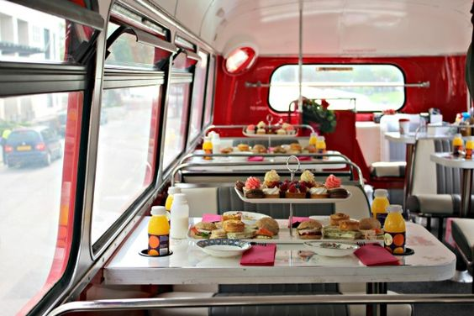
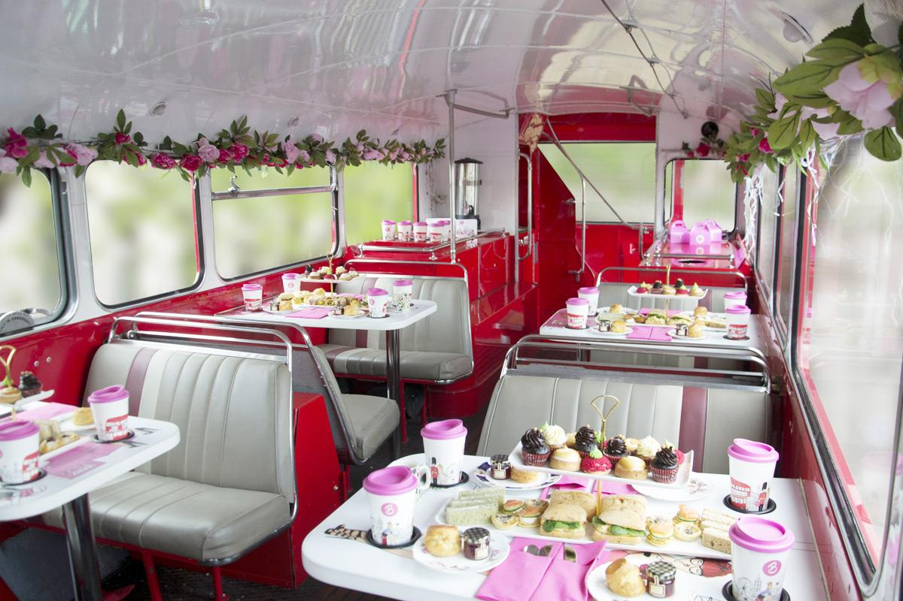

FLOOR PLANS

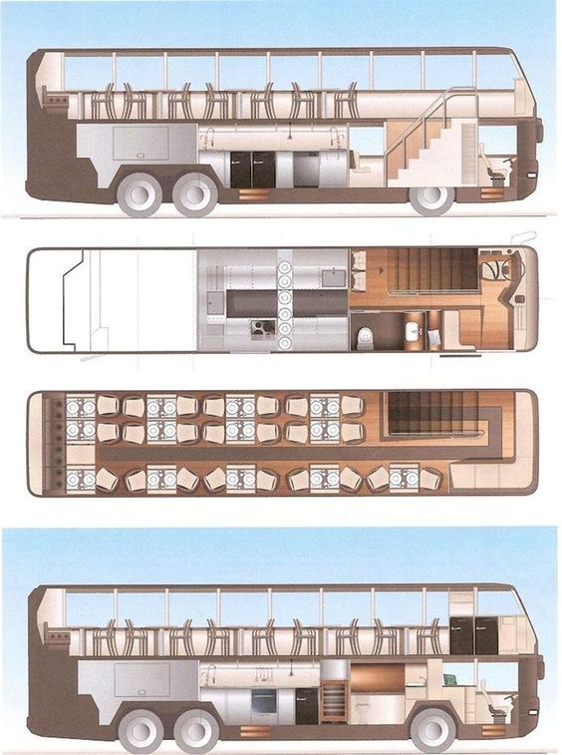

INTERIOR FITTING
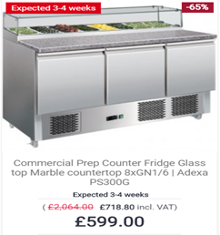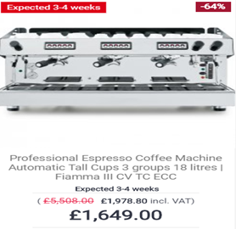
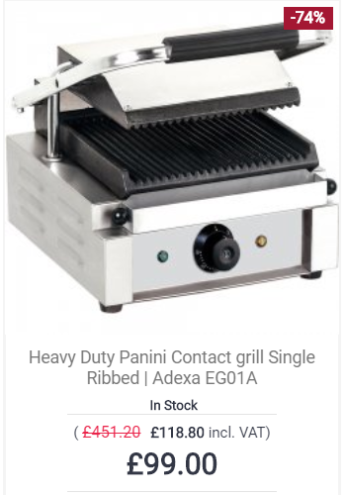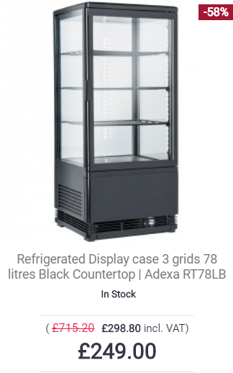
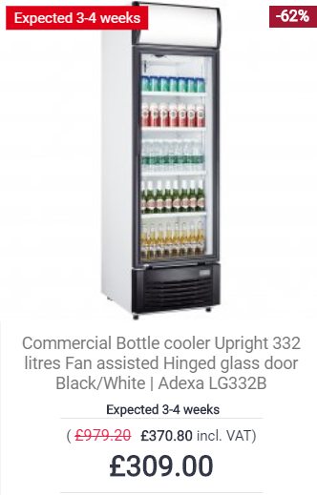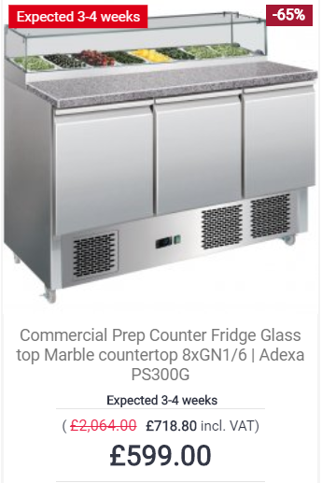

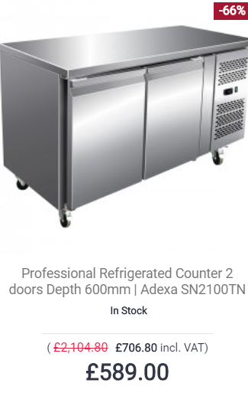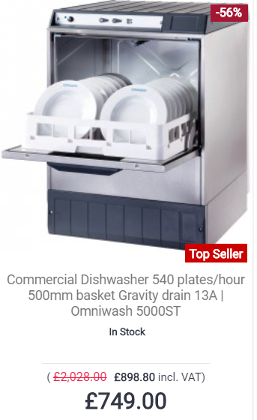

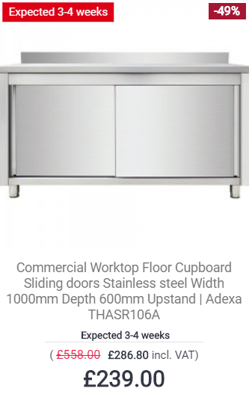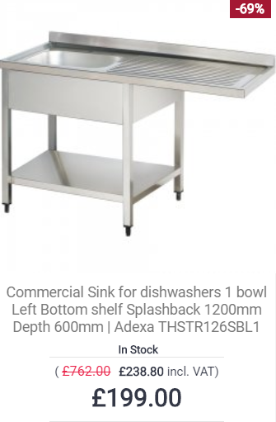

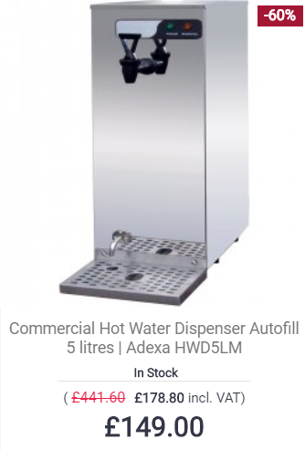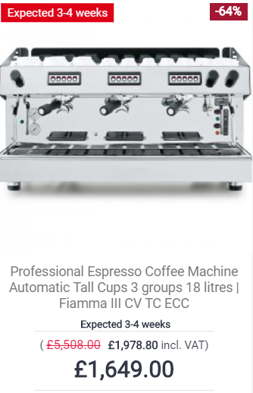

https://adexa.co.uk/Cooking-Appliances-31/Panini-Grills-258

We have sourced good quality products at low prices to keep our costs down. When our business is more successful then we expand in the future and we will look at purchasing more high-end quality products.

We will be using Locally produced products to support local businesses for example we will use welsh coffee beans.

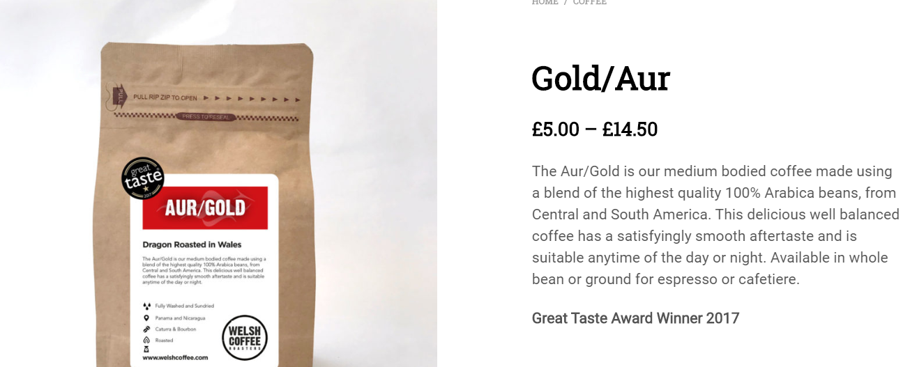

https://welshcoffee.com/product/welsh-coffee-bean-gold-aur/

REFERENCES
Adexa catering equipment direct (2019). Available at: https://adexa.co.uk/Cooking-Appliances-31/Panini-Grills-258
Advanced battery supplies (2019). Available at: https://advancedbatterysupplies.co.uk/product/gf-12-090-v-gel-battery/
Schofield, T. (2018). What are Physical Resources in Business?. Available at: https://www.study.com/academy/lesson/what-are-physical-resources-in-business.html

Welsh coffee company (2019). Available at: https://welshcoffee.com/product/welsh-coffee-bean-gold-aur/
Speaker Notes

April 1712455

The local council will inspect our business to ensure we are following food law code of practice; we will have to display our food hygiene rating certificate. As we comply to the high level of food hygiene standards, our rating will be high, and our customers are reassured when they see the certificate clearly displayed. (Gov.UK 2019).
The health and safety Act 1974 mean the business is responsible for securing the health, safety and wellbeing of all employees.
I conducted a job analysis of the business. Four job descriptions were then devised and each partner personal specifications were matched to each job description.
Gaps in training still needed has been identified and will be completed by each partner.

A review of staffing levels will be needed after three months.
If bookings for parties increase through all evenings and weekends, a rota system will have to be devised, so the evening work is rotated, and all partners get a day off.
The use of an agency for extra staff may also be needed, we all have families and life events to consider also and must allow for this. Work hours and personal life must be balanced to avoid stress which can lead to illness and dissatisfaction. This approach will ensure a smooth and successful running business.

CONCLUSION
The SWOT analysis identifies a strong position in today’s competitive market, our unique mobile business gives us the extra competitive edge, creating convenience for our customers, which will be our biggest selling point. It also allows for us to access future competition or changes in regulations that may become threats and apply contingency plans to overcome our weakness.
Convenience - Residential homes find it hard to operate outings for their residents due to their individual needs and staffing levels. We give the opportunity for residents to access a social experience outside of their home together.
Also, consumers today have busy lives, so by organising and bringing their parties to their desired location gives our business that extra edge people are looking for.
As our core group are the elderly from residential homes, we must consider there may be short notice cancellations. When illness such as the flu occurs, it tends to affect most of the residents as they live together. With this in mind a contingency plan is wise, so we do not lose business. Being mobile we have other options, for example; business parks will give us a large volume of customers as many are located far from towns and the use of amenities.
We can advertise online we will be in the business park that day and deliver flyers.
The financial model has a detailed and methodical analysis of the mobile tearoom, showing a healthy profit. This profit will be used to build on the party and events side of the business.
Consumers today are looking for the newest trend and unique, sensorial experiences.
Consumers also like to know the story behind the product and service provided, including the people their values and origin of ingredients. (Marcuta, et al, 2014).
We clearly display this information on our website, including our mission statement, which will peak our customers interest.
Expansion will consist of a deluxe, top of the range bus adapted specifically for first-class parties. This means we can charge more for this enhanced, luxurious experience and give our stakeholders a higher return on their investment in our company.

References

Gov UK (2019) Licensing, Available at www.gov.uk. (Accessed 10/3/19).
Health and Safety at Work Act, (2019) Available at www.rbkc.gov.uk. (Accessed, 12/2/19).
Marcuta, L, Marcuta, A and Marzon, B, (2014) ‘Modern Tendencies in Changing the Consumers Preferences’ Procedia Economics and Finance, vol 16, p, 535-539, Available at www.sciencedirect.com. (Accessed 12/3/19).
Workplace Pensions, (2019) Available at www.gov.uk. (Accessed, 13/2/19).

Speaker Notes
Leanna 1712164

Marketing & Promotional Activities.

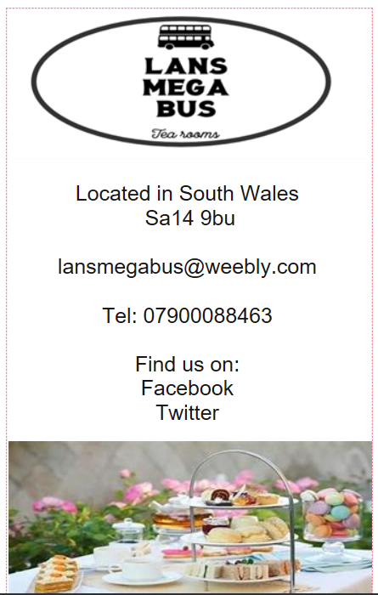
Our promotion materials will consist of paper-based and online services to advertise our business. Here are the ways of advertising that will cost our business. We will produce business cards and flyers like in the example here, which we will hand out in our local and surrounding areas and ask local business’s for permission to leave some at their premises and in return we will offer these business’s to advertise their business on our bus. We will also have our cards and flyers on our bus so that customers can take them if they would like to recommend us to their friends and family. These forms of advertising will come at a small cost for our business with 1000 business cards costing £27:59 and 1000 flyers costing only £14:99. We will also purchase these every month and continue to distribute them daily in the same way to ensure customers, especially the ones who do not have online access, stay interested in our business and to encourage new customers to visit us.
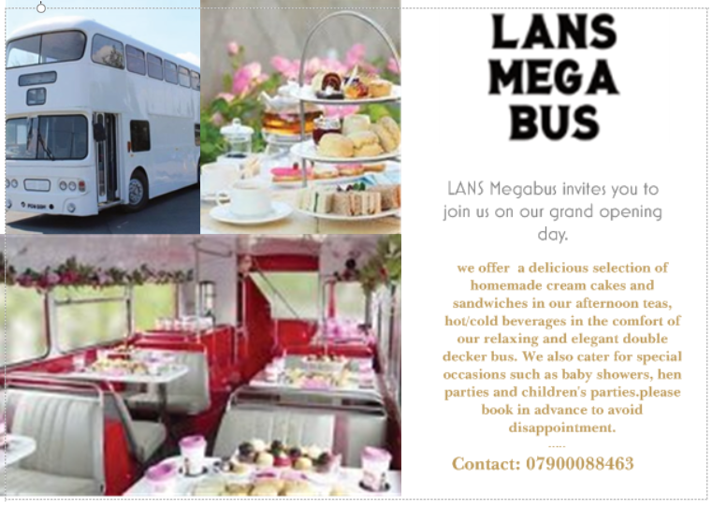
Another source we are going to use is newspaper advertising, we will put an ad in the local paper, again aimed at potential customers who may not use online services. This again will come at a small cost for our business costing only £10, which we will then place every week. The final form of advertising that will cost the business is radio, this is the most expensive with short radio ads ranging from £250-£1000 per week. This is something all business partners will have to agree on once the business has taken off.
The main source of our advertising will be through our website and social media. These are very effective ways of advertising for a number of reasons. ‘It improves brand awareness, cost effective, helps engage with customers, improves brand loyalty, healthier customer satisfaction, marketplace awareness and more brand authority’ (Nelson, 2018). We will use our social media pages, website, business cards and leaflets to show potential customers what products we have on our menu, prices, special offers and locations we will be at. Our social media pages will be updated daily and our leaflets will be issued monthly giving customers all the information they need to know about where we are situated throughout the month and what special offers we will be promoting during the month. This will ensure that our customers all always up to date with us.
‘Websites are worthwhile investments for small businesses they help you be found online by potential customers, connect with existing customers and market your product and services’ (Maxon, 2018). Our website will show customers information about our business partners, menus, contact details, location and about our hiring services for parties and events. We will expand our hire service by offering customers to hire us not only for events discussed previously but offering to cater for extra events such as baby showers and princess and super hero afternoon tea parties for children, who can dress up as their favourite princess or super hero, and a member of staff will also dress up as a princess/super hero so the children can have a meet and greet with them, at a set price of £15 per head. After researching local competition, we arrived at these prices to ensure we are not undercut by competition.
We compiled a questionnaire which we distributed to potential customers and we received excellent feedback back with a high interest in our services. Our questionnaire identified that our main target age is 25-40 years with 54% saying they are very interested in the idea of a mobile tea room and would use this service weekly, and 100% of those asked said they were interested in our special offers. These figures can be seen in the graphs provided.
We will run promotional activities such as special offers, ‘the most important purpose a promotion serves is that it sets a business apart from its competitors. You have to stay ahead of your competitors in order to keep customers doing business with you’ (Whaley, 2015). We will offer deals such as:
- Sandwich & drink & crisps/cookie
- Cake & hot drink
- Loyalty cards for drinks
We will always keep up to date with our competition to ensure that we offer our customers the best prices for our services and keep our customers loyal.
The future of our business.
The aim for our future advertising is to expand it to radio advertising once our business has taken off and doing well.
And for our future promotions ideas we hope to be granted an alcohol license to further promote our special offers and achieve more interest and expand our special events.
And hopefully to expand our business by investing in another bus and hire more staff and getting our business known further afield.

References.
Maxon, M (2018) Why should small businesses create a website in 2008? http://www.themanifest.com (Accessed 18th March 2019).
Nelson, S (2018) 7 reasons why social media marketing is important for your business. http://www.digitaldoughnut.com (Accessed 18th March 2019).
Whaley, K (2015) Why promotions are so important and why you should run them often. http://www.b2bmarketing.net (Accessed 18th March 2019).

Speaker Notes
Natalie 1712163
Start-up costs
The total start-up costs for this new and exciting business venture is £84671.14, broken up as follows:
Our total start-up costs consist of three areas, as the graph above identifies, the largest amount of capital will be utilised for capital costs. These include all major costs we face during the first financial year, which are necessary requirements to get the mega bus up and running. Budgeted within these costs are what we will also require for our first 3 months of operating. As can been seen in the table below.
The capital to fund these costs will be obtained from the four partners/owners personal saving. They are as follows: Leanna Jenkins £21,250 April Fuge £21,250 Natalie Thomas £21,250 Sarah Rees £21,250

After intense research into securing part of the capital against the business via a bank loan, over a five-year period fixed at a rate of 7.4%, £25,000 would see an extra monthly expense of £496.92.
Therefore, it was agreed by the owners, to keep expenses as low as possible during the first year, to maximise profits. This will help us build a prosperous financial back ground, to accommodate our future expansion plans.

Production costs & Pricing
Mills & Rosenburg (2010) explains, to ensure success as a business it is essential to know how much all products cost and how much profit each makes.
The break down costs based on products to produce each item are as follows –

Black/White coffee -

Afternoon Tea served with tea/coffee -

Based on the cost to purchase the stock required to produce the following items, the profits are as follows:

When pricing our goods, we have considered many factors, including the degree of competition, demand, cost structure and the state of economy, as suggested by Lucey (2009).
Along with our differentiation services and atmosphere the competitive prices we will offer can be seen above.
Myddelton (2000) explains, customers will not usually pay more for products than they think they are worth.
Barring this in mind, as part of our marketing/pricing strategy, we have set prices based on the responses gathered from the questionnaires we distributed to our potential customers, identifying they found the £15 price bracket to be reasonable.

Financial Statement
Our company is expected to see a gross annual income of £212,895, during the first FY-2019 and a net profit margin of between £90,000 and £115,000. (see below)

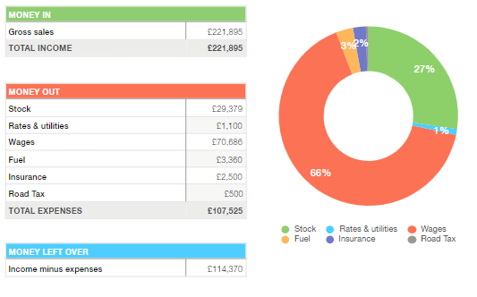
These figures are based on our weekly sales schedule at Residential homes, selling 25 afternoon teas per sitting, twice a day, five days a week up until 8th September ( schedule can be seen below). Then in the following months of the year progressing to three sitting per day, selling 20 for five days a week. They also include youth clubs estimate sales of £86.60. All sales are based on a cash basis.

Cashflow Forecast FY2019
Hunstad (2005) explains, a cash flow forecast should document all components relating to the costs and sales of your business. When the data documented is of high quality and understood, it is possible to achieve the generous rewards of a cash flow forecast.
Our cash flow forecast (below) for FY2019, includes sales based on the schedule above, considering the pre-paid expenses accounted for during our set up costs. Making amendments for the seasonable holidays, along with the following FY insurance and road tax.
Wages have been set above the national minimum wages, at £20,884, and include pension contributions.
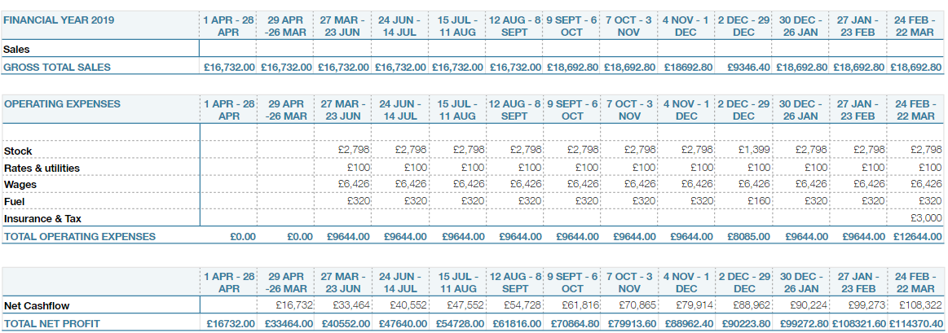
After intense research into the demands of our services, we believe these figures to be achievable. However, with constant changes in economic and social demands we understand that there may be need to adjust these schedules. In the event of this we have an alternative schedule in place consisting of two sittings a day, serving just twenty seats of the possible thirty and no evening youth club meets. With these schedules in place we will still see an estimate net profit after all expenses of £25,272 and would leave an extensive amount of time during weekdays/weekends to explore other areas. Such as party hire/events.
Private parties or events will be charged at the same price per head as the afternoon tea above, with the replacement of a soft drink instead of hot beverage.

Break Even
It is important to know your breakeven point. Stutely (1999 p. 233) states “you break even when you just cover the costs of buying or making the product and other operating expenses”.
Our weekly average operating expenses are £2411, which is made up from- wages, utility, fuel and stock, when sold at £15 per head, our afternoon tea breakeven point is 161 units, out of the 250 we schedule for weekly. See below
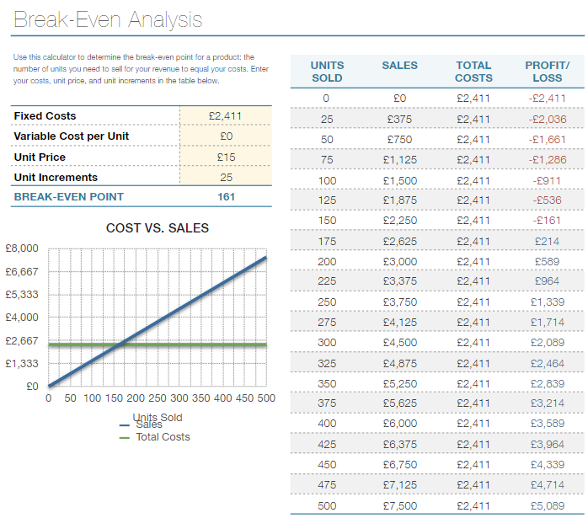

References
Hunstad, M (2005) ‘Better forecasting: Know your cash flows’. Financial Executive. Vol 21. Issue 4. pp.60. Available at https://search-proquest-com.ezproxy.uwtsd.ac.uk/docview/208906090?accountid=130472&rfr_id=info%3Axri%2Fsid%3Aprimo. (accessed 21/03/2019).
Lucey, T (2009) Costing. 7th Edition. Hampshire: Cengage Learning EMEA.
Mills, E & Rosenburg, M (2010) Start Your Own Coffee and Tea Shop. Surrey: Crimson Publishing.
Myddelton, D, R (2000) Managing Business Finance. Harlow: Pearson Education Limited.
Stutely, R (1999) The definitive Business plan. Harlow: Pearson Education Limited.

Business Plan Presentation Preparation
To allow us to plan and manage this business plan presentation, we complied a Gantt chart which has helped us keep track of each task on a weekly basis.
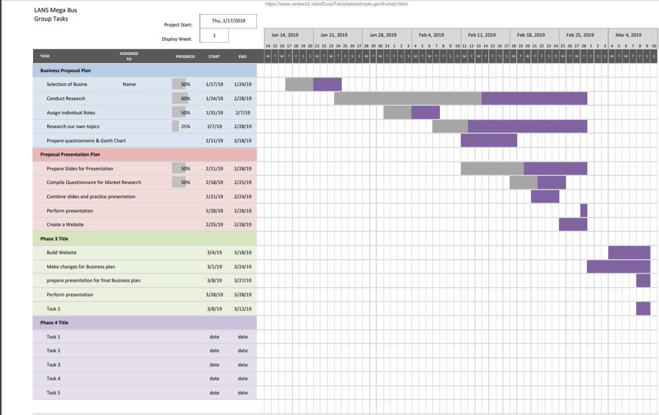
Contribution Audit
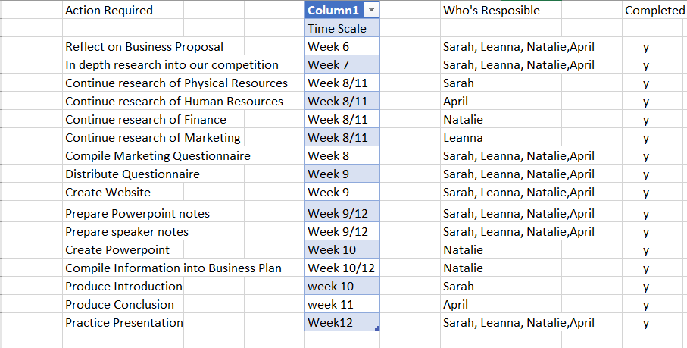

Power Point Presentation
Slide 1
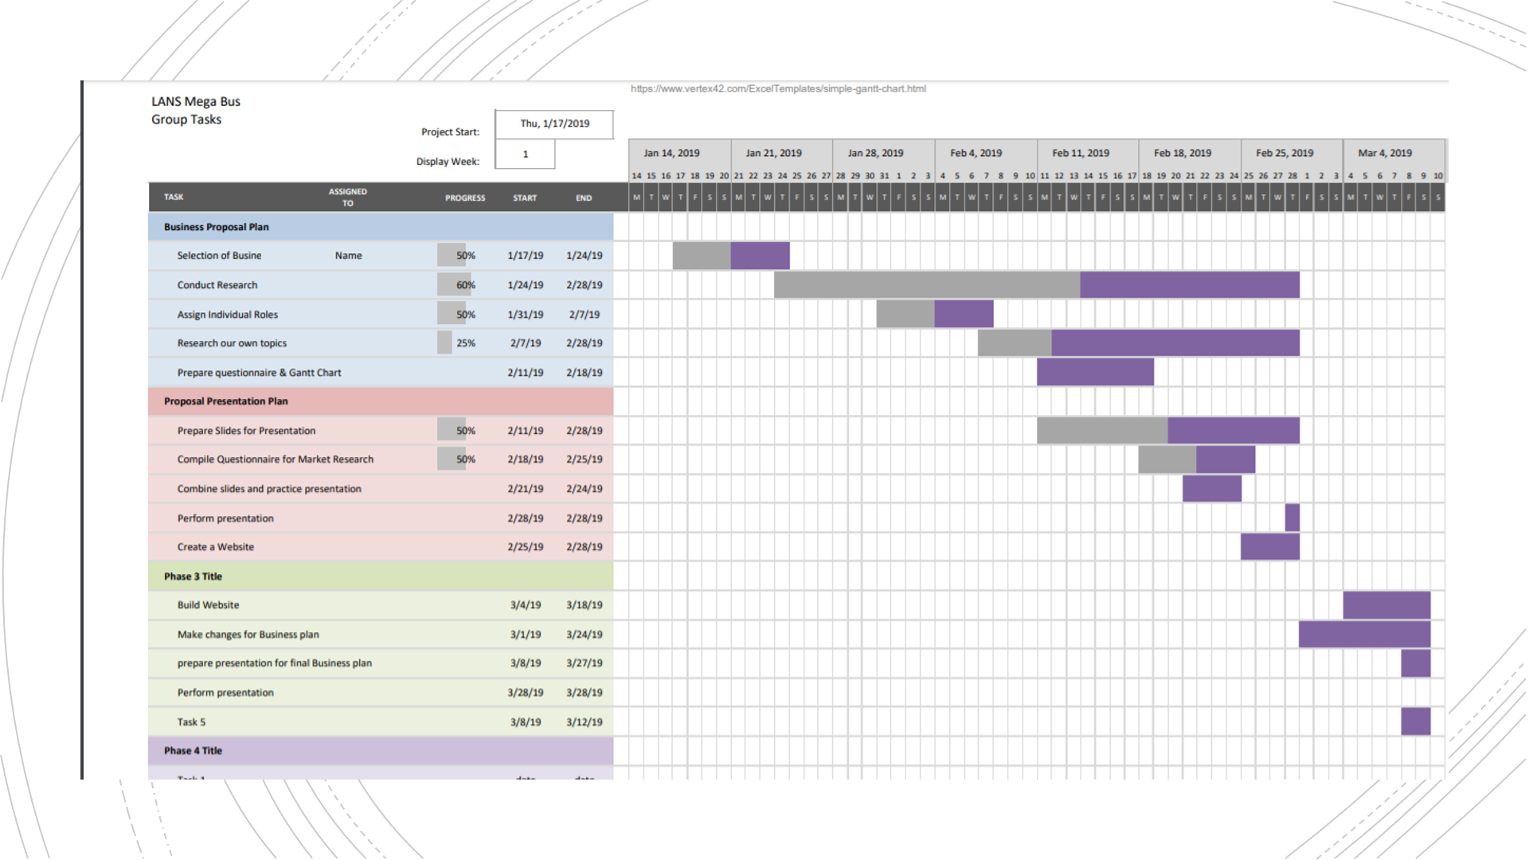

Slide 2
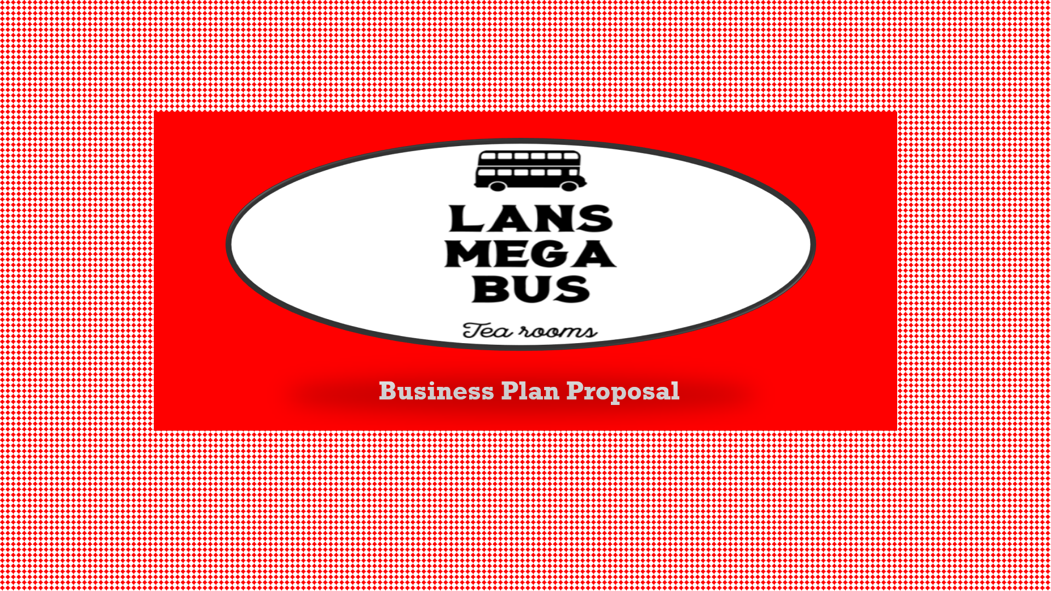

Slide 3
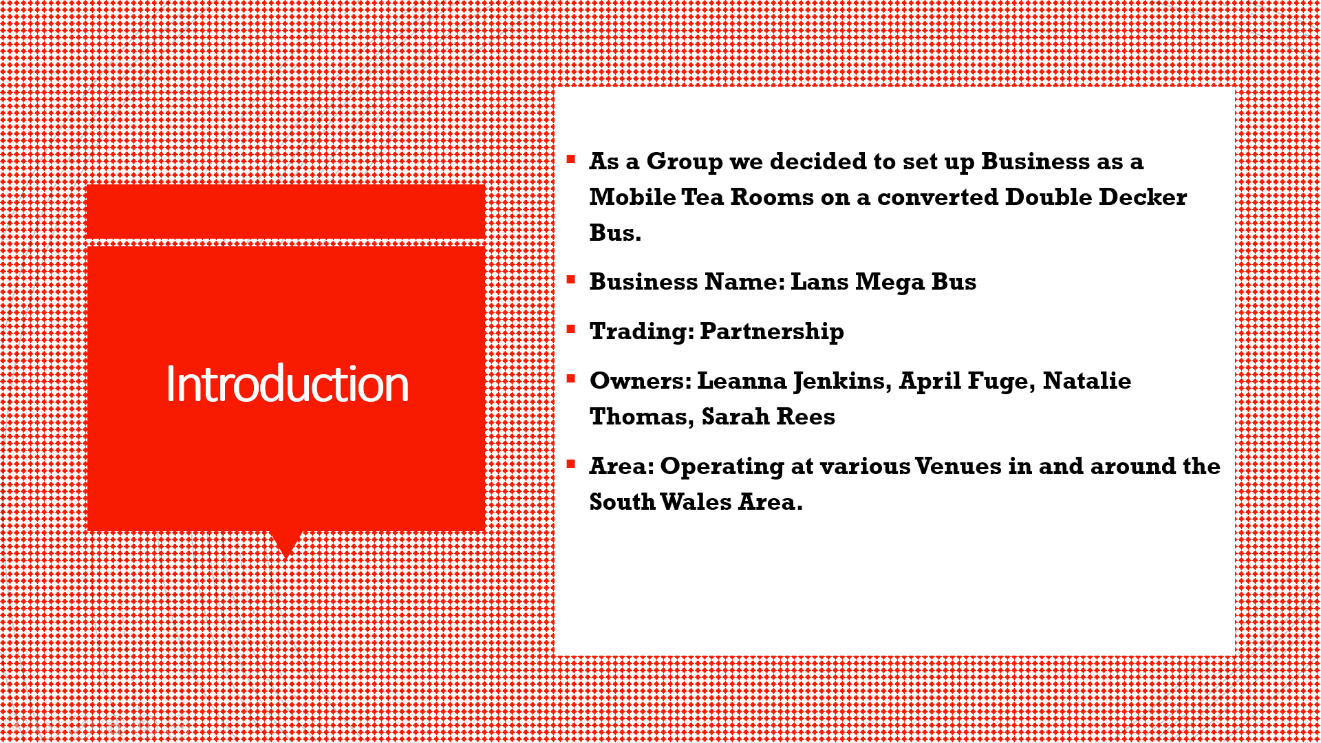

Slide 4
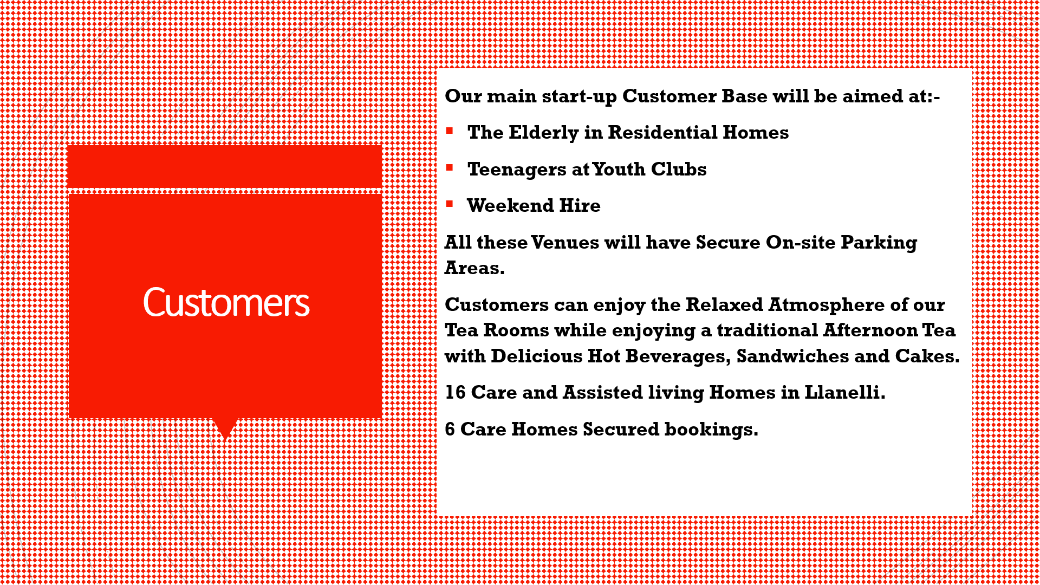

Slide 5
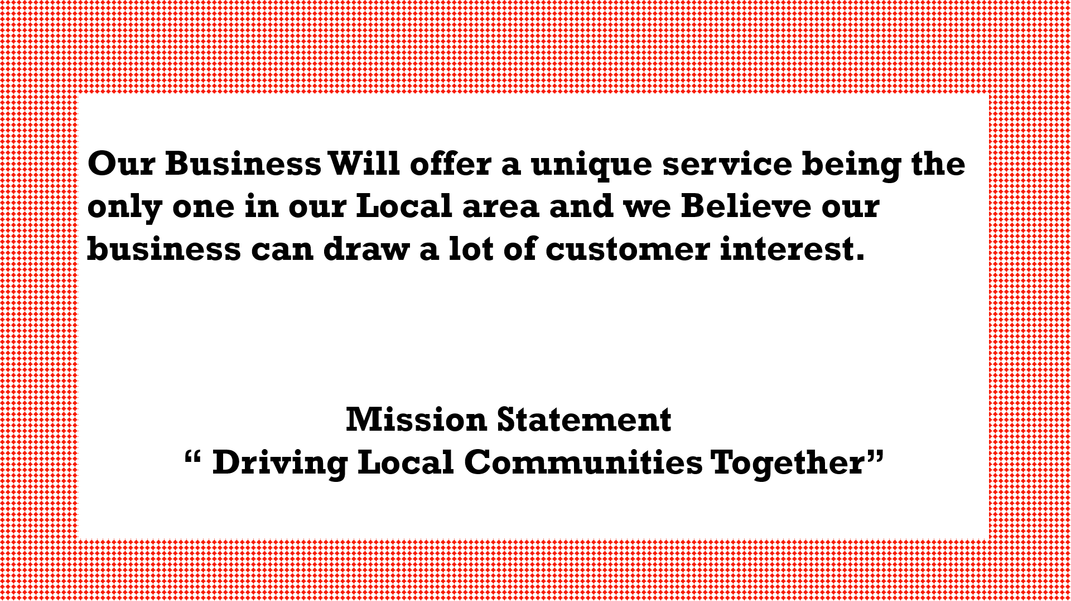

Slide 6


Slide 7
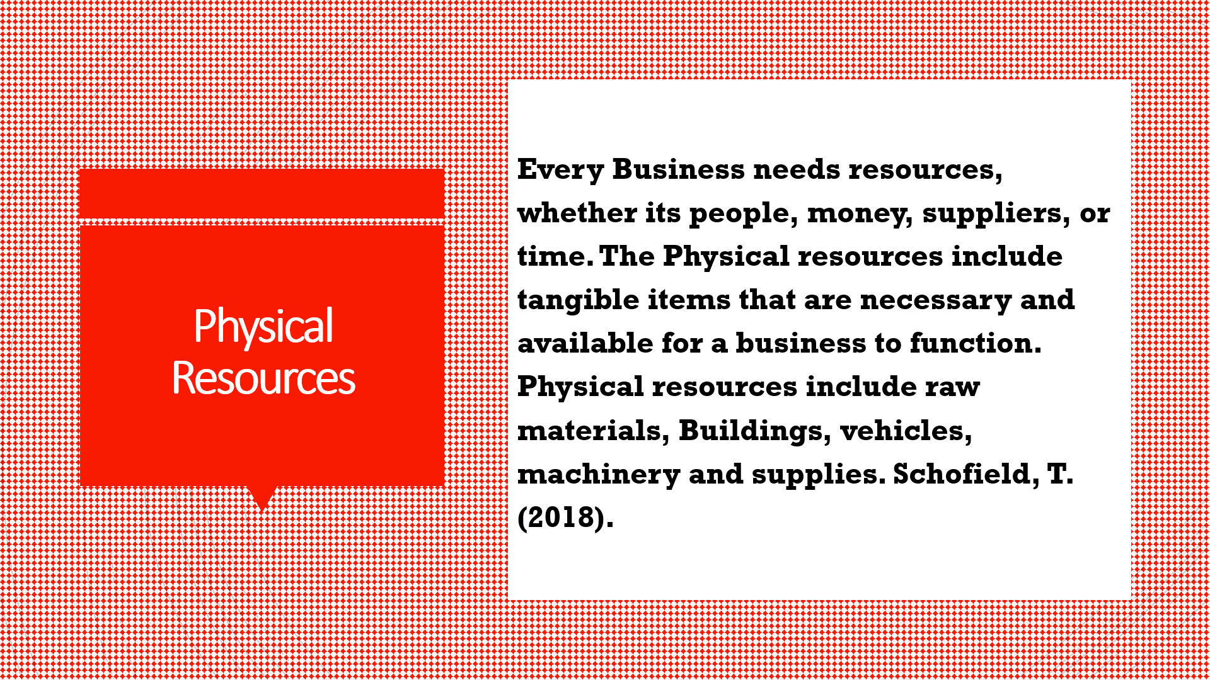

Slide 8
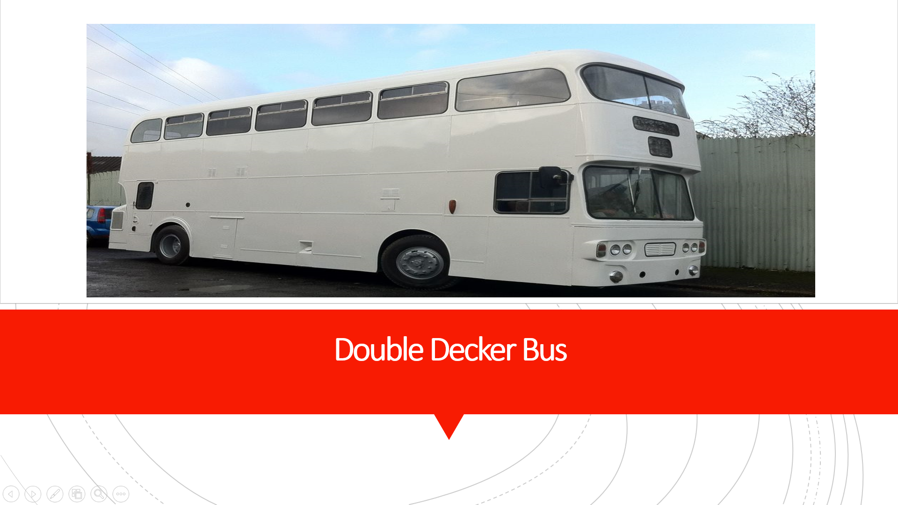

Slide 9
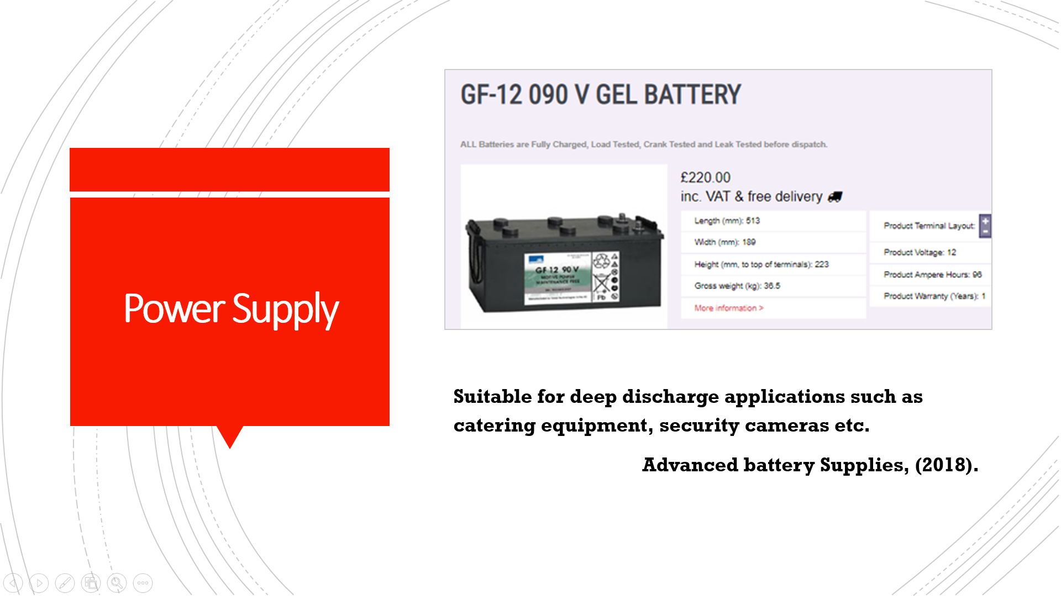

Slide 10
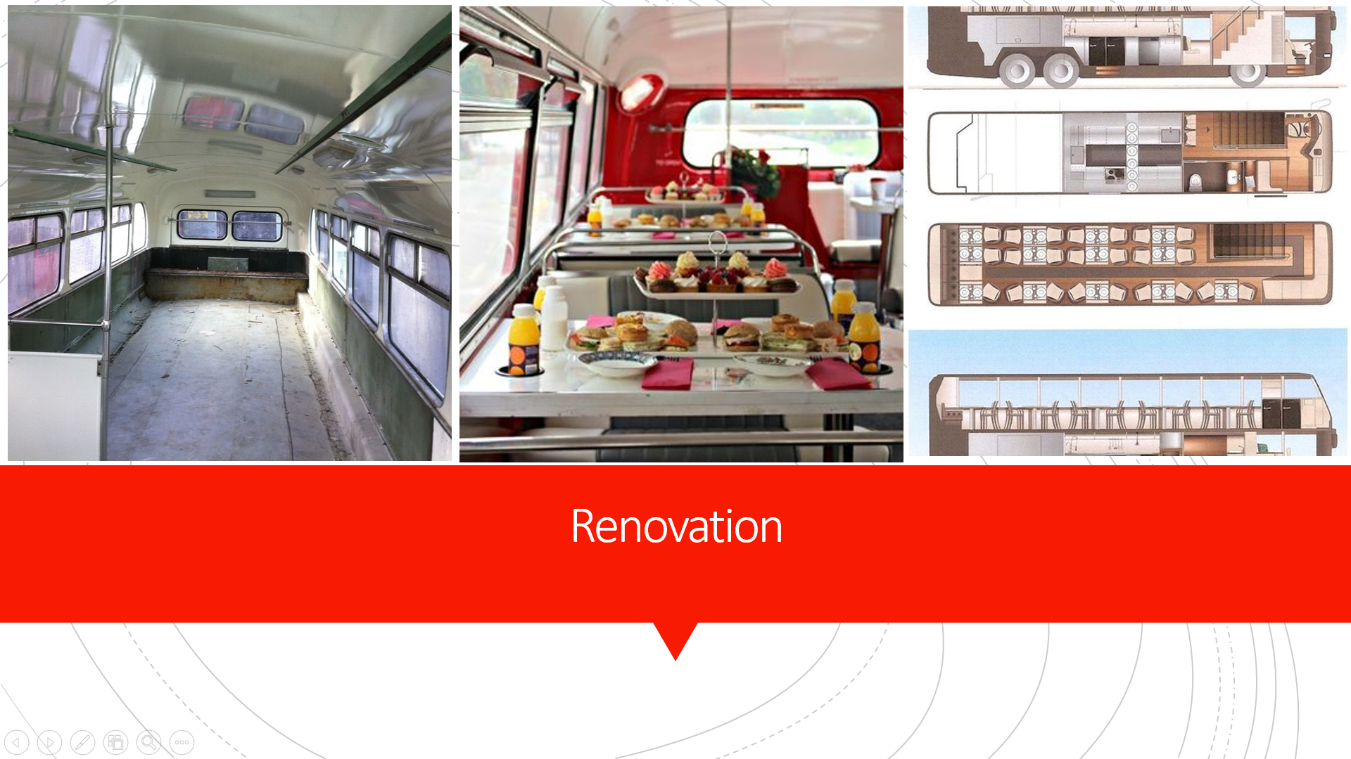

Slide 11
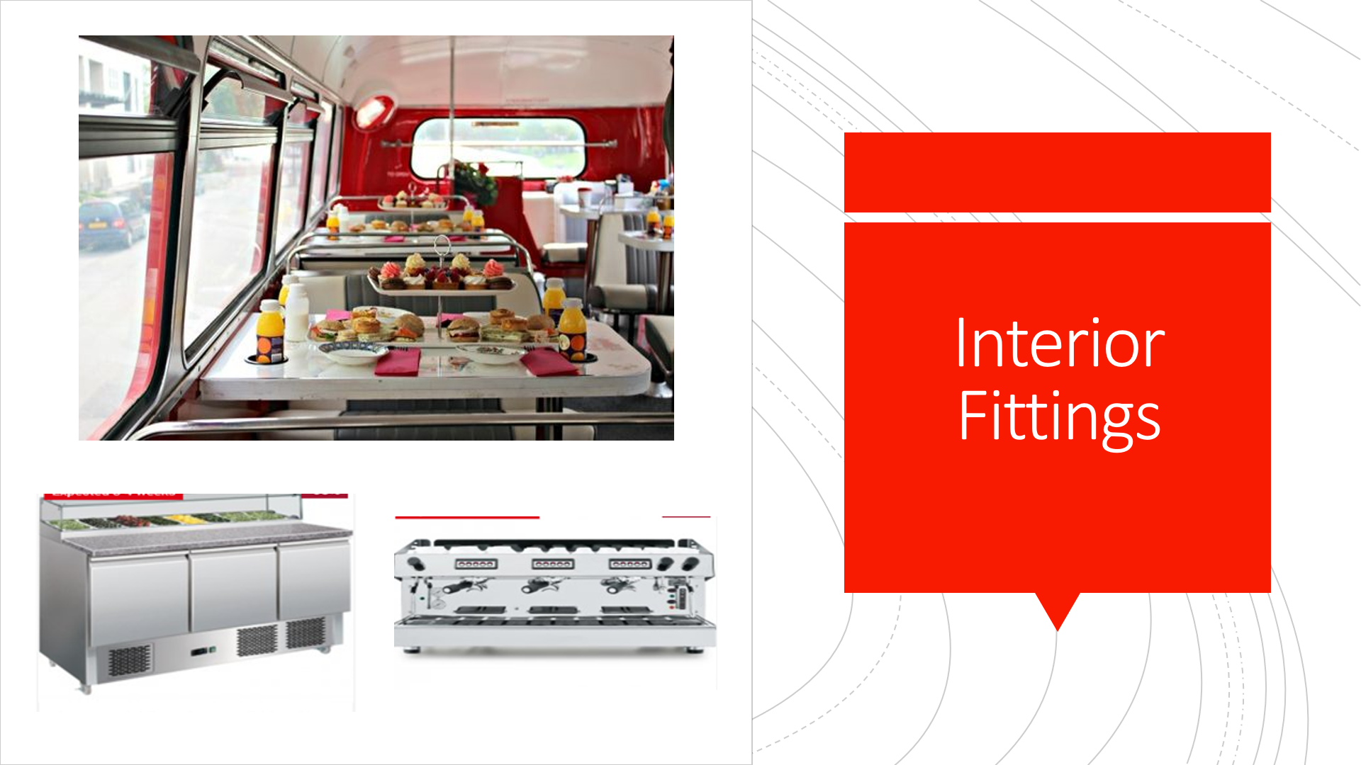

Slide 12
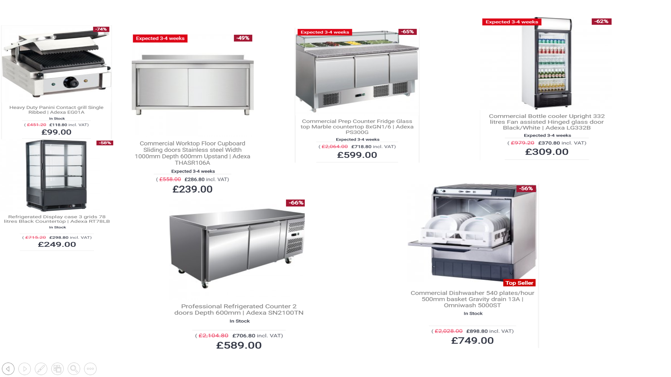

Slide 13
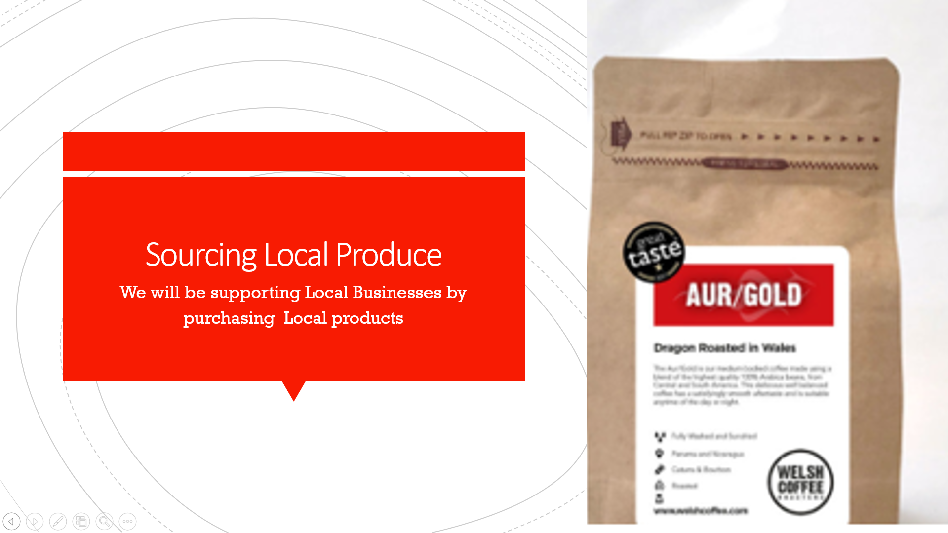

Slide 14


Slide 15
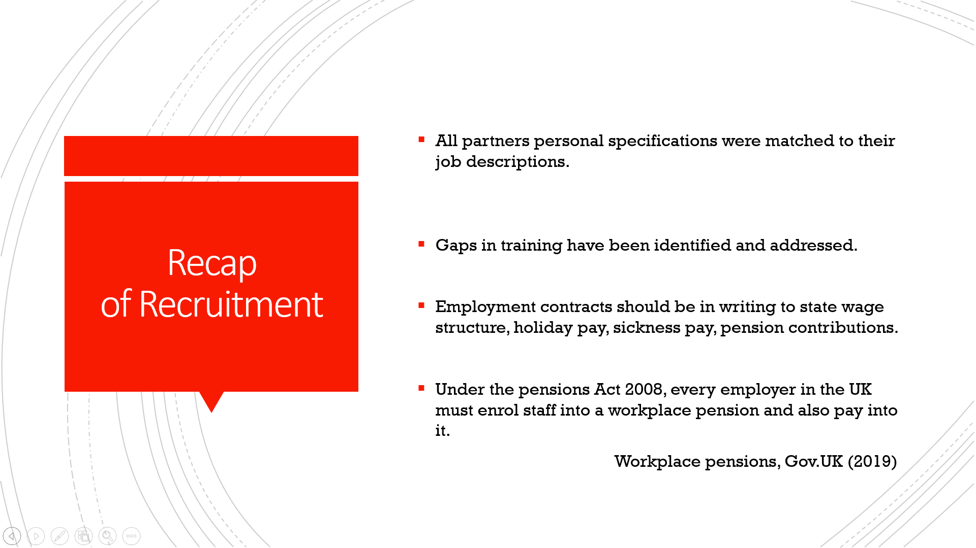

Slide 16
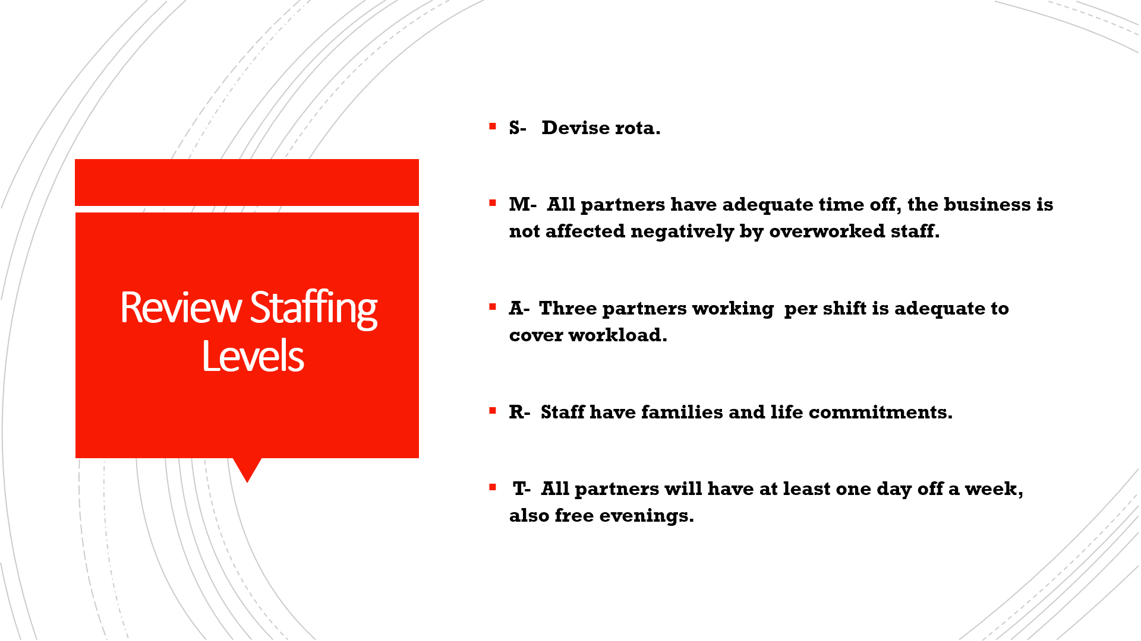

Slide 17
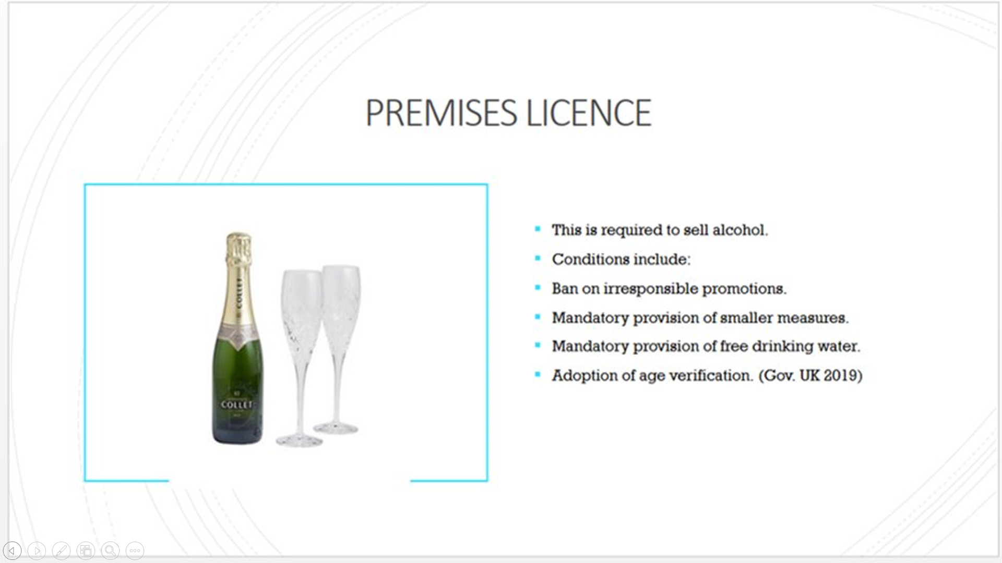

Slide 18
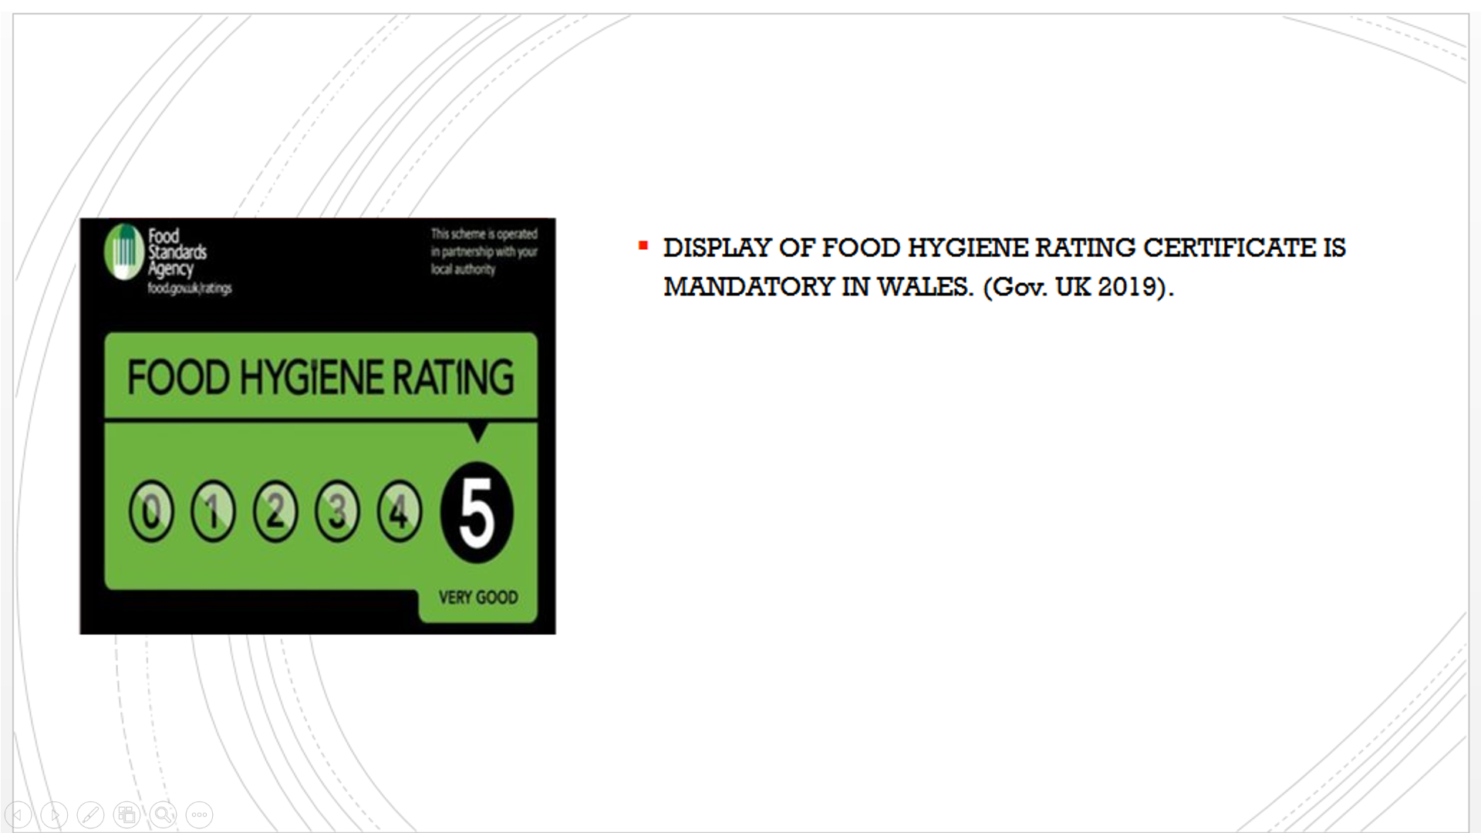

Slide 19


Slide 20
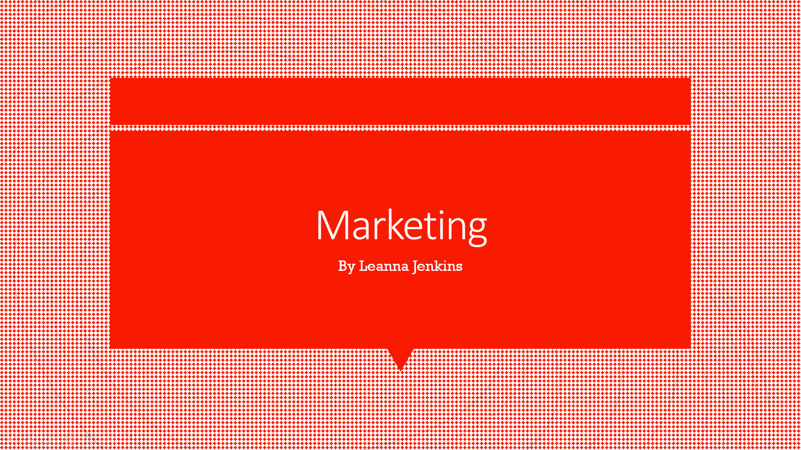

Slide 21
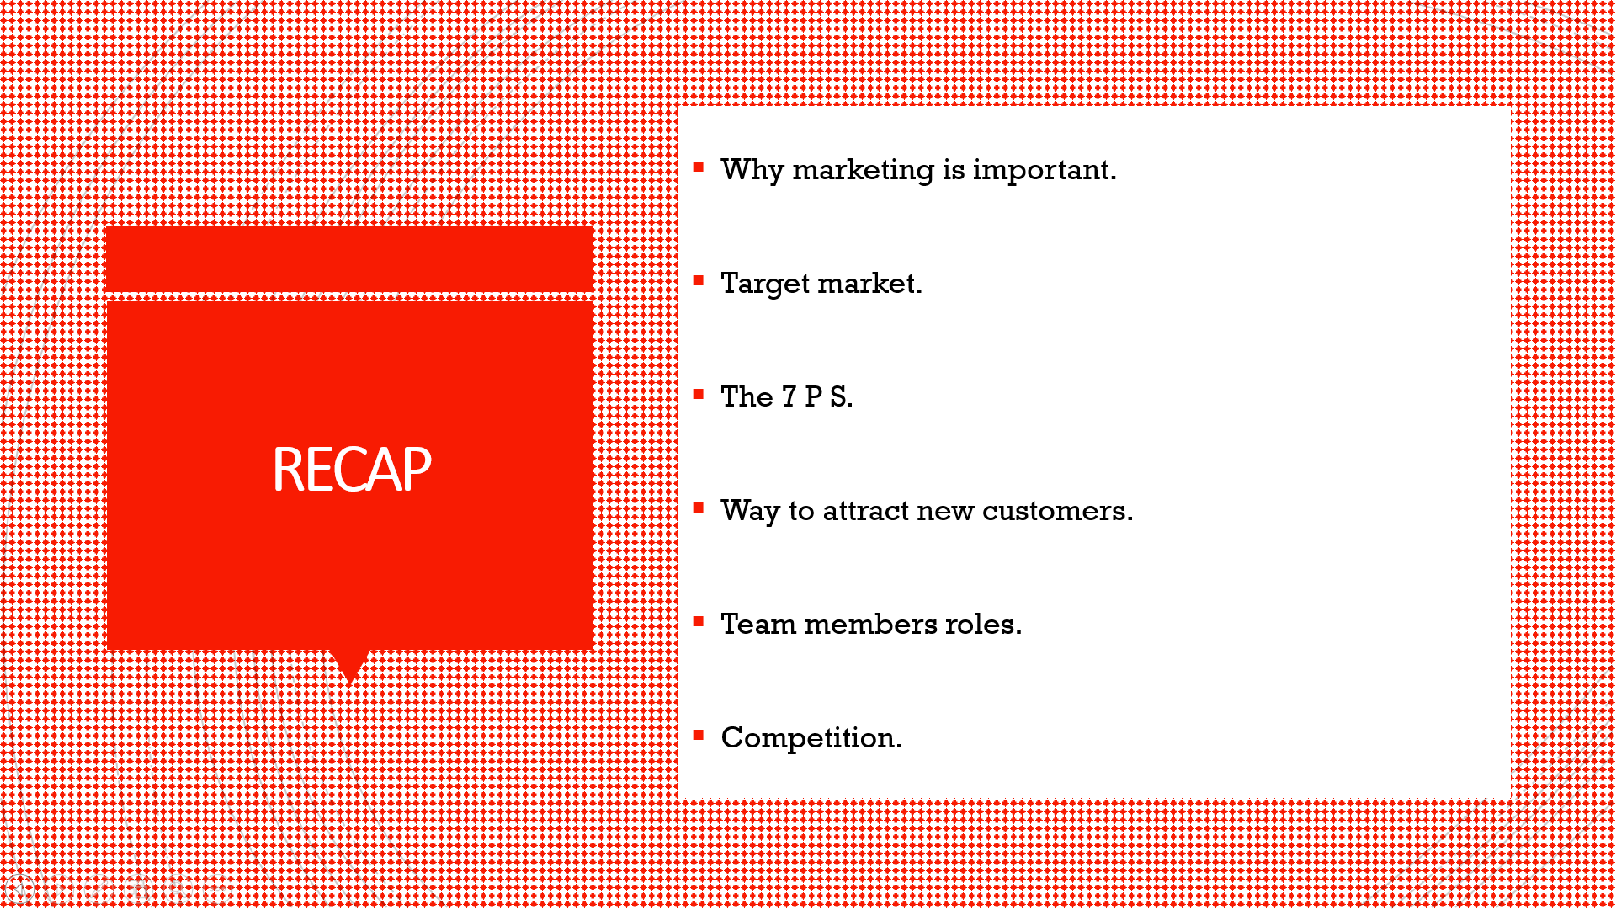

Slide 22
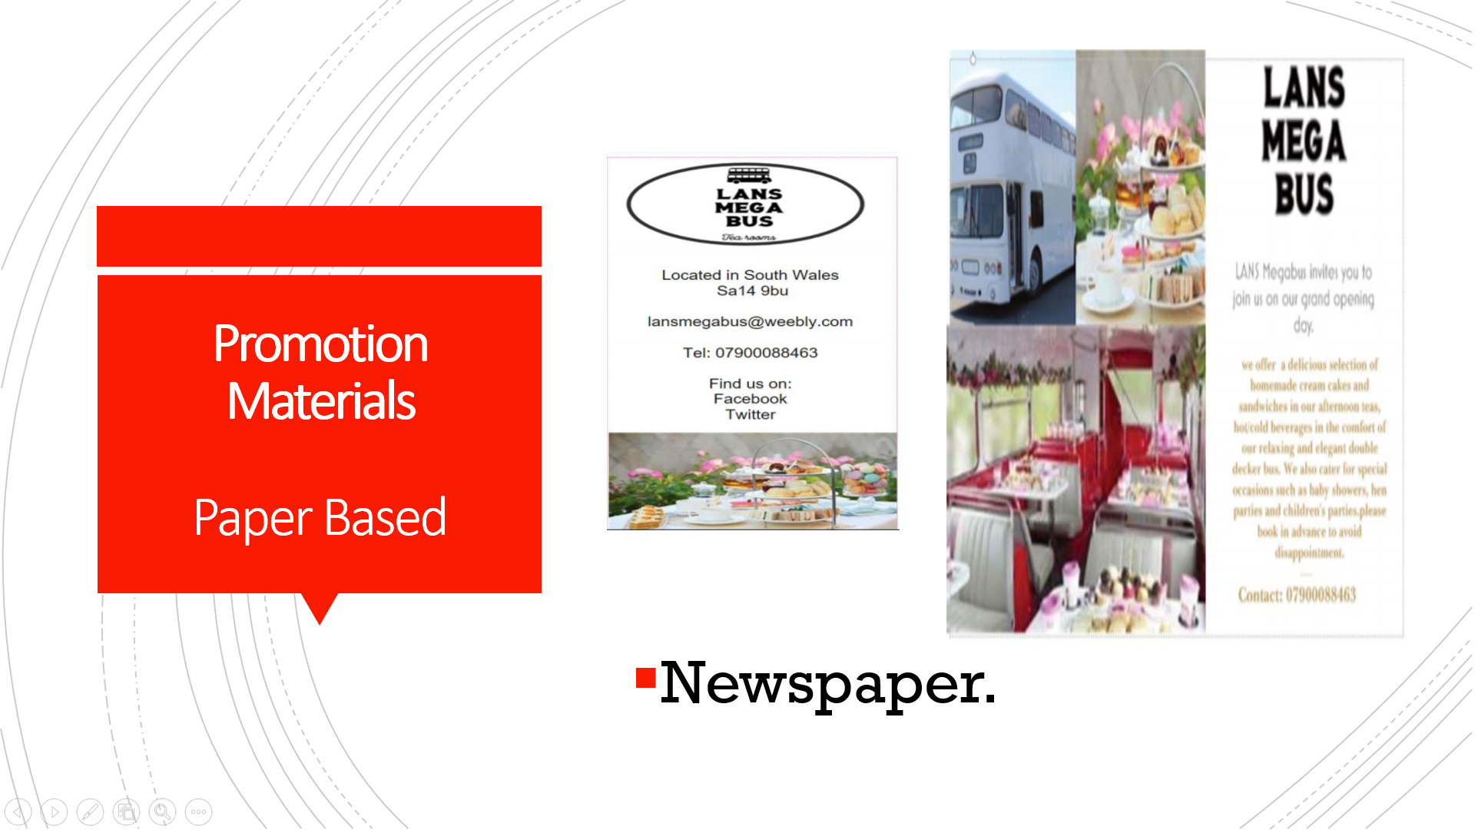

Slide 23
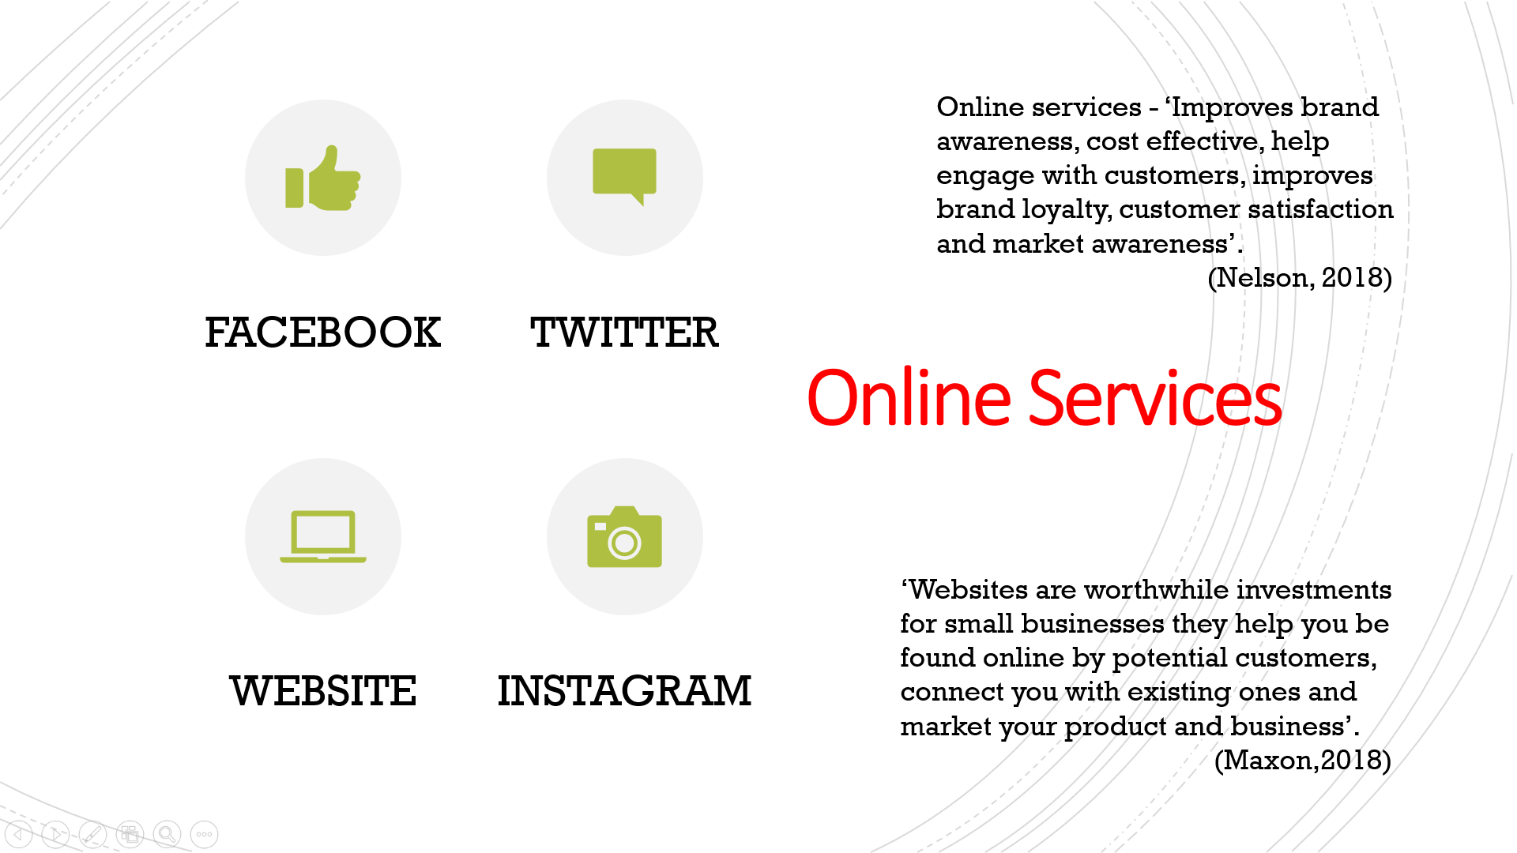

Slide 24
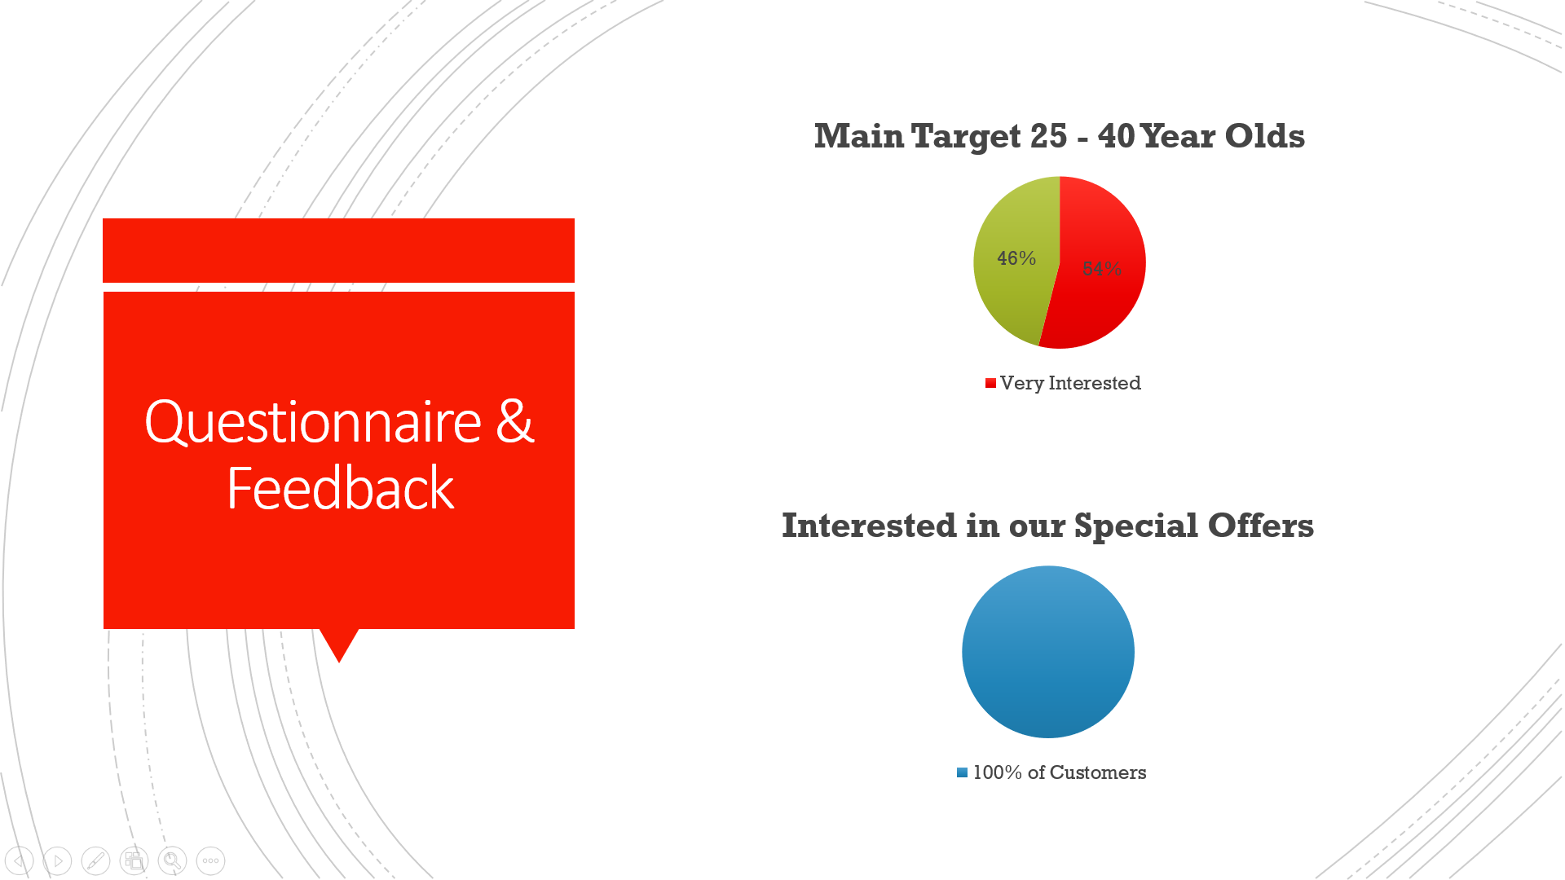

Slide 25
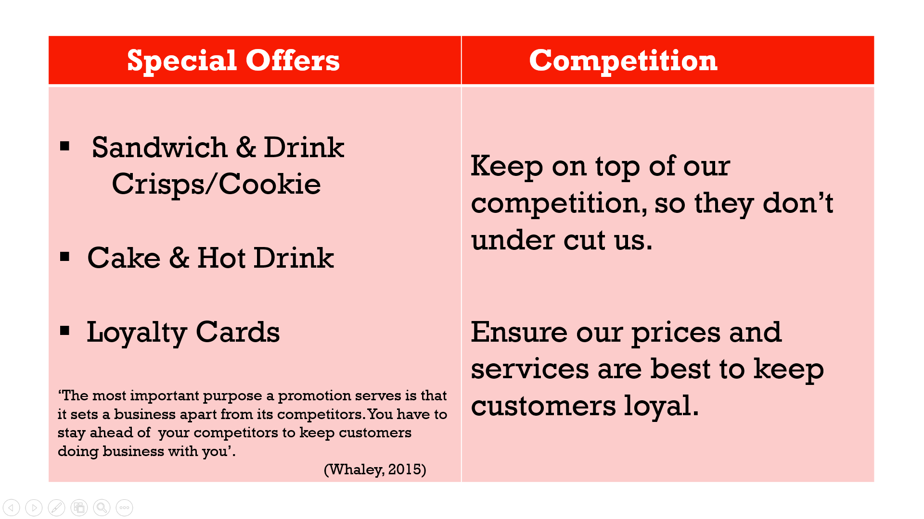
Slide 26
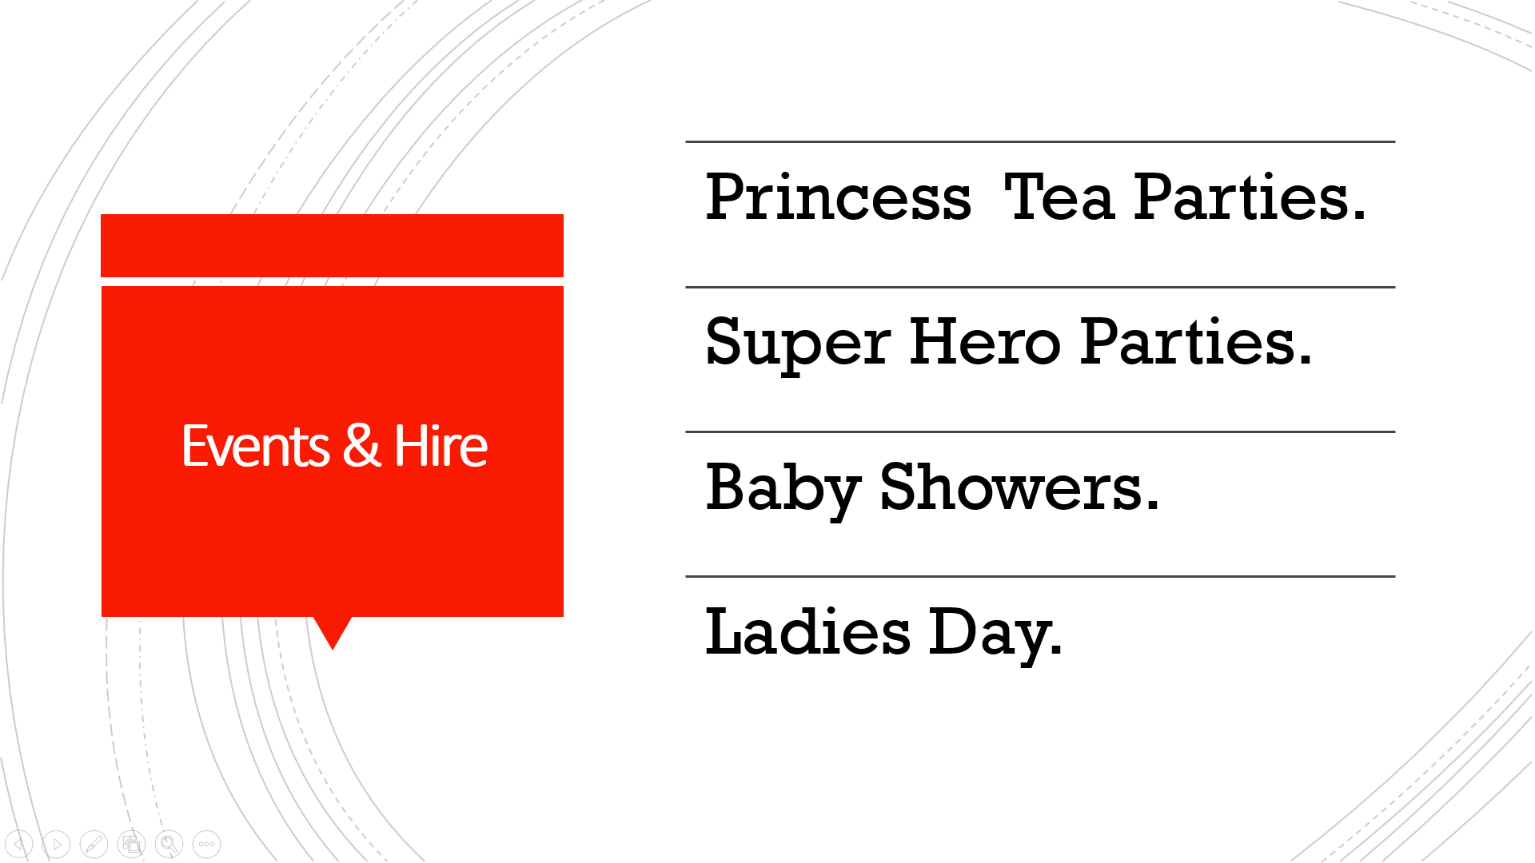

Slide 27
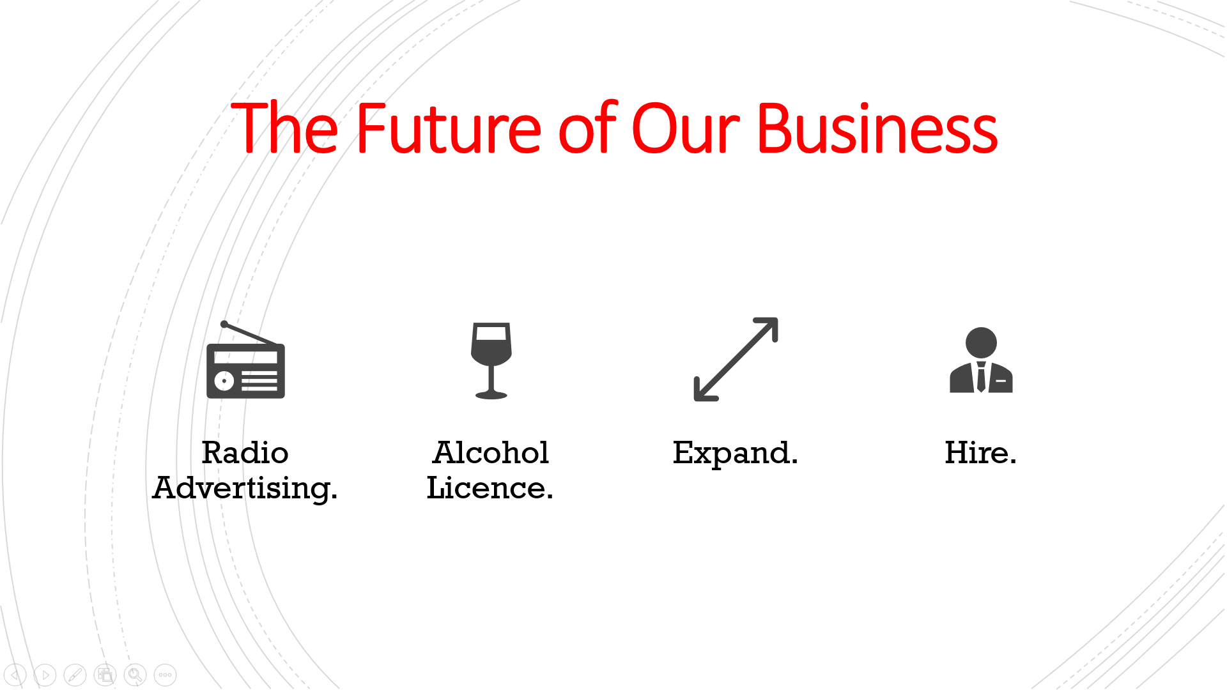

Slide 28


Slide 29
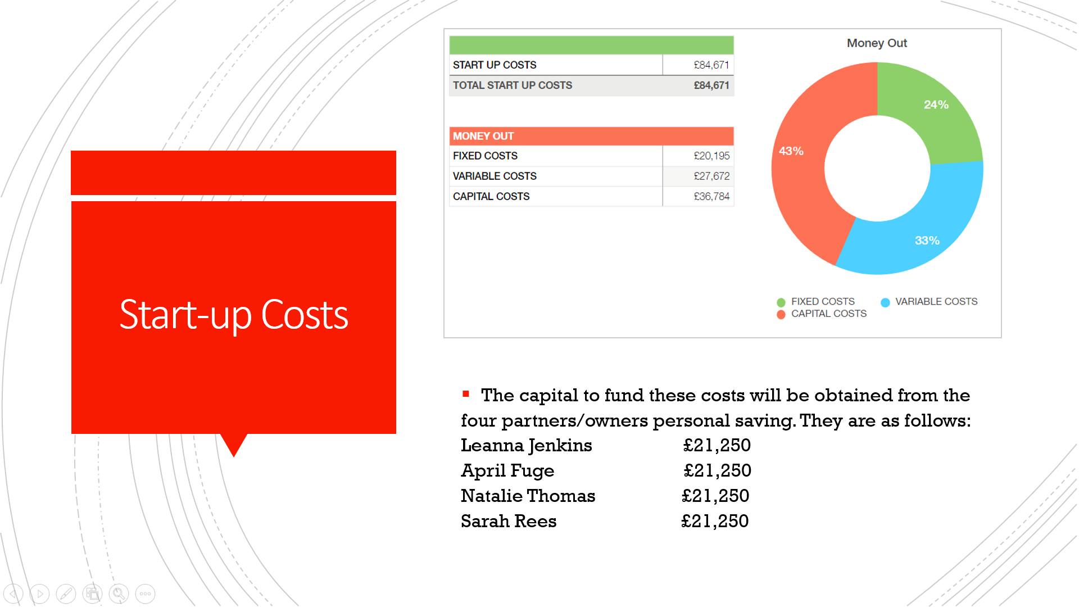

Slide 30
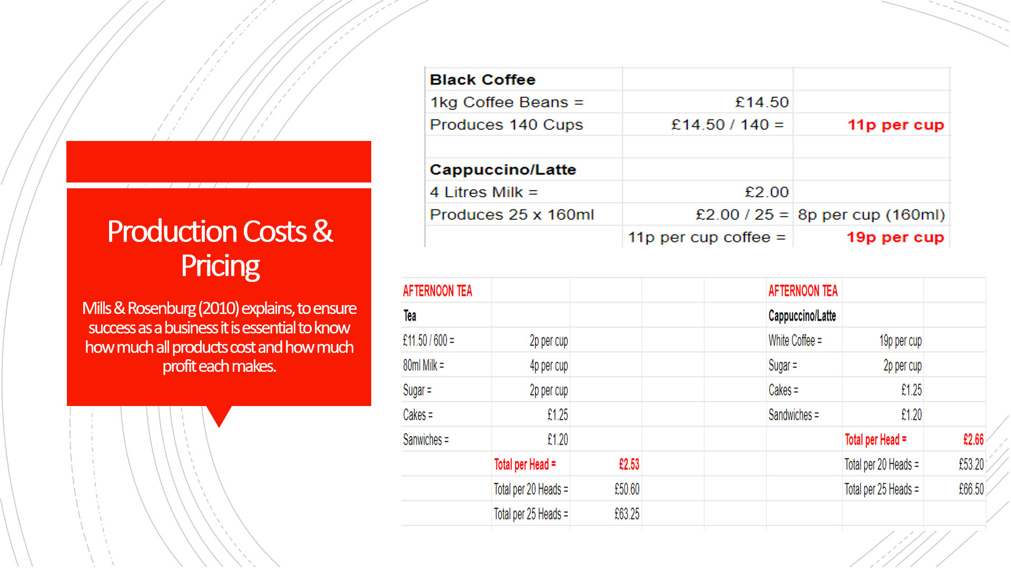

Slide 31
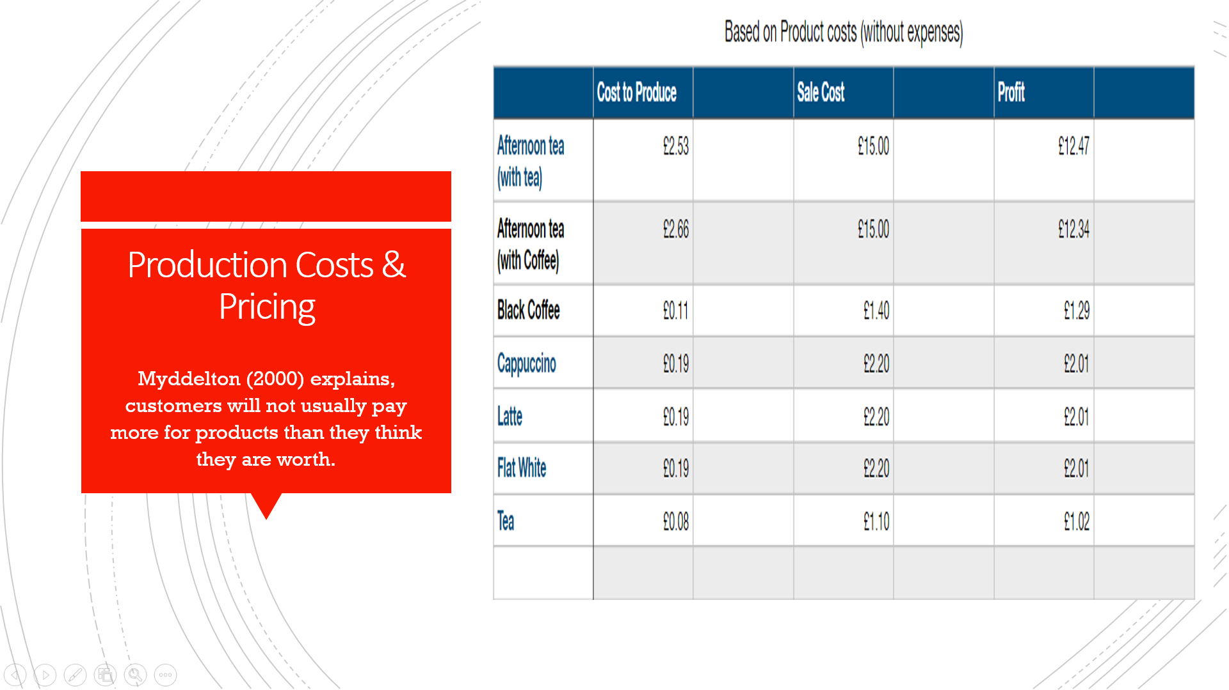

Slide 32


Slide 33
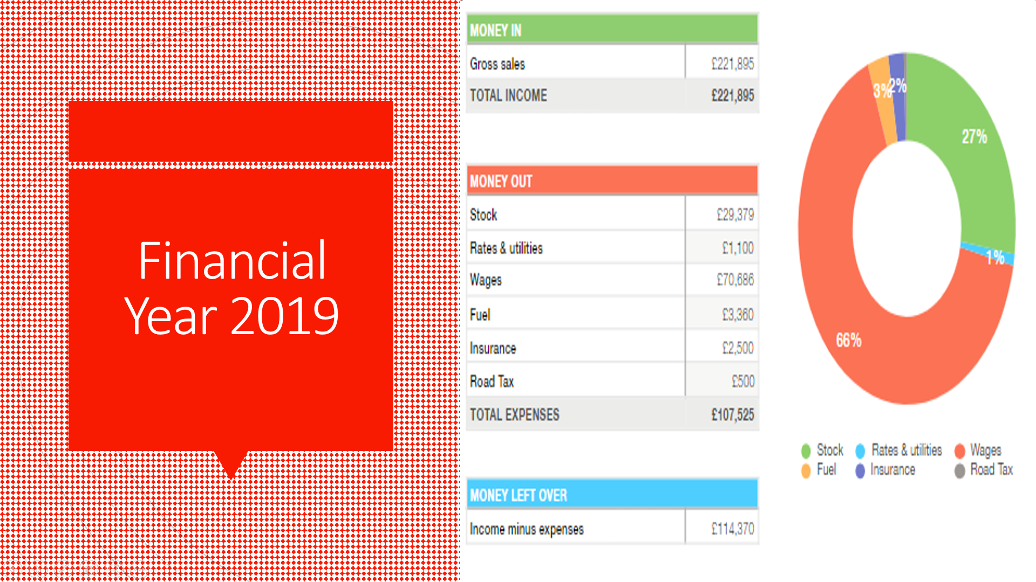

Slide 34
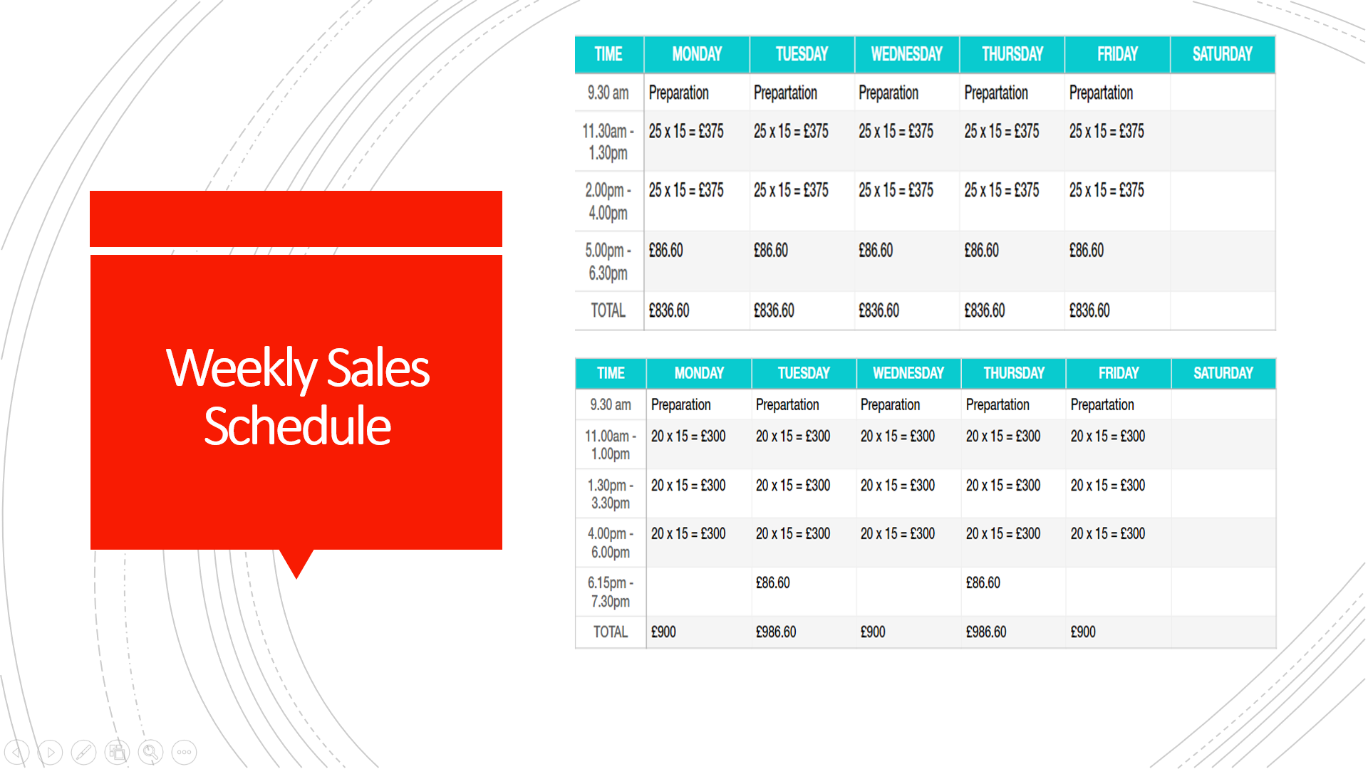

Slide 35
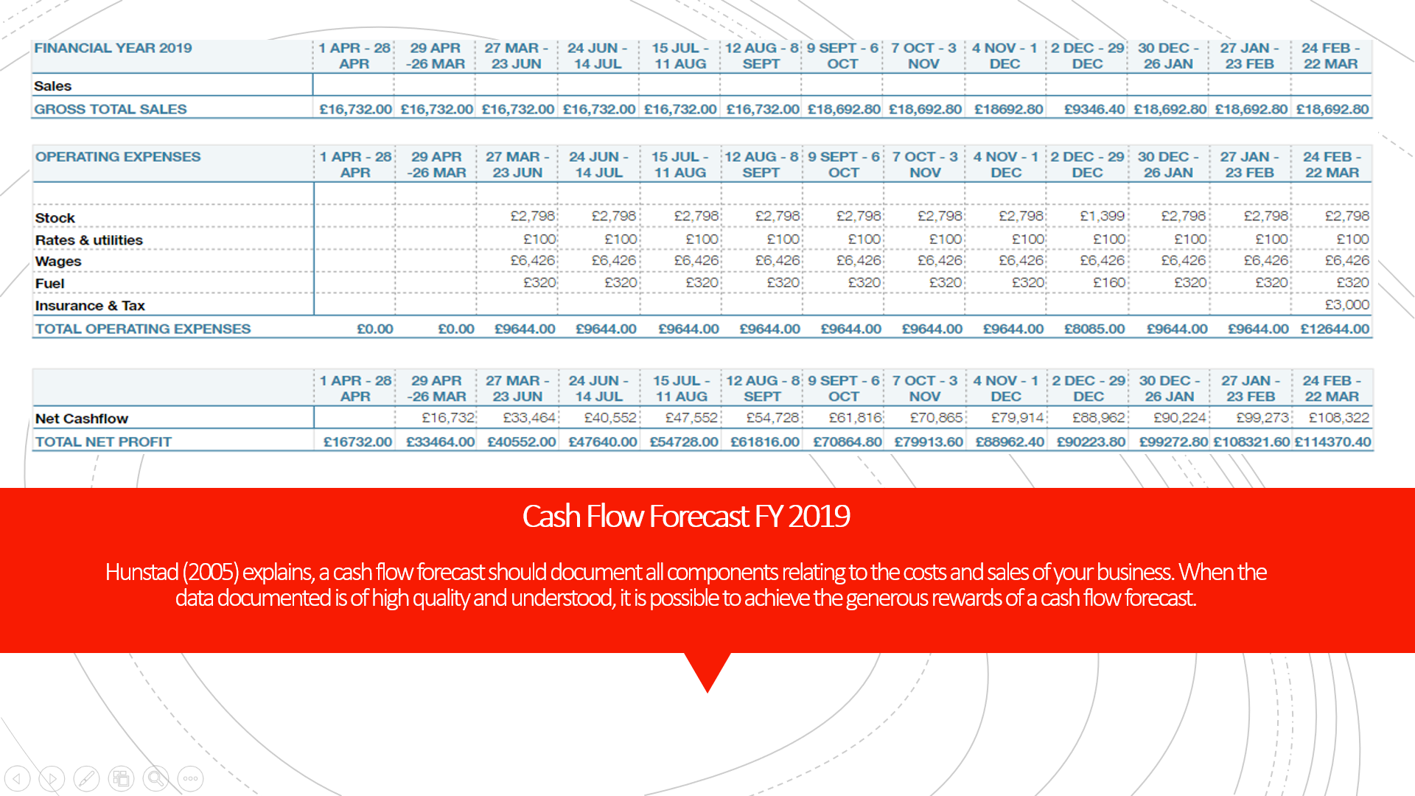

Slide 36
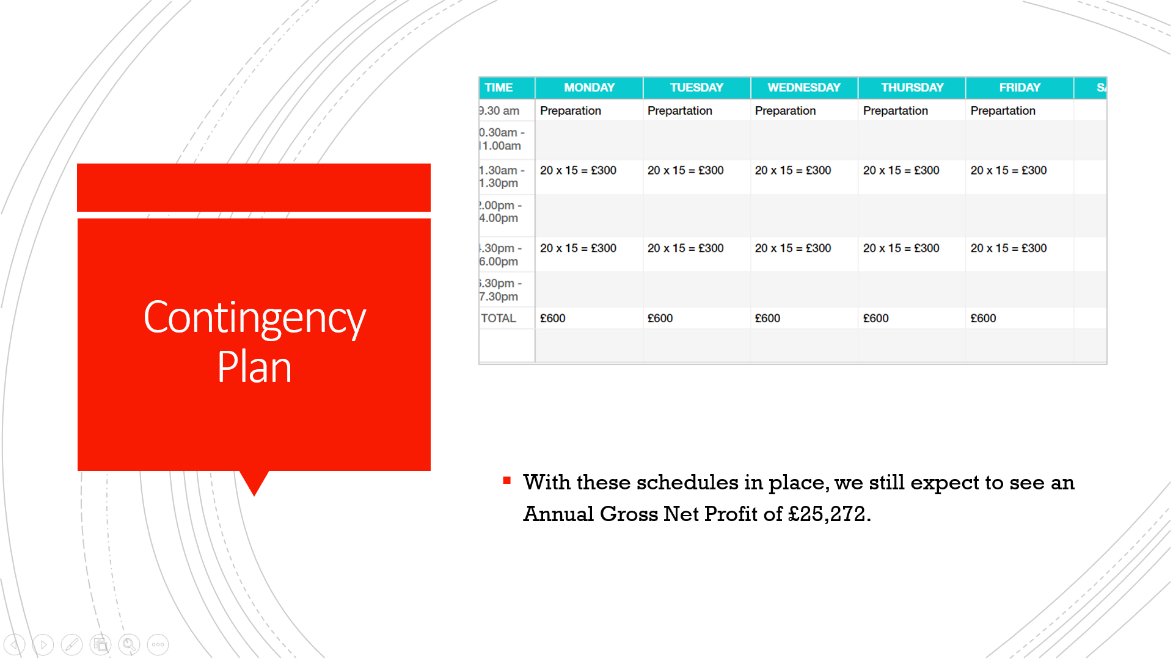

Slide 37
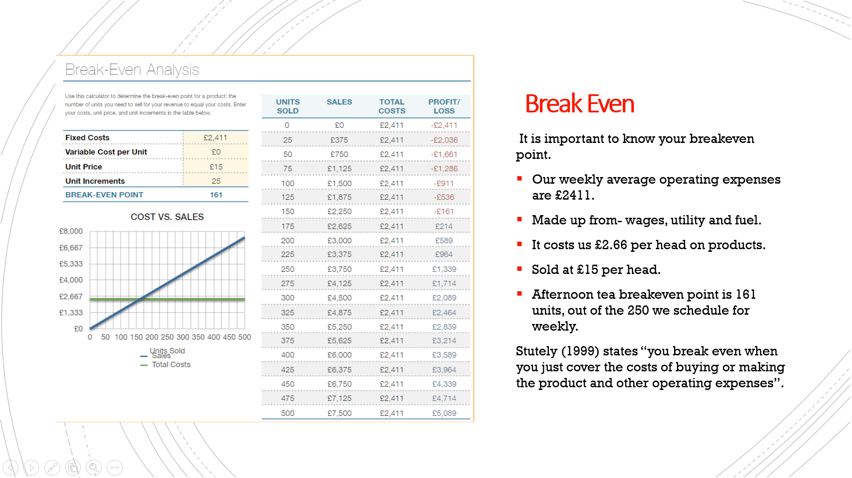

Slide 38


