Circuit Design – Assignment 1

Hayden Taylor

2308276

OME

10/01/2025

Table of Contents
2 Table of Figures 2
3 Table of Tables 2
No table of figures entries found. 2
4 Section 1 – Introduction 3
5 Section 2 – Proteus simulation 3
6 Section 3 – Bread board 8
7 Section 4 – Conclusion 14
8 Section 5 – References 15
9 Section 6 – Appendix 16

Table of Figures
Figure 1 - IC channel ports description [2] 3
Figure 2 - Circuit diagram to make. 4
Figure 3 - Proteus simulation working green light. 5
Figure 4 - Proteus simulation working red light. 5
Figure 5 - Proteus simulation with oscilloscope attached. 6
Figure 6 - Oscilloscope channel A Voltage readings 6
Figure 7 - oscilloscope channel B Voltage readings 7
Figure 8 – breadboard [3] 8
Figure 9 - Breadboard built and red LED showing 9
Figure 10 - Breadboard showing green LED 10
Figure 11 - oscilloscope of breadboard off time calculation channel 1 red 11
Figure 12 - breadboard oscilloscope time period channel 1 red 12
Figure 13 - oscilloscope channel 2 yellow 13
Figure 14 - oscilloscope channel 2 yellow 14
Figure 15 - calculations 16

Table of Tables

No table of figures entries found.

Section 1 – Introduction
There were 2 parts of an astable 555 timer circuit that was completed, the circuit was designed and simulated on proteus before being built on a bread board for testing. This report will contain the completed photos of the circuits in both proteus and breadboard, the calculations needed to work out the resistor values R3 and R4, the on and off times, the time period and the frequency. For both simulations the circuits were connected to an oscilloscope to calculate these results. There will also be an explanation of the building processes of each and any complications that were identified.
The astable 555 timer circuit works via the sharp changes between low voltage and high voltage, meaning the output is constantly changing between low and high. [1] This can be seen in the circuits produced with the changes of green light to a red light. The 555 timer IC is the device with 8 ports and the different ports have the different functions that allow for this to happen. [2]
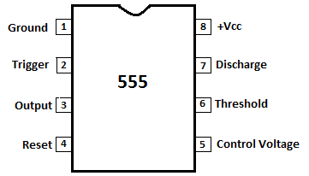
Figure 1 - IC channel ports description [2]

Section 2 – Proteus simulation

The first part of this assignment was the proteus simulation of the circuit. Proteus is a circuit design software used to design a circuit and make sure that the circuit will function as intended. The learner was tasked to build the circuit given in the brief, it contained a 555 astable IC, capacitors, resistors and a green and red LED. The circuit was built and then calculations were completed to get the correct resistance for the resistors to allow the circuit to work.
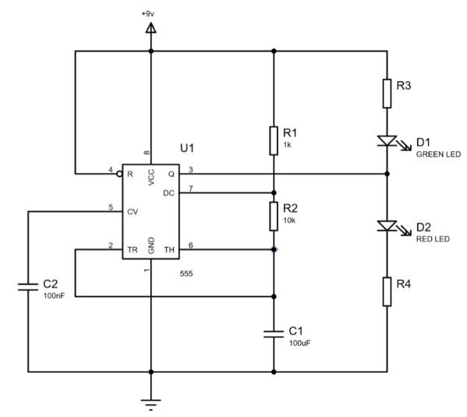
Figure 2 - Circuit diagram to make.
Figure 2 is the circuit diagram that had to be made on proteus. The first part was placing the astable 555 timer IC into the simulation, the power supply and ground were then added and connected to the IC through wires. Once these were in place and connected the other components were just placed into the simulation and then the wires connecting everything was completed. When connected the wires and the components together it was important to use the IC pin numbers in a schematic way, it was followed in a numerical order. This made sure that the correct pins were connected to the correct components. Once the circuit was built the calculations were done for the resistors.
Calculations for resistors:
Channel A
Resistor value = (Voltage supply – Voltage forward) / Current I
(9 – 22) / 10mA
Resistors 3 and 4 = 680 ohms
These values were then added to the proteus circuit and then the simulation was started. This is where the green light and the red LED were seen alternating. This is exactly how the circuit should work.
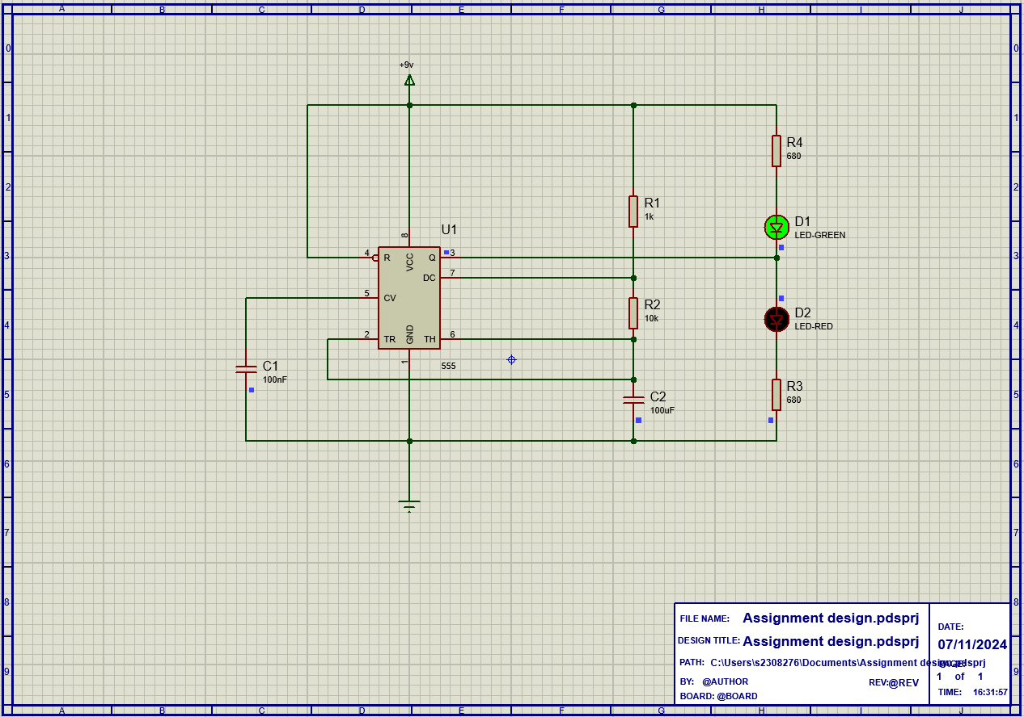
Figure 3 - Proteus simulation working green light.
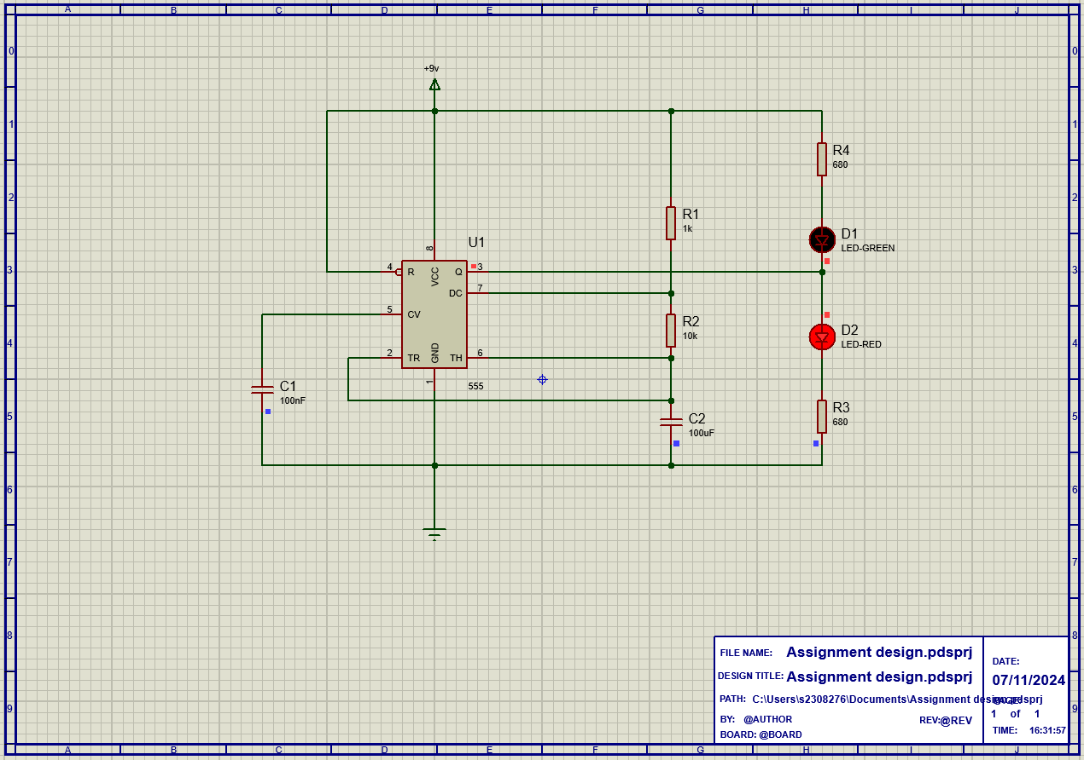
Figure 4 - Proteus simulation working red light.
Figures 3 and 4 show the full circuit mid simulation. The figure 3 has the green light on and the red off and the figure 4 shows that it had alternated to the red light on and the green off. This showed that the circuit had been built correctly. By the simulation working and the lights alternating it showed that the learner had built the circuit and the calculations of the resistors was correct.
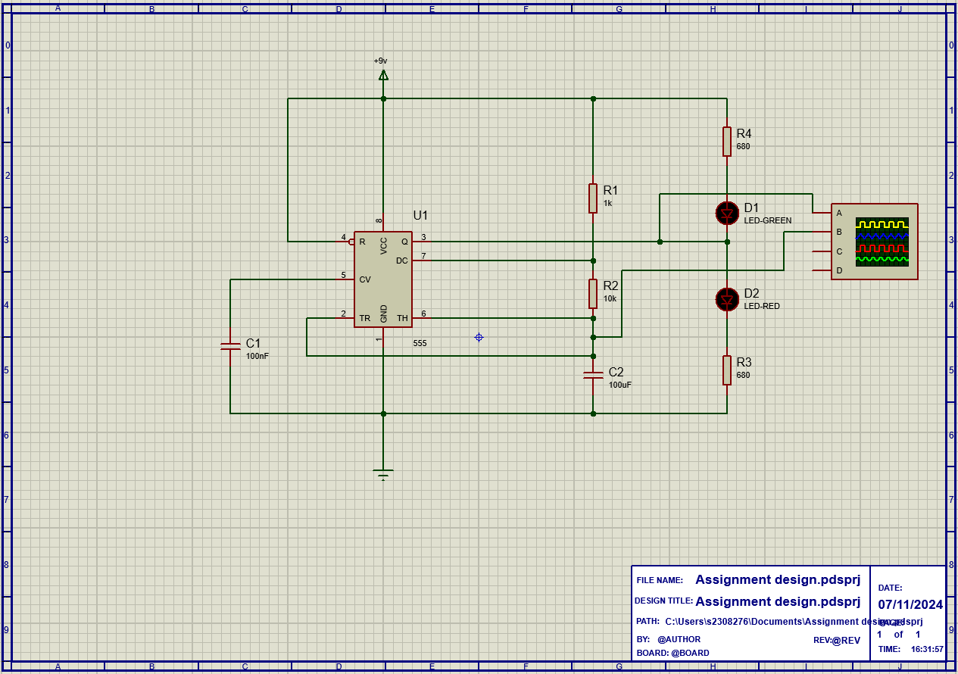
Figure 5 - Proteus simulation with oscilloscope attached.
Figure 5 shows how the oscilloscope was attached to the circuit for the other calculations for the on time, off time, time period and frequency. Once this was attached to the circuit, it was possible to see the timing and voltages which allows for the other calculations to be completed.
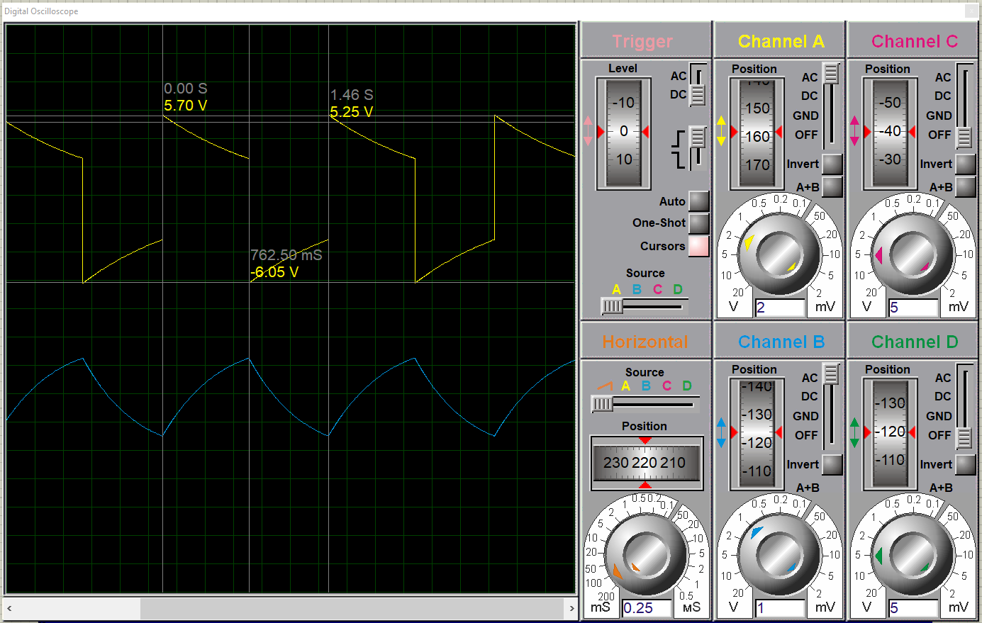
Figure 6 - Oscilloscope channel A Voltage readings
Figure 6 shows channel A and the readings of voltages compared to time. This allows the learner to see the time period, on time and off time. The time period is worked out via a full wave being complete. This includes the downward part and an upward of the wave. Using the cursors 3 were placed on the graph, one at the beginning of the wave, one at the bottom of the downward phase and one at the end of the upward phase. In figure 6 it shows that the time period is 1.46s. Using this calculation, the frequency of these waves were calculated:
Frequency = 1 / time period
1 / 1.46 = 0.684Hz
The other calculations that could be worked out using the graph was the on time and the off time.
The on time calculations are:
762.5ms – 0 = 762.5ms or 0.7625s
The off time calculations are:
1.46 – 0.7625 = 0.6975s
Figure 15 shows the calculations that were done.
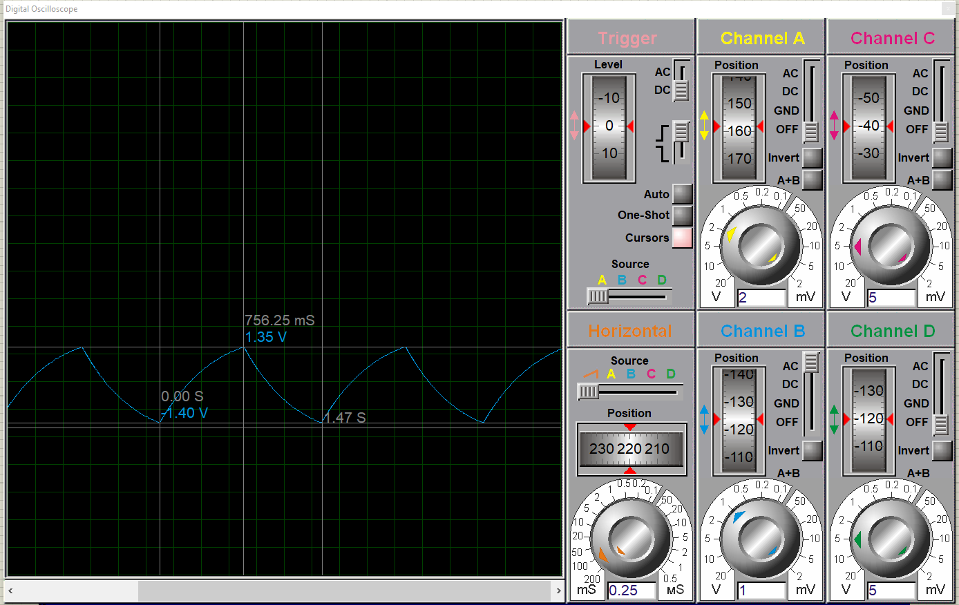
Figure 7 - oscilloscope channel B Voltage readings
Figure 7 shows the channel B which shows the waves and allows for the same calculations as that happened on channel A, the time period, frequency and the on and off time.
The time period is the last cursor and is 1.47s
The frequency:
1 / 1.47 = 0.68Hz
One time:
756.25ms – 0 = 756.25ms or 0.75625s
Off time:
1.47 S – 0.75625 S = 0.71375 S

Comparing figures 6 and 7:
The channels are placed in different positions on the circuit, and it is noticed that the shape of the waves is different and this is determined by the voltages and the timing in the circuit. Channel A shows it has a higher voltage as the highest reading is 5.7 V and the highest of the channel B is 1.35V.

Section 3 – Bread board
The second part of this assignment is the circuit being built on a breadboard. This part is important to see the circuit working as this shows that the simulation was correct, and the calculations done were also accurate. After the simulation was completed, it allowed the learner to know all the values of the resistors and capacitors that would be needed in the breadboard circuit which helped to identify which components was needed before making.
The first part of the building of the circuit was understanding the breadboard and the way it works. The middle part has lots of rows of 5 and they work horizontally and the two columns on both sides run vertically, so attaching the components into the breadboard is important. As shown in figure 8.
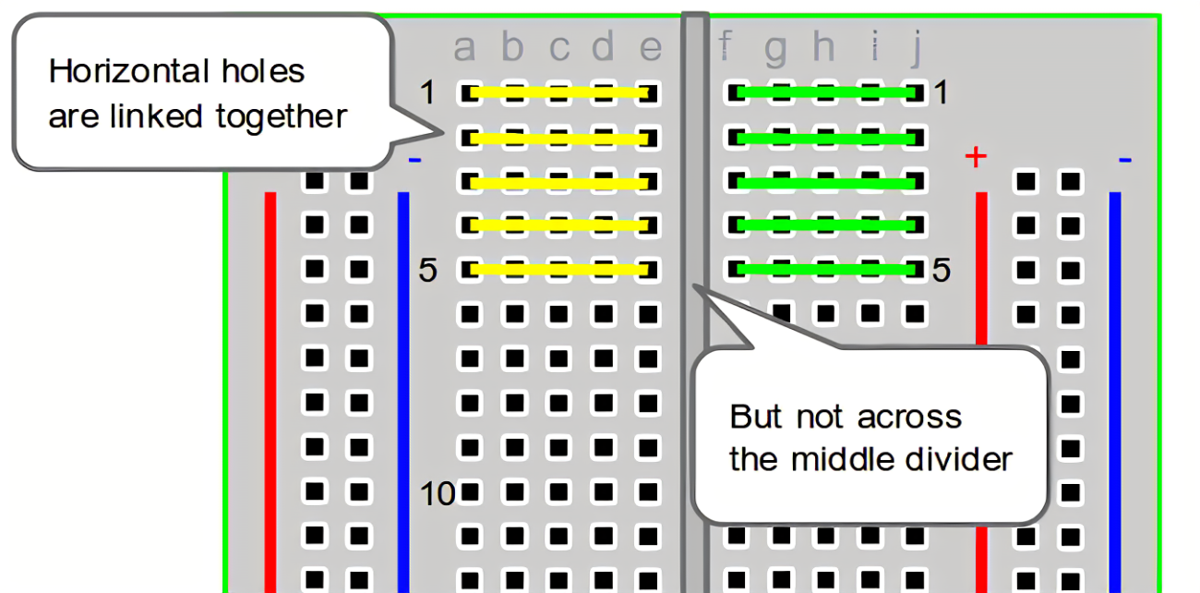
Figure 8 – breadboard [3]
The first part of building the circuit was placing the IC in the breadboard, this had to go over the divider. The learner ensured they had all the components and wires that they would need before starting the build so that they knew they had everything, and they could follow the drawing without having to think about getting components or wires. Like the proteus simulation the learner found it important to attach the components to the breadboard initially and then follow the IC pins to attach them just like the simulation process. Once the IC was placed in the two capacitors, four resistors and the green and red LED were placed round the circuit in similar positions as the drawing shown. Following each pin of the IC was important when connecting the different components as these will determine how the circuit works.
The first time that the circuit was built it didn’t initially work which meant some problem solving had to occur. After some deliberation it was the capacitors being placed into the breadboard in the wrong way. One capacitor needed to be connected to earth and the other one the two pins in the capacitor could not be placed in the same row. After these changes the circuit worked as intended and the red and green LEDs alternated. This was the exact performance that the proteus simulation showed as well. This shows that the breadboard build worked well.
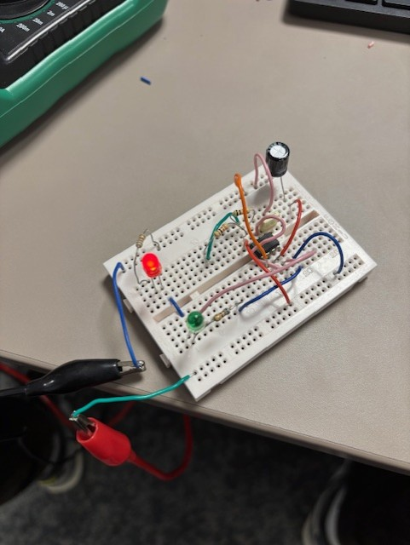
Figure 9 - Breadboard built and red LED showing
Figure 9 shows the breadboard circuit built and working with the red LED showing.
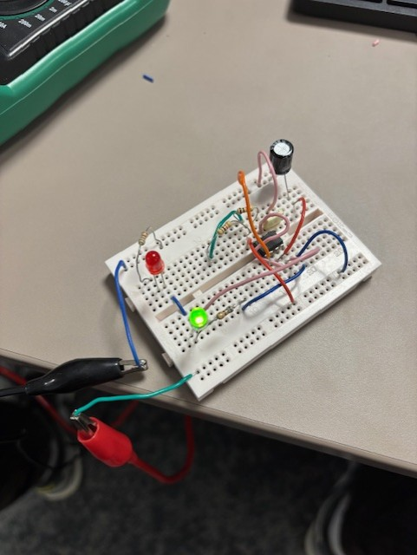
Figure 10 - Breadboard showing green LED
Figure 10 shows the breadboard circuit working with the green LED showing.
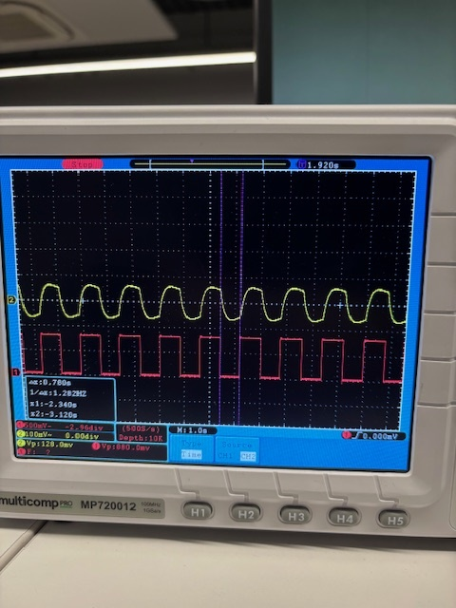
Figure 11 - oscilloscope of breadboard off time calculation channel 1 red
In figure 11 it shows the purple markers showing the off time of channel 1 (red). This tells us the time period being 1.6s. The off time being 0.78s. The frequency of 1.282Hz. The oscilloscope does the calculations, but these can be double checked via the same calculations that were done for the proteus simulation (figure 15).
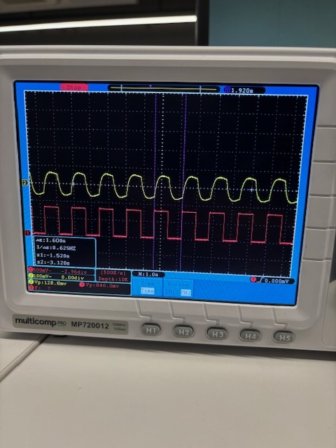
Figure 12 - breadboard oscilloscope time period channel 1 red
Figure 12 shows the time period of the channel 1 (red). This shows the frequency of a full wave being completed which is 0.62Hz. Using the time period and the off time the on time can be calculated. 1.6s – 0.78s = 0.82s.
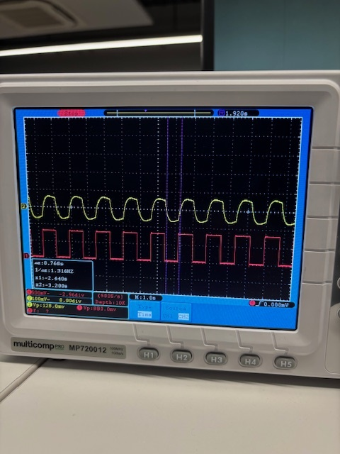
Figure 13 - oscilloscope channel 2 yellow
Figure 13 shows the off time of channel 2 (yellow). The off time of this channel is 0.76s. The frequency is 1.316Hz.
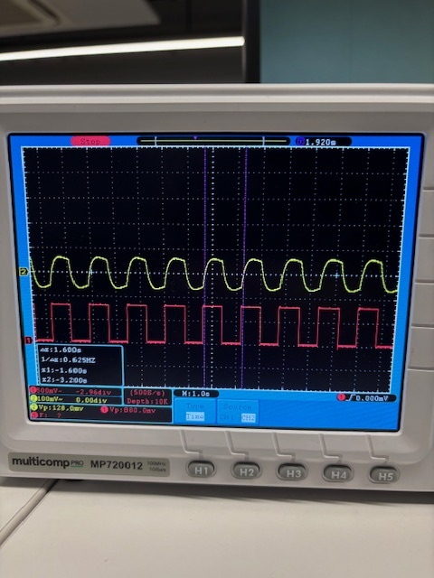
Figure 14 - oscilloscope channel 2 yellow
Figure 14 shows the time period of the yellow channel being 1.6s. The frequency 0.625Hz. Using the time period and the off time the on time can be calculated. 1.6s – 0.76 = 0.84s.
One issue with the breadboard build that was noticed was how easy human error can affect the circuit, for example the different components needed to be attached to the breadboard in certain ways otherwise it does not function. This meant that there were often where the circuit would not be working, and it was often hard to see where the error was and how it could be changed. The components that were being used are fragile which meant handling them and putting them into the breadboard was difficult not to break them as this would also affect the circuit.

Section 4 – Conclusion
In conclusion of this electronics report it shows the learner completed both parts of building a circuit, the proteus simulation was completed and worked and the same circuit was built onto a breadboard and worked as well. The calculations done of the resistance, on off time, time period and frequency were calculated for both the proteus simulation and the breadboard. Overall, both parts where completed accurately and gave the results needed.

Section 5 – References
[1] “555 Astable | Electronics Club,” electronicsclub.info. https://electronicsclub.info/555astable.htm
[2] Saurabh, “IC 555 Timer Working: Pin Diagram, Specifications & Features,” Electronics For You, Nov. 27, 2018. https://www.electronicsforu.com/technology-trends/learn-electronics/555-timer-working-specifications
[3]Computer Skills Envato Tuts+. (2013c). How to Use a Breadboard and Build a LED Circuit. [online] Available at: https://computers.tutsplus.com/how-to-use-a-breadboard-and-build-a-led-circuit--mac-54746t.

Section 6 – Appendix
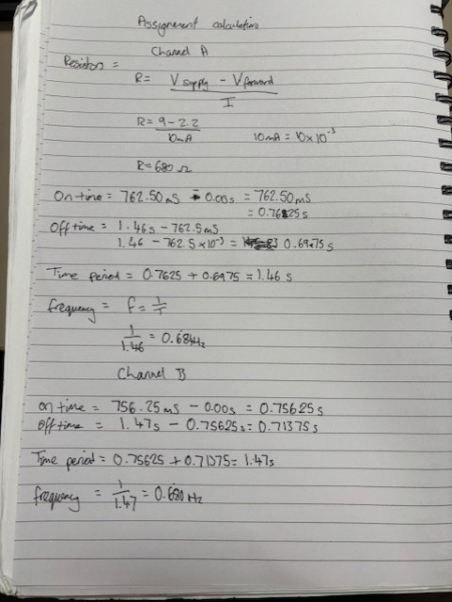
Figure 15 - calculations

