

Student name: Eden Goytom
Student ID: 2417491
Module name: Introduction to Physiology Module code:
Module code: BMHP5023
Lecturer name: Lou Angela Wells

Assessment: Component 1 Written Assignment (Case Study Report)

1. Introduction
I work as a practice nurse at a local GP surgery, and I've noticed that more and more people are being diagnosed with Type 2 diabetes from past few years the figure is going higher as in 2021 there were only 3.8 million but in 2025 the total figure reach to 5 million (Diabetes profile).
A lot of the time, it's evident during appointments that many patients don't fully grasp their disease or how the choices they make every day effect their blood sugar levels. This may make it tougher for individuals to stick to their care plans and keep their condition under control.
Because of this, I choose to get clear and easy information that I can use to help patients comprehend their diabetes. This report will talk about what diabetes is, how the body controls blood sugar, how glucose and oxygen are used to provide energy, and why patients need to keep an eye on their blood sugar levels. I'll also provide them useful tips on how to live a healthier life.
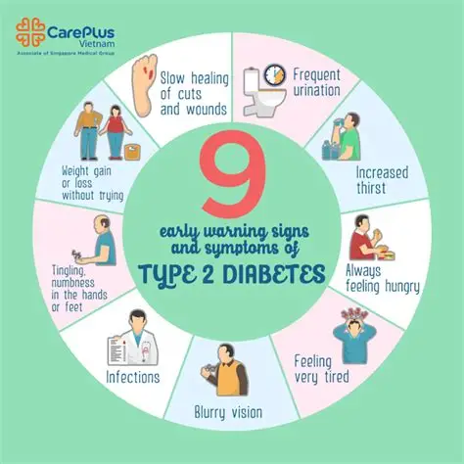
Diabetes mellitus is a long-term illness in which the amount of glucose in the blood gets too high (NHS, 2023a). Glucose is necessary because it gives the body energy, but too much of it over time can hurt blood vessels and organs.

Different kinds of diabetes
There are several kinds of diabetes:
Type 1 diabetes is when the body destroys the cells in the pancreas that create insulin (NHS, 2023a).
Type 2 diabetes is the most prevalent type. It arises when the body doesn't create enough insulin or doesn't use it properly (Diabetes UK, 2022).
Gestational diabetes occurs throughout pregnancy and may elevate the chance of subsequently developing Type 2 diabetes (NHS, 2023a).
Risk Factors
From what I see in my clinic, common risk factors include:
- Being overweight or obese (Public Health England, 2020)
- Not being physically active
- Eating an unhealthy diet (British Dietetic Association, 2022)
- Getting older
- Having a family history of diabetes (Diabetes UK, 2022)
Link to the Endocrine System
The endocrine system helps control hormones in the body. The pancreas plays an important role by releasing insulin and glucagon to keep blood sugar levels stable (NHS, 2023d). In Type 2 diabetes, this system does not work properly, which leads to high blood sugar levels.

2. Blood Sugar Regulation
When elucidating diabetes to patients, I typically first by clarifying how the body ordinarily regulates blood glucose levels.
Post-consumption, food is metabolised into glucose, which subsequently enters the bloodstream. This results in an elevation of blood glucose levels (NHS, 2023c). The pancreas subsequently secretes insulin, facilitating the transport of glucose from the bloodstream into the body's cells for energy utilisation or storage.
Prolonged fasting results in a decrease in blood glucose levels. The pancreas secretes a hormone known as glucagon, which instructs the liver to release stored glucose into the bloodstream (NHS, 2023c).
- This equilibrium maintains blood glucose levels within a healthy range.
- Nevertheless, in numerous people I encounter with Type 2 diabetes:
- Their bodies exhibit inadequate responsiveness to insulin.
- Glucose remains in the bloodstream rather than entering cells.
- With the passage of time, the pancreas exhibits diminished efficacy (Forbes and Thortveitite, 2020)
This results in persistently elevated blood glucose levels, which may precipitate severe health complications, including cardiovascular disease, renal impairment, and neuropathy if inadequately controlled (NICE, 2022).

3. Cellular Metabolism

I explain to patients how the body uses glucose to make energy, which helps them understand why blood sugar control is important.
Cellular respiration is the process by which the body makes energy. This process uses both oxygen and glucose.
Glycolysis is the first step in the process, in which glucose breaks down into smaller parts (NHS, 2023c).
After then, the mitochondria carry out more steps (the Krebs cycle), which make molecules that carry energy (Forbes and Thortveitite, 2020).
In the end, oxygen is used to make a lot of energy in the last step (WHO, 2019).
This energy is necessary for many bodily functions, such as moving and working of organs.
People with diabetes have too much sugar in their blood because glucose doesn't get into their cells well enough. This means that the cells may not have enough energy. At the same time, high blood sugar levels can damage organs and tissues.

4. Recording and tracking blood sugar levels for type 2 diabetes
As a practice nurse, one of the most important things I encourage patients with Type 2 diabetes to do is regularly check and record their blood sugar levels. This is a key part of managing their condition safely and effectively, as it helps them understand what is happening in their body on a daily basis.
Recording blood sugar levels allows patients to see how their glucose levels change throughout the day and in response to different activities. For example, patients can begin to recognise how certain foods affect their blood sugar. Meals that are high in sugar or refined carbohydrates may cause a rapid increase, while balanced meals with fibre and protein may lead to more stable levels (Diabetes UK, 2022). Similarly, physical activity can lower blood sugar levels, while stress or illness may cause them to rise. By tracking these patterns over time, patients can make more informed decisions about their lifestyle.
Another important reason for monitoring is that it helps identify trends. Rather than relying on a single reading, regular tracking provides a clearer picture of whether blood sugar levels are consistently too high, too low, or within the target range (NHS, 2023b). This is especially useful during consultations, as I can review these records with patients and adjust their care plan if needed. For example, medication doses may need to be changed, or dietary advice may need to be reinforced. This supports a more personalised and effective approach to care (NICE, 2022).
Monitoring also plays a vital role in preventing both hyperglycaemia (high blood sugar) and hypoglycaemia (low blood sugar). Although hypoglycaemia is less common in Type 2 diabetes, it can still occur, particularly in patients taking certain medications. Regular checks help patients recognise early warning signs and take action before the situation becomes serious (American Diabetes Association, 2020).
Patients can monitor their blood sugar levels in different ways. The most common method is a finger-prick test using a glucometer, which provides immediate results. Some patients may also use continuous glucose monitoring (CGM) devices, which track glucose levels throughout the day and night and provide more detailed information about trends and fluctuations (NHS, 2023b). These tools can improve confidence and help patients feel more in control of their condition.
If blood sugar levels are not regularly monitored, there can be serious consequences. Patients may not be aware that their levels are consistently high, which can lead to long-term complications such as nerve damage, kidney disease, and cardiovascular problems. In some cases, very high blood sugar levels can lead to medical emergencies such as hyperosmolar hyperglycaemic state or, less commonly, diabetic ketoacidosis (American Diabetes Association, 2020). Without monitoring, these conditions may develop without early warning signs.
Overall, recording and tracking blood sugar levels is essential for safe diabetes management. It helps patients understand their condition, supports better decision-making, and allows healthcare professionals to provide more effective care. In my experience, when patients fully understand the importance of monitoring, they are more likely to take an active role in managing their health and achieving better outcomes.

5. Recommendations
There are several important lifestyle modifications that can benefit people with diabetes, based on my own experience and the advice I have right now.
Food
I tell my patients to consume a balanced diet with more fibre, such whole grains, fruits, and vegetables, and to cut back on sugary and processed foods (British Dietetic Association, 2022).
Being active
Regular activity, like walking or biking, helps the body use insulin better. Patients should try to get at least 150 minutes of exercise each week (Public Health England, 2020).
Losing weight
According to Diabetes UK (2022), even reducing a modest amount of weight will help you regulate your blood sugar better.
Smoking
I highly urge patients to cease smoking since it raises the risk of problems (WHO, 2019).
Drink
Patients should minimise their alcohol consumption since it might alter blood sugar levels (NHS, 2023a).
More Help
Patients can learn more about their disease through education programs (NICE, 2022).
Apps and digital technologies can help keep track of things.
Emotional support is vital since living with diabetes may be hard.
Being part of a healthcare team makes ensuring that patients get the help they need.

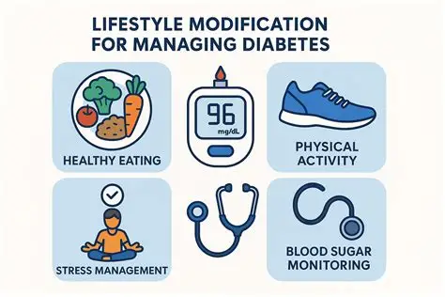

6. Conclusion
As a practice nurse, I am aware of how vital it is for patients to have a comprehensive understanding of their diabetes and the methods that may be utilised to control it. This study has provided an explanation of what diabetes is, how regulation of blood sugar can be achieved, and how the body generates energy.
In addition, it has been demonstrated that it is vital to monitor blood sugar levels on a frequent basis in order to effectively prevent problems and maintain management of the illness.
Changing even the smallest aspects of one's lifestyle, such as changing one's nutrition, being more physically active, and giving up smoking, can have a major impact. I am able to assist patients in taking charge of their health and improving their quality of life by giving them with information that is easy to understand and support.

References

American Diabetes Association (2020) Standards of Medical Care in Diabetes—2020. Diabetes Care, 43(Suppl 1), pp. S1–S212.
British Dietetic Association (2022) Diabetes and diet. Available at: https://www.bda.uk.com (Accessed: 4 April 2026).
British Psychological Society (2020) Stress and mental health. Available at: British Journal of Health Psychology - Wiley Online Library (Accessed: 4 April 2026).
Diabetes UK (2022a) Eating a healthy diet. Available at: What is diabetes? | Getting to know the basics | Diabetes UK (Accessed: 4 April 2026).
Diabetes UK (2022b) Diabetes in the UK: Key statistics. Available at: https://www.diabetes.org.uk (Accessed: 4 April 2026).
Forbes, J.M. and Thiruvoipati, T. (2020) ‘Mitochondrial dysfunction and insulin resistance’, Diabetes & Metabolism Journal, 44(4), pp. 441–453.
National Institute for Health and Care Excellence (2016) Type 2 diabetes: prevention and management in adults. Available at: https://www.nice.org.uk/guidance/ng28 (Accessed: 4 April 2026).
National Institute for Health and Care Excellence (2022) Type 2 diabetes in adults: management. Available at: https://www.nice.org.uk (Accessed: 4 April 2026).
NHS (2023a) Type 2 diabetes. Available at: https://www.nhs.uk (Accessed: 4 April 2026).
NHS (2023b) Blood glucose monitoring. Available at: https://www.nhs.uk (Accessed: 4 April 2026).
NHS (2023c) Insulin and the body. Available at: https://www.nhs.uk (Accessed: 4 April 2026).
NHS (2023d) The endocrine system. Available at: https://www.nhs.uk (Accessed: 4 April 2026).
Public Health England (2020) Health matters: obesity and weight management. Available at: https://www.gov.uk (Accessed: 4 April 2026).
Public Health England (2020) Smoking and health. Available at: https://www.bing.com/search?q=Public+Health+England+(2020)+Smoking+and+health.+Available&cvid=7b4f305474624bec80f6f3f88d60b1b0&gs_lcrp=EgRlZGdlKgYIABBFGDkyBggAEEUYOTIHCAEQ6wcYQNIBBzMwN2owajSoAgCwAgA&FORM=ANAB01&PC=W204 (Accessed: 4 April 2026).
World Health Organization (2018) Obesity and overweight. Available at: https://www.who.int/news-room/fact-sheets/detail/obesity-and-overweight (Accessed: 4 April 2026).
World Health Organization (2019) Diabetes fact sheet. Available at: https://www.who.int (Accessed: 4 April 2026).

