

LEVEL 4 ASSESSMENT

Student name: | Adam David Moore | Student ID number: | 1004334
Programme: | B.Sc Computing Portfolio
Module: | Information Engineering
Module code: | ACCB4013 | Contribution to Overall Module Assessment (%): | 70%
Lecturer: | B Holland | Internal Verifier: | G Thomas
Assignment Title: | Database Design (The Book Store) | Word count (or equivalent): | 1,883
Submission deadline: | May 6th 2019 | Return date of provisional marks & written feedback:

Contents

Database Design 3
Design Criteria 3
Entity Relationship Diagram 4
Database 5
Relationships 5
Reports 6
Forms 11
User Guide 16
Main Menu 17
Using Forms 17
Using Reports/Queries 17
Design Improvements 17
Bibliography 18

Database Design

Design Criteria

Relational database normalisation is an essential rule to follow in database design, normalisation reduces data redundancy [1] and makes a database more robust [1]. A relational database design is also said to be good when it confirms to the third, fourth or fifth normal form [2]. A logical design, allowing effective linking of tables via appropriate primary and foreign keys and conforming to at least the third normal form is therefore essential for the needs of Dylan’s book store.
In order to create the entity relationship diagram, upon which the database will then be modelled, considerations must be made around the actual needs of Dylan’s book store. We can identify essential entities immediately, such as customers, employees, suppliers, books and orders (customer orders and stock orders). There are other entities that could be integrated, such as authors and invoices (customer orders and stock orders). Dylan’s book store is a very small company and the company’s focus on a friendly, personal customer service model makes a more simplistic approach to the design of this system is preferable.
The small nature of this business and perceived lack of exposure of employees to information technology results in the identification of non-functional requirements. The system itself must be user friendly, intuitive, simple and functional.

Entity Relationship Diagram

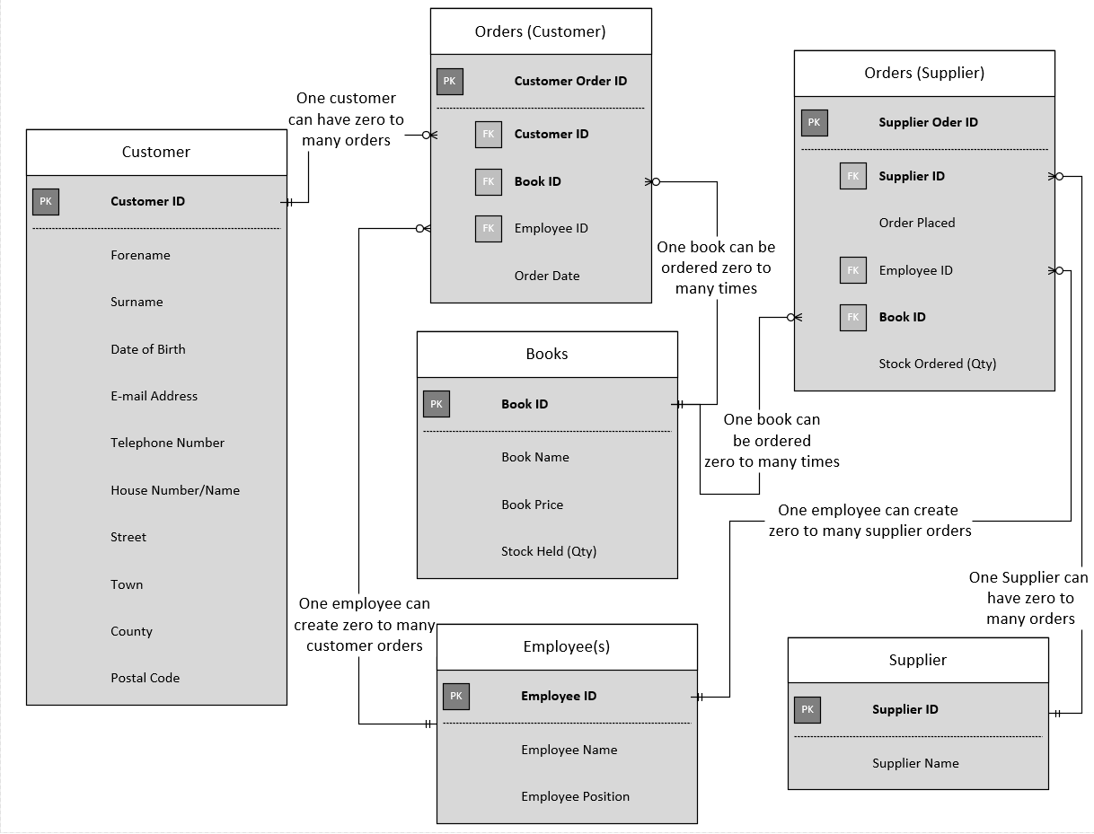

The customer, employee, supplier and book entities will be four separate tables within the database, each holding a unique identifier in their respective IDs. The orders will be where these identifiers or ‘keys’ culminate. The presence of the customer ID, Book ID and employee ID foreign keys in the customer orders entity, for example, will enable all information attributed to each key (for example, the customer ID) to be looked up in each order; therefore, a customer’s full address can be looked up against a specific order ID, via the Customer ID foreign key, for example. Similarly, the book name or price could be looked up via the Book ID foreign key, and the employee responsible for processing the order (or their position) could be looked up via the Employee ID foreign key.

Database

Relationships

The layout of the relationship is slightly different in access when compared with what was produced in Visio, all links are, however, identical. Any difference in layout is exclusively due to layout constraints.

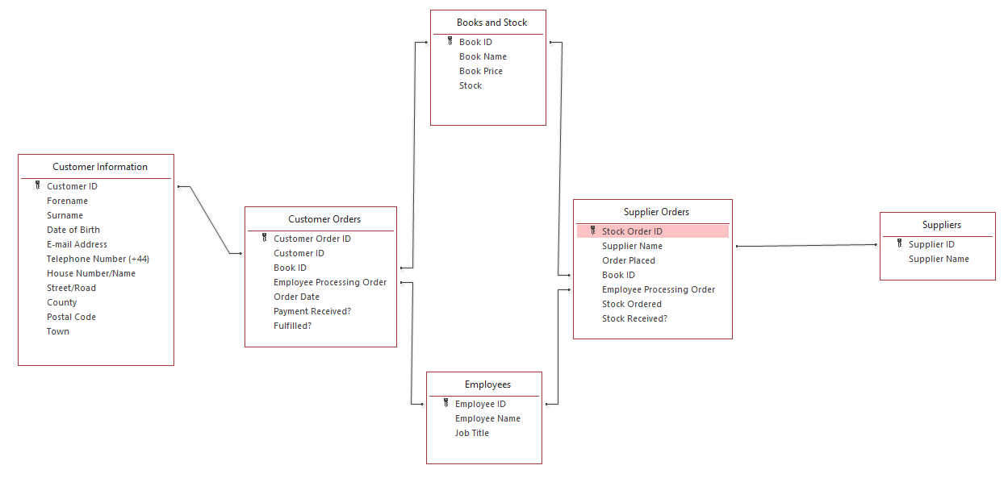

Main Menu

The main menu is designed to be as simplistic and user-friendly as possible. This will enable employees with limited informatics knowledge to use the intuitive design with ease.
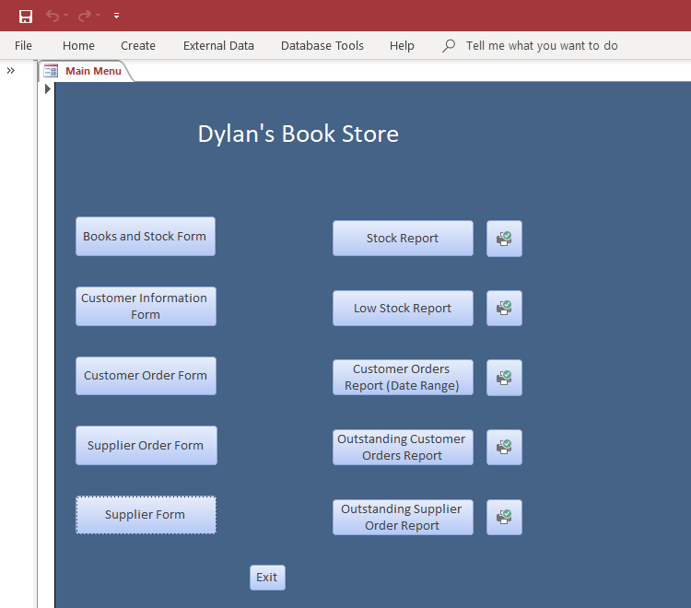
With forms laid out in a columnar fashion on the left, and reports (and printing for reports) laid out in a columnar fashion on the right, and all buttons clearly labelled, the database is very accessible and user-friendly.

Reports

Customer Orders (Date Range) Report

This report requires the user to enter a ‘start’ and ‘end’ date to define the date range within which the report will export information. The screenshots below demonstrate the date range input screens.

Start Date:
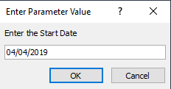

End Date:
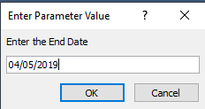

Once the date range has been entered, the user can view the report output:
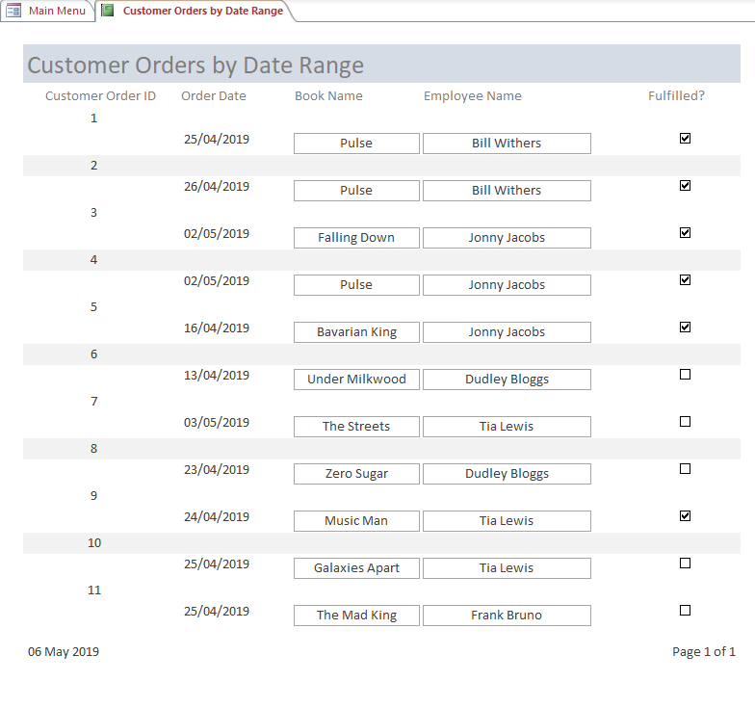
Users are also able to print this report from the home page via the ‘print’ icon next to the report on the main menu form. As when running the report, users will need to define the date range prior to the report being printed.

Outstanding Customer Orders Report

This report is activated simply by clicking the report icon on the main menu or can be printed via the print icon next to the report icon. The report demonstrates all outstanding orders from customers that have not yet been fulfilled by Dylan’s book shop.
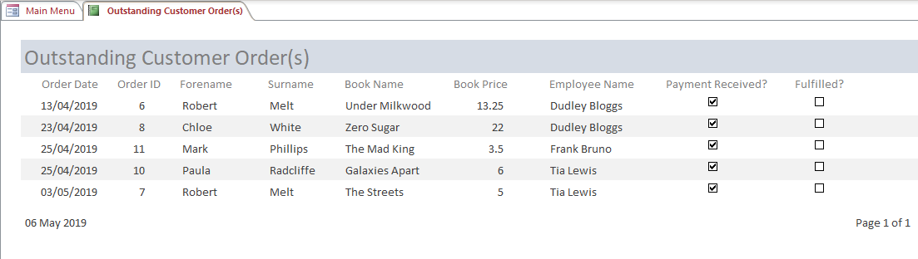

This report will enable a targeted approach to order fulfilment. This report is geared more towards sales and order fulfilment staff, helping them to track their outstanding tasks in terms of customer orders.

Outstanding Supplier Orders Report

The outstanding supplier orders report is activated by clicking the report icon on the main menu or can, much like all other reports, be printed via the printer icon next to the report button. This report demonstrates stock levels of books and stock orders that have been placed with suppliers and have not yet been received.

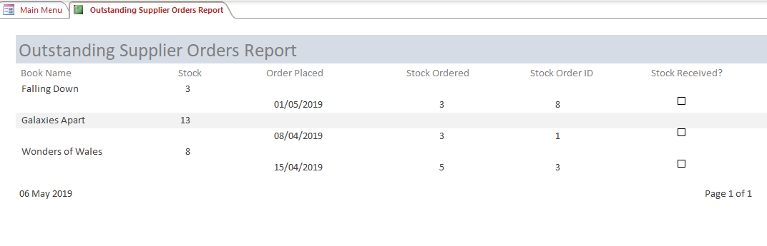
This report is targeted more at managerial staff and stock assistants. The report enables fast identification of outstanding stock orders so that managerial staff or those with responsibility over stock can contact the relevant suppliers for information.

Low Stock Report

Configured to show any book which has a stock value of 3 or less, the stock report will enable effective management of stock by quickly alerting managerial staff or stock assistants of any book that currently has low stock (<=3). This will then enable these staff to place orders with suppliers, if necessary, to resolve the potential stock issue.
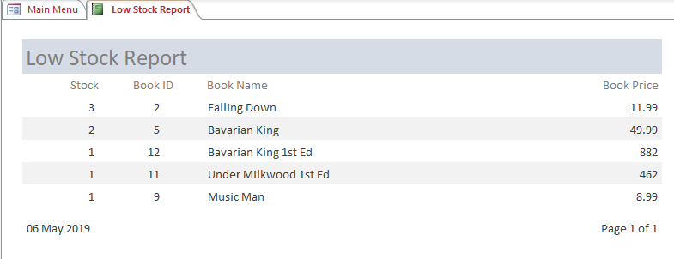

Stock Report

The stock report is the most basic report available from this database. Very simply, the report demonstrates book names (as these mean more to a user than the book id, presumably) and stock level. The order is descending, with the highest level of stock positioned highest on the list.

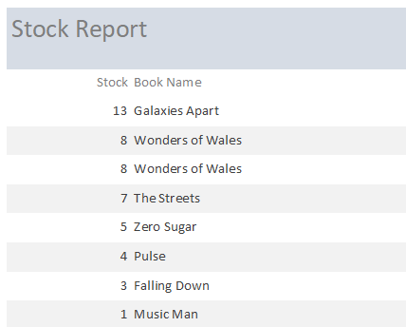

Forms

Customer Information Form

The customer information form allows users to update all existing records, scroll through all existing records, add new customers (shortcut added), delete records and exit the form at a click of a button.

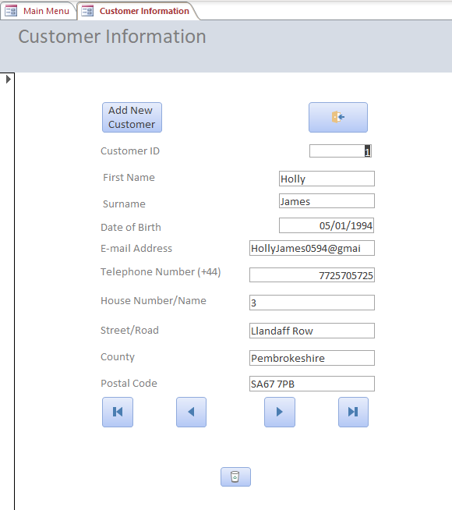

Books and Stock form

The books and stock form will allow any employees to add any new books being offered by Dylan’s book store, adjust the price of any existing books, update stock levels and delete any existing books, for example if they are no longer being sold by Dylan’s book store.

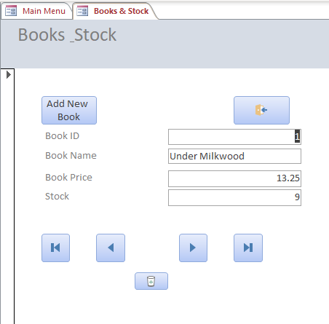

Customer Order form

The order forms are central to the entire system. The customer order form enables system users to select most of the criteria from a drop-down menu. For example, rather than needing to recall book IDs, employee IDs or even customer IDs, employees will simply need to make use of the drop-down menus which give them all the information they will need to select the appropriate ID.

The form when opened has a series of buttons, as before there are buttons to create new orders, exit the form, manoeuvre between records and delete records. The screenshots below demonstrate the form when opened and when selecting options from the drop-down menus.
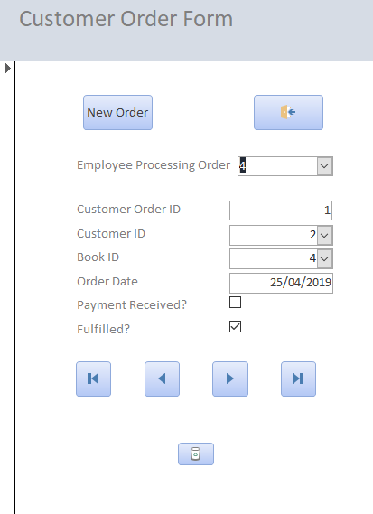

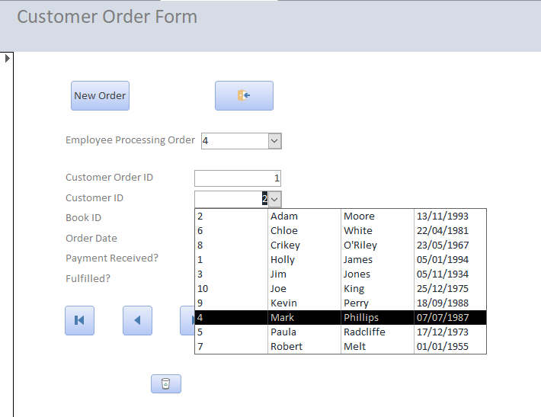

Supplier Order form

Much like the customer order form, the supplier order form offers similar functionality. It can be accessed via the home page and has an identical layout, in terms of the buttons available. Users can delete records, create new orders, cycle through existing records and exit the form.

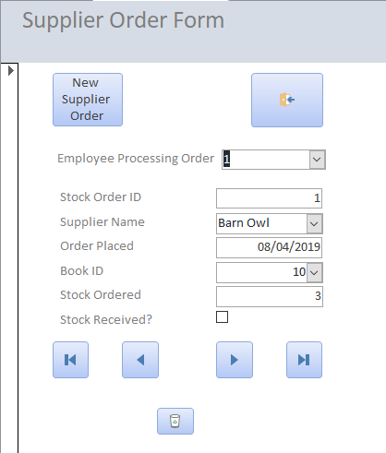
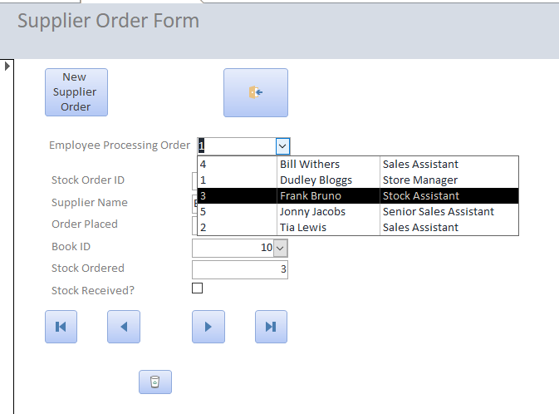

Supplier form

When Dylan’s book store engages with new suppliers, or ceases to engage with existing suppliers, the supplier form will need to be utilised by employees. This form allows users to create new suppliers, amend existing suppliers, cycle through suppliers and delete existing suppliers.

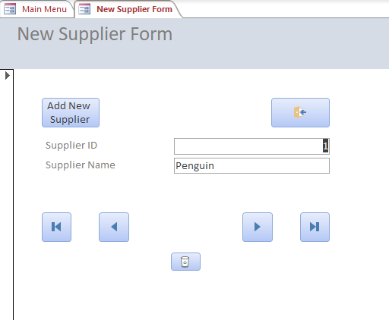

User Guide

A simple user guide detailing how the system should be navigated and all its various components can be found below.

Main Menu

From the main menu, you will be able to navigate to various forms. Forms will the way we create new entries, such as a new customer and updating existing entries, such as to reflect new levels of stock after taking a delivery, updating the status of orders.
Each button will open a different form, these are clearly labelled on the buttons themselves.
Reports are also available via the main menu. These reports can be printed with the printer icons next to then respective reports if required.

Using Forms

The layout of every form is relatively uniform. At the top left of the form, there is an icon that can be clicked to create a new entry. This should be used when there is a new customer whose details need to be entered, there is a new order, a delivery of stock has been taken and so on. The top right has an icon that, when clicked, closes the form. This should be clicked when you are done working with the form and wish to return to the main menu. The bottom has four ‘arrow’ icons, the furthest left will take you to the first entry associated with the form (table). The second ‘arrow’ icon will show the previous entry. The third ‘arrow’ icon will show you the next entry. Finally, the fourth ‘arrow’ icon will take you to the very last entry.

Using Reports/Queries

Reports can be initialised much like forms; simply click on the appropriate button on the main menu. The ‘printer’ icons next to the reports will print the adjacent report. Each report is designed to assist in essential operational tasks that must be carried out by the employees of Dylan’s book store. Ensuring enough stock is available, managing stock surplus, managing unfulfilled customer orders, managing unfulfilled supplier orders and assessing customer orders (within a specified data range) to determine what books have been particularly popular are all possible as a result of the available reports.

Design Improvements

The design of this database could be improved dramatically with the introduction of a login system, where users of the system (employees) are assigned login details by an administrator of the system. The addition of audit trails and access levels based on these logins could then identify user error and identify training needs and prevent junior users of the system from creating new employees, suppliers, or other functions that are deemed inappropriate for more junior members of staff. In its current state, the system is certainly open to ‘abuse’ from employees, or even customers if the terminal is left unattended in the store. Similarly, the only way it may be intended for junior members of staff to interact with the system is to utilise forms for data entry or updating the database information; as reports are available from the main menu, it could be a negative in that decreased productivity is an outcome of system implementation. These vulnerabilities could be exposed whereby, for example, one member of staff retrospectively amends all sales information so that the information held on the system, and therefore the reports demonstrate, that one member of staff is responsible for all sales completed. These vulnerabilities are likely not too great an issue in such a small business, but on a larger scale they would be extremely worrying and upgrades to the database would most certainly be required to address the vulnerabilities.

Bibliography

[1] K. Kumar and S. K. Azad, “Database normalization design pattern,” in 2017 4th IEEE Uttar Pradesh Section International Conference on Electrical, Computer and Electronics (UPCON), 2017, pp. 318–322.
[2] Tok Wang Ling and Cheng Hian Goh, “Logical database design with inclusion dependencies,” in [1992] Eighth International Conference on Data Engineering, pp. 642–649.

