Qualification: CIPD Diploma in Applied Human Resources

Module Name: Contributing to Coaching and Mentoring 5ADCM

Word Count
Activity 1 – 1024
Activity 2 - 1011

Student Name: Lucy Moriarty
Student Number: 2014451
CIPD Membership Number: 5749316X

By signing below, I confirm that the work/evidence presented is my own, unaided work. I understand the regulations pertaining to candidate malpractice and the action that may be taken as a result.

Signed: Lucy Moriarty
Date: 26.07.2021

Table of Contents

Topic | Page
Evidence Matrix | 1 - 2
Activity 1 - Report and Evidence.  Be able to assess the impact of coaching and mentoring activity within an organisation and make recommendations for further development. | 5 - 24
Activity 2 – Report and Evidence  Be able to support the implementation of coaching and/or mentoring programmes within an organisation. | 25 - 29

Candidate name: Lucy Moriarty |  |  |  | CIPD Membership/registration No.:
Qualification title: CIPD Diploma in Applied Human Resources |  |  |  | Unique Learner No. (ULN):
Unit code | Unit title | Assessment criteria no. | Evidence description | Evidence reference number | Assessor  initials | I/V initials if sampled
5ADCM | Contributing to Coaching and Mentoring | 1.1 | Care Council for Wales Induction Booklet | EV. 1.1
5ADCM | Contributing to Coaching and Mentoring | 1.1 | Mentoring Resource Pack | EV. 1.2
5ADCM | Contributing to Coaching and Mentoring | 1.1 | The roles and responsibilities of a Buddy | EV. 1.3
5ADCM | Contributing to Coaching and Mentoring | 1.2 | Initial Review, Supervision and Annual Performance Review | EV. 1.4
5ADCM | Contributing to Coaching and Mentoring | 1.2 | Managers Induction Booklet | EV. 1.5
5ADCM | Contributing to Coaching and Mentoring | 1.2 | Support Worker Induction Booklet | EV. 1.6
5ADCM | Contributing to Coaching and Mentoring | 1.3 | Learning and Development Policy | EV. 1.7

5ADCM | Contributing to Coaching and Mentoring |  | 1.3 | Email from Kim in Learning and Development | EV. 1.8
5ADCM | Contributing to Coaching and Mentoring |  | 1.4 | Email to Kim in Learning and Development and Kim’s reply. | EV. 1.9
5ADCM | Contributing to Coaching and Mentoring |  | 1.4 | Email to Line Manager | EV. 1.10
5ADCM | Contributing to Coaching and Mentoring |  | 1.4 | Supervision Form | EV. 1.11
5ADCM | Contributing to Coaching and Mentoring |  | 2.2 | GROW Model | EV. 1.12
5ADCM | Contributing to Coaching and Mentoring |  | 2.5 | Email from Line Manager | EV. 1.13
Candidate declaration:
- I confirm that the work/evidence presented for assessment is my own unaided work.
- I have read the assessment regulations and understand that if I am found to have ‘copied’ from published work without acknowledgement, or from other candidate’s work, this may be regarded as plagiarism which is an offence against the assessment regulations and leads to failure in the relevant unit and formal disciplinary action.
- I agree to this work being subjected to scrutiny by textual analysis software if required.
- I understand that my work may be used for future academic/quality assurance purposes in accordance with the provisions of the Data Protection Act 1998.
- I understand that the work/evidence submitted for assessment may not be returned to me and that I have retained a copy for my records.
- I understand that until such time as the assessment grade has been ratified through internal and external quality assurance processes it is not final.
Signature: |  | Lucy Moriarty |  |  |  | Date: | 07.07.2021
Notes on candidate evidence matrices
Candidates should be encouraged to develop a matrix indicating how their evidence relates to each unit/module and learning outcomes/assessment criteria. This helps advisors and assessors to support candidates to draw links between units and encourage cross-referencing and the possible multi-use of evidence.

Activity 1
Coaching and Mentoring are both beneficial within an organisation. Both concepts develop and strengthen skills to ensure employee loyalty by showing an interest in the development of skills and their progression. As described by McCarthy (2014) coaching and mentoring helps develop understanding and self-awareness to enhance performance regardless of role. Coaching and mentoring techniques do differ, but they also display similarities through the processes, skills and values that are required.

Within my organisation there are no standalone coaching and mentoring policies and procedures and there are no formal coaching and mentoring methods included in any other organisational policies or procedures. However, there is information documented in induction booklets about the importance of mentoring. The induction booklets aren’t created in house but instead by an external provider, Care Council for Wales (EV.1.1). The induction booklet also provides a link to a mentoring resource pack (EV. 1.2) which details mentoring guidance to managers, mentors and mentees this is also provided through an external provider. When new staff members commence their employment, they are assigned a buddy (EV.1.3), this will usually be a senior staff member, to provide guidance throughout the initial review period of six months. The ‘buddy’ concept is used in all departments across the organisation. Once the initial review period has been successfully completed, there are no formal procedures or guidance to support line managers in developing individuals through coaching and mentoring practices going forward, and so the skills and knowledge developed initially are not built upon.

There are elements of coaching and mentoring that are being completed in supervisions or 1:1’s. Supervisions are held between staff and their line managers every 6-8 weeks as per policy. Within the “Initial Review, Supervision and Annual Performance Review” policy (EV.1.4) it mentions methods around supervisions and how they can be conducted, this includes support between the supervisee and line manager through face-to-face meetings. The policy does not mention any formal coaching and mentoring procedures but does however state that “mentoring sessions can also be effectively utilised”. Within the managers induction booklet (EV.1.5), it provides a more detailed overview on effective coaching methods and provides guidance for line managers on how to ask coaching questions. The induction booklet also refers to coaching being an essential leadership style as defined by Daniel Goleman.

Within my organisation there are no formal procedures to encourage individuals, teams or the organisation in achieving objectives this is only identified during the induction period. The Learning & Development policy also does not reference any methods surrounding coaching and mentoring, however, as advised by the Learning and Development team in our weekly team meeting, the policy is currently under review. I recently approached the Learning and Development team asking if a new section of coaching and mentoring practices could be considered to be added in the updated L&D policy. The coaching and mentoring policy could provide follow on information from the guidance that is set out in the Support Worker induction booklets (EV.1.6). The policy would formalise a coaching and mentoring process and would provide guidance to enable all individuals to take responsibility for their own learning. The L&D team agreed that this would be a suitable addition to the L&D policy providing that managers were invested in promoting the benefits to staff members (EV 1.7). To ensure that implementation of a “coaching culture” would be a success, managers would need to be consistent in embedding the required skills and knowledge through encouragement to improve job performance and being supportive in the achievement of organisational objectives. To ensure this the methods could also be added to the organisation’s annual strategic priorities.

My organisation has a top down approach and coaching and mentoring does not happen at an executive level. As established coaching and mentoring is provided by peers and direct line managers during the probation period. If a formal process was introduced it would need to be integrated into existing operational practices and not seen as an addition, this would need a clear understanding of coaching and mentoring methods and to aid “buy-in” from the organisation. As explained by Clutterbuck and Megginson (2005) the results and rewards of coaching and mentoring will need to be visible to others, they identified that behaviours that achieve success are recognised but are not related to a coaching culture as coaching and mentoring sessions are often completed in a private setting As informed by L&D my organisation uses an informal ‘co-coaching’ model with other similar organisations within the third sector (EV. 1.8). A more formal practice of coaching and mentoring could be implemented throughout the organisation through existing processes but without any prior understanding of practices there could be a cost to the organisation due to training of a leadership team or the use of external coaching.

The beginning of an employee’s career within the organisation sees the introduction of coaching and mentoring through the induction process and it is also lightly touched upon within supervisions throughout, there is however no ongoing encouragement of practices on a wider scale. As aforementioned I had recommended to the Learning and Development team, the implementation of coaching and mentoring methods into policies and procedures (EV. 1.9). With the support of learning and development it would ensure the integration of practices throughout the business. I also approached my line manager to recommend a revision of the organisation’s supervision forms (EV. 1.10). There are 2 separate supervisions forms one for the operations and development team and a separate form for office-based staff. Within the office-based form it asks the supervisee about current work priorities and if there have been any successes and if so, how they can be built upon (EV. 1.11). The supervision form focuses on successes that have been achieved but does not open conversations around development. I feel that the supervision meetings could be utilised to encourage development through coaching and mentoring practices being discussed more regularly to enable understanding. With the practices being promoted through the Learning and Development policy and becoming a more formal part of the supervision and performance management processes, will enable the creation of objectives needed to encourage growth and development for individuals and the organisation.

References

Clutterbuck, D. and Megginson, D., 2005. Making Coaching Work; Creating a Coaching Culture. London: CIPD, p.36.
McCarthy, G., 2014. Coaching and mentoring in business. Los Angeles [etc.]: Sage, p.2.

EV1.1

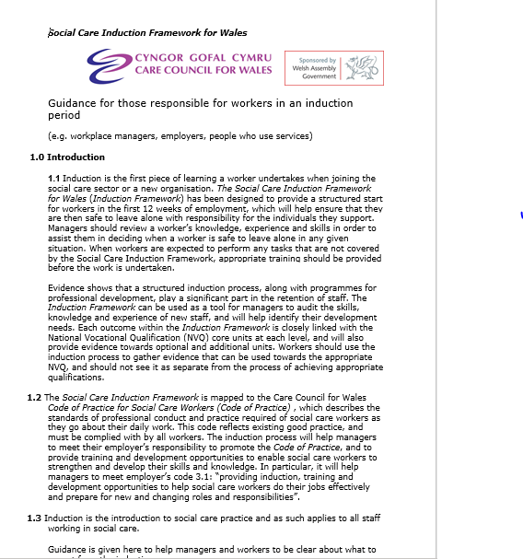

EV1.2

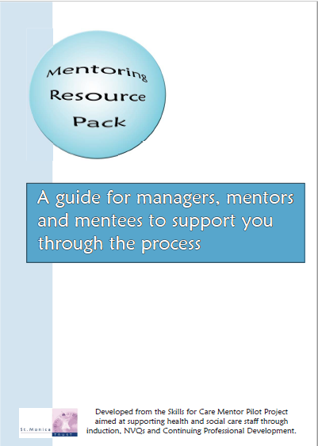

EV. 1.3

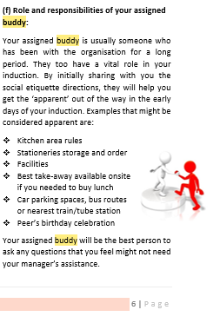

EV. 1.4

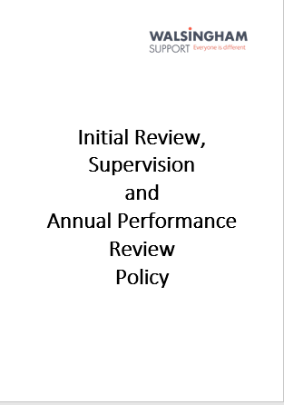
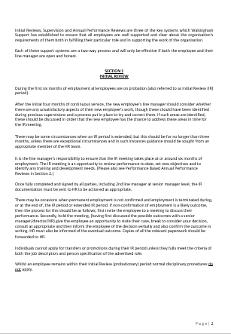

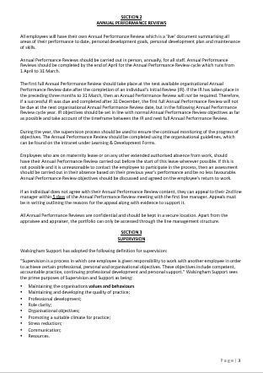

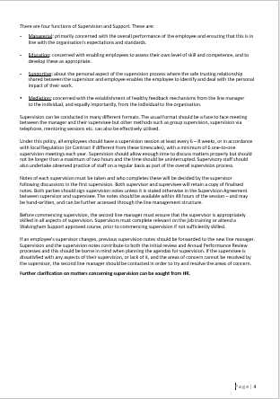

EV. 1.5



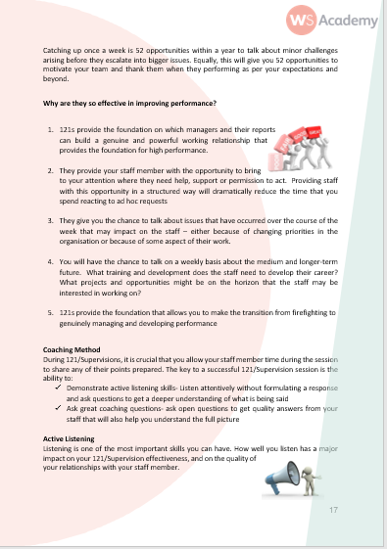

EV. 1.6



EV. 1.7
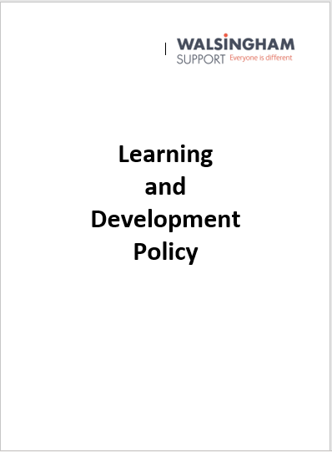

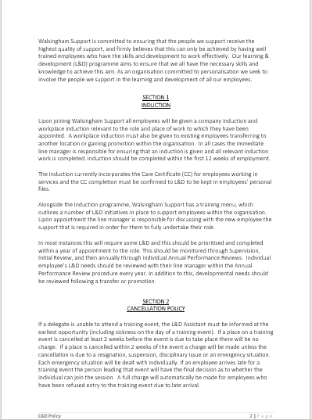

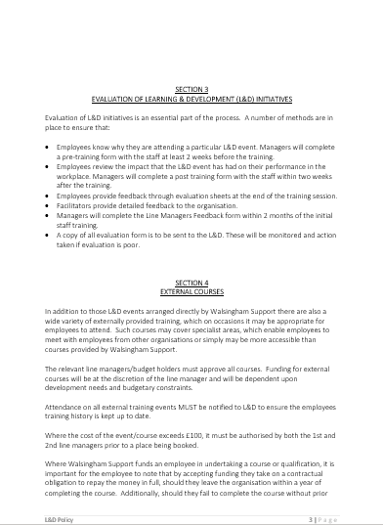

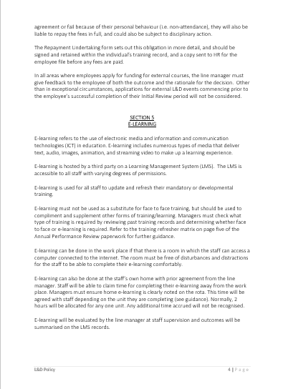

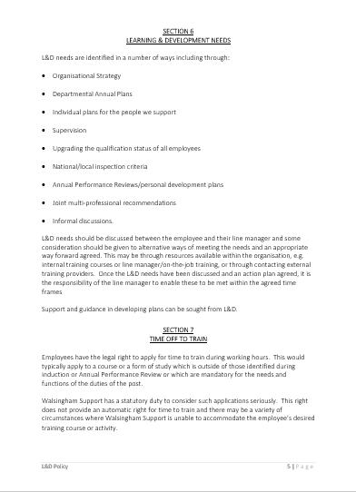

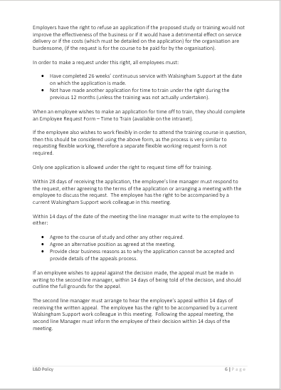

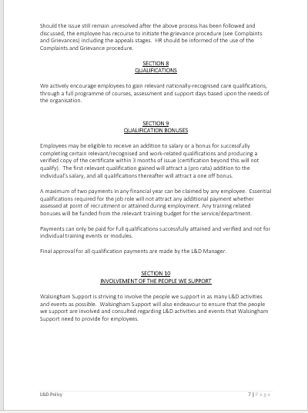

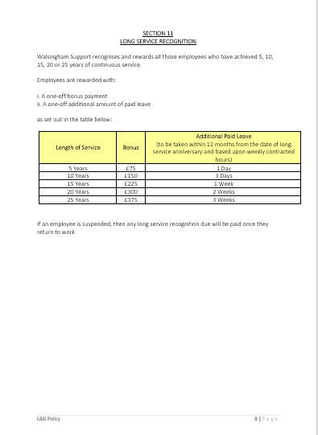
EV. 1.8
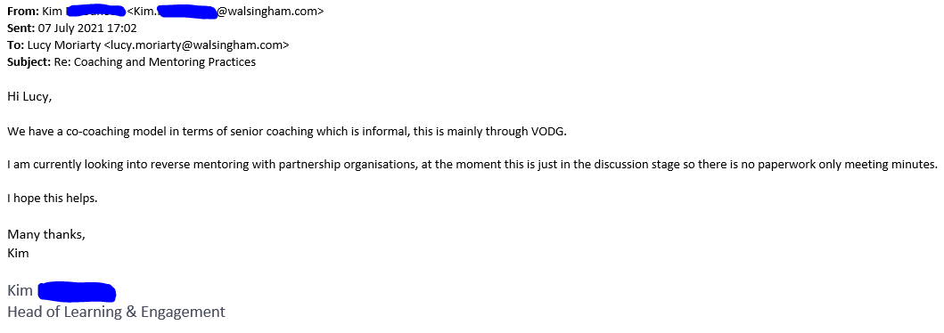

EV. 1.9
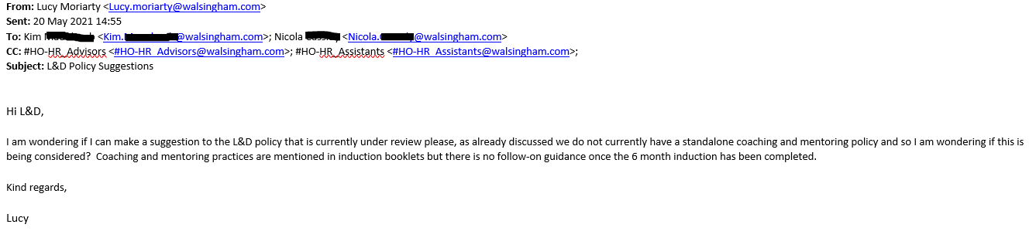



EV. 1.10
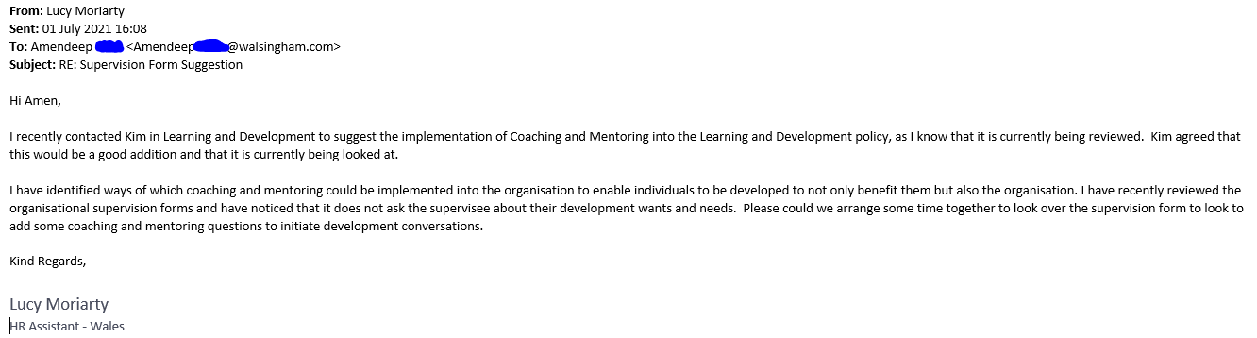

EV. 1.11
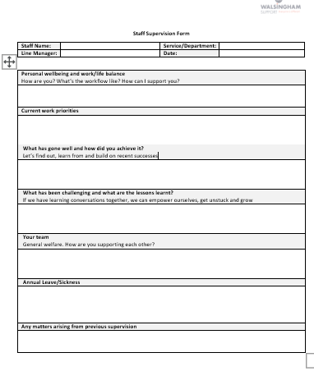

Activity 2
The benefits of coaching and mentoring within an organisation is vast. It is essential in empowering employees, building trust and loyalty, cultivating talent and in achieving success. Coaching and mentoring can also support employee retention, improve employee morale and recognise employees who have potential. Through these practices it enables businesses to achieve their strategic objectives. Working towards a ‘coaching culture’ is imperative in achieving a workplace success. As informed by Caplan (2003) to achieve a coaching culture there are certain behaviours that need to be strongly embedded, and it is beneficial for all staff within the organisation to distinguish that continued learning is essential to individual and organisational success.

In most organisations a coaching culture is implemented through line managers meeting with their staff in face to face meetings relating to their performance. The meetings take form in 1:1’s, bi-monthly supervisions and appraisals and enable managers to coach and mentor their staff. One of the major barriers of a coaching culture is that management at executive level may not fully commit to the fulfilment of coaching and mentoring techniques, by not providing a lead by example practice it doesn’t provide an idealistic view of what valuable coaching and mentoring should be. Effective managers/coaches ask questions instead of providing answers, supports instead of judging and aids development instead of ordering what must be done Ibarra and Scoular (2019).

As aforementioned in LO1 coaching and mentoring processes within my Organisation are minimal, however, mentoring is referred to in induction booklets and in the supervision policy and forms, displaying that there is some, but very little knowledge or understanding around implementing coaching and mentoring practices to the organisation in its entirety. As there are no formal or recognised coaching and mentoring practices and it is only briefly mentioned at the beginning of the employees life cycle, it would be constructive to promote the benefits to the organisation of continuing coaching and mentoring methods following the successful completion of the probation period. To successfully promote t a ‘coaching culture’ to an organisation the benefits would need to be communicated to all employees to ensure the ‘buy-in’ and to provide an understanding. As identified in LO1 I recommended the implementation of Coaching and Mentoring practices into the revised Learning and Development policy, with reference to a coaching model to provide visual information.

After further investigation into the organisations coaching and mentoring methods, there are elements of mentoring included in supervisions, however, from reviewing the supervision forms there doesn’t seem to be any questions leading to conversations around the individual’s development or to provide a coach/coachee and mentor/mentee relationship. Within the current supervision plan, coaching and mentoring could be effectively formalised through the introduction of a personal development plan to coincide with the supervision form. Clutterbuck and Megginson (2005) explains that coaching provides an opportunity for discussions regarding behaviours, priorities and most importantly performance.

A personal development plan can be implemented into supervision meetings. The Supervision format can concentrate on the employee’s current workload and well-being and with the introduction of a PDP it can provide a structured discussion around the individuals development needs within the confines of a trusted and confidential relationship. To support the implementation of the personal development plan it can be developed using the GROW model (EV. 1.12) to create an array of open coaching questions to define and agree goals and explore how they will be achieved. This will also provide line managers with an understanding of the knowledge and skills required to begin a coaching/mentoring relationship. By integrating the PDP into supervision meetings, it will ensure a smooth process of introducing coaching and mentoring to the organisation and the probability of ‘buy-in’ and it being a success.

It is vital that when approaching a “coaching culture” that line managers have the required skills and knowledge to adequately support and develop employees and the organisation in achieving their objectives. As suggested by Caplan (2005) line managers must act as role models ensuring that they portray the desired behaviours. As coaching and mentoring is a new concept in my organisation, it would be beneficial for new coaches/mentors to undertake coaching and mentoring training programmes through external companies. This would be particularly helpful for senior management and line managers but could prove to be expensive.

As previously identified, there are no coaching and mentoring practices formalised within my organisation and so with the introduction of new methods it is beneficial to introduce it into a process that already exists. This would help ease coaches/mentees into participating and gaining an understanding of what coaching and mentoring is about and what is required of them. In addition to this, to ensure that everyone within the organisation is supportive of coaching and mentoring practices would be to include it as part of its organisational strategies. As my organisation has a “top-down” approach, coaching and mentoring would be encouraged by senior management acting as role models for coaching and mentoring behaviours. To encourage the required behaviours an external coaching and mentoring provider could be utilised to implement the skills and knowledge needed at senior and executive levels, and support with encouraging the methods throughout the wider organisation. As explained by Caplan (2005) coaching and mentoring aids the way that staff are developed, determines succession planning and enables line managers share their knowledge and expertise.

Recently within my organisation there has been a newly appointed Director of People and Engagement, this is a new role and is a result of a recent restructure. This new role has been introduced to determine changes within the organisational culture and drive forward strategies which in time will be pave the way for a coaching culture. As mentioned in (LO1) I approached my line manager to arrange a meeting to review the organisational supervision forms as they were very rigid and did not create a coaching conversation. My line manager supported my recommendations and agreed that the supervision forms would need to be changed accordingly to support the implementation of coaching and mentoring into the learning and development policy (EV. 1.13).

References
Caplan, J., 2003. Coaching for the future. Wimbledon: Chartered Institute of Personnel and Development, p.4.
Caplan, J., 2003. Coaching for the future. Wimbledon: Chartered Institute of Personnel and Development, p.20.
Caplan, J., 2003. Coaching for the future. Wimbledon: Chartered Institute of Personnel and Development, p.23.
Clutterbuck, D. and Megginson, D., 2005. Making Coaching Work; Creating a Coaching Culture. London: CIPD, p.20.
Ibarra, H. and Scoular, A., 2019. The Leader as Coach. [online] Harvard Business Review. Available at: <https://hbr.org/2019/11/the-leader-as-coach> [Accessed 22 June 2021].

EV. 1.12
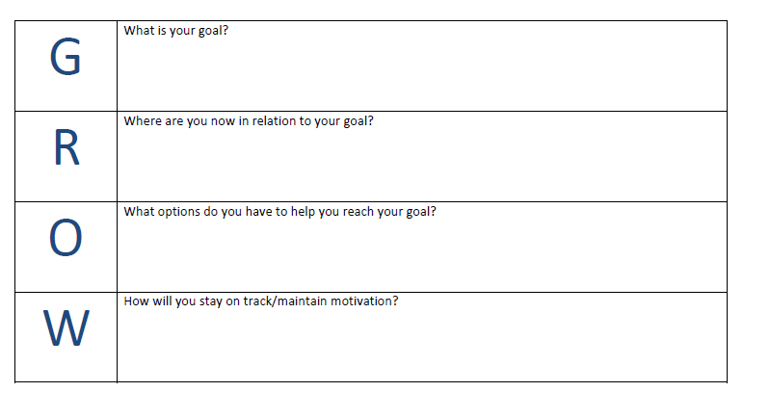
Sir John Whitemore GROW Model

EV. 1.13



