Executive Summary
Learning has evolved with time, in the beginning people used to learn on stones, then papyrus (Mark, 2016), followed by paper, blackboard and the 21 Century has revolutionized technology to be not only a medium of communication but an important learning tool. As of the beginning of this year we were accustomed to a blended learning that involve the in-class and virtual learning.
The in-class learning has been going on for years where students come to attend sessions, the lecturers and students interact where students participate in class activities like presentations, ask questions, video discussion, debate (Kraus, Sears, and Burke, 2013) and classes are at a predefined set of time. The ability to physically be in the same place and ask questions help students to clarify on a particular question they were not sure of.
Blended learning involves the use of technology (Adams Becker et al. 2017) and in-class, the technology part helped students to reduce printing papers, they email their work to the lectures and have access to wide selection of resources ranging from google search to a tone of academic materials, journals, past papers and many more online resources.
Covid-19 struck in February 2020, it disrupted our way of life we never imagined before, in the midst of this all, students were forced to abandon their classes and resort to attending lesson virtually where they attend lessons through tools like Skype that provide an interactive experience where the students see each other face to face (Young , 2013) with the lecture using a camera embedded on the laptop.
The closing of schools, universities and other training institutions increased the need to use Moodle, an open source learning management system that has been instrumental in storing, sharing and distribution of learning materials and contents. The education institutions, students and parents can have access to the system, lecturers can deposit learning materials which students can access (Lopes, 2014). After completing assignments, students email or can upload the completed work on Moodle.
Virtual learning has revolutionized the learning where now one can learn remotely, anytime, student have access to a resource including digital library, student attend online meeting to discuss group projects and students have access to multimedia production which include video, text manipulation and audio editing.
Virtual learning is rich in production, easy to access, available in a wide selection of contents, readily available, the providers are creative and match on with the speed of the need from the users. The innovation in virtual learning has seen different sectors partner to share knowledge (Pavel, Fruth, and Neacsu, 2015).
Technology development has increased the speed of bandwidth, the broadband service to every corner on the country mean that no student is left out. The fast internet helps big files especially videos to download in a very short time and help video sharing tools like Skype face to face conversation take place without interruption or time lag.
As I write this now, universities and education institutions are creating ways on how virtual learning will become the new norm and it will change learning for good that the big part of learning will become virtual and in class session will become less encouraged.
In order to understand virtual learning better I carried out a study to learn the impact of Virtual learning Environment on student's experience. This will help to understand benefit to students and the education institutions and the impact it has.

Benefits of Virtual Learning
Students enjoy student life where they meet friends, some it is their first-time experience to be out of home, university environment is a place full of fun, a number of social activities go hand in hand with academic activities. The library and other leaning events help to solidify what they learn in class. This all may come to be things of the past as Covid-19 pandemic is shifting education to Virtual learning to become the norm.
Benefits of virtual learning include the following;
- Study anywhere
- Learn anytime
- High quality contents
- Access to a wide number of resources.
Study anywhere
Learning has shifted to our homes, offices, on the bus and anywhere, this has given opportunities for people to mingle jobs and learn new skills, the parents can attend lessons while at home and look after children at the same time. People who used to travel miles, or from one country to another can now just stay in their countries and learn.
This has increased students time to spend it on learning, the time they would be meeting friends, go out for social events etc., transport daily to go for classes can be utilized to do revision. My take on this extra time students have will lead to students to innovate new tools, resources and inventions.
Virtual learning has a number of benefits as it is cheaper – it reduces the expense for students to travel, accommodation and food. It helps to bond the family together as students spend most of the time at home with the family and being under the watchdog of the parents the students do revision.
Exams, assignments, course work are can be done online, contents are sent by email or the course work is posted on Moodle where students have access to the contents, special classes can be arranged for students to ask questions, the Moodle has access to academic materials that the school provides which students utilize in their revision.
Virtual learning has challenges to students from disadvantaged communities that they don’t have access to good learning devices, the don’t have broadband or may have to work in order to earn income, this way when at home they don’t get time to attend online lessons as they are interrupted with work schedules.
Learn anytime
with virtual learning, education is open 24 hrs., 365 days a year, it never close, this gives one access to learning nonstop. With different time zones, students can arrange to host an online meet up to discuss academic matters, this is a slight change from the in-class where students meet up for social events and don’t discuss much about academic. With virtual learning, students meet online to discuss academic issues, so the time is used wisely.
High quality contents
With a number of sources of information, the application of a wide selection of digital media tools and multimedia components, the virtual learning is engaging, with quality contents that increase interest and confidence to the learners. There are a number of tools to test sceneries, meet volunteers to carry out research work, exchange ideas, the vast amount of materials online help to select the best contents out there.
Access to a wide number of resources
Online resources including digital library that the university provides has journals, periodical newsletters, digital textbooks, past papers, pdf books, reading material, that are relevant to students and teachers. By having access to a wide selection of resources give students a leverage to educational contents that suit their academic needs and helps to perform better.
Students who have access to materials online have an added advantage to students without online presence like some students in schools in Africa, they lack access to Moodle, the internet and broadband, this has impeded their learning, made them lose interest and confidence especially during the Covid-19 when universities are closed.
The teachers have developed the art of creative teaching and applied different approaches to engage students, these include the use of PowerPoint, survey tools, graphics, audio, video, short documentaries, visual tools, these play a vital role for the development of education to students.
The parents can communicate with the lecturer or administration staff to enquire about the performance of their child, the lecturer can advise all through online. These kinds of tools make it easy for parents' engagement with the education institution.
Students especially doing art or computer programming benefit a lot from online contents as it provides them with the tools for developing project much more easer, it provides online collaboration, resources for sharing files, a place where you ask questions and get back answers, real life projects and a host of events where you can meet like-minded people to design or develop systems.
The findings I carried out (please see graph below) I find some interesting facts, 50% of the respondents interviewed on the question of the impact with the family say it had no impact, surprisingly of those interviewed 50% live with the families and 50% live alone, my take on this is that people who live with family have had an impact on virtual learning and those who live alone have not felt the impact of virtual learning.
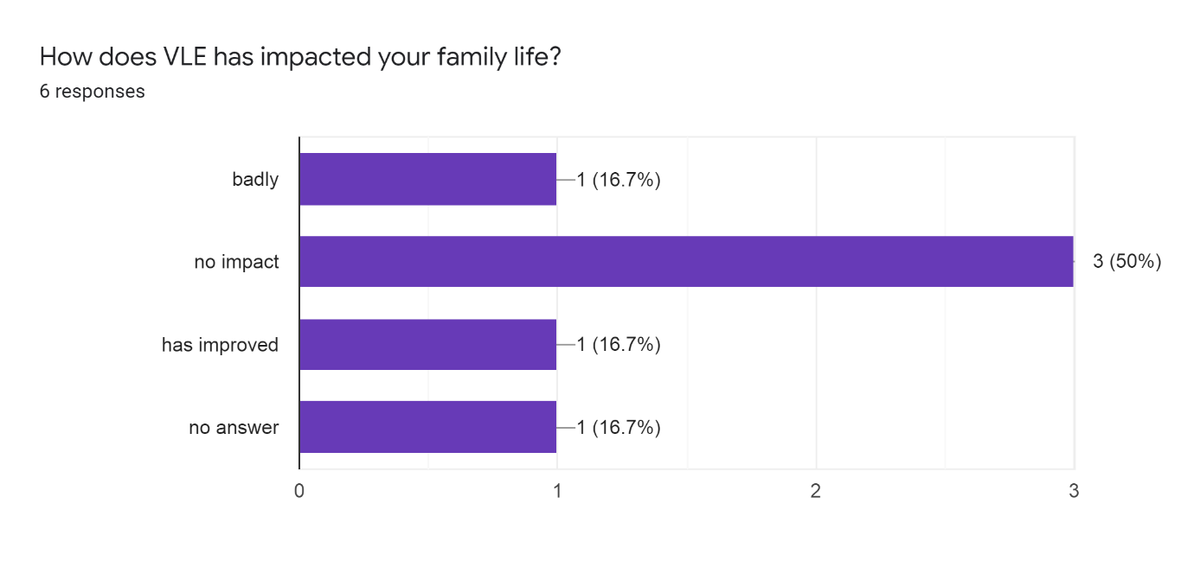
Students who have family and study at the same time benefit immensely in virtual learning as they have access to learning materials from home and as in this pandemic, they work from home and study from home which gives them a good load to time to care after the family.
Virtual Learning has a positive response to the interrelations between students, the mobile phone has been instrumental in building a quick and easier response in communication between students. Apps like WhatsApp, a free smart phone service has made it easier for students to send messages instantly to each other to discuss group assignments and publishing (Barhoumi, 2015) contents. Video sharing tools like Skype has been instrumental in students to meet as well online face to face.
Moodle has made it easier to share files, and access contents, virtual learning environment tools and resources are readily available, this has seen 66% of respondents from my research feel confident in the use and application of the services it provides.
The interview I carried out the majority of the respondents were female, there is a digital gender gap that women are not into technology, despite virtual learning to have many benefits, the majority of respondent prefer to have both in-class and virtual learning. Technology is mainly used by young people below the age of 30 years, the frequent social media and spend more time on virtual learning than those over 30’s, it is no wonder the majority of people in the research prefer to have a combination of in-class and virtual learning. Young people below 30 years prefer virtual learning.
Conclusion
In the research I carried it is evident that young people and male enjoy the use, application and services of virtual learning. The older generation prefer a mixed blend of both in-class and virtual learning.
With the shift to virtual learning and the friendly approach it provides, the users find it easy and have confident in using virtual learning tools. The continual using of virtual learning in change the older generation to prefer virtual classes than both blended classes.
The family has been one of the biggest beneficiaries as the students who would have spent a big chunk of time at university now spend time at home, this give parents time to keep an eye and encourage their children to study more.
Family that have are studying have the benefit of learning from home and care after their family members. This would be difficult with only in-class learning.
In-class learning turns out to be higher as the cost of transport, accommodation and even fees are way higher than online learning. The application and resources on Moodle have helped students learn from home, share resources, have access to the university digital library, communicate with the lecturer and has helped students feel confident in the use of virtual learning.
References
Adams B., S., Cummins, M., Davis, A., Freeman, A., Hall Giesinger, C., & Ananthanarayanan, V. (2017). NMC horizon report: 2017 higher Education Edition. Austin: The New Media Consortium.
Adina-Petruta P., Andreas F., and Monica-Nicoleta N. (2014). ICT and E-Learning – Catalysts for Innovation and Quality in Higher Education. 2nd GLOBAL CONFERENCE on BUSINESS, ECONOMICS, MANAGEMENT and TOURISM, 30-31 October 2014, Prague, Czech Republic. Procedia Economics and Finance 23 (2015) 704 – 711.
Ana. P. L. (2014). LEARNING MANAGEMENT SYSTEMS IN HIGHER EDUCATION. Polytechnic Institute of Porto (IPP) / ISCAP / CICE (PORTUGAL). Proceedings of EDULEARN14 Conference. 7th-9th July 2014, Barcelona, Spain. 5362.
Chokri B. (2015). The Effectiveness of WhatsApp Mobile Learning Activities Guided by Activity Theory on Students' Knowledge Management. Taibah University, Saudi Arabia. CONTEMPORARY EDUCATIONAL TECHNOLOGY, 2015, 6(3), 221-238.
Leanne Y. (2013). Webconferencing, screen-sharing and online meeting rooms. Distance services librarian, University Library Services. University of Sunderland. [accessed on 28th/08/2020]. https://pdfs.semanticscholar.org/c324/5fb06b47dee18f05602a7f8c77c9bac13b1f.pdf.
Sue K., Sharon R. S, and Brian L. B. 2013. Fort Lewis College, Durango, CO 81301. The Journal of Effective Teaching, Vol. 13, No. 2, 2013, 83-93. [accessed on 29th/08/2020].

Appendix:
1/ Questionnaire
what is your age group? *
  - 20-30
  - 31-40
  - 41-50
  - Over 50
What is your gender?
  - Male
  - Female
  - Prefer not to say
what is your preference between VLE and class-based learning?
  - Virtual Learning
  - Class-based learning
  - both types of learning
  - None of them
How does VLE has impacted your family life?
  - badly
  - no impact
  - has improved
  - no answer
On the scale of 1 to 5, Can you describe the effect of VLE on your learning environment.
 | 1 | 2 | 3 | 4 | 5
bad |  |  |  |  |  | excellent
On the scale of 1 to 5, Can you describe the effect of VLE on your relation with fellow student.
 | 1 | 2 | 3 | 4 | 5
bad |  |  |  |  |  | excellent
on scale of 1 to 5, how would you describe your level of confidence toward VLE.
 | 1 | 2 | 3 | 4 | 5
poor |  |  |  |  |  | Excellent
Do you agree or disagree with using virtual learning in higher education context?
  - Strongly disagree
  - Disagree
  - Agree
  - Neutral
  - Strongly agree
According to your experience what are the most needed skills for a successful VLE on order of importance.
  - Effective and Appropriate Communication
  - Effective Time-Management
  - Motivation and Independence
  - Basic Technical Skills
  - A Good Study Environment
The opportunity to learn using VLE at a time, place and pace to suit myself encourages me to learn independently.
  - Strongly disagree
  - Disagree
  - Neutral
  - Agree
  - Strongly agree
VLE has a positive impact on my effectiveness as a student.
  - Strongly disagree
  - Disagree
  - Neutral
  - Agree
  - Strongly agree

2/Graphs



