This purpose of the essay is to show findings after comparing and analysing two articles. The articles used are ‘The economic impact of major sports events: A review of ten events in the UK’ by Chris Gratton, Simon Shibli, Richard Coleman (2006) and ‘The economic impact of local sport events: significant, limited or otherwise? A case study of four swimming events’ by Robert Wilson (2006). In brief it will talk about why using two articles that were both published in 2006 can make there comparisons fair and with both articles discuss sporting events and focus on the size of each event rather than the sport itself. This will also help the essay to be fair although Gratton et al (2006) uses 10 different sports events and Wilson, (2006) uses 4 events of the same sport. It will look into the typology used in each of the articles. The central theme in each articles is to find out where the majority of the income is derived from, in Wilson (2006) case it would also be to use the information found during his research to determine whether a local event could be as economically beneficial as a major event. Complementary to this would be the references used to create each of the articles and whether they could impact the writer's opinions.

While in this case both articles were published in 2006, this allows the articles to be compared in a fair way. Despite this the article by Gratton et al (2006) is about major sporting events, and Wilson (2006) is about local. There is a clear size difference between the type of events studied by each of the authors. However each author's main focus is to determine the economic impacts within each of their events. With Gratton et al (2006) using 10 events and Wilson (2006) using only 4, there is a clear difference with the amount of research each of the author’s would do to make their educated conclusions.
Additionally the authors were focusing more on the size of the events rather than the sport that was played. Each author wanted to find out the economic impact that came from each of the events they studied. As Bowdin (2002) said ‘Major events are events that, by their scale and media interest, are capable of attracting significant visitor numbers, media coverage and economic benefits’ this shows that major events have the ability to impact the host community where the events have taken place.
Then again the typology used in Wilson (2006) article was a typology created by Gratton’s previous work as seen in Figure 1 Appendix 1. Which in Wilson (2006) opinion was short of a section as he concluded that an additional type should be made that would recognize regular events like the ones he studies. In addition to this another author Gibson et al (2012) has further agreed with Wilson (2006) idea to create a type E whilst also backing Gratton et al (2000) typology sections A,B,C and D.
Equally important both authors recognize that events are mainly spectator driven however for Wilson (2006) case there were more competitors than spectators proving that not all events are purely spectator driven as Gratton et al (2006) believes when he says ‘ the economic impacts can be attributed to spectators and these would be categorized as ‘spectator driven’ events’.
After examining the research done by Wilson (2006) and Gratton et al (2006) it is clear to see the use of primary and secondary research has been done. The use of questionnaires to get an insight from the attendees from each event have impacted their opinions. From the research done by Wilson (2006) he was able to determine that the majority economic impact came from the competitors rather than the visitors or spectators as the events was more competitors due to the events only having appeal to friends and family. Within the research found by Wilson (2006) he was also able to look at all the additional spend that benefited the host communities, even if it was on a low scale. Gratton et al (2006) was also able to use the questionnaires to find the additional expenditure from the attendees. The use of questionnaires can be beneficial to research as the researcher does not need to be present while research is being conducted Mcleod (2018) allowing the author to gather a lot of information in a cheap and effective manner. However these questionnaires can be dismissed due to emotion or feeling towards the outcome of an event for example if a competitor lose they may be bias towards the questionnaire.
Considering Wilson (2006) cites Gratton et al (2000) around 8 times shows that Wilson (2006) article was strongly influenced by Gratton’s previous work. However the other article studied in this essay is an updated addition to Grattons previous work with a lot more research conducted and a larger range of events. These factors contribute to Wilson (2006) outcome of an idea to add an additional type E. At the time of Wilson (2006) publication it leaves you to wonder whether if Wilson had read Grattons new work would his outcome to disprove Grattons typology have been different, With both articles published in 2006 and only within 7 months of each other this leads to believe wilson would not have read the 2006 article by Gratton. However articles can take at least 3 months to go through peer assessment to be published according to Elsevier (2018) which further leads to believe if either articles could have benefited from reading one another as part of research.
Over time all the authors in the articles used in this essay have either been part of ‘sport industry research centre’ or ‘leisure industry research centre’ all of which are based in Sheffield university with this, it is highly possible all authors could have met and discussed since the publication of both articles and made an updated typology that suits all. More recently Getz et al (2015) have also come up with a typology which may satisfy Wilson.

In conclusion to both articles, with publication in 2006 each articles are compared fairly due to being able to access the same information before publication. This allows the authors to be influenced by similar previous work. With both authors focusing on the size of an event to determine how a major or local events can economically impact a host area, they have proven in their own articles that each event can be of an impact whether it is through spectators or competitors. Each event studied by the authors had relevant research conducted to enable them to determining whether their events additional spend come from, enabling them to cut out any deadweight information that could affect their conclusions. With the typology by Gratton et al (2000) was made in 2000, Wilson (2006) made an educated change to the typology that would add smaller local events with an outsider impact to the host community. Though reading each article and seeing that Gratton et al (2006) events are run by a lottery fund enabling the host comminutes to spend less money allowing them to have the maximum income from outsider and additional expenditure. This shows effective and sustainable management in the events. Both articles are on economic impacts with a clear opinion that the events studied by Gratton et al (2006) were spectator driven and the events by Wilson (2006) being competitor driven it the biggest difference, the way each author conducted research is very similar and also the background of each author with them all teaching at Sheffield University. This all leads to believe both articles are different in the sense of who impacts the host communities but very similar in the way of how they analysis in order to gather their findings.

Appendix 1
Figure 1

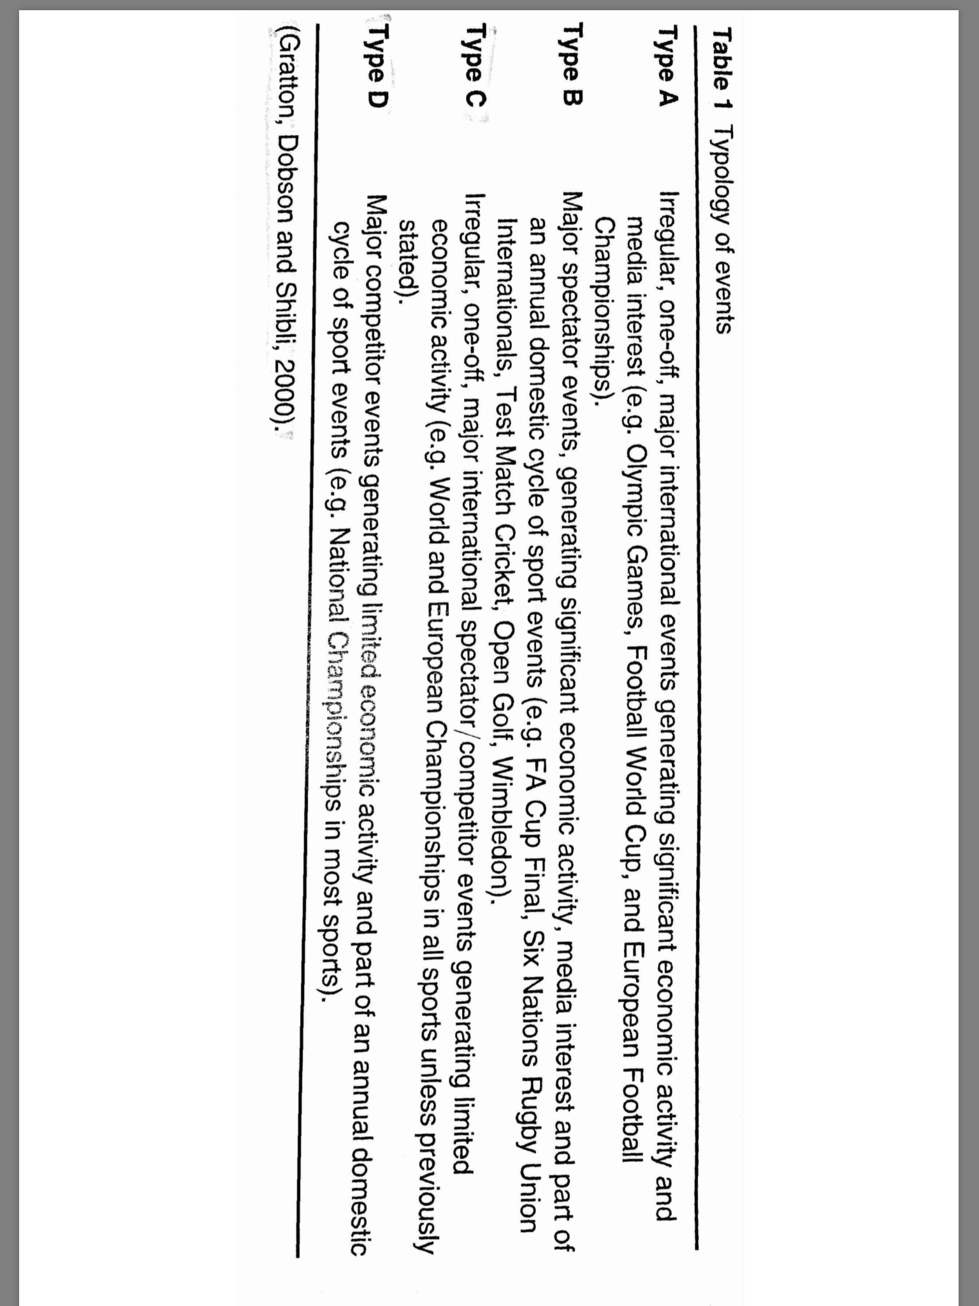

References List
Anon, (2018). [online] Available at: http://libweb.surrey.ac.uk/library/skills/In [Accessed 4 Feb. 2018].

Anon, (2018). [online] Available at: https://www.researchgate.net/profile/Simon_Shibli [Accessed 4 Feb. 2018].

Biblio.com. (2018). Chris Gratton Books - Biography and List of Works - Author of 'Research Methods For Sports Studies'. [online] Available at: https://www.biblio.com/chris-gratton/author/1935508 [Accessed 4 Feb. 2018].

Bowdin, G. (2012). Events management. London: Routledge, p.18.

Getz, D. and Page, S. (2018). Progress and prospects for event tourism research.

Getz, D. and Page, S. (2016). Progress and prospects for event tourism research. Tourism Management, 52, pp.593-631.

Gibson, Kaplanidou & Kang, 2012. Small-scale event sport tourism: A case study in sustainable tourism. Sport Management Review, 15(2), pp.160–170.

Gratton, C., Shibli, S. and Coleman, R. (2006). The Economic Impact of Major Sports Events: A Review of Ten Events in the UK. The Sociological Review, 54(2_suppl), pp.41-58.

Shibli, S. and Gratton, C. (1999). Assessing the Public Profile of Major Sports Events: A Case Study of the European Short Course Swimming Championships. International Journal of Sports Marketing and Sponsorship, 1(3), pp.54-71.

Shu.ac.uk. (2018). Rob Wilson | Sheffield Hallam University. [online] Available at: https://www.shu.ac.uk/about-us/our-people/staff-profiles/robert-wilson [Accessed 4 Feb. 2018].

Simplypsychology.org. (2018). Questionnaire | Simply Psychology. [online] Available at: https://www.simplypsychology.org/questionnaires.html [Accessed 4 Feb. 2018].
Times, P. (2018). Social Science &amp; Medicine. [online] Journals.elsevier.com. Available at: https://www.journals.elsevier.com/social-science-and-medicine/policies/peer-review-policy-and-publication-times [Accessed 4 Feb. 2018].

Wilson, R. (2006). The economic impact of local sport events: significant, limited or otherwise? A case study of four swimming events. Managing Leisure, 11(1), pp.57-70.

