Dissertation proposal
Thomas Richards
P149671

Word count:2297

In this proposal I will outline the ideas I have been contemplating and expanding upon them to discover the focus of my dissertation. The idea I’m currently investigating is, how much of a factor luck has on becoming an establish photojournalist/photographer? From my current study of photojournalism, I have found that a lot of establish photojournalists burst on to the scene by luckily being at the right place at the right time. Then subsequently riding that initial kick start of recognition for the rest of their career.

Key word one: Luck

The first key word I want to look into is luck. The definition of luck in the Cambridge Dictionary is “the force that causes things, especially good things, to happen to you by chance and not as a result of your own efforts or abilities”. One of the main subject matters of photojournalism is war, capturing the destruction and devastation it has on the area it takes place furthermore it looks into the lives of the soldiers and civilians. War photography is fascinating due to the surreal nature of the images, they’re so out of the norm for the average viewer. They really capture your interest getting you lost in all the emotions captured in one single images.

War photography I feel is the most luck based out of any other form of photography because if you happen to be in the right place at the right time, you can be the only person to ever capture a specific moment. To recreate a moment would be almost impossible therefore if you’re the only person to capture an event you’ll instantly get publish in newspapers and all over the internet if the importance of the images is great enough. One of the great war photographers Robert King got his first publication out of luck. He spent weeks out in Sarajevo trying to capture the on-going conflict there, but he was getting told his images were good enough. He got dropped by his agency out there, but he still stayed there and out of nowhere he got offered the front page in the Guardian newspaper to photograph how the French army were paying for prostitutes with cigarettes and food.
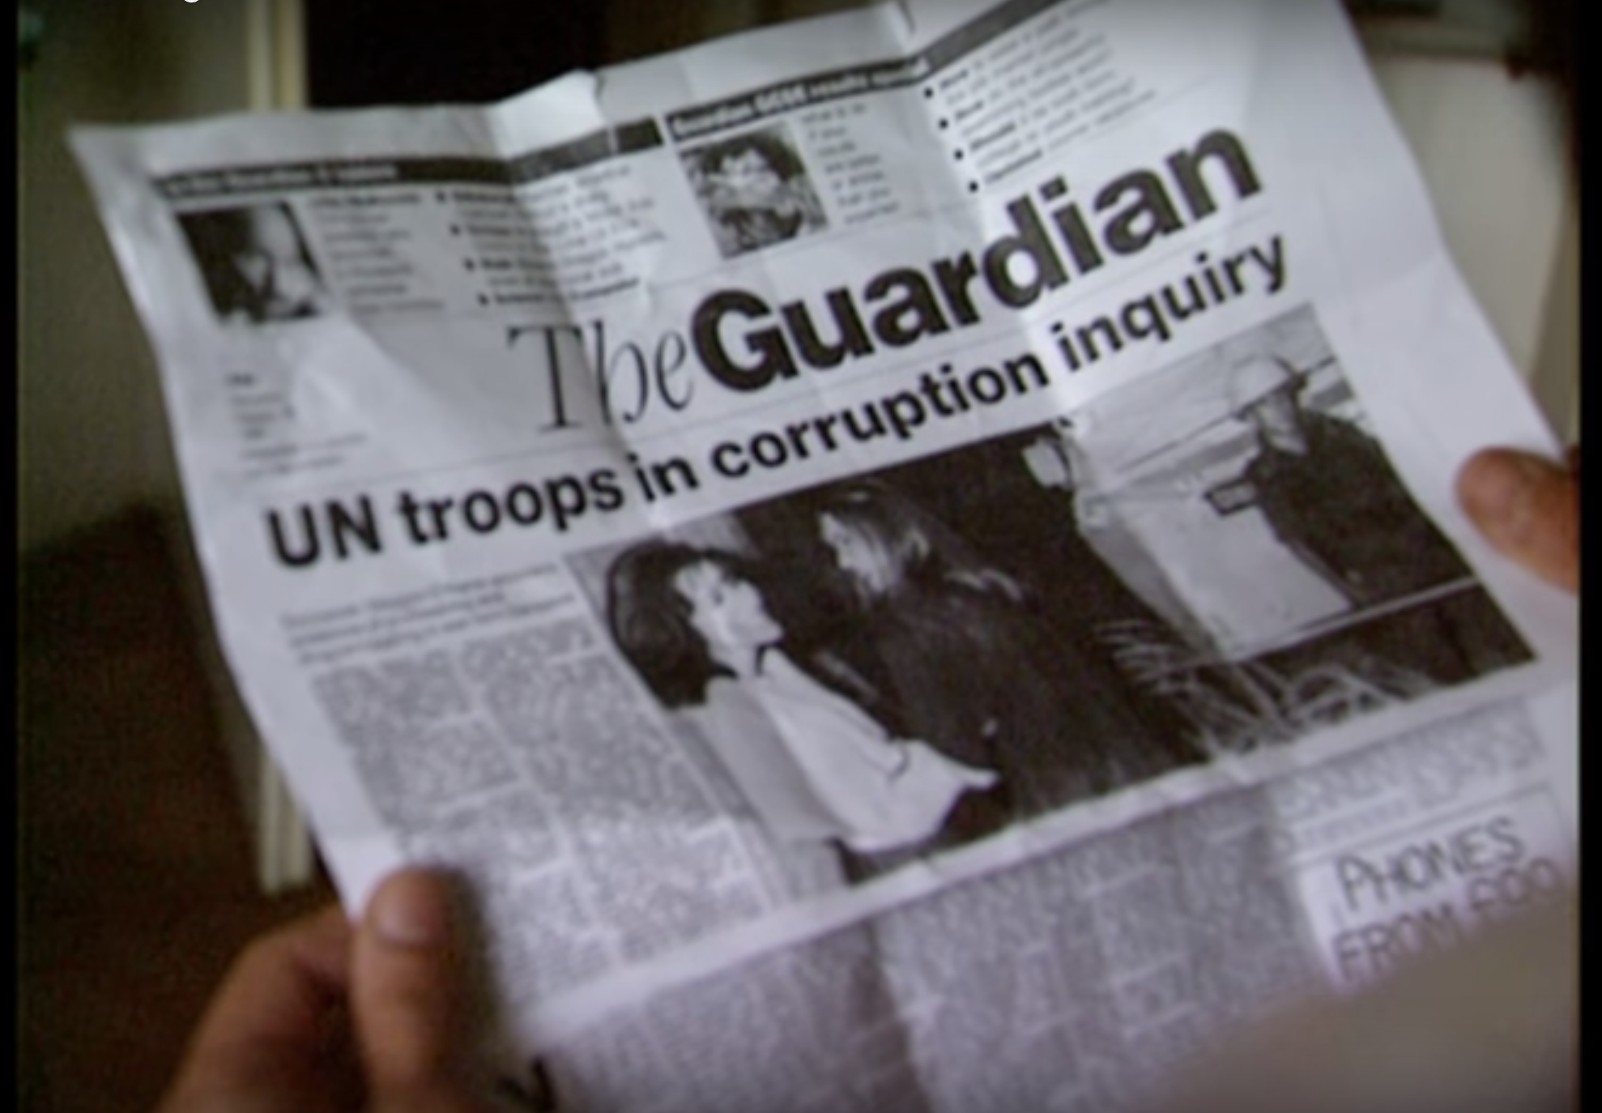

(Figure 1)
“It’s funny how it works out ya know yesterday I was in a lull ya know and now I’ve been uhh somebody’s thrown down a life preserver in this well I’ve been trying to climb out of”
(Shooting Robert King, 2008)

Robert King is even aware of his own luck, he knows how quickly things can change. It comes from nowhere this opportunity of a lifetime to help save his career. As if some divine power has granted him this gift. If Robert chose to leave Sarajevo after he got dropped by his agency, he wouldn’t have been handed this opportunity to make his name and get established for the first time. Where Robert really made a name for himself was in Grozny. After the Russians took control of Grozny which is the capital city of Chechnya the press pack left, Robert arrived in the city as the rebels were launching their counter-offensive.

“I knew something was going to happen in Grozny so I stayed there and made some great pictures.”
(Shooting Robert King, 2008)

This incident once again proves how luck is a huge factor in becoming an established photojournalist. Due to the fact Robert went to Grozny at the right time he was able to capture scenes that no other journalist would due to the fact they had left.

When looking at these events can they come down to Robert King being lucky? What would’ve happened to his career if he had decided to leave Sarajevo after being dropped from his agency? Would he have taken some new career path that would lead him to the same recognition he has now? I’m not sure. It is possible that Robert could have produced some great images somewhere else and got published front page then. But it is hard to deny that Robert got a lucky opportunity because he was in a place surrounded by so many other photojournalists, yet he was the one to get approached out of all of them to cover a front-page story.

Key word 2: Recognition

In the photographic world it is hard to achieve recognition for your work as you have so much competition from independent creators the market is so saturated. So, trying to emerge onto the scene is difficult for anyone and it is only getting more difficult to more accessible cameras become to the public. Nowadays anyone can start taking photographs because almost everyone has a mobile phone and almost all of them have cameras on them, they’re always on your person so you can capture any moment you like. It’s not how things were back in the 1940’s where cameras were still somewhat of a luxury and you would have people like Henri Cartier-Bresson making monumental work on the streets because that is not what many people got to see back then. Nowadays everyone is filming and photographing on the streets.
(Figure 2)

The story of Spanish former photojournalist Cristina de Middel rise to commercial success through herself published photobook titles ‘The Afronaughts’ is one I find particularly interesting. She worked as a photojournalist in Spain for eight year before wanting to create fiction with her camera. In 2012 she self-published her book ‘The Afronaughts’. The photobook depicts the story of the short-lived idea of a space program in Zambia. The book highlights the strangeness of the idea of the space program but also you see the magic of the potential idea of the dream of going to Mars. The way this fantasy photobook caught the attention of booksellers and lovers alike was through photographer and photobook collector Martin Parr. The quote below is from The Guardian.

“The Afronauts became the word-of-mouth book at last year's Arles photography festival. Martin Parr, photographer, photobook collector and champion of all things new and interesting in the photobook world, bought five copies. Soon after, it began selling rapidly (cover price: €28) through online orders and in the various independent bookshops that De Middel had managed to convince to stock a few copies. By the end of last year, it had sold out its print run of 1,000 (it now changes hands on eBay for £750 and is listed on rare book site AbeBooks for £1,052)”
(O’Hagan, 2013)

From this you can directly see how Martian Parr effected the reputation of this book and the price of it, the book is worth over one thousand pounds more than it was originally selling for. So due to the fame Martin Parr has achieved in the photographic world he was able to sway the opinions of other people and the books fame took off from there. Cristina de Middel was struggling to get her book into book stores with each store only willing to take a few copies of the book. The book was discouraged when she was first showing off the concept originally. Cristina de Middel began by showing her idea to the gallery she was with and they discouraged then idea as did the photography agencies she showed it to originally. She said in an interview with The Guardian that the photography agencies criticised the book and said, “It was too documentary for one and too conceptual for the other.” It’s very interesting how Robert King and Cristina de Middel both faced the same struggles with their agencies when trying to emerge onto the scene in their respected fields. They both moved past the problems they faced from their agencies and perceiver with their work, receiving the due credit for their efforts.

The need for recognition in the art world is something every artist strives for; you want the satisfaction of getting your voice heard. To have the recognition that your ideas are some of the most profound out there and that they need to be put on display in some of the greatest galleries in the world. Nobody who creates art doesn’t want any recognition, if you say I make art for myself and nobody else. By saying that you want to receive the recognition from your peers that your practice works this way. in the book ‘Hegel’s Phenomenology of Spirit’ there is a quote I found that states:

“It is solely by risking life that freedom is obtained; . . . the individual who has not staked his or her life may, no doubt, be recognized as a Person; but he or she has not attained the truth of this recognition as an independent self-consciousness.”
(Goodreads, 2019)

From Hegel’s thinking I took this and applied it to the way both Robert King and Cristina de Middel both achieve their own success and recognition by taking a risk. For Robert King staying in Sarajevo and Cristina de Middel quitting her job to self-publish her book, from them taking these risks they were rewarded with freedom. Which was is them achieving success in what their dreams were and following on from that achieving success in their respected fields in photojournalism. From this hypothesis I could apply it to my own practice, by taking more risks with my work and really believing in my work and moving past any setbacks I could achieve success.

Key word 3: Innovation

In art innovation is what moves it forwards, individuals come along with a new way of thinking on how to visualise an idea that speaks to an audience in a way no one else has. With the medium of photography, I find it very difficult to innovate with it, an image is the most literal depiction of a moment in time, the photo is an exact replica of what was in front of the camera. When you view the raw file of a photo or a developed negative there is no disputing what is in that frame was in that frame. There is no room for interpretation. This is where I feel photography struggles, without that space to apply yourself to the work or when the work doesn’t get you asking questions the work is lost amongst all other work. Documentary photographers I feel have to push themselves further than other artists to achieve this, firstly the work needs a compelling subject matter and secondly the images need to be informative as well as impressionistic.
(Figure 3)

A documentary piece of work that I feel utilises both of these factors in Reneke Dijkstra images of bullfighters. The work has a fascinating subject matter, you stare into the eyes of these typical ‘strong men’ who are the epitome of masculinity. Yet you’re not looking at a ‘strong man’, you’re looking at a man who is exhausted and venerable.

“It was both about these life-threatening situations, all these emotions they had been through.” (Tate, 2003) This is how Reneke Dijkstra describes what she wanted to portray through the work. You can see the struggle the man in this image has been through, ripped clothes and blood on his face, struggling to compose himself for the image. You can see yourself in this image, it puts into perspective how you would feel after a life-threatening situation, the image doesn’t tell you about the bullfighter’s personal life. You just see the emotions after a horrific event. All these factors are what makes this work an innovative
piece of work, it allows you to place yourself in this scenario creating that personal connection with the work.

This way of covering a story differs greatly from the work or Robert king and Cristina de Middel. With Robert King covering a war zone, there is no room from impressionism and interpretation, he needs to capture exactly what is happening at that moment to convey to the rest of the work the facts about this horrific place. This is the struggle I see with war photography, it’s difficult to connect with it due to the nature of the images. I feel unless you’ve experienced the difficulties of war you can’t fully engage with the work and you won’t spend as much time with the images like you would with Reneke Dijkstra portraits, where there is space to engage with the context of the image. A similar problem comes with the photobook ‘Afronauts’ by Cristina de Middel, you’re told the story of the space program so you’re being told what it’s about losing the idea of creating this fantasy in your mind.

In conclusion researching into the complexity of becoming an established photojournalist and photographer I have learnt about the many factors that go into achieving success in such a competitive and saturated industry. There is evidence to support how much of a factor getting lucky can be but furthermore it shows how you need to be an innovative practitioner with the medium of photography. To innovate you need to take risks, being bold and believing in what you’re working on is good enough to be published. Your work needs to be able to speak correctly to your audience, the type of photographer you want to be. This is how the practitioners I have looked at have achieved their success after doing more research, they took risks with their images to create something that engages with people, they achieved their success through luck but also due to their ability to create a compelling piece of work.

My question for my dissertation is:

Has the medium of photography reached its limit of experimentation? Due to the accessibility of the medium now due to the fact most people have a camera phone on them at all times will this cause more upcoming artist to stray away from the medium due to the saturation of it?

Bibliography

Shooting Robert King (2008) Directed by Richard Parry [film]. Available at https://www.youtube.com/watch?v=FPNEqJrj6ms (accessed 1st May 2019)

O’Hagan, S (2013) ‘How photographers joined the self-publishing revolution’ Available at https://www.theguardian.com/artanddesign/2013/apr/14/photography-self-publishing-afronauts-space (Accessed 1st May 2019)

Goodreads (2019) Hegel's Phenomenology of Spirit. Avaliable at https://www.goodreads.com/work/quotes/995802-ph-nomenologie-des-geistes (Accessed 5th May 2019)
Tate (2003) Rineke Dijkstra: Cruel and Tender [Video]. Available at https://www.tate.org.uk/context-comment/video/rineke-dijkstra-cruel-and-tender

(Accessed 6th May 2019)

(Figure 1)
Shooting Robert King (2008) Directed by Richard Parry [film]. Available at https://www.youtube.com/watch?v=FPNEqJrj6ms (accessed 1st May 2019)

(Figure 2)
Brotons,G (2019) Christina de Middel. Available at http://www.lademiddel.com/the-afronauts-1.html (Accessed on 5th May 2019)

(Figure 3)
Davies, L (2012) ‘Fresh from the fight: the men who take on raging bulls’ Available at https://www.telegraph.co.uk/culture/photography/9257629/Fresh-from-the-fight-the-men-who-take-on-raging-bulls.html (Accessed 6th May 2019)

