

BA Hons International Hotel Management

Title: “Smart Hospitality Expo”

Module Title: International Meetings Management for the Hotel Industry

Module Code: BMIH6007

Student Name: Dillu Miah

Course Leader: Kathryn Flynn/ Jemma Smith

Student Number: 2118854

Actual Word Count: 1082

Date of Submission: 10/05/2024

Smart Hospitality Expo
"Smart Hospitality Expo" is a forward-thinking event that showcases the latest technological innovations in the hospitality sector. This event brings together industry leaders, technology companies, and hospitality professionals to explore cutting-edge solutions for hotels, restaurants, and travel services. The expo focuses on how technology can improve guest experiences, streamline operations, and contribute to sustainability.
Event Features:
-Technology Exhibitions:
Companies could demonstrate their latest hospitality-focused technology, including smart hotel rooms, AI-based customer service, robotic room service, contactless check-in, and digital concierge services. Attendees can interact with these technologies to see how they transform the hospitality experience.
- Workshops and Training Sessions:
Interactive sessions that focus on technology implementation and staff training. Topics might include using AI for guest services, implementing contactless solutions, and leveraging data analytics to improve operations.
- Panel Discussions and Keynotes:
Industry experts discuss the latest trends and future prospects for technology in hospitality. Topics could cover AI and automation in hotels, sustainability in hospitality, and the impact of technology on guest satisfaction.
-Networking and Collaboration Opportunities:
Dedicated sessions for hospitality professionals to connect with technology providers and industry experts. These sessions aim to foster partnerships and encourage collaboration on new projects.

Feasibility Factors:
Target audience:
Anyone in the hospitality industry looking to improve their services with the use of technology innovations. New entrepreneurs are also welcome and those who are potentially wanting to open their own hospitality business.
Venue and Location:
The Tower Hotel, London, St Katherines Way, E1W 1LD
£300 to book on June 11 2024 14:00-18:00. (300 people)
Transportation is available, the tube station (9 minute walk) in close to the venue. Uber/taxis are available to reach the venue. Ferry terminal (1 minute walk) and bus stop (10 minute walk) is close by. Tower hill car and coach park are available at the venue so those who wish to drive themselves have parking available.
2. Budget and Funding:
Outgoings:
Venue rental - £300
Marketing- Social Media (free), Posters 50 A4 posters £35-£40 on av.
Staff- Included in hotel price
Technology setups/Décor- £500
Food- Starters and Appetizers- £1000 max
Income:
Tickets per head £30 (30x300=£9000 (if all tickets sell)
Sponsorships- Companies could provide sponsorships in order to show their products and services and get potential customers from attendees.

Potential brands and companies to attend:
- Google Nest: Provides smart thermostats, security systems, and voice-activated devices.
- Philips Hue: Offers smart lighting solutions for hotels and homes.
- IBM Watson: Known for AI-based solutions in various industries, including customer service and data analysis.
- UiPath: Offers robotic process automation (RPA) for streamlined operations.
- Square: Provides contactless payment systems and point-of-sale solutions.
- Samsung Pay: Offers a digital payment system for touch-free transactions.
- SoftBank Robotics: Known for humanoid robots like Pepper, which can be used for customer interaction and concierge services.
- Boston Dynamics: Offers robots for security and logistics.
- Oculus (Meta): Offers VR headsets that can be used for virtual tours and experiences.
- Magic Leap: Provides AR technology for interactive guest experiences.
- Oracle Hospitality: Provides property management systems (PMS) for hotels.
- Amadeus: Offers PMS solutions and other hospitality-focused technologies.
- ALICE: Offers a platform for hotel guest services, including room service, maintenance, and housekeeping requests
- Concur: Provides travel and expense management solutions.
- Micros Systems: Offers automation solutions for hotels and restaurants, including point-of-sale systems and inventory management.
- Toast: Provides restaurant management software and point-of-sale solutions.
- Eco-Products: Offers compostable and recyclable products for hospitality.
- Tesla: Known for energy storage and solar solutions.
- Deloitte: Provides consulting services for the hospitality sector, focusing on technology and innovation.
-Accenture: Offers consulting and technology solutions for business transformation.
These brands and companies represent a diverse range of technologies and services that would be relevant to a “Smart Hospitality Expo." They bring expertise in various aspects of technology, automation, sustainability, and guest experience, making them ideal participants for such an event.
Health and Safety:
Have the hotel staff to demonstrate their health and safety procedures in case of an emergency, such as the fire exits.
Marketing and Audience Engagement:
Have those involved in the expo, brands and the hotel to showcase the event on social media. The tower hotel has 21.2k followers on Instagram and therefore they could post the event on their page in order to show numbers on how many people would be interested before finalizing guest numbers. Their page could also post the link to buy the tickets. Posters could be put up all around London as it is a busy city and could show potential attendees what the program would entail.
Why is the Smart Hospitality Exposition beneficial for the hospitality industry?

The "Smart Hospitality Expo" allows the hospitality sector to learn, adopt, and explore modern technologies while promoting innovation and sustainability. Industry leaders, technology suppliers, and hospitality experts showcase AI-based customer service, smart hotel rooms, and contactless check-in at the event. To improve guest experiences and streamline operations, guests may learn more about these technologies and their uses in hospitality through interactive workshops, panel discussions, and keynotes. Lee, M. et al. (2019) states that guests in the hospitality industry would gain better experiences through the uses of technology by making their issues getting solved quicker. The event also fosters collaboration between technology businesses and consultants through unique networking possibilities. A smart location choice at The Tower Hotel in London, easy transit, a clear budget, and a rigorous health and safety plan assure the event's practicality. Overall, the Smart hotel Expo encourages the hotel sector to embrace technology, improve productivity, and provide excellent guest experiences. Muller, C. (2010) states that technology will bring more knowledge to consumers and employees, making things more efficient and eliminating some of the inefficiencies of old practices.

Slides:
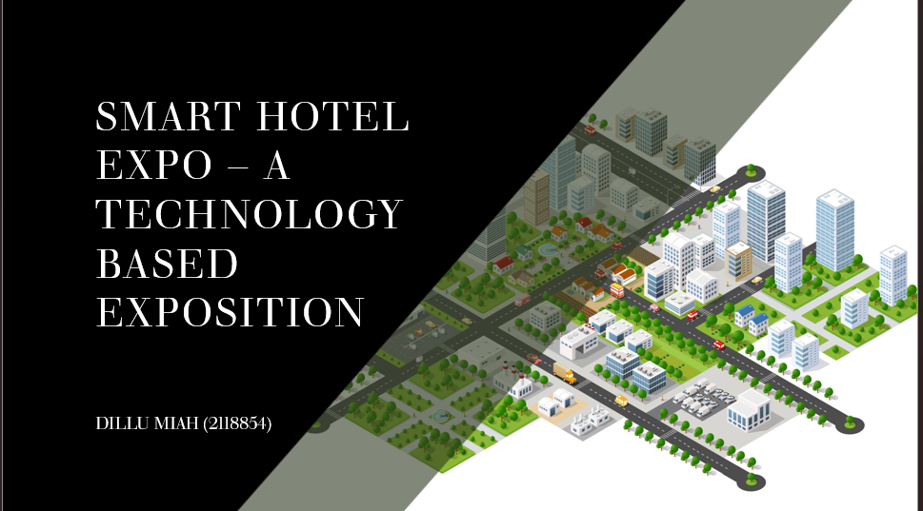

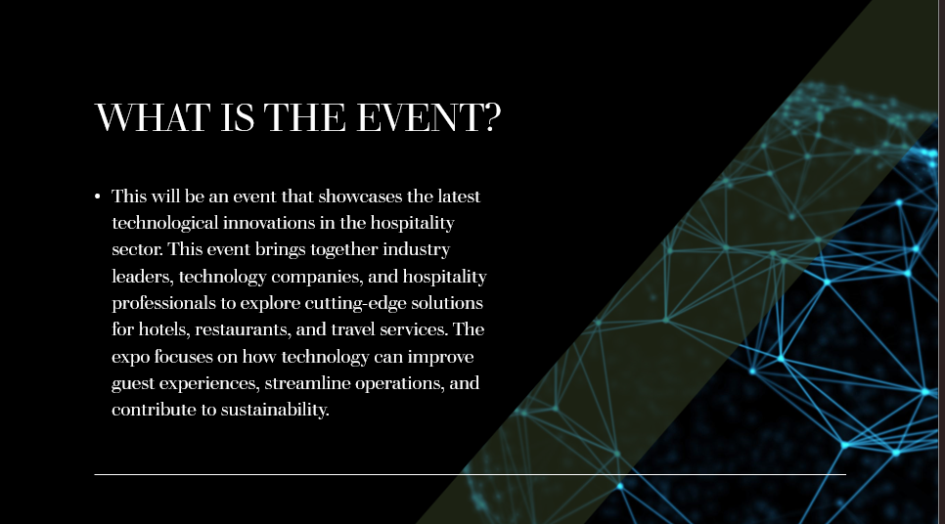

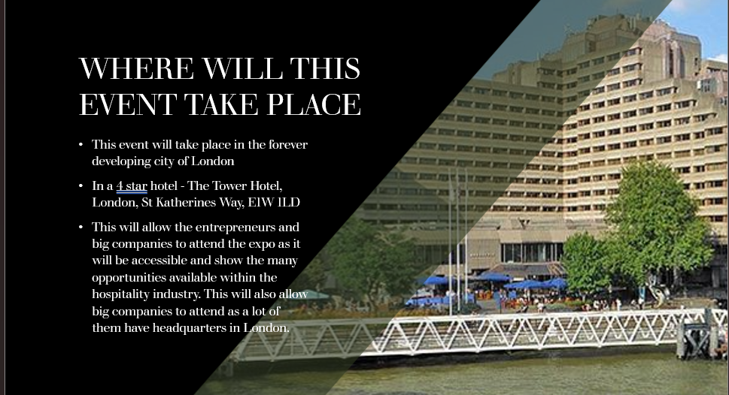

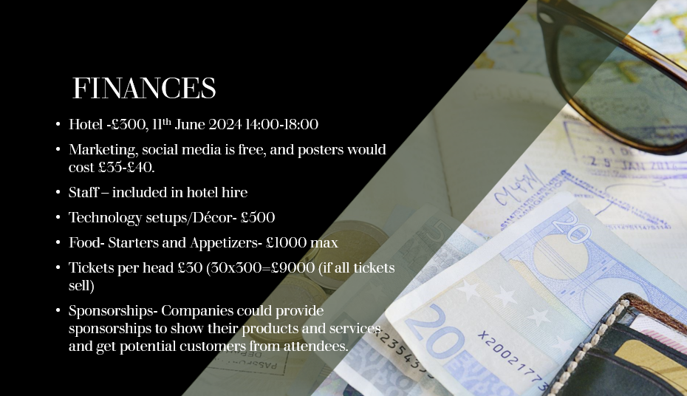

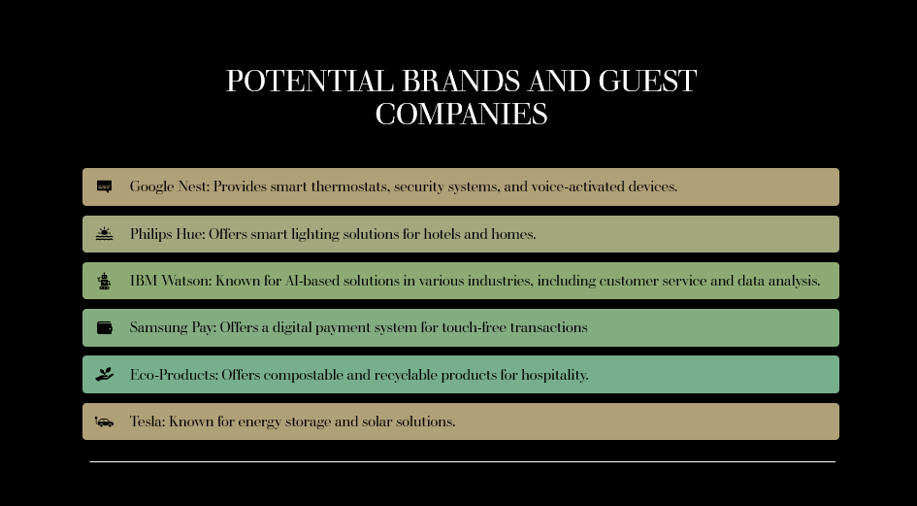

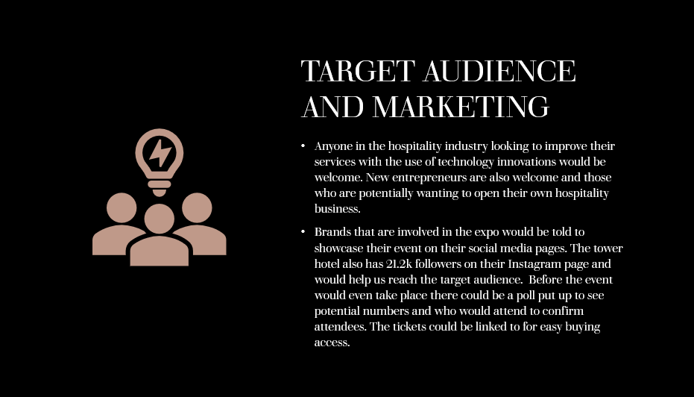

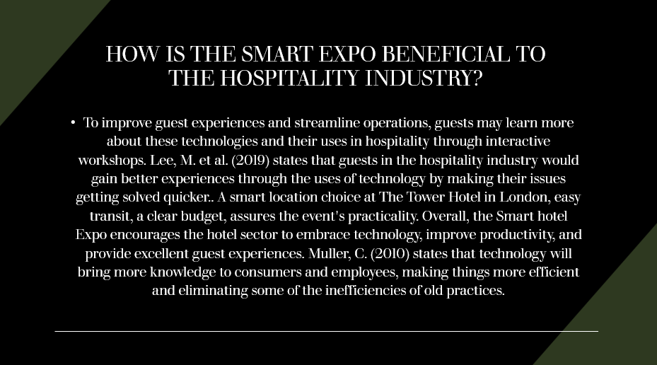

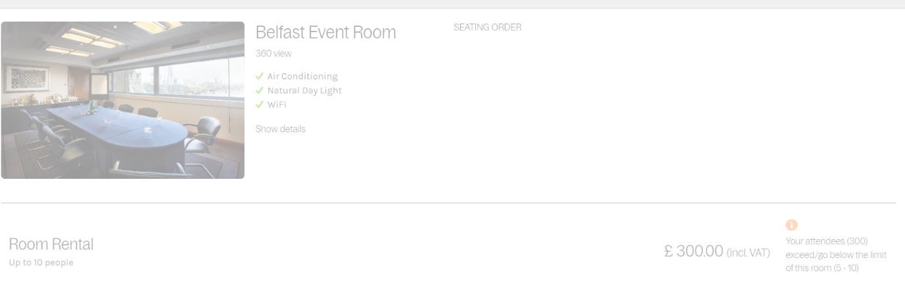
References:

The Tower Hotel (2016) MeetingPackage. Available at: https://meetings.clermonthotel.group/venue/tower-hotel (Accessed: 1 May 2024).
‌
Muller, C. (2010) ‘Hospitality technology: a review and reflection’, Worldwide Hospitality and Tourism Themes. Edited by R.B. DiPietro, 2(1), pp. 9–19. Available at: https://doi.org/10.1108/17554211011012568.
‌
Okumus, F. (2013) ‘Facilitating knowledge management through information technology in hospitality organizations’, Journal of Hospitality and Tourism Technology, 4(1), pp. 64–80. Available at: https://doi.org/10.1108/17579881311302356.

Lee, M. et al. (2019) ‘Integrating technology to service innovation’, Journal of Hospitality and Tourism Technology, ahead-of-print(ahead-of-print). Available at: https://doi.org/10.1108/jhtt-01-2019-0013.

‌

