  “Information Booklet: Chronic Heart Disease - A Guide to Long-Term Management for Health and Care Service Users”
  Programme: | MSc Public Health and Social Care in Practice
  Module: | Community Care and Management for Longer-term Conditions
  Module code: | LCHS7003
  Lecturer: | Dr. MOHAMMED KHAN
  Assignment Title: | Information Booklet of Long-term Condition Management: Chronic Heart Disease
  Student Name: | MD.SAKYF JAWAD
  Student ID: | 2435265

Table of Contents
Introduction 2
Section 1: Understanding Chronic Heart Disease 3
Definition of Chronic Heart Disease 3
Prevalence of Chronic Heart Disease 3
Risk Factors for Chronic Heart Disease 5
Section 2: The Impact of Chronic Heart Disease 6
Evidence-Based Treatments Available Through the NHS 8
Section 3: Theoretical Frameworks for Long-Term Condition Management 10
The NHS and Social Care Long-Term Conditions Model 10
The Chronic Care Model (International Framework) 10
Section 4: Health and Social Care Policy Context 11
Section 5: Recommendations for Improving Person-Centred Care 13
Conclusion 15
References 16

Introduction
Chronic heart disease (CHD) affects millions of people in the United Kingdom and across the world. The booklet is intended to be able to give people with a recently diagnosed heart standard and precise information, as well as those who help them. It includes the nature of the condition, therapies that are provided by the NHS and useful long-term plans of managing health and wellbeing. Learning about the condition is a significant move by the patient to manage his health and live a complete life. This guide will discuss what is chronic heart disease, the ways it can impact a person and his family, the evidence-based therapies used in treating the condition, and support services that are intended to help manage the condition.

Section 1: Understanding Chronic Heart Disease

Definition of Chronic Heart Disease
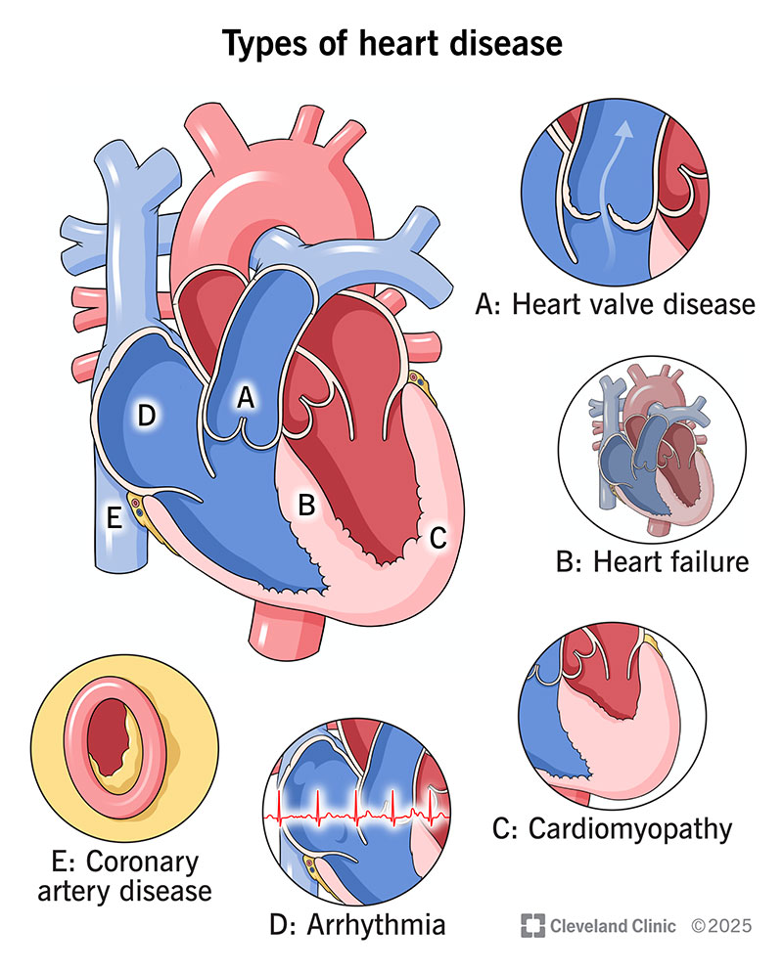
Coronary artery disease (CAD), also chronic heart disease (CHD) is a permanent illness where blood vessels that deliver oxygenated blood to the heart muscle are constrained or obstructed by a deposition of fatty materials referred to as atheroma (Baigent et al., 2021). This constriction limits the blood supply to the heart, which may lead to chest pain (angina), heart attacks and heart failure. Other heart problems such as heart failure (when the heart cannot pump blood properly), arrhythmias (abnormal heart rhythms) and valvular heart disease are also often associated with chronic heart disease (Barker et al., 2018). Symptoms of CHD include:
Stable angina: This is the predominant symptom. Stable angina is a transient chest pain or discomfort that occurs intermittently in a consistent pattern. It is often seen with physical exertion or mental turmoil (Brugts et al., 2023). It subsides with rest or the use of nitro-glycerine, a medication for angina.
Dyspnoea: Certain individuals experience shortness of breath with little physical exertion.

Prevalence of Chronic Heart Disease
Global Perspectives
Source: (Cleveland Clinic, 2022)
CHD is one of the most frequent health causes of mortality worldwide, 9 million deaths in 2021 and 17.8 million deaths due to CHD and stroke in 2019 (Cheema et al., 2022). In 2022, the prevalence of coronary heart disease (CHD) was 315 million cases in the world, and the death rate has been on the rise over the past few years (Gluckman, 2025). The major cause of death across the world is cardiovascular diseases (CVDs) such as heart disease and stroke, which cause about 32% of all deaths in the world, with most of the deaths recorded in low- and middle-income countries (Khan et al., 2023).
- Prevalence: In 2022, there were 315 million prevalent cases of CHD globally. The age-standardized prevalence has decreased by 18% since 1990 (Guleria et al., 2025).
- Geographic variation: Central Europe, Eastern Europe, and Central Asia had the highest age-standardized prevalence of CHD in 2022.
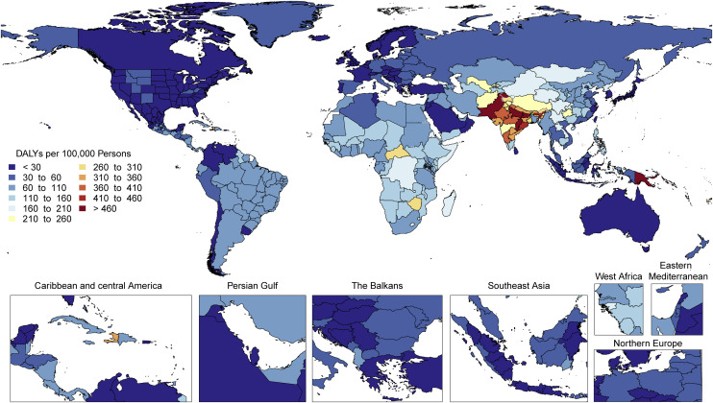
- Global burden: ischemic heart disease (coronary heart disease) accounted for the highest global age-standardized disability-adjusted life-years (DALYs) of all diseases in 2022, at 2,275.9 per 100,000 (NHS, 2024).

United Kingdom Statistics
Coronary heart disease (CHD) is the most prevalent type of heart disease and there are 2.3 million heart disease victims in the UK. CHD causes about 66,000 deaths and results in an annual hospital admission of heart attack in about 100,000 individuals (World Health Organization, 2025). The total population affected by the cardiovascular disease is more at approximately over 7.6 million and it is the number one cause of mortality in the UK, more than 170,000 deaths annually (National Heart, Lung, and Blood Institute, 2022).
- Approximately 2.3 million individuals in the UK are affected by coronary heart disease (CHD), comprising around 1.5 million men and over 800,000 women (NHS, 2023).
- Approximately 66,000 fatalities annually are attributed to coronary heart disease (CHD) (MacKenna et al., 2025).
- Cardiovascular disease, encompassing coronary heart disease, is the predominant cause of mortality in the UK, accounting for approximately 25% of all deaths, or over 170,000 annually (Metra et al., 2023).
Source: (Roth et al., 2020)
- Approximately 100,000 hospital admissions annually result from heart attacks, equating to one admission every five minutes.

Risk Factors for Chronic Heart Disease
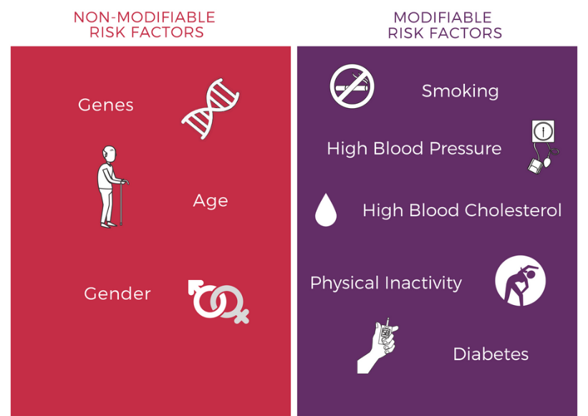
As prevention is a key to the prevention of chronic heart disease, it is vital to know what risk factors help predict the presence of the condition and also how to manage it once diagnosed. Risk factors are further categorized into two (non-modifiable factors or those factors that you cannot alter) and modifiable factors (those factors that can be altered by a change in lifestyle or medical care).

Non-Modifiable Risk Factors
- Age and sex: Risk increases with age, and men typically develop heart disease at an earlier age than women (Meyers and Goodlin, 2016). However, post-menopausal women's risk increases substantially.
- Family history and genetics: Having a family member with heart disease increases your risk.
- Ethnicity: People of South Asian, African, and Caribbean descent face higher cardiovascular risk.
Modifiable Risk Factors
The World Health Organization and cardiovascular health research have identified the following modifiable risk factors as the most important:
- High blood pressure (hypertension): Elevated blood pressure is the leading global risk factor for cardiovascular disease, contributing to 10.8 million deaths in 2019 (Kalra et al., 2022).
Source:(DrMahadevanRamachandran, 2018)
- Smoking: Tobacco use remains a major modifiable risk factor, affecting approximately 35% of populations studied (Gopinathannair et al., 2021).
- Diabetes mellitus: People with diabetes have significantly elevated cardiovascular risk.
- Obesity and overweight: Excess weight contribute to hypertension, high cholesterol, and diabetes.
- Physical inactivity: Sedentary behaviour is a key risk factor for heart disease development and progression.
- Unhealthy diet: Diets high in salt, saturated fats, and low in fruits and vegetables increase risk.
- Excessive alcohol consumption: Harmful alcohol use damages the cardiovascular system.
- Chronic stress and poor mental health: Psychological stress can increase heart disease risk and worsen outcomes (Elsworth, 2011).
- Air pollution: Environmental air quality significantly impacts cardiovascular health.

Section 2: The Impact of Chronic Heart Disease

- Physical Health Impact: Chronic heart disease poses great physical restrictions, which impact on quality of life and daily operations. The condition manifests a variety of debilitating symptoms such as chest pain or discomfort (angina), dyspnoea, fatigue, palpitations, and swelling of the legs and ankles. Heart failure is accompanied by a constant feeling of fatigue that limits the capacity to engage in normal activities; about 75% of heart failure patients complain of having difficulty in carrying out their daily activities (Dufour et al., 2023). Heart disease in old age may significantly influence life. Approximately 180 people die of CHD every day in the UK which is equal to thousands of heart attacks each year (Cleveland Clinic, 2022). The survivors usually require constant medication, observation and repetitive procedures. Heart failure or stroke is also an additional disability caused by CHD.
- Psychological and Emotional Impact: It has a strong psychological influence. Heart disease patients have a lot of anxiety, depression and fear of recurrent attacks. A survey carried out in the UK indicated that more than half of the heart disease patients felt anxious or depressed about their disease (Carmin et al., 2024). Depression and anxiety are cardiac conditions, which are more prevalent among heart disease patients than in the general population. Approximately one-third of working-age adults with CHD were diagnosed with an anxiety or depression compared with 30% a decade ago (Centers for Disease Control and Prevention, 2024). Health concerns, as well as the burden of medication and lifestyle management, tend to be emotionally taxing. The impact of the mental illnesses after the cardiac events is especially acute. The acute cardiac events like heart attacks may lead to anxiety, depression, and post-traumatic stress disorder, and these disorders have significant outcomes on recovery and long-term cardiac outcomes.
- Social and Family Impact: CHD may restrict work, social and family life socially. Financial strain and social isolation-treatment, loss of income, lifestyle changes (e.g., abandoning activities or changing a diet) may cause financial strains (Roth et al., 2020). Lack of support is often reported by many patients: one study has found that heart patients have named perceived financial strain and lack of social support as key challenges. The effects of chronic heart disease are far-reaching that only to the individual patient; it spreads to the families and the wider social network. People who play the role of informal carers are usually family members and friends and they offer essential but unpaid care support. These caregivers administer complicated medical programs, make dietary changes (sodium restriction), transport, aid in medication management, and offer both practical and emotional aid (Strauss, Hall and Narkiewicz, 2021).

Evidence-Based Treatments Available Through the NHS

The NHS provides comprehensive evidence-based treatments for coronary heart disease (CHD) management. Management of coronary heart disease (CHD) may alleviate symptoms and reduce the likelihood of further complications. Coronary heart disease may be successfully controlled with a combination of lifestyle modifications, pharmacotherapy, and, in some instances, surgical intervention (Surrey, 2025). Appropriate therapy may alleviate the symptoms of CHD and enhance cardiac function.
Lifestyle and Self-Care
Lifestyle changes and self-management are always the beginning of the treatment. NHS doctors recommend to patients to stop smoking, follow a heart-healthy diet (abundant in fruits, vegetables, whole grains and oily fish), maintain normal weight, restrict alcohol consumption and exercise. A Mediterranean diet (high amounts of vegetables, low-fat and fat proteins, and health-promoting fats) is frequently used (Welch, 2023). Exercising (e.g., 20-30 minutes a day of walking) may make the heart healthier and control weight and blood pressure. Cardiac rehabilitation programs involving led exercises, heart education and support are highly urged to the patients. According to NICE (2025), guidelines, cardiac rehab must commence prior to the patient leaving hospital and follow-up rehab sessions incorporating exercise, stress management and lifestyle education.
Medicines
A range of pharmaceuticals is used to treat CHD. They generally aim to reduce blood pressure, expand arteries, or prevent blood clot formation.
- Blood-thinning medicines: Blood thinners are a class of medications that diminish the likelihood of a myocardial infarction by reducing blood viscosity and inhibiting coagulation (NHS, 2024). Common blood-thinning medicines include:
- Statins: Individuals with elevated cholesterol levels may be offered statins, a class of cholesterol-lowering medications (NHS, 2023). However, additional statins include:
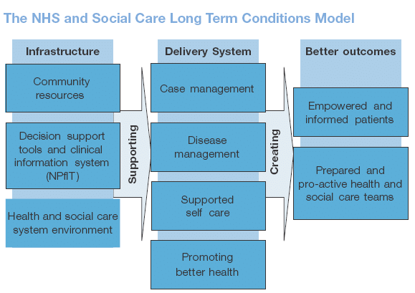
- Beta blockers: Beta blockers, such as atenolol, bisoprolol, metoprolol, and nebivolol, are often used to manage angina and hypertension.
- Angiotensin-converting enzyme (ACE) inhibitors: ACE inhibitors are often used to manage hypertension. Examples include ramipril and lisinopril. They decrease the levels of a hormone known as angiotensin-2, which induces vasoconstriction (NHS, 2020).
Source: (Elsworth, 2011)
Procedures and surgery
Should the blood vessels be constricted due to atheroma accumulation or if your symptoms remain unmanageable with pharmacological treatment, interventional treatments or surgical intervention may be required to restore patency or circumvent occluded arteries (NHS, 2023).

Section 3: Theoretical Frameworks for Long-Term Condition Management

The NHS and Social Care Long-Term Conditions Model
The NHS and Social Care Long-Term Conditions Model, which was launched in 2005 and improved by the further policy development offers a complex approach to the management of any chronic disease such as heart disease (Ogunbayo et al., 2017). This model is structured around the support of people based on their needs where risk stratification is used to determine patients who need various levels of support.
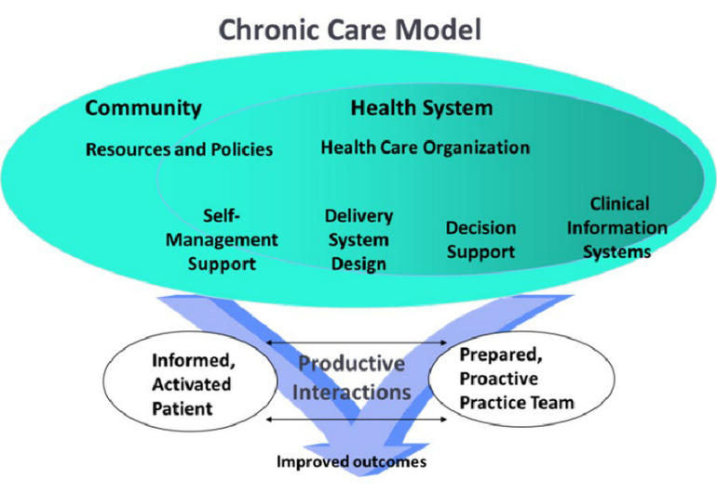
The model is based on a three-level intervention: patients at low risk get information and self-management support; patients at moderate risk get disease management support; and patients at high risk get case management. In the case of chronic heart disease, it includes frequent observation, medical treatment optimization, follow-up organization, and access to special services when necessary (Valentín Fuster and Kelly, 2010).
The model focuses on systematic assistance to patients to self-care their condition with the assistance of collaborative care planning, goal setting, and access to self-management support programmes (Ogunbayo et al., 2017). Community matrons with nurse specialists are an important part of the model as they collaborate with complex patients with various long-term conditions, create personal care plans, avoid hospitalization, and communicate care across various services.

The Chronic Care Model (International Framework)
One international model that can be used to complement the NHS model is the Chronic Care Model created by Ed Wagner and others at the MacColl Center of Health Care Innovation (Gee et al., 2015). The CCM is composed of 6 major elements:
Source: (Gee et al., 2015)
- Self-Management Support: A patient should be educated about his/her condition and assisted to manage it in order to encourage active participation and engagement during and after medical visits, as well as to empower (Grudniewicz et al., 2023). This is through joint care planning, goal setting, and linking patients with peer support groups and resources.
- Delivery System Design: Defining roles and responsibilities of the members of healthcare team and scheduling the work and frequent follow-ups to deliver not emergency but planned care to patients.
- Decision Support: The application of the existing, evidence-based guidelines, as well as the consideration of the preferences of a particular patient so that the decisions about the treatment process are patient-centred and informed by the best available evidence (Ogunbayo et al., 2017).
- The Clinical Information Systems: Installing systems (such as electronic health records) enabling the monitoring of the state of patients, their medications, assessments, and treatment plan, allowing communication between and among the healthcare system (Barker et al., 2018).
- Organization of Healthcare: Developing quality-based healthcare organizations that have a robust clinical leadership dedicated to enhancing chronic care management and prevention (Baigent et al., 2021).
- Community Resources: Collaborating with local agencies, non-profit agencies, and community groups to bridge the gap in care and social and emotional wellbeing of patients.

Section 4: Health and Social Care Policy Context
National and local health policies in the UK actively shape heart disease care:
NHS Long Term Plan (2019): One of the priorities is cardiovascular disease. The plan had a vision of eliminating 150,000 heart attacks, strokes and cases of dementia by 2029 (Welch, 2023). It invests money and initiatives to enhance the diagnosis and management of high-risk conditions (the ABCs atrial fibrillation, blood pressure, cholesterol). Early detection and prevention the plan and the NHS England documents focus on early detection and prevention: such initiatives as the NHS Health Check program, CVD prevention audits (CVD Prevent), genetic testing of familial cholesterol problems, and broader public health campaigns. NHS England also designed local heart health leadership positions in each of its Integrated Care Systems (ICS) by 2024-2025 in order to align national heart health initiatives (NHS, 2023).
Inequalities and Prevention Strategy: NHS England and Public Health England developed the agenda of Health Matters: Preventing CVD. It points out that despite the decrease in CVD mortality, the gains have stopped and disparities are still big. Indicatively, in the most deprived locations in England, the likelihood of dying prematurely of CVD is almost 4 times as compared to the least deprived locations (World population review, 2023). This has changed national guidance that now clearly associates CHD care with social determinants. Some of the strategies are reduction of salt/sugar in food, control of tobacco, and widening community health checks in underserved communities.
National Guidelines and Standards: NICE (2025), generates guidelines and quality standards of heart disease and its risk factors (e.g., hypertension, diabetes, heart failure). The GPs are motivated (through QOF) to achieve the blood-pressure, cholesterol, and drug goals among CHD patients. The NHS Care Act 2014 and other requirements promote the integration of health and social care.
Local Initiatives: Practically, community programs are implemented by the local NHS bodies (ICBs/ICSs) and councils. Heart disease prevention activities such as community blood pressure screening, pharmacy check-ups on heart risk and patient education workshops are common in many areas. ICSs are starting to incorporate CVD prevention within local initiatives, although it is reported to have difficulties (workforce, data exchange) and requires increased national reinforcement (NHS, 2024).

Section 5: Recommendations for Improving Person-Centred Care
To improve chronic heart disease care, a person-centred approach is essential. This means:
- Shared Care Planning: Patients should participate in care decisions. Quality standards recommend heart disease patients set goals and create a written care plan with their healthcare team (Carmin et al., 2024). The care plan can include medical treatment, symptom monitoring, lifestyle goals, and social support (World Health Organization, 2025). It should address clinical targets and patient priorities like attending family events or travelling safely. Setting goals with patients and families improves adherence and satisfaction.
- Support for Self-Management: Health services should help patients manage heart disease daily. This includes angina/heart failure awareness, diet/exercise advice, medication reminders, and when to seek help. Patients can be empowered by structured education or digital tools like blood pressure logging apps or medication trackers (Cheema et al., 2022). NICE and heart charities encourage self-management. For instance, cardiac rehabilitation teaches self-care. One-on-one coaching and group programs help people learn and share. Easy access to information (leaflets, online videos) and timely follow-up (nurse calls) helps patients follow treatment plans.
- End-of-Life Care: Medical treatment and palliative care should be considered for severe heart failure. End-of-life and palliative care should be included in care plans. Controlling breathlessness and pain, providing psychological and spiritual support, and discussing advance care directives may be needed (Centers for Disease Control and Prevention, 2024). Later-stage patients can be comforted and respected by integrating cardiology and palliative teams.
- Whole-Person Care: Guidelines emphasise looking beyond heart symptoms. Because many patients have multiple conditions, holistic care should address mental health, mobility, nutrition, and social needs (Dufour et al., 2023). Collaboration with social care (home support, transport) and voluntary services (befriending, exercise groups) improves outcomes (Carmin et al., 2024). Helping a patient get home adaptations or joining a walking club promotes independence and well-being.

Conclusion
Chronic heart disease is mostly prevalent and severe and yet effective management can significantly enhance quality of life and life expectancy. Many of the complications and heart attacks are now preventable through advances in treatment and concerted preventive efforts. To patients and families, it is very important to understand the disease, manage the risk factors and adhere to medical recommendations. The NHS offers a broad array of interventions that include medications and surgery, rehabilitation and community programs all of which seek to assist people to live as best possible with heart disease. Keep in mind that the treatment of heart disease is a collaboration: with physicians, nurses and relatives. Always consult assistance in case of disturbing symptoms (pain in the chest, dyspnoea, or new fatigue). Request a clear care plan and self-care advice to your care team. Appeal to the available resources: cardiac rehab, support groups, credible websites, and easy-to-use resources (blood pressure cuffs, apps).

References
- Baigent, C., Windecker, S., Andreini, D., Arbelo, E., Barbato, E., Bartorelli, A.L., Baumbach, A., Behr, E.R., Berti, S., Bueno, H., Capodanno, D., Cappato, R., Chieffo, A., Collet, J.-P., Cuisset, T., de Simone, G., Delgado, V., Dendale, P., Dudek, D. and Edvardsen, T. (2021). European Society of Cardiology guidance for the diagnosis and management of cardiovascular disease during the COVID-19 pandemic: part 1—epidemiology, pathophysiology, and diagnosis. Cardiovascular Research, [online] 118(6), pp.1385–1412. doi: https://doi.org/10.1093/cvr/cvab342.
- Barker, I., Steventon, A., Williamson, R. and Deeny, S.R. (2018). Self-management Capability in Patients with Long-term Conditions Is Associated with Reduced Healthcare Utilisation across a Whole Health Economy: Cross-sectional Analysis of Electronic Health Records. BMJ Quality & Safety, [online] 27(12), pp.989–999. doi: https://doi.org/10.1136/bmjqs-2017-007635.
- Brugts, J.J., Radhoe, S.P., Pascal R.D. Clephas, Aydin, D., W.F, M., Szymanski, M.K., Rienstra, M., van, Fonseca, C., Gerard C.M. Linssen, Willem, J., Boersma, E., Asselbergs, F.W., Arend Mosterd, Hans‐Peter Brunner‐La Rocca, Rudolf, Emans, M.E., Saskia L.M.A. Beeres, Loek van Heerebeek and Kirchhof, C. (2023). Remote haemodynamic monitoring of pulmonary artery pressures in patients with chronic heart failure (MONITOR-HF): a randomised clinical trial. The Lancet, 401(10394), pp.2113–2123. doi: https://doi.org/10.1016/s0140-6736(23)00923-6.
- Carmin, C.N., Ownby, R.L., Fontanella, C., Steelesmith, D. and Binkley, P.F. (2024). Impact of Mental Health Treatment on Outcomes in Patients With Heart Failure and Ischemic Heart Disease. Journal of the American Heart Association, 13(7). doi: https://doi.org/10.1161/jaha.123.031117.
- Centers for Disease Control and Prevention (2024). About Heart Disease and Mental Health. [online] Heart Disease. Available at: https://www.cdc.gov/heart-disease/about/about-heart-disease-and-mental-health.html.
- Cheema, K.M., Dicks, E., Pearson, J. and Samani, N.J. (2022). Long-term Trends in the Epidemiology of Cardiovascular Diseases in the UK: Insights from the British Heart Foundation Statistical Compendium. Cardiovascular Research, [online] 118(10). doi: https://doi.org/10.1093/cvr/cvac053.
- Cleveland Clinic (2022). Heart Disease: Symptoms, Risk Factors & Treatment. [online] Cleveland Clinic. Available at: https://my.clevelandclinic.org/health/diseases/24129-heart-disease.
- DrMahadevanRamachandran (2018). RISK FACTORS OF HAVING A HEART DISEASE. [online] Total Cardiac Care. Available at: https://www.totalcardiaccare.com/risk-factors-heart-disease-2/.
- Dufour, E., Bolduc, J., Leclerc-Loiselle, J., Charette, M., Dufour, I., Roy, D., Poirier, A.-A. and Duhoux, A. (2023). Examining nursing processes in primary care settings using the Chronic Care Model: an umbrella review. BMC primary care, [online] 24(1), p.176. doi: https://doi.org/10.1186/s12875-023-02089-3.
- Elsworth, C. (2011). Community mobility and physical activity participation in individuals with mulitple sclerosis. University of Birmingham Institutional Research Archive (University of Birmingham).
- Gee, P.M., Greenwood, D.A., Paterniti, D.A., Ward, D. and Miller, L.M.S. (2015). The eHealth Enhanced Chronic Care Model: a theory derivation approach. Journal of Medical Internet Research, [online] 17(4), p.e86. doi: https://doi.org/10.2196/jmir.4067.
- Gluckman, T. (2025). Epidemiology and Risk Factors of Cardiovascular Disease. [online] Managedhealthcareexecutive.com. Available at: https://www.managedhealthcareexecutive.com/view/epidemiology-and-risk-factors-of-cardiovascular-disease
- Gopinathannair, R., Chen, L.Y., Chung, M.K., Cornwell, W.K., Furie, K.L., Lakkireddy, D.R., Marrouche, N.F., Natale, A., Olshansky, B. and Joglar, J.A. (2021). Managing Atrial Fibrillation in Patients With Heart Failure and Reduced Ejection Fraction: A Scientific Statement From the American Heart Association. Circulation: Arrhythmia and Electrophysiology, 14(7). doi: https://doi.org/10.1161/hae.0000000000000078.
- Grudniewicz, A., Gray, C.S., Boeckxstaens, P., Maeseneer, J.D. and Mold, J.W. (2023). Operationalizing the Chronic Care Model with Goal-Oriented Care. The Patient: Patient-Centered Outcomes Research, 16(6), pp.569–578. doi: https://doi.org/10.1007/s40271-023-00645-8.
- Guleria, R., Singh, A., Majmudar, H.P., Ang, Z.Y. and Awasthi, P. (2025). Evidence-Based Management of Heart Failure: Clinical Impact and National Health Service Implications. Cureus. [online] doi: https://doi.org/10.7759/cureus.92735.
- Kalra, P.R., John G.F. Cleland, Petrie, M.C., Ahmed, F., Foley, P., Kalra, P.A., Lang, N.N., Lane, R., Macdougall, I.C., Pierpaolo Pellicori, Pope, M., Robertson, M., Squire, I.B., Thomson, E. and Ford, I. (2022). Rationale and design of a randomised trial of intravenous iron in patients with heart failure. 108(24), pp.1979–1985. doi: https://doi.org/10.1136/heartjnl-2022-321304.
- Khan, N., Chalitsios, C.V., Nartey, Y., Simpson, G., Zaccardi, F., Santer, M., Roderick, P., Stuart, B., Farmer, A. and Hajira Dambha-Miller (2023). Clustering by Multiple Long-Term Conditions and Social Care Needs: A cohort study amongst 10,025 older adults in England. doi: https://doi.org/10.1101/2023.05.18.23290064.
- MacKenna, B., Brown, A.D., Croker, R., Walker, A.J., Goldacre, B., Tsiachristas, A., Evans, D., Inglesby, P., Bacon, S.CJ. and Curtis, H.J. (2025). Variation in prescription duration for long term conditions: a cohort study in English NHS primary care using OpenPrescribing. British Journal of General Practice, [online] p.BJGP.2024.0326. doi: https://doi.org/10.3399/bjgp.2024.0326.
- Metra, M., Tomasoni, D., Adamo, M., Bayes‐Genis, A., Filippatos, G., Abdelhamid, M., Adamopoulos, S., Anker, S.D., Antohi, L., Böhm, M., Braunschweig, F., Gal, T.B., Butler, J., Cleland, J.G.F., Cohen‐Solal, A., Damman, K., Gustafsson, F., Hill, L., Jankowska, E. and Lainscak, M. (2023). Worsening of chronic heart failure: definition, epidemiology, management and prevention. A clinical consensus statement by the Heart Failure Association ( HFA ) of the ESC. European Journal of Heart Failure, 25(6). doi: https://doi.org/10.1002/ejhf.2874.
- Meyers, D.E. and Goodlin, S.J. (2016). End-of-Life Decisions and Palliative Care in Advanced Heart Failure. Canadian Journal of Cardiology, 32(9), pp.1148–1156. doi: https://doi.org/10.1016/j.cjca.2016.04.015.
- National Heart, Lung, and Blood Institute (2022). Coronary Heart Disease - Treatment. [online] www.nhlbi.nih.gov. Available at: https://www.nhlbi.nih.gov/health/coronary-heart-disease/treatment.

- NHS (2020). Treatment - Coronary heart disease. [online] NHS. Available at: https://www.nhs.uk/conditions/coronary-heart-disease/treatment/.
- NHS (2023). NHS England» Addressing palliative and end of life care needs for people living with heart failure: a revised framework for integrated care systems. [online] www.england.nhs.uk. Available at: https://www.england.nhs.uk/long-read/addressing-palliative-and-end-of-life-care-needs-for-people-living-with-heart-failure/.
- NHS (2024). NHS England» Cardiovascular disease high impact interventions . [online] www.england.nhs.uk. Available at: https://www.england.nhs.uk/ourwork/prevention/secondary-prevention/cardiovascular-disease-high-impact-interventions/.
- NICE (2025). Quality statement 3: Medication for newly diagnosed and pre-existing chronic heart failure with reduced ejection fraction | Chronic heart failure in adults | Quality standards | NICE. [online] Nice.org.uk. Available at: https://www.nice.org.uk/guidance/qs9/chapter/Quality-statement-3-Medication-for-newly-diagnosed-and-pre-existing-chronic-heart-failure-with-reduced-ejection-fraction.
- Ogunbayo, O.J., Schafheutle, E.I., Cutts, C. and Noyce, P.R. (2017). Self-care of long-term conditions: patients’ perspectives and their (limited) use of community pharmacies. International Journal of Clinical Pharmacy, 39(2), pp.433–442. doi: https://doi.org/10.1007/s11096-016-0418-y.
- Roth, G.A., Mensah, G.A., Johnson, C.O., Addolorato, G., Ammirati, E., Baddour, L.M., Barengo, N.C., Beaton, A.Z., Benjamin, E.J., Benziger, C.P., Bonny, A., Brauer, M., Brodmann, M., Cahill, T.J., Carapetis, J., Catapano, A.L., Chugh, S.S., Cooper, L.T., Coresh, J. and Criqui, M. (2020). Global Burden of Cardiovascular Diseases and Risk Factors, 1990-2019: Update From the GBD 2019 Study. Journal of the American College of Cardiology, [online] 76(25), pp.2982–3021. Available at: https://www.sciencedirect.com/science/article/pii/S0735109720377755.
- Strauss, M.H., Hall, A.S. and Narkiewicz, K. (2021). The combination of beta-blockers and ACE inhibitors across the spectrum of cardiovascular diseases. Cardiovascular Drugs and Therapy, 37(4), pp.757–770. doi: https://doi.org/10.1007/s10557-021-07248-1.
- Surrey (2025). Community Matrons. [online] Surrey Downs Health and Care. Available at: https://surreydownshealthandcare.nhs.uk/community-matrons/ [Accessed 9 Nov. 2025].
- Valentín Fuster and Kelly, B.B. (2010). Epidemiology of Cardiovascular Disease. [online] Nih.gov. Available at: https://www.ncbi.nlm.nih.gov/books/NBK45688/.
- Welch, L. (2023). Caring for people with long-term conditions and multimorbidity. Foundations for 21st-Century Health and Social Care, pp.138–155. doi: https://doi.org/10.4324/9781003198338-11.
- World Health Organization (2025). Cardiovascular diseases (CVDs). [online] World Health Organization . Available at: https://www.who.int/news-room/fact-sheets/detail/cardiovascular-diseases-(cvds).
- World population review (2023). Heart Disease Rates by Country 2022. [online] worldpopulationreview.com. Available at: https://worldpopulationreview.com/country-rankings/heart-disease-rates-by-country.

