BA International Hotel Management

Module Code: BMIH6002
Module Title: Managing Food and Beverage Operations

Placement Hotel: Mercure Sheffield Kenwood Hall and Spa, Kenwood Road, Nether Edge, Sheffield, UK.

Lecturer Name: Neil Dyer
Student Name: Khaled Chowdhury
Student ID Number:2112453

Table of Contents
Introduction 3
A brief overview of the hotel's Food and beverage operation 4
Section 1: Reflection on Experience and Personal Development 4
Section 2: Critical Analysis of Work-Based Skills and Technical Knowledge 4
Section 3: Reflection on Organisational Issues 4
Section 4: Future Action Plan 5
Conclusion 5
References 5

Introduction
My learning log will focus on my hotel placement experiences as waiter of Managing Food and Beverage Operations. My most important responsibilities as a waiter at a resort are to welcome and take orders from customers, serve food and drink, and make sure they're relaxed. A tough situation these days got here up when a customer complained about their meals considering they needed to wait a long term. The traveller wasn't comfortable even after I attempted to apologize and offer picks, and matters became worse, which led to awful opinions from both the guest and the management.

A brief overview of the hotel's Food and beverage operation
The hotel placement working experiences as a waiter was really fantastic for me. My placement was Mercure Sheffield Kenwood Hall and Spa, Kenwood Road, Nether Edge, Sheffield. UK. It is the kitchen that produces the tasty meals that entice customers to return time and time again. It is also the engine room that keeps everything functioning efficiently. For any hotel, a well-kept kitchen is a must, and when planning or redesigning kitchen space, there are a few important considerations to remember (O'Shannessy and Minett, 2017)
I need to consider that the kitchen's layout should be planned with efficiency in mind. To save travel time and increase efficiency, all of the important stations should be easily accessible from one another. I have observed that in a hotel kitchen, the prep area, the sink, and the stove are the most crucial areas (Hagg, 2013). The storage space, the walk-in fridge, and the dishwashing area are other important stations. I am well knowledgeable about food safety regulations and hygiene standards. In addition, I know a variety of cooking methods and styles. I successfully plan and execute menu items using this information. I may instruct other kitchen employees in similar methods and practices as well (Clavé, 2017)
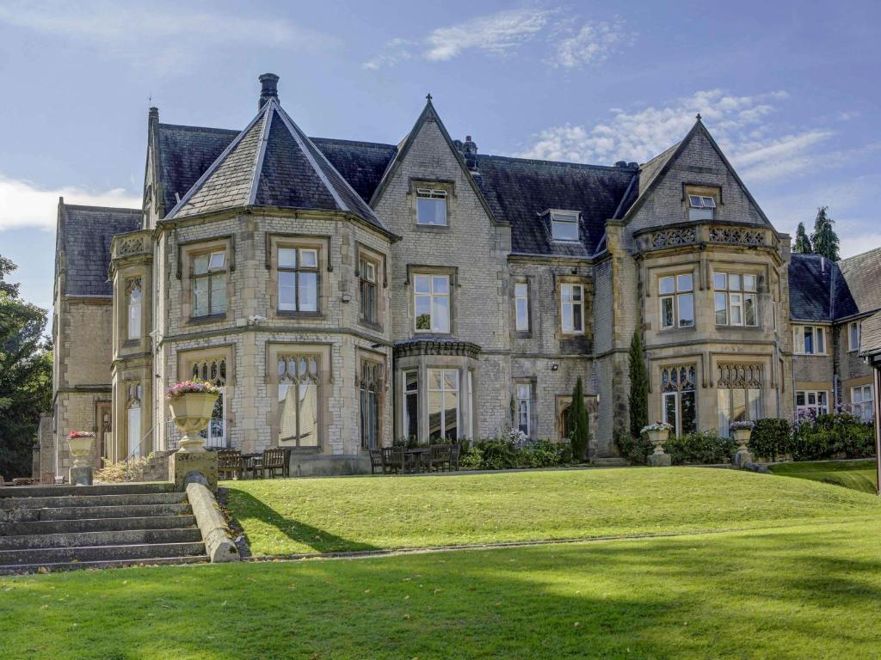
Figure: Mercure Sheffield Kenwood Hall and Spa (Farrell, 2016)

Section 1: Reflection on Experience and Personal Development
I have observed that the circumstance made me feel irritated and ashamed. I take awesome delight in supplying superior customer service; consequently it was once disappointing to meet a disgruntled customer (Hagg, 2013). I likewise felt helpless, now not knowing the way to manage the scenario skilfully and maintain the traveller’s enjoy intact. I used to be also left feeling demotivated and doubting my capabilities as a server after listening to complaint from the traveller as well as the control. (Tewari and Tewari, 2019)
My communication skills, both in writing and speaking, are excellent. Speaking with me is simple for both customers and other kitchen staff members. In addition, I feel at ease resolving client complaints and settling disputes in a formal way. It's generally a good idea to separate raw poultry and shellfish from cooked dishes with wash all kitchenware and cutting boards thoroughly in hot water after each use. (Triantafillidou, 2016)
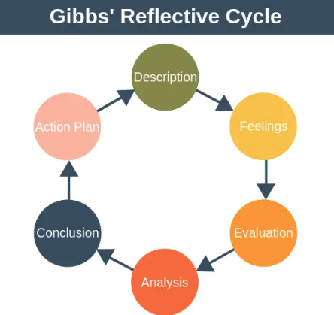
Figure: Gibbs (Singh and Chaudhary, 2018)

Section 2: Critical Analysis of Work-Based Skills and Technical Knowledge
After some thinking, I see that a number of factors had a component in this example's adverse conclusion. I had no affect over the prolonged wait time for the guest's dinner; it used to be the outcome of immoderate demand causing delays in the kitchen (Hagg, 2013). I renowned, but, that by giving common updates on the development in their order and suggesting selections to lessen the annoyance, I may additionally have higher managed the guest's expectations. In addition, I admit that I have to have treated the guest's troubles with more poise and composure rather than by using turning into defensive or disillusioned (Dawson, 2017)
I need to consider that most hotels provide a breakfast buffet that is open to visitors. This might include things like bacon, toast, oatmeal, eggs, muffins, fruit, and so forth. Pizza, spaghetti, salads, burgers, sandwiches, and salads are typical lunch and dinner choices; however they may differ based on the hotel. I need to consider that In addition, a lot of hotels have a bar or lounge where visitors may purchase beverages. (Singh and Chaudhary, 2018)

Section 3: Reflection on Organisational Issues
I have experienced that a lot of travellers forget how important it is to choose the proper drinks while making hotel reservations. But the whole experience may often be made or broken by the calibre of a hotel's beverage selection. For example, if a hotel only serves inexpensive, mass-produced beer, its visitors are likely to be dissatisfied. I have experienced that However, a hotel that puts time and effort into curating a list of regional specialty brews is likely to get positive reviews from customers. For other drinks, the same idea holds true (Triantafillidou, 2016)
I have learned that when it comes to coffee, a hotel with an excellent espresso machine is more likely to appeal to travellers who value than one that delivers inferior coffee. I need to consider that in summary, the selection of drinks for hotel guests must to always be based on quality. In hotel kitchens, food is produced and served to visitors. I belief that Maintaining a high level of hygiene and cleanliness is necessary to prevent foodborne diseases- There are several approaches to guarantee a sanitary and spotless kitchen (Tewari and Tewari, 2019)

Section 4: Future Action Plan
Action Plan
What do I want to learn? | What do I have to do? | What support and resources will I need? | How will I measure success? | Date
Communication  skills verbal and  written | I want to improve my Communication  skills verbal and  written (Farrell, 2016) | In addition to culinary skills, I have completed courses in food safety and sanitation. I'm always up for trying new things and taking on more duties (Fallon and Rutherford, 2010) |  | Within 6 months
Teamwork and  networking | I want to improve my Teamwork and  Networking (Clavé, 2017) | I have good time management and task prioritization skills. I ensure that every assignment is finished in accordance with the specified rules since I am a well-organized and efficient worker (ASET, 2017) | Additionally, I can adjust to changes in the kitchen and deal with unforeseen circumstances that may come up | Within 12  months
Time and self-  management | I want to improve my Time and self-  Management (O'Shannessy and Minett, 2017) | I am a lifelong student who is always looking to increase the amount of information that I possess (Hagg, 2013). | Additionally, when necessary, I can work alone and take the initiative (Powers and Barrows, 2017) | Within 6 months
Problem-  solving skills | I want to improve my Problem-  solving skills | When an issue in the kitchen arises, I take the initiative to fix it. I have the quick thinking to solve problems in novel ways (Boone, 2016) | Additionally, I feel at ease interacting with other kitchen staff members to address any concerns (ASET, 2017) | Within 8 months

Conclusion
I have learned that the table surfaces should all be regularly cleaned. I have experienced that Cutting boards, appliances, cutlery, and surfaces are all included in this. I have learned that the areas used for preparing food have to be kept apart from spaces used for storing or disposing of trash.

References
ASET (2017) Good Practice Guide for Work-based and Placement Learning in Higher Education, ASET, Sheffield
Boone, J. (2016). Contemporary Marketing. Cengage Learning.
Clavé, S. A. (2017). The Routledge Handbook of Gastronomic Tourism. Routledge.
Dawson, C. (2017). Introduction to Research Methods: A Practical Guide for Anyone Undertaking a Research Project. Little, Brown Book Group.
Denney, D. R., and Testa, M. R. (2019). Sustainability in the Hospitality Industry: Principles of Sustainable Operations. Routledge.
Fallon, M.& Rutherford, D. (2010) Hotel Management and Operations, Wiley, London.
Farrell, J. (2016). Restaurant Operations Management: Principles and Practices. Pearson.
Hagg, E (2013) Internship Guide Eleven, The Hague
O'Shannessy, V., and Minett, D. (2017). Food and Beverage Service (2nd ed.). Cengage Learning.
Powers, T., and Barrows, C. W. (2017). Introduction to Management in the Hospitality Industry. John Wiley and Sons.
Singh, R., and Chaudhary, R. K. (2018). Food and Beverage Management. McGraw-Hill Education.
Tewari, J., and Tewari, N. (2019). The Business of Tourism Management. SAGE Publications India.
Triantafillidou, A. (2016). Cultural Tourism and Business Management. Routledge.

