Qualification: CIPD Diploma in Applied Human Resources

Module Name: Developing Professional Practice

Word Count:
Activity 1 (850)
Activity 2 (1074)
Activity 3 (1179)
Activity 4 (1078)
Activity 5 (869)
TOTAL = 5050

Student Name: Laura Walters
Student Number: 2005785
CIPD Membership Number: 57493192

By signing below, I confirm that the work/evidence presented is my own, unaided work. I understand the regulations pertaining to candidate malpractice and the action that may be taken as a result.

Signed: L. Walters
Date: 24/12/2020

CONTENTS

ACTIVITY 1 5
ACTIVITY 1 - EVIDENCE 7
ACTIVITY 2 16
REFERENCE LIST 18
BIBLIOGRAPHY 18
ACTIVITY 3 20
ACTIVITY 3 - EVIDENCE 22
REFERENCE LIST 25
BIBLIOGRAPHY 25
ACTIVITY 4 26
REFERENCE LIST 28
BIBLIOGRAPHY 28
ACTIVITY 5 30
DEVELOPMENT PLAN 32

Candidate name: LAURA WALTERS |  |  |  |  | CIPD Membership/registration No.:  57493192
Qualification title: CIPD Diploma in Applied Human Resources Level 5 |  |  |  |  | Unique Learner No. (ULN):  2005785
Unit code | Unit title |  | Assessment criteria no. | Evidence description | Evidence reference number |  | Assessor  initials | I/V initials if sampled
5CDPP | Developing Professional Practice in Human Resources |  | 1.1, 1.2, 1.3 | Email Correspondence Confirming Course Enrolment | EV1.1
5CDPP | Developing Professional Practice in Human Resources |  | 1.1, 1.2, 1.3 | WEST Application of Number Results | EV1.2
5CDPP | Developing Professional Practice in Human Resources |  | 1.1, 1.2, 1.3 | WEST Communication Results | EV1.3
5CDPP | Developing Professional Practice in Human Resources |  | 1.1, 1.2, 1.3 | WEST Digital Literacy Results | EV1.4
5CDPP | Developing Professional Practice in Human Resources |  | 1.1, 1.2, 1.3 | Induction Questionnaire | EV1.5
5CDPP | Developing Professional Practice in Human Resources |  | 1.1, 1.2, 1.3 | Coleg Sir Gar Handbook | EV1.6
5CDPP | Developing Professional Practice in Human Resources |  | 1.1, 1.2, 1.3 | UWTSD Code of Conduct | EV1.7
5CDPP | Developing Professional Practice in Human Resources |  | 1.1, 1.2, 1.3 | CIPD Code of Conduct | EV1.8
5CDPP | Developing Professional Practice in Human Resources |  | 1.1, 1.2, 1.3 | UWTSD Distance Learning Guide | EV1.9
5CDPP | Developing Professional Practice in Human Resources |  | 1.1, 1.2, 1.3 | Cohorts 3 and 4 Timetable | EV1.10
5CDPP | Developing Professional Practice in Human Resources |  | 1.1, 1.2, 1.3 | Screenshot – Quick Links Page on UWTSD Website | EV1.11
5CDPP | Developing Professional Practice in Human Resources |  | 1.1, 1.2, 1.3 | Link to UWTSD Course Handbook | EV1.12
5CDPP | Developing Professional Practice in Human Resources |  | 1.1, 1.2, 1.3 | Link to Library Catalogue on UWTSD Website | EV1.13
5CDPP | Developing Professional Practice in Human Resources |  | 1.1, 1.2, 1.3 | Screenshot – Hwb Page on UWTSD Website | EV1.14
5CDPP | Developing Professional Practice in Human Resources |  | 1.1, 1.2, 1.3 | Screenshot – IT Service Desk | EV1.15
5CDPP | Developing Professional Practice in Human Resources |  | 1.1, 1.2, 1.3 | Module Tiles on Moodle Page | EV1.16
5CDPP | Developing Professional Practice in Human Resources |  | 1.1, 1.2, 1.3 | Learning Agreement with Employer | EV1.17
5CDPP | Developing Professional Practice in Human Resources |  | 1.1, 1.2, 1.3 | Welcome Pack from CIPD | EV1.18
5CDPP | Developing Professional Practice in Human Resources |  | 1.1, 1.2, 1.3 | Screenshot – CIPD Knowledge Hub on CIPD Website | EV1.19
5CDPP | Developing Professional Practice in Human Resources |  | 1.1, 1.2, 1.3 | Screenshot – CIPD Student Hub on CIPD Website | EV1.20
5CDPP | Developing Professional Practice in Human Resources |  | 1.1, 1.2, 1.3 | UWTSD Managing Your Learning Document | EV1.21
5CDPP | Developing Professional Practice in Human Resources |  | 3.1 | Trent showing an individual’s details | EV3.1
5CDPP | Developing Professional Practice in Human Resources |  | 3.1, 3.2 | Trent showing Pembrokeshire structure | EV3.2
5CDPP | Developing Professional Practice in Human Resources |  | 3.1, 3.2 | Resource Management Group Minutes | EV3.3
5CDPP | Developing Professional Practice in Human Resources |  | 3.1, 3.2, 3.3 | Rota showing authorisation to go into work on a nominated day | EV3.4
5CDPP | Developing Professional Practice in Human Resources |  | 3.1, 3.2 | Establishment Figures | EV3.5
5CDPP | Developing Professional Practice in Human Resources |  | 3.1, 3.2 | Establishment Notes | EV3.6
5CDPP | Developing Professional Practice in Human Resources |  | 3.1, 3.2, 3.3 | Statement from Workforce Planning | EV3.7
5CDPP | Developing Professional Practice in Human Resources |  | 3.1, 3.2, 3.3 | Correspondence with Payroll re. forms | EV3.8
5CDPP | Developing Professional Practice in Human Resources |  | 3.1, 3.2, 3.3 | Correspondence with Payroll re. dates | EV3.9
Candidate declaration:
- I confirm that the work/evidence presented for assessment is my own unaided work.
- I have read the assessment regulations and understand that if I am found to have ‘copied’ from published work without acknowledgement, or from other candidate’s work, this may be regarded as plagiarism which is an offence against the assessment regulations and leads to failure in the relevant unit and formal disciplinary action.
- I agree to this work being subjected to scrutiny by textual analysis software if required.
- I understand that my work may be used for future academic/quality assurance purposes in accordance with the provisions of the Data Protection Act 1998.
- I understand that the work/evidence submitted for assessment may not be returned to me and that I have retained a copy for my records.
- I understand that until such time as the assessment grade has been ratified through internal and external quality assurance processes it is not final.
Signature: |  | L. Walters |  |  |  | Date: | 24/12/2020

Notes on candidate evidence matrices

Candidates should be encouraged to develop a matrix indicating how their evidence relates to each unit/module and learning outcomes/assessment criteria. This helps advisors and assessors to support candidates to draw links between units and encourage cross-referencing and the possible multi-use of evidence.

Evidence matrices can be developed using the unit/module and learning outcomes/assessment criteria, giving candidates an opportunity to link their evidence to each outcome.

Another approach is to have a more generic form where candidates list evidence and tick relevant boxes to show coverage.

Whatever approach is employed candidates should be encouraged to complete these forms themselves and not expect assessors to do this for them.

ACTIVITY 1

This course is called the CIPD Diploma in Applied Human Resources at level 5, this is the equivalent of the second year of a university degree. It is a method of learning which allows you to work alongside education, whist building knowledge and applying it to the workplace simultaneously. The course is fully funded by the Welsh government and organised through Coleg Sir Gar, however, is delivered by UWTSD on the Carmarthen campus. My enrolment onto the course is outlined in my email correspondence with Carola Platz from Coleg Sir Gar (EV1.1). To access the funding, WEST tests must be completed for the Welsh government, in Applicant of Number (EV1.2), Communication (EV1.3) and Digital Literacy (EV1.4). Tasks will be set throughout my two-year study to boost my skills in these areas. My induction questionnaire demonstrates that I understand the course and its components (EV1.5). Coleg Sir Gar have also provided their own handbook which contains health and safety information, useful contacts, the student code of conduct etc. (EV1.6). Usually, Carola, the course co-ordinator, visits the learner in their place of work every fifty six days. During the pandemic, this has been adapted to either a workplace visit or phone call. The purpose of this is to make sure the learner is enjoying the course, is completing all work in a timely manner, and are filling out the relevant sections on e-track. This is the system Coleg Sir Gar uses to track progress e.g. completing WEST activities, meetings with Carola, completing questionnaires etc. A contract has been signed between myself, the learner, and the college. This is kept by the college.

Within the course are sixteen modules and the course is worth ninety credits. UWTSD expects its students to abide by their code of conduct which can be viewed via a link in the module handbook, and through a link on module (EV1.7). The CIPD has its own code of conduct which makes its professional standards clear, and what they expect from their students and members (EV1.8).

The course consists of one workshop a month on the university campus, with the option of dialing in via ‘Teams’ due to Covid-19 restrictions. Under the ‘course information’ tile in Moodle (will be discussed below), the university have uploaded their distance learning guide to help aid the online learning process (EV1.9). During these workshops, the assignment is discussed and the lecturer highlights where to find the information to complete the assignment. It is also an opportunity to ask any questions. The timetable outlines the dates of the workshops and what assignment is due for the module and when it needs to be submitted by (EV1.10).

A multitude of information is available to facilitate the online learning. Primarily, the course information can be accessed on the UWTSD website via Moodle (EV1.11). This is where all the course information can be found, referencing tools and handbooks (EV1.12). On the university website, I also have access to Hwb which is a dashboard containing general information associated with the university not just my course e.g. wellbeing resources, a map of the campus etc (EV1.13). There is also a link to the online university library site, which contains many ebooks, journal articles and books to order and collect (EV1.14). I can also access information from academic journals, as highlighted in the course information on Moodle, and the CIPD website. Additionally, there is also a dedicated IT team to assist in any enrolment or online issues (EV1.15). On moodle, the course is divided by module and all of the relevant information for that topic is under that ‘tile’ (EV.16).

I have signed a learning agreement with my employer, which states that I am responsible for my own learning, but that the organisation will do its best to support me during this time (EV1.17). The organisation allows me to attend workshops in work time, and they give me a day of paid protected learning time for every assignment due.
The CIPD themselves, have sent correspondence to welcome me as a new student, and to direct new students to useful information (EV1.18). As part of my induction, I provided my details to the course organiser and paid my membership fee to access the CIPD resources, and to be able to obtain my qualification on completion of the course. They also have the knowledge hub section on the website, (EV1.19) which gives guidance, provides fact sheets, podcasts and webinars surrounding a range of HR topics. The CIPD have useful guides, tailored to students studying for their CIPD qualification, for example, their guide on how to write a critical review. These can be found under ‘study guides’ in the student hub section of the website (EV1.20).

In addition to this plethora of information provided by Coleg Sir Gar, CIPD and UWTSD, there is also a document on moodle under ‘course information’, regarding managing your learning (EV.21). It advises on how your time should be divided, how many credits a module is worth, how much self-directed learning time should be put in, in order for the individual to gain the most from the diploma.

ACTIVITY 1 - EVIDENCE

EV1.1
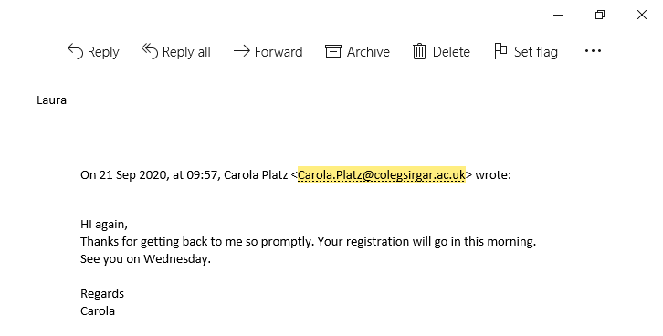
EV1.2
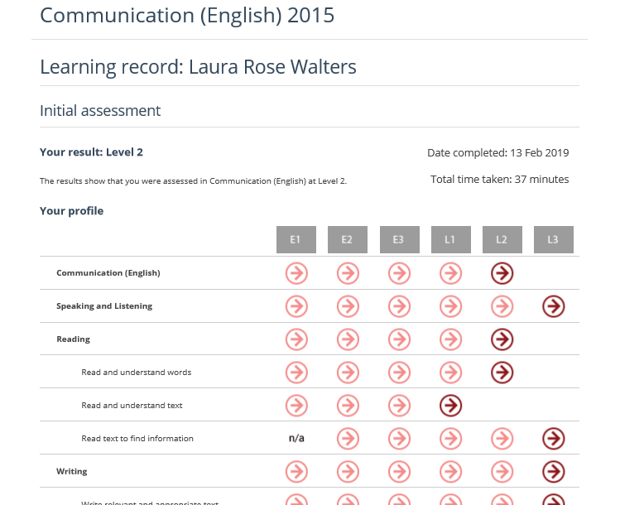

EV1.3
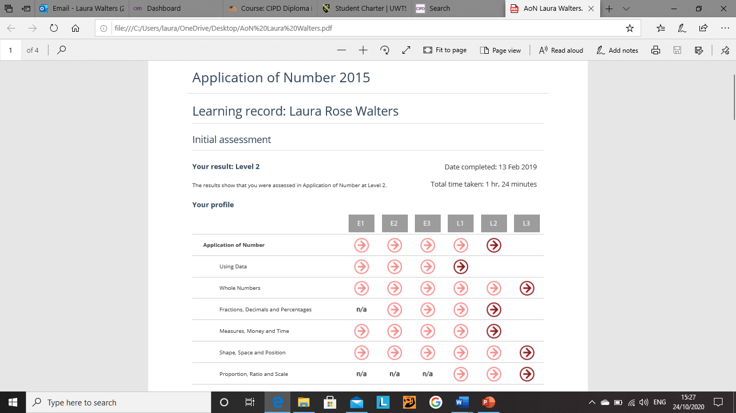
EV1.4
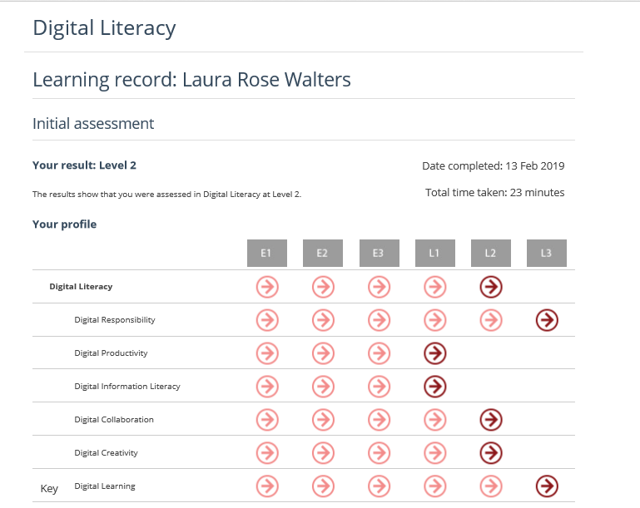

EV1.5

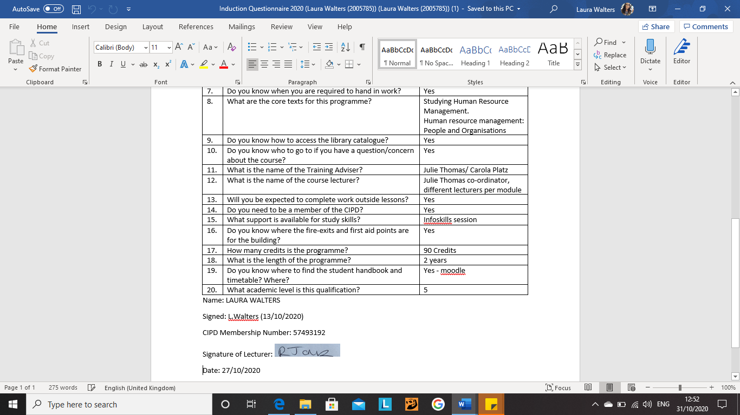
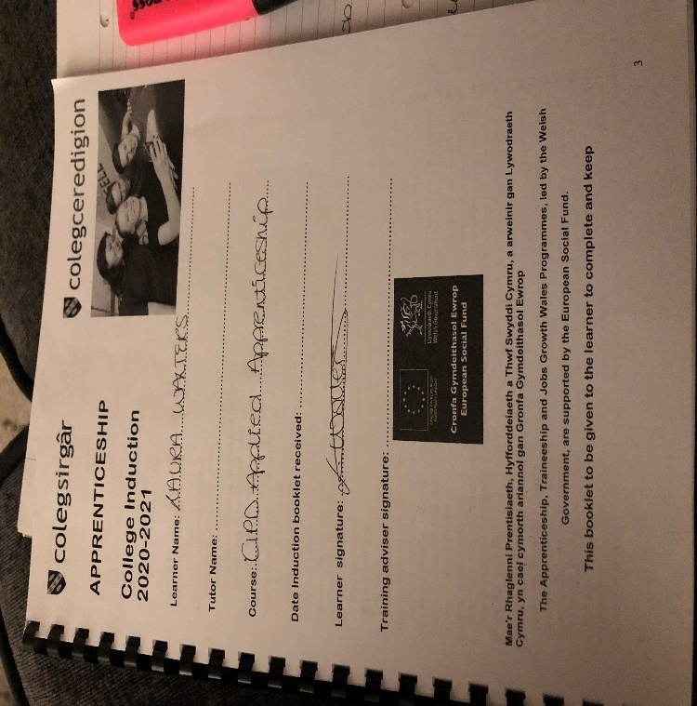
EV1.6

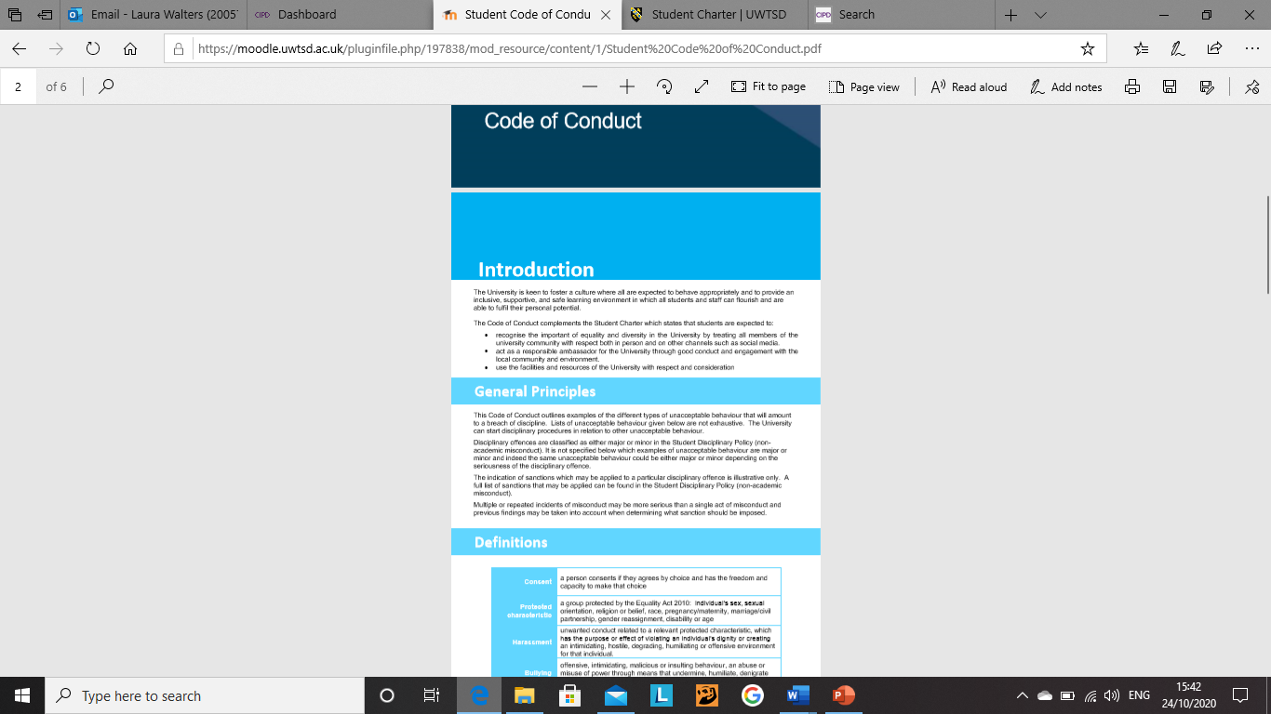
EV1.7

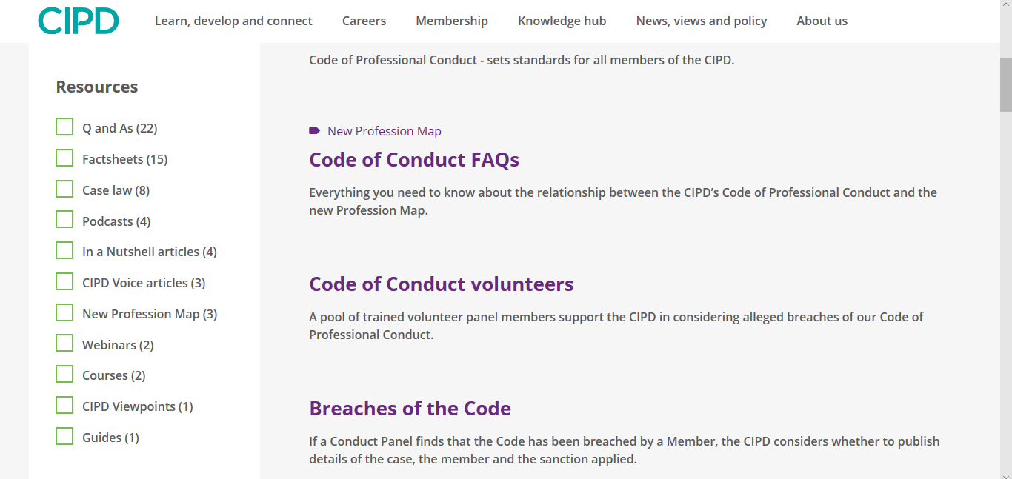
EV1.8

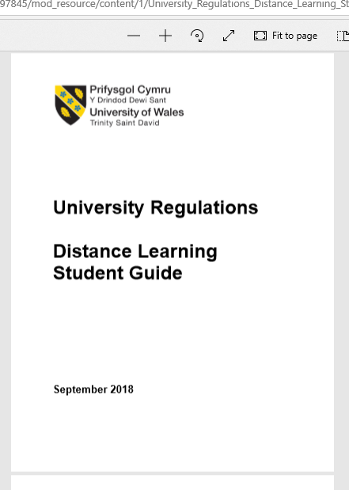
EV1.9

EV1.10

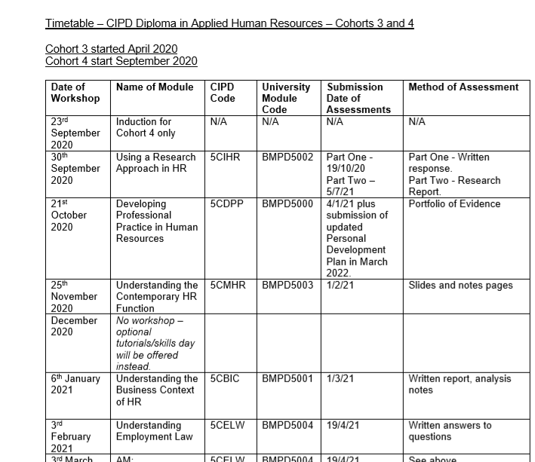


EV1.11

EV1.12
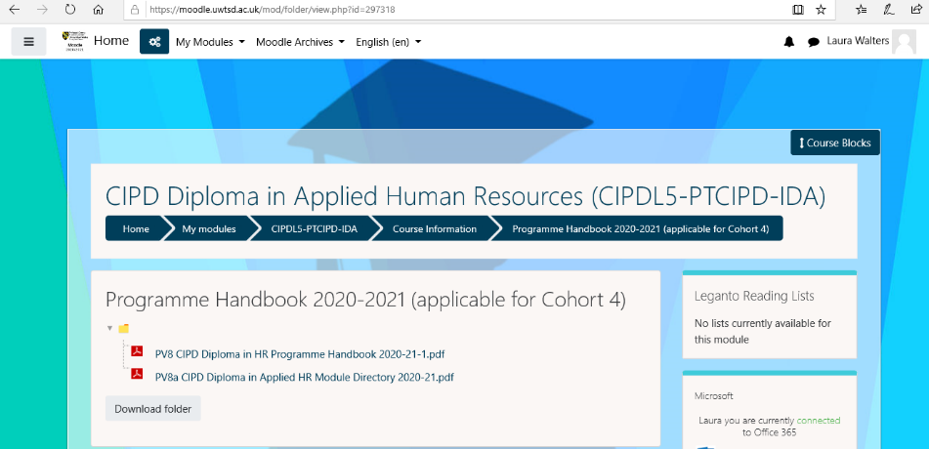


EV1.13

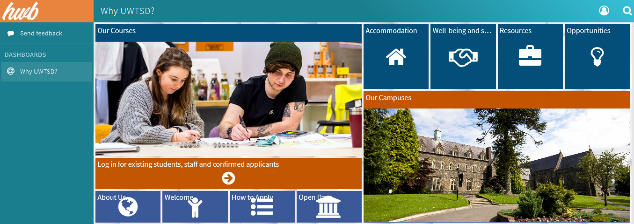
EV1.14

EV1.15


EV1.16
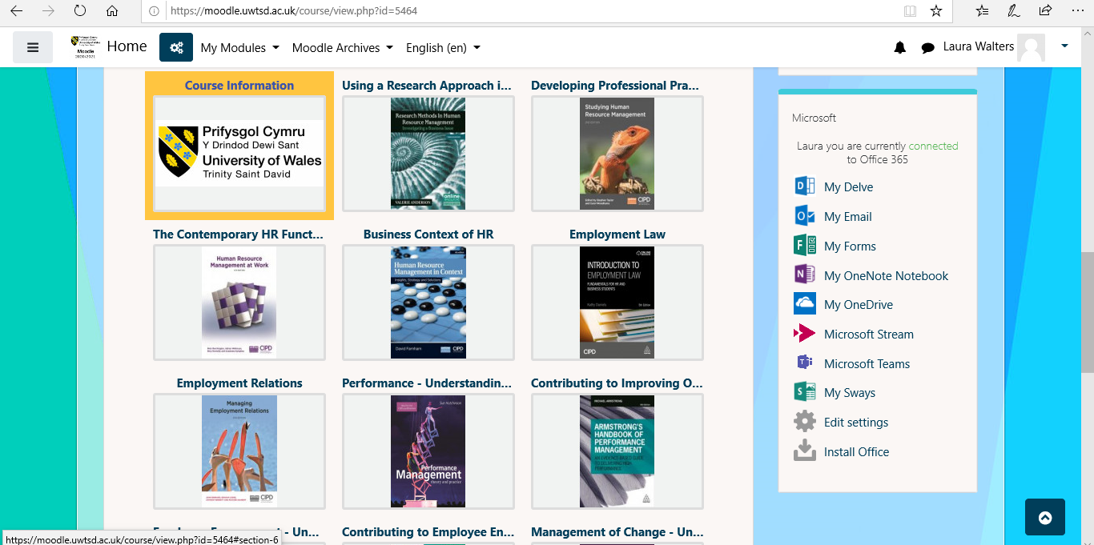

EV1.17

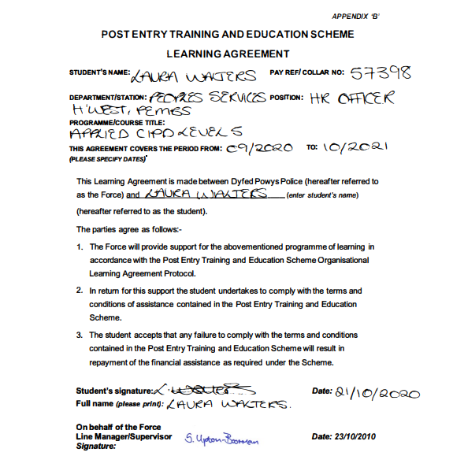

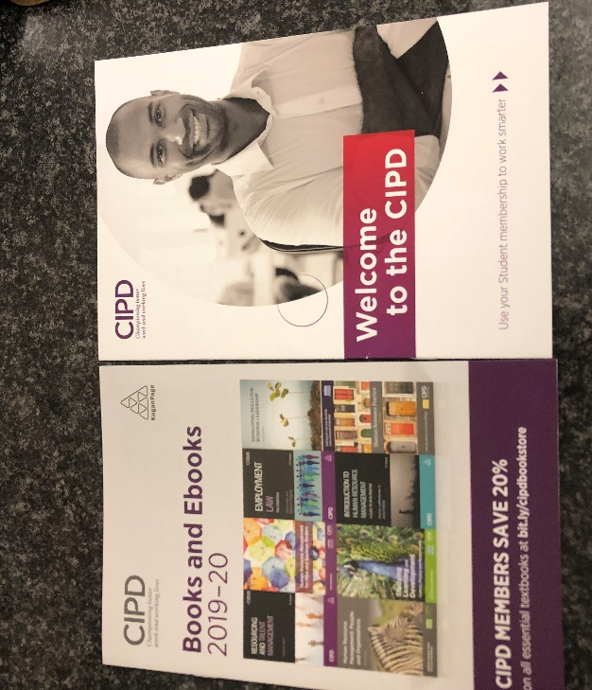
EV1.18


EV1.19


EV1.20

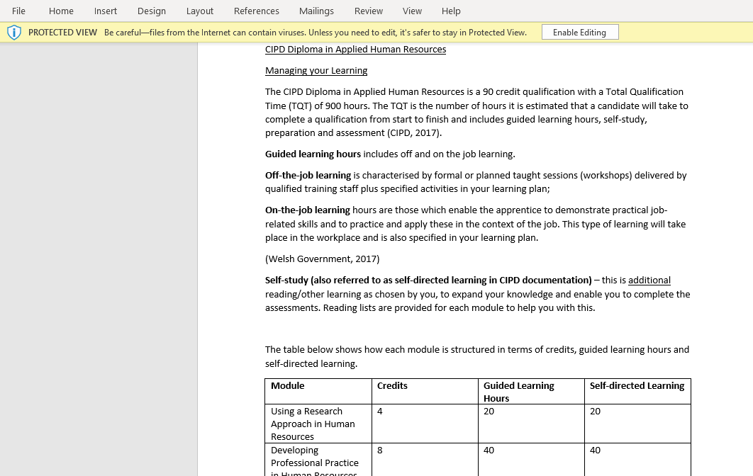
EV1.21

ACTIVITY 2

According to Lester, to be a HR professional is to have specialist knowledge and experience in the HR field. This can be gained by obtaining qualifications, going to events, networking and reading academic literature (2010). The CIPD is the only recognised professional body associated with HR and being a member of the CIPD demonstrates a level of professionalism, due to the code of professional conduct that the CIPD requires its members to follow (Perkins and Johns, 2016, p.75-6).
The profession map demonstrates areas in which HR professionals can continuously develop, “CPD” (Perkins and Wilkinson, 2016, p.110). The 2013 version will be looked at here, though there is a newer version, structured slightly differently, containing “purpose, which are evidence-led, principle-led and outcome-driven.” Building off this then is, “core knowledge, core behaviours and specialist knowledge” (CIPD, 2020).
There are four levels of which a HR professional can enter the map which correlates to their level of expertise (CIPD, 2020). For example, a HR director is likely to sit at band four and so the development areas higher up the band.
There are two key areas which lie at the core of the map. Firstly, ‘insights, strategy and solutions’. This simply means, the individual understands the people skills needed to provide an effective HR service, has the competencies to execute the role as well as solid HR knowledge. The individual can suggest recommendations and help implement new strategies which would benefit the organisation (Perkins and Wilkinson, 2016, p.110). Negotiation with stakeholders could be used as an example of when these skills are relevant (Johns and Perkins, 2016, p.85). It is crucial that HR draw upon these insights from their professionalism, to reach a decision.
The second core area is ‘leading HR’. HR construct and implement HR practices and drive the HR service. They should be role models in the organisation and embody the ethics of the CIPD (Perkins and Wilkinson, 2016, p.110). You would not expect line managers to adopt new HR practices, if HR professionals did not adopt them themselves. These two core principles define the HR profession – being strategic in implementing positive practice and leading by example.
There are ten professional areas in which one can develop. The first is organisational design (Woodhams and Wilkinson, 2016, p.111). HR professionals should look to make the organisation as efficient as possible through its design, weighing up best practice versus best fit. The role of line managers in HR practices is a good example here. In the 1990s there was a shift whereby HR took on a more strategic role, and thus line managers adopted a lot of the operational HR tasks (Swift, 2016, p.3). Next is organisational development. HR creates the environment and structures for line managers to ensure a positive and productive workforce in HR’s ever increasing strategic role, line managers are then entrusted in implement change (Johns and Perkins, 2016, pp.68-9).
Linking to this is the next area, resourcing, and talent planning (Woodhams, Perkins and Wilkinson, 2016, p.110). HR must be business conscious, (Johns and Perkins, 2016, pp.70-1) and think of short- and long-term objectives. They should aim to invest and mould their teams in order for them to reach their full potential and therefore extend the potential of the organisation as a whole (Woodhams, Perkins and Wilkinson, 2016, p.110). This involves identifying those individuals who potentially have more to give to the organisation. Similarly, the CIPD map shows learning and development (CIPD, 2020). This builds off the previous area, in facilitating the development of the organisation, e.g. enrolling capable individuals on courses (Woodhams, Perkins and Wilkinson, 2016, p.110).
Motivation is a key aspect which ties this all in together. The organisation should build a motivational culture of which benefits, and reward schemes are utilised to get the best out of each individual, e.g. end of year bonuses. This encourages individuals to maintain high levels of performance which in turn will generate high performance levels in the organisation (Woodhams, Perkins and Wilkinson, 2016, p.110). The CIPD defines this on the map as, “performance and reward” (2020). Employee engagement is similar to this, but focuses on the relationships between individuals within the workplace (Woodhams, Perkins and Wilkinson, 2016, p.110). Line managers have a key role to play here, encouraging individuals to reach their full potential, whilst taking an interest on their wellbeing and ensuring all forms of support are in place. An organisation may choose to create surveys to do this as effectively as possible (CIPD, 2020). “Employee relations” link to this, ensuring the organisation and employees work together. This will involve mediation where necessary and personal meetings for example (CIPD, 2020). Finally, “service delivery and information” is essential in HR’s strategic role, in creating practices, ensuring it is cost effective and provides the product/ service the consumer expects (CIPD, 2020).
These areas for development define the HR profession in the sense that if all these areas are continuously assessed and developed, the organisation will continue to operate successfully, as explained previously. By investing in the staff, talent planning and making processes more efficient, one enables the organisation to do the same, whilst ensuring its staff remain motivated and stimulated. It also ensures that the organisation is up to date on all law and legislation, and that employees are given equal opportunities and are treated fairly.
The following behaviours are essential for the HR professional to be effective. Curiosity and the courage to challenge are similar in that they promote change and thus “add value” to the organisation. If one did not remain open to change and ask questions, there would be no pressure to improve HR practices, and organisations may fall into the trap of ‘this is the way it has always been done”. An individual must be collaborative, using effective communication skills to negotiate with various stakeholders to implement a new idea, being a “skilled influencer” to get the stakeholders on board. To suggest ideas at all, one must be “personally credible”, having the knowledge to see the project through. As well as being a “decisive thinker”, i.e. having the skills to carry out the changes, the CIPD use analysing data as an example of this. As mentioned previously, the HR professional should be a “role model” of best practice, working as a ‘guinea pig’ to demonstrate their suggestions could work. Above all, they must be “driven to deliver” and should be passionate about the HR practice they are trying to improve (CIPD, 2020).

REFERENCE LIST

Johns, T. and Perkins, G. (2016) ‘Developing Professional Practice’ in Studying Human Resource Management. 2nd edn. London: Chartered Institute of Personnel and Development.
Lester, S. (2010). On professionals and being professional [online]. Stan Lester Developments. Available at: devmts.org.uk/profnal.pdf [Accessed 09/10/2020].
Swift, G. (2016) ‘Human Resource Service Delivery’ in Human Resource Management: People and Organisations. 2nd edn. London: Chartered Institute of Personnel and Development.
The Chartered Institute of Personnel and Development (2020) Code of Professional Conduct. Available at: https://www.cipd.co.uk/about/what-we-do/professional-standards/code [Accessed 15/11/2020].
The Chartered Institute of Personnel and Development (2020) The 2013 Profession Map. Available at: https://www.cipd.co.uk/learn/profession-map/2013-profession-map [Accessed 05/11/2020].
Woodhams, C. Perkins, G. and Wilkinson, K. (2016) ‘Developing the Knowledge and Skill of the HR Professional’ in Studying Human Resource Management. 2nd edn. London: Chartered Institute of Personnel and Development.

BIBLIOGRAPHY

Harvard Business Review (2020) Adapting Negotiations to a Remote World [podcast]. Available at: https://hbr.org/podcast/2020/08/adapting-negotiations-to-a-remote-world [Accessed 04/11/2020)
Horn, R. (2009) ‘Organising Life and Work’ in The Business Skills Handbook. London: Chartered Institute of Personnel and Development.
Johns, T. and Perkins, G. (2016) ‘Developing Professional Practice’ in Studying Human Resource Management. 2nd edn. London: Chartered Institute of Personnel and Development.
Lester, S. (2010). On professionals and being professional [online]. Stan Lester Developments. Available at: devmts.org.uk/profnal.pdf [Accessed 09/10/2020].
Swift, G. (2016) ‘Human Resource Service Delivery’ in Human Resource Management: People and Organisations. 2nd edn. London: Chartered Institute of Personnel and Development.
The Chartered Institute of Personnel and Development (2020) Code of Professional Conduct. Available at: https://www.cipd.co.uk/about/what-we-do/professional-standards/code [Accessed 15/11/2020].
The Chartered Institute of Personnel and Development (2020) The 2013 Profession Map. Available at: https://www.cipd.co.uk/learn/profession-map/2013-profession-map [Accessed 05/11/2020].
Woodhams, C. Perkins, G. and Wilkinson, K. (2016) ‘Developing the Knowledge and Skill of the HR Professional’ in Studying Human Resource Management. 2nd edn. London: Chartered Institute of Personnel and Development.

ACTIVITY 3

Though I am new to my role in Dyfed Powys Police (DPP), I have had the opportunity to be involved in the planning, implementation, and monitoring of projects. The project I will focus on here is the restructure of Pembrokeshire division. DPP uses the ‘Trent’ system to distribute officers and staff across HQ and its four divisions. Each individual is allocated a ‘seat’, and when an officer on response for example, is moved from station A to station B, they will need to move ‘seat’ on Trent, so that it clearly demonstrates where that person is working and what role they are undertaking (EV3.1). Trent feeds into various other systems, e.g. outlook, the Sickness Management system, and the Duty Management system. It is vital that Trent is accurate so that locations and line managers are accurate.
The project involved restructuring Pembrokeshire division on the Trent system, to reflect the structure of uniformed policing on the beat. Prior to the restructure, officers could either sit in a seat in Haverfordwest, Milford Haven, Pembroke Dock, or rural (Tenby and Narberth) (EV3.2). This is what would show as their job location, and their appropriate line manager would align to this also. In reality, the officers were located in either of the following: Haverfordwest, Milford Haven, South Pembrokeshire (Tenby and Pembroke Dock) and rural (Fishguard and Narberth). This was altered by the senior leadership team (SLT), to meet demand more effectively. For example, Tenby often needs officers based in Pembroke Dock, to assist during the summer months when there is increased demand. It allows the fluid movement of officers between stations. The nature of work required in Narberth and Fishguard, justified their grouping under the ‘rural’ banner. Additionally, we decided to move two Neighbourhood Tasking Unit seats and turn them into Tutor Pod seats. The Tutor Pod assists in the training of new student officers on division and so develops officers and ensures the best service is provided for the public, working towards DPP’s goal “to safeguard communities”.
This planning was carried out by the SLT, of which I am part of. At resource management groups (RMG), we decided on which seats we wanted and where (EV3.3). I then worked with other departments such as, Workforce Planning, Payroll and the Business Support Unit (BSU), in HQ, to build the structure on the Trent system (EV3.4). The authorised establishment numbers needed to be identified and what the actual establishment numbers were, I had to consider budgets here. This information is available on the T-Card (EV3.5). The Chief Inspector in Pembrokeshire, then had to decide on how these numbers could be split across the various sections of Pembrokeshire. I had to communicate this to workforce planning. One problem which occurred was that the actual establishment figure was higher than the authorised establishment figure. To solve this problem, a discussion took place with workforce planning, and together we filled the difference with temporary seats for the officers rather than substantive seats, which did not require extra money being used from the division’s budget. We did this by brain-storming and weighing up options (Morton, 2017). Substantive seats are those DPP receive funding for, and so if these seats were where we wanted them, the temporary seats were an effective tool one could utilize to balance the numbers. I then had to work out how many substantive seats and how many temporary seats were required in each section (EV3.6).
Much negotiation was carried out, for the new structure to be implemented as soon as possible. Firstly, I negotiated with workforce planning, to push our meeting forward to discuss the Trent structure (EV3.7), highlighting the importance of the project. As a team, we then discussed the new structure with Payroll, who are involved in the final part of the Trent moves, and came to the agreement that the effective date for the new structure would be 1st December 2020 (EV3.8). Once the structure was created, it was my role and workforce planning’s, to move the correct officers into their new seats which had been created by the BSU. We negotiated with Payroll, who were agreeable that a single spreadsheet containing this information would suffice, rather than the usual eform system (EV3.9). This was a lot quicker, as we would have had to have created one for everyone, of which there were at least eighty people.
I was able to monitor the moves, as I receive email notifications from the system to inform me when they have occurred. Once I saw the moves had been processed, I then double checked they were aligned on the system with the correct supervisor, correcting any potential errors. There is often confusion as some line managers show on the system as being sat in a particular station, but due to the fast paced, unpredictable nature of the policing role, they are often to required to cover other areas across division.
During this assignment, I drew upon academic literature to ensure I was engaging in project work effectively. Morton outlines the five steps to project management. The first is “initiation and conception”. In my case, this would have taken place at RMG where the restructure of Pembrokeshire division was discussed. The next is “planning”. An example of when I did this was liaising with workforce planning and my supervisor to allow us both to choose a date and enter the workplace during the pandemic. We also had to plan to ensure no one else would be in the room so that we abided by Covid-19 regulations. “Launch and execution” is the next stage. The project was launched in December and since then I have completed eforms for a number of officers moving across division. There have been no problems and the project was a success. Morton then identifies the final stage as “project closure”, this is now done, all the moves were processed and systems up to date (2017).
Upon reflection, this project should have been undertaken with more urgency. For example, some officers, upon their retirement, will have inaccurate postings on their record as the Trent structure was not accurate. Perhaps the decision to move individuals should not have been carried out in practice until the Trent structure was finalised and implemented. This would have avoided confusion from the officers, and this would have also made my role easier, whereby it would have been easier to identify accurately, where my vacancies were. This could not be done with the old structure as it did not match the practical structure of the response officers. It then made it difficult to feed back my establishment figures to the resourcing board. However, once the project was underway, I believe all parties used effective communication tools e.g. Skype, email and meetings to ensure the project was completed to a high standard. We drew upon each individuals knowledge, I had the knowledge of the Pembrokeshire vision, Workforce Planning had ability to ensure we stuck to the establishment figures and thus funding for officers was accurate and within budget, and the BSU used their IT expertise to implement the design.

ACTIVITY 3 - EVIDENCE

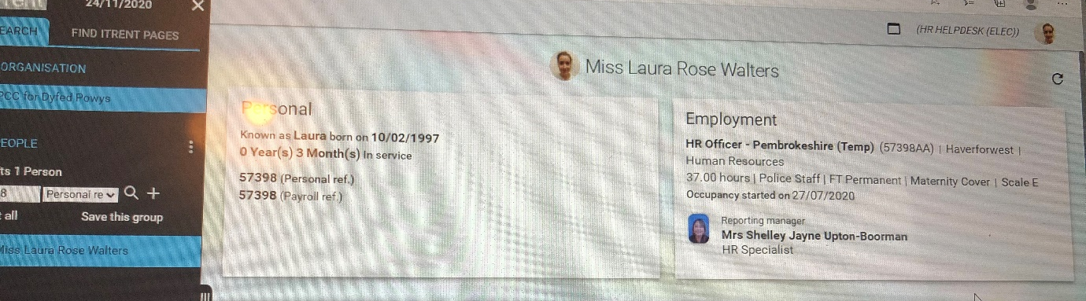
EV3.1

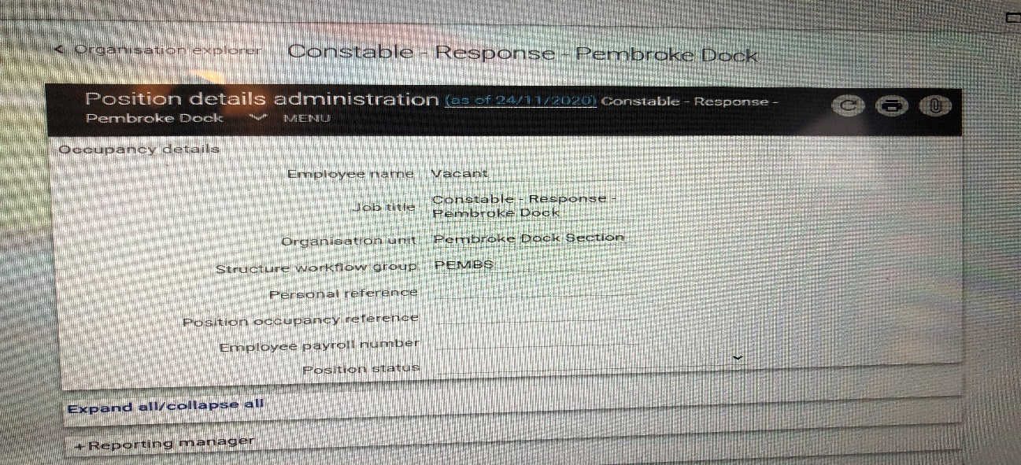
EV3.2

EV3.3


EV3.4
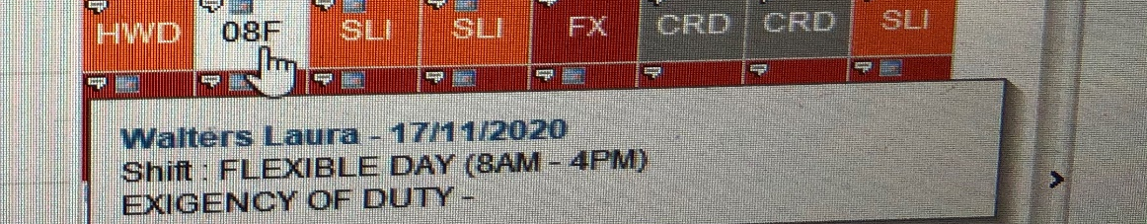
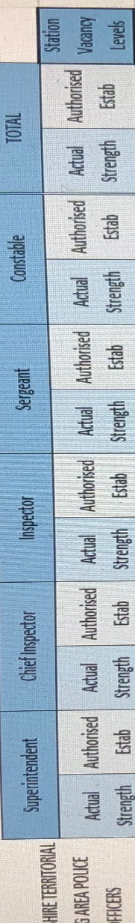
EV3.5

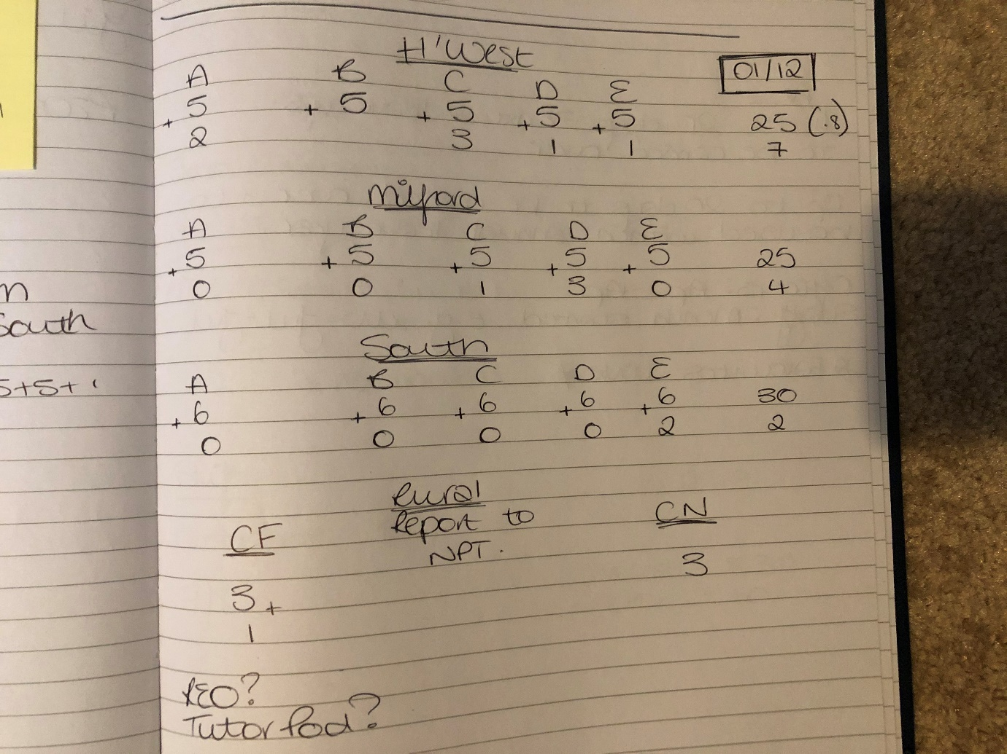
EV3.6

EV3.7

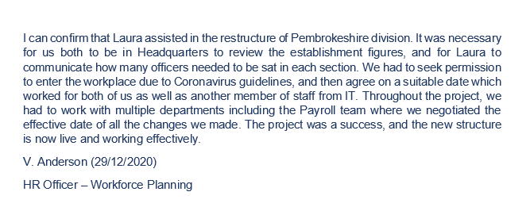


EV3.8
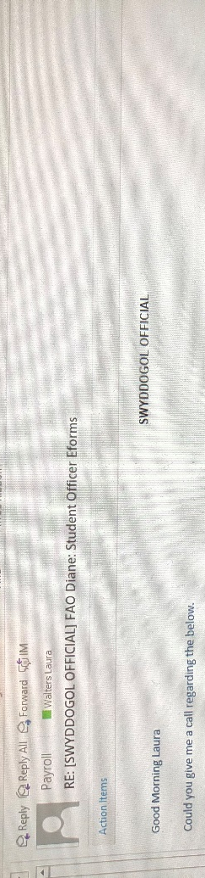

EV3.9

REFERENCE LIST

Morton, M. (2017)5 Project Management Steps: Process Group Project Management. Available at: https://www.teamgantt.com/blog/5-crucial-project-management-phases [Available at: 23/12/2020].

BIBLIOGRAPHY

Morton, M. (2017)5 Project Management Steps: Process Group Project Management. Available at: https://www.teamgantt.com/blog/5-crucial-project-management-phases [Available at: 23/12/2020].

ACTIVITY 4

Teams tend to be a formal coalition of individuals who have a head of department. A group, is usually an informal gathering of individuals e.g. a committee (Watson, 2014, p.210). Both, are similar in the sense that the dynamics of it, determine its success in achieving its objective. Cioca summarises the elements of effective teamwork as: clear goals, excellent communication, monitored performance, team support and conflict management (2016).
A report carried out at Google, highlighted the following important factors for individuals, which would lead to a better team dynamic and team performance. It was noted that individuals sought out “psychological safety”, an environment where they felt comfortable to suggest new ideas without being perceived negatively by their colleagues. They also wanted to be able to rely on their team, if one individual’s performance drops, it impacts the rest. It should also be clear who has ownership of what, what the teams’ goal is and how that contributes to the objective of the organisation (ReWork, Blog).
The construction of the team is essential in defining its dynamic. Miller describes Tuckman’s theory of team building, and how Belbin’s “team role model” contributes to this (2014, p.23). Belbin outlines three types of roles, and within those roles are various sorts of people. Here, personality plays a key factor in the dynamic of the team. The first type of role is the “task related”. Within this are the shapers who push boundaries but can tread on toes, the implementer who is organised but a little stuck in their ways and the completer finisher, someone who is accurate but tends to worry and dither. The second type of role is “team related”, including: the resource investigator, bold and confident but can lack motivation as time passes. There is also the co-ordinator who exudes confidence but can be easily manipulated. Finally, there is the team worker, sensitive and considerate but often indecisive. The third type is the “individual/ thinking related” stage. This includes, the plant, someone who is creative but can often be a poor communicator, the monitor elevator, someone who is highly logical but risks coming across as uninspiring. And the specialist, who is “motivated by the pursuit of knowledge” but “dwells on the technicalities” (Watson, 2014, p.216).
Miller links Belbin and Tuckman’s theories as follows. The first stage of Tuckman’s theory is “forming”. It is unlikely that there will be any conflicts in the team at this point as each individual is attempting to understand the other. Miller explains how strong leadership is necessary from the team leader; to effectively allocate tasks, using the Belbin model, and outlining a clear goal and individuals can see how their work benefits the organisation as a whole. Miller suggests that the Shaper style of leadership or co-ordinator style would be applicable here (2014, pp.23-4). Next is the, “storming” stage. Time has passed and the team members are likely to be increasingly comfortable with each other. With this, brings the confidence to assert opinions and conflicts are likely to develop. The sensitive team worker will struggle, as opposed to perhaps the resource investigator or shaper (Miller, 2014, pp.24-5). The third stage is “norming”, whereby most conflicts should have been discussed and dealt with by an effective leader, feedback on processes considered and thus the team can be given more ownership of tasks. Communication is key here, and the monitor evaluator, though diligent in their work, lacks in this skill (Miller, 2014, pp.25-7). The fourth stage is “performing”. This builds off the previous in the sense that the team require minimal amounts of supervision, are communicating well and everyone is aware of each other’s roles and capabilities. This mix of personalities throughout the stages of the team, define its dynamic.
One should not forget the importance of the team leader here. They may be under pressure from various stakeholders, and so the goal the team is trying to meet needs to be delivered with the skills and personalities of the team in mind (Johns and Perkins, 2016, pp.83-4). They must balance giving individuals responsibility, to demonstrating strong leadership and direction (Watson, 2014, p.216). Watson mentions that increased globalisation has called for an increased demand in remote working. The coronavirus pandemic has accelerated this. Leaders therefore, have had to develop their skills to monitor their teams working from home effectively (2014, p.221 and p.223).
The politics within organisations can both positively and negatively impact teams and organisational goals. Individuals, are all driven by different motives and can often be selfish in their pursuit of this. Rodgers defines politics in this context as, “the playing-out of these differing interests” (2009, p.4). He notes that often this can be at the detriment of the organisation if an individual prioritises their own interests. However, he mentions that “coalitions” naturally occur in an organisation between those individuals who share similar views. This can help drive change, to the benefit of the team and thus the organisation. Furthermore, he argues that it is something a supervisor cannot remove, rather, it can be used as a constructive tool to develop ideas, control different arguments and potential team conflict, and reach a team resolution. (Rodgers, 2009, p.4) Coalitions can be dangerous with regards to team dynamic. They risk causing rifts in teams, overpowering of smaller groups and ultimately conflict, a poor working environment and hence a less productive team. Again, it is vital, that the manager controls this. In large organisations, such as those in the public sector, there is a clear hierarchy of which messages can be passed down and tasks allocated (Watson, 2014, p.228). However, these messages can often get lost or misinterpreted along the way, and jobs missed in a long chain; henceforth causing conflict between departments. This causes resentment and frustration. Depending on the individuals’ personality, one may become withdrawn and demotivated or antagonised and resentful. On the other hand, in smaller companies, primarily in the private sector, which are perhaps family run, family politics can get in the way of organisational goals. Here, leaders fall into the trap of not listening to their teams’ ideas, feedback and thus do not improve processes. This leaves the organisation with a demotivated workforce, lacking in innovation and drive, which results in poor performance levels, poor teamwork and goals not being met (Watson, 2014, p.228). In these sorts of companies, decisions and communication is only present within a select few, and messages and goals are not clearly communicated to the rest of the team.

REFERENCE LIST

Cioca, L. (2016) ‘Teamwork Training: how to make it work’, Science for Work. [Blog]. Available at: https://scienceforwork.com/blog/teamwork-training/ . [Accessed: 20/11/2020].
https://rework.withgoogle.com/guides/understanding-team-effectiveness/steps/identify-dynamics-of-effective-teams/ [Blog] (Accessed: 16/11/2020)
Johns, T and Perkins, G. ‘Developing Professional Practice’ in Studying Human Resource Management. London: Chartered Institute of Personnel and Development.
Miller, T. (2014) ‘When Four Worlds Collide’ in Training Journal (May) pp22-27.
Rodgers, C. (2009) ‘Informal Coalitions’ in The Business Skills Handbook. London: Chartered Institute of Personnel and Development.
Watson, G. (2014) ‘Effective Team Building and Communication’ in Developing Skills for Business Leadership. London: Chartered Institute of Personnel and Development.

BIBLIOGRAPHY

Chartered Institute of Personnel and Development (2014) Building the Best Team. Available at: https://www.cipd.co.uk/podcasts/building-best-team [Accessed: 16/11/2020].
Cioca, L. (2016) ‘Teamwork Training: how to make it work’, Science for Work. [Blog]. Available at: https://scienceforwork.com/blog/teamwork-training/ . [Accessed: 20/11/2020].
https://rework.withgoogle.com/guides/understanding-team-effectiveness/steps/identify-dynamics-of-effective-teams/ [Blog] (Accessed: 16/11/2020)
Johns, T and Perkins, G. ‘Developing Professional Practice’ in Studying Human Resource Management. London: Chartered Institute of Personnel and Development.
Lacerenza, C. Tannenbaum, S. Marlow, S. and Salas, E. (2018) ‘Team Development Interventions: Evidence-Based Approaches for Improving Teamwork’ in American Psychological Association, 74, (4), pp517-531.
Miller, T. (2014) ‘When Four Worlds Collide’ in Training Journal (May) pp22-27.
Rodgers, C. (2009) ‘Informal Coalitions’ in The Business Skills Handbook. London: Chartered Institute of Personnel and Development.
Watson, G. (2014) ‘Effective Team Building and Communication’ in Developing Skills for Business Leadership. London: Chartered Institute of Personnel and Development.

ACTIVITY 5

Introduction
Following a self-assessment on the CIPD website at band two, I have identified the areas outlined in my findings section, as my key development areas. I took the assessment at this level, as it appeared suitable for the level I am working at, and the stage of my HR career. I am working as a HR Officer, and am new to my organisation, Dyfed Powys Police (DPP). The areas I identified as requiring development were employee engagement and performance and reward. In my personal development plan (PDP) I have focused on performance and reward, as this was a topic I was both most interested in and felt I wanted to gain a better understanding of.
I have created a PDP (EV5.1), to ensure I continue to develop in the areas throughout my career, and will log my progress in a separate record plan, (EV5.2) to ensure I remain on track.
Findings
On completion of the CIPD assessment, it was clear that the core area where I needed to develop was insights, strategy, and solution. Those professional areas I was less able in, where identified as, employee engagement and performance and reward. Upon completion of the behavioural assessment, all results came out similar. Therefore I selected the ones I felt personally, I wanted to improve on, to further my HR career. Please see profession map below.
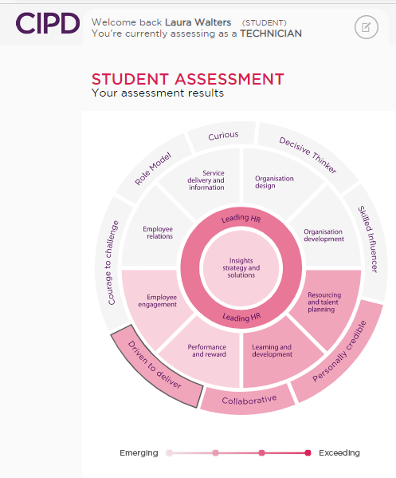

Core area – insights, strategy and solutions
It was clear that this was the core area I needed to develop. This includes remaining up to date on HR trends and issues, to assess whether this is influencing my own organisation. If so, I can then work with my team and management to try and address issues and continuously develop the organisation. To do this, I will need to visit the CIPD website regularly, review recent surveys and attend webinars and CIPD events. I could also tailor my research here, to look specifically at areas I think would be most beneficial to the organisation, and/or those areas that interest me most, or perhaps where I feel my HR career may lead to.
Professional area – performance and reward
Both performance and reward, and employee engagement where identified as development areas for myself, according to the CIPD profession map. I have chosen to select performance and reward as this is an area I am most interested in, and feel personally, I need to develop more so than employee engagement. This will include reviewing reward benefits in my own organisation. As I am new to the organisation, I feel this will help me gain a rounded knowledge of why we operate in a certain way, enabling me to do my part better. Upon gaining a better understanding, I will be more capable of suggesting ideas of continuous improvement, as when I review employment law and cases via the CIPD and ACAS websites, I can apply this to DPP. It is essential to retain staff to further the organisations’ objectives.
Behaviours – personally credible and driven to deliver
I will look to develop in two behavioural areas. The first, personally credible. As I am at the early stages of my career it is important that I am receiving regular feedback from my peers to address any issues and to continuously develop. This will also involve, as mentioned previously, on reading about key HR topics, remaining up to date on trends and key HR cases.
The second, driven to deliver, gives the opportunity for me to look at my skills and my methodology in the way that I work. I will then be able to identify what I do well and what I do not do as well. Once I have this information, I can then seek support from my peers as to how to improve and discuss ideas as to how they operate. The aim in doing this, is that the team exchanges ideas and we work as efficiently as possible. On a personal level I will be improving myself, but hopefully, this will also have a positive effect on the organisation.
In addition to this, I also completed two questionnaires. The Belbin team questionnaire identified me as a team worker and also scored highly in the specialist category. In the communication questionnaire, my results identified me as being in the assertive category. I was pleased with this result, and will aim to continue communicating in the way I do. I do hope to be able to contribute more to team meetings and discussions, however, it is my belief that this will naturally improve as I gain more experience in my role at DPP, and upon researching and reading articles on the CIPD website.
Conclusion
On my PDP, I have clearly outlined which areas I want to improve on, how I will achieve it, what/who I will need to help support me, and the timeframe I wish to improve by. The majority of my development areas will have an ongoing timeframe, as this task is about continued professional development, and as I am young in my HR career, I do not feel this is something I will have achieved in a matter of months. All developments and achievements will be updated and recorded on both the PDP and personal record.

DEVELOPMENT PLAN

Development Plan

NAME: | LAURA WALTERS | MEMBERSHIP NUMBER: | 57493192
COVERING THE PERIOD FROM: | DECEMBER 2020 | TO: | ONGOING

This record sheet is for your guidance only – you may present your development plan in any other format.

Planned outcome

Where do I want to be by the end of this period? What do I want to be doing? (This may be evolutionary or “more of the same”.)

What do I want/need to learn? | What will I do to achieve this? | What resources or support will I need? | What will my success criteria be? | Target dates for review and completion
INSIGHTS, STRATEGY, AND SOLUTIONS  Review recent CIPD survey results (such as Employee Outlook or Learning and Development Survey), and identify any trends or risks which may impact your organisation. | Regularly visit the CIPD website (once per week), to keep up to date with new trends and surveys.  Meet regularly with line manager to discuss survey’s which are applicable to my organisation. | CIPD website  Line management support, link this learning to my own organisation. | Being able to explain what I’ve read to my line manager, and hold a discussion on its potential impact on the organisation.  Whether I make time to review these surveys. | Ongoing, review Jan 2021.
INSIGHTS, STRATEGY, AND SOLUTIONS  Undertake some online research using the CIPD website on the principles of business and HR metrics, and how they can be used to benefit the organisation. | Look on the CIPD website for relevant articles and further reading. | CIPD website  Line management support to discuss ideas re my organisation. | Evidence of notes taken during research process.  Being able to explain what I’ve read to my line manager, and hold a discussion on its potential impact on the organisation. | Ongoing, review Jan 2021.
PERFORMANCE AND REWARD  Research employment legislation around reward and pay (including the Equal Pay Act) using the CIPD, ACAS and other relevant websites. | Use the CIPD and ACAS websites to gain an understanding of reward pay. Use these to source further reading. | CIPD website.  ACAS website.  Course, core textbooks. | Be able to discuss legislation with colleagues with confidence.  Relevant notes collated. | March 2021
PERFORMANCE AND REWARD  Talk to a reward specialist in your organisation to understand the different elements of reward including job evaluation, fixed pay, variable pay, employee benefits and total reward and their purpose and impact in attracting, motivating and retaining talent. | Identify who the reward specialist is in my organisation and arrange a meeting. | Reward specialist advice. | Meeting scheduled.  Demonstrate the ability to converse with the specialist on the subject, providing valuable insights as well as the specialist. | April 2021.
PERSONALLY CREDIBLE  Reflect on occasions where you have been less successful or unable to provide advice and guidance on an issue within your area of expertise. Work to understand why, specifically considering your level of understanding of the issue, as well as the practicality and objectivity of your advice. | Discuss development areas with line manager.  Personally, take time to think about areas of development. | Line manager.  Skype – to facilitate the discussion with my manager. | Meeting scheduled.  Areas where I required development, showing improved performance levels. | Ongoing
PERSONALLY CREDIBLE  Gain feedback on your expertise within the workplace from a key customer, manager or peer. Pick one development area to focus on. Work to build up your expertise in this area. | Discuss development areas with line manager and other experience HR Officers. | Skype – to facilitate the discussion with my manager and peers  Line manager.  Divisional HR Officers. | Skype session scheduled. | 30th Jan 2021.
DRIVEN TO DELIVER  Conduct a SWOT analysis on yourself as to the way you approach your work. What are the downsides to your approach? What opportunities does it offer? | Written SWOT analysis completed. | Potential line manager support to identify these areas. | Written SWOT analysis completed. | March 2021.  Ongoing.
DRIVEN TO DELIVER  Develop a methodology for keeping a record of your work, particularly any complex projects. Ask your colleagues how they keep a track of their progress, and find a method that works for you. | Each project I undertake make a not of the methodology first. Check this with another divisional HR Officer prior to completing the task. | Divisional HR Officer support. | Notes taken from Skype meetings.  Scheduled Skype meetings. | Ongoing.

