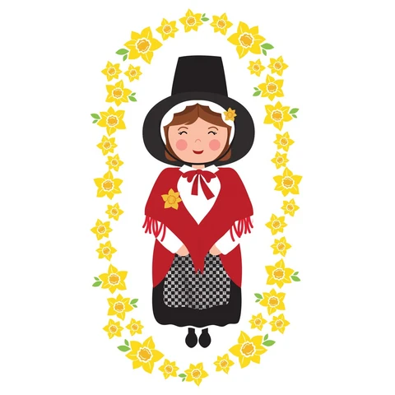

Celebrating language and
Culture belonging to Wales.
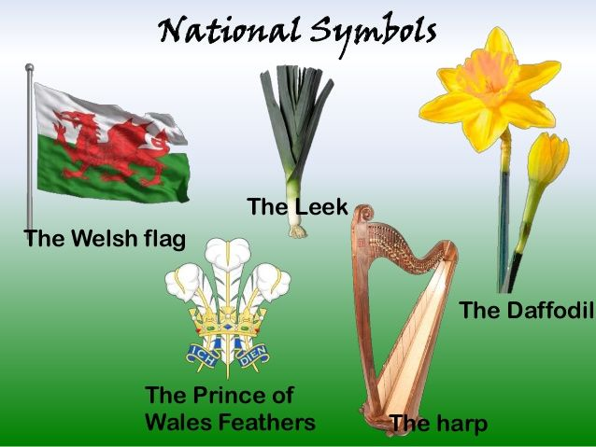
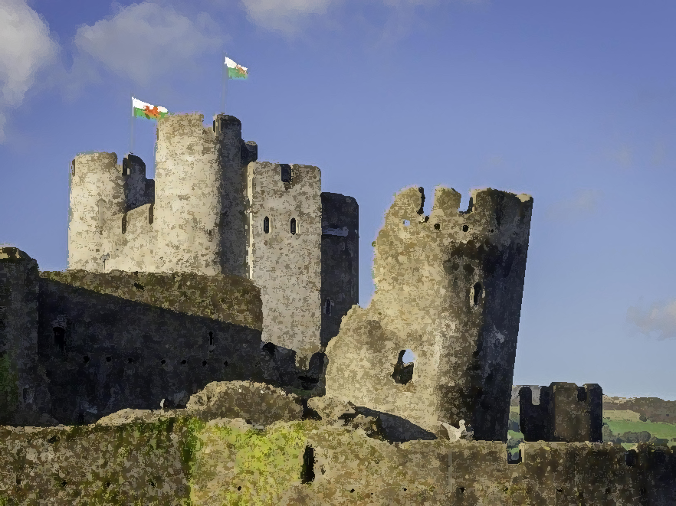
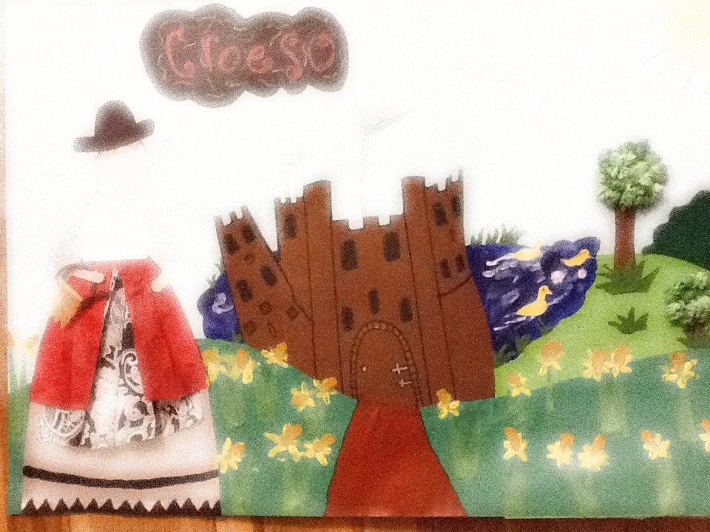
Contents:
(Pinterest, 2020)
(CADW, 2020)
(star editions, 2020)
SJIE5004 by Vanessa Busson

Rationale Pages:3-4

Overview of activities Pages: 4-6

Evaluation Pages: 6-7

Appendices Pages:8-14

References Pages: 15-16
(Gladys Briggs, 2020)

The teaching and learning of Welsh and Welsh culture are the priority of the Welsh Government. Schools across Wales have become more aware of the role they play in developing the Welsh language and maintaining it. Since the 1988 campaign for a separate curriculum in England, a huge emphasis has been placed on planning and developing activities across all subject areas to promote cultural, geographical and historical elements to enhance understanding of the local area while developing the Welsh language. The Welsh Government in Education (Welsh Government Welsh in Education, 2017) states;

The Welsh Language is integral to those reforms, as it is to Government-wide objectives of building resilient communities, culture and language, and promoting and protecting Wales’ place in the world.

In a variety of contexts children and young people need different opportunities to use the Welsh language. Their awareness of Welsh will enrich their learning as an everyday language. Donaldson’s Successful Futures highlight the importance of educational experiences being part of the curriculum, to broaden children and young people’s horizons, stimulate their imaginations and promote enjoyment in learning (Donaldson, 2015, p 38). Our future Welsh speakers will not be dominated by changes to the curriculum alone. One of the Cymraeg 2050’s main modified changes; the number of Welsh medium educational settings is to increase by one million Welsh speakers. Planning for the latest Welsh language curriculum to come into effect. We need to understand how to improve the path children and young people take through the selection of languages can be beneficial by the application of more Welsh as a learning experience. Cwricwlwm Cymreig emphasises;

Curriculum development should be at the heart of the practitioner, school and national efforts which seek to raise standards for all, tackle the attainment gap and ensure an education system that is a source of national pride and enjoys public confidence (hwb.gov. 2020).

The Welsh Government aims to have a million Welsh speakers by 2050. In order to achieve this they will be working with schools and build on existing projects including Welsh Language Charter (Siarter Iaith), Cymraeg Campus and the Welsh language practices project and maintain that all schools regardless of their linguistic nature follow the same framework to ensure all learners are confident in using their Welsh language, foster positive attitudes towards the language and increase the use of the language inside and outside of the school (Welsh Government, 2017-21, p.5). This approach will provide encouragement for schools not yet engaged in the journey by provided specific starting points and goals. At the same time, it offers guidance and advice for the schools already involved to develop further building on the good work that has already been achieved and encouraging them to continue with optimism that Siarter Iaith and other associated programmes have developed. This framework will provide educational settings with starting points and goals to ensure that they implement changes to meet the expectations of Donaldson’s Successful Futures document stating that the renewed focus in schools should be ‘learning Welsh primarily as a means of communication particularly oral communication and understanding’ (Donaldson, 2015. P 115).
While Welsh may not be the main language spoken in my educational setting, the emphasis of the school is on cultural, wide variety of experiences concentrates on geographical, historical aspects and the awareness of the local and wider Wales and the development of the Welsh language. This in affect is the process recommended by Donaldson’s Successful Futures where he states ‘children and young people should have their learning developed across the curriculum’ (Donaldson, 2015, p 113). A new reformed National curriculum in Wales 2022 is going to change the way children and young people learn in schools. To ensure children and young people learn they have written six Areas of Learning and Experience, expressive arts; health and wellbeing; humanities; languages, literacy and communication; maths and numeracy and science and technology. With this in mind there are four aims to the curriculum ambitious and capable learners; enterprising and creative; ethical and informed citizens and healthy and confident (Welsh government, 2020). This new curriculum should see an approach to education with all pupils gaining access to all areas of learning and education, where creative activity and imagination as an essential part of learning which leads us to Steiner’s theory where his approach to education was the idea that moral, spiritual and creative sides require as much attention as their intellect (Steiner, 1861- 1925).

(See Appendix 1) A lesson plan is created to help teachers with the differentiation of the activity for a group of year 8 pupils whose second language is Welsh and might have different levels of Welsh language skills and are also on the Additional learning needs (ALN) register. This plan shows various ways pupils will access a series of language activities, depending on their needs. With the focus of this educational setting being Literacy and numeracy, this activity helps develop their skills in all core areas. From the literacy policy in my educational setting, oracy, reading and writing are a main focus. (Penglais, 2017) These are also one of the requirements from the new curriculum in Wales 2020 stating that Literacy means speaking; listening; reading and writing skills (Welsh Government, 2020).

(See Appendix 2) The first activity involves a comprehension focusing on St David’s Day and aims to target listening skills. The pupils are required to listen to the me read out the exercise and follow it by concentrating on the worksheet in front of them. During this, I will point out key words which the pupils will write in their exercise book. Once the reading out of the comprehension worksheet has been completed, I will then ask all pupils to point out any words that they themselves do not understand, these will then be discussed. The main aim of this is to trigger the pupils’ knowledge and an opportunity for the pupils to review the text they already know and determine the ones which they need to learn. This is in line with an article written by Jack Richards (Teaching Listening and speaking from Theory to Practice, 2020)where he shows us that the ‘successful listening can be looked at in terms of the strategies the listener makes use of when listening’. This is the starting point of the topic of St David which is a significant celebration in Welsh culture. The second part of this activity is the questions. I will read through the questions before asking pupils to answer them in their exercise books. To target the use of oracy that complies with the literacy framework ( Penglais, 2017) pupils are required to work with their peers in the class and discuss the answers before we encourage the completion of the task by answering questions in full sentences in their books. Once all pupils are happy with their completed work, I will write answers on the board and get pupils to mark each other’s work. I feel this task has been particularly important task for learners to become independent and who engage and play an active role in the task highlighting the theory of Vygosky (1896-1934) who believed that ‘knowledge and thought are constructed through social interaction with family, friends and peers (Bates, 2019, p 48).
(See Appendix 3) In accordance with new curriculum in Wales 2020, incorporating languages, literacy and communication, the learner is asked to use the internet and find pictures for the text on the worksheet. On the other hand, the pupils have the option of including their own drawings. Piaget (1936) a theorist of cognitive development suggests that children ‘learn best through doing and actively exploring’ he highlights that teachers should respect each learner’s interests, abilities and limits. I believe that this activity gives the learner a choice and therefore follows the theory Piaget believes (Bates, 2019). Pupils became engaged with each other as well as concentrating on the task and a choice was given for them to take ownership of this task.
(See appendix 4). The main objective of the final part of St David’s day task is to further a pupil’s memory and knowledge. A matching pair game using Welsh vocabulary and images was presented to the pupils and the freedom to explore this project. The pupils were paired together and asked to support each other. This was especially good to see how the pupils themselves took the lead in this activity. Although, most of the task has been in English because we are a Welsh medium school and English is spoken first and foremost, however, we follow the Framework (Siater Iaith) and ensure that the use of incident Welsh in some or most lessons enhances the Welsh language and we give Welsh speakers the opportunity to be fully bilingual. This also helps increase the Welsh language inside the school. All pupils that took part in this task regardless of their ability in the Welsh language and how they chose to complete it were able to participate in a way that they could give their full potential and achieve a sense of individuality but also engage with their peers.
(See Appendix 5) I have put in an extended task which pupils can access if they have completed all other tasks. Although this group of year 8 pupils were learners with ALN the extended task was available if needed. This task requires pupils to complete a word search. All words are associated with Wales and St David and furthers their knowledge of Wales and St David. By giving the pupils a wordsearch as an extended task it provides reinforcement of spelling and concentration of red herring or decoy words. This is an individual activity as it gives the learner further ownership of their work. This supports Piaget’s theory that learners will flourish in group-working whereas others may need the one to one support.
To reflect on my St David’s day activity, I think it works well because all worksheets contained most or all the same words this showed the pupils repetition and helped them focus when learning the vocabulary. ‘Repetition is the first Principle of All learning’ (Bruner, 1971). I observed pupils listening to me read and follow the worksheet, throughout reading the comprehension I focused on keywords. This gave the pupils an opportunity to reflect on what they already knew and learn new words. As St David and words associated with Wales was the focus this is in response to the promotion of the Welsh language and Welsh culture. By delivering the lesson this way it coincides with Bruner’s theory that ‘a practitioner’s role is not to impart information by rote-learning but instead facilitate learning by designing sessions where the learner can discover the relationship between bits of information (Bates,2019). To support the guidelines of the Siater Iaith framework, I also provided an activity where incidental Welsh could be used alongside those pupils who are more fluent to aim that all learners are ‘confident in using their language skills’ (Siarter Iaith framework, 2017 p 5).
To conclude I think that all activities worked well and flowed into each other. A Welsh theme was notable throughout this lesson providing the pupils with the knowledge of Welsh culture. The use of the vocabulary I pointed out during the lesson encouraged pupils to discuss what they knew and also ask questions on the vocabulary they did not understand promoting the theory of Vygotsky where he believes the principles underpinning scaffolding are ‘build interest in the subject and engage with people and break the given tasks into smaller chunks’. With this in mind it helped the pupils come out of their comfort zone by discussing the text. By choosing St David as a theme the Welsh culture was covered as this is a theme followed up every year and is celebrated throughout Wales. I introduced the Welsh pairing game using all the vocabulary of the lesson to further the Welsh and promote Donaldson’s idea of thematic learning cross several curriculum areas. The lesson plan was adhered to and almost all aspects of the criteria were successful. To develop this activity I could ask the pupils to read the comprehension themselves although that then would require them to read all words, but with me reading it and pointing out key words the pupils visual learning began. Breaking up the activity with an internet task meant that the learner could bring his or her ideas to life. Piaget believes that ‘encouraging learners to learn from each other and emphasise that everyone will have something to offer gains respect’ and I believe therefore the pairing game was so successful. I encouraged students to speak in the Welsh language and develop their bilingual skills and followed the Bilingualism policy of my educational setting that states ‘The use of the Welsh Language should be promoted in the school other than the usual Welsh lessons (Penglais, 2017). I used oracy which is a big focus in my educational setting provided all the necessary resources to promote differentiation for all pupils to be able access the curriculum. Reflecting on this activity, I believe I have supported the Welsh language, its culture and its heritage, while at the same time promoting many of the policies of the educational setting and the Welsh government.

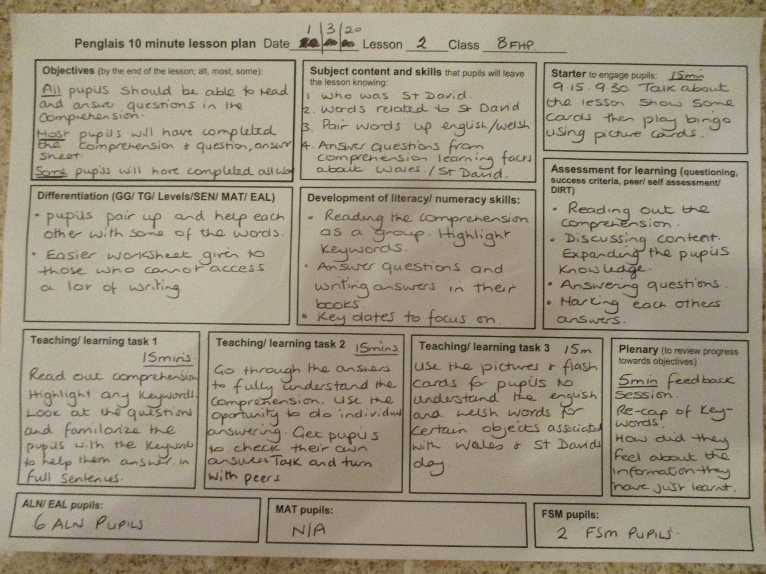
Appendix 1

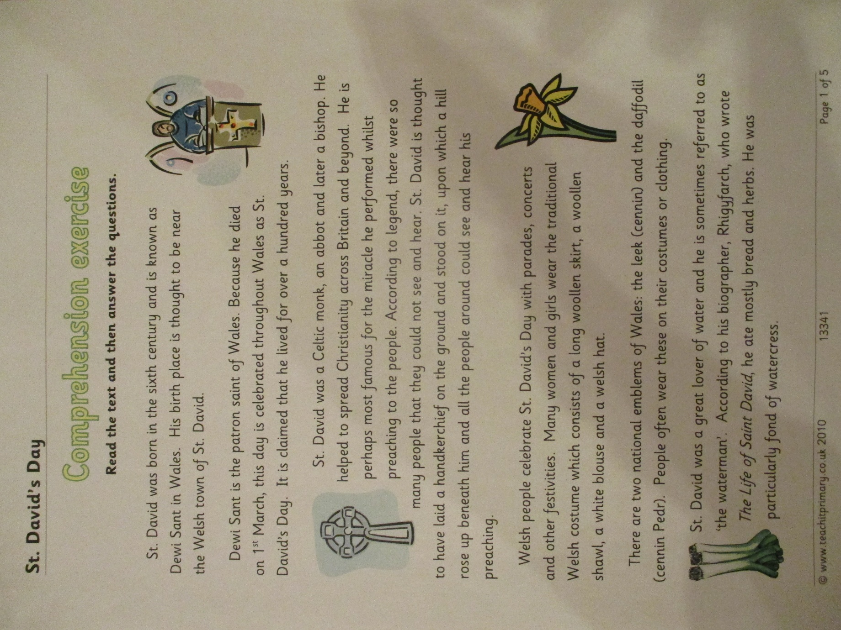
Appendix 2

Appendix 3
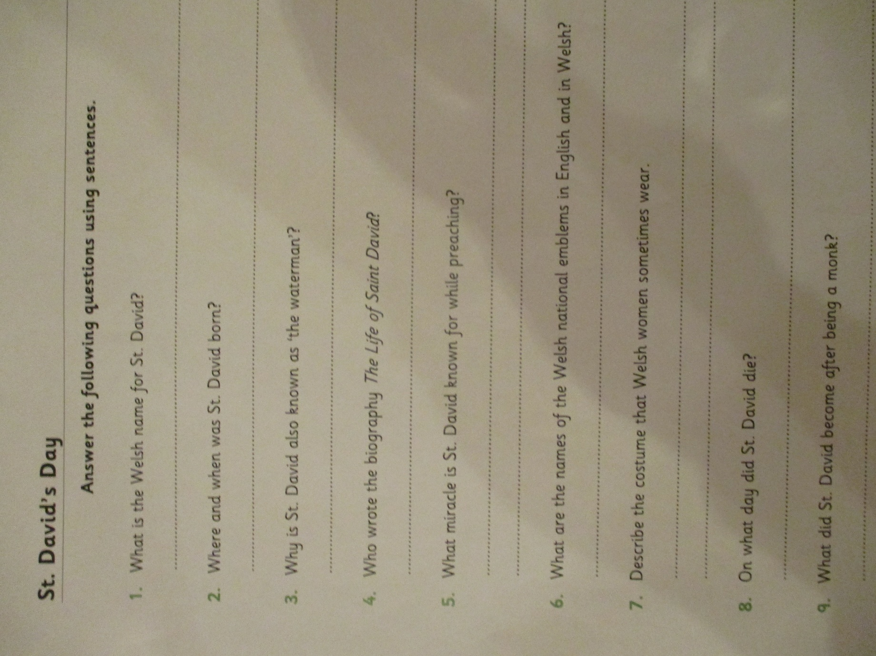

Appendix 4
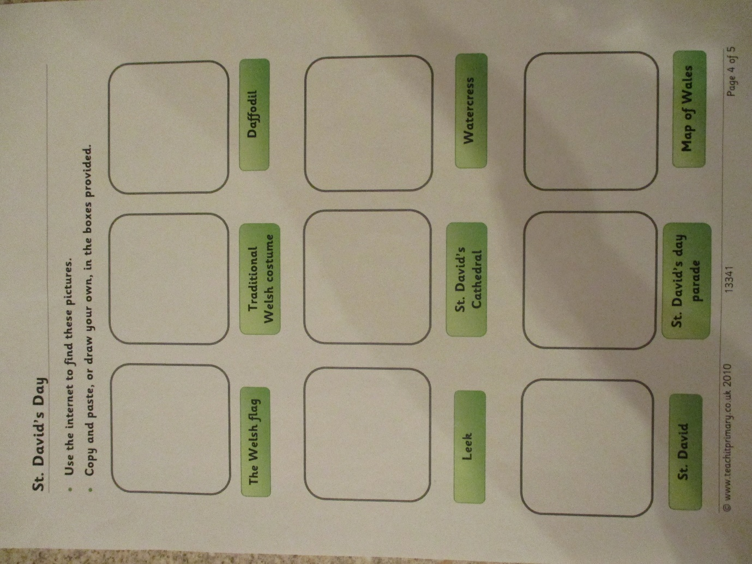

Appendix 5
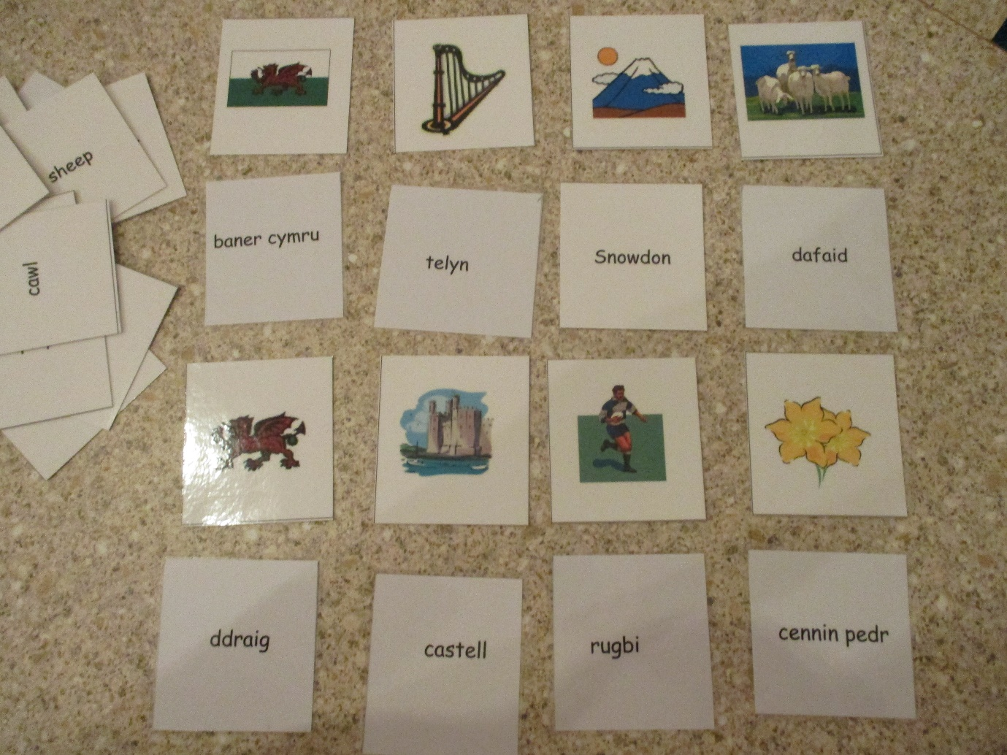

Appendix 6
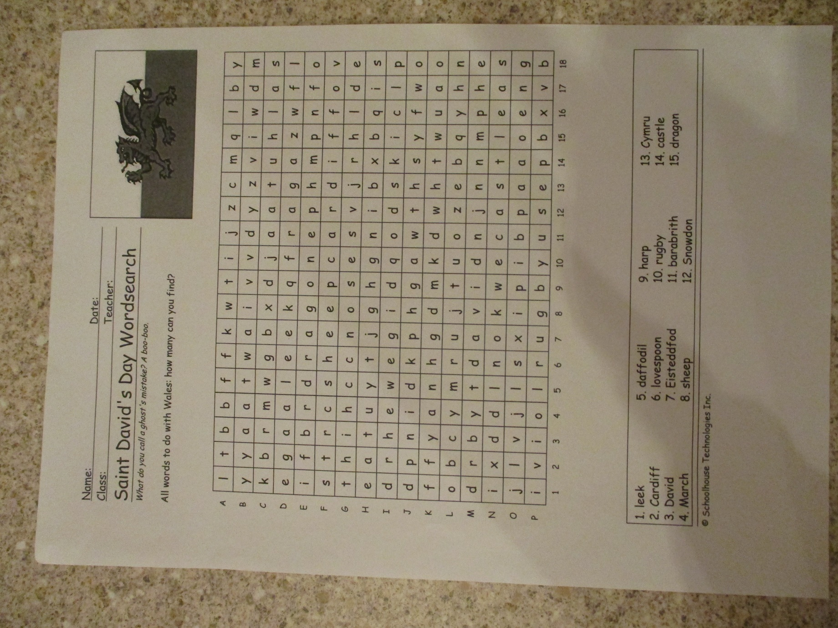

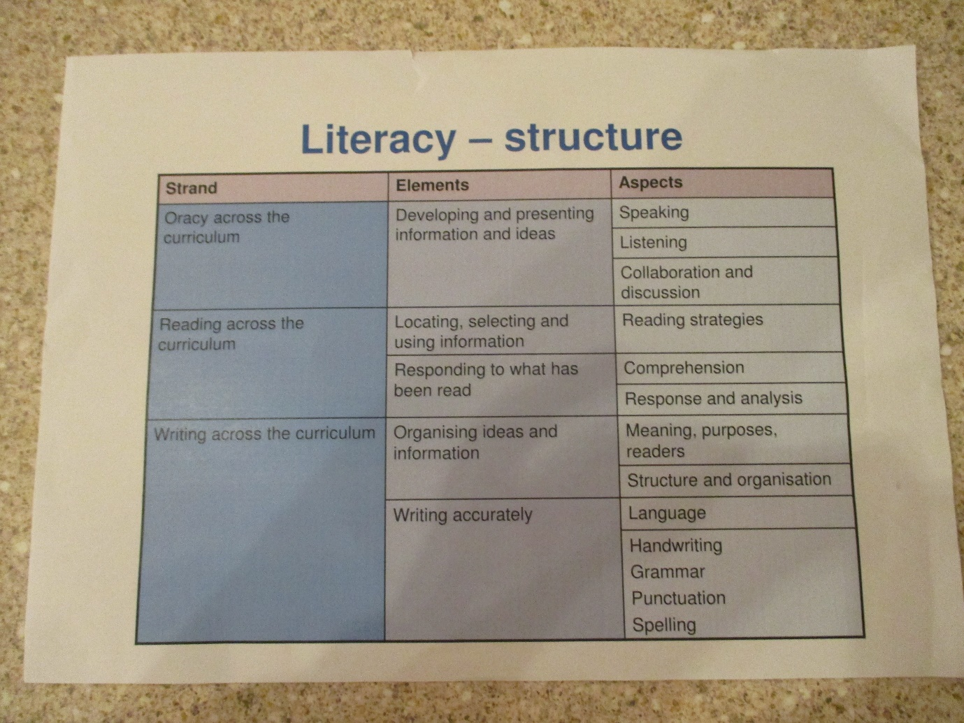

References:
Bates, B 2019. Learning theories Simplified. 2nd Ed London : Sage, pp 48 [Accessed 14 November 2020].
Bruner, J., 1971. The Relevance Of Education. 1st ed. New York: W.W. Norton.
CADW, 2020. Caerphilly Castle. [image] Available at: <https://www.visitwales.com/en-us/attraction/castle/caerphilly-castle-cadw-1891933> [Accessed 23 October 2020]
Gladys Briggs, 2020. [image] Available at: <https://gladysbriggs.wordpress.com/support-learning-activities/> [Accessed 23 October 2020].
Hughes, M., 2017. Literacy Policy. [online] Penglais School. Available at: <http://penglais.org.uk/index.php/information/school-policies.html> [Accessed 14 November 2020].
Hughes, M., 2017. Bilingualism Policy. [online] Penglais School. Available at: <http://penglais.org.uk/index.php/information/school-policies.html> [Accessed 14 November 2020].
https://hwb.gov.wales/api/storage/afca43eb-5c50-4846-9c2d-0d56fbffba09/curriculum-for-wales-guidance-120320.pdf, 2020. [ Accessed 10 November 2020].
Pinterest, 2020. National Symbols. [image] Available at: <https://www.pinterest.co.uk/pin/358739926550768849/> [Accessed 23 October 2020].
Professorjackrichards.com. 2020. Teaching Listening And Speaking From Theory To Practice. [online] Available at: <https://www.professorjackrichards.com/wp-content/uploads/teaching-listening-and-speaking-from-theory-to-practice.pdf> [Accessed 13 November 2020].
star editions, 2020. Welsh Lady. [image] Available at: <https://stareditions.com/products/sm556-welsh-lady?variant=636214018064> [Accessed 20 October 2020].
Siarter Iaith framework, 2017: Initial guidance for schools. Cardiff: Welsh government, p 5
Welsh Government Welsh in Education, 2017. Welsh In Education. Cardiff, p.2.
Welsh government, 2020. A New Curriculum In Wales. Cardiff: Welsh government, pp.6-7.

