Should Readymade Pieces Be Classed as Art? Marcel Duchamp ‘Fountain’ and How It Changed the Art World

Looking at the work of Marcel Duchamp in particularly his piece the ‘fountain’ and other the readymade pieces that have been inspired since, studying the the arguments weather it should be or should not be considered as art work. The different artists that have put readymade pieces in galleries and their reason why they think that it is art work. A lot of the work is controversially called art and some pieces are part of the Tate’s collection of art works. One of these pieces that is said to be influenced by Duchamp’s work is by Italian artist Piero Manzoni entitled ‘Merda d’arista’ or ‘Artists shit’ where Manzoni packaged exactly 30g of faecal matter into 90 tins. The Tate has number 004 in its collection, purchased in 2000. It is said the be ‘an ironic statement to the art market’ (1) but do all readymade exhibits make a statement and is this why these pieces can be considered as artwork? In this essay I will be looking and discussing the arguments for and against readymade objects being put in under the artwork bracket.

Duchamp’s ‘Fountain’ has been claimed to be the most famous ready made in art history, I for one would have to agree with 17 replica urinals made commissioned by Duchamp after the original signed wrongly by Duchamp as R. Mutt, where thrown away. The ‘fountain’ is still discussed 100 years on, and has inspired some other great conceptual artists. The ‘fountain’ was not the first piece of ‘readymade’, that would be the ‘bicycle wheel on a stool’ which he had made 2 years prior and said he just like the ‘look of it’ (2). The ‘fountain’ made its first appearance at an independent art show where Duchamp was on the board this is said to be why he did not sign the piece by his true name, it was originally a practical joke but this joke changed the art world.

A more contemporary artist Tracey Emin has used a readymade as an installation piece named ‘my bed’ in 1988 for this Emin, slept, had sexual encounters while menstruating.

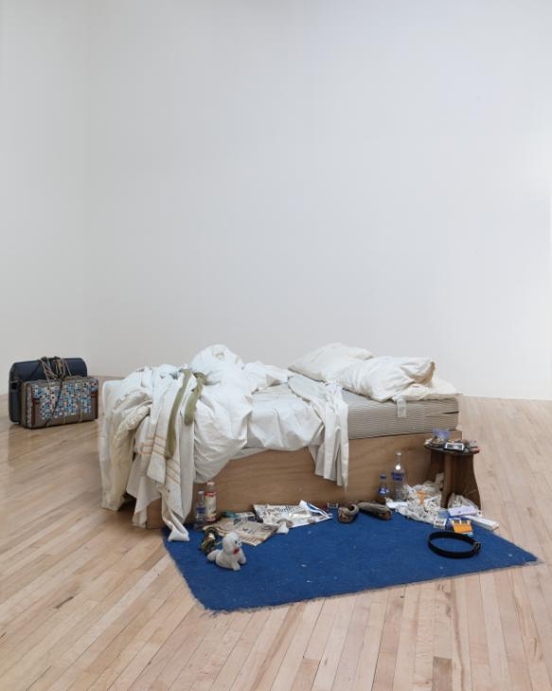
(figure 1)

She has had a lot of criticisms for this piece saying that ‘anyone could make an unmade bed’ and to that she has responded ‘yes but they didn’t, I did’. This installation has been shown in the Tate in 2015 amongst Francis Bacon’s work and Emin’s sketches (3) this was her own choice as she said that her work linked to Bacons through the movement of the rolls and curves in his work and that it reminded her of the rolls in the duvet and the movements whilst in the bed. Both Duchamp and Emin have taken things people use in day to day life and call it ‘Art’ both have been discussed and both have been put in the Tate museum, London. Emin has to physically sleep and smoke in the bed before she can exhibit it, going back to a dark period of her and almost relive it. I think that the process she has to go through to create the bed is more artistic than the piece itself, going through the motions and emotions of a time that the viewer can imagine and relate to the depression and passion that had been felt. She has taken those feelings and visualised them, by making her bed allowing herself to be vulnerable to the public eye. Giving her work some meaning, it wasn’t a bed she chose at random it was about the past.

The works by another British artist, Damian Hirst titled the physical impossibility of Death in the mind of the living is slightly different Hirst paid £6,000 for a tiger shark that was set in formaldehyde to preserve it in a vitrine. The concept of having a dead animal on display as art certainly made some animal rights supporters upset, what is it about the piece that allows it to be art? Well, it depends on how you perceive it anything that comes from the natural world is beautiful in its own way, flowers and humans and animals but is the intention behind it what makes it art, much like in case of Emins My Bed. The name of the piece shows that Hirst comes from a very conceptual way of thinking and that the intention and making the viewer think and assess life and death is the art behind the piece ‘pushing the viewer out of their element by introducing into a gallery setting a shark that was real enough to frighten you’ , I think this because a lot of Hirsts work revolves around death and skulls. Hirst has said that the title for the physical impossibility of death in the mind of the living is just a way that he had described the idea of death to himself (4). This piece was what Hirst selected for an exhibition that explored the influenced by Marcel Duchamp. Duchamp’s conceptualized art influenced Hirst as they were both used to shock audiences and used the concept of the work to over shine the visual aesthetic.

Jeff Coons another artist working with readymade objects created a series called ‘Pre-New’ which were composed of hoovers/ vacuum cleaners mounted acrylic and illuminated by fluorescent lights, the work in this series set about exploring the way the viewer can transfer desires onto seductively gleaming inanimate objects and how newness can have such an appeal. Koons has said that ‘If one of my works was to be turned on it would be destroyed.’ (5) Koons used brand new he purchased these vacuum cleaners for the purpose of not using them as they were intended to be used, Duchamp did this also with his ‘Fountain’ he purchased it from a plumbing supply shop and turned it on its side to call it art. Of course the meaning of the ‘Fountain’ is not as thoughtful as Koons ‘Pre-New’ it did change the art world because when it was first exhibited at the society of independent artists inc. it was this society that decided that their would be no jury on what could be exhibited that Duchamp repurposed and really put the ‘readymade’ in the art world. (6)
It reminds me of the artist Martin Creed, there is an interview with Creed where he says that “Art is anything used as art by people” (7) and with ready made art I find this to be
true. Creed is another artist who uses ready made objects, a lot of his work often has many of the same or similar objects place or stacked beside each other which is almost always in height ascending or descending order. Creed is known for getting under peoples skin and not doing things in the traditional way, much like how Marcel Duchamp did not stick to the traditional way of sculpture by putting a urinal on display. Although Creed does see his work differently his ‘Sheet of A4’ before getting his foot in the door and being on the front cover of the Tate Gallery Publication this ‘Sheet of A4’ is a piece of work that he had once sent to the Director of the Tate Britain, Nicholas Serota who had his secretary neatly flatten it and put it into an envelope to be returned to Creed. A lot of Creeds early works where quite comical in ways with these heavy and serious names like, Work 79; some blue tack kneaded, rolled and depressed against a wall or Work 100; On a tiled floor in an awkward place, a cubic stack of tiles built on top of one of the existing ones, you don’t know theres any art in the room until you trip over it. Work 79; some blue tack kneaded, rolled and depressed against a wall is quite literally the process and what the final product was, it was a small piece of blue tack that was depressed against a wall. The process of how it was made was the blue tack was put on the wall is the artistic part just like how Emin made her bed the process is a very important part of conceptual art, how you got to the final product is often much more critical to both the artist and the viewer, it can ignite feeling for artist weather that is tangible such as touching blue tack being able to imagine the feel of it in your hands and being able to the imagine the process Creed went through to get Work;79 or it’s a more intangible and emotional feeling of how Emin felt in a dirty bed for four days drinking and smoking, having relations with men in that bed, being able to draw any connection to those processes that she went through.

Is Ready made still revolutionary?
With Duchamp’s ‘fountain’ now over 100 years old, and even the latter works like Emins ‘My Bed’ that is now 20 years old, that had once spun so much controversy in the art world and media is now a central form of art and art production.

After viewing much of the different works by the artists that had been inspired by Marcel Duchamp and the different ways different artists used the ‘ready made’ I have come to the conclusion that yes, ready made can be considered art work. In this world sometimes we can walk past and have day to day objects that we see and use but we never actually see them, we don’t see them for anything bar their use, part of what I like about the ready made is that when these uses are taken from an object we can then appreciate the look, just like how some art critics have said about the curves in the ‘fountain’ and the reflection of the porcelain that beauty would never have been seen until the use had been taken from it and it wasn’t functional but put in an art space and considered art. I also think that a lot of this work that has been discussed in this essay is conceptual, which is the idea or concept around the art work that then over weighs the aesthetic of the work, this is like the piece by Hirst where the wanted to scare and wow his audience, painting a shark on large canvas wouldn’t have done that, but a 13-foot dead tiger shark in formaldehyde did. Making the viewer imagine if it had not been dead then they would be and getting them to think about greater things and have questions about not just the shard but the concept in which Hirst had first thought of it, if a piece of art work can connect and make the viewer wonder or spark a feeling of interest and imagination then I do think that it should be classed as art.

Bibliography

- Milner, C (2002) ‘Tate values excrement more highly than gold’
http://uk.phaidon.com/agenda/art/articles/2016/may/26/the-fascinating-tale-of-marcel-duchamps-fountain/

- Jakaws (2015) ‘Tin of Artist’s Shit Valued at $80,000.00 “Explodes”’ http://livehopething.blogspot.co.uk/2015/02/tin-of-shit-valued-at-8000000.html

- Emin, T (2015) ‘My bed’ Tate shots
http://www.tate.org.uk/context-comment/video/tracey-emins-my-bed-tateshots

- Damien Hirst and Gordon Burn, ‘On the Way to Work’ (Faber and Faber, 2001)
http://damienhirst.com/the-physical-impossibility-of

- National Gallery Scotland
https://www.nationalgalleries.org/art-and-artists/87198/new-hoover-convertibles-green-red-brown-new-shelton-wetdry-10-gallon-displaced-doubledecker-1981

- Dr Harris, B and Dr Zucker, S (2012) Duchamp, Fountain
https://www.khanacademy.org/humanities/ap-art-history/later-europe-and-americas/modernity-ap/v/marcel-duchamp-fountain-1917

- Jones, j (2000) Let There Be Light the Observer
https://www.theguardian.com/theobserver/2000/mar/19/life1.lifemagazine11

