Introduction
Describe the nature of the organisation and the operational context:
The Welsh Ambulance Service Trust (WAST) was established in 1998 and serves a population of over three million people and covers an area of over 20,640 km (WAST, 2022). The WAST employs almost 3,500 people with approximately 70% of the workforce within Emergency Medical Services (EMS), including Clinical Contact Centres (CCC) (WAST, 2022).
Wales consists of not only urban but rural and remote areas which require a more dynamic approach to the way the WAST responds to patients’ varying needs. The service answers and responds to non-urgent, urgent, and emergency calls within the community that require some form of clinical triage and intervention.
The organisational structure contains many directorates beneath the Chief Executive Officer, the below identifies the hierarchical structure with a detailed view on the Digital Directorate:
Furthermore, the service works closely with key stakeholders both internally and externally to meet targets set by Welsh Government (WG) that include financial constraints, Research and Development, succession planning to include the Integrated Medium Term Plan (IMTP), and continually striving to better the patient experience.
Identify the BUSINESS Problem:
WAST is on a journey of embracing digital technology to support the development of our clinical offering as an ambulance service within the wider National Health Service (NHS) Wales (WAST, 2020). One agreed and funded priority was to procure an electronic Patient Clinical Records (ePCR) solution with the application being operational on all clinicians’ WAST iPads.
WAST (2020) identified 4 key investment objectives for the ePCR business case:
1 | To use better data and access to information to improve the quality of patient care
2 | To increase data sharing in a collaborative whole system approach
3 | To improve efficiency by using high quality data to reduce waste
4 | To increase the value of our clinical data through quality and timeliness

By implementing the electronic record, the above key objectives should be achieved. Porter et al., (2018) state that electronic patient records are clinically safer and more robust to scrutiny than traditional paper records. They go on to say that access to patient health records through the digital medium is preferable in all instances.
The current handover to clear process involves both a WAST clinician and ED staff communicating the formal handover whilst physically with the patient, however, once the verbal handover is complete, both the ED staff and WAST clinician must leave the patient to attend a fixed Hospital Arrival Screen (HAS) to enter their individual Personal Identification Number (PIN) to complete the handover process. Unfortunately, this is challenging due to the location of the HAS, with other contributing factors including, distractions on the way that may separate them which will delay the process resulting in added time away from caring for the patient. Handover pressed prematurely by another member of ED staff where patients would be classified as handover complete whilst the formal physical handover was still taking place. Data isn’t accurate due to the many discrepancies in the process whilst this further delays the WAST clinician clearing resulting in lost hours with reduced ambulance availability to respond to waiting emergency calls.
Possible causes and effects of business problems can be brainstormed and documented as a visual diagram which is recognised as the Fishbone diagram, also known as Ishikawa Fishbone Diagram:
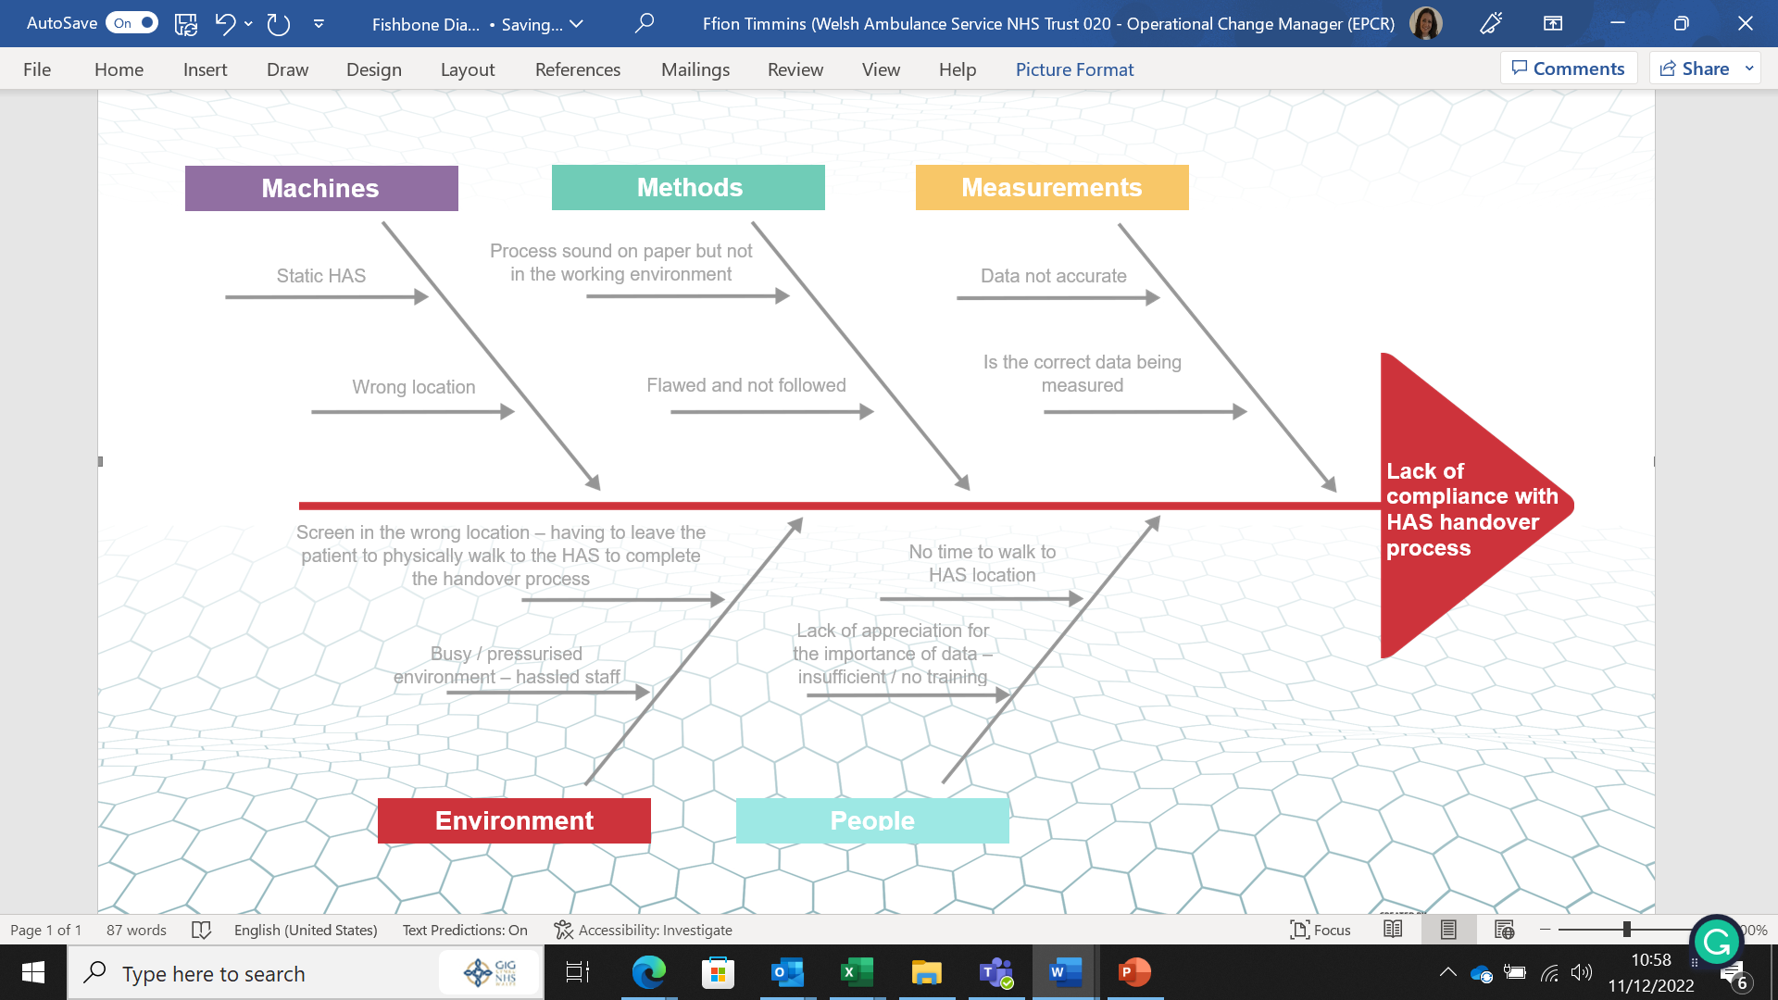
(TemplateLab, 2017)
Explain how it can be improved using an Information System:
The use of an Information System is recognised as critical in improving the efficiency, cost-effectiveness, quality, and safety of healthcare (Gomes and Romão, 2018)
The lack of compliance and process would be improved using an Information System showing the required work breakdown structure which highlights all key deliverables of the project:

Need more detail re how it will be improved here and possibly a quote

Justification
Explain the change you will be introducing:
The ePCR application on WAST clinician’s iPad is a mobile device, therefore, capturing live data which will result in an improvement in the process. Currently, the ePCR functionality does not support the dual PIN handover process. A dedicated screen on the ePCR application could act in lieu of the existing HAS screen and can be designed to include dual PIN handover when a physical handover has occurred. The system would need to be designed so that both WAST and ED staff would enter their PIN to allow the handover “stamp” to be recorded accurately before the closure of the ePCR record.

Justify why you think these changes are important:
The issue of inaccurate handover recordings identified a need to improve the use of data by adding a robust process, that is measurable and that will enhance patient care and safety. A recent Health Inspectorate Wales (HIW) report has indicated that the current patient handover process is not adequately used across HAS sites in Wales and is not compliant with the hospital handover guidance issued by the WG in 2016. The guidance stipulates the need for a timely patient handover to clear within 15 minutes (WAST, 2021).

A key element to the above is that the HAS is not available in every cubicle or corridor as they are static units located in a couple of places in ED. Furthermore, the process isn’t compliant due to a busy ED with staff having no time to leave their area of work, a lack of energy, and no understanding of the importance of the data. The expectation from HIW and WG is to capture accurate data, by using a technology system incorporating the handover recording into the ePCR application would improve the process and allow for a safer handover process with minimal distractions which would provide a timely flow of live, tangible, and accurate data with no room for errors. This will also result in a timelier release of WAST resources to respond to other 999 calls waiting in the community.

Aims and Objectives
Aim
Implementing the handover to clear process using the ePCR Dual PIN instead of the current HAS will result in accurate handover data and improve patient safety, furthermore, it will enable WAST resources to clear in a timelier manner. By the end of September 2023, a 10% improvement is anticipated, which will positively increase with ongoing training, support, and monitoring moving forward.
Objectives (SMART)
By the end of July 2023, we will have worked closely with operational colleagues and key stakeholders to ensure the following SMART (Specific, Measurable, Achievable, Realistic, Time-Bound) objectives:
Constant liaison with the supplier to ensure the solution is configured as desired. The training needs of all users will be identified, planned, and delivered. Testing and deploying the new process will be carried out with continual review through the Plan, Do, Study Act (PDSA) cycle. The launch of the new data collection from the point of handover.
Accomplishing the objectives should achieve the overall aim as planned. The above objectives are not only SMART but follow Leavitt’s Diamond Model which is based on four major interdependent components of People, Task, Technology, and Structure. A change in any component will also affect the other three.
Literature Review (based on the business problem)
Define your search strategy
A literature review gives readers the opportunity to learn more about a particular topic. The initial searches were as extensive as possible to try and identify relevant literature about the business problem, the search was undertaken using multiple specific keywords to base the research on Google Scholar which were ‘lack of compliance in hospital handover’ which produced over 26,000 results. To ensure studies were relevant and not outdated the search criteria were narrowed to a time frame set to 10 years with anything written from 2012 onwards and published in English. However, the search still produced over 18,000 results, which indicates that the search criteria needed to be narrowed down.
Another systematic review of the literature was performed by searching multiple databases, including Pubmed, Medline, and MIDRIS. Some of the search terms used were ‘handover data’, ‘timely handover’, ‘ambulance handover’, and ‘accurate data’. Once the search results were populated, further sub-headings and synonyms were added along with utilising the Boolean operators (AND, OR, NOT or AND NOT) to combine and exclude keywords and to increase the specifics of the search.
Reading the search results in full would be impossible due to the vast number of studies populated as the subject is quite broad. Reading the title and abstract of the studies determined their suitability or relevance to the identified problem which would then necessitate reading the full article.
PRISMA Diagram

Present your results and discuss the emerging themes. (evidence of how implementation and adoption of IS solved business problems and evidence of the use of different project management methodologies for IS implementation projects).
Whilst carrying out this literature review the author has been drawn to the lack of information on systems currently in use to support a digital handover process. Moreover, it is apparent that this sphere of work has not presented a problem for other United Kingdom based ambulance services that rely upon a HAS to track the ambulance hospital handover process and has therefore not developed or introduced an electronic mobile solution.
Studies conducted by Tan et al., (2021) stipulated that patient safety could be improved during the handover process by implementing an electronic handover process, furthermore, the findings from surveys are consistent with previous studies indicating that combining both a verbal and electronic handover together would overall improve the overall patient care. However, a systematic review of the literature on hospital handover concluded there is no reliable evidence to state that standardising handover procedure leads to sustained patient improvements (Sujan et al., 2015).
Fitzpatrick et al., (2018) postulated that a digital handover is not always possible due to the patient’s condition being time-critical and requiring immediate ED care, clinicians have found a way around the issue with observations being written on their gloves or on a random piece of paper, resulting in the need to complete the ePCR following the physical handover. They strengthen their statement by adding that clinical information written on a glove is inherently dangerous towards a robust clinical handover, yet they concede that it is necessary for the clinician to do this to ensure that all pertinent clinical information is presented at handover. However, they acknowledge that these practices do not comply with the traditionally held view of a handover process due to there being no physical data capture as to the physical point of patient handover, thereby transference of clinical care between originations is somewhat clouded furthermore, these practices inevitably lead to delays in the availability of the clinicians to respond to the next waiting 999 incident.
Limited evidence of the digital handover process contained within the conducted surveys undertaken on this area identified that ambulance clinicians are reporting several factors contributing to the delay in the ePCR completion following the point of physical handover, these being technical in nature, consisting of inadequate system architecture and poor user interface design (Altuwaijri et al., 2018).
Hovenkamp et al., (2018) reported that the clinician’s satisfaction with the quality of the patient handover is determined by different factors, one being the use of handover interfaces. Therefore, both studies make a contribution to evidence that inadequate digital systems do have a negative impact on the patient handover experience.
However, JENSEN et al., (2013) went on to state that the patient handover needs to be improved by addressing cultural issues among multidisciplinary staff and that a lack of professional awareness and knowledge plays a key role in identified failures. Staff training combined with structured tools has the potential to change the culture and improve the handover process.
Dawson et al., (2013) concur somewhat with the above views, that Ambulance Clinicians and ED staff are lacking awareness of the importance of each other’s required duties, and education and training would improve the handover process. However, they clearly maintain that the responsibility for accurately demonstrating the point of formal patient handover resides with the first attending clinician, interestingly they discuss the merits of capturing a signature on a piece of paper. Whilst this is less time-consuming, having to physically attend a static HAS to be an onerous part of the handover process, utilising paper is clearly outside of the modern held view of carbon footprint reduction by the limitation of paper use.
The writings of …………………. Conclude that an electronic solution is best placed to limit carbon footprint impact and to robustly strengthen the clinician to clinician transference of data to ensure maximum clinical safety is maintained at all times.

Identify a suitable Project management methodology with justification:
When selecting a project management methodology, there are numerous theories around, each with their own individual strengths and weaknesses. Whilst many are effective long-standing methodologies, Kerzner (2017) stated that traditional methodologies are somewhat predictable and that due to various factors projects have been unsuccessful. Due to their rigid policies and procedures, they are becoming less popular.
A traditional methodology is Waterfall which consists of five stages that need to be completed singularly before moving to the next stage, it lacks flexibility as the process is rigid with an added risk of having nothing to show the customer until the very end of the project (TemplateLab, 2017).
Kerzner (2017) further added that Agile is now becoming the preferred methodology, with different types being Scrum, Lean, and Kanban. Reduced rules, practices, and documentation mean it is lightweight with the ability to be flexible in process, in comparison to the traditional method.
“Agile development models are currently the rage, for product development, agile methodology is truly amazing” (Ahmed 2012), but also goes on to say that one of Agile’s limitations is that it doesn’t suit a project where staff work in varying time zones, as communication is constantly required and a key to the project’s success. Agile has a lack of associated documentation that could potentially cause issues further down the line when most of the original project staff have dispersed to other roles.
Nevertheless, PRINCE2 is the preferred and recognised methodology within the NHS and WAST, however, there are limitations with PRINCE2 which are document-heavy with a need for constant senior management involvement, which can delay timelines due to other work commitments. However, as the ePCR is a small project team and as the limitations are known and understood they can be worked around. Adding the dual PIN handover process interface would be a relatively small part of the project in comparison to the implementation of the full ePCR application, therefore the PRINCE 2 methodology will be applied as it will allow following the same structure and method of the overall ePCR project and the need for the required documentation.
Describe the selected Project management methodology
Projects IN Controlled Environments (PRINCE) was developed by the Central Computer Telecommunications Agency (CCTA) in 1989. Due to the need to develop the methodology and in consultation with European organisations, in 1996 PRINCE2 was developed (Anon, 2021).
The PRINCE2 methodology provides a structured framework to be followed through a project’s entity, pertinent objectives are set at the very start where management mechanisms are in place to allow for monitoring and tracking. The objectives are continually reviewed and analysed at the end of the project to identify if they were achieved (Hinde, 2018).
Hinde (2018) illustrates the PRINCE2 four integrated elements, which are, principles, themes, processes, and project environment. Additionally, the below framework addresses the planning, delegation, management, and control of the six aspects of project performance – time, cost, quality, risk, scope, and benefits.
PRINCE 2 | 7 Principles | 7 Themes | 7 Processes
1 | Continued Business Justification | Business Case Theme | Start a Project
2 | Learn From Experience | Organisation Theme | Initiating a Project
3 | Roles and Responsibilities defined | Quality Theme | Directing a Project
4 | Manages by Stages | Plans Theme | Controlling a Stage
5 | Manages by Exception | Risk Theme | Managing Product Delivery
6 | Focus on products | Change Theme | Managing Stage Boundaries
7 | Tailor to Suit Project Environment | Progress Theme | Close a Project

As stated earlier, PRINCE2 is the preferred methodology to be used by WAST, this ensures a consistent project management approach that the Project Manager can keep control of all aspects.
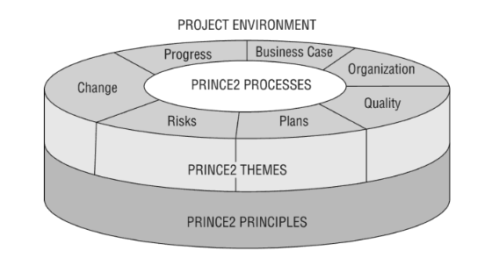
Hinde (2018)
Digital Directorate ePCR Team:
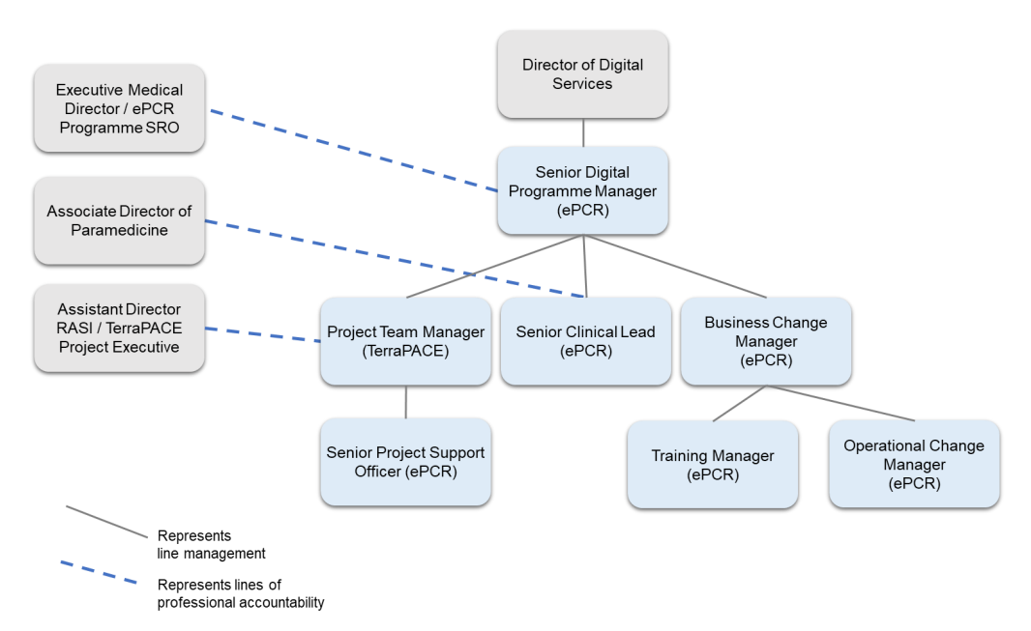
Discuss how you will implement the project management methodology

Discuss how you will evaluate the impact of your project
One of the key Quantitative Benefits of the ePCR project was to improve the hospital handover process, by implementing the new dual PIN handover process this should be achievable. Evaluating the impact of the new process will be continually monitored and carried out by closely looking at the data captured at the Data Warehouse (DW) end

Discussion
- Reflect on how you envisage your change will influence wider system improvements
- Relate this to other relevant domain knowledge from the literature
- Discuss possible extension or downstream benefits of your intervention

