

MBA
Global Business Challenges
BMMB7006
Module Lead: Rebecca Francis-Davies
Student Name: Md Sakib Ahmed
Student ID: 2503767

Executive Summary
Microsoft has now become a much bigger player in the AI business, and it poses tough questions. Microsoft isn't just a consumer of AI. It's also a cloud provider, model developer, platform operator and supplier of AI tools to regulated industries. The result is a “scale advantage” for Microsoft. But a failure can have a great impact upon many customers, sectors, countries.
This report offers an assessment of the approach Microsoft should take towards AI risks in the United Kingdom and the European Union. It incorporates PESTLE analysis, enterprise risk management, responsible AI and macroeconomic analysis. Results show that there is a strategic pull-and-push relationship. Even during times of economic uncertainty, there's demand for Azure and Copilot, allowing for continued investment. Yet, expansion is associated with expense, energy usage and supply chain strain and cyber risk. Regulation adds complexity. The EU AI Act introduces specific responsibilities for high-risk and general-purpose AI (European Commission, 2025). A flexible, regulator-led approach is followed in the UK. This can facilitate quicker innovation, but it can also lead to uncertainty as the responsibilities are split among the regulators.
The report lists five key risks: lack of data lineage and privacy control, biased, unsafe or opaque outputs, regulatory fragmentation, cyber and third-party model risk and loss of customer trust. Microsoft already has the processes and a large-scale security program in place, as well as standards defined for responsible AI. These are significant assets. But, with the scale of Microsoft's AI ecosystem, policies are not enough. Controls need to be tested, evaluated and correlated to product release (Floridi and Cowls, 2019). The report suggests a USD $165 million Microsoft Responsible AI Assurance Programme over 24 months. It involves a worldwide AI inventory, danger-based launch gates, enhanced data lineage, unbiased red teaming, third-party assurance, and customer transparency and sustainability measures. Establishing strong compliance through clear goals will boost trust, and prevent severe incidents. As a result, responsible AI isn't just a legal obligation, but also a long-term competitive advantage for Microsoft around the world.

Table of Contents
Executive Summary 2
1. Introduction 4
2. Microsoft’s AI Position and Strategic Exposure 4
3. International Economic Environment and Macroeconomic Effects 5
3.1 Demand, finance and infrastructure investment 5
3.2 Costs, labour and geopolitical exposure 6
4. Integrated PESTLE Analysis for Microsoft 7
4.1 Political and Regulatory Conditions 7
4.2 Social and Workforce Conditions 8
4.3 Technological, Legal and Environmental Conditions 9
5. AI Risk Management Priorities 9
5.1 Data Governance and Privacy 11
5.2 Ethical AI, Bias and Human Oversight 11
5.3 Regulatory Compliance in the UK and EU 12
5.4 Cybersecurity, Operational Resilience and Model Supply Chain 12
5.5 Customer Trust, Competition and Sustainability 13
6. Comparative Strategic Analysis: United Kingdom and European Union 14
7. Recommendations and Implementation Plan 15
7.1 Governance and Decision Rights 17
7.2 Data, Testing and Third-Party Assurance 17
7.3 Compliance, Trust and Sustainability 17
7.4 Programme Control and Risk Mitigation 18
8. Conclusion 18
Bibliography 19

1. Introduction
AI is reshaping the design, workflow and competitive landscape of products and services that multinational companies create. Generative AI can help cut software dev, data analysis, and customer service expenses. But it can also produce misinformation, expose confidential data and enable upright decisions or problematic actions. The question, therefore, is not so much whether or not Microsoft should invest in AI, but how it can increase AI with a commensurate pace of innovation in legal, ethical and organisational control.
This matter is particularly crucial for Microsoft, as it has total end-to-end operations in various segments of the AI value chain. It offers cloud infrastructure via Azure, distributes Microsoft and third-party models, and also utilises AI for its operations (Mikalef and Gupta, 2021). Therefore, risks can be from Microsoft's systems, from external model vendors, from business partners or from customers. This makes it hard to identify responsibility and can amplify the potential financial, legal and reputational damage. This report will guide Microsoft's senior leadership on the impact of political, technological, regulatory and economic change on AI risk management. It is a comparison between the United Kingdom and the European Union, as both are key markets and have different regulatory strategies. EU's approach is a harmonised, risk-based legal framework, and the UK's approach is primarily existing regulators and sector-specific regulations. The analysis thus compares the impact of these differences on the compliance expense, design of Microsoft's products, evidence requirements, speed to market and customer trust.
The report uses a Microsoft-specific PESTLE analysis and enterprise risk management principles and responsible-AI research. These frameworks are backed by recent academic, governmental, regulatory and organisational evidence (Raisch and Krakowski, 2021). The report ends with concrete, actionable, cost-effective and time-bound recommendations to ensure innovation is safeguarded while accountability, regulatory compliance and long-term competitive advantage are enhanced.
2. Microsoft’s AI Position and Strategic Exposure
Today, AI is not a single project, but a part of Microsoft's strategy to build things. Microsoft earned US$ 281.7 billion in revenues and operated with operating income of US$ 128.5 billion in 2025. Azure's revenue was more than US$ 75 billion and grew by 34 per cent. The findings indicate that cloud and AI services are increasingly playing a significant role in Microsoft's success (Microsoft, 2025a).
This is supported by the degree of adoption. As of December 2025, Microsoft had over 150 million people using Copilot. As of October 2025, there were more than 26 million users of GitHub Copilot. Additionally, Copilot Studio has been embraced by over 230,000 organisations, with 90% of Fortune 500 companies leveraging it to enhance their businesses (Microsoft, 2025b; Microsoft, 2025c). These are the numbers for network benefits. The higher the number of customers using Azure, the greater the demand for it, the more developers will be drawn to it, and the more it will be supported and enhanced. Scale also increases exposure, though. There is potential for a model failure, privacy breach or unsafe output to impact multiple organisations simultaneously.
The risks faced by Microsoft are higher than the risks faced by an average user of AI. It provides infrastructure, the development of applications, the distribution of models and deployment to the customer. Microsoft Foundry has over 11,000 models, both Microsoft and third-party models. It has more than 80,000 users, including 80% of the Fortune 500 companies (Microsoft, 2025d). This will reduce the dependency on a single provider of the model. However, it also widens Microsoft's supply chain and makes it more difficult to trace back the responsibility. The potential source of harm can come from a model provider, customer data, system integration or end use of the application. Microsoft would thus have to monitor the entire service chain - not just their built models.
This is a comparable compromise to that of the OpenAI partnership. It provided Microsoft with early access to cutting-edge models and boosted Azure demand. But it also poses concentration, intellectual property, and governance issues. In March 2025, the UK Competition and Markets Authority (CMA) decided not to investigate the partnership as a merger. This eliminated a short-term regulatory risk but did not alleviate concerns about dependency or potential future competition issues (CMA, 2025).
Evidence shows that AI generates value when it is coupled with technology and quality data and with skilled employees (Mikalef and Gupta, 2021). But the post-fine-tuning, integration or deployment in other contexts can also alter the capabilities of Generative AI (Feuerriegel et al., 2024). Continuous, use-case-level monitoring is thus needed, not just a one-shot model approval, for Microsoft.
3. International Economic Environment and Macroeconomic Effects
3.1 Demand, finance and infrastructure investment
Microsoft is impacted by the macroeconomic environment in terms of demand for its products, capital allocation, energy costs, labour markets and exchange rates. The OECD predicts growth will decelerate to 0.9 per cent in 2026 for the UK and 0.8 per cent for the euro area. Inflation is also expected to be 3.7 per cent. in the United Kingdom. Weak growth and high and ongoing inflation could lead to postponing AI initiatives or expecting quicker outcomes on AI investments (OECD, 2026a; OECD, 2026b). This is relevant, as Azure usage and Microsoft 365 subscriptions require customers to be ready to increase their spending on digital.
Microsoft is not likely to be deterred by higher interest rates. In 2025, the company had an operating cash flow of US $136.2 billion and US $94.6 billion in cash and short-term investments ($94,600,000,000.00) (Microsoft, 2025a). Indirect risk is greater. High-cost finance can strain customers' technology budgets and drive up data-centre financing costs throughout Microsoft. In 2025, Microsoft also spent US $64.6 billion on its property and equipment. This poses a challenging capacity decision. Investing too little means that Azure may not realise its full potential, while investing too much risks having unused infrastructure if demand for Azure drops.
3.2 Costs, labour and geopolitical exposure
AI also alters Microsoft's business model. Specialised chips, electricity, cooling, networks, and employees are required for advanced models. According to Microsoft's report, the investments for scaling AI infrastructure led to a decrease in the percentage of cloud gross margin, while Azure experienced strong growth figures (Microsoft, 2025a). The drop in inference prices could benefit unit economics. Stanford reported that the prices of obtaining GPT-3.5-level performance decreased by over 280 times in the period from November 2022 to October 2024 (Maslej et al., 2025). But lower-cost AI could drive up overall consumption. Management should therefore not only track growth among users, but also the number of profits and energy consumed per workload unit that is risked.
This gives rise to an automation-augmentation tension in AI. While job elimination can lower cost, excessive job elimination can lead to the loss of human knowledge, which can put unsafe outputs under question. Microsoft should dovetail Copilot deployment with process rework and clearly defined accountability and risk-driven reskilling. Chip supply, where data is stored, and infrastructure are also impacted by geopolitical tension. These operational risks are not ones that can be addressed with financial hedging. Microsoft should provide a model for situations with lower demand, limited supply, decreased energy supply, and stricter localisation. This would enable investment decisions to be taken based on the prospect of growth as well as the downside risk.
4. Integrated PESTLE Analysis for Microsoft
PESTLE framework only works when it alters decisions. In the case of Microsoft, the factors are closely interrelated. These consequences include political pressure, which can turn into regulation; regulation alters technical design; technical design alters energy use and cost, and these impact public trust. Table 1 thus associates each of the external factors with a Microsoft-specific risk and management implication.
Table 1. Microsoft-specific PESTLE analysis
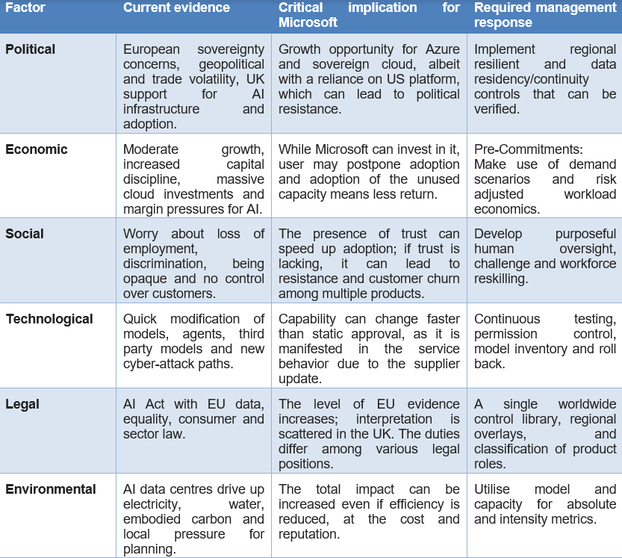Source: Author analysis based on Microsoft (2025a; 2025c), HM Government (2025), European Commission (2024a), OECD (2025a; 2025b) and CISA (2024).
4.1 Political and Regulatory Conditions
Political backing of AI opens up growth opportunities for Microsoft, while also intensifying the pressures for national control. AI infrastructure, adoption and skills are drivers of productivity and public-service reform in the UK AI Opportunities Action Plan (HM Government, 2025). This aids the demand for Azure, Copilot, and sovereign-cloud services. But government officials could be unwilling to depend on a single US company for systems. Microsoft's European digital commitments are through local data controls, promises from European oversight and operational resilience. However, their value is in the fact that that is just words and an experience in enforceable contracts and continuity plans. The EU has a more directive approach. The European Commission's AI Act came into force in August 2024, bringing in obligations based on the type of AI systems and risk level (European Commission, 2024). In May 2026, a provisional agreement was reached between the Council and the Parliament that some of the high-risk requirements be deferred until December 2027 and August 2028. This will give it extra preparation time but will not eliminate the risk records and technical documentation, logging and post-market monitoring Microsoft will need (Microsoft, 2025b). The retrofit of such controls after development would be much costlier and would slow down product launches.
In the UK, we are open for business, but we're not open for abuse. The Data Protection Act 2018, Data (Use and Access) Act 2025 and sectoral regulations continue to apply in the UK as UK GDPR. It is important for Microsoft, therefore, to adopt a single set of controls for AI globally, instead of separate product-based controls.
4.2 Social and Workforce Conditions
To be accepted by the public, AI must be considered fair, safe, and controllable. Business documents and software code, identity records and communications are important to Microsoft because customers store them in its ecosystem. When Copilot causes harm, users are not to blame or allowed to split up Microsoft from a third-party model. So even if some legal responsibility is passed to customers, Microsoft may be found liable for a damaged reputation.
Positive communication is not the only way to build trust. Clear governance mechanisms, stakeholder collaborations, and operational procedures are essential for responsible AI throughout the AI lifecycle (Papagiannidis et al., 2025). This is also true with the public in the UK. Moreover, only 29 per cent of adults believed that the government would be competent at using AI for some tasks in August 2025, compared to 43 per cent who did not. While this evidence is on the Government's side, it shows that organisations can't take AI for granted. Adoption is also impacted by the workforce response. When Copilot is introduced primarily as a way to cut jobs, employees can be reluctant to embrace it. There is also a risk of automation bias that users might take the output of these systems at face value. This is because human oversight is ineffective when reviewers don't have the time, knowledge, or authority to challenge a system (Langer et al., 2024). Microsoft should therefore state its doubts, maintain audit trails and establish well-defined stop-and-escalate procedures. Although speed is somewhat affected by these controls, they can save customers from making wrong decisions and foster their confidence for a long time.
4.3 Technological, Legal and Environmental Conditions
The pace of technology advancement is quicker than normal corporate approval processes. Agentic AI enables multiple tasks to be performed without requiring human intervention again and again. This is useful, but it will amplify the impact of any error. Content filters might block an unsafe response, but they might not prevent an agent from transmitting information or modifying a record or approving a faulty transaction. Microsoft should therefore review the permissions, identity, memory, tool access, and rollback controls prior to release. The NIST AI Risk Management Framework can aid in this lifecycle approach, with governance, mapping, measurement, and management (NIST, 2023; NIST, 2024).
A big Microsoft vulnerability is cybersecurity. CISA (2024) reported that the US Cyber Safety Review Board found that the intrusion into Exchange Online in 2023 could have been prevented and was a testament to the challenges within Microsoft's security culture. Microsoft's actions were through its Secure Future Initiative and by dedicating the equivalent of 34,000 full-time engineers to priority security projects. A significant investment, however, no proof of control effectiveness with regard to resource levels. Indicators of severe incidents, containment time, reduction in system privileges and repeated audit findings should be measured.
Other legal areas of risk include privacy, copyright, competition, employment and product safety and contract law. For every AI use case, Microsoft needs to determine if it's operating as a provider, deployer or processor. The environmental risk is almost as tangible. Microsoft has said its total emissions are 23.4 per cent higher than in 2020, partly due to the growth of AI and cloud (Microsoft, 2025). Decisions about data centres should thus be based not only on the efficiency for individual AI requests, but also on the absolute emissions, water usage, and limitations of electricity grids.
5. AI Risk Management Priorities
Microsoft's AI risk management should distinguish between inherent and residual risks. Inherent risk reflects potential harm prior to controls; residual risk reflects potential harm after governance, testing and contractual controls (Batool et al., 2025). This separation enables senior management to make a fair assessment of the effectiveness of control, prioritise investment and consider whether there is a need for more action.

Table 2. AI enterprise risk assessment for Microsoft
Risk | Likelihood | Impact | Existing control | Control gap | Residual priority
Data governance and privacy | High | Severe | Retrieval, plug-ins, customers data, third-party models - multi-faceted lineage through privacy programme, responsible-AI review, Azure security. | Retrieval, plug-ins, customers data, third-party models - multi-faceted lineage through privacy programme, responsible-AI review, Azure security. | High
Bias, unsafe output and weak oversight | High | Severe | Pre-deployment checks, testing, Responsible AI Standard (imprecise cross-language testing, domains and downstream use) | Pre-deployment checks, testing, Responsible AI Standard (imprecise cross-language testing, domains and downstream use) | High
Regulatory fragmentation | High | Major | Role Conditions and Evidences can vary according to the product/region. | Role Conditions and Evidences can vary according to the product/region. | High
Cyber and model supply chain | Medium–High | Severe | Secure Future Initiative, platform security, supplier contracts: timely injection, permissions to agents, model updates and supplier concentration. | Secure Future Initiative, platform security, supplier contracts: timely injection, permissions to agents, model updates and supplier concentration. | High
Trust and market access | Medium | Severe | There is still a limited level of transparency reporting, enterprise assurance, brand strength evidence on a product level and the likes. | There is still a limited level of transparency reporting, enterprise assurance, brand strength evidence on a product level and the likes. | Medium–High
Environmental and infrastructure | High | Major | The capacity demand and water demand can still rise, rise, rise! | The capacity demand and water demand can still rise, rise, rise! | Medium–High
Source: Author assessment. Ratings reflect Microsoft’s current scale, published controls and the UK–EU operating context.
5.1 Data Governance and Privacy
Quality of data, permission, representativeness, and provenance are important to AI performance. There is Microsoft processing of information via Azure, Microsoft 365, LinkedIn, GitHub and Bing. Unauthorised access is not the only key risk. Microsoft should be aware of what data has been inserted into a model, the purpose why it was used is legal, where it is stored and whether outputs can disclose sensitive data (European Commission, 2024b). This is more difficult in cases where Copilot is integrated with customer documents, foundation models and third-party plug-ins. Responsibility being shared can thus be a control gap.
Microsoft must mandate machine-readable sporadic progress of information concerning all high-impact AI systems. The source, legal basis, consensual status, location, longer retention, transformation and use of the model should be recorded. The introduction of a new data source or plug-in should prompt a privacy/impact assessment. This strategy is aligned with the data-governance provisions of the EU AI Act and the lack of fairness, transparency and automated decisions requirements by the ICO (European Commission, 2024a; ICO, 2025a; ICO, 2026). High heritage would also reduce investigations and aid customer audits. Any high-impact systems must be fully approved by the lineage, have a data-protection impact assessment and name an accountable owner prior to release.
5.2 Ethical AI, Bias and Human Oversight
The responsible-AI principles are a powerful part of the ethical basis of Microsoft, yet principles cannot be used to conclude on the safety of releasing a product. The primary problem lies in their consistent use on a variety of products, languages, industries and third-party models (European Commission, 2024a). Bias can be introduced to training data, labels, product design or the context of application of an output. Mean accuracy can thus cover up severe victimisation of smaller or underrepresented groups.
Microsoft ought to mandate disaggregated testing on all the high-impact systems. Performance across pertinent demographic groups, language and operating environments should be shown. Unfinished evidence must be restricted and not warranted historically by an overall claim of fairness. Responsible AI Standard already focuses on governance, measurement and transparency by Microsoft, but these standards need to impact real release actions (Microsoft, 2025b). Users must be aware of the presence of AI, what information it was using to generate an output, its major constraints and alternative ways to challenge it. The need to clarify AI-aided decisions to the individuals concerned is also mentioned in ICO guidance (ICO, 2025a). Tracking by humans can work only when the reviewers can have enough evidence in time and authority to dismiss the output.
Generative AI can also support fraud, harmful content and cyber operations. Microsoft cannot prevent every misuse, while excessive restrictions can reduce legitimate value. Higher-risk capabilities should therefore require stronger identity checks, rate limits, monitoring and incident response. Current safeguards remain imperfect and should be treated as layers, not guarantees (Bengio et al., 2025).
5.3 Regulatory Compliance in the UK and EU
The risk of compliance is substantive since Microsoft may be a model provider, system provider, deployer, distributor or data processor. Within the EU AI Act, the responsibilities vary according to the organisation and the level of risk the system involves and also draw on the availability of a general-purpose model. A single Microsoft product can thus be made up of multiple components controlled. The legal map by Microsoft needs to be country-specific at the product level as opposed to the general country level.
The EU system adds more paperwork, costs of monitoring and testing and this could also be seen to enhance the competitiveness of Microsoft. Microsoft has an opportunity to recover the fixed compliance costs through the high number of products available as well as the number of customers, whereas small competitors might not have the ability to generate such assurance. General-purpose AI responsibilities have been in effect since August 2025, such as transparency and copyright specifications (European Commission, 2025).
In the UK, there is more written flexibility, and it does not warrant more lax protection. Data-protection requirements in the UK were reformed by the Data (Use and Access) Act 2025, but the ICO is still working on guidance regarding automated decision-making (UK Parliament, 2025; ICO, 2026). One global control baseline and local legal requirements should be added to Microsoft. Credible releases should be used, but not because of completion deadlines or compliance.
5.4 Cybersecurity, Operational Resilience and Model Supply Chain
AI risk and cyber risk are becoming more interlinked. Confidential data can be revealed through prompts, retrieval systems and logs. Software permissions are also actions that AI agents can perform. An update of system behaviour may occur through a third-party model update, which does not alter the appearance of the interface. Therefore, AI assurance should be part of the Secure Future Initiative in Microsoft instead of addressing it like it would an ethical programme. The Cyber Safety Review Board found that the 2023 Exchange Online intrusion was caused by security failures that the board could have prevented, and this was why governance asserts needed to have quantifiable consequences (CISA, 2024).
Azure AI Foundry and Copilot require a model supply-chain register. It will have to record the name of the individual provider, model version, licence, evaluation result, constraint and the history of the incidents and replacement decision. Liability can be transferred through contracts, but they cannot protect the customer from harm. Microsoft is recommended to test the high-impact third-party models independently, establish suspension levels and keep the tested fallback models.
The framework developed by NIST facilitates the unceasing process of identifying and handling AI risks, and the ISO/IEC 42001 offers an AI management system at the organisational level (NIST, 2023; NIST, 2024; ISO, 2023). The certification helps, but it does not indicate that all the models are safe. The scope and limitations of every independent audit should be brought to light by Microsoft.
5.5 Customer Trust, Competition and Sustainability
The customer trust is economics asset as Microsoft does not sell a one-time product but long-term sales platforms. The customers must be convinced that their information is safe, the results of AI processes are subject to challenge and services will be held to account. Azure, Microsoft 365, GitHub and Copilot might experience a severe collaboration failure. Measuring trust must not be seen as an operating outcome but looked upon as a communication issue as well.
Microsoft ought to supply a standard AI service card detailing intent, information usage, restrictions, assessment outcomes, mandated human supervision, safeguards and regional regulations. Detailed evidence should be provided to high-impact customers via a secure evidence portal. Nonetheless, complete disclosure to the whole society can reveal an intellectual property or security loophole. Layered transparency should then be used in Microsoft. Of concern is the competition risk. The combination of cloud and productivity, identity and AI models at Microsoft enhances convenience but has the potential to make clients more dependent. Whereas the CMA ruled that Microsoft-OpenAI was not a merger requiring a competition investigation, the analysis substantiates that large AI collaborations should be examined in terms of competition (CMA, 2025). Microsoft ought to be in favor of model choice, portable logs and pragmatic switching paths. Sustainability has an impact on procurement as well. Of its 2020 baseline, Microsoft reported a 23.4 per cent higher in emissions due in part to the rising use of AI and cloud (Microsoft, 2025c). Total and per-use energy, water and carbon reporting should be done.
6. Comparative Strategic Analysis: United Kingdom and European Union
There is a difference between the AI governance of the UK and the EU. In the EU, there is a horizontal risk-based law—duty of providers, deployers and distributors. This makes compliance more expensive, but provides Microsoft with a certain standard throughout the single market. The companies that make up the UK are based on the regulators and the sector's principles. This is a great method for experimenting; however, it doesn't exactly assist with an absence of clarity since it will be Microsoft that decides how to interpret overlapping legal responsibilities.
Microsoft must make version-controlled compliance packs available for the EU, where the system purpose, call, testing, logging, human oversight and model updates are supported. While these packs could represent a good savings opportunity for compliance, suboptimal evidence could increase the liability of Microsoft. Consideration should be given to having a high-impact AI release to be considered by an AI Regulatory Forum in the UK, with a record of decisions kept. Microsoft shouldn't have separate product systems (UK Parliament, 2025). Ownership and data lineage, testing, incidents, and transparency should be part of one control baseline, along with the inventory aspect. Local rules can be mapped to the evidence, with UK and EU overlays. It avoids duplication and makes sure it's extremely quick and an added advantage.
Table 3. UK–EU comparison and strategic response
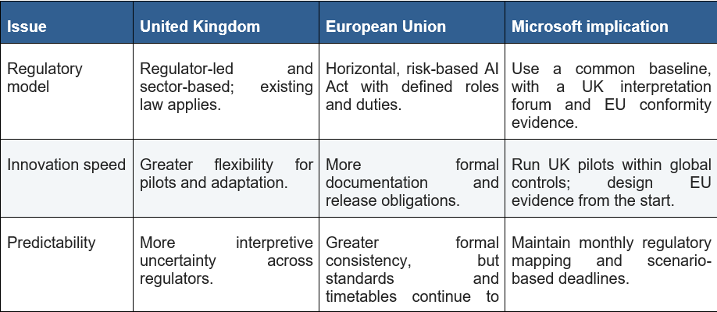
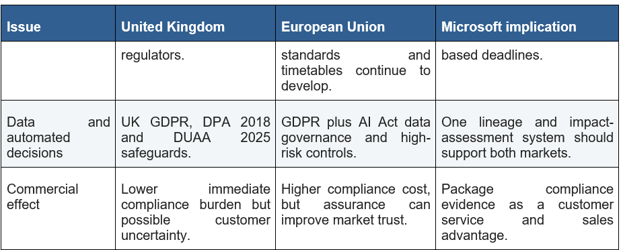Source: Author analysis based on European Commission (2024a; 2025), Council of the European Union (2026), HM Government (2025) and ICO (2025a; 2025b; 2026).
7. Recommendations and Implementation Plan
Microsoft must create an AI Assurance Programme, also for 24 months. It should be sponsored by the Board Audit Committee and managed by appropriate leaders in responsible AI, legal, privacy, security and engineering. An investment in systems of governance, specialist staff, testing, compliance, training and customer assurance should be supported with a USUSD 165m budget. Funding should be progressive through quarterly reviews based on risk reduction and effectiveness of controls and on business value delivered (Microsoft, 2025a).
Table 4. Costed SMART implementation plan: Microsoft Responsible AI Assurance Programme
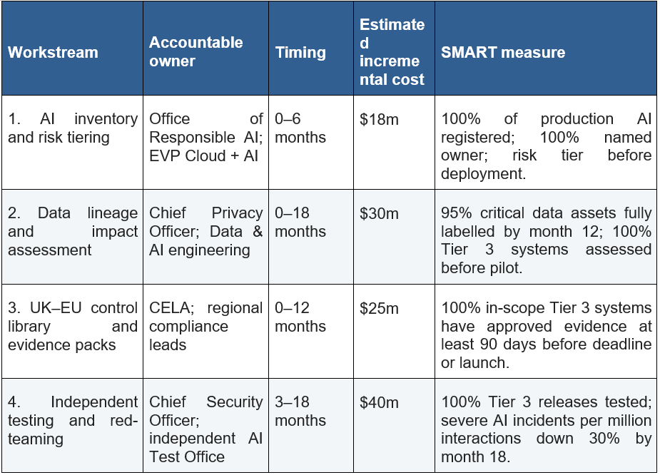
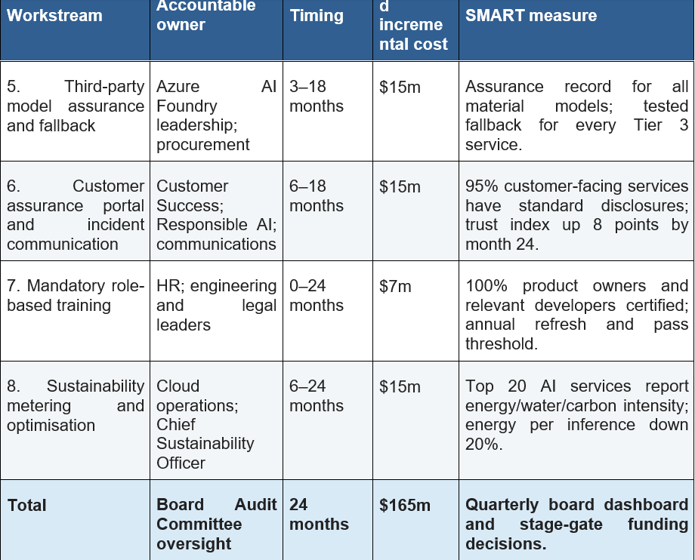
Source: Author estimates. Costs exclude normal product R&D and data-centre capital expenditure and should be validated through Microsoft’s internal budgeting process.
7.1 Governance and Decision Rights
Microsoft must create a worldwide catalogue of all production AI systems and major AI functions and ensure they're required to perform (HM Government, 2025). Each record should include an identification of the owner, legal role, model, data source, jurisdiction, users, risk tier and supplier dependency. The deployment must not happen if necessary information and/or approval is not secured. The registration should be complete in 6 months, with the ownership name starting from month 1. Microsoft should also have four levels of risk. Tier 1 is low-impact support; Tier 4 is no support. Tier 3, which could have an impact on rights, safety or essential services, should be independently tested, legally reviewed, impact assessed, human oversight & executive approval. This risk-based approach does not squander the scarce resources of assurance on low-impact tools and improves the process of making and assuring high-impact decisions.
7.2 Data, Testing and Third-Party Assurance
All high-impact systems should have machine-readable data lineage and automatic impact-assessment triggers introduced into them by Microsoft. Provenance approved, lawful basis, retention and location (95 per cent critical data) by month 18. All Tier 3 systems should have privacy and AI impact assessments done before being used in a pilot. Microsoft should also establish an independent branch to test and red-team AIs. It should cover bias, security, privacy leakage, robustness, agent permissions and predictable misuse. Results should be used directly as a basis for making decisions about release. Azure AI Foundry maintain models’ assurance for every material third-party model, limits, licences, incidents and exit options. By month 18, a tested fallback model is also required for all Tier 3 services.
7.3 Compliance, Trust and Sustainability
There needs to be a single UK-EU library of control requirements, aligned to the EU AI Act, UK data law, equality duties and sector regulations, to which Microsoft must adhere. All Tier 3 systems shall have an evidence pack 90 days prior to a legal or customer deadline. This reduces the amount of redundancy and is still compliant. Microsoft should maintain a Microsoft AI Assurance Portal for its customers with information around service cards, model versions, data-use disclosures, test results, incident notifications and downloadable testing evidence. At 18-months, 95% of AI services providing assistance with customer interaction should include transparency information. Surveys and complaints, lost contracts, and response times are all indicators of trust. Microsoft should provide energy, water and carbon metrics on the top 20 most widely-used AI services and achieve an energy per inference reduction by 20 per cent by month 24.
7.4 Programme Control and Risk Mitigation
In the programme, there should be 3 decision gates. The inventory coverage, risk tiers and baseline measures should be verified at the Gate 6th month. Data lineage and independent tests should be checked at month 12 in Gate 2. Guest verification, third-party fallback and measurable incident reduction should be achieved at gate 3 (month 18). Further funding to be based on achievement or a recovery plan agreed by the board. Microsoft should conduct two provider failure, regulatory prohibitions, data leaks, harmful autonomous actions, and infrastructure shortages scenario exercises per year (Microsoft, 2025a). Report to the Board Audit Committee regarding Root Cause Review within 30 days of occurrence and severe incident within 24 hours of occurrence. Such measures of success or release speed, incidents, regulatory findings, trust, energy use, revenue, and rework should all be accomplished in risk-adjusted innovation.
8. Conclusion
Microsoft has a much better play in AI, since it has the enterprise software, the developer tools, the customer relationships and the cloud infrastructure. But being in this role also means that you are in the limelight. A failure can cascade via third-party models, Azure services, Copilot applications, and customers' decisions. That's why governance is needed throughout the AI value chain at Microsoft.
The regulatory environment varies between the UK and the EU. Formal proof and risk classification & monitoring are required in the EU. There is flexibility in the UK, but there are significant duties under the data protection laws as well as equality and consumer/sector laws. Therefore, Microsoft should implement a robust worldwide control baseline, with a legal superlayer in each region (CISA, 2024). Microsoft has a proven history of a responsible AI program and solid security measures. They're quite good, but they don't exhibit a well-planned control behaviour. Proposed US $165 million over 24 months assistance programme introduces ownership, data lineage, independent testing, supplier assurance, Customer transparency and Sustainability. Includes measurable SMART targets and stage gates. This reduces the danger and liability and promotes ethical innovation, and also helps to provide an advantageous future.

Bibliography
Batool, A., Zowghi, D. and Bano, M. (2025) ‘AI governance: a systematic literature review’, AI and Ethics, 5, pp. 3265–3279. Available at: https://doi.org/10.1007/s43681-024-00653-w
Bengio, Y. et al. (2025) International AI Safety Report 2025. Available at: https://internationalaisafetyreport.org/
Competition and Markets Authority (CMA) (2025) Microsoft/OpenAI partnership merger inquiry. Available at: https://www.gov.uk/cma-cases/microsoft-slash-openai-partnership-merger-inquiry (Accessed: 10 July 2026).
Council of the European Union (2026) Artificial intelligence: Council gives final green light to simplify and streamline rules. Available at: https://www.consilium.europa.eu/en/press/press-releases/2026/06/29/artificial-intelligence-council-gives-final-green-light-to-simplify-and-streamline-rules/ (Accessed: 11 July 2026).
Cybersecurity and Infrastructure Security Agency (CISA) (2024) Review of the Summer 2023 Microsoft Exchange Online intrusion. Available at: https://www.cisa.gov/resources-tools/resources/CSRB-Review-Summer-2023-MEO-Intrusion (Accessed: 11 July 2026).
European Commission (2024a) AI Act: regulatory framework for artificial intelligence. Available at: https://digital-strategy.ec.europa.eu/en/policies/regulatory-framework-ai (Accessed: 12 July 2026).
European Commission (2024b) Regulation (EU) 2024/1689 laying down harmonised rules on artificial intelligence. Official Journal of the European Union. Available at: https://eur-lex.europa.eu/eli/reg/2024/1689/oj (Accessed: 12 July 2026).
European Commission (2025) Guidelines for general-purpose AI models. Available at: https://digital-strategy.ec.europa.eu/en/policies/guidelines-gpai-providers (Accessed: 12 July 2026).
Feuerriegel, S., Hartmann, J., Janiesch, C. and Zschech, P. (2024) ‘Generative AI’, Business & Information Systems Engineering, 66(1), pp. 111–126. Available at: https://doi.org/10.1007/s12599-023-00834-7
Floridi, L. and Cowls, J. (2019) ‘A unified framework of five principles for AI in society’, Harvard Data Science Review, 1(1). Available at: https://doi.org/10.1162/99608f92.8cd550d1
HM Government (2025) AI Opportunities Action Plan. Available at: https://www.gov.uk/government/publications/ai-opportunities-action-plan (Accessed: 13 July 2026).
Information Commissioner’s Office (ICO) (2025a) Guidance on AI and data protection. Available at: https://ico.org.uk/for-organisations/uk-gdpr-guidance-and-resources/artificial-intelligence/guidance-on-ai-and-data-protection/ (Accessed: 12 July 2026).
Information Commissioner’s Office (ICO) (2025b) The Data (Use and Access) Act 2025: what does it mean for organisations? Available at: https://ico.org.uk/about-the-ico/what-we-do/legislation-we-cover/data-use-and-access-act-2025/the-data-use-and-access-act-2025-what-does-it-mean-for-organisations/ (Accessed: 14 July 2026).
Information Commissioner’s Office (ICO) (2026) Automated decision-making and profiling: consultation materials. Available at: https://ico.org.uk/about-the-ico/ico-and-stakeholder-consultations/ (Accessed: 12 July 2026).
International Organization for Standardization (ISO) (2023) ISO/IEC 42001:2023 Information technology — Artificial intelligence — Management system. Available at: https://www.iso.org/standard/42001 (Accessed: 13 July 2026).
Maslej, N., Fattorini, L., Perrault, R., Gil, Y., Parli, V., Kariuki, N., ... & Oak, S. (2025). Artificial intelligence index report 2025. arXiv preprint arXiv:2504.07139.
Microsoft (2025a) Annual Report 2025. Available at: https://www.microsoft.com/investor/reports/ar25/index.html (Accessed: 14 July 2026).
Microsoft (2025b) Responsible AI Transparency Report 2025. Available at: https://www.microsoft.com/en-us/corporate-responsibility/responsible-ai-transparency-report/ (Accessed: 12 July 2026).
Microsoft (2025c) Environmental Sustainability Report 2025. Available at: https://blogs.microsoft.com/on-the-issues/2025/05/29/environmental-sustainability-report/ (Accessed: 15 July 2026).
Mikalef, P. and Gupta, M. (2021) ‘Artificial intelligence capability: Conceptualization, measurement calibration, and empirical study on its impact on organizational creativity and firm performance’, Information & Management, 58(3), 103434.
National Institute of Standards and Technology (NIST) (2023) Artificial Intelligence Risk Management Framework (AI RMF 1.0). Available at: https://www.nist.gov/itl/ai-risk-management-framework (Accessed: 13 July 2026).
National Institute of Standards and Technology (NIST) (2024) Artificial Intelligence Risk Management Framework: Generative Artificial Intelligence Profile. Available at: https://www.nist.gov/publications/artificial-intelligence-risk-management-framework-generative-artificial-intelligence (Accessed: 11 July 2026).
OECD (2025a) OECD Economic Outlook, Volume 2025 Issue 2: United Kingdom. Available at: https://www.oecd.org/en/publications/oecd-economic-outlook-volume-2025-issue-2_9f653ca1-en/full-report/united-kingdom_9fc28efb.html (Accessed: 15 July 2026).
OECD (2025b) Global economy proves resilient but remains fragile. Available at: https://www.oecd.org/en/about/news/press-releases/2025/12/global-economy-proves-resilient-but-remains-fragile.html (Accessed: 15 July 2026).
Papagiannidis, E., Mikalef, P. and Conboy, K. (2025) ‘Responsible artificial intelligence governance: A review and research framework’, Journal of Strategic Information Systems, 34(2), 101885.
Raisch, S. and Krakowski, S. (2021) ‘Artificial intelligence and management: The automation–augmentation paradox’, Academy of Management Review, 46(1), pp. 192–210.
Siau, K. and Wang, W. (2018) ‘Building trust in artificial intelligence, machine learning, and robotics’, Cutter Business Technology Journal, 31(2), pp. 47–53.
UK Parliament (2025) Data (Use and Access) Act 2025. Available at: https://www.legislation.gov.uk/ukpga/2025/18/contents (Accessed: 15 July 2026).

