Zakriya Mohsen Fathi
2003845
database analysis and design

Table of Contents
Introduction 3
Context Diagram 4
Level 0 DFD 5
Entity relationship diagram ERD 8
Degree of Relationships 9
Membership class 10
Third normal form 10
Customers 11
The Kitchen Staff 11
Conclusion 11
REFERENCES 16

List of Figures
Figure 1: Context Diagram 4
Figure 2: Level 0 of the Data Flow Diagram – Level 0 DFD 5
Figure 3: ERD Diagram 9

List of Tables
Table 1: Customers 3NF 10
Table 2: The Kitchen Staff 3NF 11

Introduction
The purpose to conduct this research is to study the design and construct the following chart of the business entity Celtic Caterers busy in the economic activity of catering located in Swansea. In this study will be analysing several factors relating to database and design including Level 0 of the Data Flow Diagram – Level 0 DFD, entities/organisations, relationships/association, level/degree of relationships, and membership per the diagram.
Also in this study will be explaining the technical terms. Moreover, the researcher will create an innovative and unique style of database using one of the basic computer software that is Microsoft Access. Level 0 of the Data Flow Diagram – Level 0 DFD is also referred to as Context Diagram. However, Level 1 of the Data Flow Diagram – Level 1 DFD is the detailed structure presented in form of a diagram is known as Context Level Diagram.
Smooth business operations are needed to be equipped with good resources of processes and systems. Without the resources of processes and systems, no business entity can perform smooth functioning and will face numerous challenges. The business entrepreneur can use a data flow diagram - DFD to reduce the business risk and challenges. In database management systems, ER is referred to as Entity-Relationship. Entity-Relation – ER is a process of data communication that links and transfers the data between different ends as per the need and formulas. The model of the Entity-Relationship Diagram builds a communication link between the interconnected scope of knowledge and information in a specific domain. (Online Visual Paradigm, 2021).

Context Diagram
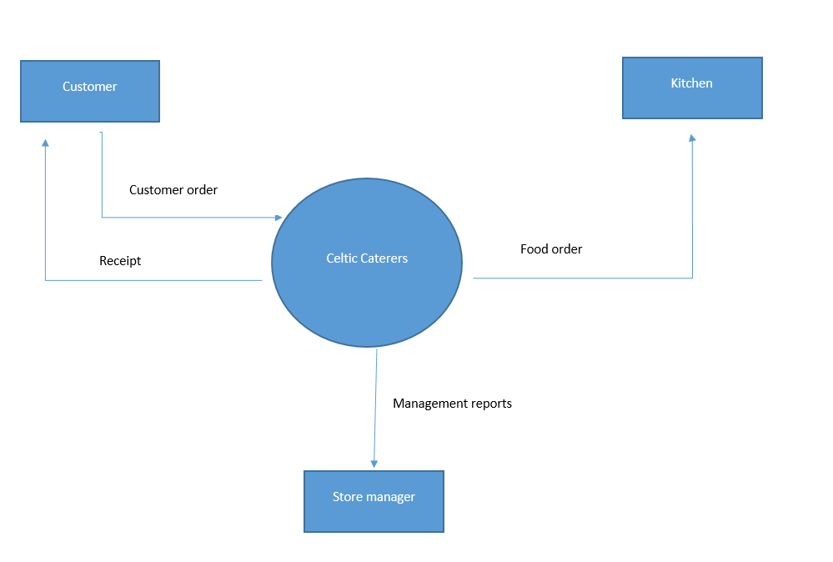
Figure 1: Context Diagram

The purpose of the context diagram is to provide the details, instructions and their communication bridge regarding different resources being used in the system. One of the key advantages of the context diagram is that it provides the users with the facility of feedback. It is the factor of feedback that makes the whole communication process from simple communication to effective communication features. (Bangerter, 2017). One of the key features of the context diagram is that several external entities can submit their queries and feedbacks using the available resources. Preview provided by the context diagram system reflects the complete processing of the data and the information processing mechanism and backend working can be reviewed in case of confusion or mistakes. (Juffs, and Harrington, 1996).

Level 0 DFD
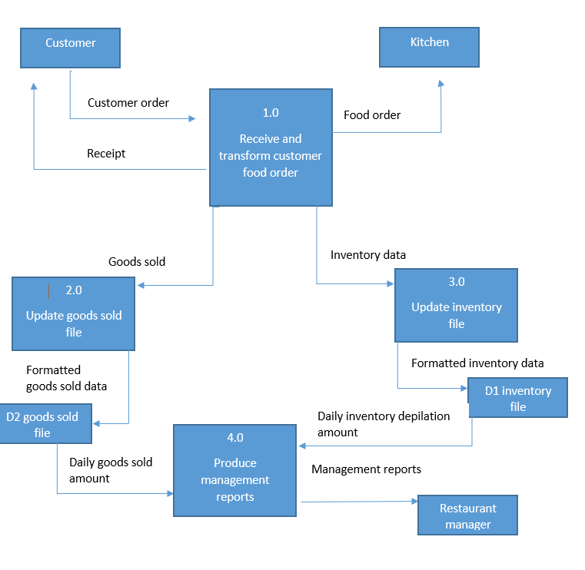
Figure 2: Level 0 of the Data Flow Diagram – Level 0 DFD

Using input and output resources in a systematic manner that may be designed to achieve certain goals and objectives are represented in a data flow diagram – DFD. DFD is also known as Data Flow Diagram is the method of representing various information stored in the database in the shape of input and output combination to extract the desired results from the database system. The system of data flow diagram – DFD comprises of further two systems in it that are “Yourdon and Coad” and “gane and sarson”. The sub systems of DFD “Yourdon and Coad” and “gane and sarson” are used for representation visual entries that include several elements of external, data flow, data stores and process entities. The data represented in the sub systems of DFD “Yourdon and Coad” and “gane and sarson” has visual presentation differences among the two sub systems of DFD. The presentation of “gane and sarson” may be represented in the form of circular diagrams. However, the sub system of DFD named “Yourdon and Coad” is represented in the shape of squared rounded diagrams (Online Visual Paradigm, 2021).
The researcher in this study will be examining and describing the use of data flow mechanisms and their significance in data management systems. The data represented in the sub systems of DFD “Yourdon and Coad” and “gane and sarson” has visual presentation differences among the two sub systems of DFD. (Harrington, 2008). The presentation of “gane and sarson” may be represented in the form of circular diagrams. However, the sub system of DFD named “Yourdon and Coad” is represented in the shape of squared rounded diagrams. Both the systems of DFD process the data along with the provided information and feed instructions to provide the data outgoing flow (Online Visual Paradigm, 2021).
Level 0 of the Data Flow Diagram – Level 0 DFD is also referred to as Context Diagram. However, Level 1 of the Data Flow Diagram – Level 1 DFD is the detailed structure presented in form of a diagram is known as Context Level Diagram. Level 0 can be easily represented and can be understood as it is a database system’s general presentation style (Harrington, 2008). Level 0 of DFD is part of the context diagram. Level 0 may also be known as or referred to as an analysed process or modelled structure. Level 0 is the one way of the high-level processing system that works with the relationship of database and external entity to get desired results of the database system. It is not necessary that Level 0 of the Data Flow Diagram – Level 0 DFD can only be used with only a specific system for particular processing. Level 0 of the Data Flow Diagram – Level 0 DFD can be used in a complex database management system. The researcher in this study analysed that Level 0 of the Data Flow Diagram – Level 0 DFD may also be used for the business activity of Celtic Caterers who are engaged in the business activity of catering (Online Visual Paradigm, 2021).
The purpose of using data flow holds or DFD - data flow diagrams is to engage the database management mechanism in complex and different nature of the process that may work as a singular entity or may also be used in multiple or multitasking processes simultaneously. The arrows used in Level 0 of the Data Flow Diagram – Level 0 DFD referred to or used to represents the data flow into and out of the system. Every system in the information and communication technology tools and equipment needs to have at least one source of output to show the results. The system of Level 0 of the Data Flow Diagram – Level 0 DFD is a part of information and communication tool and equipment that needs at least one output source and it is essential in the database management system to keep the user aware of the data management and data flow in the database system (Online Visual Paradigm, 2021).
The diagram used by the research in this study to represent the data flow system of Level 0 Data Flow Diagram – Level 0 DFD shows that each of the processes of the data communication in the database system links somehow within the external entities. The database management system of Level 0 Data Flow Diagram – Level 0 DFD helps the store manager to keep track of the products available in the store and that of those that are out of stock and the products that may be essential for the business activity. The diagram used in the following by the researcher to describe Level 0 of the Data Flow Diagram – Level 0 DFD comprises company management, canteen management and different meal types outflow for the business of Celtic Caterers (Online Visual Paradigm, 2021).

Entity Relationship diagram (ERD)
One of the key features of the context diagram is that several external entities can submit their queries and feedbacks using the available resources. Preview provided by the context diagram system reflects the complete processing of the data and the information processing mechanism and backend working can be reviewed in case of confusion or mistakes. (Juffs, and Harrington, 1996; (Claudia, 2021).
The sub systems of DFD “Yourdon and Coad” and “gane and sarson” are used for representation visual entries that include several elements of external, data flow, data stores and process entities. The diagram used by the research in this study to represent the data flow system of Level 0 Data Flow Diagram – Level 0 DFD shows that each of the processes of the data communication in the database system links somehow within the external entities (Juffs, and Harrington, 1996).
Entities can be anything, place, object or person. Entities are part of the database management system and are considered to be the most basic yet most essential part of the database management system. It is the entities that help the database management system to store the data in the required form that may be in the shape of a table (Claudia, 2021). The information stored in the database in the shape of a table or any other format according to the database management system the presentation of the data and information is known as entities in the database management system (Juffs, and Harrington, 1996). The services offered by the business of Celtic Catering are the entities that may include the provision of services and products including waiters, food, beverages, chairs, ambience, crockery and other necessary items.
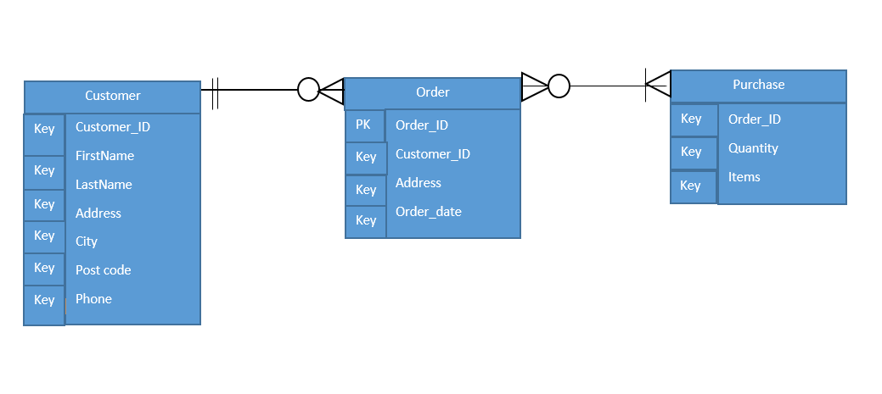

Figure 3: ERD Digram

Degree of Relationships
The relationship is the connection between two entities. the connection between the two entities may be building with some logical reasoning or with the use of some predefined functions that may lead the user of the database management system to achieve certain desired goals and objectives for using the specific database system. In database management systems, ER is referred to as Entity-Relationship (Juffs, and Harrington, 1996). Entity-Relation – ER is a process of data communication that links and transfers the data between different ends as per the need and formulas. The model of the Entity-Relationship Diagram builds a communication link between the interconnected scope of knowledge and information in a specific domain. In the database management system, several relationships may be used among different entities (Diwan, 2018). A binary function of relationships helps the user of the database management system to build a degree of relevance and equality among the entities. A ternary function of relationships helps the user of the database management system to build relationships among the given criteria to identify the level of equality, for instance in the business of Celtic Catering the entities of three different categories are store manager, kitchen department and kitchen staff (Teorey, et, al., 2008). The users of database management systems are aware of the fact that it is not necessary to restrict the number of entities to two or entities in the database management system. It is the fact and practice that the database management system and mechanism can be run and operated with the use of only a single entity in the database management system. The set of relationships built in the database management system among the entities are known as Uniform Resource Identifier – URI (After Academy, 2021).

Membership class
The structure used with the combination of several different objects in an organised way in the database management mechanism is a class or may also be known as a membership class (Teorey, et, al., 2008).

Third normal form 3NF

Third normal form 3NF
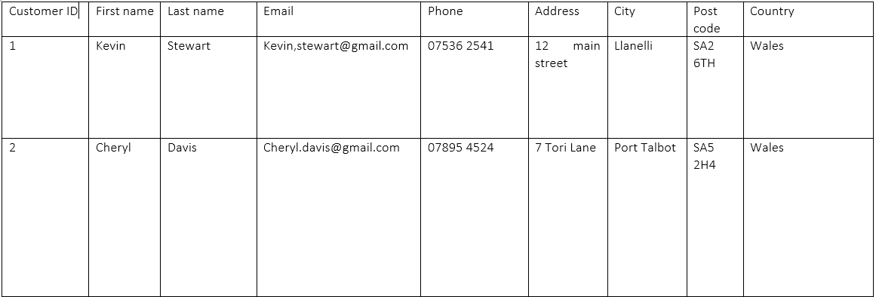
Customer ID | First name | Last name | Address
1 | Kevin | Stewart | 12 Main street
2 | Cheryl | Davis | 7 Tori Lane
Address | Country
12 Main street | Wales
7 Tori Lane | Wales

Table 1: customers

Third normal form 3NF
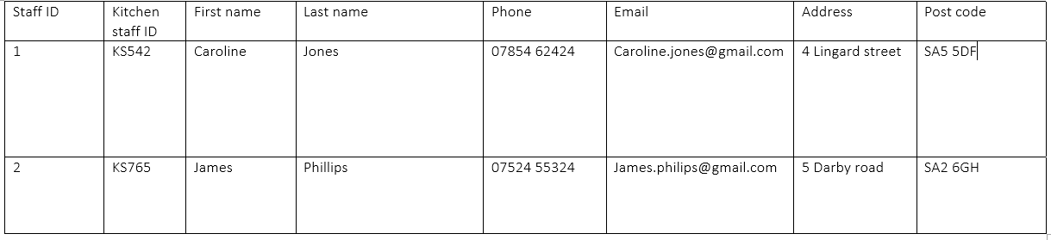
Staff ID | Kitchen staff ID | Last name
1 | KS542 | Jones
2 | KS765 | Phillips
Address | Post code
4 Lingard street | SA5 5DF
5 Darby road | SA2 6GH

Table 2: The Kitchen Staff
In the database management system, it is essential and key to forming a good database system to use the “second normal form” of the data and the entities must have no direct impacts over the other values and information used in the database (Teorey, et, al., 2008).

Conclusion
Analysing several factors relating to database and design including Level 0 of the Data Flow Diagram – Level 0 DFD, entities/organisations, relationships/association, level/degree of relationships, and membership per the diagram. (Bangerter, 2017; Diwan, 2018). Level 0 of the Data Flow Diagram – Level 0 DFD is also referred to as Context Diagram. However, Level 1 of the Data Flow Diagram – Level 1 DFD is the detailed structure presented in form of a diagram is known as Context Level Diagram. (Online Visual Paradigm, 2021). Smooth business operations are needed to be equipped with good resources of processes and systems. Without the resources of processes and systems, no business entity can perform smooth functioning and will face numerous challenges. The business entrepreneur can use a data flow diagram - DFD to reduce the business risk and challenges. In database management systems, ER is referred to as Entity-Relationship. Entity-Relation – ER is a process of data communication that links and transfers the data between different ends as per the need and formulas. The model of the Entity-Relationship Diagram builds a communication link between the interconnected scope of knowledge and information in a specific domain. (Online Visual Paradigm, 2021). The purpose of the context diagram is to provide the details, instructions and their communication bridge regarding different resources being used in the system. One of the key advantages of the context diagram is that it provides the users with the facility of feedback. It is the factor of feedback that makes the whole communication process from simple communication to effective communication features (Bangerter, 2017). One of the key features of the context diagram is that several external entities can submit their queries and feedbacks using the available resources. Preview provided by the context diagram system reflects the complete processing of the data and the information processing mechanism and backend working can be reviewed in case of confusion or mistakes (Juffs and Harrington, 1996).
Using input and output resources in a systematic manner that may be designed to achieve certain goals and objectives are represented in a data flow diagram – DFD. DFD is also known as Data Flow Diagram is the method of representing various information stored in the database in the shape of input and output combination to extract the desired results from the database system. The system of data flow diagram – DFD comprises of further two systems in it that are “Yourdon and Coad” and “gane and sarson”. The sub systems of DFD “Yourdon and Coad” and “gane and sarson” are used for representation visual entries that include several elements of external, data flow, data stores and process entities. The data represented in the sub systems of DFD “Yourdon and Coad” and “gane and sarson” has visual presentation differences among the two sub systems of DFD. The presentation of “gane and sarson” may be represented in the form of circular diagrams. However, the sub system of DFD named “Yourdon and Coad” is represented in the shape of squared rounded diagrams (Online Visual Paradigm, 2021).The data represented in the sub systems of DFD “Yourdon and Coad” and “gane and sarson” has visual presentation differences among the two sub systems of DFD (Harrington, 2008). The presentation of “gane and sarson” may be represented in the form of circular diagrams. However, the sub system of DFD named “Yourdon and Coad” is represented in the shape of squared rounded diagrams. Both the systems of DFD process the data along with the provided information and feed instructions to provide the data outgoing flow (Online Visual Paradigm, 2021).
Level 0 may also be known as or referred to as an analysed process or modelled structure. Level 0 is the one way of the high-level processing system that works with the relationship of database and external entity to get desired results of the database system. It is not necessary that Level 0 of the Data Flow Diagram – Level 0 DFD can only be used with only a specific system for particular processing. Level 0 of the Data Flow Diagram – Level 0 DFD can be used in a complex database management system. The researcher in this study analysed that Level 0 of the Data Flow Diagram – Level 0 DFD may also be used for the business activity of Celtic Caterers who are engaged in the business activity of catering (Online Visual Paradigm, 2021).
The purpose of using data flow holds or DFD - data flow diagrams is to engage the database management mechanism in complex and different nature of the process that may work as a singular entity or may also be used in multiple or multitasking processes simultaneously. The arrows used in Level 0 of the Data Flow Diagram – Level 0 DFD referred to or used to represents the data flow into and out of the system. Every system in the information and communication technology tools and equipment needs to have at least one source of output to show the results. The system of Level 0 of the Data Flow Diagram – Level 0 DFD is a part of information and communication tool and equipment that needs at least one output source and it is essential in the database management system to keep the user aware of the data management and data flow in the database system (Online Visual Paradigm, 2021).
One of the key features of the context diagram is that several external entities can submit their queries and feedbacks using the available resources. Preview provided by the context diagram system reflects the complete processing of the data and the information processing mechanism and backend working can be reviewed in case of confusion or mistakes (Juffs and Harrington, 1996; Claudia, 2021).
Entities can be anything, place, object or person. Entities are part of the database management system and are considered to be the most basic yet most essential part of the database management system. It is the entities that help the database management system to store the data in the required form that may be in the shape of a table (Claudia, 2021). The information stored in the database in the shape of a table or any other format according to the database management system the presentation of the data and information is known as entities in the database management system (Juffs, and Harrington, 1996). The services offered by the business of Celtic Catering are the entities that may include the provision of services and products including waiters, food, beverages, chairs, ambience, crockery and other necessary items.
The relationship is the connection between two entities. The connection between the two entities may be building with some logical reasoning or with the use of some predefined functions that may lead the user of the database management system to achieve certain desired goals and objectives for using the specific database system. In database management systems, ER is referred to as Entity-Relationship (Juffs and Harrington, 1996). Entity-Relation – ER is a process of data communication that links and transfers the data between different ends as per the need and formulas. The model of the Entity-Relationship Diagram builds a communication link between the interconnected scope of knowledge and information in a specific domain. In the database management system, several relationships may be used among different entities (Diwan, 2018). A binary function of relationships helps the user of the database management system to build a degree of relevance and equality among the entities. A ternary function of relationships helps the user of the database management system to build relationships among the given criteria to identify the level of equality, for instance in the business of Celtic Catering the entities of three different categories are store manager, kitchen department and kitchen staff (Teorey et al., 2008). The users of database management systems are aware of the fact that it is not necessary to restrict the number of entities to two or entities in the database management system. It is the fact and practice that the database management system and mechanism can be run and operated with the use of only a single entity in the database management system. The set of relationships built in the database management system among the entities are known as Uniform Resource Identifier – URI (After Academy, 2021).
The structure used with the combination of several different objects in an organised way in the database management mechanism is a class or may also be known as a membership class (Teorey et al., 2008).
In the database management system, it is essential and key to forming a good database system to use the “second normal form” of the data and the entities must have no direct impacts over the other values and information used in the database (Teorey et al., 2008).

REFERENCES
After Academy (2021) What is the degree of relation in DBMS?, Available at: https://afteracademy.com/blog/what-is-the-degree-of-relation-in-dbms (Accessed: 2021)
Amit Diwan (2018) N-ary Relationship in Database, Available at: https://www.tutorialspoint.com/N-ary-Relationship-in-Database (Accessed: 2021).
Bangerter, J., 2017. Data Flow Diagram Symbols, Types, and Tips. Dipetik Maret, 12, p.2019.
Claudia F. (2021) What is an Entity in a Database?, Available at: https://study.com/academy/lesson/what-is-an-entity-in-a-database.html (Accessed: 2021).
Harrington, J., 2008. Special relativity and the future: a defense of the point present. Studies in History and Philosophy of Science Part B: Studies in History and Philosophy of Modern Physics, 39(1), pp.82-101.
https://www.tutorialspoint.com/N-ary-Relationship-in-Database
Juffs, A. and Harrington, M., 1996. Garden path sentences and error data in second language sentence processing. Language learning, 46(2), pp.283-323.
Online Visual Paradigm, (2021) DFD Tutorial: Yourdon Notation, Available at: https://online.visual-paradigm.com/knowledge/software-design/dfd-tutorial-yourdon-notation/ (Accessed: 2021).
Teorey, T.J., Buxton, S., Fryman, L., Güting, R.H., Halpin, T., Harrington, J.L., Inmon, W.H., Lightstone, S.S., Melton, J., Morgan, T. and Nadeau, T.P., 2008. Database design: know it all. Morgan Kaufmann.

