Table of content
1. Introduction 1
1.1 Background of Zara 2
1.2 Study Objective 2
2. Zara’s strategic direction and the vision, mission and value 4
2.1 Zara’s vision, mission and value 4
2.2 Zara Hong Kong’s strategic direction 4
3. Hong Kong casual wear industry 5
3.1 Macro-Environmental Analysis for Hong Kong 5
3.2 Opportunities and threat in Hong Kong 5
3.3 Concluding comment 5
4. Corporate and Business Strategies 6
4.1 Corporate Strategies of Inditex 6
4.2 Business Strategies of Zara 6
4.3 Balanced Scorecard 6
5. Value chain of Zara 7
5.1 Primary activity 7
5.2 Supporting activity 7
6. Conclusion and Recommendations 8
6.1 Conclusion 8
6.2 Recommendations 8
7. Contingency Plan 9
8. References 10
8.1 Academic References 10
8.2 Non-academic References 13

Introduction

This report is going to analyze the current strategy of Zara, the business environment it is facing, the effectiveness of the strategy and the potential risk will be discovered and solved with recommendation.

Background of Zara

Zara is a Spanish brand of fast fashion. The first store opened in Spain and established in 1975. Zara offer various products such as clothing, shoes, accessories for men, women and children. The company will renew its product in a period of every one to two weeks.
In 1985, Zara officially grouped under Inditex Group (Figure 1.1). Inditex Group is a worldwide fashion company and the main business are in textile design, production and sales related activities. Inditex Group owns multi brands including Zara, Pull&Bear, Massimo Dutti, Bershka, Stradicarius, Oysho and Zara Home (Annual Report, 2021). In 1988-90, Zara expanded its business to global such as in Portugal, United States, France. In 2003, Zara Home is created and mainly selling home goods and household products (Inditex, 2022). In May 21 2004, Zara opened its first store in Hong Kong and occupied a space of 15,000 sq ft at the IFC Mall (GovHK, 2004). In 2007, Inditex embraced the E-commerce and started Zara’s online business in 2010. In September 9 2015, Zara Hong Kong followed the direction and started the online store (RetailNews, 2015).

Study Objective

In the midst of the COVID-19 in 2020, Inditex closed around 1,200 stores including the brand of Zara around the world (Jolly, 2020). However, the financial report in 2021 reflected that it made the right decision and showed a good sales and balance sheet. In the light of this, the project is going to assess on Zara’s current situation in relation to key areas of a strategic management and mainly focus on Zara Hong Kong business. The objective is to explore a sustainable and competitive strategy for Zara in the future to maintain the business advantage in the market and stay competitive in the fast fashion market.
This report will be presented into five parts. In the first part, it will discuss about the relationship of Zara between “Strategic Direction” and the “Vision, Mission, and Value”. Then, it will be the Macro-Environmental Analysis for the Hong Kong casual wear industry and determine the opportunities and threats for the industry. For the third part, it will generate an evaluation of corporate and business strategies and assess the effectiveness based on the Balanced Scorecard. And fourthly, value chain analysis in the post-pandemic environment will be discussed. Lastly, the report will conclude and recommend for both corporate and business level strategies for Zara.

Figure 1.1: Timeline of Zara
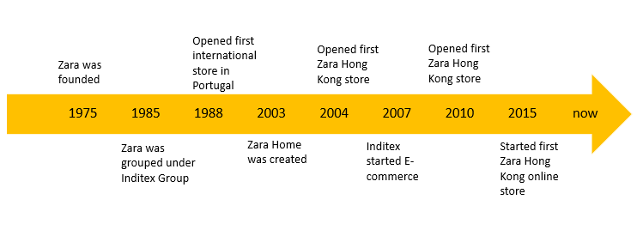
Source: Constructed by the author

Zara’s strategic direction and the vision, mission and value

Zara has well developed its brand with a clear vision, mission and value. The below will explore how does Zara’s current strategy aligns with them.

Current strategic direction of Zara

Zara uses vertical integration strategy. It operates a good supply chain and retail networks. The communication and data can be easily exchange so that it helps to make quick business decision and always produce trendiest clothes that its customer needs. New designs take only 2 weeks from production to sales. As the fashion trend is changing rapidly so Zara rather choose to manufacture in small batches. One more thing that Zara is doing differently is that the manufacturing has more than 50% of it done in Spain. It can shorten the lead times by doing local production. Its in-house logistics can ensure fast delivery to the stores within 48 hours so it can always deliver trendiest clothes. Zara spends little on advertising and focus in-store awareness of brand. It usually locates the stores in the best shopping districts and malls around the world so it is effective to attract most customers in different regions and countries. E-commerce and digital marketing can cost less than traditional ways so Zara boost this area in recent years. As Zara has good control of production and cost, it can provide a competitive price in the market which the customers can get trendy clothes with affordable price. The mission of Zara is to give customers what they want and get it to them faster than anyone else. The current practice really aligns to its mission (Mission statement, 2021).
Zara is working towards sustainability. Starting from 2020, garments labelled with “Join Life” are produced with green process or raw materials that help to reduce impact to environment (Sustainability, 2021). The “Join Life” products have reached to nearly 35% of the total product range which achieved beyond the initial goal of 25%. It also provides clothing collection programme and distribute the received garments to the NGO of different regions to get the clothes reused to recycled. There is also a circularity project by Zara to recycle the pre-consumption cotton and wool from apparel production (Annual report, 2021). The vision of Zara is to contribute to the sustainable development of society and that of the environment with which we interact. The value includes beauty, clarity, functionality and sustainability. It demonstrated that it is responsible to improve the lives of people and preserve the natural resources.

Hong Kong casual wear industry

Hong Kong casual wear industry is evolving. For Zara Hong Kong, the first store has opened in 2004 and has started its own online store since 2015. There are 12 stores in Hong Kong now (Zara Hong Kong, 2022). The lifestyle in Hong Kong is fast-paced and its main city’s productivity is coming from finance and retailing. Casual wear retailers are required to keep up the rapid changing trends and demands in order to excel in the business. Zara as a fast fashion chain stores in Hong Kong matches well with the lifestyle of Hong Kong. It locates the stores in most popular shopping malls such as Time Square in Causeway Bay and Pacific Place in Admiralty. The shops are nearby luxury fashion boutiques so it can attract potential customers who is looking for trendy clothes with a relatively cheaper price. As the locations are in the busy area which has a lot of business around, people can easily shop from weekdays to weekends. The promotional methods align with Zara Global to rely mainly in store display, catalogs and customer experience in shops. Its main competitors in Hong Kong are H&M and Uniqlo but Zara can always differentiate itself from the other two fast fashion brands because of its fast-changing new trendy clothes available every two weeks.

Besides the above current strategy adopted by Zara Hong Kong, it is also good to explore through the PESTEL analysis which could bring more insights of opportunities or threat to Zara Hong Kong. The first and most important factor is economic aspect, and ranked second place is environmental aspect, thirdly social aspect and finally technological aspect (Figure 3.1) (Yüksel, 2012).

Economic aspect

The economy of Hong Kong in 2020 had a sudden drop in 2020 and it only grew up to pre-2020 level in 2021. It causes short-term threat to casual wear industry in Hong Kong. The Gross Domestic Product (GDP) of Hong Kong in 2021 was 368.14 billion USD which has grown by 24 billion USD when compared to 2020 (344.88 billion USD). However, it was similar to 2019’s performance which was 363.05 billion USD. It shows that Hong Kong is catching up the pre-pandemic economic performance but the improvement is so little. In addition, Hong Kong’s inflation rate skyrocketed to 4.5% in September 2022. It has become the highest rate since 2015. The retail sales in Hong Kong dropped by 2.9% year-on-year in 2022. One of the major categories in the sales drop came from clothing, footwear and allied products (i.e., -13.3% in 2022) (Trading Economics, 2022). Therefore, it has concerned that Hong Kong people have less motivation to shopping casual wear. There will be more likely for people to purchase durable fashion rather than trendy fashion when the economy is not good so it has a short-term threat to the industry.

Environmental aspect

Fashion industry has become the top five-largest polluting industries (WWF HK, 2022) and Hong Kong people has rising awareness to fashion materials and the production process. This is a short-term threat to casual wear industry especially for the fast fashion chain stores. From the data of Hong Kong Trade Development Council (HKTDC) (2022), the ready to wear garments produced globally increased from 5 billion pieces in 2000 to 10 billion in 2020. It could show that the waste from garment has been increased at the same time. The fashion industry consumes water and emits greenhouse gases during manufacturing, causes water pollution during fabric dyeing and bleaching and the non-degradable fabric produced. The ecological footprint has become an issue nowadays and the corporates should not ignore its responsibility to cause less harm to the environment. Implementing sustainable practices in fashion production can reduce carbon emissions and waste and this is a trend to casual wear industry in Hong Kong. People aware of the eco-friendly fashion and it might not only be threat but also long-term opportunity to the industry. The eco-friendly fashion production does not require high technology and skills so it is actionable to most companies in the industry. If the industry is willing to take the step to make green fashion, it could bring benefits to both sales and the natural environment.

Political aspect

Hong Kong government provided some beneficial policies to retailers to maintain the business under COVID-19 so it has a short-term opportunity. The government has given 2 rounds of Consumption Voucher Scheme (CVS) in 2021 and 2022 (Consumption Voucher, 2022). All Hong Kong permanent resident of 18 age or above can obtain the CVS with a total value of HKD $15000 ($5000 in 2021 and $10000 in 2022). People have to use the money through the designated digital wallets (e.g., Alipay, Tap & Go, WeChat Pay) within a given timeline. It could shortly boost the consumption of casual wear retailers. In addition, there was rental enforcement moratorium for small and medium-sized enterprises tenants in 2021 (BCLP, 2022). The government helped to relieve the immediate financial pressure for the enterprises and make them legally defer the rent payment for 6 months. It prevented the landlords from terminating the tenants due to late payment. On the other side, the government also offered interest-free loan to landlords in order to improve their cash flows. For individuals, the government also offered tax deduction for domestic rental expenses and capped at HK$100,000. The above policies could release the financial pressure of the local caused by COVID-19 and it had short-term benefit to boost the retail sales. However, it may not sustain in long run.

Technological

The e-commerce and digital wallets are the uprising trend in Hong Kong which has long-term benefits to casual wear industry. The e-commerce penetration rate is expected to grow to 72.6% in 2022 (Statrys, 2022). Hong Kong is actually having the high internet penetration at 89.4% and the efficient logistical infrastructure that was ranked 12th in the World Bank’s global ranking of logistics capabilities and quality (The World Bank, 2018). It makes the shipping and delivery fast and support the e-commerce activity in Hong Kong. In addition, the online payment methods have extended from traditional cash payment to card payment or digital wallets. In JP Morgan’s Global insight report, the use of digital wallets is expected to grow 32% annually. The technological advancement makes the casual wear industry has more opportunity to capture potential business online. This will have a long-term benefit.

Figure 3.1: PESTEL analysis for Hong Kong casual wear industry.
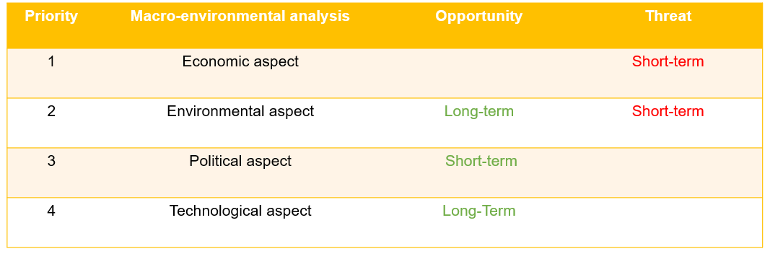
Source: Constructed by the author

Concluding Comments

The economic aspect impacts the most to Hong Kong casual wear industry but it is a short-time threat. COVID-19 has affected the economy since early 2020 and it is close to the end of the pandemic in 2022. It is estimated that the economy will keep growing in the coming years. As long as the company can overcome this short-term threat, it is still favorable in the future. For the environmental aspect, there is growing awareness about eco-friendly fashion in Hong Kong and the trend is pushing more fashion companies to take responsibility in protecting the environment. This may be a short-term threat to the casual wear retailers who have not adopted green fashion but it is a long-term opportunity for those who has already started. The entry to green fashion is not difficult so it is beneficial to the industry. For political aspect, the Hong Kong government provided a list of policies to help the casual wear retailers overcome the financial difficulty caused by the poor economy and it created a short-term opportunity to the fashion retailers but it may not last for a long time. Lastly, the technological advancement in e-commerce and digital wallets in Hong Kong helps to create long-term opportunity to the casual wear retailers and this is a rising trend. It provides a convenient way to capture sales with the advantage of good internet penetration and logistics in Hong Kong. Generally speaking, the macro-environment is favorable to casual wear industry.

Corporate and Business Strategies

Inditex and Zara has developed the corporate and business strategy. Inditex has utilized related diversification while Zara is on the way to best-cost provider strategy. This section is going to analyze their strategies in details.

4.1 Corporate Strategies of Inditex

Inditex keeps growing its business by related diversification. It adds new but related products to the business profile. It owns 7 brands and they are Zara, Pull&Bear, Massimo Dutti, Besrshka, Stradicarius, Oysho and Zara Home. The brands are all fashion and home textile. Each brand has different style and positions in order to help Inditex capture as much market as possible. Inditex invested a lot in in-house logistics, supply chain and technology to support and manufacture for the brands. All brands shared the same integrated system. It also utilizes the RFID technology in the supply chain to increase the efficiency in product distribution to different stores. It has a centralized manufacturing sites to produce the fashion or home textile products and a large team of designers to draw designs quickly and meet the market needs. Inditex fully enjoys the benefits of related diversification by sharing the resources with the 7 brands. The value chain of Inditex has the competitiveness and create synergy effects among the brands.

4.2 Business Strategies of Zara

Zara is on its way to best-cost provider strategy (Sharkie, 2003). Zara is under Inditex so it has its in-house production and manufacturing facilities. There are several products including woman, man, kids, home, beauty and Zara origins. It produces most of its products and outsources small parts in some Asian manufacturers. The suppliers are mainly near the production facilities across Europe. It can shorten the lead time between sourcing and manufacturing to increase the efficiency. The time-to-market is relatively shorter because of its full control of design and production. It adopts a vertical integration strategy so it can control raw material sourcing, design, marketing and distribution (Lopez & Fan, 2009). It has 300 designers that can produce 12,000 new designs every year. It takes around 2 weeks to market a new product. The in-house designers always observe the fashion trend and the insights from the store manager to draw designers.

The product development team has close communication with store manager, procurement and production team. As it has to keep up with the fashion trend all the time, it produces limited inventory for each batch of designs. Therefore, it has a low inventory cost. Zara has its distribution capacity to deliver within 24 hours in Europe and within 48 hours in other markets. The new production line of Zara home also shares the resources from apparel line due to its focus in home textile so they share the same technology and manufacturing. So, Zara can differentiate by the resources, supply chain efficiency and the design. In addition, in-house production enables it to control the cost but the labor cost is not low though. Zara’s model makes it own a lot of teams in the supply chain so it owns a lot of staff in the production. It is on its way to become more of best-cost provider strategy.

4.3 Balanced Scorecard

After analyzing the corporate and business strategy, a set of organizational performance objectives under balance scorecard can help to measure and monitor the strategic goals (Sharma, 2009). From financial aspect, Inditex has a good return on equity (ROE) rate of 21% and return on capital employed (ROCE) of 28% in 2021 (Table 4.1) (Annual report, 2021). Both showed a rebound from 2020 so it generated good profits from equity and efficiently utilized the capital. It maintained good cash flow in 2021 which was almost doubled that of 2020. Net sales caught up the 2019 level and achieved 27,716 million of Euro. For Zara and Zara home’s business, the sales also aligned to corporate’s performance and achieved record high sales since 2018. The ROCE also had 25% which means it could generate good profit by well utilizing the capital.

From non-financial aspects, Zara addressed a lot in customer satisfaction. Zara provides personalization of customer service. It has electronic customer-relationship management system (e-CRM) to enhance the competitiveness in customer service. Also, Zara aims to offer a unique shopping experience to customers so it has a standard customer service training to enhance the skills and knowledge of the sales rep. Therefore, the front line can adopt the customer-centric approach. The RFID technology is one the learning of Zara in business operation to improve the efficiency to provide customer care. Another learning and growth are the people empowerment. Zara employs a lot of young talents to the company each year especially in its design team. It promotes two-thirds of the store managers and gives full trust to the managers to operate its store. Zara generally has low turnover rate. The internal business process within Zara is that it set up a sophisticated technology driven system to make the internal information exchange quickly from the stores and the headquarter. The continuous effort in improving the information system help the business run better. It has also good internal work culture to encourage risk-taking and fast implementation. Therefore, it makes Zara to excel in creating trendy fashion.

Table 4.1: Financial measures of Inditex and Zara
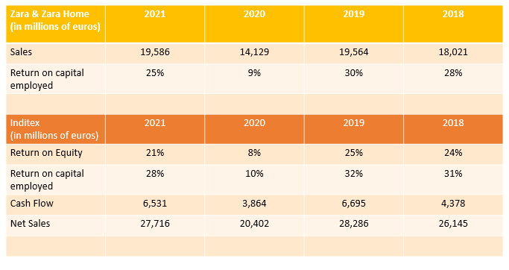
Source: Constructed by the author

Value chain of Zara

Zara is on its way to best-cost provider strategy so it uses both cost leadership and broad differentiation strategy. This section will talk about the value chain of Zara which has added value to the business (Porter, 2001).

Primary activity

In inbound logistics, Zara procures the raw materials that are required by the new trend of designs. It mainly gets the raw materials which is nearby the manufacturing site so that it can have fewer lead time. For the manufacturing process, internal comprise of 40% and the rest is outsourced. Most of the external manufacturing sites are in Asia where the labor cost is lower so it is cost effective. The finished product will return back to the internal site for quality assurance and repackaging. The outbound logistic of Zara is a centralized system to distribute according to the demand and quantity. It can efficiently carry out the world. Marketing of Zara mainly replies on the in-store display and the strategic location of the stores. It keeps a low expense in marketing. It provides value for money products which also contains some products with slightly premium price. The service in Zara is to provide efficient and customer-centric shopping experience. Each staff in stores have their own company gadget to check the inventory of the clothes any time when customer reaches out. It also guarantees the customers about the after-sales policies such as exchange and return of goods so that the customers can purchase quickly.

5.2 Supporting activity

The firm infrastructure which has headquarter, management team, legal team, design team, procurement team quality assurance, finance and accounting. It has also human resource management to recruit talents, staff trainings and people planning. For designers, Zara tends to hire large number of young designers rather than hiring exclusive designers so it has quantity over quality. It maintains the competitive advantage of Zara to be always providing trendiest clothes to the market. The technology development in Zara like RFID technology, textile technology, process engineering and feature design are helping it to differentiate. For procurement, Zara uses Inditex resources to supply its raw materials, machinery, laboratory equipment and office. Therefore, it is very cost-effective in operation and enjoys the benefit of economy of scale.

5.3 Concluding Comments

Zara has the advantage of getting the resources from Inditex in the logistics, procurement and the technology. As the corporate has the great teams especially in design, it enables Zara to deliver large quantity of creativity and designs with high efficiency. As this makes Zara differentiates from the other fast fashion retailers, it can compete in the market with valuable or even slightly premium price with little marketing cost. The in-house supply chain and low inventory cost due to limited production can help Zara control costs. Therefore, the value chain of Zara is actually the greatest competitiveness of the company.

Conclusion and Recommendations

With the deep understanding of Zara’s VMV, the macro-environmental analysis of Hong Kong casual wear industry, the analysis of corporate and business strategy and the value chain analysis, there can be conclude for Zara to see the problem and provide the recommendation plan.

6.1 Conclusion

Zara has a clear vision of contributing to sustainable development to the society. It adopted a few projects including “Join Life” tag and recycling pre-consumption cotton and wool. It is still in its preliminary stage so more improvement can be made. The Hong Kong business environment has a higher trend to push fast fashion industry to be responsible to the natural resources and reduce waste. Zara Hong Kong can change the short-term threat into long-term opportunity if it is willing to step out to contribute more in sustainable fashion. It can make its customer to shop more with less worries in polluting the environment and can definitely increase sales and bring profits to Zara. In addition, Zara is using low expense in marketing as its strategy so online advertising about the green initiative of Zara is a cost-effective way to raise the awareness of people to shop for eco-friendly clothes in Zara. The brand reputation is the thing that Zara care the most. It can make the current or future green project being seen by the public and create good brand reputation of sustainable fast fashion company.

Zara needs to push forward to become fully beneficial to best-cost provider strategy. It has already done so well in value chain due to the resourceful backup from Inditex and also long experience from the production teams. The high efficiency from supply chain and the in-store experience add value to its business. As COVID-19 was a great challenge which made Hong Kong environment become tough in the economic aspect, adopting more on online sales could lower the operating cost and creating higher sales volume by reaching out more potential customers outside of the physical locations. The RFID technology that Zara is using enable customers to check the accurate number of stocks and assist Zara in both physical and online sales. It can help Zara overcome the short-term threat in economics and capture the long-term opportunity in technology advancement in E-commerce and digital wallets.

6.2 Recommendations for both corporate and business level

From the corporate strategy level, it is recommended to stay in related diversification strategy. Inditex has leveraged its great resources and well-established textile production skills and knowledge to expand a great profile in fashion and home textile. This is the strength and also the competitive advantage of Inditex. With the assumption of the global economy affected by COVID-19 has nearly come to and end and will rebound in the future, it is suggested to expand its fashion brands with the same strategy. With such expansion, Inditex is able to compete with the outside competition and make the new entrants of the fashion industry harder. It can thus strengthen the position in Inditex in the fashion industry.

From the business strategy level, it is recommended to push Zara forward to be more of best-cost provider strategy. In the discussion of Hong Kong economic environment, it has a short-term threat now and people may not have a good motivation to shopping clothes. A good way to obtain more sales is to focus more on online sales and bring the benefit of online-to-offline (O2O) commerce (Chang, Hsu & Yang, 2018). Online advertising should be boosted by Zara to attract people visit the website or mobile app. Collaborating fashion influencers can help to promote the latest Zara’s apparel or home décor. With the increasing mobile commerce trend, people can easily see the ads from their mobile phone make impulsive and instant purchasing decision so that it can boost the sales of Zara Hong Kong. To assist the O2O commerce, it is suggested to build a “digital service kiosk” in every physical store to help the online customers pick up the clothes in the stores with high efficiency. It has the advantage of reduce the staff cost in each store to lower the operating cost. To help Zara Hong Kong to become more contributing to eco-friendly fashion, it is suggested to increase the amount of “Join Life” tag clothes available in Hong Kong stores and create some online campaign to educate its customers to get “Join Life” tag clothes and recycle their old clothes in Zara. Online advertising can also promote Zara’s initiatives in sustainable fashion and promote its value.

6.3 Strategy evaluation for Zara Hong Kong

The strategy is consistent to the goal of Zara to contribute to the sustainable development of the society. Increase the amount of “Join Life” tag clothes in Hong Kong and promoting to the green fashion to the public can help Zara to increase brand reputation in eco-friendly fashion industry. Also, the strategy has good consonance to respond to the external environment. The “digital service kiosk” is developed based on the E-commerce and online shopping trend. It can help its customers shop Zara’s products anytime and anyplace. Additionally, the strategy has good advantage in maintaining the competitive advantage of Zara to be efficient in product and service delivery. The focus in Zara online store can maximize the usage of the well-established inventory system in Zara and create business opportunity online. Customers can easily track the accurate number of stock online by the RFID technology in all products. The “digital service kiosk” creates better customer experience so it is beneficial to the brand. Finally, the strategy is feasible. Zara Hong Kong has its website and mobile app so the online platforms are ready to use. Increasing more online penetration by online advertising is feasible to work.

6.4 Implementation plan for Zara Hong Kong

For the strategy implementation, there is a one-year timeline for the project (Table 6.1). Firstly, it will kick start the installation of the “digital service kiosk” machine in each store. The machine will be placed nearby the cashier. It is mainly for the use of online pick-up service and in-store inventory checking. There will be also a 3 months campaign to promote online sales by online advertising in some social media platforms such as Instagram and Facebook. It targets to attract more customers to use the online service. Secondly, Zara Hong Kong will increase the proportion of “Join Life” tag clothes that is available both online and offline. There will be a measurement to keep track the number of “Join Life” tag clothes so that customers can easily shop accordingly. In the same time, there will be a second phase of online advertising to promote Zara’s green fashion so as to increase people’s brand awareness and understand this campaign’s rationale behind. It can educate the public and encourage them to choose the “Join Life” clothes in Zara’s store.

Table 6.1: Gantt chart for implementation plan of Zara Hong Kong
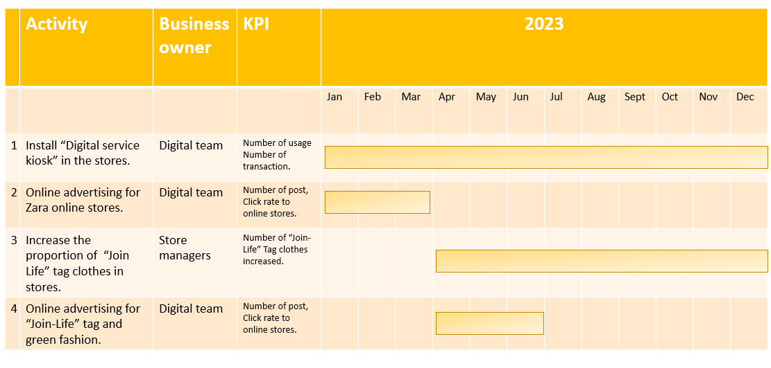
Source: Constructed by the author

Contingency Plan

The strategy recommended is based on the scenario of economy of Hong Kong will rebound. There is also a contingency plan for the scenario of the economy getting even worse in the near future.

References

Academic References

Chang, Y. W., Hsu, P. Y. & Yang, Q. M. (2018) Integration of online and offline channels: a view of O2O commerce. Internet Research.
Lopez, C., & Fan, Y. (2009) Internationalisation of the Spanish fashion brand Zara. Journal of Fashion Marketing and Management: An International Journal.
Porter, M. E. (2001) The value chain and competitive advantage. Understanding business processes, 2, 50-66.
Sharkie, R. (2003) Knowledge creation and its place in the development of sustainable competitive advantage. Journal of Knowledge management.
Sharma, A. (2009) Implementing balance scorecard for performance measurement. ICFAI Journal of Business Strategy, 6(1), 7-16.
Yüksel, I. (2012) Developing a multi-criteria decision making model for PESTEL analysis. International Journal of Business and Management, 7(24), 52.

8.2 Non-academic References

BCLP (2022) The Hong Kong 2022-23 Budget – Key updates on real estate sector. Available at: https://www.bclplaw.com/en-US/insights/the-hong-kong-2022-budget-key-updates-on-real-estate-sector.html (Accessed: 3 Oct 2022).
Consumption Voucher (2022) New Round of Consumption Voucher Scheme. Available at: https://www.consumptionvoucher.gov.hk/202122/en/newround.html# (Accessed: 3 Oct 2022).
GovHK (2004) ZARA opens its first store in Hong Kong Available at: https://www.info.gov.hk/gia/general/200405/20/0520132.htm (Accessed: 4 Oct 2022).
HKTDC (2022) Slowing the fast fashion impact. Available at: https://hkmb.hktdc.com/en/D7qvaA9v/sustainability/Slowing-the-fast-fashion-impact (Accessed: 3 Oct 2022).
Mission Statement (2021) Zara mission and vision statements analysis. Available: https://mission-statement.com/zara/ (Accessed: 3 Oct 2022).
RetailNews (2015) Zara’s online store opens in Hong Kong and Taiwan Available at: https://www.retailnews.asia/zaras-online-store-opens-in-hong-kong-and-taiwan/ (Accessed: 4 Oct 2022).
Inditex (2022) History Available at: https://www.inditex.com/itxcomweb/en/group/history (Accessed: 4 Oct 2022).
Inditex (2021) Annual Report 2020/2021 Available at: https://static.inditex.com/annual_report_2021/en/documents/annual_report_2021.pdf (Accessed: 4 Oct 2022).
Jasper Jolly (2020) Zara owner to close up to 1,200 fashion stores around the world Available at: https://www.theguardian.com/business/2020/jun/10/zara-owner-to-close-up-to-1200-fashion-stores-around-the-world (Accessed: 4 Oct 2022).
Statrys (2022) Hong Kong e-Commerce statistics and trends for 2022. Available at: https://statrys.com/blog/hk-ecommerce-trends (Accessed: 3 Oct 2022).
Sustainability (2021) What makes Zara’s Join Life branding initiative sustainable? Available at: https://sustainabilitymag.com/esg/what-makes-zaras-join-life-branding-initiative-sustainable (Accessed: 3 Oct 2022).
The World Bank (2018) International LPI. Available at: https://lpi.worldbank.org/international/global (Accessed: 3 Oct 2022).
Trading Economics (2022) Hong Kong GDP. Available at: https://tradingeconomics.com/hong-kong/gdp#:~:text=The%20Gross%20Domestic%20Product%20(GDP,source%3A%20World%20Bank (Accessed: 3 Oct 2022).
Trading Economics (2022) Hong Kong Retail Sales YoY. Available: https://tradingeconomics.com/hong-kong/retail-sales-annual (Accessed: 3 Oct 2022).
WWF HK (2022) Sustainability in fashion. Available: https://www.wwf.org.hk/en/cities/fashion/ (Accessed: 3 Oct 2022).
Zara Hong Kong (2022) Official website. Available: https://www.zara.com/hk/ (Accessed: 3 Oct 20220.

