Student Name: Abi Morgan
P Number: 151095
Programme of Study: Contextual Practices - Ways of Perceiving
Topic: Exploring the ‘Selfie’
Module: M4X01559
Words: 1320

So, if - like many others - you are confused about what the ‘selfie’ is, in 2013, Oxford English dictionary officially added ‘selfie’ to the dictionary which explains that it is “A photograph that one has taken of oneself, typically one taken with a smartphone or webcam and shared via social media.” (Definition of selfie in English. 2018)

In my exhibition at the Mission Gallery, we will be exploring the ‘selfie’ going all the way back to the first photographs from the 1800s and onwards to show how the world has become ‘selfie obsessed’ today. In 2018, we are surrounded by selfies taken by millions of people every day on our social media (SNSs) which has become the platform for how people express themselves to the world. Not only are selfies now meant for a much larger audience but they are also the subject of judgement from all its viewers, this is something that has changed over time.
This also raises a lot of questions, for instance, are ‘selfies’ a real representation of ourselves? And is there a deeper meaning behind our ‘selfies’?
We will also be exploring artists and influencers such as Andy Warhol and Jean Pigozzi who influenced the trend of the ‘selfie’.

The theme that runs throughout my exhibition is how the ‘selfie’ has changed over time and how it isn’t just how people express themselves but that it is now where people get their confidence and self-esteem from.
I will also be looking at the Ajzen's Theory of Planned Behaviour which explains the factors that make people want to take photos of themselves. Some believe that taking pictures of themselves comes from subjective norms, alleged behavioural control and narcissism which makes them then want to post on their SNSs.

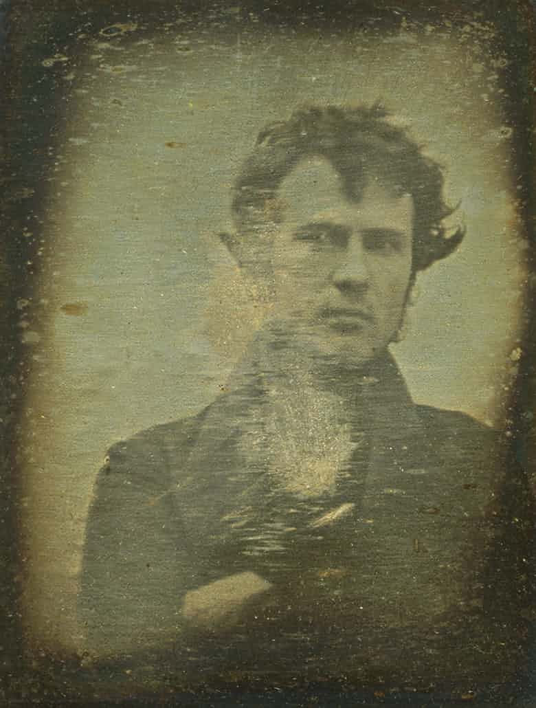
The history of the first ever ‘selfie’ took place in 1839, where Robert Cornelius who was a photography enthusiast set up his camera at his family’s store. Back in the 1800s, it wasn’t as quick to take a selfie like it is today and it took some time and persistence. To take a photo of himself, Cornelius had to; remove the lens cap; run into the frame where he stood for a minute; before covering up the lens again.
Figure 1. “The first light picture ever taken, 1839” (2018)

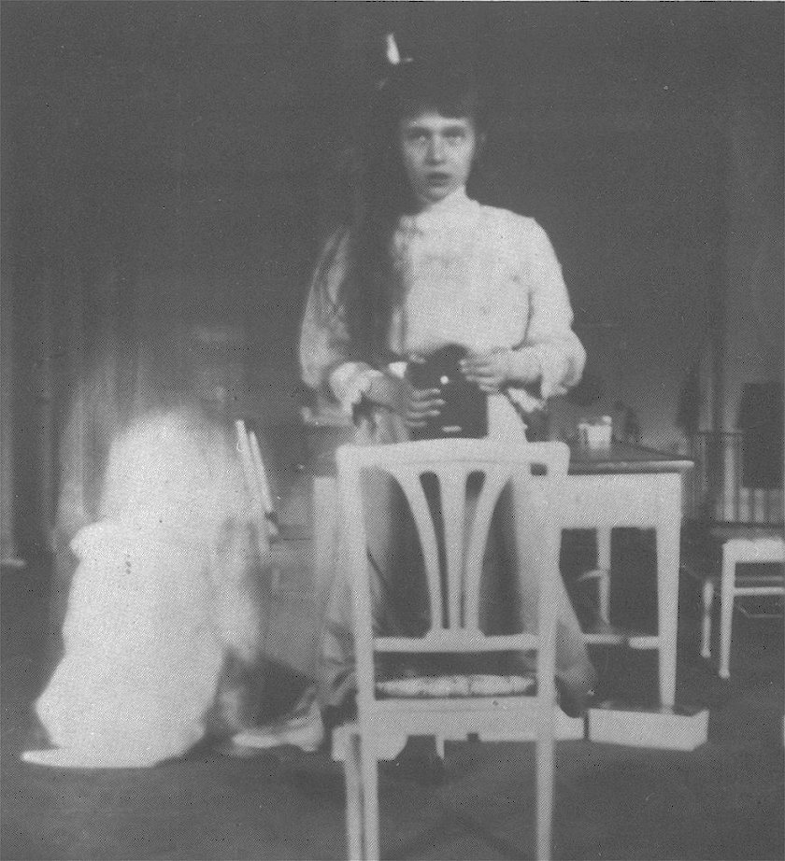
It was around 60 years after Robert Cornelius’ first selfie that the Kodak Brownie box was first sold in 1900 which led to many people owning their own camera and often they would end up taking pictures of themselves through reflective surfaces. Grand Duchess Anastasia Nikolaevna of Russia was one of the first teenagers to try this photographic self-portraiture, and it was not long until this ‘trend’ got very popular and cameras became more desirable since people loved this way of being able to express themselves through photography.
Here we are starting to see how taking selfies supported people’s needs to fit in with subjective norms. This pressure didn’t exist with Cornelius as selfies were rare and societal standards had not been set.
Figure 2. 1913: Duchess Anastasia Takes a Selfie. (2018).

Also, during this time, it was much harder and slower to take pictures, meaning you couldn’t take 20 pictures and instantly choose the best one as it took time to send pictures away to be developed and printed, whereas today it only takes a few seconds to take and view them. Inevitably, this means the pictures were more staged, planned and less spontaneous.
This is the reason I chose to include Cornelius’ in my exhibition, because (as far as we know) he was the pioneer of selfies.
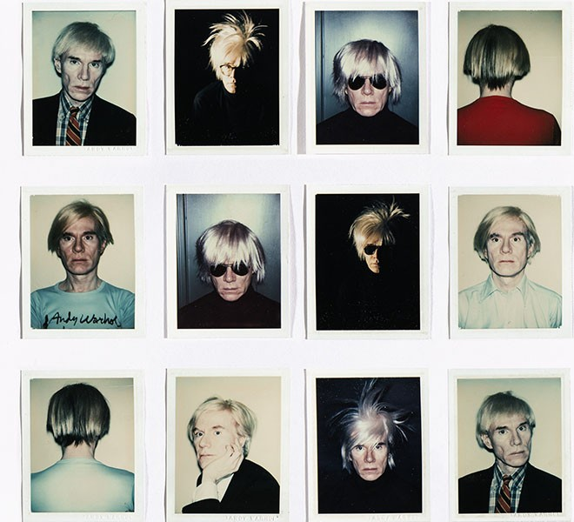
Andy Warhol was one of the most influential artists of his time, using his art to portray himself in different ways. Some people believe that Warhol foreshadowed the ‘selfie’ because he was an expert at representing himself in many diverse and imaginative portraits. It was hard to tell which version of him was the real one because a lot of his work concealed his identity. It could be argued that Warhol was displaying some of the self-absorbed traits in behaviour which are now common in some people’s posting of selfies.
Figure 3. PORTRAITS OF ANDY WARHOL. (2018).

Ryan Moule stated “Where there is distortion in photography, we can also say representation. Who is doing the distorting or representing, and for what purpose?” (Moule, R. 2018)
Warhol’s way of distorting his presentation of himself was through putting on wigs, outfits and makeup whereas nowadays, with a touch of a button we can airbrush away all our “imperfections” and make ourselves look like something that we aren’t.

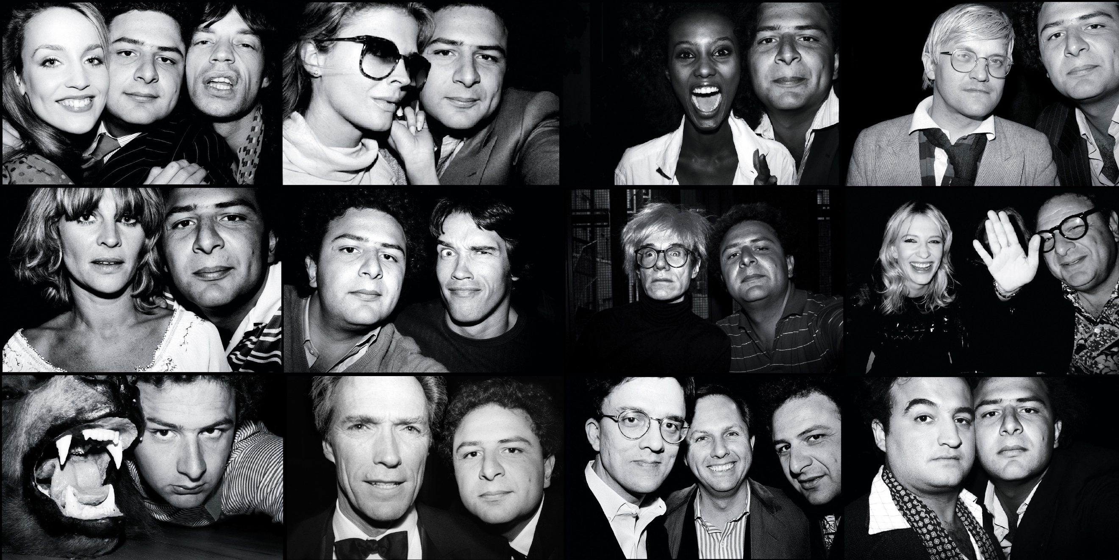
I chose Andy Warhol’s work to be in my exhibition because he played a big role in the art of self-expression within his work, which played a huge part in how the ‘selfie’ came around. Warhol said, “in the future, everyone will be world-famous for 15 minutes” (NPR.org. 2018) which is accurate considering these days we can upload a ‘selfie’ onto Instagram and there is an element of fame from gaining followers and ‘likes’ on our timeline and feeds.
Figure 4. Photographs by Jean Pigozzi
I first came cross Jean Pigozzi’s work in the Saatchi Gallery from the “selfie to self-expression” exhibition in 2017. He is regarded as the “King of Celebrity Selfies” because he had taken ‘selfies’ with rock stars, models, actors, artists and comedians for more than four decades. By including himself alongside these celebrities, he was elevating his own status above that of his peers.
Whilst he claimed his classmates would take pictures of pretty trees and flowers, Pigozzi would often take unusual photographs of cars in accidents and close pictures of dogs purposely overexposed from using a flash.

I decided to have Pigozzi’s work in my exhibition because no one at that time was taking selfie’s like he was. I like what Pigozzi says,
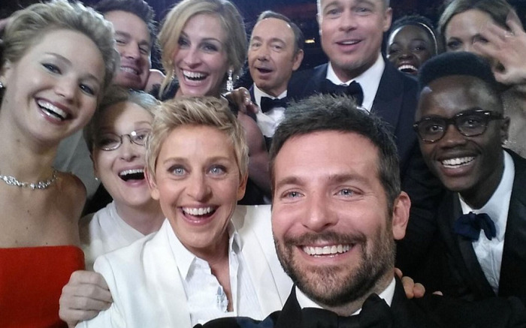
“There were people taking self-portraits for a hundred years. They would put the camera on a tripod and they would have a long tube with a little pump and you’d press it and take your picture, but people doing it the way I did it? [turning the camera around] I never saw anybody doing that.” (Carter, A. 2018).
Figure 5. What You Didn’t See in Ellen DeGeneres’ Famous 2014 Oscar Selfie. (2014)

In 2014, Twitter announced that it was the year of the ‘selfie’ as a picture of Ellen DeGeneres jam-packed with other Celebrities at the Oscar’s hit Twitter and many other Social Networking sites (SNSs), making it the most shared picture on Twitter which was retweeted more than three million times. This spontaneous selfie although apparently random, contains a collection of some of the most famous celebrities of the time which gives it such a high status in the entertainment world.

Now, it’s almost like an event or gathering is never complete without a ‘selfie’ of your family, friends or with complete strangers. Whilst selfies are meant to be just about us and how we look, no matter who is with us and what they look like, we still want to ensure that we are presenting on our SNSs are good. Without realising it, we are all representing elements of Cornelius, Pigozzi and Warhol who are strong influences on our self-expression.

Cornelius took a lot of care to ensure that he captured the best representation of himself, which we still do, but we use tools such as filters to speed up the process. Inadvertently, by applying these tools we start to distort our portraits to the extent that they no longer bear a true resemblance to us. This is partly the influence of Warhol, which means we can create a new persona for ourselves which portrays how we want to be perceived not who we are. Guy Debord quotes “But certainly, for the present age, which prefers the sign to the thing signified, the copy to the original, representation to reality, the appearance to the essence... illusion only is sacred, truth profane... as truth decreased and illusion increases, so that the highest degree of illusion comes to be the highest degree of sacredness.” (Debord, G., Debord, G. and Knabb, K. n.d.).

Pigozzi’s simple act of turning the camera around to face himself instead of using mirrors or cameras on tripods seems second nature now, but this was made acceptable because of his pictures.
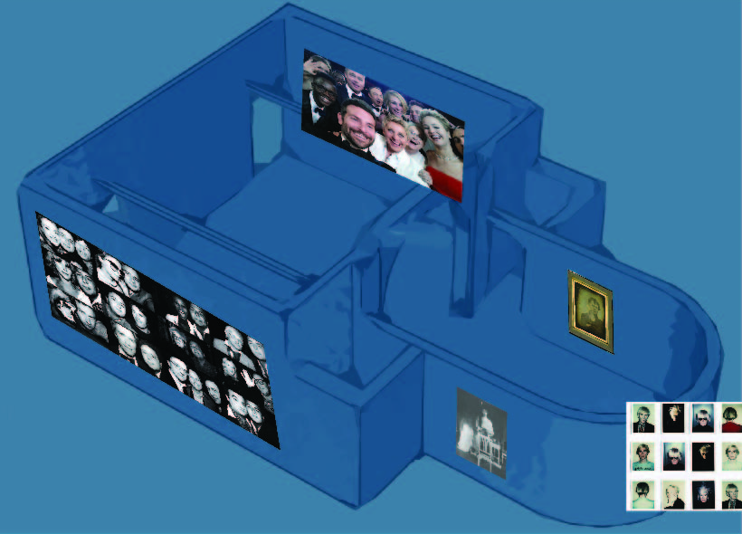
Figure 6. Map of my exhibition at the Mission Gallery

Bibliography

- Andrews, S. (2014). Selfies. Awards & honors; Smartphones, p.74.
- Anon, (2018). Robert Cornelius’ Self-Portrait: The First Ever “Selfie” (1839). [online] Available at: https://publicdomainreview.org/collections/robert-cornelius-self-portrait-the-first-ever-selfie-1839/ [Accessed 29 Apr. 2018].
- Barthes, R. (1988). Camera lucida. New York: The Noonday Press.
- BBC News. (2018). 2014: The Year of the 'Selfie'. [online] Available at: http://www.bbc.co.uk/news/blogs-trending-30394875 [Accessed 2 May 2018].
- Bergen, U. (2018). Seeing Ourselves Through Technology: How We Use Selfies, Blogs and Wearable Devices to See and Shape Ourselves | SpringerLink. [online] Link.springer.com. Available at: https://link.springer.com/book/10.1057%2F9781137476661 [Accessed 2 May 2018].
- Carter, A. (2018). How Jean Pigozzi Became Undisputed King of the Celebrity Selfie. [online] Vanities. Available at: https://www.vanityfair.com/style/2017/09/jean-pigozzi-undisputed-king-of-the-celebrity-selfie [Accessed 2 May 2018].
- Chen, T., Chen, Y. and Luo, J. (2017). A Selfie is Worth a Thousand Words: Mining Personal Patterns behind User Selfie-posting Behaviours. [ebook] pp.1-2. Available at: https://arxiv.org/pdf/1702.08097.pdf [Accessed 2 May 2018].
- Debord, G., Debord, G. and Knabb, K. (n.d.). The society of the spectacle.
- Definition of selfie in English. (2018). [online] Oxford Dictionary. Available at: https://en.oxforddictionaries.com/definition/selfie [Accessed 2 May 2018].
- Kim, E., Lee, J., Sung, Y. and Choi, S. (2016). Predicting selfie-posting behavior on social networking sites: An extension of theory of planned behavior. Computers in Human Behavior, 62, pp.116-123.
- Librarycatalogue.uwtsd.ac.uk. (2018). Selfie Me. I Am (Micro) Celeb!: Understanding the Role of Micro-Celebrity Practice in Selfie Culture. [online] Available at: http://librarycatalogue.uwtsd.ac.uk/primo_library/libweb/action/display.do?tabs=detailsTab&ct=display&fn=search&doc=TN_proquest1813622160&indx=1&recIds=TN_proquest1813622160&recIdxs=0&elementId=0&renderMode=poppedOut&displayMode=full&frbrVersion=&frbg=&&dscnt=0&scp.scps=scope%3A%2844WHELF_UWTSD%29%2C44WHELF_UWTSD_Ebsco%2Cprimo_central_multiple_fe&tb=t&mode=Basic&vid=44WHELF_UWTSD_VU1&srt=rank&tab=tab1&dum=true&vl(freeText0)=celebrity%20selfie&dstmp=1524334995816 [Accessed 2 May 2018].
- Lucian.uchicago.edu. (2018). selfies | The Chicago School of Media Theory. [online] Available at: https://lucian.uchicago.edu/blogs/mediatheory/keywords/selfies/ [Accessed 2 May 2018].
- Mail Online. (2018). Jean Pigozzi spent decades taking celebrity selfies. [online] Available at: http://www.dailymail.co.uk/femail/article-4974168/Jean-Pigozzi-spent-decades-taking-celebrity-selfies.html [Accessed 2 May 2018].
- NPR.org. (2018). Warhol Was Right About '15 Minutes Of Fame'. [online] Available at: https://www.npr.org/templates/story/story.php?storyId=95516647 [Accessed 2 May 2018].
- Sung, Y., Lee, J., Kim, E. and Choi, S. (2016). Why we post selfies: Understanding motivations for posting pictures of oneself. Personality and Individual Differences, 97, pp.260-265.
- Moule, R. (2018). Subverting the Sign.

- First light picture ever taken, 1839. (2018). [image] Available at: https://publicdomainreview.org/collections/robert-cornelius-self-portrait-the-first-ever-selfie-1839/ [Accessed 2 May 2018].
- Pigozzi, J. (2018). [image].
- PORTRAITS OF ANDY WARHOL. (2018). [image] Available at: http://HOLLYWORDREPORTER.COM [Accessed 2 May 2018].
- What You Didn’t See in Ellen DeGeneres’ Famous 2014 Oscar Selfie. (2014). [image] Available at: http://footwearnews.com/2017/influencers/awards/ellen-oscar-selfie-photo-318872/ [Accessed 2 May 2018].
- 1913: Duchess Anastasia Takes a Selfie. (2018). [image] Available at: https://www.theatlantic.com/technology/archive/2013/11/1913-duchess-anastasia-takes-a-selfie/281853/ [Accessed 2 May 2018].

