
Electric and hybrid propulsion control
Assignment 1 | Part B

M3x8668
p146770
Cameron Lamnea

Abstract

In the first section of this assignment the director of an engineering company producing buggies for off road recreational usage approached the author of this paper. The director wanted to understand the duty cycle that one of his buggies goes through on a general showcase track at a corporate event.
An analyses of a typical duty cycle was carried out to provide the director with the insight he desired.
Now further to this the company are considering producing a series hybrid version of their buggies. The director of the company will be provided with the following within this paper.
Alternative internal combustion engine (ICE) for use with a generator, energy storage device and controller that will be used with a motor and controller with a final drive solution to create a full series hybrid replacement for the buggies old setup.
The director will also be provided with recommendations on the above and an outline of the costings.

Contents
Abstract 1
1.0 Introduction 3
2.0 Technology Review 3
2.1 Final drive ratio estimate 4
2.2 Motor 5
2.3 Controller 8
2.4 Battery & Battery management system 9
2.5 Generator 10
2.6 Transformer 11
3.0 System specification and discussion and Preliminary costings 12
4.0 Conclusion and recommendations 13
4.1 Efficiencies 13
4.2 Weight 13
4.3 Findings on final drive ratio estimate accuracy 14
4.4 Battery conclusions 15
4.5 Additional vehicle maintenance requirements 16
4.6 Fuel Benefits 16
4.7 Final Comments 19
5.0 References 20

1.0 Introduction

The company director wants a full series hybrid system to replace the traditional ICE setup currently in place on the previously analysed buggy. A series hybrid system is made up of the following components,
- An electric motor a suitably matched controller.
- An appropriately selected final drive ratio between the motor output and the road wheels.
- A battery or similar storage system that can meet the input and output power ratings of the motor
- An ICE generator that can supply enough power for the entire system to function throughout the duration of the course, considering the minimum level the storage unit can drain to.
The above requirements will be selected, analysed and justified when recommending a set up to the director or the company.
Other considerations that will be included in the report are,
- Safety aspects.
- Maintenance requirements (incl. charging etc).
- Benefits in fuel consumption over the ICE only based system.
- Table of costings for the design.

2.0 Technology Review

In this section the various options for components to be used in the series hybrid setup will be reviewed.

2.1 Final drive ratio estimate

It is known from my Excel spread sheet data on the track designed, the buggy needed to output a maximum power of 4.09KW to overcome a maximum total resistance of 819N. Despite a potentially smaller ICE unit, the addition of all the other aspect of the hybrid series means that the weight of the buggy is not expected the change much when the conversion is completed. This will be verified once the specification is complete. However, to complete the specification a motor must be selected and the power it needs to output must be known for this to be done. So, for now the weight will be taken as the same 356 KG and the same maximum power and total resistance used to calculate the final drive estimate which will be used to select a motor.
Two aspects will be considered in the following calculations, Max RPM and Max Nm.
- Max RPM (at road wheel)
Radius of Polaris RZR170 driven wheels = 4.5 inches, 114.3mm, 0.114m.
Circumference = 2xpixr = 0.716m
7m/s is the max speed of buggy around track with ICE only setup.
7m/s divided by 0.716m = 9.777 revs/sec, 586 RPM
5m/s is the max speed of buggy at the point of the track were the total resistance is highest.
5m/s divided by 0.716m = 6.98 revs/sec, 418 RPM
- Max N (max total resistance at road wheel)
819n of total resistance
Knowing the above data should a gear ratio for the final drive of 10:1 be used the motor would need to output,
5860 RPM
81n/m of max torque
(Ehsani, Gao and Emadi, 2018)

2.2 Motor

There are some powerful and efficient motors based on brushless DC design currently available.
Take the Yasa P400 series for example.
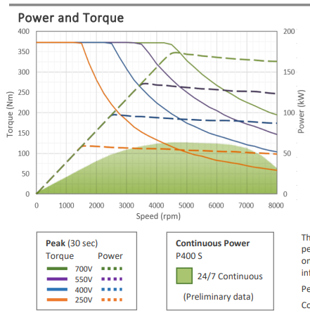
Graph 1 – This shows the Yasa P400 E-Motors series power and torque figures at various voltage levels. (P 400 Series E-Motors, 2018)
As can be seen from Graph 1 the Yasa P400 can produce over 50kw of power and 375Nm of torque when run at its lower power input capabilities.
Yasa make a 750-series motor capable of even greater outputs so do other brands such as Emrax with similar motors (Emrax 268 Technical Data Table, 2018)
The motor chosen is a smaller Emrax motor, the Emrax 188 BLDC (Brushless DC Motor) in its air-cooled, low power 100 vDc form. (Emrax 188 Technical Data Table, 2018)

Here are some images of the chosen motor.
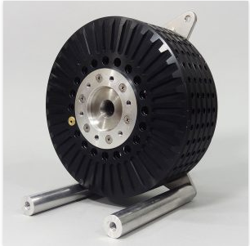
Image 1 - Emrax 188 BLDC Motor. (EMRAX, 2018)
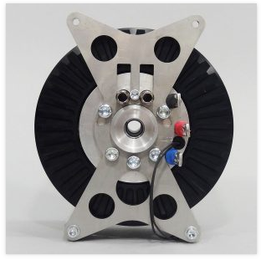
Image 2 - Emrax 188 BLDC Motor. (EMRAX, 2018)
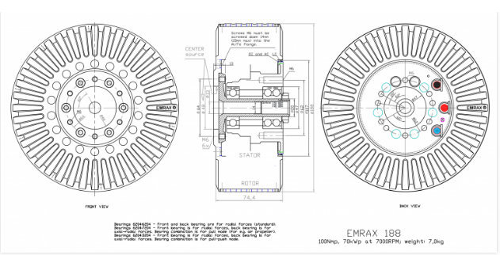
Image 3 - Emrax 188 BLDC Motor schematic drawing. (EMRAX, 2018)
In its chosen form the Emrax 188 BLDC Motor specs are as follows.
Cooling | Air Cooled
Weight | 6.8KG
Max Voltage (vDc) | 100
Max RPM | 7000
Peak Power at max RPM | 70KW
Continuous Power | 15-28KW between 3000-6000 rpm
Max current | 800 Arms
Continuous current | 400 Arms
Max Torque | 100 Nm
Continuous Torque | 50 Nm
Torque / motor current | 0.15 Nm / 1Aph rms
Motor efficiency | 92-98%
Controller / motor signal | Sine wave
Table 1 – Emrax 188 BLDC Motor specifications, low power, water cooled format. (Emrax 188 Technical Data Table, 2018)

2.3 Controller

The chosen controller is the Sine-Wave BLDC Motor controller VEC700.
Its specifications are as follows.
Voltage Range | 48V, 72V, 96v
Rated continuous current | 400 A
Peak current | 700 A
Weight | 6.5KG
Signal type | Sine Wave
Fully Programable | Yes, via PI400I-Vec Cable
Efficiency | >98%
Table 2 – VEC700 controller specifications. (Green Energy, 2018)
This controller is more than capable of delivering adequate voltage and current to the motor via the correct sine wave signal format. It is fully programable and works with many types of throttle input devices, such as twist grips and foot pedals.

2.4 Battery & Battery management system

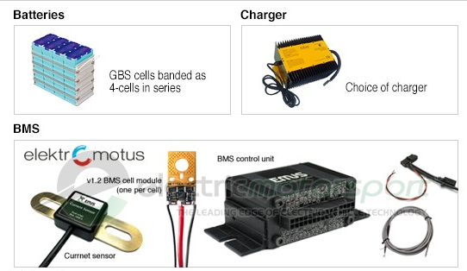
Image 4 - This image shows a 4-cell lithium ion (Li-Ion) battery (under batteries, top left of the image) and the BMS Control unit with its current sensors and cell modules.
The battery pack itself is a 96v 40Ah Li-Ion battery pack, the battery pack consists of 8 GBS 12v (4-cell) 40Ah LiFeMnP04 units in a series setup.
The control unit is an advanced EMUS BMS system. It has advanced battery management capabilities, including voltage and current balancing and advanced charging control.
Nominal Voltage | 12.8v
Nominal Capacity | 40 Ah
Chemistry | LiFeMnP04
Operational Voltage Range | 11.2 to 14.4v
Max charging current | 3c
Max discharge current | 3c continuous / 10c pulsed
Cycle life | >1500 (80%DOD)
Weight per cell / Weight per 8 cells | 6.6kg / 52.8kg
Table 3 – Battery Pack specifications per cell. (Electricmotorsport.com, 2018)
There are 8 of these cells shown in Table 3 in series within this battery pack. The voltage is therefore increased to 96v, but the Ah and Max Charge/Discharge rates remain the same. The chemistry in the Li-Ion battery makes for a very fast charging / discharging battery. Perfect for the short burst, high intensity of the track.

2.5 Generator

The generator chosen is a Clarke PG3800DV 3kVA 230/110v dual voltage petrol generator. It will be used on its 110v AC setting.
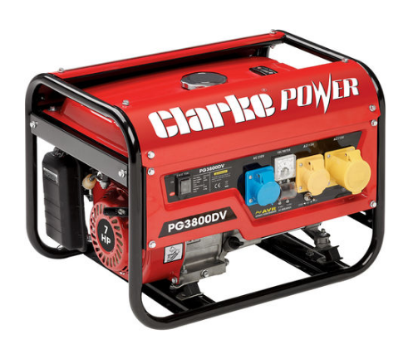
Image 5 – This shows the Clarke PG3800DV generator set.
Max output | 3000w
Continuous output | 2700w
Voltage | 110v AC 16Amp
Weight | 43.7kg
Engine | 7hp
Fuel tank capacity | 15l
Fuel Consumption | 1.9l/h at ¾ load
Voltage regulation | Automatic
Table 4 – Clarke PG3800DV specifications. (Machinemart.co.uk, 2018)

2.6 Transformer

As the generator outputs 110v AC current, a transformer is needed to input the required voltage to the EMUS Battery management system and then on to the battery and then motor controller.
The ElCON PFC2500 2.5KW transformer charger has been chosen to do this. It will connect to the Generators 110v AC outlet and connect directly to the EMUS BMS. It has auto cut off / variable charging current to ensure the battery is always topped up to 100% but never overcharged.
Efficiency | >93%
Continuous output | 2000w
Input voltage | 110v AC
Output Voltage | 36-288VDC
Waterproof and Shockproof | Yes
Can Connection for BMS systems | YES
Table 5 – Transformer specification. (Electricmotorsport.com, 2018)

3.0 System specification and discussion and Preliminary costings

The chosen system consists of the following.
Item | Justification | Cost (£)
Emrax 188 BLDC Motor | Has enough power and torque and can operate within the ranges of both required for the track. | 2173
Sine-Wave BLDC Motor Controller VEC700 | Can control the chosen motor correctly and with high level of programmability. | 980
96v 40Ah Li-Ion battery pack | Will deliver enough power to the motor and can charge/discharge at high enough rates to keep up with the requirements of the track. | 2137 + 20% VAT = 2564
EMUS Battery management system | Can safely manage the high voltage battery and charging system to ensure there Is no battery failure and a reliable feed of voltage is supplied to and from the battery. | Incl. In battery pack.
Clark PG3800DV Generator | Outputs adequate power for the system and has low fuel usage. | 322
ECLON PFC2500 2.5 KW transformer charger | Can deliver almost all the power from the generator to the BMS unit with high efficiency. It’s high output rate of 2000w continuous to the BMS system, along with the high charge/discharge rates of the battery will ensure there is always a high supply of charging power from the generator available to the motor. | 601 + 20%VAT = 721
 | Total Cost | £6780
Table 6 – Justifications and costings of components.

4.0 Conclusion and recommendations

In section 2.1 a final drive ratio estimation was made, to validate this the efficiencies within the system and a more accurate estimate of the final setup weight is required.

4.1 Efficiencies

In the following table losses will be estimated taking their highest loss estimates as values.
Component | Efficiency losses
Emrax 188 BLDC Motor | 8%
VEC700 controller | 2%
ElCON PFC2500 | 7%
Total Losses | 17%

Taking this and the continuous output rating of the charger at 2000w into account this gives 1660w input from generator directly to the road wheels at a time of max power draw.

4.2 Weight

In the following table the new vehicle weight will be estimated. The generator unit will be similar to the original engines weight and will not be included as an addition or reduction to weight.
Factor | Weight
Polaris RXR170 base weight | 227KG
2 Passengers | (62 x2) KG
9l of fuel reduced to 3l (1.5 hours running time of generator minimum) | 2.21166
Emrax 188 Motor | 6.8KG
VEC700 Motor Controller | 6.5KG
Battery Pack & BMS | 52.8KG
Transformer | 3KG
New total | 422KG

4.3 Findings on final drive ratio estimate accuracy

This data was inputted into the existing Excel spread sheet with some additional data columns to generate the following graph.

Graph 2 - This graph shows the power in KW required as the buggy travels around the track.
The max power required increased to 4223w, a slight increase. The maximum total resistance increased to 844 N, again a slight increase.
Based on this, the initial final drive estimate can now be considered final as a ratio of 10:1 is still well within the capabilities of the Emrax Motor and no significant increase in requirements was found.

4.4 Battery conclusions

The chosen Li-Ion battery pack offers much higher charge and discharge rates and capacity options than a standard lead acid battery. It is therefore a good choice for the 140s blast around the track. To validate this the following graph was generated.

Graph 3 – This graph shows the joules in the battery in KJ for each second the buggy travels around the track. Note that some peaks on the graph such as around 20s may be above 100% battery charge. At this point the charging system would manage the charge to ensure only the power required was drawn from the generator and the battery would not go above its safe full capacity.
As can also be seen from Graph 3 the battery is near its starting charge at the end of the lap. This means it would only lose a small amount of charge per lap, a small amount of time left idling after every few laps would maintain a full battery, this would ensure a driveable buggy without waiting around for it to charge for long periods.
The battery discharges by a maximum amount of 48.85 KJ in one lap. The battery is 40Ah and can emit 13,824 J for an hour continuously, by dividing this by 0.038 which is 140s out of an hour we get 363.8 KJ available for the 140s period. Over the 140s period this would go down to 314.95 KJ. This means the battery is operating within the top 13.5% of its charge range. This will ensure a long battery life and low risk of battery damage, it would have an 86.5% buffer of charge. (Ehsani, Gao and Emadi, 2018)

4.5 Additional vehicle maintenance requirements

The generator unit used on the vehicle will need to be maintained in the same manner as the existing engine would have been, with regular servicing etc.
All other aspects of the buggies original maintenance routine (chain, tyres etc.) will still be the same. The battery will need to be load tested after 1500 cycles of discharge below 80% and recharge to ensure it is still viable. (Ehsani, Gao and Emadi, 2018)
The addition of the battery and hybrid series components however cause some health and safety risks. The only people who will now be able to perform any maintenance on the vehicle will need to be hybrid certified due to the high voltage and current running through the vehicle. The system will need to be well insulated with a black box for the battery in the event of a crash. (Sandford, 2018)
No external charging will be required, short periods left on idle will ensure the battery is brought to full charge due to the high-power output of the generator unit and the transformer to the battery.

4.6 Fuel Benefits

The fuel usage of the Clarke Generator is far less than that of the 6.5hp unit it will be replacing. This is due to far less load placed on the generators motor over the buggies original motor, which had to drive the road wheels.
The generator can run at a constant economic RPM maintaining good engine efficiency, whilst the original unit had to vary its load and RPM constantly meaning it would rarely be operating at an efficient RPM zone.
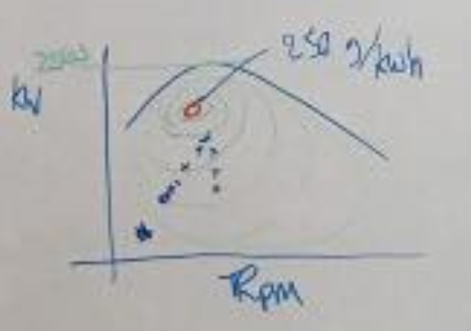
Image 6 – This shows the fuel efficiency peak at 250g/kwh in the middle of the graph shown, with Kw on the Y axis and RPM on the left. (Fuel Efficiency Graph, 2018)
As explained by Mark Sandford using the above graph, the lower crosses you see in Image 6 are how the original engine would change in efficiency zones as its RPM changed travelling around the track. The Clarke Generator running at a much more constant RPM would be able to maintain a point far closer to the peak efficiency point. See Image 7 below for a clearer graph. (Sandford, 2018)
Just looking at the fuel consumption per hour of the existing Polaris RZR170 engine at a constant rpm range would not be beneficial to compare with the 1.9l/h usage of the Clarke Generator. The RZR170’s engine would need to be plotted over the entire track at each different rpm output on an efficiency graph such as the one in Image 6 & 7. This rpm data is beyond the scope of this assignment.
But in principle the generator will be more fuel efficient.
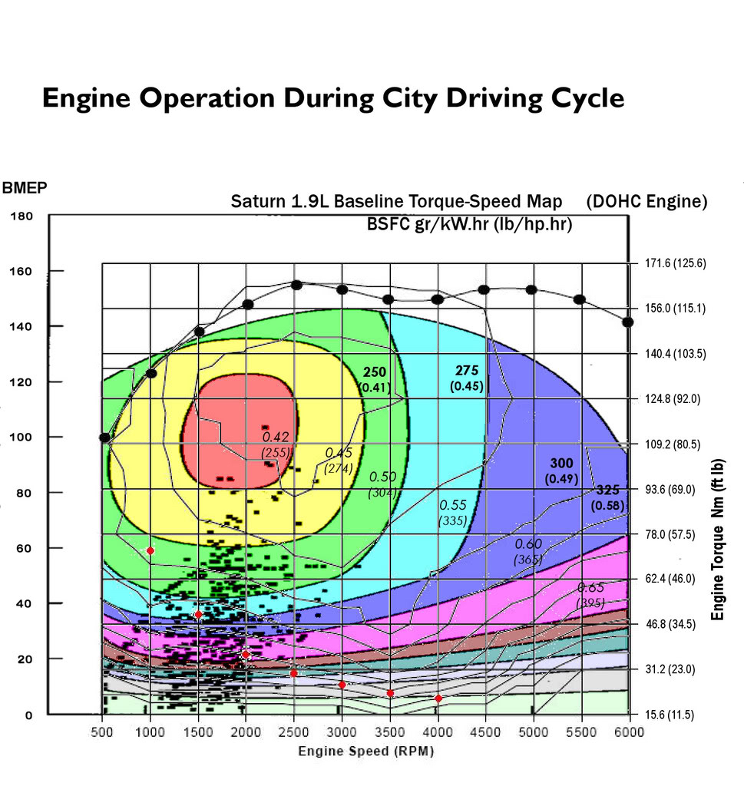
Image 7 – This image shows a 1.9l engine operating on an efficiency graph. (NGA 178, 2018)
The black dots on Image 7 show the vehicles efficiency as its RPM changes in this case during city driving. As can be seen more clearly than in Image 6 the same effect is occurring. The generator set would be always able to remain in the green zone on this specific graph for example. (Sandford, 2018)

4.7 Final Comments

Far more fuel efficient and more powerful buggies can be created using hybrid series technology. The extra weight of the hybrid series components is negligible due to the additional power potentials.
However, there is the financial aspect, the additional £6780 cost the hybrid series setup adds, which would when profit margins and increased labour and build costs are factored in be over £11,000. This makes the buggy unrealistic for anybody to purchase over the original format. It is on this basis that the recommendation is that the company does not go ahead with the hybrid series buggy plans because at this stage the technology required is too expensive. In the future it will most likely be common place and far more affordable, but currently it is unviable. (Ehsani, Gao, Emadi, 2018)

5.0 References
Emrax 268 Technical Data Table. (2018). [eBook] Emrax. Available at: http://emrax.com/wp-content/uploads/2016/12/emrax_268_technical_data.pdf [Accessed 17 Mar. 2018].
Emrax 188 Technical Data Table. (2018). [eBook] Emrax. Available at: http://emrax.com/wp-content/uploads/2016/12/emrax_188_technical_data.pdf [Accessed 17 Mar. 2018].
EMRAX. (2018). Products - EMRAX. [online] Available at: http://emrax.com/products/ [Accessed 17 Mar. 2018].
P 400 Series E-Motors. (2018). [eBook] Yasa. Available at: http://www.yasa.com/wp-content/uploads/2018/01/YASA_P400_Product_Sheet.pdf [Accessed 17 Mar. 2018].
Green energy. (2018). Sine-wave BLDC motor controller VEC700. [online] Available at: https://www.miromax.lt/en/m-6/c-39/c-146-sine-wave_bldc_motor_controllers/product-514-sine-wave_bldc_motor_controller_vec700#product [Accessed 21 Mar. 2018].
Electricmotorsport.com. (2018). Electric Motor Sport, Inc. [online] Available at: http://www.electricmotorsport.com [Accessed 21 Mar. 2018].
Machinemart.co.uk. (2018). Machine Mart Power Tools and Machinery. [online] Available at: https://www.machinemart.co.uk [Accessed 20 Mar. 2018].
Fuel Efficiency Graph. (2018). [Pen] Swansea: UWTSD.
NGA 178. (2018). Car Efficiency - China. [online] Available at: https://nga.178.com [Accessed 17 Mar. 2018].
Sandford, M. (2018). Lecture on Hybrid Series Vehicles.
Ehsani, M., Gao, Y. and Emadi, A. (2018). MODERN ELECTRIC, HYBRID ELECTRIC, AND FUEL CELL VEHICLES. [S.l.]: CRC PRESS.

