
Software Development (pyton) ACCB4017

Student Name: Diana Cretu
Student ID: 2112907

Lecturer Name: Suneth Fernando

Submission date: 29.04.2022
Table of Contents
Part A (Understanding) 3
A1:Variables. 3
A2: IF/ELSE Statement. 3
A3:Loops. 5
Part B (Implementation) 6
Exercise 1: Write a program to show how the variables can hold different types of value. 6
Exercise 2: Write a program to get valid input from the user and make geometric calculations. 9
Exercise 3: Write a program to allow the user to input car mileage per day for a week and calculate total mileage and money spent on it. 13
Exercise 4: Write a program Game 16
Table of figures 21
Bibliography 22

Part A (Understanding)

A1:Variables. In this part, I will discuss the variables and their importance in writing programs. Also, will give some examples of how the variables are handled in Python.
“The most powerful feature of a programming language is the capability to operate with variables” [1]. Variables are used to store information, data, or value. In programming, the value stored in a variable is always represented by the location address like a variable name.
The main disadvantage of a variable is when assigning a new value to a variable the old value will be deleted. Whatever the data entered in the system it is stored in a variable and when it’s needed to manipulate this data, the system will take the value and perform any calculation. Therefore, any software solution or code should use variables, in order, to hold the user’s input.
A good feature of Python programming language it checks variable types at runtime, which means that's a variable can be not declared explicitly. There are different types of variables, global and local.
“Assign a value to variables is the most difficult task in computer programming.” [2] The signed name should be descriptive and understandable. The assignment operator to give a name is equal “=”. Once we have defined a variable, we can call it as many times as we need to operate with this. The variable value has, also, different types of values like integer, float, boolean, and string.

A2: IF/ELSE Statement. At this point, I will explain what an if/else statement is, how and why they are used and give a code example of when I can implement it.
An IF/ELSE statement it's known as the decision making or validation statement it decides based on the given condition or expression. This statement is often used with Boolean expressions(true/false).
The first and the most primitive form of the condition statement is the IF statement. So, we have the keyword “IF” followed by the condition and then in the next line is a statement which will be executed if this condition results in true. After the test expression or IF condition results in “true” that means any statement which is inside the “if “block will be executed, if this condition results in false then the control of the program will skip to this statement after the IF block. An example of an IF statement is in Fig.1.
Figure 1
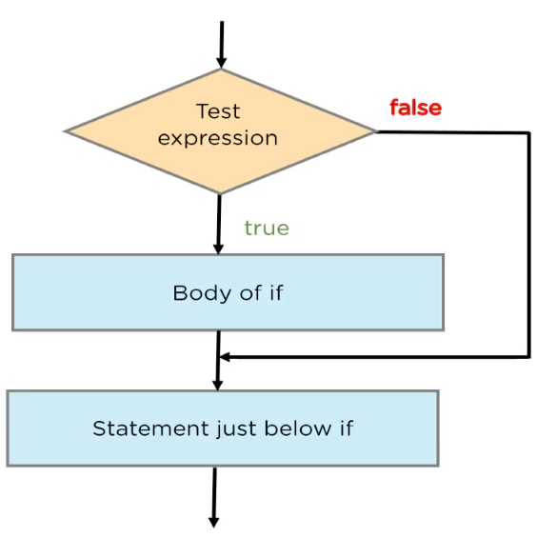
The next format of the if statement is the IF-ELSE statement, here we can specify the statement that will be executed in a case when a condition is true and a separate set of statements in case the condition is false. So, in this case, we assign a statement for both cases when an expression can be true and false. In comparison with the if statement the program execution will move on to the else block in case of a false not to statement below the IF. An example of an if-else statement using a flow chart is presented in figure 2.
Figure 2
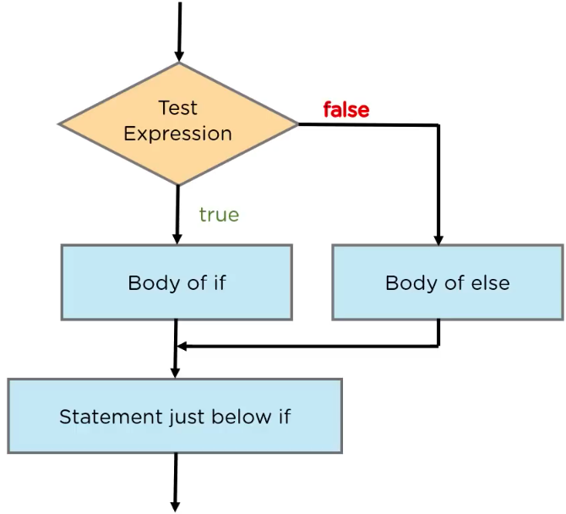

The other type of if statement is Nested IF, this is a kind of if statement when you have an if statement within an if statement. This statement comes when you must filter a variable more times. In nested if we have two expressions to test at the same time. As examples of how this statement is used in the flowchart see Fig.3.
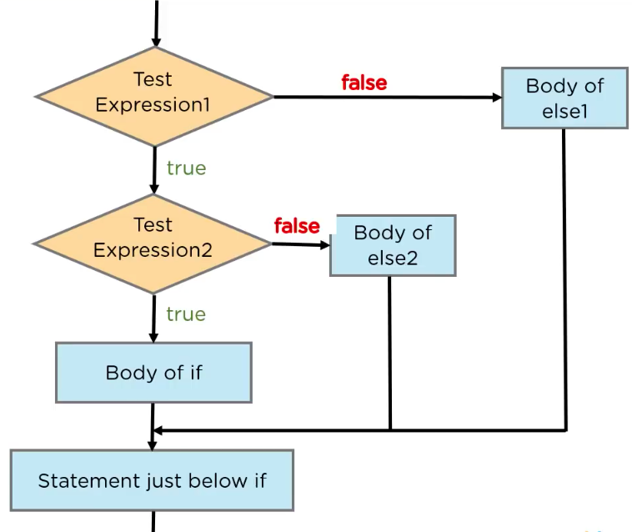
Figure 3.

The most complex if statement is the IF-ELIF-ELSE statement. This statement is used to check more conditions and go through that block of if statement which is true and after that move out to statement below If-elif. The program starts at the first condition expression if it’s true then the program will execute the statement from the body of if. in the case when the first expression is false it will move ahead to expression 2, once the condition is checked and the result will be true the program will run the statement from the body of Elif1 and after that move to statement below if-elif block. This complex statement keeps checking every condition till the next block below.
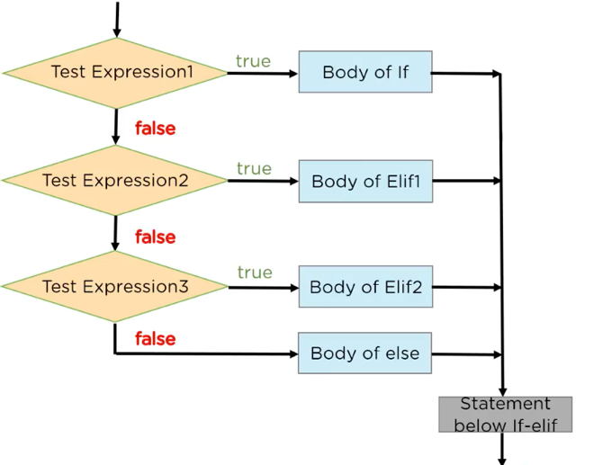
Figure 4

A3:Loops. In this paragraph, I will explain why loops are needed in a program and what types of loops exist. Also, will analyze suitable examples of each in Python.
Python provides the possibility to repeat a piece of code several times to get the result using loops. In the writing program, loops are important to be able to create dynamic programs which are flexible to do different things and essential to save time and minimize errors. Generally, the loops are programming elements that repeat a portion of code.
There are two types of loops: based on w3school, “for loops” which “are used for iterating over a sequence” [3] or performing a set number of repetitions, and “while loops” to repeat the code until a given condition is met.
Figure 5 Example of FOR loop
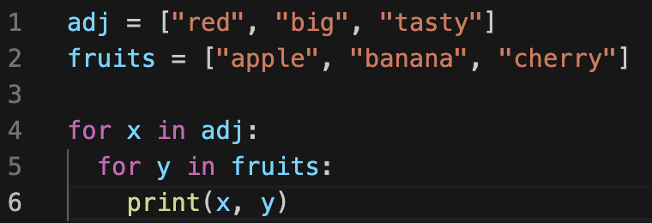 Output: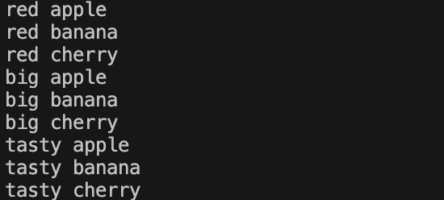
Figure 6 Example of WHILE loop
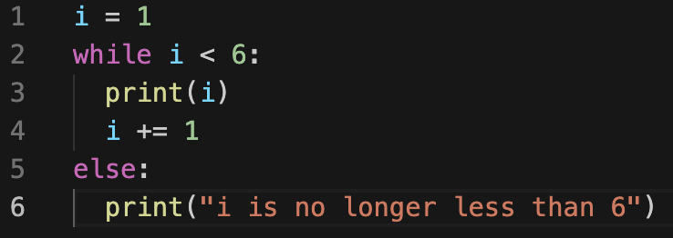 Output: 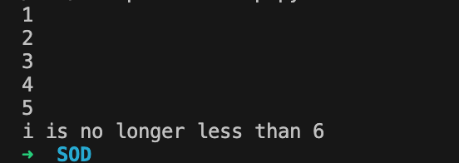

Part B (Implementation)

Exercise 1: Write a program to show how the variables can hold different types of value.
- Logical stages:

- Request the user to enter a name.
- Check the value entered if is a string (if not, back to 1)
- Prompt the user to enter the age.
- Check the value entered if is an integer, more than 0 and positive(if not, back to 2)
- Prompt user to enter height
- Check the number entered for height is not above 2.2 metres, is float type, and positive (if not, back to 3)
- To print results on the screen

In this exercise I will define 3 variables, the user will enter these values and will see on the screen his input.
- Code with annotation, ready to copy and paste:
#Program to define different types of variables and display the user inputs

while True: #testing the input of name
name=str(input("Please enter you name:\n")) #Prompt user to input name
if name.isalpha(): #Check if is string
print("Welcome "+name)
break
else:
print( "Invalid input, try again")

while True: #testing the input of age
try:
age = int(input("Please enter your age:\n ")) #Prompt user entering the age
if age>0: #Check for negative value
print("Age accepted")
break
elif age<=0: #Check for positive value
print("Must be positive and above 0, try again")
except ValueError: #validate user input
print("Sorry, i don\'t understand that!\n") #message for invalid input
continue

while True: #testing the input of age
try:
height = float(input("Please enter your height:\n ")) #Prompt user entering the age
if height>0 and height<2.2: #Check for negative value
print("Height accepted")
break
elif height<0:
print("Must be positive and more than 0, try again")
elif height>2.2: #Check for real height,(boundary)
print("Unless you are a giant, that seems a bit high!")

except ValueError: #validate user input
print("Sorry, i don\'t understand that!\n") #message for invalid input
continue
print("Thanks, you entered:", name, " - " , age,"y.o."," - " , height, "m tall")

- The figures below it's a screenshot of the result of testing in different situations.
- Normal “Happy Path” (Normal values):
Figure 7_Happy Path_Exercise1
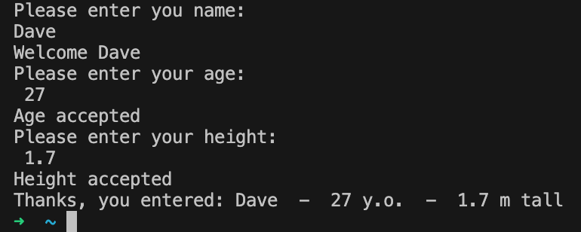
Result: Program executed as expected

- Boundary, test name for acceptable input and out-of-range value :

Figure 8_Boundary1_Exercise1
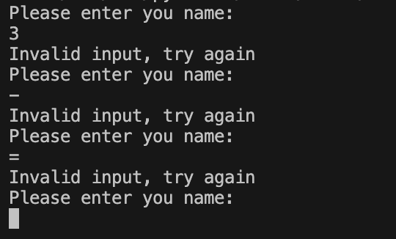
Result: Program executed as expected, the user was not allowed to enter out of range value

- Boundary, test age for an acceptable input:
Figure 9_Boundary2_Exercise1
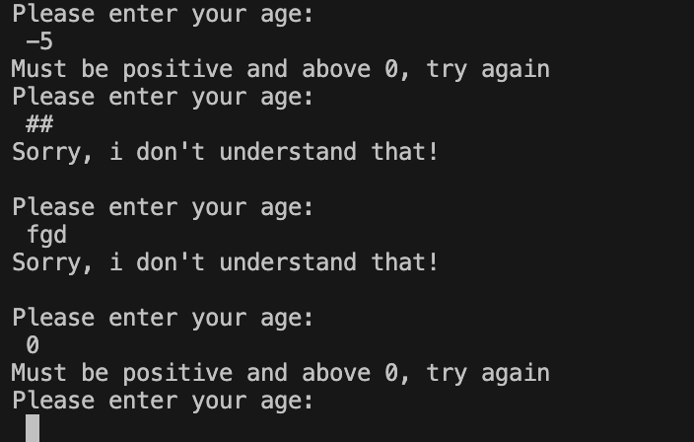
Result: Program executed as expected

- Boundary, test height for an acceptable input:
Figure 10_Boundary3_Exercise1
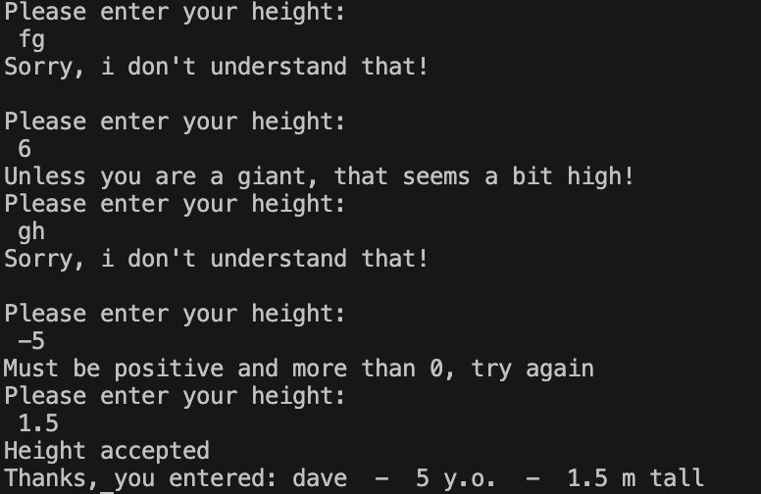
Result: Program executed as expected

Exercise 2: Write a program to get valid input from the user and make geometric calculations.
- Logical stages:
- Request the user to enter the radius, side of the square, width, and length of a rectangle.
- Check that all inputs entered are digits and positive (if not, back to stage 1, for each of them)
- Check the number entered for the radius, side of the square, width, and length of a rectangle, to be logically admissible in geometry based on the previous inputs from the user (if not, back to 1)
- To make the calculations of area of square and rectangle, and shaded area
- To print results on the screen

In this exercise, I will use a function to validate the user's input to be digit and positive.
- Code with annotation, ready to copy and paste:
#Program to get input from users and make geometrical calculations.
from math import pi #import pi from match library

def get_non_negative_int(prompt): #function to check non integer inputs
try:
value = int(input(prompt)) #Condition for numeric output to be True
except ValueError:
print("Sorry, I didn't understand that.") #Error message
return get_non_negative_int(prompt) #Step back

if value < 1: # this part checks if positive value
print("Sorry, your response must not be negative or 0.")
return get_non_negative_int(prompt) #Step back
else:
return value
#Prompt the user for inputs
radius = get_non_negative_int('Please enter radius of circle:\n ')
side = get_non_negative_int("Please enter side of square:\n ")
if side>radius-1: #Check if possible in geometry to incorporate square in circle
print("It can not be greater than radius of square = ", radius, "Try again")
side = get_non_negative_int("Please enter side of square:\n ")
width = get_non_negative_int("Please enter width of rectangle:\n ")
if width >radius-side: #Check if possible, in geometry to incorporate rectangle in circle
print("It should be less than or equal to", radius-side)
width = get_non_negative_int("Please enter width of rectangle:\n ")
lenght = get_non_negative_int("Please enter lenght of rectangle\n ")
if lenght>radius-2: #Check if possible in geometry to incorporate rectagle in circle
print("It can not be greater area of circle, you can try less or equal to ", radius-2)
lenght = get_non_negative_int("Please enter lenght of rectangle\n ")
#Calculations:
area_square = side*side
area_rectangle = width*lenght
area_circle = pi*radius**2
shadearea = area_circle - area_rectangle - area_square
#Calculated results
print ("The shaded area is ", (round(shadearea, 1)), "cm")

- The figure below it's a screenshot of the result of testing in different situations.
- Normal “Happy Path” (Normal values):
Figure 11_Happy Path_Exercise2
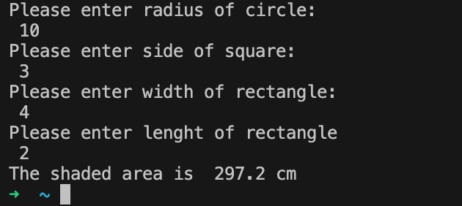
Result: Program executed as expected

- Boundary: test all variables for acceptable digits and positive values:
Figure 12_Boundary1_Exercise2
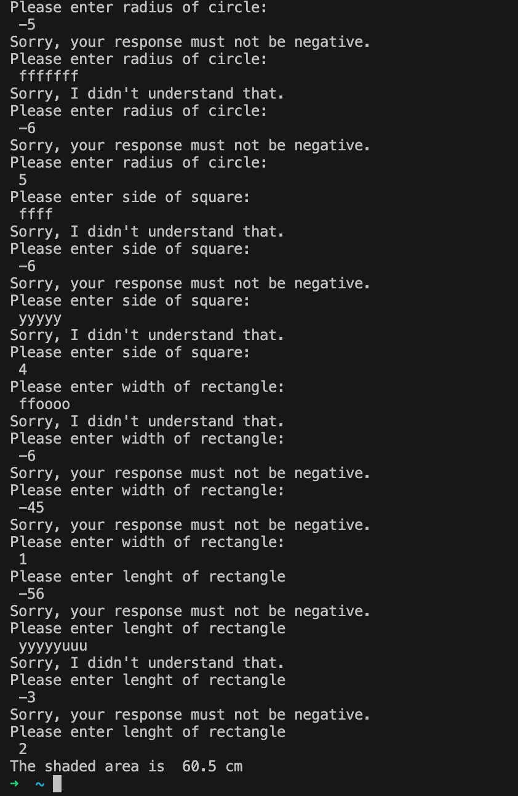
Result: Program executed as expected, the user was not allowed to enter negative values and string type values.

- Boundary: test the side of the square for out of range inputs including geometry parameters:
Figure 13_Boundary2_Exercise2
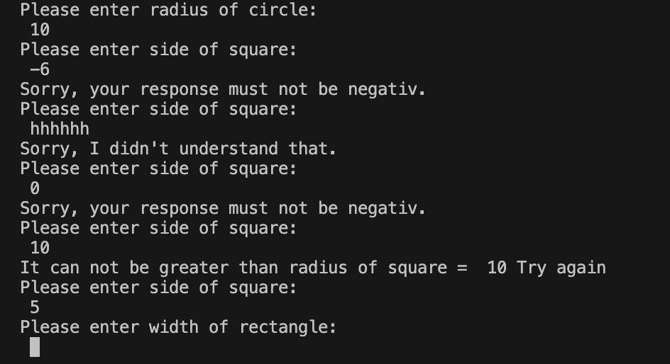
Result: Program executed as expected

- Boundary: test the width of the rectangle for out of range inputs including geometry parameters, when it can be incorporated into the circle:
Figure 14_Boundary3_Exercise2
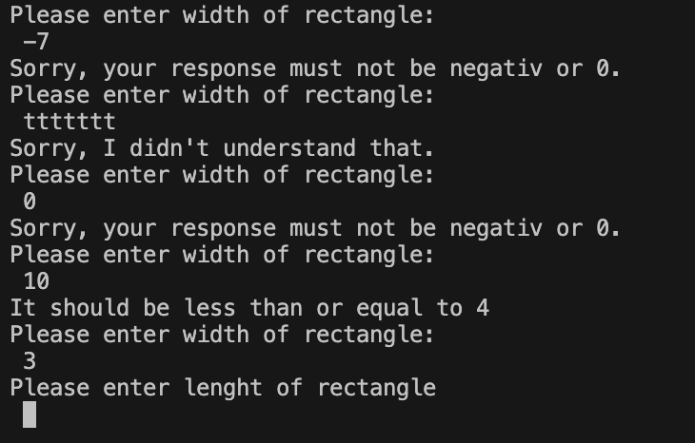
Result: Program executed as expected

- Boundary: test the length of the rectangle for out of range inputs including geometry parameters, when it can be incorporated into the circle:
Figure 15_Boundary4_Exercise2
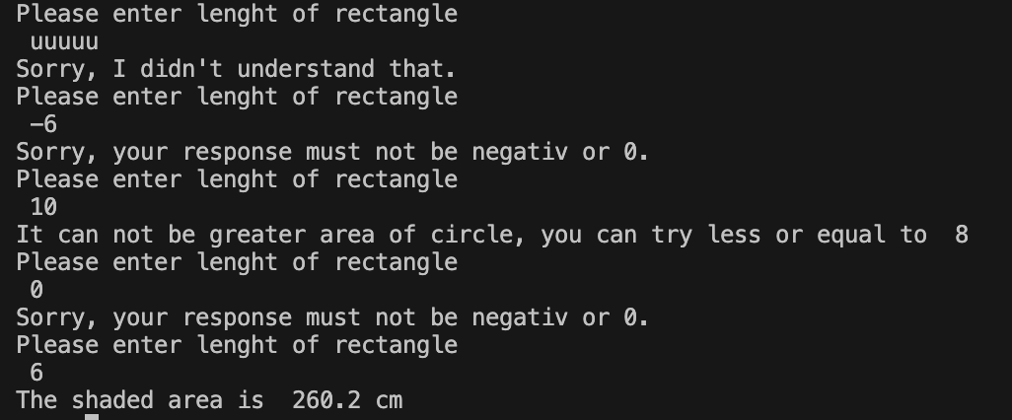
Result: Program executed as expected

Exercise 3: Write a program to allow the user to input car mileage per day for a week and calculate total mileage and money spent on it.
- Logical stages:
- Request the user to enter the mileage for Monday, Tuesday, Wednesday, Thursday, Friday, Saturday, and Sunday using the function.
- Check that all inputs entered are digits and positive using function “is a digit”(if not, back to stage 1, for each of them)
- Repeat entering and checking all variables in a list of “weekdays”.
- To make the calculations of total mileage and money spent per week.
- To print results on the screen.

In this exercise, I will use two functions incorporated one in another to get input and validate it at the same time.
- Code with annotation, ready to copy and paste:
#Program to calculate mileage per day for a week
def is_digit(string): #function to check non integer inputs
if string.isdigit():
return True
else:
try:
float(string)
return True
except ValueError:
return False

def insertMiles(): #Function to insert value for weekdays
miles = input() # Read the inputs
if is_digit(miles): # Check if it is digit
miles = float(miles) # Check if is float type
else :
print("Sorry, I don\'t understant that, Please try again:") # Print error message if True
miles = insertMiles() #Go back to funtion
if miles < 0: #Check if number is positive
print("It cannot be negative, Please try again:") # Print error message if True
miles = insertMiles() # Go back to function
return miles # Return inputs

if __name__ == "__main__":
rate = 1.35 #Create a variable
consumption = 11.2 #Create another variable
WeekDays = ["Monday", "Tuesday", "Wednesday", "Thursday", "Friday", "Saturday", "Sunday"] #Create a list

totalMileage = 0
for day in WeekDays: #Pass all days in a week using FOR loop
print("Enter miles for {0}".format(day))
totalMileage += insertMiles() #Make calculations

spent = (totalMileage / consumption) * rate #Make calculations of money
print("The total mileage was: {0}".format(round(totalMileage,1))) #Print total mileage
print("Cost of petrol: {0}".format(round(spent,2))) # Print result of spent money

- The figure below it's a screenshot of the result of testing in different situations.
- Normal “Happy Path” (Normal values):
Figure 16_Happy Path_Exercise3
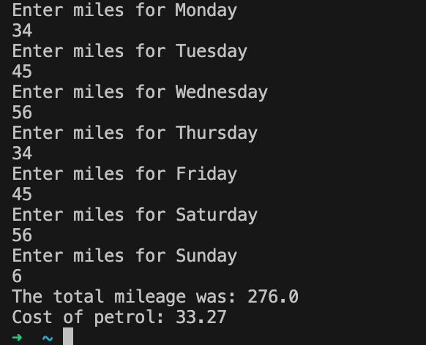
Result: Program executed as expected

- Boundary: test the “Monday” variable for acceptable value type and positive values:
Figure 17_Boundary1_Exercise3
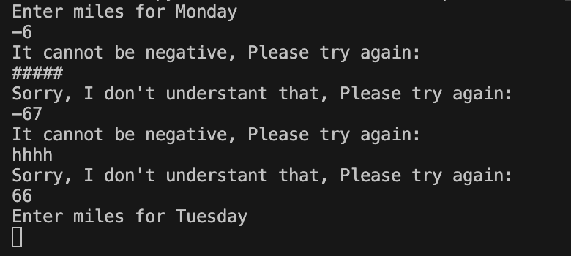
Result: Program executed as expected, the user was not allowed to enter negative values and string type values.

- Boundary: test the “Thursday” variable for acceptable value type and positive values:

Figure 18_Boundary2_Exercise3
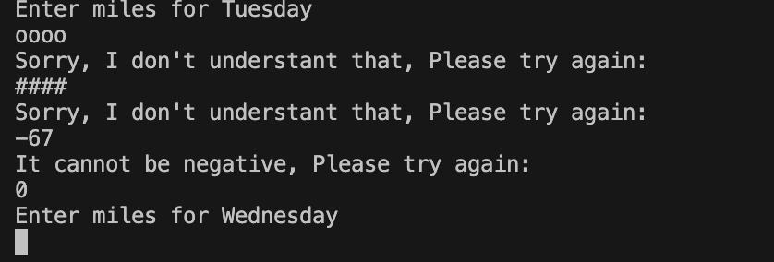
Result: Program executed as expected and value “0” is allowed in case the car didn’t make any journey.

- Boundary: in the same way test all variables for acceptable value type and positive values:
Figure 19_Boundary3_Exercise3
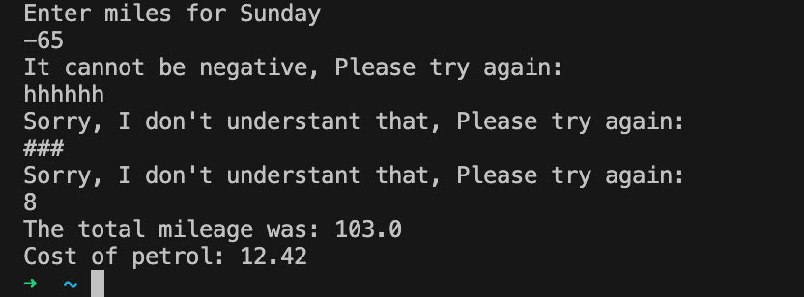
Result: Program was executed as expected and was not allowed to enter negative numbers or string type values.

Exercise 4: Write a program Game
- Logical stages:
- Request the user to enter Guess1.
- Function Check if Guess1 is digit type, positive and in range of game area. (control structure)
- Request the user to enter the Guess2.
- Check if Guess2 is digit type, positive and in range of game area. (if not, back to 2)
- Check pairs if exist - Updating the board, if not display the message of hided animals
- Count and print results and number of turns on the screen

In this exercise, I will define more function, to get input from user, check pairs, update the game board,
- Code with annotation, ready to copy and paste:
#Pair Game
def show_Game(GameArea): #Function to display GameArea
indexArea = "" #Display first list
infoArea = "" #Displaying second list
index = 0 #Starting index
for item in GameArea: #Start for Game Area
indexArea += str(index) + "\t"
index += 1
infoArea += item + "\t"

print(indexArea) #Printing game Board
print(infoArea)

def get_input(nr,GameArea,firstGuess = -1): #Function to read User guess
print("Please enter guess {0}".format(nr))
Userguess = input() #Prompt user to guess
if Userguess.isdigit(): #Check if it is digit
Userguess = int(Userguess)
else : #If is False
print("You must enter a positive number... try again")
Userguess = get_input(nr, GameArea, firstGuess) #Step back to function
if Userguess > 11: #Check if UserGuess is between 0 and 11
print("This position is not available... try between 0 and 11")
Userguess = get_input(nr, GameArea, firstGuess) #Step back to function
if GameArea[Userguess] == 'X': #Check if index is available
print("This position", Userguess,"has been already guessed above... try others")
Userguess = get_input(nr, GameArea, firstGuess) #Step back to function
if firstGuess == Userguess: #Check if User Guess is not duplicated
print("You cannot enter 2 identical digits... try again")
Userguess = get_input(nr, GameArea, firstGuess) #Step back to function
return Userguess

def CheckPairs(nr1, nr2, GameList): #Function to Check Pairs
if GameList[nr1] == GameList[nr2]: #Check if are pair
print("Well done, that\'s a match on:", GameList[nr2])
return True
#If false print
print("Not a match. Position {0} was {1} and position {2} was {3}".format(nr1, GameList[nr1], nr2, GameList[nr2]))
return False

def ChangeGameArea(nr1, nr2, GameArea): #Functon to update the Board
GameArea[nr1] = "X" #Update guessed position
GameArea[nr2] = "X" #Update guessed position

if __name__ == "__main__":
#Starts from the following:
pairs = 6
turns = 1
Animal = ["Cat", "Dog", "Tortoise", "Tiger", "Dolphin", "Giraff"]
GameList = [Animal[4], Animal[0], Animal[3], Animal[1], Animal[0], Animal[2], Animal[5], Animal[3], Animal[1], Animal[4],Animal[2], Animal[5]]
GameArea = ['?', '?', '?', '?', '?', '?', '?', '?', '?', '?','?', '?']
GameFlags = True

print("Welcome to the pairs game! There are {0} pairs to find".format(pairs))
print("Here is the board:")
while GameFlags: #Repeating while all pairs found
print("You've had {0} turn(s) so far".format(turns))
show_Game(GameArea) #Prompt the game start
guess1 = get_input(1 ,GameArea)
guess2 = get_input(2, GameArea, guess1)
if CheckPairs(guess1,guess2,GameList): #Check for pairs
ChangeGameArea(guess1,guess2,GameArea) #Updating the board
pairs -= 1 #Exclude paired index
if pairs == 0: #Check if any pairs still available
GameFlags = False
print("Well done, you got them all. You did it in {0} turns".format(turns))
turns += 1 #Allow to repeat

- The figure below it's a screenshot of the result of testing in different situations.
- Normal “Happy Path” (Normal values) to get one pair:
Figure 20_Part_Happy Path_Exercise4
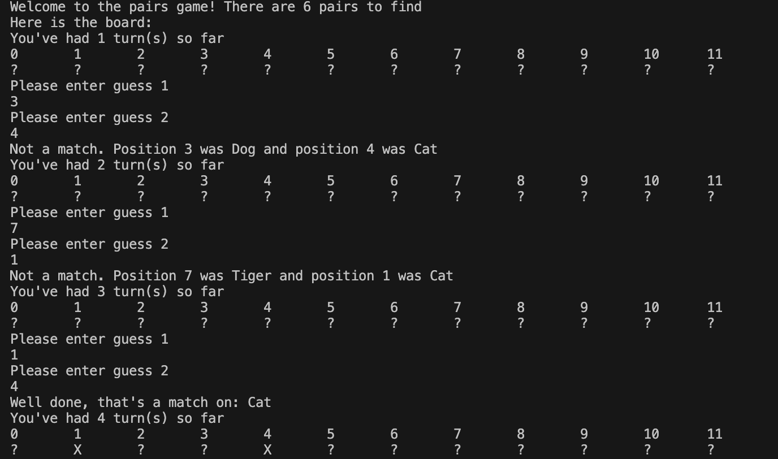
Result: Program executed as expected till guess one pair

- Normal “Happy Path” (Normal values) to get all pairs:
Figure 21_Full_Happy Path2_Exercise4
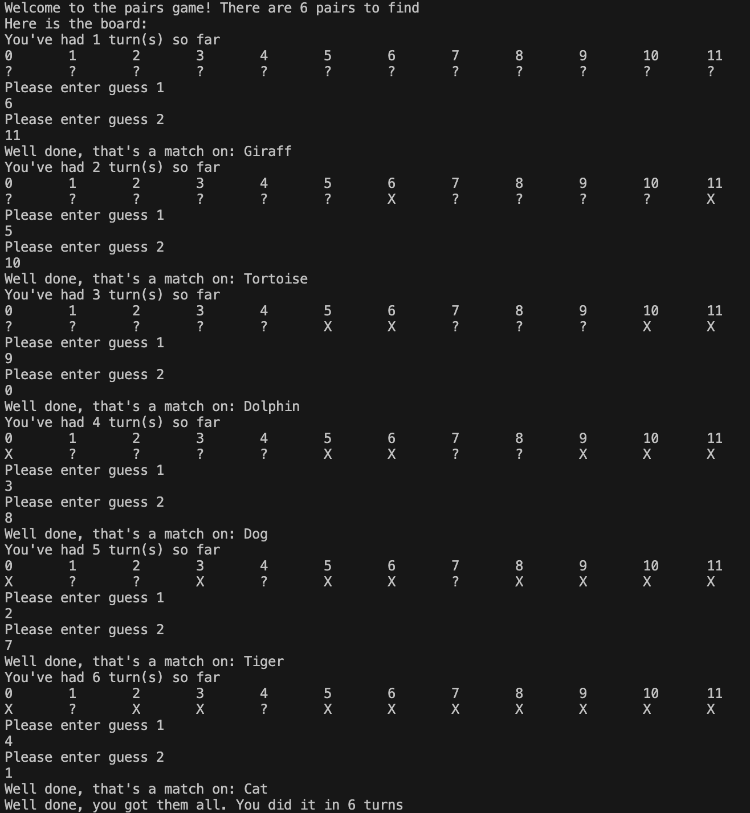
Result: Program executed as expected

- Boundary: test user’s input for acceptable type of value :
Figure 22_Boundary1_Exercise4
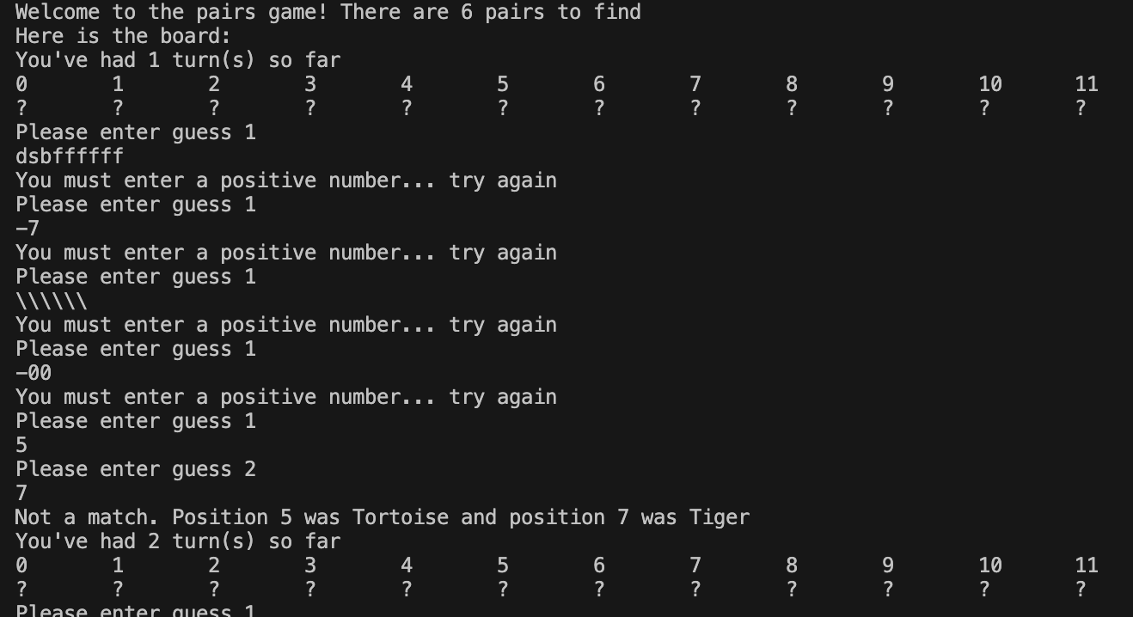
Result: Program executed as expected, the user was not allowed to enter out of range type value

- Boundary: test guessed numbers do not be reused:
Figure 23_Boundary2_Exercise4
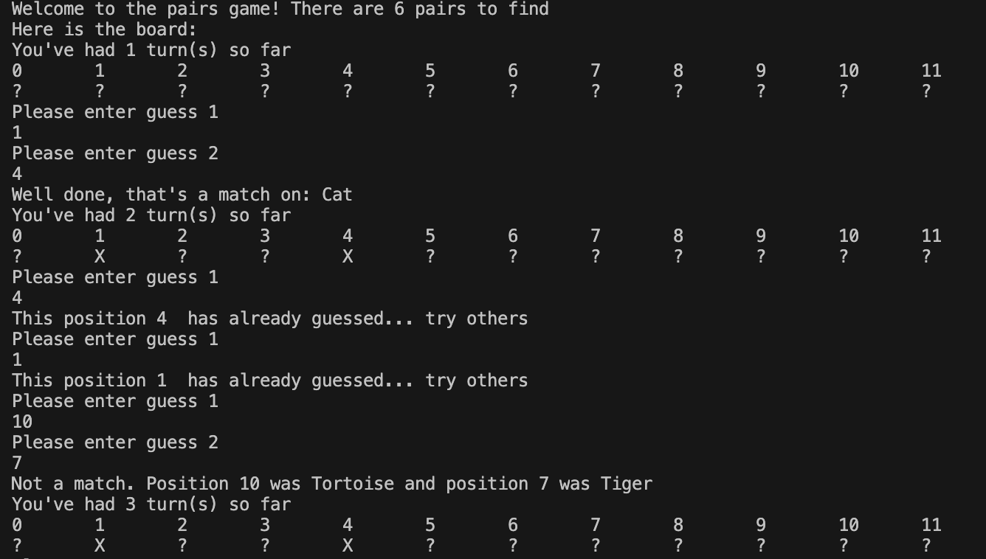

Result: Program executed as expected, it does not allow to enter twice the same value

- Boundary: test does not accept 2 identical guess numbers:
Figure 24_Boundary3_Exercise4
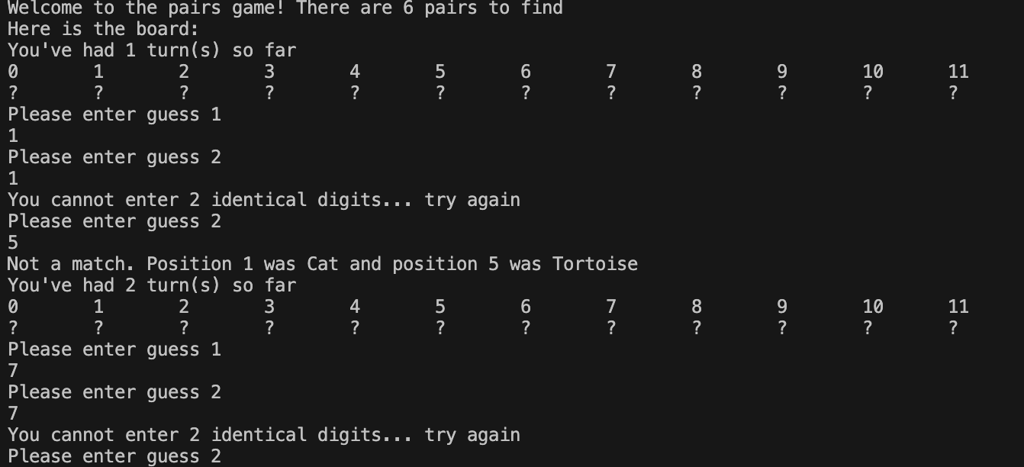
Result: Program executed as expected and starts from the 2nd guess to enter other value.

- Boundary: test one more time for acceptable input and out of range numbers:
Figure 25_Boundary4_Exercise4
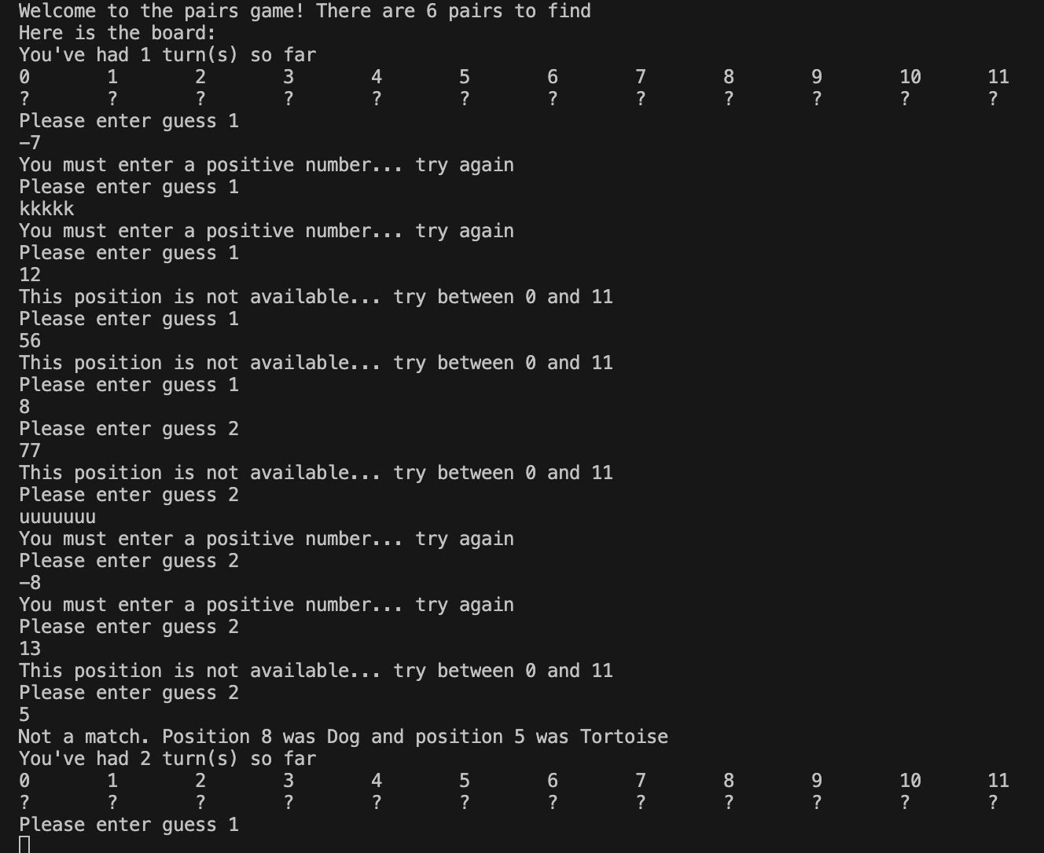
Result: Program executed as expected

Table of figures

Figure 1 3
Figure 2 4
Figure 3. 4
Figure 4 5
Figure 5 Example of FOR loop 5
Figure 6 Example of WHILE loop 5
Figure 7_Happy Path_Exercise1 7
Figure 8_Boundary1_Exercise1 7
Figure 9_Boundary2_Exercise1 8
Figure 10_Boundary3_Exercise1 8
Figure 11_Happy Path_Exercise2 10
Figure 12_Boundary1_Exercise2 10
Figure 13_Boundary2_Exercise2 11
Figure 14_Boundary3_Exercise2 11
Figure 15_Boundary4_Exercise2 12
Figure 16_Happy Path_Exercise3 14
Figure 17_Boundary1_Exercise3 14
Figure 18_Boundary2_Exercise3 15
Figure 19_Boundary3_Exercise3 15
Figure 20_Part_Happy Path_Exercise4 18
Figure 21_Full_Happy Path2_Exercise4 18
Figure 22_Boundary1_Exercise4 19
Figure 23_Boundary2_Exercise4 19
Figure 24_Boundary3_Exercise4 20
Figure 25_Boundary4_Exercise4 20

Bibliography

[1] | Jeffrey Elkner, Allen B. Downey and Chris Meyers, “Learning with Python,” Sphinx, 2012. [Online]. Available: http://www.openbookproject.net/thinkcs/python/english2e/ch02.html. [Accessed 24.02.2022].
[2] | E. Matthes, Python Crash Course, 2nd Edition: A Hands-On, Project-Based Introduction to Programming, No Starch Press, 2019.
[3] | “w3school,” Refsnes Data, 1999-2022. [Online]. Available: https://www.w3schools.com/python/python_for_loops.asp. [Accessed 23.04.2022].

