  Component One: Student Journal (learning log) 750 words +/- 10%  Contribution to Overall Module Assessment: 25% | Student No: | 2239006
 | Module Title: | Operating Hotel Facilities
 | Module Code: | BMIH4006
 | Lecturer:
Title: Housekeeping Department- First Impression

Introduction: I started the first day of the placement being excited about meeting other people and learning new things about the hospitality industry. Having experience in interacting with customers, the housekeeping department is a new chapter for me thinking that the work is very hard and meticulous.

Experience: Starting the day, I was introduced to a part of the team by our lovely manager, who I am pleased to say is doing a great job and resonates with the whole team. The hotel where my placement takes place is one of the largest hotel chains in the UK with a variety of locations with more than 800 hotels in the country. I have been located at Premier Inn Tamworth South, which provides all its guests with comfy beds, a power shower, and Wi-Fi. Meeting the team, the manager presented us with the tasks for the day. As I mentioned, the housekeeping job is a meticulous activity, where you must ensure that the guest's accommodation is spotless and well-stocked. The housekeeping team has shown me each step of cleaning a guest room and taught me to give attention even to the small details. The hotel where my placement takes place has got strict policy about cleaning the rooms to ensure guests have higher standards of cleanliness and presentation. The first step once you walk into the room is to make sure you leave the fresh air to come in, you have to spray the bathroom and then take all the lining and the towels that have been used by customers. Once you’ve cleaned the bathroom and dusted the whole room you can make the beds which can be quite difficult if you are a beginner, beds must be checked well before using the clean lining. They have a precise way to set the beds and ensure that they look spotless. Another important aspect within the housekeeping department is health and safety, housekeepers often work with chemicals that can pose health risks if not handled properly. I have been around each housekeeper and I have been impressed by how difficult is to provide dedication and professionalism even though we are different people the work that they provide is the foundation of a comfortable and enjoyable stay. I observed their systematic approach to cleaning and organizing each space, paying attention to every detail. All the housekeeper has a room to clean and is individual work, I have noticed that if it’s needed they help each other that’s leading to good communication and teamwork.

Reflection: The whole experience in the housekeeping department provided me with additional appreciation for the essential role that housekeepers play in the overall guest experience. Even though their work passes unnoticed by the guests, the housekeeping staff is the foundation for an enjoyable and comfortable stay within the hotel industry.

Analysis: As I reflect on my experiences today, I'm struck by the parallels between the housekeeping department and other areas of the hotel. Just as the front desk staff greets guests with a warm welcome, and the restaurant team serves delicious meals with care, the housekeeping team ensures that every guest accommodation is a clean and inviting sanctuary. Each department plays a vital role in creating a memorable experience for guests, and I'm excited to continue exploring these connections throughout my internship.

Conclusion: Overall, my first day in the housekeeping department was both enlightening and inspiring. I'm grateful for the opportunity to learn from experienced professionals in the field and to gain hands-on experience that will shape my future career in the hospitality industry. I am grateful to the housekeeping team for agreeing to show me what a day looks like in the housekeeping department they taught me from their experience, and showed me how to pay attention to small details that can make a difference within the hospitality industry. I do appreciate their dedication to the work that they provide contributing to the success of business growth. I look forward to continuing to immerse myself in the world of housekeeping and to contributing to the success of the team in the days and weeks ahead.

Component Two: Health and Safety Guide
Contribution to Overall Module Assessment: 25%
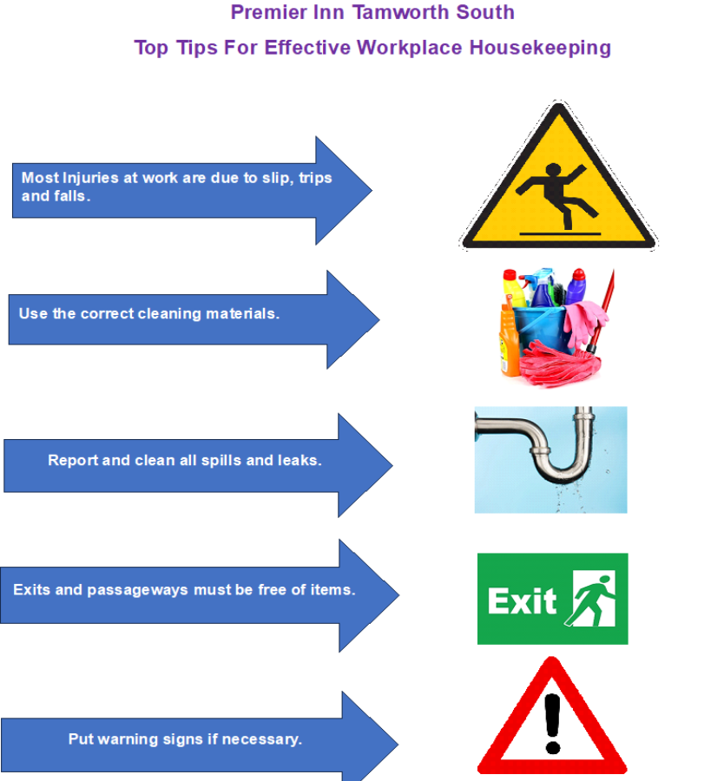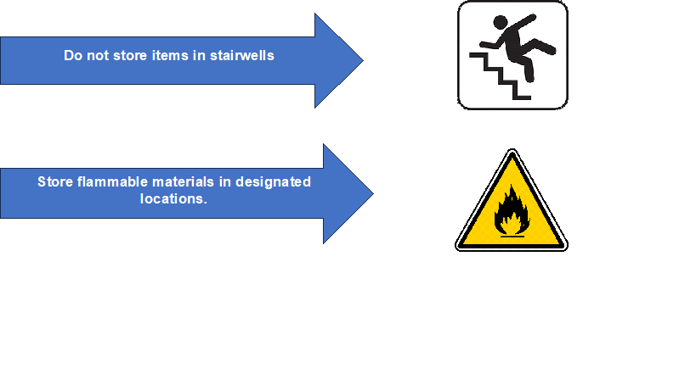

Reference List https://en.wikipedia.org/wiki/Premier_Inn
https://www.premierinn.com/gb/en/hotels/england/staffordshire/tamworth/tamworth-south.html
https://cdn.whitbread.co.uk/media/2023/07/Whitbread_ESG_Report_2022.pdf
https://www.premierinn.com/gb/en/why/force-for-good.html
https://www.makrosafe.co.za/blog/Top-tips-for-effective-workplace-housekeeping
https://www.tripadvisor.com/ShowUserReviews-g504160-d1431772-r722382713-Premier_Inn_Tamworth_South_Hotel-Tamworth_Staffordshire_England.html
https://ebookcentral.proquest.com/lib/trinity/detail.action?docID=315165&pq-origsite=primo
https://www.proquest.com/docview/2806445710?accountid=130472&parentSessionId=vxu531HOukGCYFUh3UxdsLIEP%2FhnZ7QsYcLK2gKid6o%3D&pq-origsite=primo&sourcetype=Scholarly%20Journals

