

Student name: | Kirsty Garrett | Student ID number: | 0950562
Programme: | DA Program - BSC in Supply Chain and Logistics
Module: | Business Planning
Module code: | ACMA 4015 | Contribution to Overall Module Assessment (%): | 100%
Lecturer: | Dr Moutushi Tanha | Internal Verifier: | Dr Irina Neaga
Assignment Title: | Developing a Business Plan | Word count (or equivalent): | 1583 words
Submission deadline: | 04/12/2025 | Return date of provisional marks & written feedback: | 20 working days after submission

AI Acknowledgement
I confirm that I have not present any AI-generated materials as my own work in this portfolio.
However, I acknowledge that I have used or may have used the AI in the research and proofreading of my portfolio.

Name: Kirsty Garrett
Student ID: 0950562

Executive Summary: Health Hub & Café
The Health Hub & Café is a community-centered space combining healthcare services with a wellness-focused café. It offers medical consultations, health education, and support programs alongside nutritious, locally sourced meals, creating a space where people can care for their bodies and connect with others. By integrating healthcare and nutrition under one roof, the Hub encourages proactive health management and fosters community engagement. I am confident this business will succeed, meeting real needs while providing diverse revenue streams. With personalized care, technology, and a supportive environment, the Health Hub & Café sets a new standard for wellness, helping people improve their lifestyle, health, and overall well-being.
Acknowledgement
We would like to express our sincere gratitude to everyone who contributed to the successful development of the Health Hub & Café project. Our heartfelt thanks go to the healthcare professionals, nutrition experts, and community members whose valuable insights and support made this initiative possible.
We appreciate the dedication and hard work of the project team, whose commitment to promoting holistic health and wellness has been instrumental in bringing this vision to life. Special thanks to our partners and sponsors for their generous resources and unwavering encouragement.
Finally, we acknowledge the trust and enthusiasm of our community, whose participation continues to inspire us to create a space that fosters health, well-being, and connection.
Thank you all for being part of this journey toward a healthier future.

Contents Page

Cover Page & AI Declaration ................. 1
Executive Summary & Acknowledgements ..... 2
Contents ......................................................... 3
Mission Statement .......................................... 4
Industry Overview ............................................ 5
PESTEL Analysis .......................................... 6–7
SWOT Analysis ................................................. 8
Market Analysis .......................................... 9–11
Competition Analysis .................................... 12
Marketing Mix (7Ps) ....................................... 14
Year 1 Personal Forecast .......................... 15–17
Break-Even Analysis ...................................... 18
Stress Analysis ............................................... 19
Operations Forecast ...................................... 20
Conclusion ..................................................... 21
References .................................................. 22–23
Appendix ....................................................... 24

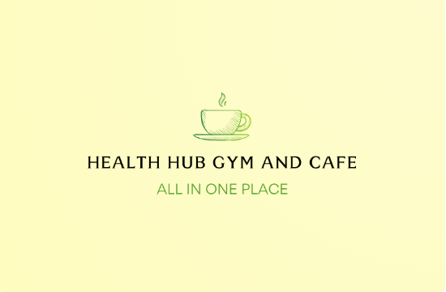
Design.com (2025) Logo Maker

The Health Hub

Mission Statement
Our mission is to create a welcoming space where people can get fitter, enjoy nutritious food, and relax in ways that feel good. We aim to make our gym inclusive for everyone, from beginners to experienced athletes, helping members feel supported, confident, and part of a genuine community.
Alongside our training options, our café will offer fresh, wholesome meals and beverages that make healthy choices easy and enjoyable, catering to all dietary needs. By combining fitness and nutrition, we strive to help people build lasting healthy habits and maintain balance in their daily lives. Everything we do is designed to help our members feel stronger, healthier, and truly at home.

Industry Overview

Gym Industry
The health and fitness sector in the UK is thriving. In 2024, approximately 11.5 million adults aged 16 and over were members of gyms or fitness clubs, across roughly 5,607 venues nationwide (Leisure Opportunities, 2025). Total revenue reached £5.7 billion last year, up from £4.05 billion in 2022, representing a strong compound annual growth rate of approximately 13.1% in membership revenue (UK Health, 2025).
Membership now accounts for 16.9% of the population, making the UK one of the most fitness-focused countries in Europe. Despite economic pressures such as rising living costs and higher operating expenses, gym attendance remains high, with over 600 million individual visits recorded in 2024 (HCM Fitness, 2025). Growth is occurring across both private and public operators (see Appendix 1 for a 5-year growth graph).
Future projections estimate steady growth, reaching 16–17 million members by 2030. Low-cost gyms, boutique studios, and hybrid digital models are expected to expand in popularity (UK Health, 2025).
Café Industry
The UK café market has also experienced steady growth. As of 2025, total café and coffee shop turnover is approximately £6.6 billion, with around 8,300 cafés in operation (IBISWorld, 2025). Major branded coffee chains and dessert parlors continue to expand, with the top operators projected to operate 5,750 outlets by the end of 2025, reflecting 2.7% year-on-year growth (Lumina Intelligence, 2025).
Independent cafés continue to thrive by meeting consumer demand for premium, ethical, and locally sourced offerings. The café sector is projected to continue growing steadily through 2030, with branded chains and specialty coffee outlets driving expansion to over 13,200 outlets. (See Appendix 2 for weekly coffee demand statistics.)

PESTEL Analysis Framework
PESTEL analysis is a strategic tool used to evaluate external factors that can affect a business. It helps identify challenges and opportunities in the macro-environment, allowing businesses to respond effectively (Paul Vanzandt, 2023).
The six key factors are:
Political, Economic, Social, Technological, Environmental, and Legal.
Gym Pestel Factors
PESTEL | Key Information
Political | Compliance with local health and safety regulations. Support for physical activity through government wellness campaigns and policies.
Economic | Gym membership costs and local income levels. Inflation impacting equipment and utility costs. Economic growth can increase customer spending and loyalty.
Social | Rising health consciousness and fitness trends across all age groups. High demand for inclusive, community-focused fitness environments. Awareness of nutrition supports integrated wellness hubs.
Technological | Online booking and fitness tracking apps. Digital marketing and smart gym equipment. Fingerprint entry for anytime access. Social media is vital for attracting local clientele.
Environmental | Energy-efficient equipment and operations. Waste reduction through recycling and refurbishing gym machines. Reducing greenhouse gas emissions from electricity and heating.
Legal | Compliance with employment laws, minimum wage, and working conditions. Liability and insurance requirements for gym operations. Data protection regulations for member information.

Cafe Pestel Factors
PESTEL | Key Information
Political | Compliance with food safety and hygiene regulations. Licensing and zoning laws determine operational locations. Government support may be available for small businesses.
Economic | Disposable income influences café visits. Inflation affects ingredient and utility costs. Economic cycles impact consumer spending.
Social | Growing café culture and demand for social spaces. Health-conscious trends influence menu choices, such as gluten-free options.
Technological | Online ordering and delivery platforms. Digital payment systems and loyalty apps. Social media marketing and influencer engagement.
Environmental | Use of sustainable packaging and energy-efficient appliances. Climate impacts ingredient sourcing. Eco-friendly practices reduce environmental footprint.
Legal | Labor laws and employee rights. Compliance with food labeling and allergen disclosures. Data protection for customer transactions.

SWOT Analysis
SWOT analysis is a tool that helps organizations evaluate their Strengths, Weaknesses, Opportunities, and Threats, providing insight into internal and external factors that could affect business success (Gürel & Tat, 2017). The concept is credited to Albert S. Humphrey, a management consultant at the Stanford Research Institute, who developed it in the 1960s–70s using data from Fortune 500 companies (Humphrey, 2005).
Category | Details
Strengths | Unique combination of gym and café, offering both fitness and nutrition in one space. Cross-promotion between services increases customer engagement. Attracts health-conscious customers. Builds a supportive community environment.
Weaknesses | High setup and operational costs. Limited space for gym equipment and café seating. Dependence on skilled staff for both fitness and food services. Seasonal fluctuations in customer visits.
Opportunities | Growth in health and wellness trends.  Partnerships with health brands, influencers, and local businesses.  Expansion of menu options and fitness classes.
Threats | Competition from established gyms and cafés.  Economic downturns reducing discretionary spending.  Changing consumer preferences.  Rising costs of supplies and equipment.

Market analysis
The concept of a Wellness Hub, combining a gym and café, aligns perfectly with the growing focus on healthy living. Modern consumers seek more than just a place to exercise; they want an environment that supports their overall wellbeing in a convenient and enjoyable way.
By offering fitness options, nutritious meals, and a welcoming community atmosphere, this business stands out in the current market. Such a holistic approach encourages longer visits, repeat attendance, and loyalty, as members feel part of a supportive and engaging community. Overall, the market for a combined gym and café is highly promising.
Target Market
Prime Targets Include:
Young adults (18–35)
Health-conscious, gym-active, interested in new fitness classes, smoothies, and social spaces. Working professionals looking for convenient early morning or lunchtime work out with healthy meals.
Fitness enthusiasts
Regular gym users who value fitness, nutrition, and recovery options.
Secondary Targets Include:
Students
Seeking affordable fitness options and study-friendly café spaces.
Residents and families
Interested in general wellbeing, light workouts, and healthy food choices.

Older Adults (55+)
Prefer low-impact options such as yoga, stretching, Pilates, and gentle strength training. Value social spaces, making the café a great place for community, routine, and connection. Along with meeting new people.
The health hub is aimed to serve a wide range audience from young adults to older adults offering fitness, nutrition, and wellness services suitable for all age groups. Offering a mixture of training options, welcoming group classes, and a café with healthy food meeting all dietary requirements. The health hub can become a place where people of all ages can connect and feel supported in their wellbeing throughout life.
Objective | Actions | Key Performance Indicators (KPIs) | Timeline
Membership Growth & Retention | Launch flexible membership plans, referral programs, and loyalty incentives. | 500 active members in Year 1; 75% retention rate. | 12 months
Café Performance | Offer a healthy menu with seasonal items; run café promotions. | Average daily sales with 10% month-on-month growth. | 6–12 months
Branding & Marketing | Run social media campaigns, partner with local businesses, host wellness events. | 5,000 social media followers; at least 1 community event per quarter. | 12 months
Operational Efficiency | Maintain high hygiene and service standards; optimize staffing. | Customer satisfaction score 70%; reduce operational costs by 10%. | 6–12 months
Community Engagement & Events | Organize workshops, fitness challenges, and nutrition classes. | Host at least 1 event every other month; 100 attendees per event. | Ongoing
Digital Presence & Innovation | Develop an app for class bookings, café orders, and fitness tracking. | 1,000 app downloads; 50% active users in Year 1. | 12 months
Sustainability | Implement eco-friendly practices: local sourcing, waste reduction, energy efficiency. | 20% reduction in single-use plastics; 50% sustainable sourcing. | 12–18 months
Strategic Objectives and Aims

Our short-term objectives focus on building a strong local presence by attracting a loyal customer base, delivering exceptional service, and creating a seamless wellness experience that combines fitness and nutrition. Long-term, we aim to expand into multiple locations, grow a vibrant wellness community, and become a leading lifestyle brand known for redefining health through innovation, inclusivity, and holistic support.
We envision a future where taking care of your body and mind is convenient, enjoyable, and accessible to all. Not a chore, but a lifestyle people look forward to every day.

Competition Analysis
An example of a direct competitor would be David Lloyd gym Gloucester and Riverside sports.
David Lloyd Gyms is a bigger UK driven gym. Which offers a gym, pool, spa, racquet courts and classes, It also offers a café/restaurant lounge which provides meals, coffee, social spaces, and even business-hub workspace options for members. David Lloyd (2025).
Riverside Sports & Leisure Club Gloucester has a gym / leisure center component and hosts a large The Roastery Café which serves coffee and brunch, not just to members but to any visitors. Riverside Leisure (2025).
Indirect competitors’ example would be At-home fitness / virtual fitness providers. Such a home workout apps, online classes, home-gym equipment. They target people who want to exercise and stay fit choosing to work out at home instead of visiting a gym. Even though they don’t provide fitness facilities, they compete for the social coffee and drink convenience part. Which is what our café what would offer.
Advantages
Combining fitness, nutrition, and social spaces creates a convenient one-stop solution. Smaller business’s offers personalized attention through tailored workouts, diet guidance, and strong community support, building loyalty big chains can’t match. Nutritious, locally sourced meals can meet health-conscious and dietary needs. By focusing on the local community, the business will feel more personal, convenient, and drive customers into different lifestyles, giving it a clear competitive edge.
Challenges
We will also need to keep in mind some challenges we may come across. Things like home fitness apps, online workouts, and meal delivery services offer convenient alternatives that reduce in-person visits. Changes in health and safety regulations, food standards, or employment laws could impact operations, and economic ups and downs might affect memberships or café spending. Or even unexpected events like the pandemics. By trying to stay aware and ahead we can adapt and continue providing a unique, welcoming space for fitness and healthy living.
Location
Our gym and health hub café will be located within a prime location in Ebbw Vale. In a unit on ‘The Walk’ in the town center. It offers ideal visibility and access surrounded by nearby shops. Its central location lets residents combine workouts, errands, and café visits. The space can host both gym facilities and a welcoming café, creating a convenient, community-focused hub for health and social connection.

Marketing 7ps
The 7Ps marketing mix, introduced by Booms and Bitner (1981), expands the traditional 4Ps to include People, Process, and Physical Evidence, making it ideal for service-focused businesses like a wellness hub.
P | Summary
Product | A neighborhood gym combined with a healthy café, offering strength and cardio training, group classes, personal training, and nutritious meals, smoothies, and snacks in one convenient location.
Price | Fair and flexible gym membership plans. Café items priced to reflect quality without being expensive. Members receive discounts, bundles, and promotions.
Place | Modern, convenient space with the café near the entrance. Online class bookings available for busy schedules.
Promotion | Social media campaigns, local partnerships, wellness events, fitness challenges, workshops, and special offers to build a supportive community.
People | Caring, knowledgeable, and supportive staff, including trainers and café team members, creating a welcoming environment for all.
Process | Simple and user-friendly experience for sign-ups, class bookings, and café orders via app or in person.
Physical Evidence | Clean, modern gym facilities and a warm, inviting café. High-quality equipment, fresh ingredients, thoughtful presentation, and consistent branding.

Year 1 – Personal Forecast
In the first year, the Health Hub is expected to grow steadily as the community becomes familiar with the services. Revenue will primarily come from gym memberships and café sales, particularly during busy mornings and evenings. While initial costs such as staff, rent, and supplies will be high, careful cost management and strong customer engagement aim to achieve profitability by the end of Year 1.
Research indicates that gyms typically reach break-even within 16–24 months (Gym Business Plan, 2025).

Category | Year 1 Forecast | Impact Level | Key Impact | Risks
Total | £381,250 | High | Total inflow from gym, PT, and café | Membership and café sales lower than forecast. Mitigate with promotions, events, loyalty programs
Gym Membership Total | £108,000 | High | Core recurring revenue for gym | Seasonal drop offs and offer New Year promotions, loyalty incentives
Personal Training Revenue | £54,750 | Medium | Enhances revenue and member retention | Session cancellations. Flexible scheduling and packages
Café Total | £127,750 | High | Diversifies revenue; drives community footfall | Competition or seasonal dips. Introduce specials, bundles, marketing campaigns
Variable Costs | £30,000 | Medium | Supplies & consumables for gym/PT and café | Supply chain disruption maintain multiple suppliers
Gross Profit | £351,250 | High | Revenue minus variable costs | Lower revenue affects gross profit monitor monthly
Fixed Costs / Operating Expenses | £180,000 | High | Rent, salaries, marketing, other overheads | Cost overruns, monthly review, negotiate contracts
Rent & Utilities | £60,000 | High | Essential for operations | Unexpected increases. Secure long-term lease
Staff Salaries | £96,000 | High | Core to daily operations | High turnover, recruit carefully, offer incentives
Marketing & Promotions | £18,000 | Medium | Encourages membership and café | Track campaign performance and adjust spend
Other Expenses | £6,000 | Medium | Miscellaneous operational costs | Unexpected costs Maintain contingency fund
Net Profit / Contribution | £171,250 | High | Revenue minus all costs; key for stakeholder returns | Revenue shortfalls or unexpected costs. Maintain and reserve
Profit Margin (%) | 45% | High | Operational efficiency indicator | Rising costs could reduce margin control expenses
Break even Profit | £195,450 | High | Revenue needed to cover all costs | Falling below this increase revenue streams and promotions
Break-Even Gym Memberships | (To be calculated) | Medium | Gym units required to cover costs | Membership drop-off. Marketing & loyalty programs
Break even Café Days | (To be calculated) | Medium | Café days required to cover costs | Events, specials, and bundles
Average Gym Members | 500 | Medium | Recurring revenue and community engagement | Competition unique classes & PT packages
PT Sessions per Day | 5 | Medium | Adds revenue and member retention | Seasonal variation off-peak incentives
Average Café Daily Profit | 350 | High | Supports business diversification | Seasonal dips and Menu specials & marketing
Annual Footfall (Gym & Café) | 120,000 | Medium | Overall popularity and engagement | Marketing effectiveness run events & loyalty programs

Break Even Analysis
In its first year, the business expects to generate total revenue of £381,250. Fixed costs covering rent, utilities, staff salaries, marketing, and other regular expenses which are projected at £180,000. Meanwhile variable costs, mainly for supplies, are estimated at £30,000.
This leaves a contribution margin, revenue minus variable costs of £351,250, which is around 92% of total revenue. Based on these numbers, the business is expected to reach its break-even point early on, with approximately £185,800 of revenue contributing to profit beyond that threshold.
Overall, this suggests a solid financial position with a healthy margin of safety above the break-even level.

Stress Analysis
The below table analysis identifies potential factors that could put pressure on the Health Hub’s performance and profitability, along with their impact.

Business Area | Stress Factor | Impact
Gym | Seasonal fluctuations in memberships | Fewer members during holidays or summer can reduce monthly revenue.
Gym | High maintenance and equipment costs | Unexpected repairs or replacements can increase expenses and affect profitability.
Café | Fluctuating customer demand | Fewer customers during off-peak hours or seasons can reduce daily revenue.
Café | Supply chain or inventory issues | Delays or price increases in ingredients can raise costs and affect menu availability.

Operations Forecast
The table highlights how a gym and café combined creates a smoother, more connected wellness experience. By sharing forecasting, supplies, and daily operations the business can run more efficiently and keep costs down. Altogether, the combined setup boosts convenience, builds a sense of community, and encourages people to stay longer and engage more with both sides of the business.
Operational Area | Gym Application | Café Application | Combined Health Hub Value
Forecasting | Predict member attendance, class demand, peak hours, equipment usage | Forecast customer flow, menu item demand, ingredient needs | Optimizes shared staffing, energy usage, and inventory planning for both services
Procurement | Purchase fitness equipment, cleaning supplies, maintenance contracts | Order food ingredients, beverages, packaging, kitchen supplies | Consolidates suppliers where possible, reduces costs, and improves purchasing efficiency
Production | Deliver fitness classes, personal training, workout programs | Prepare meals, snacks, smoothies, and beverages | Creates integrated wellness packages: training + nutrition programs
Distribution | Provide classes, programs, and digital workout content | Serve café products for dine-in, takeaway, or delivery | Enables cross-promotion (e.g., post-workout smoothies, meal plans for members)
Transportation | Transport equipment when necessary (repairs, replacements), manage incoming deliveries | Receive food deliveries; occasional catering transportation | Shared logistics reduce delivery fees and streamline storage handling
Facility Design | Layout of gym floor, equipment spacing, studio rooms, locker rooms | Café floor plan, kitchen workflow, customer seating | Unified design increases member flow, creates a wellness-centric environment, and boosts dwell time

Brief Conclusion Overview
This business outline of a business plan shows be very profitable. The break-even point is much lower than the expected revenue, there’s a comfortable safety net. With multiple income sources and careful cost control, it’s well placed to grow steadily and stay strong, even in a competitive market. Building our business up to its full potential and growing success.

References

Booms, B.H. & Bitner, M.J., 1981. Marketing strategies and organization structures for service firms. In: J.H. Donnelly & W.R. George, eds., Marketing of Services. Chicago: American Marketing Association.
Gürel, E. & Tat, M., 2017. SWOT analysis: A theoretical review. The Journal of International Social Research, 10(51), pp.994–1006.
Humphrey, A.S., 2005. SWOT Analysis for Management Consulting. SRI Alumni Newsletter.
Vanzandt, P., 2023. PESTEL Analysis Framework.

Websites Researched
Allcock, S. (2024). The O2 celebrates growth in leisure and debuts UK signing of Activate. [online] FeastMagazine. Available at: https://www.feast-magazine.co.uk/press-release/the-o2-celebrates-growth-in-leisure-and-debuts-uk-signing-of-activate-47951 [Accessed 10 Oct. 2025].
Auckland, O. (2023). 8 key fitness trends for clubs in 2024. Les Mills. Available at: https://www.lesmills.com/uk/clubs-and-facilities/research-insights/fitness-trends/8-key-fitness-trends-for-clubs-in-2024/ [Accessed 25 Nov. 2025].
D, P. (2023). Gym: Our Business Plan. BusinessDojo. Available at: https://dojobusiness.com/blogs/news/gym-business-plan [Accessed 22 Nov. 2025].
David Lloyd Gyms (2025). Online website. Available at: https://www.davidlloyd.co.uk/clubs/gloucester [Accessed 26 Nov. 2025].
Design.com. (2025). Logo Maker | Create Your Free Logo | Design.com. [online] Available at: https://www.design.com/s/logo-maker?code=25OFFSEM&utm_adgroup=logo_free&utm_keyword=free%20logo%20maker%20online&utm_network=o&msclkid=aadab4e278c41dcf0f1addcef783df1b&utm_source=bing&utm_medium=cpc&utm_campaign=UK%3A%20Generic%20Logo&utm_term=free%20logo%20maker%20online&utm_content=Logo%20-%20Free [Accessed 15 Oct 2025].
Ed, E. (2025). UK Health & Fitness Market Report 2025. [online] Available at: https://www.ukactive.com/wp-content/uploads/2025/04/UK-Health-and-Fitness-Market-Report-2025.pdf?. [Accessed 30 Oct.2025].
Healthclubmanagement.co.uk. (2025). UK Health and Fitness Market Report | HCM insight. [online] Available at: https://www.healthclubmanagement.co.uk/health-club-management-features/Market-intelligence/37731 [Accessed 30 Nov. 2025].
IBISWorld (2024). Cafes & Coffee Shops in the UK - Market Research Report (2014-2029). [online] Ibisworld.com. Available at: https://www.ibisworld.com/united-kingdom/industry/cafes-coffee-shops/6242/ [Accessed 3 Nov. 2025].
Lumina Intelligence (2025). Cafes and Coffee Shops. [online] Available at: https://www.lumina-intelligence.com/market/cafes-and-coffee-shops/. [Accessed 11 Nov. 2025].
River Side and Leisure (2025). Available at: https://www.riversidesports.co.uk/gloucester/club-overview [Accessed 26 Nov. 2025].
Sette, S. (2025). Third Space Preps London ‘Mega-Gym’. Fitt Insider. Available at: https://insider.fitt.co/third-space-preps-london-mega-gym/ [Accessed 30 Nov. 2025].
UK Active (2025). UK Health and Fitness Market report reveals exponential growth as penetration rate hits 16.9% and revenue grows 8.8%. UKactive. Available at: https://www.ukactive.com/news/uk-health-and-fitness-market-report-reveals-exponential-growth-as-penetration-rate-hits-16-9-and-revenue-grows-8-8/ [Accessed 16 Oct 2025].
UHY Hacker Young (2025). Number of UK gyms grew by just 1.8% to 5,030 in 2024 – lowest increase since the pandemic. [online] Available at: https://www.uhy-uk.com/insights/number-uk-gyms-grew-just-18-5030-2024-lowest-increase-pandemic. [Accessed 6 Oct 2025]

Appendix

Appendix 1
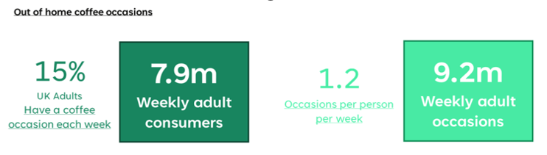
Lumina Intelligence 2025.

Appendix 2
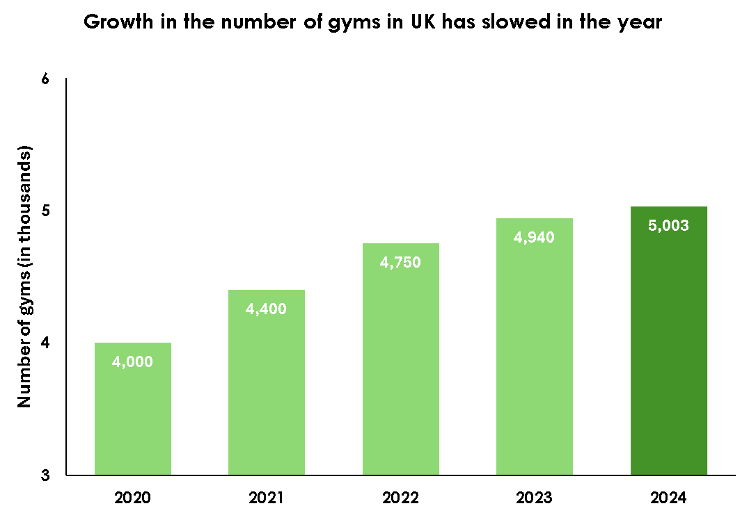

‌UHY Hacker Young. (2025).

