


Vanessa Emmanuella Liverpool (1917235)
Zainab Atta

Knowledge and Information Management of Amazon.com
BMSW5106

Executive Summary

Amazon one of the largest e-commerce worldwide, who aims to obtain the leading market by having the leading knowledge management is retaining big data relating to its consumers personal information while creating innovative ideas through purchasing items. This report critically evaluates and investigates the systematic approach Amazon uses in sharing and exchanging their knowledge base. Throughout the report it is explained how Amazon uses tacit and explicit knowledge in order to provide an efficient service for its users and to maintain their clientele. It further explains all the theories used it this report to critically assess how Amazon is able to maintain its position while creating a vast amount of profit during covid-19. The last part of this report communicates discussions relating to how Standard Operations Procedures has been important to Amazon and what was achieved during these processes. It explains further what areas those Amazon.com needs to improve and what possible change I could suggest to the company in order to progress and overcome its challenges, while recommending another company where it can learn from which uses models such as Nonaka explicit and tacit knowledge.

Table of Contents
Executive Summary 1
1. Introduction 3
1.1 Introduction of Amazon.com 3
1.2 Knowledge Management Theories Models and Principles 4
1.3 Expectations and Outcome 4
2. Knowledge and Information Management and Amazon.com 4
2.1 Amazon Impact on Covid -19 6
2.2 Knowledge Management 6
2.3 Data Information and Knowledge 7
2.3 The Importance of KM in an Organisation 8
2.4 KM satisfying customers and competitive benefits 9
3. Evaluation of Knowledge and Information Management Models/Theories 10
3.1 Strategic Knowledge Analysis 10
3.2 Customer Relationship Management 11
3.3 The SECI Model and knowledge discussion 11
4 Knowledge Management techniques used by Amazon.com 12
4.1 Knowledge importance within Amazon 13
4.2 The main outcomes with Amazon (SOP) 13
4.3 Amazon Knowledge management challenges 13
Conclusions 14

Introduction
This report focuses on the potentials of e-commerce to new markets is no greater demonstrated than in the success of Amazon.com. Being the topic of this report there is a considerable curiosity in obtaining the values of success. This report focuses on the position of tacit and explicit knowledge of Amazon and how they use it to purpose an information -based perspective in the light of Covid-19. The proposal is that it produces and curious argument in it claims that the key to success in a microelectronic sphere of e-business remains with managing relationships and context, which are important factors relating to tacit knowledge. The purpose of this report is to bring your focus into information and knowledge related processes reinforcing revolution in e-commerce development within Amazon.com.

Introduction of Amazon.com
Amazon.com is a cyberspace colossus today, however, this is how it all started. Amazon.com is an e-commerce titan known worldwide founded in 1994, by J Bezos. Amazon was initially called Cadabra, but Bezos Solicitor advised that him to reference to magic and might be a little obscure, it was after the browsing through the phrasebook for some insight, he came up with the magic word Amazon. Bezos thought that the idea was grand as he envisaged his online store becoming the largest and biggest in the world. Similarly, as the Amazon is one of the rivers on the planet. Originally once founded it was only an online bookstore as they were much easier to source and deliver. However, in was only in 1998 that Mr Bezos decided to diversify and expand the company with various selections such as, CD`s, videos, DVD`s, electronics, tools, housewares apparels, kitchen appliances. Equally, through mediator compliance, Amazon.com begun to sell products from established retailers such as Waterstones. Consequently, it was during the ninety nineties when the internet knowledge first emerged across the globe where most companies used internet providers and software. As a result, in 2018 Amazon Prime day sales amounted to 4.19 billion dollars and on Prime Day, shoppers, conversion was a lot higher than the average of the preceding quarter (Big commerce, 2021). Comparatively, in 2020 Amazon delivered a recording performance with an annual revenue up to 38% to $386% billion, a yearly increase of $100 billion. Net profit for Amazon was up 84% for the year as compared to last year. Amazon is the second largest US retailer behind Walmart which has not released its financial report for 2020, however it has been reported towards the end of October Walmart sales were $407 billion, up to 6.5% from the previous year (Forbes,2020).

Knowledge Management Theories Models and Principles
It is further explained, by giving an overview, this report will be elaborating on how Amazon used their consumer information in order to provide them with a better service, specifically during this pandemic Covid-19. Moreover, using their own data thanks to technology, adapting to different types of theories and techniques such as Tacit and Explicit knowledge, KM principles, and Knowledge needs analysis. Equally, using academic knowledge to process the understanding of how amazon may have applied such principles and techniques, by elaborating on the importance of Data, Information, Knowledge and Wisdom (DIKW). By relating the (DIKW) and the Management Life Cycle which develops the process of information into knowledge while it expresses how it is attained while being dispersed by amazon. As well as how amazon implemented the systems in which they use, elaborating on this subject leads to critically assess the claims of Nanoka and Takeushi on their finding. Comparatively on this, demonstrating Pluto and Aristo on their perspectives, however, I will continue this process by discussing about Van Krogh, Ross and Slocum both strategies.

1.3 Expectations and Outcome
In this report I expect to demonstrate how data and knowledge is transferred within organisations such as Amazon.com. It is also my expectations to demonstrate my academic knowledge while those techniques is being applied. as a result, analyse any findings that I may critically assess and understand how Amazon used knowledge needs Analysis during this crisis due to covid-19 and how they have used their GAP strategy to understand their customer needs. it is my prospects to demonstrate and evaluate the potential knowledge management challenges which Amazon may have faced and possibly suggest ways to reinforce their knowledge management methods from the knowledge Management Life Circle standpoint.

Knowledge and Information Management and Amazon.com
Amazon.com was initially incorporated by Jeff Bezos in July 2005. Back then he was a Wall Street hedge fund executive. He originally named the company Cadabra but feared it referenced to magic and decided that it was not ideal. Bezos moved along with his plans and decided to register the domain, he came up four different names however the one he kept was Relentless.com. in which respect if we were to browse is it would directly take you to Amazon.com. After brainstorming and being inspired by many other names, Bezos came up with the word Amazon, which he was very fascinated with as it was predominantly suitable as he envisioned his cyber warehouse becoming the vastest worldwide, similarly, like the Amazon one of the most prevalent rivers on the sphere. It was then in 1994, on the 1st of November that he registered the company as it is called today Amazon.com however, he was puzzled as what to market. At the time he decerned that he wanted to build some sort on cyber retailer but was unsure of what exactly the items would be. Granted, after exploring a little deeper, he came up with selling books as they are one of the easiest items to supply, box and disperse. Meanwhile, Amazon were not the only company to sell books online at the time, Silicon Valley Bookstore also begun to sell in the early 90`s. on the contrary, Amazon approach was with a superior expediency, where they dispatched straight to consumers mailing address worldwide. Along with books, Bezos foresaw the company being a technology company where it could make its customers transactions easier. While selling books was a great start and innovative for Amazon, the company increased by selling computer games and music in 1998, around the same period Amazon also enlarged its territories by providing its services across many countries such as the UK and Germany by securing other cyber bookstores.
Moreover, it was around the year 2000` that Amazon magnified by selling customers software, toys, games, electronics, home items and lots more. Amazon, then launched its Amazon Wed Services (AWS). It was then around 2006 that Amazon enlarged its AWS range with its Elastic Compute Cloud (EC2). In addition, trailed with their Simple Storage Service (S3) shortly after. Similarly, it was in 2007 that we saw the launch of the first Kindle e-readers, these took over the e-book market and by 2012, the Kindle established about 50% of all Android – operated tables sales. In fact, the success of Kindle led Amazon into the e-book publishing market in 2011. For this reason, that same year, Amazon revealed that e-books sales was taking over the sales of printed books. Unquestionably, Amazon has since increased into additional service sectors, such as drone delivery, fresh food produce and the list goes on.
With that being said, Amazon acquired and made use of the modern technological revolution to upsurge its productivity towards its customers. It is safe to say, form the application of AI to manage and process purchases to conducting trials on drones and robots, Amazon is in not way scared of trying out the latest invention in tech. however, this comes with a few pros and cons. They had also adopted automated process for hiring and firing, such innovation had been criticised for making a choice without contemplation of other elements such as individual private life. “Anytime Feedback Tool” enabled personnel to either admire or condemn their colleagues, however this same platform also controls the trajectory of an employee performance against set Key Performance Indicators, while handling orders from customers. Undoubtably, Amazon has been adopting several automated solutions to increase efficiency (Interesting Engineering, 2021).

2.1 Amazon Impact on Covid -19
It is safe to say, that Amazon was in some way built for the pandemic and may well arise from it with more tenacity than it originally went in. arguably, Amazon Shareholders and team figured out at a very early stage of the pandemic that it would be a very unprecedented moment in our lives and to its customers worldwide. Once consumers figured out to an extend what was happening around the globe, they all begun to order essential on Amazon, which of course gave the company a surge in orders in the first quarter. To mend the consumers needs the company focused on hiring an additional 175,000 employees between March-April. Amazon added another 36,400 people bringing its headcount to 876,800 an increase of 34% over a year. To add, for a least three months Amazon brought in $75.4 billion in revenue a 26% gain over 2019. In addition, their cloud computing systems also surged to $10 billion in a quarter as customers were unable to go out to some extend and so they streamed on Netflix and also had conference meeting via various platforms. Through early May the company stock went up by 25% for the year. With that being said, all these efforts came with a lot of polemic as the staff at Amazon begun to protest demanding for adequate safety precautions to be put in place within the company. In the second quarter it is believed that Amazon spent $4 billion or more on covid related items such as protective gears and employee testing kits. However, Amazon at some point during the pandemic stumbled to deliver as efficiently as prior to covid-19. Amazon took the time out to ensure that consumers life was better, by lowering costs. Customers to visiting Amazon.com increased tremendously, which led to more revenue for the company (Amazon. Com, 2020).

2.2 Knowledge Management
Knowledge Management (KM) is defined as the process of capturing, disturbing and efficiently using knowledge or and a discipline which promotes an integrated approach to identifying, evaluating, retrieving and sharing of an organisation information asset. These assets may consist of databases, policies, documents and procedures while incorporating uncaptured expertise and experience in the individual workers (Neeta,2002).
Similarly, according to Nanoka (1991), there are two types of knowledge, explicit and implicit. Explicit knowledge is noticeable information available in literature, such as emails, reports, communication with employees and much more. Explicit knowledge can be programmed in systems and policies of any organisation. However, implicit knowledge is simply personal knowledge in the minds of others, such as their belief and experiences. The classic example in literature of tacit and explicit by Nanoka and Takeuchi. There are four modes of knowledge conversations, Socialisation (tacit to tacit), externalisation (tacit to explicit), combination (explicit to explicit) and internalisation (explicit to tacit). The first stage of knowledge management is to clearly identify what type of knowledge is needed for the success and application of collective approach. Once the managers identified the knowledge assets within the company such as competitors and suppliers, the managers must strategically plan to maximise a good outcome with knowledge asset. Figure 1 depicts the SECI model by Nanoka and Takeuchi.
Figure 1

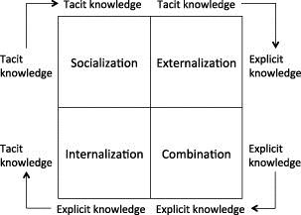
UWTSD: Moodle

2.3 Data Information and Knowledge
data is defined as an individual unit that contains raw materials which do not have any specific meaning, while information is a group of data that collectively carries a logical meaning (Midgley,2002). Knowledge is the acquisition of information acquainted with facts, truth and or principles. Data can be useful as it allows companies to more effectively detect the cause of a problem, it also allows companies to visualise what is happening I several departments at time under one system. According to the DIKW Pyramid When data is processed into information it becomes knowledge, this knowledge if transferred adequately, will be considered to be wisdom. There is a distinctive relationship between them, each building block as shown figure 2 is a step towards a higher level.
Figure 2
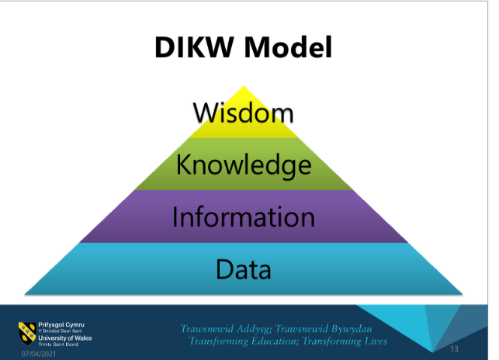
UWTSD: Moodle
Through the management life cycle, as shown if figure 3 Acquisition of knowledge through knowledge assets enables the company to innovative, this stage requires data to be transformed into information then processed into knowledge. Also, the knowledge storage or retention, which enables companies to protect personnel and avoid propagation. This cycle further explains the knowledge distribution which allows members of the company to have access to cooperative knowledge. however, it is required and important to integrate the knowledge acquired, this only happens when managers apply the knowledge within the company to make progressive decisions.
Figure 3
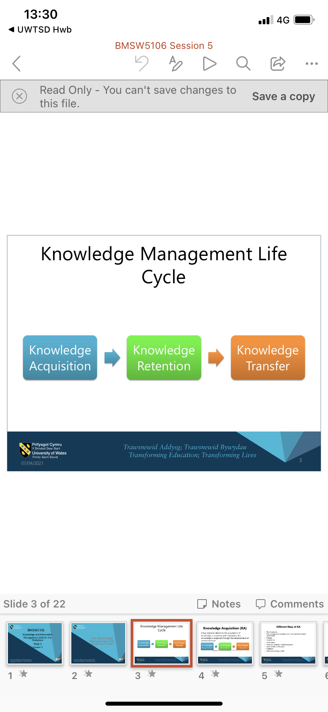

UWTSD: Moodle

2.3 The Importance of KM in an Organisation
Knowledge management is a vital asset to an organisation specifically in this case Amazon. KM has enhanced the productivity of Amazon by enabling them to make the right decisions, while ensuring that all their personnel gain total access the knowledge held by the company. This enhances the potentials of company operating successfully. As a result, the company is to work together to be more creative, informed while making wise decisions that will benefit and enhance the company.

2.4 KM satisfying customers and competitive benefits
Since the foundation of Amazon, it fair to say that the company understood that its consumers involvement is paramount. These customers propelled Amazon to provide their needs as quickly as possible and in the easiest way possible. It is safe to say that Amazon responded to their needs. moreover, there is a vital reason why KM helps organisation such as Amazon, to add value to their consumers in numerous ways:
- Amazon uses one portal, and one interface. Entirely all products purchased form Amazon.com comes through the exact same portal regardless of what is bought. For this reason, this produces acquaintances and ease for the consumer.
- Reliable performance, from a range of description reviews to a detailed display of information for every product, in the same sequence where possible. This knowledge transfer comes from excellent management skills where they have processed the information and shared it with customers I reliable manner.
- With an integrated content, Amazon have sectionally organise every page on their website, also they provide extra details, however the selection of the same is optional.
- Distribution of upstream content, while they might appear to control everything we see, for the most part, the product companies where the real expertise is, actually generates the content.
- Magical personalisation, the more we use their site the better they know us, it can also remind us of our history, recommended products we might like, and connect us to additional information they know we are looking for.
- Crowdsourcing, with features, like customer provide ratings and reviews.
- Subscription, alert and reminders, if you are not willing to browse everyday you can ask them to remind you.
- Feedback, the company is one of the most successful Ecommerce in getting consumers in getting meaningful feedback.
- Mobility, Amazon.com and its associates are available on the go and on any devices, no opening and closing time.
With that being said, Amazon acquired and made use of the modern technological revolution to upsurge its productivity towards its customers. It is safe to say, form the application of AI to manage and process purchases to conducting trials on drones and robots, Amazon is in no way scared of trying out the latest invention in tech. however, this comes with a few pros and cons. They had also adopted automated process for hiring and firing, such innovation had been criticised for making a choice without contemplation of other elements such as individual private life. “Anytime Feedback Tool” enabled personnel to either admire or condemn their colleagues, however this same platform also controls the trajectory of an employee performance against set Key Performance Indicators, while handling orders from customers. Undoubtably, Amazon has been adopting several automated solutions to increase efficiency (Learning solutions, 2020).

3. Evaluation of Knowledge and Information Management Models/Theories
According to Dorothy Leonard depicted from the book knowledge creation and management: new challenges for managers, the greatest challenge in product and services innovation is to match what customers will buy to what the organisation can produce. She goes on to say that usually the knowledge requisite to accomplish that task resides in two separate contexts that the users and that of the organisation developers. It falls on individuals experience and the experience of the base creator (Ichijo, Kazuo, 2006). It is safe to say that when knowledge within a company is shared it begins to increase. It becomes embedded within the company`s processes, products and services (Demarest,1997). It has been researched that tacit knowledge is demonstrated only in its application.

3.1 Strategic Knowledge Analysis
Strategic GAP analysis is a business management technique that requires an evaluation of the difference between a company best possible outcome and actual outcome. Strategic gap analysis aims to determine what specific steps a company can take to achieve a particular goal. This analysis should be followed by an implementation plan. Usually, most companies fail to plan a strategic plan, while they may have the resources, they fail to realise their full potential. This plan could support company to bridge the gap between their current and potential performance level (Investopedia, 2021). See figure in figure 4.
Figure 4
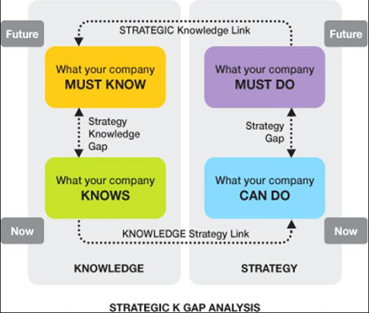
UWSTD: Moodle

3.2 Customer Relationship Management
Customer relationship management (CRM) is defined as the principles, practices and guidelines that an organisation follows when interacting with its customers. From the organisation point of view, this entire relationship encompasses direct interactions with customers, such as sales and service-related processes, forecasting and the analysis of customer trends and behaviours. Ultimately, CRM serves to enhance the customer`s overall experience. (Investopedia.com, 2020).
with that being said, Amazon has a good character when it comes to providing its customers with all the things that they need. All in one portal, the company has successfully managed to have a relationship with millions of customers all over the globe, without having any face-to-face interactions. Its simple approach is using interface, stored personal details and on the go purchasing, all of which enhances a smooth and effecting way of purchase. Amazon has fortunately been able to build its own CRM software, by tailoring to its own requirements. This software enables Amazon to encapsulate customer data, such previous purchases and location, and use those to instantly modify as customise a consumer overall experience. The company also communicate their customers queries before the stage where the is any human involvement. Amazon uses data collection, personal data storage, recommendations, customer support, Kindle marketplace, to communicate with its customers (Linkedin.com, 2017).

3.3 The SECI Model and knowledge discussion
Rather Amazon.com admits it or not, it is fair to say that the company uses advance knowledge techniques. The company have an excellent approach and relationship with its customers and has developed great values in using KM principles. Arguably, developing a decision making within an organisation, it is my conclusion the Amazon depicts the explicit the concepts of tacit and explicit knowledge, by Ikujiro Nonaka. Nonaka introduced the SECI model (Nonaka & Takeuchi 1996) which in some essence has become the strong tower of knowledge management and transfer theory. They discussed about four tway that knowledge can be categorized, such as socialization (tacit to tacit), externalisation (tacit to explicit), combination (explicit to explicit) and internalisation (explicit to tacit). The model creation spiral in figure 6 depicts knowledge being continuously converted and created as a user practice, collaborate and learn. According to Nanoka, the process should be seen as a constant dynamic swirl of knowledge rather than a static model. Amazon in that aspect is doing just that, they are constantly acquiring knowledge and then shortly transfer it by constantly communicating with their costumers through one portal and one integration. Within this integration, they are able to collect and transform data, while recycling it for future uses (Knowledge management tools, 2018).
Figure 5
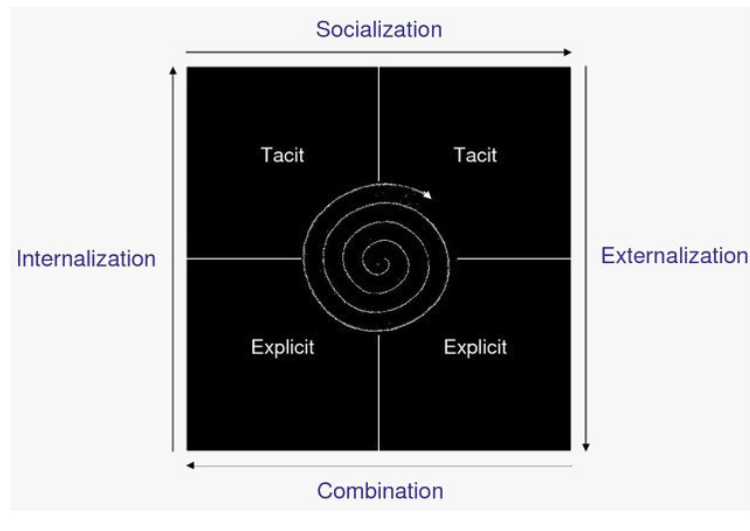

4 Knowledge Management techniques used by Amazon.com
One of the ways Amazon uses KM in its organisation is that the company uses data through recommendation engine, when a customer is looking for a particular item, this might help Amazon to workout what the customer is interest in. Its personalised recommendation system is thought to account for 35% of the company’s annual sales. Consequently, Amazon gathers individual data on each and every one of its customers while they use the website. In addition to what a customer buys, Amazon observes the items looked at, shipping address and whether a customer leaves review. Big Data has helped propel Amazon to the top of the e-commerce pile. The company links with manufacturers and tracks their inventory to ensure orders are fulfilled quickly. Through Big Data, it allows the warehouse closest to the customer to be selected and shipping costs to be considerably reduced by 10-40%. With Amazon’s grip on the field showing no signs of slowing, data and the ways it’s used is more important to the long-term future of companies than ever before or run the very real risk of falling behind to competitors (Supply chain, 2020).

4.1 Knowledge importance within Amazon
Knowledge has become very important to Amazon, as Standard Operation Procedures (SOP) are an integral part of the company, which enhances the company development, specifically in the light of covid-19 when hiring personnel is at it highest. This system helps Amazon to create key development tools and important data, for example if training every three months the system is able to recognise that person A would a refresher. It will also help to develop existing staff skills and even regarding to stock take for the warehouse. This is a key to for standardising, of knowledge transfer internally.

4.2 The main outcomes with Amazon (SOP)
Standard operating procedure is a document providing explicit directions for completing a certain task (Help juice, Inc, 2021).
Consequently, as this evaluation stated above, the company uses effective knowledge and information culture. It is safe to say that Amazon uses knowledge asset, such tacit knowledge to maintain its internal and external relationship with its customers but also its staff. The process of creating, storing, sharing and applying knowledge management has successfully been integrated within the company.

4.3 Amazon Knowledge management challenges
While Amazon sustainability ambitions are great, they are on their way to powering operations with a 100% renewable energy by 2025 as part of their goals to reach net zero carbon by 2040 (Amazon sustainability report, 2020). In order for Amazon.com to improve in the future in order to minimise challenges is to focus on their cybersecurity, as according to Forbes.com it is said that Amazon most popular infrastructure, with that great amount of Data has great responsibility to ensure cybersecurity at all cost Amazon is said to provide customers with right tools they need to secure their personal details (forbes.com, 2021). Amazon lacks accountability is very problematic. It is safe to say that Amazon is taking steps to protect its user`s data by hiring a detective to investigate the matter. Eventually, it would be great if Amazon provides its consumers and incentive plan, as when you make purchase there are not much on their portal, not many sellers offer a subscription. It is my humble opinion that Amazon, although not as wealthy as Apple, to follow their security patterns and procedures such as encryption methodology called data protection. They can also you File vault also use by Apple on their Mac computers. Both models, are rooted in their management hierarchies in the dedicated silicon of the source enclave on devices that includes a SEP (Apple.com, 2021). It is safe to say that Apple.com are using the knowledge-retention-transfer perspective on how they protect and communicate with their customers.

Conclusions
To conclude, Amazon has development tremendously for when it first begun it 1994. It safe to say that its innovative ideas and vision has enhanced the company’s development in so many areas. However, with the help of technology and the internet, Amazon always needed to be ten steps ahead, by providing their customers with what they wanted and when they wanted it. It is amazing to reflect and understand how Amazon, probably without knowing it has used the Nonaka model, using tacit and explicit knowledge. Information is an extreme valuable asset to Amazon, as it is what they process into knowledge in order to provide customers an efficient service. Amazon uses a fantastic system which is the one portal and integrated portal, where they use big data to provide customers with faster services. This report has concluded that Amazon in fact uses knowledge management practices from the knowledge acquisition, retention, transfer perspective.

References
Apple.com, (2021). Best Apple home security systems. [online] Available at: https://www.security.org/home-security-systems/best/apple [Accessed 30.04.2021]
Amazon sustainability report, (2020). Sustainability: all in – December 2020. [online] Available at: https://sustainability.aboutamazon.com/about/reprt-builder Accessed [30.04.2021]
Demarest, (1997). Journal of knowledge management practice www.tlainc.com/articl253.htm [online] accessed [30.04.2021]
Neeta, (2017). Knowledge integration strategies entrepreneurship and sustainability. Publisher global knowledge 2017
Encyclopaedia, Inc, (2021). Britannica. [online] Available at: https://www.britannica.com/technolofy/e-commerce Accessed [30.04.2021]
Forbes, (2020). Amazon`s Net Profit Soars 84% With Sales Hitting $386. [online] Available at: https://www.forbes.com/sites/sanfordstein/2021/04/30/mall-footfall-returns-dicks-and-at-home-become-alt-anchors-and-placemaking-takes-root/?sh=766207a32eb4 [Accessed 30.04.2021]
Fortune.com, (2020). Amazon was built for the pandemic -and will likely emerge from it stronger than ever. [online] Available at: https://www.google.co.uk/amp/s/fortune.com/2020/05/18/amazon-business-jeff-bezos-amzn-sales-revenue-coronavirus-pandemic/amp/
Help juice, Inc, (2021). How to write effective standard operating procedures [online] Available at: https://helpjuice.com/blog/standard-operating-precedure [Accessed 30.04.2021]
Investopedia.com, (2020). Strategic plan analysis. [online] Available at: https://www.investopedia.com/terms/s/strategic-gap-analysis.asp [Accessed 30.04.2021]
Investopdedia.com, (2020). Customer relationship management. [online] Available at: https://www.investopedia.com/terrms/c/customer-relation-management.asp [Accessed 30.04.2021]
Interesting Engineering, (2021). A very brief of Amazon: the everything store. [online] Available at: https://www.google.co.uk/amp/s/amp.interestingengineering.com/a-very-brief-history-of-amazon-the-everything-store [Accessed 30.04.2021]
Nonaka, (1991). The knowledge creating company. The Harvard business school publisher 2008
Midgley. M, (2002). Wisdom, information and wonder: what is knowledge for?

