MARKETING FUNDAMENTALS
MODULE CODE - LCBB4004

ASSESSMENT 1 – BLOGGING TO COMMUNICATE

Radostina Ilieva
Student ID : 1921577

Lecturer : Rula Alousi

Tesco PLC – Plant based and vegetarian


The study will include the process and stages of marketing the launch of own plant-based vegan products by Tesco Plc that will include the marketing mix and related research to gain a sustainable competitive advantage in the market.
Analysing the stages of the process of Plant Chef project by Tesco Plc

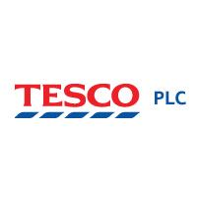
Tesco PLC launched affordable new range of vegan-based products named Plant Chef in the UK market that will bring them huge revenues and also fuel their market growth in the industry (Tesco launches new own-brand plant-based range - Retail Gazette, 2020). For this, their marketing head suggested analysing the stages of the marketing process to compete with their existing range “Wicked Kitchen”. This analysis of the market shall also enable the project to know their core competencies and apply them properly.

The stages of the marketing process are as follows:
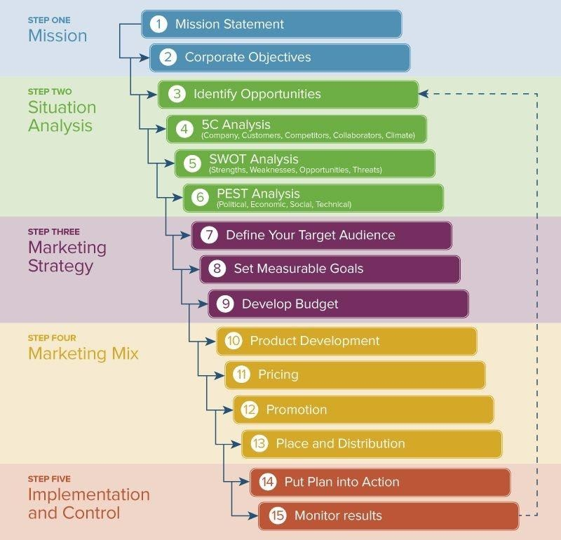

At the initiation of the project, the mission and goal of the project launch will be identified by the company (Armstrong, Kotler, and Opresnik, 2019). They will also identify what is the need for their new product launch and also align their goals with their corporate objectives. Secondly, they perform a situational analysis of the market. This will include the identification of various internal and external factors of the market they will try to penetrate like strength, weakness, opportunities, and threats of the project. Thirdly, the company will select various strategies required to market the product. Selecting a target customer in the UK and make proper budget requirements for the achievement of the goals set. Fourthly, for generating profit and sales the application of marketing mix shall be done accordingly. Finally, the plans shall be put into action, and afterwards, they will be monitored and controlled carefully to take proper recovery actions.
Determining the opportunities and threats of the market

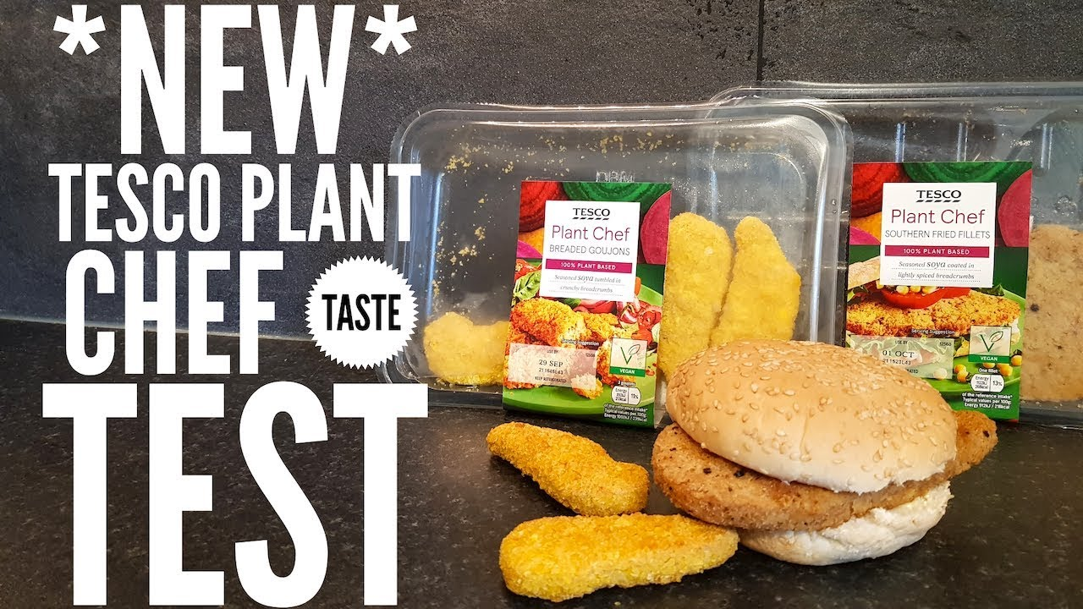

Tesco Plc assigned its research and development section to determine various strategies of situational analysis to analyse the opportunities and threats of the market they are in. The R&D section collects various data related to this from different sources like customers, suppliers, and competitors. For this, strategies like SWOT analysis, PESTLE analysis, and 5C analysis are used by the company.
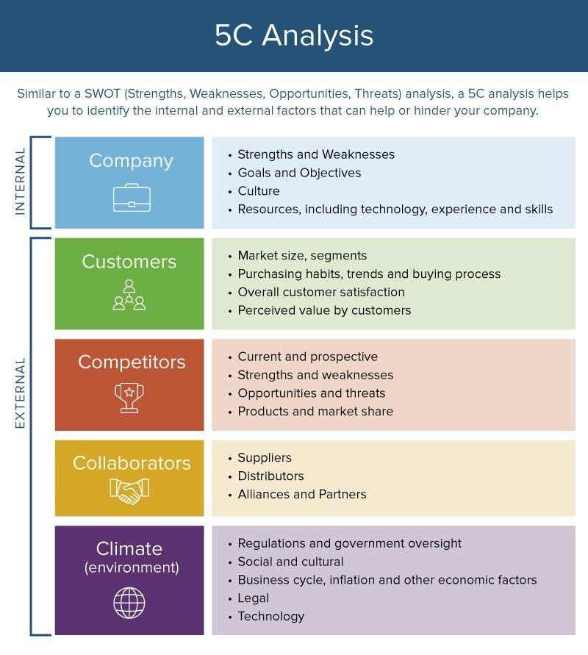
5C analysis
The 5C analysis also provides almost similar information about the internal and external factors of SWOT analysis but in a comprehensive way (Hollensen, 2019).
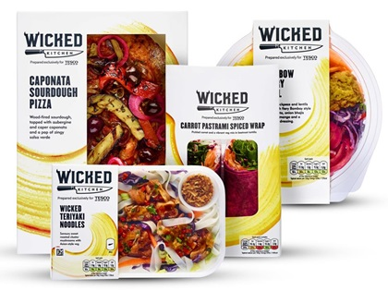
Through this analysis, Tesco plc’s Plant Chef project can analyse its existing Wicked Chef range which is also a business that sells vegan foods and is popular in the UK market. Some strengths and opportunities that the company may enjoy are, for instance, the number of vegetarians is increasing day-by-day that also increases the potential target audience for the company. A wide variety of vegan foods can be provided as they are organic. However, the competitors will provide discounted products to make larger sales that the company may be unable to do so initially. The price war shall be a great threat to the company in addition to this.

The STP Approach

In the present market situation, the STP approach is segmentation, target market, and positioning approach. This approach shall be followed by Tesco Plc to place their vegan products in the market. The STP approach is very crucial at present because the market is more customer-centric, unlike the earlier times which were product-centric (Lamb et al., 2016).
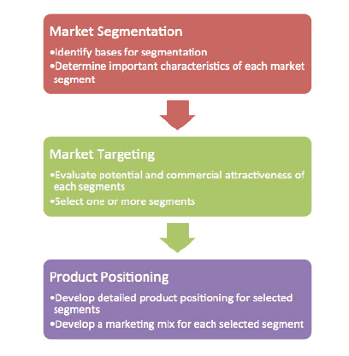
The STP approach
The market segmentation should be done based on the demographical, psychological, beliefs and values, lifestyle, behaviour, and geographical aspects of the customers (The Segmentation, Targeting, and Positioning model, 2020). The vegan products will be placed in every store of Tesco PLC.
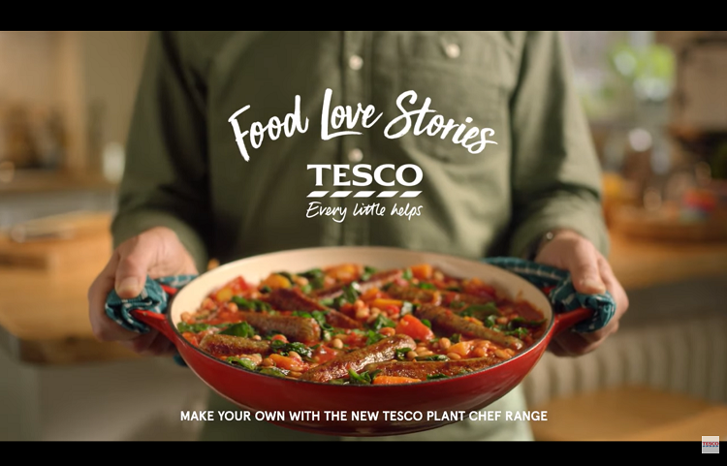
Moreover, the products shall also be placed beside the meat section to create health awareness for the customers. The market will be targeted according to the size, revenue generation, diversity of the products, and accessibility of the products. Tesco shall target the customers that are the potential to increase their brand value. In addition to this, the company will position the products in the customer’s mind by providing fresh vegan products available in the market. Various promotional activities and concern for the health of the customers shall also create a good position of their products to the targeted audience.
The 7P approach of marketing (Product and Price)

As Tesco Plc launched their brand of vegan products named Plant Chef, they will follow various procedures to place their product and price them accordingly with customer’s preference.
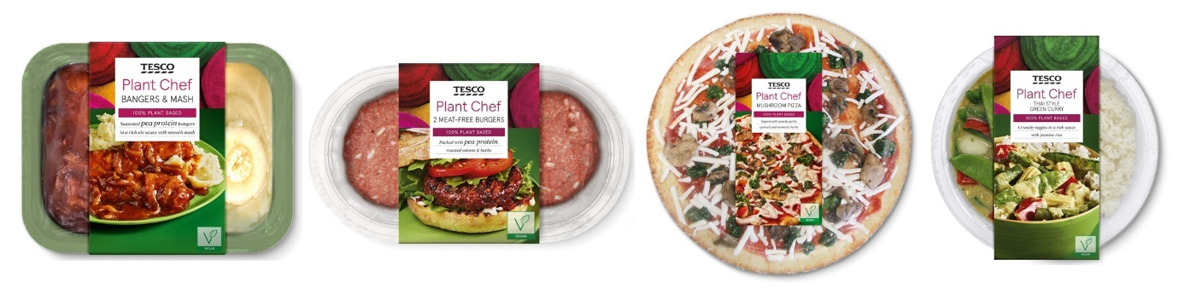
They plan to introduce diverse products like substitutes for traditional meals of the UK like battered fish and cottage pie. They’ll also launch vegan products like mushroom pizza, buttered mac, and cheese with cauliflower, and chicken goujons made from soya which are seasoned. They also will introduce about 300 vegan products which will give variations to the taste of the customers.
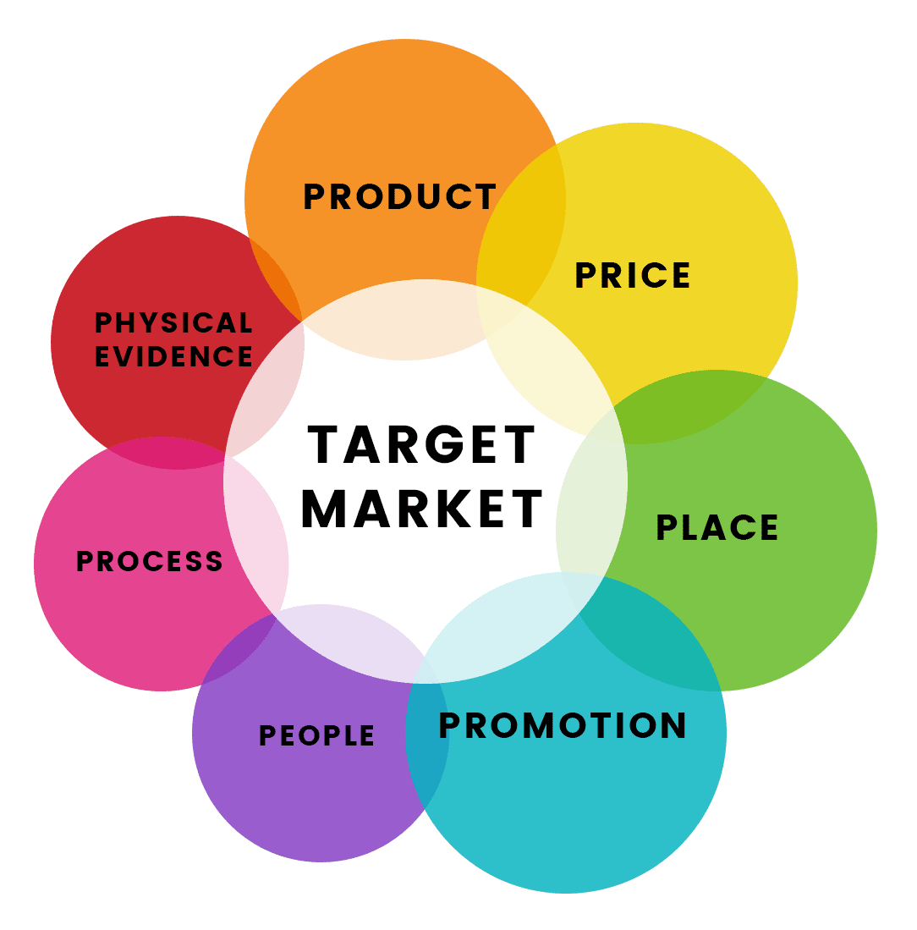
The pricing of the vegan products will be done per their close competitor range Wicked Kitchen who already sells products through Tesco Plc and has a wide market in the UK. Moreover, the price will be set initially to penetrate the current market and also attract potential customers. The pricing will be set in such a way that it will also attract the non-vegan customers to buy the products as a matter of leading a healthier lifestyle (Lim, 2020)
The 7P approach of marketing (Place and Promotion)

Tesco plc plans to place its new brand of vegan products, Plant Chef in almost all of their 3968 stores all over the UK (Number of Tesco stores in the United Kingdom (UK) and the Republic of Ireland from the financial year 2012 to 2020, 2020). They shall operate a separate section for the product line to create an attractive image for the newly launched product. Moreover, the products will also be distributed through various distribution channels of Tesco plc all over the UK mostly in the areas where the vegan products have more demand (Lindgreen and Anthony Di Benedetto, 2018).
In this present age of technology, the promotion of a newly launched product can be easily done. Earlier, where the promotion of a product was mostly done using leaflets, posters, and brochures, now the online media like Facebook, Twitter, and YouTube are much more popular (Sheehan, 2018). Tesco PLC already has a well-developed website of their own which is an advantageous point for the company as they can promote their products through the website also. Commercials on TV and Youtube will also play a great role in reaching customers nationwide. Another method that is traditional but still effective at present is providing various discounts and coupons in the sale of vegan products.

The 7p approach of marketing (People, Process and Physical Evidence)

People, process and physical evidence is considered as the stretched part of the 7p approach of marketing. Tesco Plc will also implement this section to be more productive in their product launch and its sustainability. For doing the operations of the new vegan products skilled workforce will be appointed who knows well about the plant-based food items and can also persuade the customers charismatically.

Extended 3Ps of marketing
The process of Tesco plc regarding vegan products will be like focusing on operational support, transaction process, and website design. The factors that the customers will experience besides the actual product is the physical evidence of the product. The environment that Tesco plc is providing, the ease of access to the products, and the ambience of the stores include in the physical evidence.
Implementation of the project that follows evaluation and control

Tesco Plc after analysing the market for their plant-based product launch and determining the marketing mix for the products implemented the project in the actual market. A various situational analysis was done by this company to come this far from the project implementation stage. In this stage, the marketing strategies that were discussed in earlier blogs will be put into action. Initially, the products shall be tested based on a set standard and the distribution of the products shall continue after the success of the product test based on the required standard (Winer and Dhar, 2014).
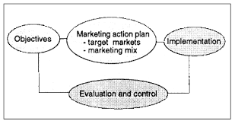
Implementation, evaluation and control
After the implementation of the product successfully the market response should be evaluated properly. The feedback from the customers is a crucial part of the evaluation of the newly launched product. As the company launched vegan products of their own the perspective of the customers is required to know whether they are providing better services than their competitors. According to this feedback, required control measures shall be taken. Moreover, if the operations related to the product launch and marketing do not go according to the required benchmark then proper controlling activities will be done to get the operations done accordingly. Another aspect of the evaluation and controlling measure is to analyse the competitor’s operations carefully. This will enable Tesco plc to become the market leader in selling the plant-based food items that they will launch.
At last, we can say that proper communication with the target audience is necessary to effectively launch a product in the market. Through these blogging posts, the targeted customers can be made aware of the launch of the new plant-based product by Tesco plc.

References
Armstrong, G., Kotler, P. and Opresnik, M., 2019. Marketing. Harlow, United Kingdom: Pearson Education, Limited.
Hollensen, S., 2019. Marketing Management. Harlow, United Kingdom: Pearson Education Canada.
Lamb, C., Hair, J., McDaniel, C., Boshoff, C., Terblanché, N., Elliott, R. and Klopper, H., 2016. Marketing. London.
Lim, W., 2020. Challenger marketing. Industrial Marketing Management, 84, pp.342-345.
Lindgreen, A. and Anthony Di Benedetto, C., 2018. Citation classics from Industrial Marketing Management: Celebrating forty-seven years of publications on business-to-business marketing management. Industrial Marketing Management, 73, pp.1-6.
Retailgazette.co.uk. 2020. Tesco Launches New Own-Brand Plant-Based Range - Retail Gazette. [online] Available at: <https://www.retailgazette.co.uk/blog/2019/09/tesco-plant-based-meals-range-vegan-vegetarian-launch-traditional/> [Accessed 29 December 2020].
Sheehan, B., 2018. Marketing Management. Lausanne: AVA Publishing SA.
Smart Insights. 2020. The Segmentation, Targeting And Positioning Model. [online] Available at: <https://www.smartinsights.com/digital-marketing-strategy/customer-segmentation-targeting/segmentation-targeting-and-positioning/> [Accessed 29 December 2020].
Statista.com. 2020. Number Of Tesco Stores In The United Kingdom (UK) And The Republic Of Ireland From Financial Year 2012 To 2020. [online] Available at: <https://www.statista.com/statistics/490947/tesco-group-stores-united-kingdom-uk/#:~:text=How%20many%20Tesco%20stores%20are,have%20been%20increasing%20since%202012.> [Accessed 30 December 2020].
Winer, R. and Dhar, R., 2014. Marketing Management. Harlow: Pearson.

