Student Name: Emilia Baraiac
Student Number: 2028688
BMSW4004_LON: PROBLEM SOLVING AND DECISION MAKING
Lecturer Name: Rexon Nting
Individual Report – Task 2

Table of Contents
Introduction 3
Identification of problems within the organisation and impact on service process 3
Analysing the information to make an effective decision regarding the problems 4
Application of problem-solving tools to address the solution of the problem 4
Application of decision-making technique to evaluate the solutions 5
Development of a plan for implementing the solution 6
Communicate with stakeholders regarding the plan 7
Development of monitoring and review techniques to implement the solution 7
Conclusion 8
References 9

Introduction
This report focuses on the problems of a healthcare institution regarding their service process that might create a major barrier to implement an effective care service process. Also, this report also sheds light on monitoring and review technique by which they can develop a positive work culture within a care institution in a decent way.
Problem-solving skill within a healthcare organisation increases the service quality process by which they can enhance patient safety within a care institution. This report covers the importance of the problem-solving skill of healthcare experts by which they can make effective decisions regarding their service process. Furthermore, this report also helps to apply the problem-solving tool as well as decision-making techniques by which they can evaluate their solutions efficiently. It is also important for care experts to communicate with stakeholders regarding their plan by which they can solve their problems adequately.

Identification of problems within the organisation and impact on service process
It is quite important for care experts within a care institution to understand their problems. In addition to this, miscommunication is one of the greatest problems in the healthcare organisation that might affect the service quality of patients. Also, a bad organisational structure decreases the morale value of employees which might increase the stress and frustration levels. Along with this, due to the complicated system, healthcare experts are not able to develop a proper cooperation strategy that might affect their care practice process. Miscommunication in a care organisation also affects the collaboration strategy that might create a major barrier in providing the best care for patients. For instance, once in my short career as a nurse I did not understand the language of other nurse who spoke in a strong accent and as a result, I brought a bin bag instead of bringing an IV fluid bag. Therefore, the miscommunication process within a care institution might create a major barrier to the care service process that could hamper the patient safety quality within a care institution.

Analysing the information to make an effective decision regarding the problems
An effective decision-making process helps care experts to provide the best quality care service to their service users by which they can enhance their organisational value effectively. It is important for doctors and nurses within a care institution to develop a strong communication strategy by which they can share their ideas in an effective way. Furthermore, the effective communication system within a healthcare institution also develops a positive work culture that enhances the organisational value proficiently. Based on the views of Tang et al. (2018), the proper collaboration strategy within a care institution prevents the medical errors by which they can improve their care service strategy. In addition to this, it is also important for a care institution to develop a proper collaboration strategy by which they can provide the best quality service to their patients. For example, once I developed communication with a dementia care seeker and he thought of me as his daughter. However, other nurses are not able to develop strong communication with that dementia patient and as a result, he refused to take his medications from them but he took his medications from me. An appropriate communication within a healthcare institution also develops a strong empathy for their patients which they can share their problems with care experts in an efficient way (Müller et al. 2018).

Application of problem-solving tools to address the solution of the problem
Problem-solving tools help to address the solution of miscommunication and organisational problems within a care institution that might improve the care service strategy in a potential way. A lot of problem-solving tools are associated to identify the solution to a problem by which medical care experts can enhance their service value efficiently and these tools are fishbone diagrams, flowcharts, strategy maps, mental maps and charting software. These diagrams help to understand the root cause of a problem that influences the medical experts to identify the appropriate solution to a problem. In addition to this, due to the application of the fishbone problem-solving tool, a care institution can develop an active listening strategy by which they can solve their communication issue effectively. Due to the implementation of this problem-solving tool, a healthcare institution is able to develop a clear service goal by which they can enhance their care practice adequately. Besides this, the flowchart describes the operational process of an organisation by which they can design a proper solution to the problem. Along with this, the care providers of a care organisation might apply this tool to improve their collaboration strategy by which they can understand the requirements of their patients effectively. So, the problem-solving tools are quite important for an organisation to provide the proper solutions to the problems that might affect the service quality of a care institution.

Application of decision-making technique to evaluate the solutions
The Decision-making technique helps to address a decision regarding the healthcare practice process by gathering the information as well as assessing the alternative solutions to the problem. Based on the assumption of Belur et al. (2021), a step-by-step decision-making process aids a healthcare institution to make a more deliberate decision regarding their care process that might enhance their care practice process significantly. Along with this, a healthcare institution might apply different decision-making techniques such as decision-making tree, Game theory, Influence diagram approach and many more.In addition to this, the Game theory is another decision-making technique that also aids to make an optimal decision-making process by which a care organisation can enhance their care practice in a positive way. Due to this Game Theory, a healthcare institution can develop a proper strategic goal that might enhance its collaboration process within a healthcare institution (Palafox-Alcantar et al. 2020). Furthermore, the Influence diagram approach helps to address the decision uncertainties that might help a care intuition to enhance their care value proficiently. Moreover, it is quite important for a healthcare organisation to apply an appropriate decision-making approach.
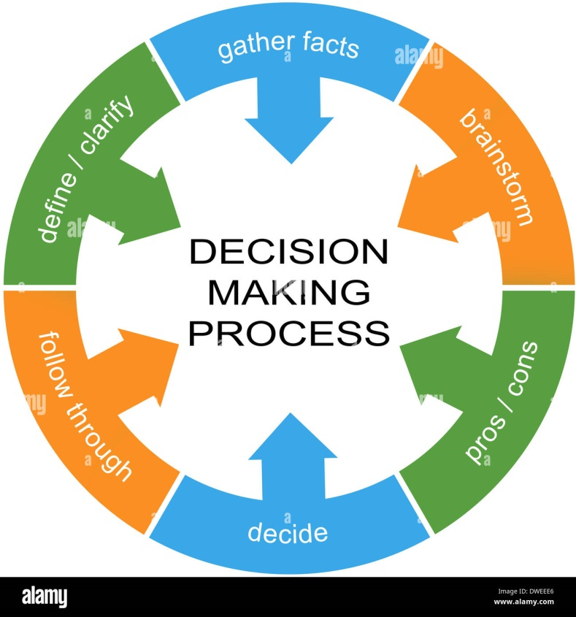
Figure 2: Application of decision-making process
(Source: Belur et al. 2021)

Development of a plan for implementing the solution
Healthcare people in a care institution can provide the proper attention to their patients which they can develop a positive work culture within a care institution. It is quite important for care experts to develop a proper plan for their care service strategy by which a care institution can mitigate their communication as well as collaboration issue. Due to this planning process, a care institution is also able to develop a positive environment within a healthcare organisation by which the care seekers can share their problems with care experts effectively. Therefore, it is necessary for a care institution to develop effective teams for specific care services by which a healthcare organisation can enhance their communication as well as collaboration strategy efficiently. Along with this, it is also essential for leaders of a care organisation to develop a proper work schedule by which care experts can provide their service by maintaining a proper timescale. In addition to this, an effective team working process also provides an opportunity for the care providers to enhance their knowledge regarding the care service process (Lacerenza et al. 2018). So, it is quite important for a healthcare organisation to develop a proper schedule as well as an effective team by which they can eliminate their miscommunication and collaboration issues to enhance their organisational culture.

Communicate with stakeholders regarding the plan
Effective communication with stakeholders helps to understand the value of an organisation as well as the requirements of its care seekers. According to the opinion of Mazur-Wierzbicka (2021), appropriate communication with stakeholders increases the trust value of a care institution by which they can attract a number of people to their care organisation. Similarly, it is also important for the leaders of a care institution to communicate with their employees regarding the team development process by which they can implement their plan in a successful way. Along with this, the communication with stakeholders also increases the problem-solving strategy by which they can enhance their care practice adequately. Moreover, it is also important for care leaders to stay consistent with their messages by which they can develop a positive communication strategy within a care institution and as a result, they can implement this plan in a proficient way.

Development of monitoring and review techniques to implement the solution
Monitoring and review techniques help a care institution to analyse the disease of care seekers positively. In addition to this, it is also important for a care institution to implement different monitoring software by which the leaders of a care institution can monitor the service process of nurses and doctors. Based on the idea of Usak et al. (2020), the monitoring and review technique within a care institution plays a critical role by which they can prevent the critical disease of care seekers effectively. Due to the application of proper monitoring and reviewing techniques, a healthcare institution can develop a proper decision-making process by which they can enhance their service quality in a potential manner. In addition to this, it is also important for a care institution to improve its innovation strategy by which it can enhance its care service quality significantly. Besides this, the proper monitoring and review techniques also reduce the medical cost by which they can enhance their care practice process efficiently. Therefore, it is quite important for a care institution to install the latest technology by which they can implement their care solutions as well as adequate manner.

Conclusion
From the above discussion, it can be summarised that language is a major barrier in a care service process that increases the miscommunication as well as collaboration issues within a care institution. This process creates a major negative impact on the organisational culture process. Furthermore, it is also important for a care institution to develop an active listening strategy by which they can improve their communication process. Moreover, it is also necessary for leaders to develop a proper team within a care institution by which they can achieve their strategic goal regarding their care practice process efficiently.

References
Belur, J., Tompson, L., Thornton, A. and Simon, M., (2021). Interrater reliability in systematic review methodology: exploring variation in coder decision-making. Sociological methods & research, 50(2), pp.837-865.
Lacerenza, C.N., Marlow, S.L., Tannenbaum, S.I. and Salas, E., (2018). Team development interventions: Evidence-based approaches for improving teamwork. American psychologist, 73(4), p.517.
Mazur-Wierzbicka, E., (2021). E-communication and CSR-a new look at organizations’ relations with stakeholders in the time of digitalization. Procedia Computer Science, 192, pp.4619-4628.
Müller, M., Jürgens, M., Klingberg, K., Hautz, W.E. and Stock, S., (2018). Impact of the communication and patient hand-off tool SBAR on patient safety: a systematic review. BMJ open, 8(8).
Palafox-Alcantar, P.G., Hunt, D.V.L. and Rogers, C.D.F., (2020). The complementary use of game theory for the circular economy: A review of waste management decision-making methods in civil engineering. Waste Management, 102, pp.598-612.
https://journals.sagepub.com/doi/abs/10.1177/1758573217735325 (Accessed 13.04.2022)
Tang, C.J., Zhou, W.T., Chan, S.W.C. and Liaw, S.Y., (2018). Interprofessional collaboration between junior doctors and nurses in the general ward setting: A qualitative exploratory study. Journal of Nursing Management, 26(1), pp.11-18.
Usak, M., Kubiatko, M., Shabbir, M.S., Viktorovna Dudnik, K. and Rajabion, L., (2020). Health care service delivery based on the Internet of things: A systematic and comprehensive study. International Journal of Communication Systems.

