Contents
Introduction 1
Development Audio Log Transcriptio0n 2
Development Coding Sheets 26
Screen Shots 48
Initial Design Notes 59

Introduction

This is the report for the semester 2 software development assignment for Mark Lawrence Edwin Vaughan (1909160). Contents are notes and screenshots to prove knowledge and skill for the subject and is not as a formal report.

Development Audio Log Transcriptio0n
Transcription of audio development log. Please accept my apologies for the erratic gramma as the translator uses artificial intelligence prediction and is therefore very stupid. Knowing this I have edited the files slightly to make then more readable.
Day 1 | Hello, my name is Mark Vaughan student number 1909160.  As part of the software development to assignment I have to keep a record of the work that is actually being done, in other words a development log.  So, I've decided to make a series of recordings partially because it's something I can quickly do between each coding and also the fact that having diabetes and only about 40% sensitivity my hands touch typing is a little problematical.  So, I am going to transcribe this recording to a word document the end and hopefully this had to satisfy the requirements for the assignment.  So, let's crack on - day one.  I have downloaded the word file from Moodle and actually looked at the specifications required for the five exercises  I’ve looked at each exercise in turn and have put, lease ways, for the bulk of them, the general parameters required  For instance, exercise one, actually, is to create three variables  This is not even an exercise for me, I learned to program in C in the 90s and admittedly C++ this has thrown me a few curves during development but, nothing I can't handle.  Variable one is essentially a book title which is a string, this means that it uses alphanumeric characters and has variable length, therefore, the string type seems to be the obvious solution.  The string characters are delimited by a null character and if memory serves can be up to 255 characters long hence the variable and the fact is marked as a string  Variable two is a float in this particular case, although I could have used a double, as such, but, with double the storage length is eight bytes as opposed to four bytes and as most measured lengths, as such, are usually at minim millimetres, cannot be no more than 10,000 units so float is probably the more logical choice for this particular variable.  As with all floats they are designed to hold fractional values so, as the real-world does not believe in whole numbers and the float is obviously the logical choice for that,  It can be either positive or negative although in this case the measurements are positive in nature and there is no such thing as a negative measurement and obviously, because of the range of the type, it can hold a very wide range of values so, again, an ideal solution for this particular variable.  The third type is a products in accounting and shopping cart and as you don't get fractional products,  is,  obviously whole numbers are the way to go on this one i.e. a whole numb  no fractions,  so integers immediately spring to mind and  again,  as we don't know how many products are in the cart, we can assume actually that it going to need a relatively wide range of values,  again,  integers are the way to go and which if memory serves are 65,355 characters in length which if I recall actually was four bytes worth,  sorry  two bytes worth, correction,  and so I've assigned an integer for that.  The second exercises,  exercise rath  as such, is our little more involved  this is actually to calculate area's  essentially  you have a large main area and two small areas inside it  which need to be deducted, so there two types,  shape types,  the circles and rectangles.  Jotted down in notes,  the calculus required,  for the circles is pi times radius squared and a rectangle with the hight times width,  pretty much junior school calculation and in this particular case,  i decided on a user defined that datatype which will have three values, height/radius, width, and length.  these act to hold the information about the shapes and  this datatype will be stored as part of an array.  I have also actually, jotted down,  in order the process which in this particular case is  calculate main area rectangle, calculate the inner rectangle and inner circle and take their the last two away from the former and then display the result,  very, very straightforward,  very, very simple.  Exercise. three is to basically an array calculus test,  it doesn't specify how many entries that you need to be entered, so i jotted down the fact that  the number of entries need to be entered in by the us  a loop then enters the values in GB pounds into the array,  the euro exchange rate needs to be in input as well and then once the total of the array has been tallied up with another loop, the amounts are converted into euros and then the answer is displayed.  Entry wise, I could have actually gone the way we were taught in class using the string streams,  functions to them enter string and convert to the relative value  I’m going to try something a little more difficult in respect that i am going to create my own personal input output class called myI/O  This is probably going to cost me a bit in time, as I haven't actually used C++ in earnest for, something, must be getting on for nine years, although I have tinkered with it in class,  but most of that actually, was based on straightforward to C, so haven’t learnt anything really new there  and like in the previous example as such,  put a process note in as well which, outlines the basic processes.  Exercise four is basically a treasure game.  Requirements on this, I’ve noted,  array to store the treasure, array to display attempts, try’s, number of try’s variable and other treasures found variable and a counter 0-2,  which indicates number of attempts made.  As only three lives, as such, then the game in theory should not go back to more than three turns if none of the treasures are found and I'll probably have to change it up to 6,  sorry 5,  the sixth being the winning go  If they find the treasure  is not necessary and I’ll leave you to have a look at the notes as such,  the process and is basically mapped out and as for exercise five is a checkers game are, I've decided I'm not an attempt that for its only 10% of the marks and it's a lot of work,  so, as we are supposed to be learning development for a business environment  and as they say,  in the line of business,  is not cost-effective so, I won't attempted it as such.  Although I will probably put notes in if I’ve got time,  actually,  outlining how an attempt to create that particular game.  I've also to put a little section the bottom of the notes asking myself some questions,  for instance, how do I define a return type for is the return type defined by, what was the  nd of that line,  sorry you will have to excuse me I’m working on a partially size screen and oh yes, by return method  The second one actually,  it is better to define a process as a class with custom members which, is probably better  I good way for management although the problem there is such  is that he tried to return the values that you don't want to use the default return um  I’m going to have a bash at to using the referenced values sorry,  reference parameters  rather than return types  away to get output but,  as I’m known to remark to Michael and I'll get the thing running first before I start polishing the turd  so in this particular case I'll use very basic string and casting functions and try and upgrade it to a full class with referenced values later on  once I got time  and is a I said, once i get a basic plan of action in place and everything else after that  is just minor tweaking.  So that's that,  I've also, as part of the process, included a number of  very, very basic flowcharts least ways,  for excises three and four  one, there is no flow involved, It's a matter of creating variables and  two is very, very straightforward  again, it probably does not really warrant a flowchart but, if I got time at the end, I might just put one in for forms sake  so that is essentially as far as gotten the end of day one  I’m going to call it a day and they now sit back a bit of think and then tomorrow day two I'll make changes as required.
Day 2 | Software development assignment Day 2,  created basic flowcharts from the notes,  spend the most part of the morning setting up a development environment, I am using Microsoft code for essential entry  sorry,  initial entry and visual studio,  actually,  for debugging and final polishing.  I've decided  actually,  to implement a user class,  input/output class - the afore mentioned myI/O,  as a general framework,  it has no guts to it at this moment in time  as the I'm just concentrating on the interfacing with the main routine  I have generally laid out the main routine - input output requirements, essentially just setting the groundwork.  Looking at the stringstream implementation on myIO  throwing up loads of errors which are due to my lack of knowledge about the particular string class  is going to cause me some time loss, so I switched to simpler coding on that  and are probably be completed on Friday and Saturday.  As such,  I'll upgrade that with a little bit of research to a full-blown string class conversion functionality.  For the moment, I just use the standard stream, I/O CIN and COUT, C-out  should I say,  for a general input and output.  I've also actually  attempted to put  referenced parameters in on some functions  but have not made that universal  in this particular class  I'll use some basic default types that for parameters and I’ll use  Rather  I'll declare the  the function as public function so they can be accessed outside of the defining block  time used for development on this time is 10 hours  I should really learn to take a break.  I Think actually started to make silly mistakes  i.ve already caught three syntax errors actually  just while reviewing the code  so there we are  got to get that  get the code down on paper first and then probably tomorrow at the  I'll start the basic debugging,  get rid of the basic syntax errors et cetera,  I should really get something to eat as I have not had anything since breakfast and I'm probably getting a bit punchy.  Actually,  as I’m finishing this recording,  so, I'll just leave it at this for today.
Day 3 | Software development assignment Day three  I’ve put in the basics of groundwork coding and I have filled out most of the functions,  actually,  with the supporting code, essentially,  what I got. Is an untested and bugged version of the first draft  I have put it into Microsoft visual studio which is particular case is the enterprise edition  and I have run basic syntax error checks and essentially worked my way through the list. Just getting rid of the silly syntax problems as such  caused by extended work yesterday.  getting to the problems I have encountered,  I've got a number of, as such,  which generated around, in fact,  has generated 59 main errors,  first main obvious one is that the switch and does not recognise a user-defined type as a string variable,  that I suspect, is either the problem as you say  with my understanding of the string itself. All our probably  More likely is just out of scope  I've also created a user-defined type - GEOM that ,  actually,  is short for geometric shape and this is the type, actually,  using to hold their information,  actually,  based, actually,  on the shapes geometry and I try to make it fairly universal.  With three parameters and also included a float type in there , actually,  say for the area and this could also double up as a volume. , actually,  if the actual shape is defined as a 3D shape as defined , actually,  by the G_type variable, which is an integer  in the program itself I’ll reference these values , actually,  by an enumeration, an integer enumeration with the index, actually,  denoted by labels referring to this type  so circle, square, rectangle, triangle, et cetera  obviously for 3D one’s, you use the 3D equivalent such as sphere, cube trapezoid,  and a pyramid for triangle  than others,  there is proper name for that particular polygon but um  is a bit academic at this moment in time.  anyway  the error thrown up on that particular one is a problematic to say  with full declaration, I suspect that each placement inside a function is properly incorrect and is to say,  is properly out of scope  invalid functions had been declared  in the Calc area which is, the type I've generated actually  to., say. <garbled> is the function I've created to do basic area calculation and the parameter on that is a  variable of the Geom type. So again,  I think there may be a, problem with the declaration on that  interfering,  actually,  with the Calc area parameter  as is not recognise actually, on  definition is obviously throwing up this action,  again.  I think it may be a scope problem  also actually  complaining about but  forward declarations , actually,  of the enumeration is saying it's a non-standard,  I I’ve got to look into that, what I might do is fall-back on my default book,  I call my default book  as I say it's one of the few really decent ones. I've got,  it’s called learn Visual C++ now by Microsoft press and it’s by a chap called Mark Andrews  give you an idea how old this as such,  is giving away a free version of visual C version 1 so it is a little bit long in the tooth  that, but the main features, actually, haven't changed much over the 20 years since I last bought the book  so any small refinements. As such,  are referred either to the geeks to geeks website. or the W3C school’s website  just,  actually,  to check up on them  syntax, and  declaration  permissions as most of the functions I've already mentioned such are part of standard C  I know about these for donkeys’ years.  So again,  I have really learned anything new there  just need to know, actually,  work where the wrinkles are, and that these websites actually  seem to be doing a fairly decent job  on the occasion. Where I’ve needed to run.  Double checked the way the parameter or a datatype in  what’s the word?  is declared.  Other errors thrown up  was the screen row constant  has not been recognised  it’s weird I’ve declared this in the main function itself, so its scope batches should be covered  actually,  by all the others,  this,  actually,  might be one of the wrinkles that he which has changed since it C  or it just could be my memory is faulty.  let’s face it  I’m using a biological computer  especially with the human malware has been going around recently  I’m surprised working at all.  Again, being a naughty boy  I’ve worked in this particular case 8 and a half hours up to this point with just breakfast in the morning and nothing to eat and very little drink in between  At least I'm getting up out of the chair every 15 minutes so just to get my legs to stretch and to refocus what's left of my eyes  still, got to develop a little more discipline,  actually,  say in my work  processes.  In that respect also,  one final problem that, was thrown actually  by the syntax checker  sorry,  the program checker  the myIO methods are declared as such  are just not being recognised and I have a suspicion.  Again,  this is a scope problem and I’ll  tackle these, actually,  once I get a bit of a fresher brain, or at least waiting  and get a bit of a decent night's sleep,  so I'll basically just a catch up, on day four
Day 4 | Hooray I’ve made it to day four  okay,  so back to software development  right,  looking at the error list from yesterday,  I’ve decided to tackle that the bulk of those problems today  <garbled>  Pardon my French  and once I’ve had a good night sleep  I’ve suddenly realised of course  that either  that I’ve have done some really stupid to things  essentially, what I have done, I haven't instantiated the class (Geom?) in the main routine  so of course, all the member functions that are non-existent.  Hence, the error list,  So, I’ve instantiated the myIO class and  which  actually  once they have been prefixed  actually  with the variable has been declared  Which, looking down on my program now is called console with a K  not mention ‘C’ as that often use that to say for a lot of the predefined  function types  for instance, standard I/O tends to use the console as a keyword,  so, putting in a ‘K’ there is a little continental, admittedly, but it should cut down on  actually  on any clashes  actually  be pre-existing types and classes  so our I.ve prefixed the input routines  actually  with the console. Class identifier,  all those particular errors disappeared  I also moved the user-defined types in this case  It’s GEOM  out of it’s function into the main declaration area  at the top of the programme itself,  these actually make them global in scope,  or as I'd like to think of them as martini variables i.e. anytime, anyplace, anywhere  another one for Michael,  I have also moved the enumeration  actually  into the space as well.  This, again  actually  giving out a global scope  actually  over the programme,  so I should just use that  actually  on all these the function definitions  i.e. external as well as internal to the geometry data type,  so this actually again, has some changed the number of errors  actually  say from 59 down to 13 and also  actually  as a result of that  I also tidied up the code a little and removed a few syntax errors that  crept in and whilst I was grafting away  and things actually are now starting to shape up  I’m currently toying with the idea of  changing the  data type actually for the storage array actually to a separate class in its own right,  and then combine  the shape calculation  sorry,  the area calculation as the  as a functionality of that particular that data class  haven’t done so is yet but, I’ll say if I got time,  I might do that or just for clarity,  I might just leave it as is, as part of the main and program code rather than insert as a separate class  I’ll sleep on that one.  Looking at the error list.  I’m having a look on-screen actually  at the case of geotype DOT none  the geotype is the enumeration I've have given  rather say its enumeration list that you I've used for accessing the various shapes,  so this particular case, I've got to earn the switch based on the shape and Geotype which is the parameter passed actually as the geometric shape type  the idea is that it reads which particular type of shape It is  i.e. a 12345  the enumeration obviously makes coding a little simpler in respect that it uses English words rather than numbers to remember.  So for instance I got geotype.circle  Sorry Geotype dot circle or Geotype dot Square  et cetera  the problem is that  even though it had made the geo-type of enumeration global  as such,  it still doesn't seem to want to recognise it  I suspect this actually,  might be a quirk of the switch function itself rather than a scope problem,  so, I got to look into that  at some time and figure that one  have a look see what else I got on my list  right I’ve got another one here that says it doesn’t recognise to getInt prompt  that's again me getting a bit punchier forgot to put the console class prefix in  so I'd sort that out actually before I sign off,  another one there for floats  I’m having a problem with the myIO class in respect that  some of the type conversions aren’t being recognised,  so I'll spend day five  actually  researching the stringstream class and rewrite that particular section of code.  Rather,  the problem sections of code  to account  actually  for the buffer string type and then apply the appropriate conversion functions to return the correct results,  that I suspect will be an all-day effort  after which,  I will transcribe these recordings across to the word file do is do some general documentation type stuff.  so,  that essentially is it for the moment, and as said, the original on first install  the original build – reported some hundred and 47 errors including syntax errors.  So, warning notes, et cetera I  I've now got this down to just to 13 at errors  which are basically just based around two general problems.  So, as I say, things up are moving ahead quite happily and hopefully all things being equal, I should be actually done with this assignment before Sunday,  which then allows me three weeks to do the remaining three assignments,  so one assignment a week over this holiday period.  Should be no problem  there I’ll make a point of of taking Sunday's off as such, for R&R and personal maintenance.  And after all, Don’t actually want to get a reputation as the ageing bomb,  so, I’ll call it a day for today,  total hours worked on this particular one is nine hours 15 minutes so  so again,  another nonworking day and that always spending a holiday break,  but as they sat when the devil drives; have a good one.
Day 5 | Hi, this is the recording for day five of the software development assignment.  It's just slightly off half past five in the morning, as you probably may have gathered that I've had a long day  started off yesterday morning  by having a look at the code on the SS stream and stringstream classes  I went straight down to basic level of such looking at the primitives, such as the I/O stream  Sorry  The Istream and Ostream classes and working way up  I can see why my Mic.. sorry,  I see why Michael introduced us to the string stream class initially as Such  It is pretty much a Swiss army knife of input and output,  I mean it’s what? four layers above primitive code so it does basically everything you need.  So I've rewritten the my I/O to accommodate this particular class  made a few changes to IT to make it a little bit more easy to read and obviously as per standard procedure. I've annotated everything  on that point,  looking at the flowcharts did on day one,  you'll properly actually see the they bear no resemblance to the actual finished product  but like most plans you know, military or otherwise they never survive first contact with the enemy,  so it’s been evolving  actually,  as been writing it,  also have got into the habit of having a notepad next to keyboard  jotting down.  Actually  changes I’ve made and put out a line down the right-hand side  as such,  in that margin I’ve put in ideas that the for  improvements  and or possible changes so at the same, handy little technique that whats needs to be passed on.  On the point of view changes  I was contemplating  actually  putting the shape class into its own separate  sorry,  shape routines into own separate class  I decided against that  only two routines in there as such,  the current setup actually which is basically a struct at the top of the  the programme listing i.e. in the declarations area  is all that’s really required  low point actually turning into a class as such,  and because it is designed as a custom class that is for this particular assignment  and if a wider use of such  there is (a) probably no requirement and (b) somebody else has probably done in a more effective fashion,  so, there is no point reinventing the wheel as Michael's often fond of saying  so then,  updated the myIO class actually with basically what I learnt  that has nailed down  eight of the…  sorry,  eight, yes eight of the 12 errors that had on the code  I spend the rest of the afternoon and just tidying up some of the other code  I've moved  The definitions actually  out from the main and routine  actually  into the main body of the text to give more global scope  again,  annotated where I made changes and  I have got this down to 2 errors  This is something actually  had me really bugged for quite a while  I sat down for the best part of 20 minutes to analyse this problem  the result is…  ,I really could kick myself for such is such a simple answer, apparently in C, the caret symbol actually is not the exponent function  again, the legacy of using Microsoft Basic java et cetera they all tend to use the exponent as a caret character as an exponent function  C++ has now got a pow (P.O.W.) function to give us powers, takes two parameters - the actual source number and also the exponent itself, which as it’s squared needs R*2  this exports the value back actually  as a completed calculation of that of the power function  so I have amended those two errors and made a note actually  in my notepad actually to put a note some where on my system just remind me for this for the future.  It is one of the unusual quirks of C++ which  I just need to just bear in mind  so, I'm now got a debugged version of the code  I have not run it yet  I'm just too knackered to carry on so,  I am going to try and get a good 10 hours sleep or so  wake up round about Midday actually  on the next day and then do a final tidying up  and on that note, I'll just bid you good morning, assuming actually you are listening at the same time, I'm recording this <heavy coughing>  oh dear, I think I might have caught this is bug but, it the could just be exhaustion  anyway, I’ll catch on the next log entry
Day 6 | Okay development diary day six  basically, just finishing up work now,  the program itself is complete, bug free.  I've spent a couple of hours updating diagrams and other items of interest  basically, started to package the entire deal up ready for transmission to on…  Turnitin  well ahead of time  primarily due to the fact that I've got three other assignments to do before the end of the month  the most crucial, which in fact that is the information technology and security.  That is about 80% done, but still needs work on its own, put entire week on that and have also got to finish off an information engineering  where I basically just go to use my existing access knowledge and just build up a database actually  according to the assignment specs that should be fairly quick  the one I have started the data analysis, but that's pure number crunching. As such,  that I'll have to do is a little bit of extra research on but,  I’m going off piste again aren’t I,  okay,  back on track  I’ve looked also  at ways that you can do to the draughts game  bit like the tic-tac-toe classwork we did  essentially It is basically to some  looking at the ways that the game can be won. i.e. one piece left  also the rules for movement and the ruled rules for taking opponent pieces and obviously the promotion rules as such,  so they can move back once reached the other side of the board  again  like tic-tac-toe, fairly simple rules  once you got that idea down pat, then obviously just a matter just developing suitable strategies which it would be a little bit more involved compared to tic-tac-toe as there are 64 slots on the on the playing board  as such,  as opposed to 9  so,  far much more room for manoeuvre, although that is limited by the fact that the actual pieces can only move one  one piece at a time and only one direction for the bulk most part  so,  as there are generally eight pieces on the board. That's a maximum of eight possible movement slots  actually  say for each particular side,  so,  this again helps to eliminate a lot of the problems on that. Obviously later game when, obviously, got to the two directions of movement.  This obviously doubles but, by then  as such,  the number of pieces you should have actually still under your command, i.e. operational will be severely reduced.  So again  your processing time and the number of them  calculated requirements…  your recursion requirements rather,  will invariably be much lower and still quite manageable  one in theory could actually  play tic-tac-toe with a board over 1024 slots across and square  so,  that would require small mainframe. I suspect but,  that is to say that's getting a bit off of piste again.  Anyway,  I have packaged up the majority work actually  on the place in self-extracting archive, so that all the tutor has to do is put on the desktop or in a dedicated folder…  Click the file to extract and then put everything down one folder ready for examination or marking if required, obviously it can be just as easily deleted  with the delete button on the folder  so pretty straight forward and are that’s another week out the way  hat is the end of the log,  so, I'll bid you adieu, and the catch on the next assignment

Development Coding Sheets

Main Routine
Exercise2()
Exercise3()
Exercise4()
ScreenClear()
myIO
CalcArea
GetInt(),GetFloat(),GetDouble()
GetBool()
GetStr()

Project: Software Development Assignment Semester 2
Process [ ] | Function [ ] | Class [ ]
Name: Main Routine
Data
Variables | active | Boolean = false
Variables | option | Integer = 0
User Defined Types | myIO – Class  enum geo_te  {none, circle, square, rectangle, triangle}  Struct geom  {  Int gtype  Float area  Float lenrad  Float width  Float height  }  Constants:  float PI =3.14159
Description | This is the main routine to demonstrate application of the exercises for the semester 2 assignment of software development.

Flow Chart

Project: Software Development Assignment Semester 2
Process [ ] | Function [ X ] | Class [ ]
Name: exercise2()
Data
Variables | idx | Integer – index variable
Variables | compArea | Float – Compound Shape Area
Variables | atrrayShape | Geom
User Defined Types | CONSTANTS  Integer MAXSHAPE = 3  Geom – see main rotine sheet for definition.
Description | This void function is the main routine for exercise 2 It creates an array of type geom to hold shape data for three shapes. The routine then calculates the areas of the shapes and then takes the area of the main shape(idx =0) and removes the areas of two enclosed shapes (idex= 1 and idx = 2) then outputs the results.

Project: Software Development Assignment Semester 2
Process [ ] | Function [ X ] | Class [ ]
Name: Exercise 3
Data
Variables | noOfEntry | Integer – user entered value
Variables | euroEx | Float – euro exchange rate
Variables | arrValues | Float array – max 100 elements
Variables | totValue | Float – totals of stored GBP values
Variables | euroValue | Float – total value in euro’s
Variables | p | String
User Defined Types

Description | This the function that acts as the main routine for exercise 3.

Exercise 4
Project: Software Development Semester 2
Process [ ] | Function [ X ] | Class [ ]
Name: Function: exercise 4
Data
Variables | grid | gridData board data table
Variables | X,Y | Integer – reference ordinates
Variables | livesLeft | Integer = 3 – player two life
Variables | treasaureFound | Integer = 0 – number of treasures found
Variables | winstatus | Boolean = false – player 2 WIN
User Defined Types | Struct gridData  [  Status Boolean  isTreasure Boolean  ]  Constants  Integer MAXLIFE = 3 – number of lives for player 2  Integer GRIDSIZE = 64 – number of cells in game grid  Integer SCREENROW = 30 – default number of lines for clearScreen()
Description | This is the main control function for exercise 4. Board is referenced using ordinate calculation (X*8)+Y. game ends when livesLeft = 0 o0r winStatus is true.

Flow Chart

Flow 1

Flow 2

Project: Software Development Assignment Semester 2
Process [ ] | Function [ X ] | Class [ ]
Name: ScreenClear()
Data
Variables | toScroll | Integer parameter
Variables | i | Integer – counter for loop
User Defined Types | None
Description | A simple screen clearing routine that outputs a number of new line characters to stabdard out to scroll previous text off screen.

Project: Software Development Assignment Semester 2
Process [ ] | Function [ ] | Class [ X ]
Name: myIO
Data
Variables | buffer | String
User Defined Types | Fn: GetString(string prompt) returns string  Fn: GetInt(string prompt) returns Integer value  Fn: GetFloat(string prompt) returns float value  Fn: GetDouble(string prompt) returns double value  Fn: GetBool(string prompt) returns Boolean value
Description | Custom I/O class to demonstrate knowledge of the class principle.

Project: Software Development Assignment Semester 2
Process [ ] | Function [ X ] | Class [ ]
Name: CalcArea()
Data
Variables | f | Float
Variables | shape | Geom& Referenced Parameter var.
User Defined Types | geom class variable (see main routine for description)
Description | This function returns a float variable which is the calculated area of a shape passed to the function. The function also sets the area value within the class.  Note: The functions uses shape data as a By Reference parameter and eill change the contents of the external variable. This allows data in externally defined datatypes to be changed without violating the scope of the function.

Project: Software Development Assignment Semester 2
Process [ ] | Function [ X ] | Class [ ]
Name: GetInt(), GetFloat(), GetDouble()
Data
Variables | result | Float
Variables | s | String
Variables | buffer | StringStream
Variables | prompt | String – parameter value
User Defined Types

Description | Integer entry member function for myIO class.

Project: Software Development Assignment Semester 2
Process [ ] | Function [ X ] | Class [ ]
Name: GetBool
Data
Variables | result | Boolean
Variables | s | String
Variables | Buffer | Stringstream
Variables | valid | Boolean = false
Variables | letter | Char
User Defined Types

Description | Function extends iostream and sstream classes. Uses getLine function to obtain a string from the cin buffer and returns it as the functions return value. No error checking or range shecking.

Project: Software Development Assignment Semester 2
Process [ ] | Function [ X ] | Class [ ]
Name: GetString()
Data
Variables | entry | String
User Defined Types

Description | Function extends iostream and sstream classes. Uses getLine function to obtain a string from the cin buffer and returns it as the functions return value. No error checking or range shecking.

Screen Shots
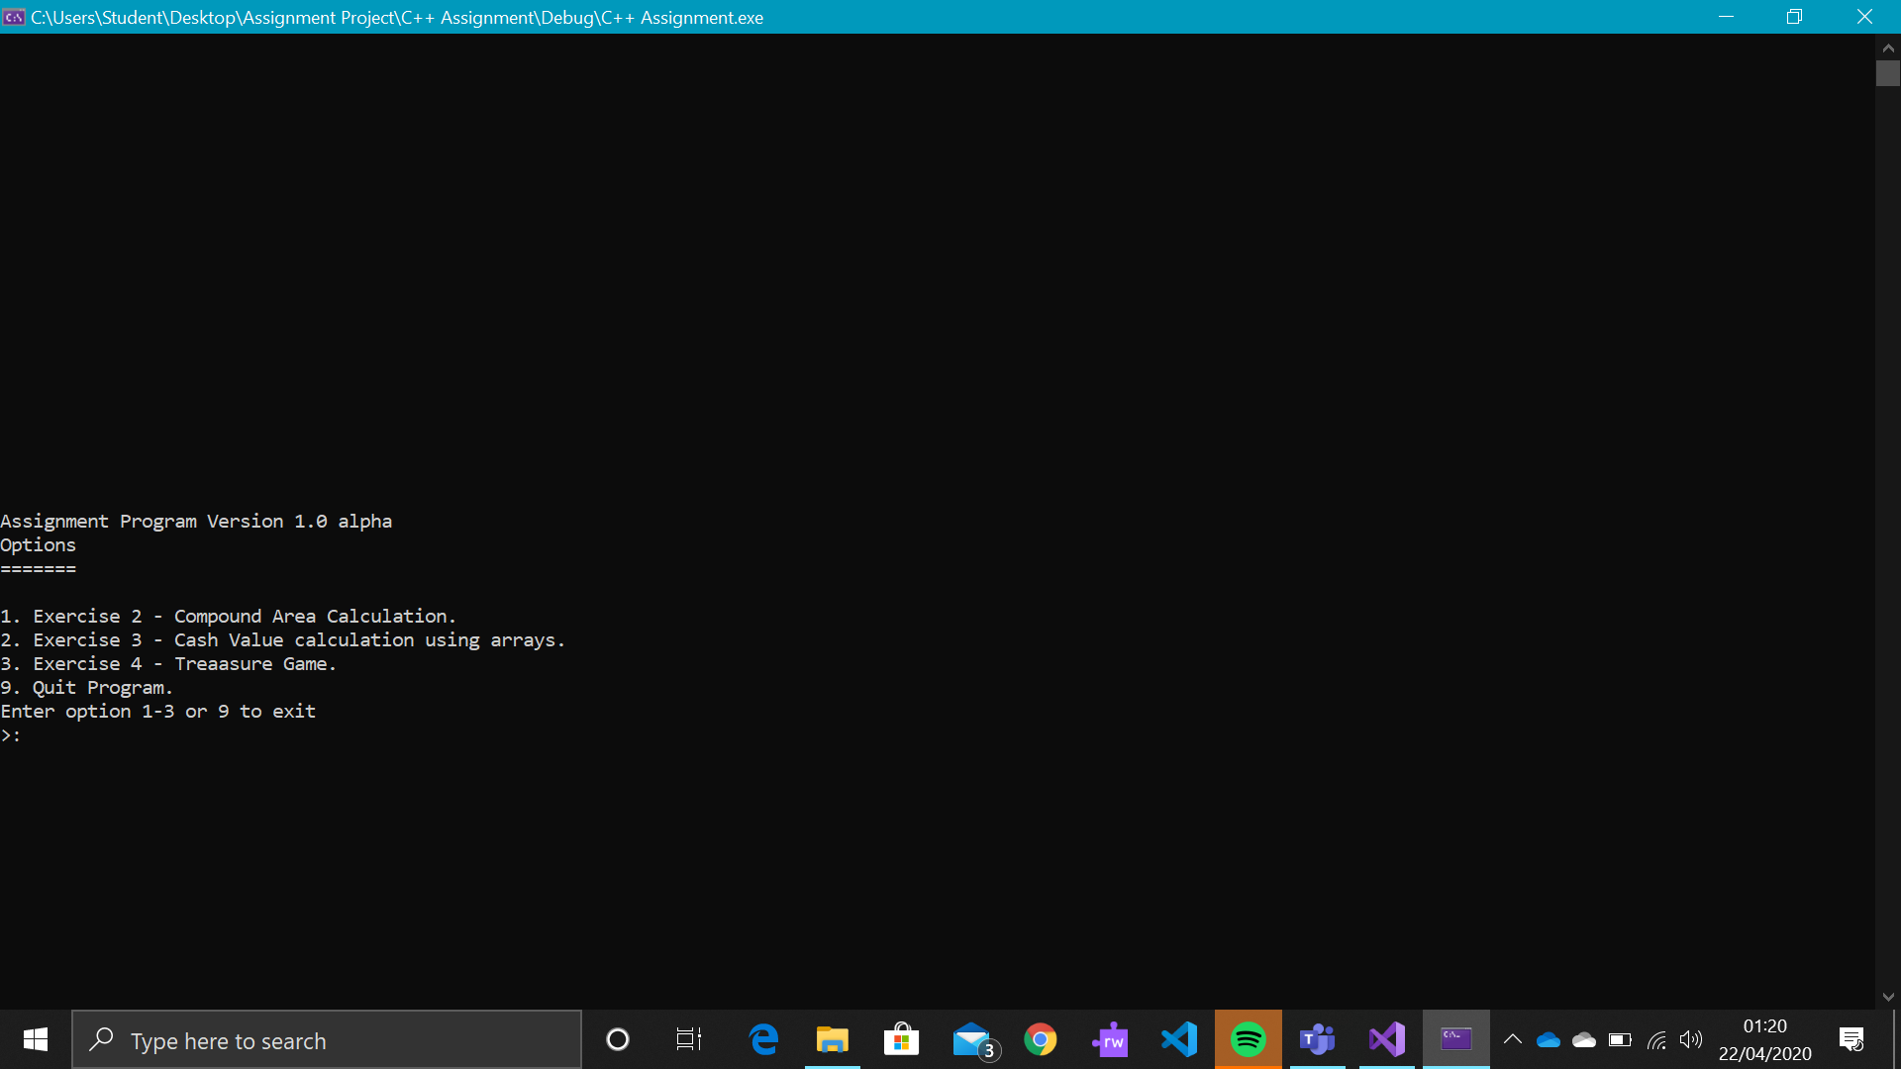
Main Screen
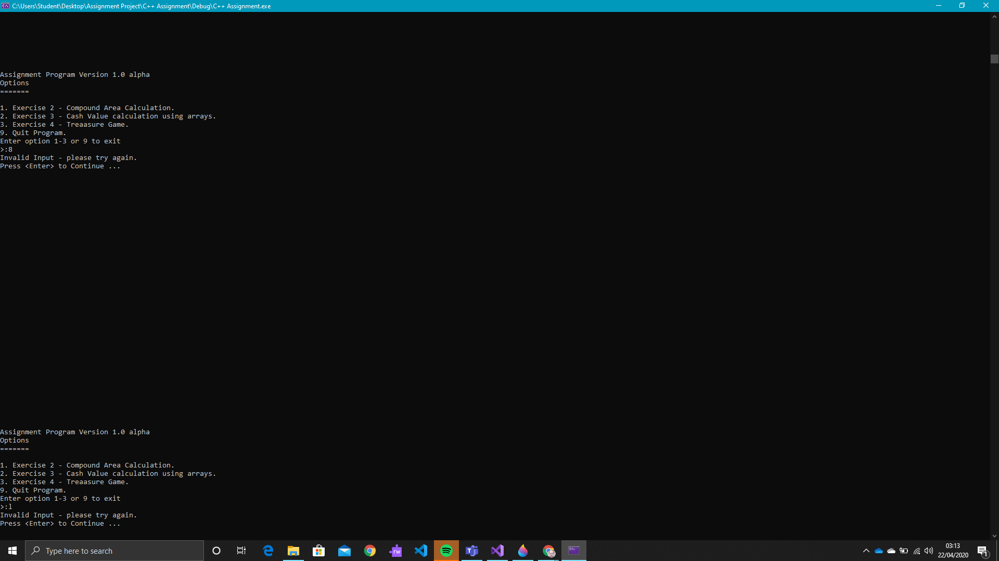
Main Menu Range Check
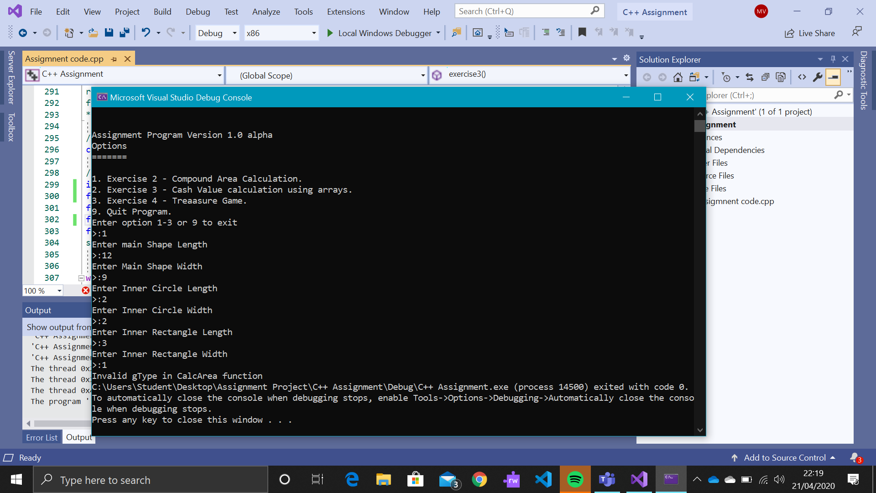
Exercise 2 Data Entry
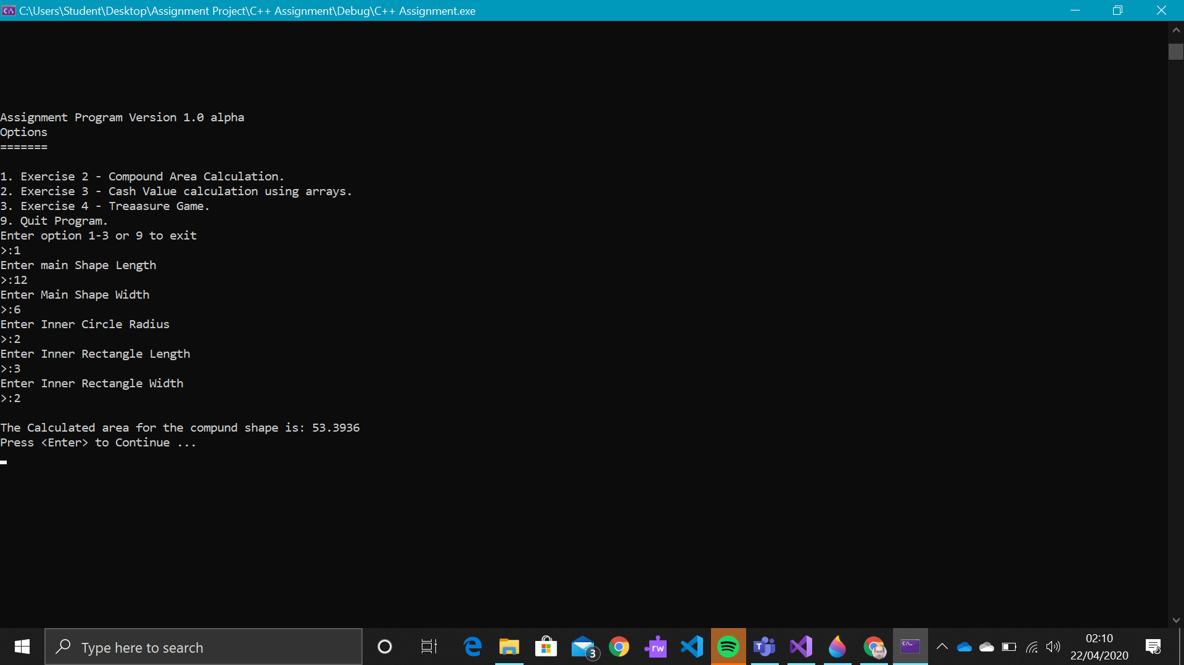
Exercise 2 Results

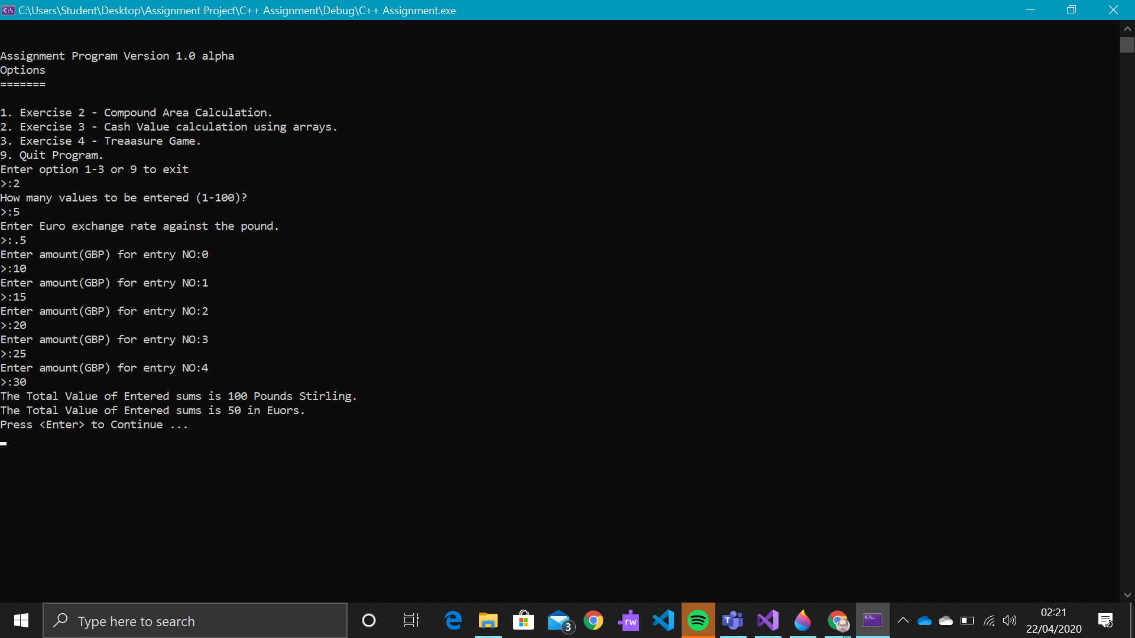
Exercise 3 Data Entry and Result

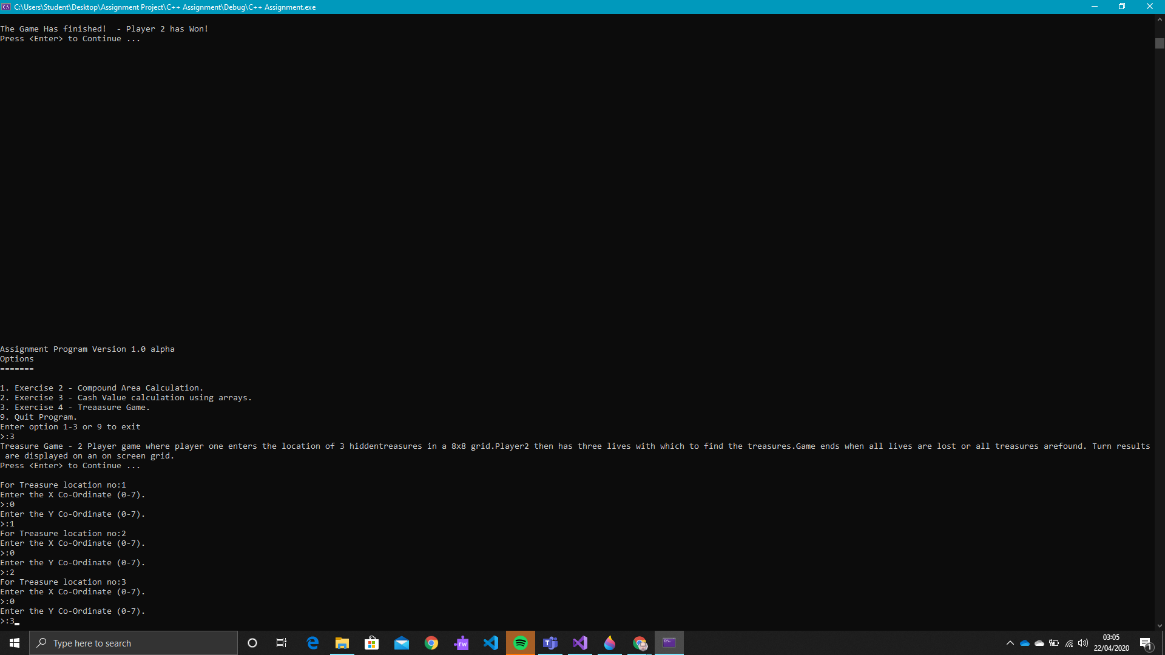
Exercise 4 Data Entry

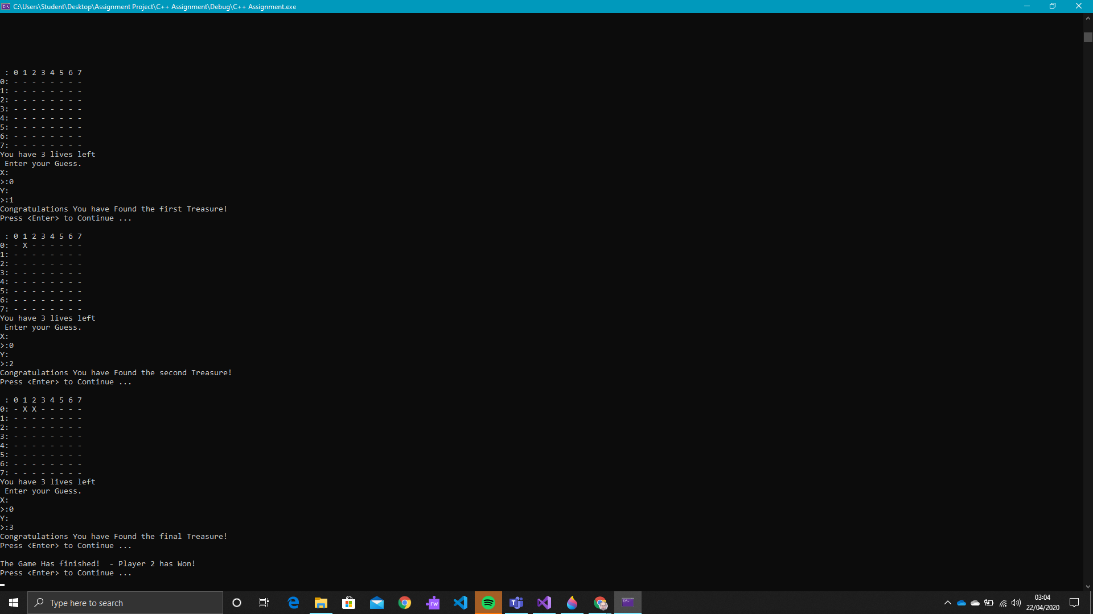
Exercise 4 Saved Treasure Check

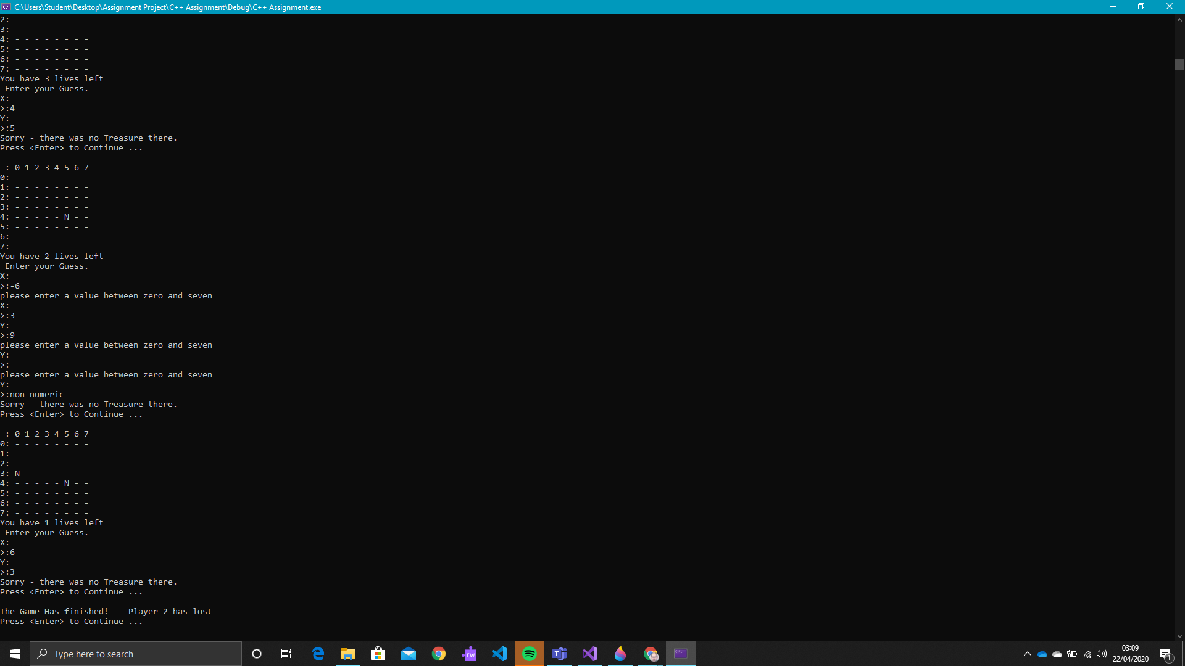
Exercise 4 Input Range Check

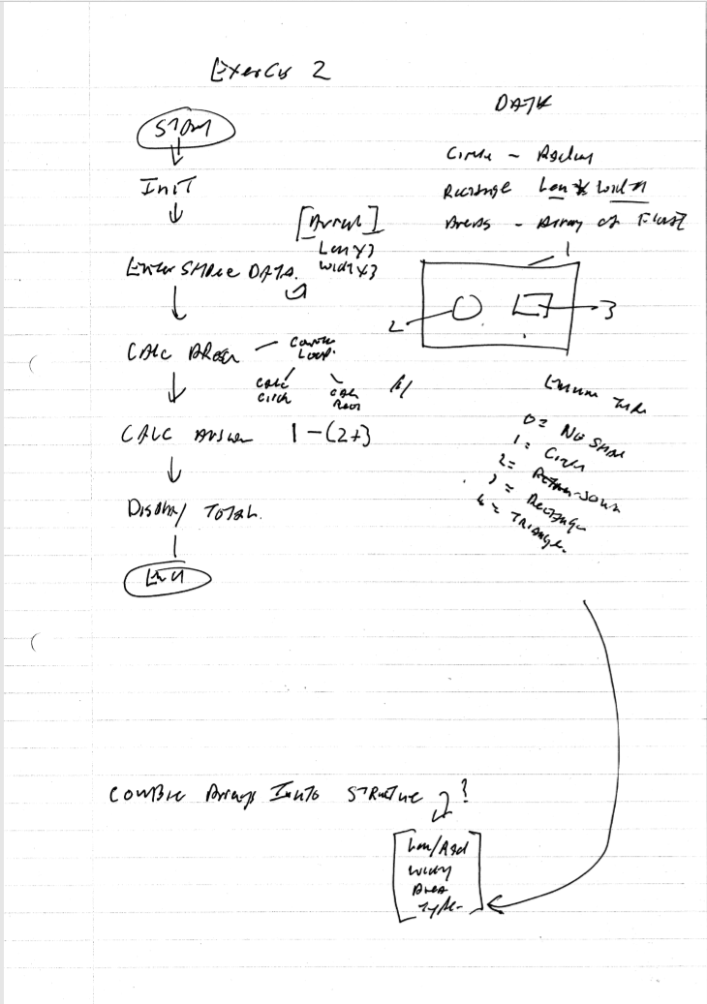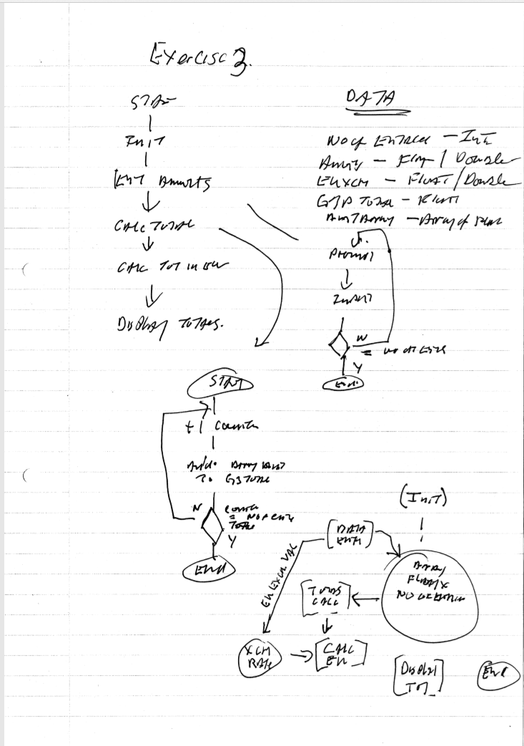
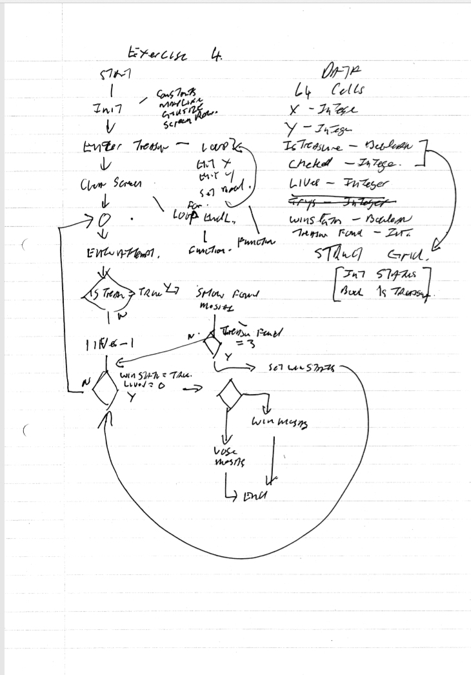

Initial Design Notes
Exercise 1

3 variables
note: make variable names meaningful.

Variable 1 - Book title.
equirements:
1. usees alphanumeric characters
2. variable unknown length
solution:
String type - not restricted to length and can store upto 255 alphanumeric characters.

result:
string bookTitle;

Variable 2 - Variable to store a messured lenght
Requirementa:
1. must hold a fractional value
2. must hold a wide range of values
3.vales are positive.

Solution:
Double type - Can store decimal fractions, range 0 - 2^63 values can be either positive or negative.
Result:
double measureLen;

Variable 3 - Count of products in a shopping cart
Requirements:
1. must be a whole number, you cannot have products that are fractional.
2. number must be positive.
3. values and range are unknown. assume no maximum value.

Solution:
integer type - can be positive or negative with range 0 - 2^32 and are real values.

Result:
int prodCount;

Exercise 2

calculate area of a rectangle and a circle and deduct from area of containing rectangle.

circle has one value, rectangles have 2 valuess.

area calc for circle is Pi x Radius squared.
rectangle calc is height x width.

create user type uShape - has 3 values, H/R, W, (t)ype
create calculation function returning a float type.

variable required

main rectangle height
main rectangle width
circle radius
inner rectangle height
inner rectangle width
enum set for rectangle and circle.

Process:
1 calc area of main rectangle(mrA)
2 calc area of inner rectangle(irA)
3 cal area of circle(icA)
4 calc mrA- (irA -icA)
5 display result.

Exercise 3

Variables required
Number of Entries (iEnt)
Array of monitary values-GBP (aVal[])
Euro Exchange Rate (eRate)
Total Value in Euro's (eVal)
index pointe for array (idx)
Running Total (rTot)

Entry Function
buffer (buf)
return value (ans)
Prompt String (prompt)

Process:
create running total variable (rTot)
enter numer of entries (iEnt)
enter Euro Exchange Rate. (eRate)
create storage array (aVal[iEnt-1])
loop1 -
display prompt
enter value
loop 2 -
get value from array element
add value to running total variable
display running total (rTot)
calculate euro value (rTot * eRate)
Display value in Euro's

Exerciuse 4
Requirements
array to store treasure
array to display attempts
lives variable
found variable
counter variable 0-2

Process
-- Initilisation --
create array for treasure list
set lives variable to 3
set found variable to 0

-- Main Routine --
Entry loop
enter three co-ords for treasure

clear screen

Player 2 loop (loop until lives = 0 or all tree treasures are found)
make entry
check if entry matches saved treasure co-ords
Y - record N char, decrement life
n - record X char
display grid
-- End Game--
if lives = 0 display you lose message
else display congrats message

Exercise 5
Build Checkers game

Rerquirements

Process

--------------------------------------------
Universal consol entry function

questions -
do I define a return type or is the type defined by the returen method?
is ist better to define the process as a class with custom members?

Software Development Assignment Log

of

Mark Lawrence Edwin Vaughan

Semester 2

Day 1 | Examines assignment criteria  Formulated document structure  Jotted notes about exercise requirements
Day 2 | Created basic flowcharts  Set up development environment  Started to code basic framework for assignment program  Implemented class framework for user interaction  Problem with string steam implementation in myIO switched to simpler coding, experimented with referenced parameters before switching to class vars using public methods.
Day 3 | Finished 1st draft of program  Basic syntax error check  Problems list:  Switch does net recognise string variable  Geom user def type not recognised in forward declaration  Invalid function decl in CalcArea due to geom type  Forward dec of enum non standard  SCREENROW const not recognised  myIO methods are not being recognised.
Day 4 | Debugging yesterday’s problems.
Day 5 | Enum does not have an assignment operator!  Created a constructor function for myIO.

