BMHP5021
An Examination and Analysis of How the ‘Early Help’ System is Signposted to UK Families by Local Authority Websites

Module Title: Protecting and Supporting Families in Health and Care
Student Name: Mohammed Mobeen Ali
Student Number: 2407750
Tutor: Gillian Weaver

Table of Contents
1. Introduction 4
2. Overview of the Early Help System 5
3. Multi-Agency Working in Early Help 7
4. Evaluation of Local Authority Websites 9
4.1 Leeds City Council Early Help Website 9
4.2 Norfolk County Council Early Help Website 10
4.3 Tower Hamlets Council Early Help Website 11
5. Comparative Analysis of Leeds, Norfolk and Tower Hamlets 13
6. Conclusion and Recommendations 14
References 15

Figure 1: Early Help System 5
Figure 2: Multi-Agency Working in Early Help 7
Figure 3: Analysis of Leeds, Norfolk and Tower Hamlets 13

1. Introduction
Safeguarding is very important in UK health and social care services. It means protecting children, young people, and families from harm, abuse, and neglect. Professionals such as social workers, teachers, and health staff work together to keep families safe and support them when they have problems. Early support can help families before their situation becomes serious.
One important way to support families is through the Early Help system. Early Help gives advice and support to families when they first face difficulties, for example problems with school attendance, parenting stress, behaviour issues, or mental health concerns. The aim is to solve problems early so they do not become bigger safeguarding risks (Samarina, 2017).
Local council websites are very important because many families search online when they need help. A clear website can help families understand what support is available and how to contact services. If the information is confusing, families may not get help quickly.
This report examines how Early Help is presented on the websites of Leeds, Norfolk, and Tower Hamlets councils. It explains Early Help, reviews multi-agency working, evaluates each website, compares them, and gives recommendations.

2. Overview of the Early Help System
Early Help is a system within the UK that provides assistance to children, youths, and families when the issues initially emerge. Its application precedes when the situation gets highly serious and when a statutory social care is required. According to the government, Early Help refers to delivering the appropriate support to the appropriate time to ensure families cope with challenges and children remain safe (Department for Education, Early Help System Guide).
Early Help is primarily aimed at preventing the deterioration of problems. With support that comes early enough, family risks, including school failure, family stress, or poor mental health could be minimised. Early Help is based on prevention and good results. It also helps to protect as children can be safeguarded by taking early action and enhancing stability of the family (Working Together to Safeguard Children, 2023).
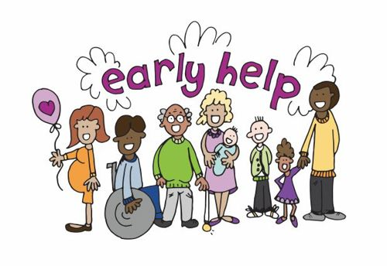
Figure 1: Early Help System
Source: (Samarina, 2017)
Many groups are targeted by Early Help. It works with young children, adolescents, parents, carers and entire families. The assistance will depend on the family needs and it can consist of various services. Indicatively, parenting programmes can assist adults in learning the behaviour of children and establishing a better relationship at home. Young people may be educated or equipped socially or personally through youth support services. Schools can offer attendance skills in case a child misses school frequently. The trained workers are also able to offer family intervention to the families and even provide mental health advice or counselling when emotional issues impact family life.
Early Help is most commonly voluntary and, therefore, the families are willing to accept the assistance and engage with professionals to change their circumstances. This collaboration instils confidence and enhances support. Early Help also refers to early intervention, i.e. help is provided in advance before problems may escalate or require statutory social care. This timely intervention enhances better results in the future of children and families.

3. Multi-Agency Working in Early Help
Multi-agency working refers to the collaboration between various professionals and organisations with the aim of assisting children, young people, and families. Rather than individual service operating independently, multiple services cooperate in information exchange as well as in planning assistance (Pauwels, 2024). This collaboration is also extremely relevant to the Early Help system since family issues are usually complicated and require the assistance of more than a single service. According to UK safeguarding guidance, effective partnership working can be used to safeguard children and enhance outcomes against families (Working Together to Safeguard Children, 2023).
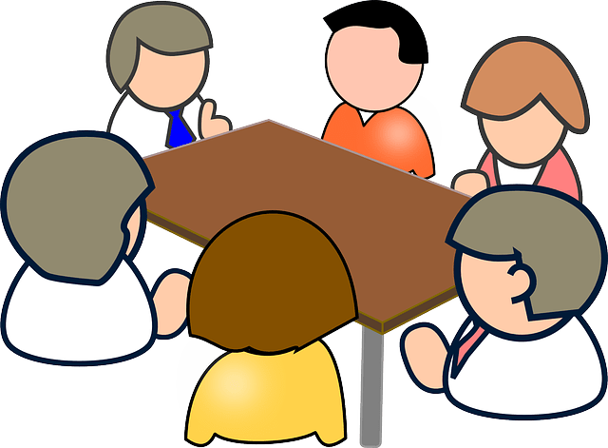
Figure 2: Multi-Agency Working in Early Help
Source: (Atkinson, 2016)
Protecting is a collaborative endeavour since none of the professionals can view the entire picture of a child or a family. An example of this is when a teacher observes low school attendance, a doctor observes health issues, and a social worker realises that there is family stress at home. By sharing information, these professionals will be able to create a more robust picture and act sooner to mitigate risk (Morrison, 2020).
Early Help work is done by many professionals. The needs of the family are evaluated by the social workers, teachers watch over attendance and behaviour, and NHS personnel offer health and mental health assistance (Manley, 2019). In case of safety issues, police might be engaged whereas parenting programmes and youth support are provided by community organisations.
Effective multi-agency working enhances the exchange of information, develops coordinated assistance strategies and assists children to remain safe and families to become more stable.

4. Evaluation of Local Authority Websites

4.1 Leeds City Council Early Help Website
Accessibility
The Leeds City Council website provides Early Help information in the children and families section. Parents can find this section from the main menu under family support or safeguarding. In most cases, the Early Help page can be reached in only a few clicks (White, 2018). The site uses clear titles and organised sections, so users know where to go. The design is simple and not crowded, which makes the information easy to read. Clear headings and short sections also help users move through the page easily. Because of this, the Leeds website is quite convenient to use, even for people who do not visit council websites often.
Clarity of explanation
The Leeds page explains what Early Help is and what its purpose is. It clearly states that the service supports children, young people, and families when problems begin (Leeds City Council, 2024). The site gives examples such as school attendance issues, behaviour problems, emotional stress, and family conflict. These examples help parents understand their situation. The language is mostly simple and written for the public. Short paragraphs and clear headings also make the information easier to understand.
Referral information
The Leeds site details the way in which families or professionals may seek Early Help. It demonstrates the process of the referral and what will occur once the request has been made. Web-based forms and instructions can be found. Nonetheless, there are aspects of the referral description that are long and maybe a little bit challenging to the users who have less English knowledge.
Contact options
Contact routes are availed in the form of phone numbers and online to allow families to decide on the mode of communication.
Extra support information
The site comprises parenting programmes information, youth services and broader family support teams.
Overall judgement
Generally speaking, the Early Help page of Leeds is clear and well organised. It has the strength of a clear structure and comprehensible explanations. The only minor weakness is that referral guidance might be streamlined.

4.2 Norfolk County Council Early Help Website
Accessibility
The Early Help is also available in the Norfolk County Council web site in the children services and safeguarding section. This area is accessible to users via family support links and occasionally this requires more menu clicks than Leeds to locate the complete Early Help information. The site layout is rational and well structured, although first time visitors might take an additional time to read through the pages before they find the right part. Part of the information is distributed on multiple interconnected pages which may slow down the search.
Clarity of explanation
The Norfolk website clearly explains the aim of Early Help and states that it supports families at an early stage to prevent problems becoming serious (Evans, 2021). The site explains who can receive support and what types of services are available. The language is generally clear, but in some parts it becomes more formal and detailed, which may be harder for parents who prefer short and simple information.
Referral information
The Norfolk site has elaborate referral instructions. It describes the ways professionals or families may request support and explains how the assessments and planning can occur. Instructions and documents on referrals are accessible on-site. This provides all the information, although the lengthy description can leave some families with their feet in the air.
Contact options
The site has phone numbers, email contacts and it includes local team details in some cases which allows one to enquire about assistance in a variety of ways.
Extra support information
Norfolk provides detailed information about parenting support, youth services, early intervention teams, and wider family programmes (Norfolk County Council, 2024).
Overall judgement
Overall, Norfolk offers very detailed Early Help information. Its main strength is full service explanation. A weakness is that longer text and extra navigation steps may reduce ease for some parents.

4.3 Tower Hamlets Council Early Help Website
Accessibility
The Tower Hamlets Council site also has the information on Early Help on the children and family support pages. This section is mostly accessed by the users by the use of safeguarding or family help menus. The navigation is organised, but the user might still make a number of clicks before arriving on the main Early Help page (Gray, 2022). As soon as it is opened the page scheme is clear and there are headings and sections that help the reader navigate.
Clarity of explanation
Tower Hamlets describes Early Help in easy and straightforward words. It pays close attention to assisting families at an early stage and reinforcing the wellbeing of children. It describes that the site offers support to parents, carers, children, and youths with various challenges. The information is presented in a straightforward and family-friendly manner that enable the users to understand fast.
Referral information
The process of referring is outlined both to the family and to the professionals. There are instructions on how one can seek help and what kind of help can be given. Pathways and routes of contacts are presented in an easy to understand way but a user can be required to read through numerous pages before he or she realises everything.
Contact options
Phone contacts, enquiry routes, and service details are available so families can choose the easiest method.
Extra support information
Tower Hamlets provides strong information about family hubs, parenting services, youth programmes, and local community organisations. Because the borough has a diverse population, the website shows awareness of community-based support.
Overall judgement
Overall, Tower Hamlets provides clear and community-focused Early Help information. Its strength is family-friendly explanation and strong local service links. A minor weakness is that users must explore several linked pages.

5. Comparative Analysis of Leeds, Norfolk and Tower Hamlets
In comparing the information covers about the Early Help on the three council websites, there are some similarities and differences in the accessibility, legibility and referral instructions. All three councils have information regarding the Early Help online and describe the service as helping children, young people, and families before the issues grow serious. Contact details are also provided on each of the websites and inform what sort of assistance families may obtain. This demonstrates that the three councils adhere to the national approach of safeguarding and seek to offer early intervention and family support. Nevertheless, the websites vary according to their ease of use by families. The Leeds site seems to be the most convenient. Early Help page has less clicks and the layout consists of clear headings and short descriptions. This assists parents to fast track in knowing the service that is offered and how they can seek help. Comparatively, Norfolk web site offers much more detailed information, yet the text is longer and the language is more formal, which can be more difficult to read by some parents. It is a good site that displays local services like family hubs and youth programmes in Tower Hamlets, but the user has to open several pages to see all the referral details being displayed in a clear way. In general, Leeds offers the most understandable and the most reachable Early Help communication.
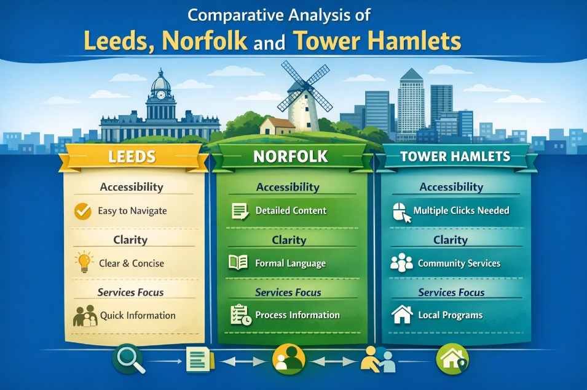
Figure 3: Analysis of Leeds, Norfolk and Tower Hamlets
Source: (Department for Education, 2023)

6. Conclusion and Recommendations
In conclusion, Early Help is an important service for safeguarding children and supporting families in the UK. It gives assistance at a tender age to ensure that issues do not escalate to a higher level. The websites of the councils are also quite important since most families do their searches online before seeking advice or assistance. When the information is straightforward and simple to locate, the family is able to conceive services faster and request assistance earlier.
This report has examined the Early Help information on the websites of the Leeds City Council, Norfolk County Council and Tower Hamlets Council. Each of the three councils describes the role of Early Help and states contacts and information about the services. Nevertheless, the ease with which the websites can be used is somewhat different. The information in Leeds seems to be the most straightforward and easy to use. Norfolk provides rather detailed explanations, although there are more lengthy parts that are more difficult to read. Tower Hamlets has good local services, but the users might have to browse through a number of pages.
This can be improved by ensuring that the councils are using less complex language, referral processes, and more conspicuous contact information to enable the families to access help quicker.

References
Atkinson, M. (2016). Multi-Agency working across Education Child care and health: research and development in the UK. Bildung und Erziehung, 59(3). doi: https://doi.org/10.7788/bue.2006.59.3.285
Department for Education (2023). Working together to safeguard children 2023: statutory guidance on inter-agency working to safeguard and promote the welfare of children. London: Department for Education.
Evans, M. (2021). Sure Start: Norfolk County Council - Community trust plans to boost centre services. Nursery World, 2011(8). doi: https://doi.org/10.12968/nuwa.2011.8.8.1096448
Gray, B. (2022). Working with families in Tower Hamlets: an evaluation of the Family Welfare Association’s Family Support Services. Health and Social Care in the Community, 10(2), pp.112–122. doi: https://doi.org/10.1046/j.1365-2524.2002.00347.x
Leeds City Council (2024). Early help and family support services. Available at: https://www.leeds.gov.uk. (Accessed: 26th February 2026).
Manley, K. (2019). Leading the health service into the future: transforming the NHS through transforming ourselves. International Practice Development Journal, 6(2), pp.1–21. doi: https://doi.org/10.19043/ipdj.62.005
Morrison, T. (2020). Working together to safeguard children: challenges and changes for inter-agency co-ordination in child protection. Journal of Interprofessional Care, 14(4), pp.363–373. doi: https://doi.org/10.1080/13561820020003919.
Norfolk County Council (2024). Early help for children and families. Available at: https://www.norfolk.gov.uk. (Accessed: 24th February 2026).
Pauwels, L. (2024). Assessment and improvement of the adaptive capacity of local Multi-Agency Working structures. CrimRxiv. doi: https://doi.org/10.21428/cb6ab371.de0bccae.
Samarina, L.V. (2017). On the early help to the children and their families. Autism and Developmental Disorders, 15(2), pp.4–18. doi: https://doi.org/10.17759/autdd.2017150201.
White, A. (2018). Social determinants of male health: a case study of Leeds, UK. BMC Public Health, 18(1). doi: https://doi.org/10.1186/s12889-018-5076-7.

