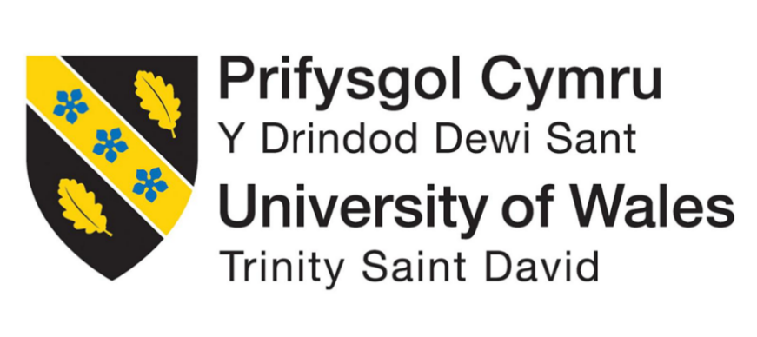

Research Proposal Title | Sustainable Innovation as A Competitive Advantage: A Case Study of Panasonic
Name Of the Student
Date Of Submission | 2/05/2025
Course ID | BMMB7028
Course Name | Business Research
Professor Name
University Name | UWTSD
Word count | 6487 Words

Table of Contents
1. Background 4
1. Research Aims and Objectives 7
3. Literature Review 8
3.1 Sustainable Innovation: Concept and Significance 8
3.2 Competitive Advantage Through Sustainability 9
3.3 Panasonic and Green Technologies 10
3.4 Market Impact and Consumer Perception 11
3.5 Sustainable Product Development 11
3.6 Barriers and Challenges in Sustainable Innovation 12
3.7 Theoretical Frameworks 13
4. Methodology 13
4.1 Research Philosophy and Approach 13
4.2 Research Design 14
4.3 Data Collection Methods 15
4.4 Data Analysis 16
4.6 Validity and Reliability 17
4.7 Limitations of the Methodology 17
5. Ethical Considerations 18
5.1 Use of publicly available and the credible sources 18
5.2 Intellectual property and the proper attribution 19
5.3 Ethical Risks 19
6. Timeline 19
7. Expected Findings 21
8. Significance of the Study 22
9. Limitations 22
10. Conclusion 23
References 24

Background
Panasonic’s Commitment to Sustainability
In the research by Kahupi et al., (2021), it has been stated that the basic for corporate maintainability has gotten to be progressively articulated in the midst of powers worldwide natural concerns, administrative changes, and advancing partner desires. Over businesses, firms are reconfiguring their operations, development forms, and key systems to address issues such as climate alter, asset exhaustion, and the socio-environmental suggestions of mechanical action (KPMG, 2021). Inside this setting, Panasonic Enterprise has developed as a paradigmatic case of a multinational endeavor that has deliberately inserted maintainability into its development and competitive positioning.
Besides as per the view of Arsawan et al., (2022), Panasonic’s maintainability direction is enunciated through its comprehensive ‘Panasonic GREEN IMPACT’ methodology, which points to accomplish net-zero CO₂ outflows in it possess operations by 2030 and diminish CO₂ outflows by more than 300 million tons over society by 2050 (KPMG, 2021). This activity is significant of the company’s commitment to adjusting its commerce operations with worldwide maintainability objectives, especially those laid out in the Joined together Countries Maintainable Advancement Objectives (SDGs) (KUSHWAHA and Dube, 2023). Through activities that include decarbonisation, circular economy hones, eco-conscious item plan.
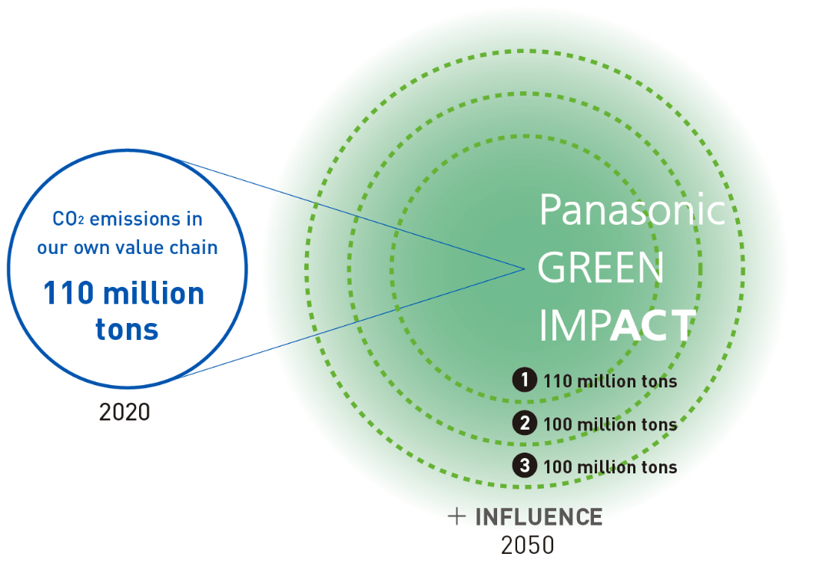
Fig-1: Panasonic GREEN IMPACT
(Source: panasonic.net, 2021)
Rationale for Focusing on Panasonic
Panasonic was chosen for this inquire about since of its solid center on maintainability. Not at all like other companies that treat natural endeavors as auxiliary, Panasonic makes maintainability a key portion of its advancement hones. Cited by Almrshed et al., (2023), this approach makes a difference turn natural challenges into openings for esteem creation through energy-efficient apparatuses, eco-packaging, hydrogen fuel cells, and lithium-ion batteries (Panasonic Corporation, 2022)
Panasonic not as it were complied with controls but too employments economic development to boost its brand, enter unused markets, and increment long-term benefits (Wijekoon and Sabri, 2021). Its commitment to natural obligation has earned it spots in vital supportability rankings, upgrading buyer believe and financial specialist certainty. These components contribute to its competitive advantage in today's showcase.
Global Trends Toward Sustainability
In the view of Singh and Maheswaran, (2024), the corporate segment around the world faces developing weight to appear natural duty. Controls like the EU's Green Bargain and TCFD advance maintainable trade hones. Buyers moreover progressively need morally delivered merchandise, empowering companies to enhance and reduce natural affect whereas still making a benefit. This is particularly vital in the gadgets industry, known for tall vitality utilize and squander.
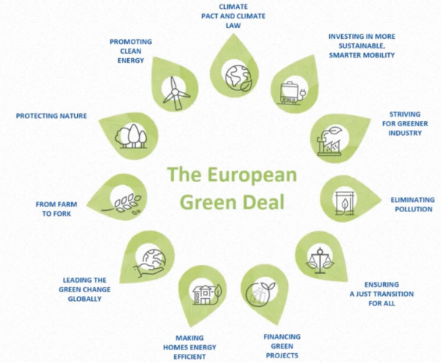
Fig-2: EU Green Deal
(Source: KPMG, 2021)
Previous Research on Sustainable Innovation
Academic research is looking at how maintainability and advancement are associated. Researchers accept that ecologically neighbourly developments can deliver businesses a competitive edge by utilizing assets admirably, decreasing costs, and coming to modern markets (Zighan et al., 2023). Companies in hardware and innovation that receive economic development tend to oversee dangers way better, comply with natural controls, and reinforce their resilience.
More point by point thinks about are required on how these procedures are utilized in person companies. As cited Wandosell et al., (2021), case ponders are significant for understanding the effect of supportability activities on showcase position and execution. This inquire about will particularly center on Panasonic to offer bits of knowledge into utilizing supportability as a key advantage.
Research Questions
How does sustainable innovation contribute to Panasonic’s competitive advantage in the global electronics sector?
To address this overarching question, the research will investigate the following sub-questions:
- What sustainable innovation strategies has Panasonic implemented?
- How do these strategies influence product development, organisational processes, and technological advancement?
- What is the perceived market response to Panasonic’s sustainability-oriented innovations?
- In what ways does Panasonic evaluate the effectiveness and return on investment (ROI) of its sustainability initiatives?
By replying to these questions, the investigate points to create hypothetically educated and for all intents and purposes important bits of knowledge into the key utility of feasible advancement inside a complex, energetic commerce environment.

Research Aims and Objectives
Research Aim
This research aims to evaluate how sustainable innovation can enhance Panasonic's position in the global electronics market. It will use a case study approach to examine the impact of sustainability practices on market standing and long-term benefits. The main question is whether sustainable innovation provides a competitive advantage as demand for sustainability grows among consumers, investors, and regulators.
Research Objectives
In order to fulfil the above aim, the research will be guided by the following specific objectives:
- Identify the sustainable innovation strategies employed by Panasonic
The goal is to find out the main sustainable innovation practices Panasonic has used in the last ten years. The research will examine reports, statements, and industry analyses to see how sustainability influences their products, technologies, and business model, focusing on green technologies and energy efficiency.
- Examine the integration of green technologies and eco-design in Panasonic’s product development processes
This research focuses on Panasonic's use of green technologies and eco-design in innovation. It will examine how R&D teams consider environmental factors, assess sustainability, and explore energy-efficient appliances, renewable energy, and reducing electronic waste to minimize impact and create market opportunities.
- Assess the impact of Panasonic’s sustainability practices on its market positioning and consumer perception
The objective is to evaluate how Panasonic's sustainable innovation initiatives influence its market position in the global electronics industry. The research will utilize consumer third-party assessments, and industry reports to determine if these practices enhance brand image and influence consumer buying behavior. It will also examine the impact on investor relations and corporate reputation.
- Evaluate the strategic advantages derived from these innovations
This objective will examine how Panasonic benefits from sustainable innovation. It will analyze strategies with Porter’s Five Forces and the resource-based view, exploring advantages like cost savings, eco-friendly products, and compliance with regulations.
- Recommend future approaches Panasonic and similar firms can adopt to strengthen their competitive edge through sustainability
The goal is to give strategic advice to Panasonic and similar companies. It focuses on integrating sustainability into innovation, highlighting circular economy practices, collaboration, green technologies, and policy advocacy.

3. Literature Review

3.1 Sustainable Innovation: Concept and Significance
According to the view of Sayyadi and Michael, (2021), it has been determined that the feasible advancement centres on making modern items, administrations, and trade models that take into account natural, social, and financial components. Its objective is to diminish natural hurt whereas still giving benefits to society and the economy. This approach changes conventional trade points to connect benefit with care for the environment and society, emphasizing the long-term biological effect of advancement (Panasonic Corporation, 2023)
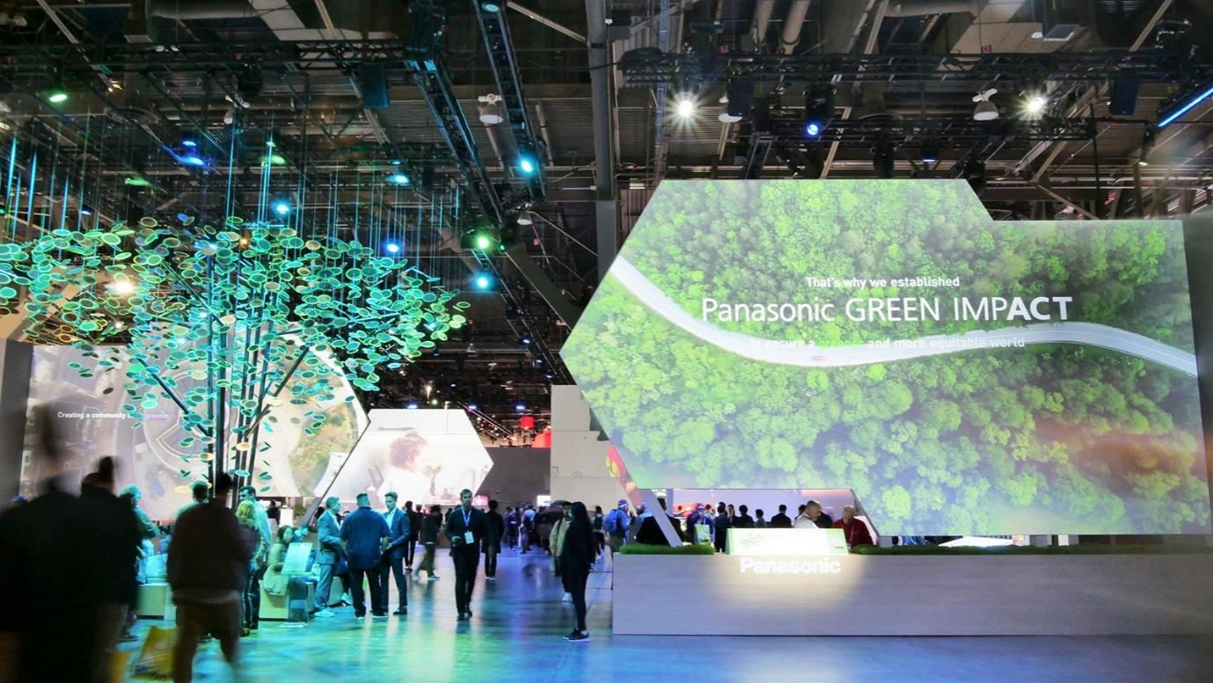
Fig-3: GREEN IMPACT City: Panasonic CES2023 Exhibition
(Source: news.panasonic.com, 2023)
On the other hand, in the view of Harmazi, (2023), in corporate procedure, feasible development can make esteem by cutting costs, moving forward notoriety, expanding client dependability, and improving proficiency. It makes a difference companies pull in eco-friendly customers and comply with stricter natural controls, giving them a competitive edge.
Benefit | Explanation
Cost Savings | Sustainable innovation often leads to more efficient processes and lower operational costs (Peterson et al., 2021).
Enhanced Reputation | Companies with green products are perceived more positively by consumers, leading to stronger brand loyalty.
Customer Loyalty | Consumers increasingly prefer companies that prioritize sustainability, enhancing long-term customer retention (Ogiemwonyi, 2022).
Operational Efficiency | Streamlining operations with sustainable technologies can lead to cost reductions and improved productivity (Li et al., 2021).
Table 1: Benefits of Sustainable Innovation

3.2 Competitive Advantage Through Sustainability
Competitive advantage implies a company performs superior than others by utilizing special abilities and methodologies. As stated by Singh et al., (2021), competitive advantage can be achieved through strategies like being eco-friendly, making green items, focusing on ecologically mindful clients.
Porter's system appears how maintainability makes a difference companies stand out. For occurrence, costs can be brought down by decreasing squander or vitality utilize (Siemens AG, 2021). Panasonic outlines this by making energy-saving innovations and green fabricating, which moves forward proficiency and pulls in eco-conscious clients.

Porter’s Strategy | Role of Sustainability
Cost Leadership | Reducing operational costs through energy-efficient production, waste reduction, and resource optimization.
Differentiation | Offering sustainable products that are perceived as superior in terms of environmental impact, quality, and innovation.
Focus | Targeting niche markets (e.g., environmentally conscious consumers or businesses) with specific green products.
Table 2: Competitive Advantage Framework

3.3 Panasonic and Green Technologies
In the research by Ahmadi-Gh and Bello-Pintado, (2022), Panasonic has situated itself as a frontrunner in the feasible gadgets space through a wide cluster of green advancements. The company’s “GREEN IMPACT” procedure and arrangement with the Joined together Countries Economical Improvement Objectives (SDGs) emphasize its commitment to tending to worldwide natural challenges whereas driving commerce success.
Panasonic’s supportability endeavors envelop different initiatives:
- Energy-efficient Apparatuses: Panasonic has created a wide run of energy-saving machines, counting fridges, discuss conditioners, and lighting frameworks, which are outlined to expend less control and decrease the generally natural impression of consumers.
- Renewable Vitality: As cited in Banmairuroy, Kritjaroen and Homsombat, (2022), The company has made critical ventures in sun powered vitality innovations, especially in sun-based boards and vitality capacity frameworks, to cultivate the selection of clean, renewable vitality solutions.
- Eco-design: Panasonic has joined recyclable materials and negligible bundling into its item plans. It centers on making items that have a negligible natural effect all through their lifecycle (Siemens 2022).
By actualizing Lifecycle Appraisals (LCAs), Panasonic guarantees that its items meet both administrative and consumer-driven green guidelines, in this way strengthening its maintainability accreditations.

3.4 Market Impact and Consumer Perception
Consumer behavior is progressively affected by supportability concerns. Agreeing to investigate by Mahdi and Nassar, (2021), 81% of worldwide customers accept companies ought to effectively help move forward the environment, with Millennials and Gen Z buyers appearing the most grounded inclination for naturally dependable brands.
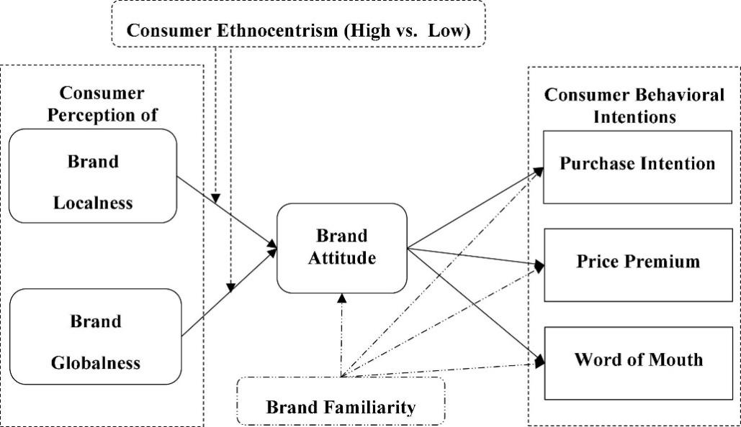
Fig-4: Frontiers in Consumer Perceptions
(Source: frontiersin.org, 2022)
In the view of Aidara, S., Mamun et al., (2021), for Panasonic, its green credentials have played a central role in shaping its brand image. The company’s commitment to sustainability has earned it multiple accolades, including inclusion in the Dow Jones Sustainability Index and the FTSE4Good Index, which serve as indicators of responsible business practices. These recognitions not only enhance consumer trust but also attract socially responsible investors. Academic literature supports the idea that companies with robust sustainability strategies tend to have higher brand equity and consumer loyalty (Arviya and Ramli, 2024).

3.5 Sustainable Product Development
As stated Recrosio, (2022), it has observed that the product innovation driven by sustainability is increasingly becoming a necessity for companies that wish to maintain their competitive advantage. Companies like Panasonic have embraced systems such as Plan for Environment (DfE) to guarantee that natural contemplations are coordinates into each organize of item development—from crude fabric sourcing to item disposal (World Economic Forum, 2020).
Dzienis and Mccaleb, (2024), advocate for Economical Commerce Demonstrate Development (SBMI), which empowers firms to reconceptualize their esteem suggestions with a center on natural affect. Panasonic’s move towards circular economy standards, such as asset effectiveness, item reuse, and remanufacturing, embodies these developing paradigms.
For case, Panasonic’s nanoe™ discuss purifiers, which utilize water-based nanotechnology, and its solar-powered arrangements give compelling cases of feasible item advancement that meet both shopper inclinations and natural requests.

3.6 Barriers and Challenges in Sustainable Innovation
As stated, Rahman and Nguyen‐Viet, (2023), in spite of the clear benefits, feasible advancement is not without its challenges. Firms frequently confront a few obstructions when endeavoring to receive green advancement techniques, especially in businesses such as gadgets, where mechanical complexity and asset utilization are high.
Some key boundaries include:
- High Beginning Costs: The research cited Biggi et al., (2025), The investigate, improvement, and execution of green innovations frequently require noteworthy forthright speculation, which can be a boundary for firms with restricted resources.
- Resistance to Alter: Organizational culture may ruin the integration of supportability into the development handle, especially when green developments challenge built up practices.
- Regulatory Complexity: As per the study Lu et al., (2022), it has been observed that the multinational companies like Panasonic confront different natural controls over locales, complicating their endeavors to standardize maintainability hones globally.
- Impact Estimation: Measuring the natural and social effect of green advancements is frequently complex and subject to methodological challenges.
Panasonic, in any case, has made critical strides in overcoming these challenges, much obliged to a long-term vital vision, collaboration with key partners, and an advancing commitment to eco-innovation.

Theoretical Frameworks
This investigate draws upon the Resource-Based See (RBV) and Energetic Capabilities Hypothesis as the hypothetical systems to examine how maintainable advancement contributes to Panasonic’s competitive advantage.
- Resource-Based View (RBV): Agreeing to Reddy et al., (2023), a firm’s assets that are important, uncommon, incomparable, and non-substitutable (VRIN) can lead to maintained competitive advantage. Panasonic’s exclusive green advances, such as energy-efficient frameworks and sun-oriented arrangements, meet these criteria, as they are both troublesome to imitate and indispensably to its competitive strategy.
- Dynamic Capabilities Hypothesis: Rahman and Nguyen‐Viet, (2023), contend that firms must have the capacity to adjust and reconfigure their assets in reaction to changing natural conditions. This hypothesis makes a difference clarify how Panasonic’s capacity to coordinated supportability into its development forms improves its versatility and capacity to remain competitive in a quickly changing market.
These systems will direct the investigation of how Panasonic’s feasible development procedures empower it to secure a competitive advantage in the worldwide gadgets market (Chidambaram et al.., 2023).
The writing study illustrates that feasible advancement is a multifaceted and deliberately critical handle that can create critical competitive focal points. By joining green innovations and eco-design into its item advancement, Panasonic has not as it were improved its brand value but too situated itself as a pioneer in the maintainable gadgets advertise. In spite of confronting obstructions such as tall beginning costs and administrative complexity, the company’s long-term commitment to supportability gives important bits of knowledge for other firms looking for to use green development as a source of competitive advantage.

4. Methodology

4.1 Research Philosophy and Approach
This study research uses an interpretivist approach, which is suitable for studying complex social issues like economic development and its role in Panasonic's competitive advantage. According to the view of Mishra and Alok, (2022), this approach allows for a deeper understanding of the experiences and meanings of those involved in Panasonic's sustainability practices. Unlike positivist methods focusing on numerical data, interpretivism emphasizes subjective factors influencing Panasonic's sustainability strategies. In the research cited by Sreekumar and Sreekumar (2023), the inductive method adopted, letting patterns and themes emerge from the data instead of testing set hypotheses. The study aims to uncover insights on how Panasonic's green technologies and eco-design practices contribute to its competitive edge, analyzing the experiences of employees, sustainability experts, and industry analysts to understand the impact of sustainable innovation on the company's strategy.

4.2 Research Design
The inquire about will utilize a case think about plan to investigate Panasonic's maintainability hones in a real-life setting. As stated by Ocaña-Fernández and Fuster-Guillén, (2021), this approach is appropriate for understanding how these hones fit into the corporate environment. The think about will distinguish the techniques Panasonic employments to coordinated supportability into its commerce demonstrate and assess their effect on competitive advantage, centering on maintainable advancement, green advances, and eco-design.
Element | Description
Research Methodology | Case Study
Research Approach | Qualitative, Interpretivist
Unit of Analysis | Panasonic’s sustainability practices and their impact on competitive advantage
Research Type | Exploratory and Instrumental
Data Sources | Secondary (Reports, Articles, Industry Data)
Table 1: Research Design Overview

4.3 Data Collection Methods
In view of Habu and Henderson, (2023), the data collection considers utilization of both essential and auxiliary information to give a comprehensive investigation of how economic development contributes to Panasonic’s competitive advantage.
a) Secondary Data
Secondary information will be collected from freely accessible sources, including:
- Panasonic’s Yearly Maintainability Reports: These reports will give bits of knowledge into the company’s CO2 emanation decreases, energy-saving innovations, and reusing activities. For case, Panasonic detailed in its 2022 Supportability Report that it had decreased its CO2 outflows by 30% since 2019, with a objective to reach net-zero emanations by 2030.
- Corporate Social Obligation (CSR) Revelations: According to view of irdaus, Zulfadilla and Caniago, (2021), CSR reports will offer bits of knowledge into Panasonic’s commitment to eco-friendly item plan and maintainable supply chains.
- Industry Benchmarking Information: Sources such as the Dow Jones Maintainability List (DJSI) and Carbon Revelation Venture (CDP) will give a benchmark to study how Panasonic compares to other companies in terms of supportability performance.
- News Articles and Press Discharges: These will offer real-time information on how Panasonic’s supportability activities are seen in the advertise and by the media
- Academic Journals and White Papers: Research articles discussing sustainable innovation in the electronics industry will help situate Panasonic's practices within broader academic discourse (Islam, Khan and Baikady, 2022).
- The reason to take secondary data into consideration is to to understand the challenges and motivations behind Panasonic’s sustainability strategies and their market impact. Up to dated secondary for the study will be collected by taking time range from 2021-2025. In the research conducted by Cheong et al., (2023), only information publicly available containing sufficient information about the topic to be taken to ensure validity of the findings.

Criteria Type | Inclusion Criteria | Exclusion Criteria
Time Frame | - Published between 2018 and 2024 to capture recent sustainability efforts | - Published before 2018, unless used for historical context
Relevance | - Focus on sustainability strategies, innovation, CO2 reduction, circular economy, or competitive advantage | - Focus on unrelated Panasonic business segments (e.g., entertainment) without sustainability context
Accessibility | - Freely available and publicly accessible | - Behind paywalls or restricted access
Credibility | - Verified authors or institutions (e.g., Panasonic, academic publishers, financial media) | - Sources with no citations or unverifiable claims
Language | - English or officially translated sources | - Non-English sources without reliable translation
Table 2: Inclusion and Exclusion criteria

4.4 Data Analysis
Data will be analyzed using thematic analysis, which is a qualitative method used to identify and interpret patterns (themes) within qualitative data (Marra and Nielsen, 2025). Thematic analysis is ideal for understanding complex, context-rich data collected from the secondary and for identifying how sustainable innovation contributes to competitive advantage. The steps in thematic analysis will include:
- Familiarization with Data: Reading through secondary data to get a general understanding of the content.
- Initial Coding: In the study it has been determined by Susilawati et al., (2025), Identifying and coding significant data points related to the research questions, such as sustainable technologies, market impact, and competitive advantage.
- Grouping Codes into Themes: Organizing the codes into broader themes, such as eco-innovation, brand positioning, and consumer perceptions.
- Reviewing and Refining Themes: Ensuring that the identified themes accurately reflect the data and research objectives (Mohajan and Mohajan, 2022).
- Interpretation and Synthesis: Synthesizing the themes into meaningful insights that address the research questions and contribute to the theoretical frameworks.

4.6 Validity and Reliability
From the research conducted Gomathi, (2022), to ensure validity, the study will apply data triangulation by using multiple data sources secondary data to cross-check findings and provide a balanced view. Only reliable information published by the reputable sources is to be taken into the consideration.
In terms of reliability, qualitative research often emphasizes transparency rather than replicability. However, this study will ensure that all research procedures, such data collection, and analysis techniques, are clearly documented to ensure consistency and trustworthiness of the findings.

4.7 Limitations of the Methodology
Several limitations must be acknowledged:
- Data availability: Not all the internal stages, metrics and sustainability innovation may not be discussed publicly.
- Data currency: Some of the secondary sources may not reflect the most sustainability activities or updates, especially if published before recent strategic change.
- Data bias: In the research by KPMG, (2021), Corporate sustainability reports and press releases may present information in a positive light that means can have bias.
- Comparability issues: Benchmarking data from the sources as the CDP and DJSI may use different evaluation frameworks making direct comparisons with other companies to be less consistent.
- Exclusion of the stakeholder perspective: The study does not capture the direct feedback from the employees, consumers and the partners of Panasonic therefore may overlook key qualitative insights.
Limitation | Brief Explanation
Data Availability | Internal metrics and innovation details may not be fully disclosed.
Data Currency | Some sources may be outdated and not reflect recent strategies.
Data Bias | Corporate reports may present overly positive views, leading to bias.
Comparability Issues | Different evaluation frameworks (e.g., CDP, DJSI) hinder consistent benchmarking.
Lack of Stakeholder Input | No direct feedback from employees, consumers, or partners may limit qualitative insight.
Table 3: Limitation of study
This technique portrays a subjective inquire about approach to ponder how feasible advancement gives Panasonic a competitive edge. It incorporates case thinks about, and overviews to get it Panasonic's maintainability hones, with topical examination to discover key subjects. Confinements exist, but it offers a strong system for this examination.

5. Ethical Considerations
According to the view of Hasan et al., (2021), Ethical integrity is central to conducting thorough and dependable inquire about. Given that this study does not include the direct members, still the academic integrity to be ensured. Panasonic workers, industry specialists, and partners included in maintainability, it is basic to guarantee that all angles of the inquire about are conducted in compliance with moral rules. Moral endorsement will be looked for from the university’s Inquire about Morals Committee some time recently the graduation of the information collection prepares. This guarantees that the investigate takes after built up moral guidelines, prioritizing the security, nobility, and rights of all members.

5.1 Use of publicly available and the credible sources
The current study will be taking data only from the sources that are publicly accessible and is legally available in the public domain such as the CSR, sustainability reports, benchmarking indices and the academic journals. No confidential, proprietary or restricted information will be used. This ensures for the respect to the intellectual property rights and avoiding unauthorized access to the sensitive information.

5.2 Intellectual property and the proper attribution
In the research conducted Nii Laryeafio and Ogbewe, (2023), all the data, insights and the information that is obtained from the external sources will be cited and they will be referenced throughout the study to ensure high academic standards. Furthermore, this does not uphold the way to ensure the academic integrity but also is ensuring that the original authors and the organizations are being credited for their contribution made. This also reduces the chances of the reducing plagiarism. Taking this into the consideration ensures that the alignment with the professional standards (Montreuil et al., 2021).

5.3 Ethical Risks
The study must take certain moral factors into account, despite the extremely low level of risk involved. As stated by Horton and Lucassen, (2023), Meeting questions may touch on delicate subjects like business policy and Panasonic's supportability problems. To prevent discomfort, members may decide to answer any questions that make them uncomfortable. Sensitive topics, such as significant challenges and future objectives, will receive extra attention to ensure proficient notorieties. The researcher emphasizes moral reflections heavily to guarantee deliberation, judgment, and decency in the study strategy. Ultimately, it proposes to follow rigorous academic standards while offering insights into Panasonic's financial performance.

6. Timeline
A clear and commonsense timeline is fundamental for wrapping up investigate on time. It points of interest each step of the inquire about, permitting sufficient time for errands and appearing covers to make strides effectiveness. In the research to collect and systematically analyse the secondary data the below stages are framed including topic selection, literature review, methodology planning, data collection, analysis, writing and final submission.
Stage | Timeframe
Topic selection & preliminary research | March 2025 (Week 1–2)
Literature review | March–April 2025 (Week 3–5)
Methodology planning | April 2025 (Week 6)
Data collection (secondary) | April 2025 (Week 7–9)
Data analysis | April 2025 (Week 10–11)
Draft writing | Late April 2025 (Week 12)
Review and revisions | End of April 2025 (Week 13)
Final submission | 2nd May 2025

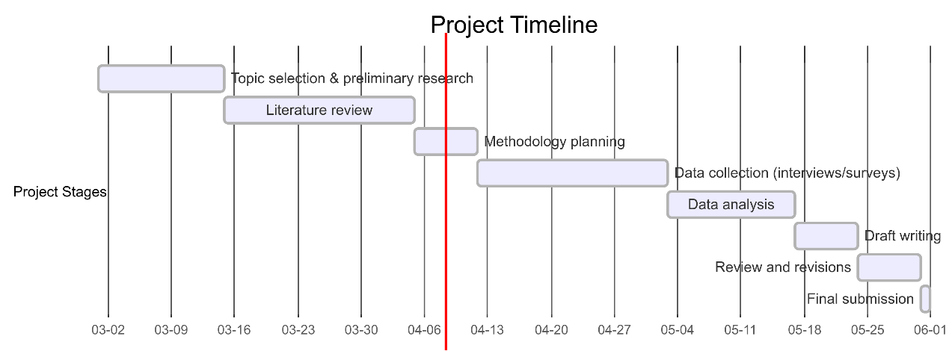
Gantt Chart: Project Timeline
(Source: Researcher)
Explanation of Timeline:
The proposed timeline guarantees that the investigate advances in a organized way whereas keeping up adaptability to address challenges that may emerge amid the consider. The stages are planned to cover wherever doable to maximize productivity and meet the last accommodation due date of 2nd May 2025.
- Topic Selection & Preliminary Research (Week 1–2): This stage centers on selecting the last investigate subject, refining the inquire about address, and conducting preparatory looks to accumulate beginning assets for the writing audit. This step is basic for laying the establishment for the whole inquire about process.
- Literature Review (Week 3–5): Amid this period, the writing audit will be conducted, distinguishing key hypotheses, past considers, and significant systems on economical development. This stage will to advise the technique and offer assistance refine the investigate goals based on the crevice distinguished in the current writing.
- Methodology Planning (Week 6): This stage involves finalizing the research design, including the data collection methods. The methodology will be carefully outlined to ensure that the data collected aligns with the research objectives.
- Data Collection: (Week 7–9): In this stage, secondary data will be collected. Scheduling and conducting these data collection process will be a priority to ensure that researcher have enough time to provide meaningful insights.
- Data Analysis (Week 10–11): The proposed timeline guarantees that the investigate advances in a organized way whereas keeping up adaptability to address challenges that may emerge amid the consider. The stages are planned to cover wherever doable to maximize productivity and meet the last accommodation due date of 2nd May 2025.
- Draft Writing (Week 12): This stage centers on selecting the last investigate subject, refining the inquire about address, and conducting preparatory looks to accumulate beginning assets for the writing audit. This step is basic for laying the establishment for the whole inquire about process.
- Final Submission (2nd May 2025): Amid this period, the writing audit will be conducted, distinguishing key hypotheses, past considers, and significant systems on economic development. This stage will advise the technique and offer assistance refine the investigate goals based on the crevice distinguished in the current writing.
This timeline permits for organized movement of the investigate whereas bookkeeping for the complexities of information collection and examination. It guarantees that each organize of the inquire about prepare is given satisfactory time for careful examination and examination, whereas keeping up adaptability to make vital alterations along the way.

7. Expected Findings
The study focuses on Panasonic’s sustainability efforts The inquire about predicts that Panasonic’s center on green items, renewable vitality, and eco-design will back its natural objectives and fortify its position in the gadgets showcase. It points to illustrate how these advancements progress Panasonic’s brand picture among eco-conscious shoppers and boost client devotion. The consider will moreover look at how these activities help Panasonic meet natural controls and extend its showcase share. Also, it will recognize potential fetched investment funds and challenges related to adjusting costs and innovative authority.

8. Significance of the Study
This inquire about is noteworthy for a few reasons. To begin with, it contributes to the scholarly writing on maintainable advancement and competitive procedure by advertising a commonsense case consider grounded in a real-world commerce setting. By investigating the case of Panasonic — a worldwide pioneer in gadgets with a strong maintainability plan — this ponder bridges the crevice between hypothesis and practice.
Second, it offers down to earth bits of knowledge for directors, maintainability experts, and policymakers. Understanding how Panasonic determines competitive advantage from its natural activities can educate vital choices in other firms, particularly those inside businesses intensely dependent on characteristic assets or energy-intensive operations. Third, the consider adjusts with modern patterns where customers and speculators progressively prioritize natural, social, and administration (ESG) variables in decision-making. Businesses looking for to future-proof their operations must get it how maintainability can be implanted in development forms, not treated as a fringe function.
Moreover, Panasonic’s vital reactions to worldwide maintainability challenges (e.g., net-zero targets, circular economy activities) can serve as benchmarks for other firms looking for to lead in corporate duty. The discoveries may moreover contribute to national and universal discussions around the part of organizations in supporting feasible advancement objectives (SDGs). Ultimately, this ponder underscores the potential of feasible development not fair as a moral basic, but as a vigorous driver of trade victory and showcase authority.

9. Limitations
The investigate on Panasonic's economic development offers vital bits of knowledge but has a few impediments. Getting to essential information is troublesome, as meeting key representatives can confront privacy issues and time confinements, which may constrain understanding of their key choices and maintainability hones. The ponder centers as it were on Panasonic, which implies its discoveries may not apply to other companies in distinctive businesses or areas. Also, dependence on auxiliary information can lead to inclination, as supportability reports frequently exhibit triumphs and make light of disappointments, making a possibly unreasonable see of Panasonic's accomplishments. Time limitations related to the scholarly calendar may too limit information collection and investigation. The fundamentally subjective nature of the investigate implies there is constrained quantitative information, influencing the capacity to generalize the discoveries. In spite of these restrictions, the ponder points to give profitable bits of knowledge into sustainability's part in competitive technique.

10. Conclusion
This research proposal about points to investigate how feasible advancement contributes to Panasonic’s competitive advantage in the worldwide gadgets advertise. By analyzing Panasonic’s green innovations, eco-design hones, and renewable vitality ventures, this consider will secondary data collection how these methodologies improve brand value, client dependability, administrative compliance, and advertise share. The inquire about will moreover investigate the inner benefits, such as taken a toll reserve funds and operational proficiency, inferred from sustainability-driven innovation.
Furthermore, the ponder will distinguish potential challenges Panasonic faces in joining maintainability, such as adjusting short-term costs with long-term picks up and keeping up mechanical administration. The discoveries will give profitable bits of knowledge for supervisors, maintainability experts, and policymakers, advertising direction on inserting maintainability inside trade procedures. Eventually, this investigate underscores the developing significance of economic advancement as a key driver of trade victory and competitive situating in a progressively eco-conscious worldwide marketing.

References
Ahmadi-Gh, Z. and Bello-Pintado, A., (2022). Why is manufacturing not more sustainable? The effects of different sustainability practices on sustainability outcomes and competitive advantage. Journal of Cleaner Production, 337, p.130392. https://www.sciencedirect.com/science/article/pii/S0959652622000385
Aidara, S., Mamun, A.A., Nasir, N.A.M., Mohiuddin, M., Nawi, N.C. and Zainol, N.R., (2021). Competitive advantages of the relationship between entrepreneurial competencies and economic sustainability performance. Sustainability, 13(2), p.864. https://www.mdpi.com/2071-1050/13/2/864/pdf
Almrshed, S.K.H., Jasim, H.M. and Hassan, A.S., (2023). The effect of innovation management on sustainable competitive advantage in contemporary organizations. Journal of Law and Sustainable Development, 11(11), pp.e1980-e1980. https://ojs.journalsdg.org/jlss/article/download/1980/1461
Arsawan, I.W.E., Koval, V., Rajiani, I., Rustiarini, N.W., Supartha, W.G. and Suryantini, N.P.S., (2022). Leveraging knowledge sharing and innovation culture into SMEs sustainable competitive advantage. International journal of productivity and performance management, 71(2), pp.405-428. http://repository.pnb.ac.id/4657/6/Article%20publish%20IJPPM.pdf
Arviya, S. and Ramli, Y., (2024). The Influence of Green Product Strategy, Green Promotion, and Brand Image on Environmental Awareness and Its Impact on Purchase Decision for Panasonic Inverter AC Products. Journal of Sustainable Economic and Business, 1(3), pp.186-200. https://journal.arepublisher.com/index.php/joseb/article/download/12/17
Banmairuroy, W., Kritjaroen, T. and Homsombat, W., (2022). The effect of knowledge-oriented leadership and human resource development on sustainable competitive advantage through organizational innovation's component factors: Evidence from Thailand’s new S-curve industries. Asia Pacific Management Review, 27(3), pp.200-209. https://www.sciencedirect.com/science/article/pii/S1029313221000828
Biggi, G., Iori, M., Mazzei, J. and Mina, A., (2025). Green Intelligence: The AI content of green technologies. Eurasian Business Review, pp.1-38. https://link.springer.com/content/pdf/10.1007/s40821-024-00288-1.pdf
Cheong, H. I., Lyons, A., Houghton, R., and Majumdar, A. (2023). Secondary qualitative research methodology using online data within the context of social sciences. International Journal of Qualitative Methods, 22, 16094069231180160. DOI: 10.1177/16094069231180160
Chidambaram, K., Ashok, B., Vignesh, R., Deepak, C., Ramesh, R., Narendhra, T.M., Muhammad Usman, K. and Kavitha, C., (2023). Critical analysis on the implementation barriers and consumer perception toward future electric mobility. Proceedings of the Institution of Mechanical Engineers, Part D: Journal of Automobile Engineering, 237(4), pp.622-654. https://www.researchgate.net/profile/Kannan-Chidambaram-2/publication/359036785_Critical_analysis_on_the_implementation_barriers_and_consumer_perception_toward_future_electric_mobility/links/623dbff021077329f2d2ddf3/Critical-analysis-on-the-implementation-barriers-and-consumer-perception-toward-future-electric-mobility.pdf
Dzienis, A.M. and Mccaleb, A., (2024). Digital and Green Transitions and Automotive Industry Reconfiguration: Evidence From Japan and China. Journal of Contemporary Asia, pp.1-27. https://www.tandfonline.com/doi/pdf/10.1080/00472336.2024.2384704
Firdaus, F., Zulfadilla, Z., and Caniago, F. (2021). Research methodology: Types in the new perspective. Manazhim, 3(1), 1-16. https://ejournal.stitpn.ac.id/index.php/manazhim/article/view/903
Gomathi, P. (2022). A Study on Consumer Satisfaction towards Panasonic TV with Special Reference to Kallakurichi District. International Journal of Science and Research (IJSR), 11(10), pp.780–782. doi: https://doi.org/10.21275/sr221016203302.
Habu, A. A., and Henderson, T. (2023). Data subject rights as a research methodology: A systematic literature review. Journal of Responsible Technology, 16, 100070. https://doi.org/10.1016/j.jrt.2023.100070
Harmazi, N.A.S., 2023. Panasonic Manufacturing Malaysia Berhad. https://ir.uitm.edu.my/id/eprint/94563/1/94563.pdf
Hasan, N., Rana, R.U., Chowdhury, S., Dola, A.J. and Rony, M.K.K., (2021). Ethical considerations in research. Journal of Nursing Research, Patient Safety and Practise (JNRPSP) 2799-1210, 1(01), pp.1-4. https://www.academia.edu/download/74657806/Ethical_Considerations_In_Research.pdf
Horton, R. and Lucassen, A., (2023). Ethical considerations in research with genomic data. The New Bioethics, 29(1), pp.37-51. https://www.tandfonline.com/doi/pdf/10.1080/20502877.2022.2060590
Islam, M. R., Khan, N. A., and Baikady, R. (Eds.). (2022). Principles of social research methodology. Springer Nature. https://www.researchgate.net/profile/M-Islam-22/publication/364810712_Principles_of_Social_Research_Methodology/links/635aba2496e83c26eb5d3b8c/Principles-of-Social-Research-Methodology.pdf
Kahupi, I., Hull, C.E., Okorie, O. and Millette, S., (2021). Building competitive advantage with sustainable products–A case study perspective of stakeholders. Journal of Cleaner Production, 289, p.125699. https://ore.exeter.ac.uk/repository/bitstream/handle/10871/124277/Building%20Competitive%20Advantage%20with%20Sustainable%20Products%20%20A%20Case%20Study%20of%20Stakeholders.pdf?sequence=1
KPMG, (2021). The KPMG Survey of Corporate Responsibility Reporting 2020. [online] Available at: https://home.kpmg/xx/en/home/insights/2020/11/the-kpmg-survey-of-corporate-responsibility-reporting-2020.html [Accessed 12 April 2025].
KPMG, (2021). The KPMG Survey of Corporate Responsibility Reporting 2021. [online] Available at: https://home.kpmg/xx/en/home/insights/2021/11/the-kpmg-survey-of-corporate-responsibility-reporting-2021.html [Accessed 15 April 2025].
KUSHWAHA, A. and Dube, D.K., (2023). Role and Importance of Ethical Consideration in Research. International Journal for Research in Education, 12 (1), 1. https://www.raijmr.com/ijre/wp-content/uploads/2023/04/IJRE_2023_vol12_issue_01_03.pdf
Li, G., Wu, H., Sethi, S.P. and Zhang, X., (2021). Contracting green product supply chains considering marketing efforts in the circular economy era. International Journal of Production Economics, 234, p.108041. https://nscpolteksby.ac.id/ebook/files/Ebook/Journal%20International/Marketing/International%20Journal%20of%20Production%20Economics%20-%20Volume%20234%2C%20April%202021%2C%20108041.pdf
Lu, X., Sheng, T., Zhou, X., Shen, C. and Fang, B., (2022). How does young consumers’ greenwashing perception impact their green purchase intention in the fast fashion industry? An analysis from the perspective of perceived risk theory. Sustainability, 14(20), p.13473. https://www.mdpi.com/2071-1050/14/20/13473
Mahdi, O.R. and Nassar, I.A., (2021). The business model of sustainable competitive advantage through strategic leadership capabilities and knowledge management processes to overcome covid-19 pandemic. Sustainability, 13(17), p.9891. https://www.mdpi.com/2071-1050/13/17/9891
Marra, M., and Nielsen, B. B. (2025). Research methodology: Best practices for rigorous, credible, and impactful research. Journal of International Business Studies, 1-3. https://www.researchgate.net/profile/Marianna-Marra/publication/388869219_Research_Methodology_Best_Practices_for_Rigorous_Credible_and_Impactful_Research/links/67ab09a5645ef274a479dc8a/Research-Methodology-Best-Practices-for-Rigorous-Credible-and-Impactful-Research.pdf
McKinsey Company, (2021). Sustainability in the Electronics Industry: Trends and Opportunities. [online] Available at: https://www.mckinsey.com [Accessed 12 April 2025].
Mishra, S. B., and Alok, S. (2022). Handbook of research methodology. Educreation publishing. https://dspace.unitywomenscollege.ac.in/bitstream/123456789/1319/1/BookResearchMethodology.pdf
Mohajan, D., and Mohajan, H. (2022). Memo writing procedures in grounded theory research methodology. https://mpra.ub.uni-muenchen.de/115246/1/MPRA_paper_115246.pdf
Montreuil, M., Bogossian, A., Laberge-Perrault, E. and Racine, E., (2021). A review of approaches, strategies and ethical considerations in participatory research with children. International Journal of Qualitative Methods, 20, p.1609406920987962. https://journals.sagepub.com/doi/pdf/10.1177/1609406920987962
Nii Laryeafio, M. and Ogbewe, O.C., (2023). Ethical consideration dilemma: systematic review of ethics in qualitative data collection through interviews. Journal of Ethics in Entrepreneurship and Technology, 3(2), pp.94-110. https://www.emerald.com/insight/content/doi/10.1108/jeet-09-2022-0014/full/pdf
Ocaña-Fernández, Y., and Fuster-Guillén, D. (2021). The bibliographical review as a research methodology. Revista Tempos e Espaços em Educação, 14(33), e15614-e15614. http://dx.doi.org/10.20952/revtee.v14i33.15614
Ogiemwonyi, O., (2022). Factors influencing generation Y green behaviour on green products in Nigeria: An application of theory of planned behaviour. Environmental and Sustainability Indicators, 13, p.100164. https://www.sciencedirect.com/science/article/pii/S2665972721000659
Panasonic Corporation, (2022). Annual Sustainability Report 2022. [online] Available at: https://www.panasonic.com/global/corporate/sustainability.html [Accessed 10 April 2025].
Panasonic Corporation, (2023). Sustainability Report 2023. [online] Available at: https://www.panasonic.com/global/corporate/sustainability.html [Accessed 10 April 2025].
Peterson, M., Minton, E.A., Liu, R.L. and Bartholomew, D.E., (2021). Sustainable marketing and consumer support for sustainable businsses. Sustainable Production and Consumption, 27, pp.157-168. https://www.academia.edu/download/110926573/j.spc.2020.10.01820240128-1-jvafuz.pdf
Rahman, S.U. and Nguyen‐Viet, B., (2023). Towards sustainable development: Coupling green marketing strategies and consumer perceptions in addressing greenwashing. Business Strategy and the Environment, 32(4), pp.2420-2433. https://onlinelibrary.wiley.com/doi/pdf/10.1002%2Fbse.3256
Rahman, S.U. and Nguyen‐Viet, B., (2023). Towards sustainable development: Coupling green marketing strategies and consumer perceptions in addressing greenwashing. Business Strategy and the Environment, 32(4), pp.2420-2433. https://www.sciencedirect.com/science/article/pii/S095965262200542X
Recrosio, E., (2022). Analysis of green innovations: a patent data study (Doctoral dissertation, Politecnico di Torino). https://webthesis.biblio.polito.it/secure/23717/1/tesi.pdf
Reddy, K.P., Chandu, V., Srilakshmi, S., Thagaram, E., Sahyaja, C. and Osei, B., (2023). Consumers perception on green marketing towards eco-friendly fast moving consumer goods. International Journal of Engineering Business Management, 15, p.18479790231170962. https://journals.sagepub.com/doi/pdf/10.1177/18479790231170962
Sayyadi¹, M. and Michael, J., (2021). Leadership in Action: Lessons from Panasonic. SBS, p.7. https://jabr.sbs.edu/SBS_JABR_Vol13.pdf#page=7
Siemens AG, (2020). Annual Sustainability Report 2020. [online] Available at: https://www.siemens.com/sustainability [Accessed 9 April 2025].
Siemens AG, (2022). Annual Sustainability Report 2022. [online] Available at: https://www.siemens.com/sustainability [Accessed 10 April 2025].
Singh, P., Rao, K.S., Chong, A.Y.W., Mui, D.K., Hung, A.J.J., Hong, A.C.Y., Verma, A., Pandey, R., Lim, J.Y., Khushboo10, K. and PV11, R., (2021). The Influence of Consumer Behavior on Brand Success: A Case Study of Panasonic Corporation. Asia Pacific Journal of Management and Education, 4(2), pp.6-19. https://rvim.edu.in/wp-content/uploads/2017/09/The-Influence-of-Consumer-Behavior-on-Brand-Success-A-Case-Study-of-Panasonic-Corporation.pdf
Singh, P.K. and Maheswaran, R., (2024). Analysis of social barriers to sustainable innovation and digitisation in supply chain. Environment, Development and Sustainability, 26(2), pp.5223-5248. https://link.springer.com/content/pdf/10.1007/s10668-023-02931-9.pdf
Sreekumar, D., and Sreekumar, D. (2023). What is research methodology? Definition, types, and examples. Paperpal Blog-Academic Writing Guides. https://paperpal.com/blog/academic-writing-guides/what-is-research-methodology
Susilawati, A., Al-Obaidi, A. S. M., Abduh, A., Irwansyah, F. S., and Nandiyanto, A. B. D. (2025). How to do research methodology: From literature review, bibliometric, step-by-step research stages, to practical examples in science and engineering education. Indonesian Journal of Science and Technology, 10(1), 1-40. https://ejournal.upi.edu/index.php/ijost/article/download/78637/29986
Wandosell, G., Parra-Meroño, M.C., Alcayde, A. and Baños, R., (2021). Green packaging from consumer and business perspectives. Sustainability, 13(3), p.1356. https://www.mdpi.com/2071-1050/13/3/1356/pdf
Wijekoon, R. and Sabri, M.F., (2021). Determinants that influence green product purchase intention and behavior: A literature review and guiding framework. Sustainability, 13(11), p.6219. https://www.mdpi.com/2071-1050/13/11/6219
World Economic Forum, (2020). The Global Competitiveness Report 2020. [online] Available at: https://www.weforum.org/reports/the-global-competitiveness-report-2020 [Accessed 12 April 2025].
Zighan, S., Abuhussein, T., Al-Zu’bi, Z.B. and Dwaikat, N.Y., (2023). A qualitative exploration of factors driving sustainable innovation in small-and medium-sized enterprises in Jordan. Journal of Enterprising Communities: People and Places in the Global Economy, 18(2), pp.372-391. https://staff-beta.najah.edu/media/published_research/2023/07/08/A_qualitative_exploration_of_factors_driving_sustainable_innovation_in_small-and_medium-sized_enterprises_in_Jordan.pdf

