Name: Molly Thomas
Student Number: 2502132

WORKSHEET 4 – TESTING (Dice Duel)

- Original code:
import random
scores=[]
print("Welcome to the dice roll game, there will be 5 rounds. Are you ready to roll your dice? y/n")
userAnswer = input().lower()

userWins=0
computerWins=0

if userAnswer == "y":
for rounds in range(1,6,1):
number1=random.randint(1,6)
number2=random.randint(1,6)
number3=random.randint(1,6)
print("You rolled...")
print(number1,number2,number3)

print("Now the computer will roll...")
number4=random.randint(1,6)
number5=random.randint(1,6)
number6=random.randint(1,6)
print(number4,number5,number6)

usersTotal=(number1+number2+number3)
computerTotal=(number4+number5+number6)
print("You rolled",usersTotal,"and the computer rolled",computerTotal)

if usersTotal > computerTotal:
userWins=userWins+1
scores.append(1)
print("You won this round!")
print("")

elif usersTotal == computerTotal:
scores.append(0)
print("Draw, no points")
print("")

elif usersTotal < computerTotal:
computerWins=computerWins+1
scores.append(2)
print("The computer has won this round!")
print("")

print("Current scores are:")
print("You:",userWins," Computer:",computerWins)
print("")

else:
print("Ok, goodbye")

print("That's the end of the dice roll game, the winner is...")
if userWins > computerWins:
print("You! Well done :)")
elif userWins<computerWins:
print("The computer has won :(")
else:
print("It's a tie!!")
print("")

print("Round stats:")
for counter in range(0,5,1):
if scores[counter]==1:
print("Round",counter+1,": You won this round")
elif scores[counter]==2:
print("Round",counter+1,": The computer won this round")
else:
print("Round",counter+1,": Draw")

- Code Testing
For each test below (i – ix), run your code and show the results of the scenarios below. Present a screenshot of what happened when the programme ran. Did the programme behave correctly or did it do something unexpected, and if so, why?

Part a)
- Computer wins round
- User wins round
- Draw
- “Go again” – enter y
- “Go again” – enter n
- “Go again” – enter Y
- “Go again” – enter b

Part b)
- Show score/score tracking (depending on how you have implemented your program)
- Show an overall win (however this is achieved eg first to 5, best of 12 etc)

Part c)
x. Analyse your code and write a short paragraph commenting on the efficiency of the original code. Could efficiency be improved and if so comment on what is currently inefficient?

Template for tests:
Test: Computer wins round

Screenshot(s) of output:
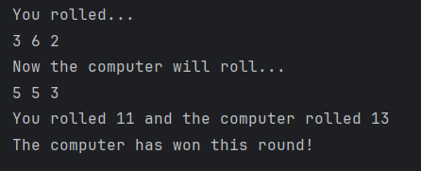
Result: Did the programme behave as expected ie syntactically and logically correct?
The program generates 3 random numbers for the computer and 3 random numbers for the user, adds them up and compares results. In this case, the computer rolled a higher number so the program states that the computer has won this round.

Test: User wins round
Screenshot(s) of output:
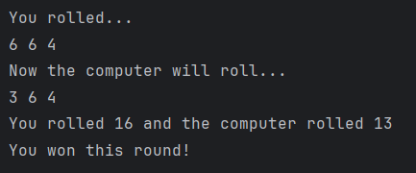
Result: Did the programme behave as expected ie syntactically and logically correct?
The program generates 3 random numbers for the computer and 3 random numbers for the user, adds them up and compares results. In this case, the user rolled a higher number so the program states that the user has won this round.

Test: Draw

Screenshot(s) of output:
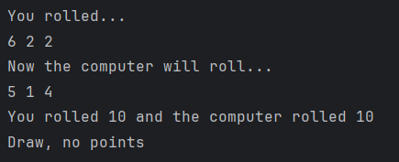
Result: Did the programme behave as expected ie syntactically and logically correct?
The program generates 3 random numbers for the computer and 3 random numbers for the user, adds them up and compares results. In this case, the computer and user rolled the same overall number so the program states that it’s a draw.

- “Go again” – enter y
- “Go again” – enter n

Screenshot(s) of output:
Result: Did the programme behave as expected ie syntactically and logically correct?
A ‘Go again?’ prompt has not been included after every round due to my program already stating that there will be 5 rounds. This feature could be added so the user interacts more with the game.

Test: Show score and score tracking
Screenshot(s) of output:
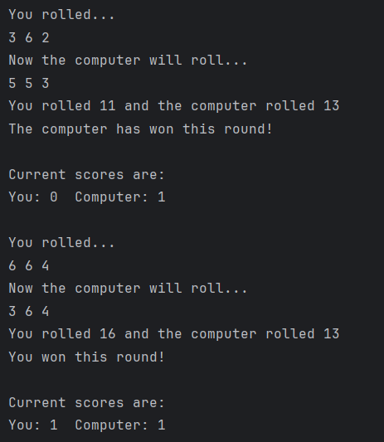
Result: Did the programme behave as expected ie syntactically and logically correct
After every round the program states who has won and keeps track of this by displaying what the current score is. As the game is 5 rounds long, this occurs 5 time in the output.

Test: Overall win
Screenshot(s) of output:
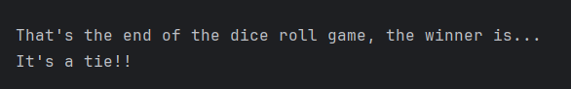

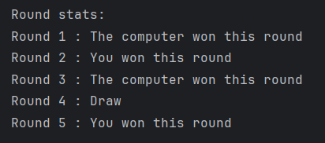
Result: Did the programme behave as expected ie syntactically and logically correct?
The program recognised that the computer and user scored the same number of points so stated a tie. The round statistics are correct when reviewing the results. The final score could also be added at the end to ensure clarity with the user.

Part c:

The code is generally efficient for a small program, but there are a few areas where it could be improved. For example, the range(1,6,1) and range(0,5,1) include unnecessary step values, as Python defaults to a step of 1. The program calculates totals using these separate variables (usersTotal, computerTotal) every round, this could be streamlined by using sum() on a collection of rolls instead of manually adding values.

Another point, the scores list is used effectively to track results, but the program assumes exactly five rounds when printing results, which reduces flexibility and could lead to errors if the number of rounds changes. Overall, while the program runs efficiently and gives correct output, it could be made more concise and maintainable by reducing repeated code and improving structure.

- Consider the results of the above tests and your analysis of program efficiency and revisit your original code in order to address any tests that failed and/or improve code efficiency.

(Note: you may not be able to solve all of the problems that were encountered, but solve as many as you can.)

Paste your full revised code here :

import random
scores=[]
print("Welcome to the dice roll game, there will be 5 rounds. Are you ready to roll your dice? y/n")
userAnswer = input().lower()
userWins=0
computerWins=0
if userAnswer == "y":
for rounds in range(1,6):
number1=random.randint(1,6)
number2=random.randint(1,6)
number3=random.randint(1,6)
print("You rolled...")
print(number1,number2,number3)
print("Now the computer will roll...")
number4=random.randint(1,6)
number5=random.randint(1,6)
number6=random.randint(1,6)
print(number4,number5,number6)
usersTotal=(number1+number2+number3)
computerTotal=(number4+number5+number6)
print("You rolled",usersTotal,"and the computer rolled",computerTotal)
if usersTotal > computerTotal:
userWins=userWins+1
scores.append(1)
print("You won this round!")
print()
elif usersTotal == computerTotal:
scores.append(0)
print("Draw, no points")
print()
elif usersTotal < computerTotal:
computerWins=computerWins+1
scores.append(2)
print("The computer has won this round!")
print()
print("Current scores are:")
print("You:",userWins," Computer:",computerWins)
print()
if rounds < 5:
while True: # loop until a valid answer is given
again = input("Go again? y/n: ").lower()
if again == "y":
break
elif again == "n":
print("End of game. Thanks for playing :)")
exit()
else:
print("Invalid response. Please answer y/n.")
else:
print("Ok, goodbye")
exit()
print("That's the end of the dice roll game, the winner is...")
if userWins > computerWins:
print("You! Well done :)")
elif userWins<computerWins:
print("The computer has won :(")
else:
print("It's a tie!!")
print()
print("The final score was... ")
print("Computer:",computerWins,"User:",userWins)
print()
print("Round stats:")
for counter in range(len(scores)):
if scores[counter]==1:
print("Round",counter+1,": You won this round")
elif scores[counter]==2:
print("Round",counter+1,": The computer won this round")
else:
print("Round",counter+1,": Draw")

