

BA Business Management

Module: Entrepreneurship
Module code: LCBB5001
Lecturer: Essa Bah
Assignment Title: Assessment Component 2
Written Report
Student ID: 2014968
Student Name: SIVIU-MIRCEA MOISA

Executive Summary
This report covers entrepreneurship and SMEs, defining different kinds of entrepreneurship and SME classifications in the UK. It describes what an entrepreneur is and lists the essential abilities needed to succeed. Entrepreneurs are essential to economic development and innovation because they possess a unique combination of resilience, inventiveness, and commercial acumen. Developing these abilities may increase the effect of entrepreneurship and promote innovation, employment growth, and sustained economic development.

Table of Contents
Introduction 4
Concept of Entrepreneurship 5
Various Types of Entrepreneurships 6
Concept of SMEs 8
The different categories of SME in UK 9
Essential Skills for Successful Entrepreneurs 10
Conclusion 12
References 13

Introduction
This report discusses the complex topic of entrepreneurship, examining its various manifestations and the vital function it fulfils in international economies. It will explore the many forms of entrepreneurship, including SMEs (small and medium-sized firms) and how they are categorized in the United Kingdom. It will also describe the entrepreneurial mindset and list the essential competencies required for success in this fast-paced industry, illuminating the indispensable traits that spur innovation and company expansion.

Concept of Entrepreneurship
The goal of entrepreneurship is to spot possibilities and come up with creative ways to take advantage of them. Establishing, running, and expanding a company enterprise all require measured risks. Creative thinking, adaptability, and a readiness to change are traits that entrepreneurs frequently possess (Canestrino et al., 2020).
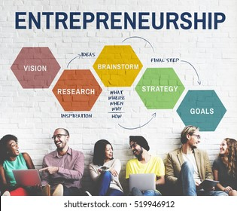
Figure: Entrepreneurship
Source: (Cardella et al., 2020)
They detect gaps in the market, create original concepts, and take initiative to make those concepts a reality, frequently by starting new businesses or launching innovative goods or services. Said another way, entrepreneurship is the act of identifying opportunities to improve the world or introduce a new idea, then taking the necessary steps to realise those concepts into viable enterprises (Cardella et al., 2020). It is similar to solving problems with a little bit of risk-taking, constantly searching for new and interesting methods to produce something that others would find appealing. Entrepreneurs create new buildings from the ground up, much like the creative architects of the commercial world.

Various Types of Entrepreneurships
The term "entrepreneurship" refers to a variety of endeavors and strategies, each suited to certain settings, objectives, and working methods (Fischer et al., 2019). The many industries, reasons for starting a firm, and effects that entrepreneurs may have on the corporate world and society at large are all reflected in these many forms of entrepreneurship.
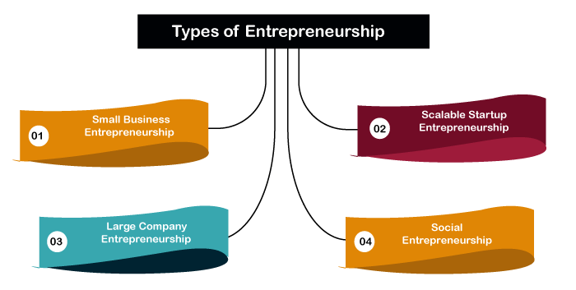
Figure: Various Types of Entrepreneurships
Source: (Callander and Cummings, 2021)
Small Business Entrepreneurship: These business owners concentrate on starting and managing small businesses, frequently in their local communities (Callander and Cummings, 2021). They work in conventional industries including local trades, food services, and retail. Rather than fast expansion, stability and gradual growth are their main priorities.
Scalable Startup Entrepreneurship: Developing inventive, scalable companies with significant development potential is the goal of startup entrepreneurs. They frequently use technology to upend sectors with the goal of expanding quickly and having a significant influence (Obschonka et al., 2019). These businesses usually look for investment capital and have an eye towards international markets.
Social Entrepreneurship: Easing social or environmental problems takes precedence above making money for social businesses (Canestrino et al., 2020). They use innovation to provide long-term fixes for issues including sustainability of the environment, healthcare access, and poverty. Together with a sustainable economy, the positive societal effect is one of their success measures.
Corporate Entrepreneurship: Intrapreneurs operate as entrepreneurs within well-established businesses. Initiating innovative initiatives, products, or procedures inside the current organizational structure, they promote an innovative and taking risks culture that propels development and competition.
Digital Entrepreneurship: Since the internet has grown in popularity, digital entrepreneurs have used e-commerce, digital marketing, online platforms, and technical breakthroughs to launch and expand their firms (Canestrino et al., 2020). This covers online shops, content production, digital agencies, and e-commerce sites.
Serial Entrepreneurship: Over the course of their careers, serial entrepreneurs consistently start and run several enterprises. Using their networks and knowledge, they frequently launch new businesses after scaling or quitting old ones.
Technopreneurship: These business owners concentrate on cutting-edge technology developments, including biotech, hardware, software, and other advances (Callander and Cummings, 2021). Their companies are focused on introducing technologically advanced solutions to the market, which frequently need for in-depth analysis and investigation.
Green Entrepreneurship: Sustainable and environmentally friendly practices are given top priority in the business strategies of green entrepreneurs. In order to reduce their ecological imprint and encourage sustainable living, they innovate by offering eco-friendly goods, services, and practices (Cardella et al., 2020).
Cultural Entrepreneurship: These business owners promote and profit from cultural goods, the arts, heritage, and customs while working in the creative industries. Their endeavours could encompass enterprises in the fashion or culinary arts, art galleries, or festivals.

Concept of SMEs
Small and medium-sized enterprises, or SMEs, are an important part of the business landscape because of their size, broadness of operations, and economic impact. Compared to bigger firms, these businesses usually employ fewer people and have lower cash turnover. SMEs are vital to global economic development, innovation, and job creation, even if definitions differ between nations. SMEs frequently display agility and flexibility, which helps them meet unique demands and react swiftly to changes in the market (Callander and Cummings, 2021).

Figure: SMEs
Source: (Cardella et al., 2020)
They provide employment possibilities in a variety of areas, which makes a substantial contribution to job creation. Small and medium-sized enterprises (SMEs) also act as centres of innovation, encouraging ingenuity and an entrepreneurial mindset among people of all ages. These companies confront particular difficulties, such as restricted access to resources, budgetary limitations, and difficulties growing their operations (Cardella et al., 2020). Governments and organisations, however, frequently offer financial initiatives, support programmes, and customized aid to ensure that SMEs prosper and make significant contributions to the socioeconomic structure of their countries.

The different categories of SME in UK
Small and Medium-sized Enterprises (SMEs) in the UK are classified according to their size, revenue, and workforce (Lewis, 2019). These classifications aid in delineating the several strata that comprise the SME sector, spanning a range of enterprises that make substantial contributions to the economy. SMEs are normally defined by the UK government using the guidelines set by the European Union.
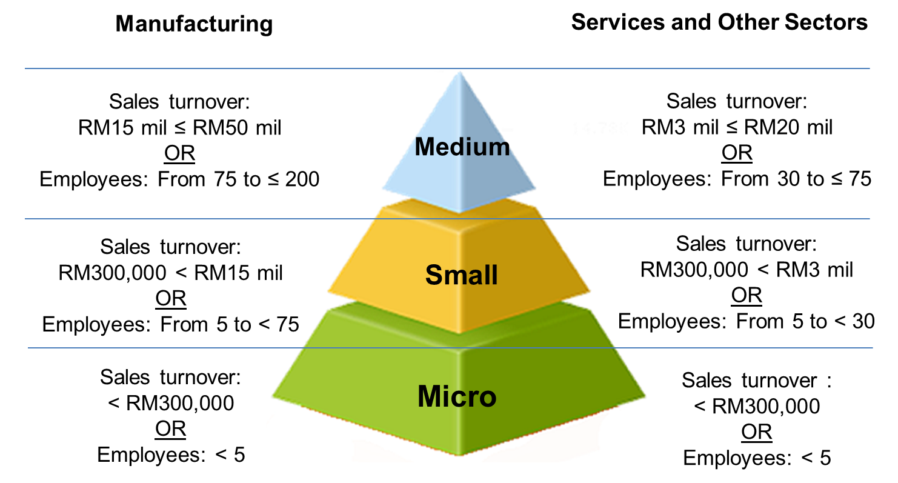
Figure: SMEs
Source: (Berger et al., 2021)
Micro Enterprises: These are the smallest organisations, often employing one to nine people. Micro enterprises usually run on a small scale, have little turnover, and have less resources (Alford and Jones, 2020). A few employees working for a freelance graphic design business or a neighbourhood artisanal craft store might serve as examples.
Small Enterprises: Ten to forty-nine workers are usually employed by small firms in the United Kingdom. They frequently have a more developed market presence and could have slightly bigger turnovers than micro firms (Berger et al., 2021). Small manufacturers of specialised machinery or boutique marketing firms can be examples of this type of business.
Medium-sized Enterprises: A medium-sized company has between 50 and 249 employees. These businesses often have higher turnover rates, a more established organisational structure, and more access to resources. A mid-sized restaurant chain or an application development business that specialises in a certain industry may serve as examples.

Essential Skills for Successful Entrepreneurs
A person who starts, plans, and supervises a commercial endeavour while taking financial risks in the sake of creativity and profit is known as an entrepreneur (Ferreira et al., 2019). A broad skill set is frequently possessed by successful business owners, allowing them to effectively handle the challenges of launching, operating, and expanding a company. The following are essential competencies for success as an entrepreneur:
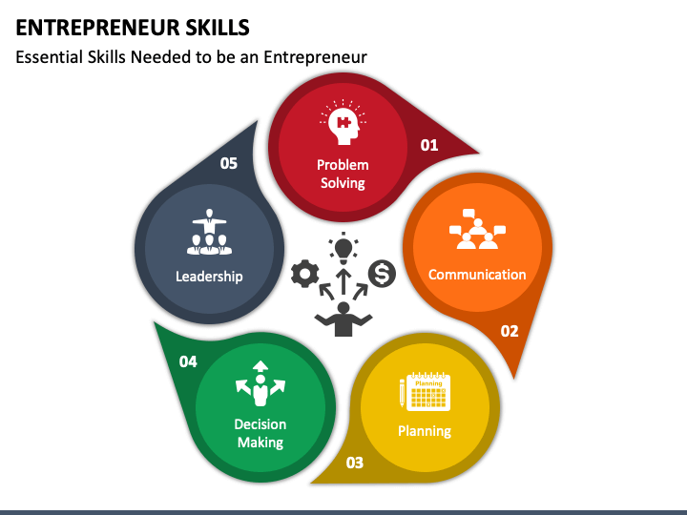
Figure: Entrepreneur Skills
Source: (Dana, 2021)
Resilience and Perseverance: Entrepreneurs must overcome many obstacles, disappointments, and unknowns (Alford and Jones, 2020). It is essential to have the capacity to overcome setbacks, persevere in the face of difficulty, and maintain dedication to one's objectives.
Creativity and Innovation: To stand out in crowded marketplaces, entrepreneurs must be creative thinkers who can come up with new ideas and reinvent their processes, goods, and services.
Flexibility and Adaptability: The corporate environment is ever-changing. Entrepreneurs have to change quickly to keep up with shifting consumer preferences, industry trends, and technology developments (Berger et al., 2021). Adopting a flexible approach facilitates enhanced decision-making and adaptability to novel situations.
Leadership and Communication: Strong leadership abilities are necessary for motivating staff, managing a team, and creating a happy workplace environment. Strong written and spoken communication abilities support networking, negotiating, and persuading stakeholders of a compelling vision.
Business acumen and financial management: It is essential to comprehend financial principles, manage budgets, examine market trends, and make data-driven judgements. To evaluate risks and possibilities, entrepreneurs need to have a keen sense of business.
Risk-taking and Decision-making: Entrepreneurs need to be at ease with taking measured chances (Berger et al., 2021). They assess circumstances, get data, and make snap decisions often in unclear or stressful circumstances.
Time Management and Prioritisation: Time management techniques must be used properly. To fulfil deadlines and objectives, entrepreneurs establish priorities, juggle several projects, and use resources wisely.
Building Relationships and Networking: It is essential to establish and maintain connections with investors, partners, clients, and colleagues in the business (Alford and Jones, 2020). Effective networks have the power to bring opportunities, partnerships, and insightful information to light.
Critical thinking and problem-solving skills: Complex difficulties are a common encounter for entrepreneurs (Dana, 2021). It is crucial to be able to evaluate circumstances, find solutions, and make wise judgements by applying critical thought and logical reasoning.
Motivation and Self-control: It is essential to be disciplined and autonomous. Entrepreneurs have to maintain their motivation while creating and attaining goals with commitment and self-control in the face of uncertainty.

Conclusion
It becomes clear that entrepreneurship is a dynamic force behind invention, economic expansion, and social advancement. The range of entrepreneurial endeavours, encompassing inventive startups and small and medium-sized enterprises, represents the depth of prospects and contributions present in the business environment. Resilience, innovation, flexibility, and strategic acumen are all necessary for the entrepreneurial path and are the cornerstones of success. Societies may leverage the transformational potential of entrepreneurship to propel innovation, generate jobs, and promote sustainable economic growth globally by cultivating a culture that supports entrepreneurial endeavors across diverse sectors.

References
Alford, P. and Jones, R., (2020). The lone digital tourism entrepreneur: Knowledge acquisition and collaborative transfer. Tourism Management, 81, p.104139.
Berger, E.S., Von Briel, F., Davidsson, P. and Kuckertz, A., (2021). Digital or not–The future of entrepreneurship and innovation: Introduction to the special issue. Journal of Business Research, 125, pp.436-442.
Callander, A. and Cummings, M.E., (2021). Liminal spaces: A review of the art in entrepreneurship and the entrepreneurship in art. Small Business Economics, 57, pp.739-754.
Canestrino, R., Ćwiklicki, M., Magliocca, P. and Pawełek, B., (2020). Understanding social entrepreneurship: A cultural perspective in business research. Journal of Business Research, 110, pp.132-143.
Cardella, G.M., Hernández-Sánchez, B.R. and Sánchez-García, J.C., (2020). Women entrepreneurship: A systematic review to outline the boundaries of scientific literature. Frontiers in psychology, 11, p.1557.
Dana, L.P. ed., (2021). World encyclopedia of entrepreneurship. Edward Elgar Publishing.
Ferreira, J.J., Fernandes, C.I. and Kraus, S., (2019). Entrepreneurship research: mapping intellectual structures and research trends. Review of Managerial Science, 13, pp.181-205.
Fischer, B.B., de Moraes, G.H.S.M. and Schaeffer, P.R., (2019). Universities' institutional settings and academic entrepreneurship: Notes from a developing country. Technological Forecasting and Social Change, 147, pp.243-252.
Lewis, K.V., (2019). Identity capital: An exploration in the context of youth social entrepreneurship. In Entrepreneurial Identity and Identity Work (pp. 15-29). Routledge.
Obschonka, M., Moeller, J. and Goethner, M., (2019). Entrepreneurial passion and personality: the case of academic entrepreneurship. Frontiers in psychology, 9, p.2697.

