

BA (Hons) Leadership and Management Skills for the Workplace
LCLM 5004
MANAGING BUSINESS INFORMATION
Word count: 2088
Student name: Marian Enescu

Student ID: 2331652

Executive summary
The report has considered Kalori Ltd. as a retail company that operates across 30 physical stores and has an e-commerce platform. However, operational inefficiencies have resulted in financial losses and delays in fulfilling orders signifying possibilities of rise in complaints and refunds from customers. The report sheds light on key challenges faced by Kalori, that restrict its business expansion and consolidation of its competitive position. In addition, an analysis of the current information systems, impacts of the outdated decision-making approach of Kalori have been provided. Data privacy issues have been explained in this report that foster uncertainty in managing customers' purchase history. In addition, the report included a new system empowered by CRM, ERP and BI tools that can help the company in analysing sales trends and train the employees for managing inventory and customer data. Change management has been regarded as an important aspect that could help address the operational inefficiencies observed at Kalori.

Table of Contents
Introduction 3
Overview of the business case/scenario 3
Identification of key challenges faced by Kalori 3
Evaluation of Existing Systems 4
Analysis of the current information systems in place 4
Identification of inefficiencies and gaps 5
Recommended Solution 6
Proposal of a suitable new or upgraded information system 6
Justification for the recommendation based on business needs, efficiency, cost, and scalability 6
Strategies by which the system can improve operations, data management, and decision-making 7
Implementation Plan 8
Steps for implementing the new system 8
Consideration of training, integration with existing infrastructure, and potential challenges 9
Conclusion 10
Summary 10
Expected benefits 10
References 11

Introduction

Overview of the business case/scenario
Kalori Ltd. represents its competitive position as a fast-growing consumer electronics retailer with 30 physical stores and an e-commerce platform. The business of Kalori witnessed an increase in sales that influenced optimization of corresponding eagerness in expanding sales (Case Scenario). However, impact of operational efficiencies anticipated from the outdated and inefficient information systems induced challenges in enhancing business performance. The necessity of optimising incumbent operations at Kalori influences the possibility of improving efficiency of business performance and helps in expanding sales.

Identification of key challenges faced by Kalori
Stock discrepancies between physical stores and online orders induced challenges across the managers at Kalori for enhancing the efficiency of stock management (Case Scenario). The ineffective CRM system at Kalori has witnessed complexities for the managers in providing personalized marketing services across customers. The result signifies challenges in sending targeted promotions of retail services across the customers along with inefficiency in handling customers’ complaints (Case Scenario). In addition, slow decision-making, lack of system integration, GDPR risks and fragmented customer data have been additional challenges faced by Kalori in streamlining operations, improving efficiency, and enhancing customers’ satisfaction.
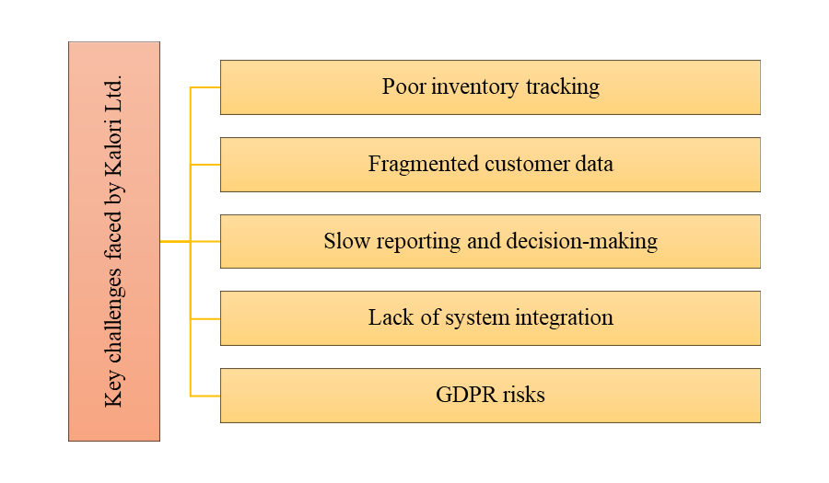
Figure 1: Key challenges faced by Kalori
(Source: Self-developed)

Evaluation of Existing Systems

Analysis of the current information systems in place
Stock discrepancies and ineffective monitoring customers' purchase history
Kalporis’ current inventory system has witnessed stock discrepancies while managing online stores and physical outlets. Zheng et al. (2025) stated that impacts of over or understocking’s lead to challenges in managing customers’ orders and facing a decline in financial performance. The reason is that the manual inventory systems lacked in managing real-time data and conveying current status of stocks that impact business continuity. In addition, discrepancies in customer relationship management have induced challenges for Kalori’s employees in monitoring customers' purchase history. Muhammad et al. (2025) commented that disconnected CRM systems induce difficulties for companies in tracking purchasing trends of customers. Consequently, the efficiency in handling complaints is subject to decline along with undertaking strategies for providing personalized marketing services.
Outdated decision-making approach, poor forecasting and data privacy issues
The reporting strategies and decision-making approach seems to be outdated as efficiency in managing digital spreadsheets often contain errors and outdated data. Alonge et al. (2025) commented that inaccuracy in sales management hinders real-time analysis of business performance across organisations. Consequently, Kalori’s managers face a challenge in analysing real-time sales trends that leads to poor forecasting and losing revenue opportunities leading to underestimated stock demands and/or overstocking as instances. Lack of system integration accounted for communication silos across departments that involved manual transfer of information. Yuniarto and Siregar (2025) stated that inaccurate forecasting increases the likelihood of errors during manual distribution of sales records due to a lack of communication. GDPR-oriented risks anticipate susceptibility to non-compliance with data protection measures while managing customers' records. The current data management system at Kalori lacks secure access controls that highlight challenges in managing data privacy. Consequently, growing concerns related to cyber threats and legal penalties persist with the organisational ambience of Kalori.

Identification of inefficiencies and gaps
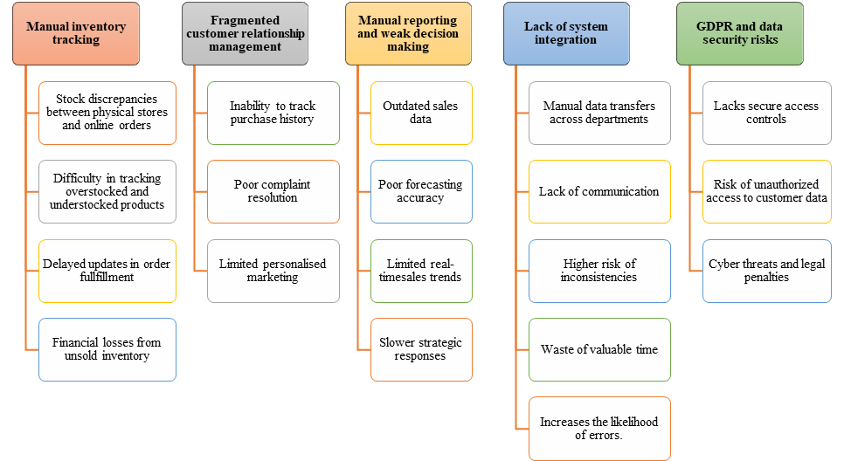
Figure 2: Inefficiencies and gaps
(Source: Self-developed)
Stock discrepancies between physical stores and online orders created confusion across Kalori's employees in ensuring the present status of stocks for fulfilling orders. Lin and Lin (2026) commented that inappropriate stock management leads to delays in fulfilling customers’ orders and increasing sales performance. As a result, the possibility of increasing sales due to discrepancies in stock management at Kalori is limited. The inefficiencies also include difficulty in monitoring the purchase history of customers, along with a lack in handling complaints due to missing purchase records. Petrova et al. (2026) stated that ineffective CRM systems limit the efficiency of developing targeted promotion of services. In this respect, Kalori faces a challenge in personalising marketing strategies across customers, resulting in dissatisfaction.
Weak decision-making and lack of system integration contribute to the inefficiency of managing sales data across relative spreadsheets that limits forecasting efficiency. The inefficiency in making decisions generates a gap in analysing real-time sales and losing revenue opportunities along with facing communication issues across departments (Case Scenario). In addition, susceptibility of security risk is anticipated from GDPR and privacy-related issues that signify instances of cyber threats on customer records. The impact relates to a gap in developing effective security mechanisms for managing customer records, which could help Kalori in retaining its reputation.

Recommended Solution

Proposal of a suitable new or upgraded information system
Integration of effective Enterprise Resource Planning (ERP) systems, a completely centralised CRM system will be effective for addressing the challenges as indeed from Kalori’s case scenario. The new and upgraded system can be significant for enhancing its financial performance, leading to increase in customers’ engagement, retention of reputation and possibility of expanding its business. In addition, the system will be empowered by integrating Business Information (BI) tools such as Microsoft Power BI and Tableau for addressing silos to manage inventory. The new system will help Kalori’s employees in generating real-time inventory of stocks’ status that will influence the continuity of business operations.
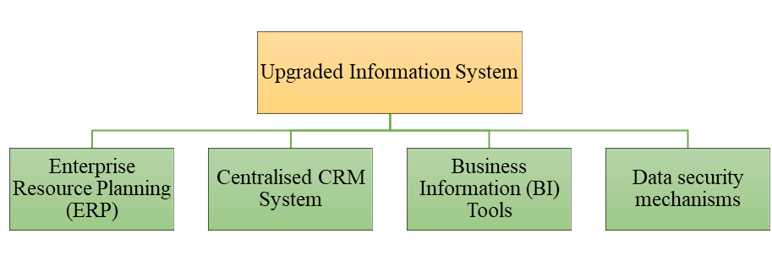
Figure 3: Upgraded information system
(Source: Self-developed)

Justification for the recommendation based on business needs, efficiency, cost, and scalability
Enterprise Resource Planning (ERP)
ERP’s integration into Kalori’s business model will play an important role in automating the updates of stocks, leading to ease in analysing stocks’ performance and reducing delivery delays. Martikkala et al. (2026) stated that the ERP system is significant for enhancing visibility of inventory status and reducing manual errors. Consequently, the likelihood of errors and reduction to business productivity can be decreased, leading to optimisation of scalability concerning business expansion. Maheshwari et al. (2026) commented that ERP systems are effective for enhancing operational efficiency and reducing manual errors regarding inventory management. In this respect, the scalability needs of Kalori can be fulfilled using ERP systems as it will enable effective stock management.
Centralised CRM System
The incorporation of a centralised CRM will be effective for amalgamating important customer records such as purchase history into respective digital databases. Ileana et al. (2025) commented that a centralised CRM system helps in monitoring the purchase life cycle of customers and enables companies in improving compliant management procedures. Consequently, the new system will help Kalori to retain more customers and develop personalised marketing strategies. The centralised CRM System will play an important role in improving satisfaction across customers, leading to an increase in repeated purchase of retail services from Kalori. Halik et al. (2026) stated that maintaining customer relations using a centralized CRM system contributes towards promoting sales. Consequently, brand loyalty will tend to increase, leading to increase in Kalori’s financial projection and business expansion by reaching out to more customers.
Business Information (BI) Tools
Business Information (BI) tools such as Microsoft Power BI and Tableau will be effective for analysing business sales in real-time and conveying results across departments, leading to redressal of communication silos. Microsoft Power BI helps in providing insights into an organisation's sales trends and future sales performance (Microsoft, 2025). The BI tool will help Kalori in implementing strategies for improving sales based on forecasted metrics and predicted financial impacts. In addition, Tableau can help companies in optimising Data-driven decision-making (DDDM) strategies for enhancing performance based on real-time business metrics (Tableau, 2026). The integration of these BI tools can be effective for making faster decisions in personal retail sales across customers based on respective trends, leading to improvement in revenue accumulation.
Data security mechanisms
Data security mechanism involves implementing two-factor authentication to protect customer records and avoiding breach of privacy. In addition, Regulation (EU) 2016/679 of the General Data Protection Regulation (GDPR) focuses on harmonising data privacy that fosters digital resilience (GDPR-info, 2026). The mechanism involves undertaking secret audits of confidential business-oriented inflation that could help in evading legal obligations. Thus, the system will help in retaining customers' engagement in the long run.

Strategies by which the system can improve operations, data management, and decision-making
The consideration of the new system will contribute towards generating value towards customers due to provision of personalised marketing facilities and maintaining the credibility of customers’ records. MS Power BI and Tableau will be important tools for analysing sales trends in real-time that can help in reducing manual errors and cost of operations. In addition, a data secret security system and adherence to GDPR principle will contribute towards effective data management, leading to fostering trust and loyalty across customers. Consequently, the new system will help in enhancing decision making approaches that will help in enhancing stock management, preventing waste and generating higher value

Implementation Plan

Steps for implementing the new system
Steps | Description | Timeline
1 | System selection comprising identification of system requirements and implementing cloud-based CRM and ERP systems. | 2 months
2 | Staff training regarding data encryption, decision-making and analysing sales trends using data analytics. | 4 months
3 | Integration with current platforms, which involve cleaning robust raw data on customers' purchasing history and trends | 5 months
4 | Change management encompasses analysing live feedback from customers after implementing ERP, BI tools and CRM systems | 4 months
Table 1: Steps for implementing the new system
(Source: Self-developed)
Analysis
Step 1 involves selecting the system where integration of centralised CRM and ERP systems are required for managing inventory and retaining customers. System selection at Kalori involves analysing system requirements for managing multiple functions that influence business objectives. Steps 2 and 3 relate to training the staff and integration of the new system with Kalori’s current e-commerce platform. Applying Kotter's change management model contributes towards adopting digitalisation across organisations that influence business success (Chuunga and Mpundu, 2025). The framework’s application can contribute towards analysing live feedback from customers after implementing ERP and CRM systems. Step 4 involves the application of the change management strategy that will help in analysing live feedback from customer safety integrating the new system. In this respect, the new system can contribute towards enhancing financial performance and achieving Kalori’s goal towards expanding business.
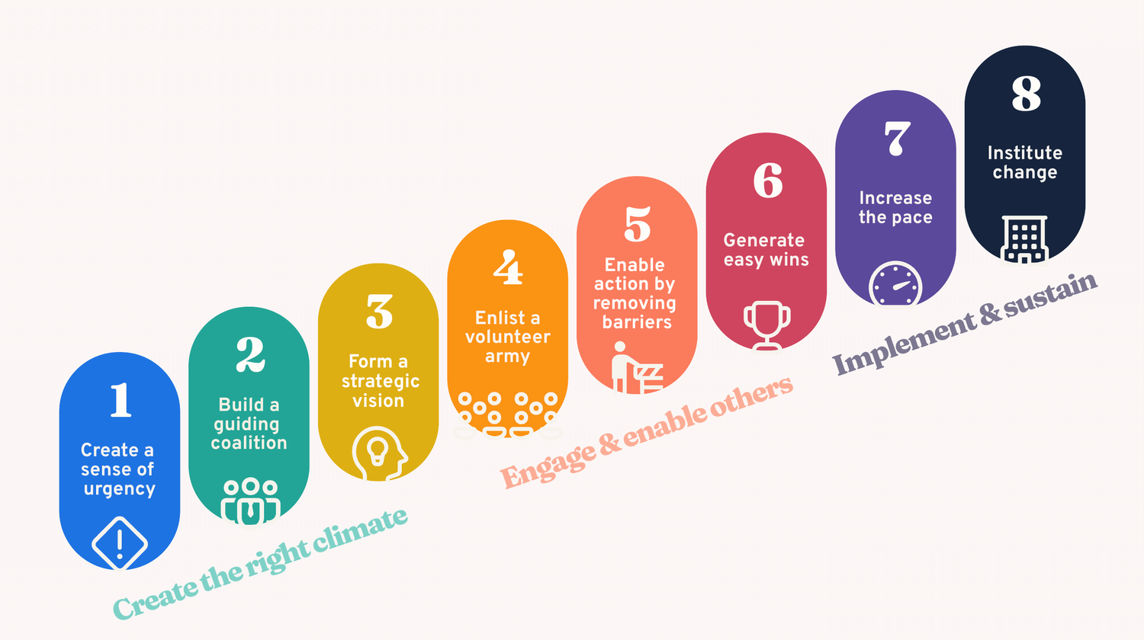
Figure 4: Kotter’s change management model
(Source: Bitesizelearning, 2024)

Consideration of training, integration with existing infrastructure, and potential challenges
The challenges related to implementing the above steps involve resistance to change across the employees at Kalori. Motivating and influencing Kalori’s employees towards optimising sales can help in fostering digitalisation through implementing CRM and ERP systems. Zolak et al. (2025) stated that staff training plays an important role in addressing resistance to changes due to the possibility of ensuring effective outcomes. As a result, susceptibility of annual error while managing stock can be addressed as trust can be fostered through communication as a change management strategy across respective departments. The integration of ERP, BI tools and CRM systems can be effective for enhancing decision-making approaches in managing robust customer records. However, challenges to knowledge management are anticipated that may delay the functionalities required for effective stock management (Zheng et al. 2025). Real-world thinking involves operational disruption and changes in behaviour across employees at Kalori to enhance their functions in understanding CRM and ERP systems for business management. Adherence to GDPR guidelines, training on cyber security and data analytics can be significant for addressing the identifying the challenges in the case study. However, significant changes within a business require time and effort for conveying the importance of change for improving outcomes (Valtonen and Holopainen, 2025). The need for additional revenue for establishing digital infrastructure and employee training may lead to delays in personalising retail services and/or analysing customers' purchase trends. This may lead to difficulty in rearing customers due to delay in optimising business management and ensuring expansion. The implementation plan will last for 15 months within which the implementation of the new system will be integrated across Kalori’s existing business management model.

Conclusion

Summary
Kalori Ltd’s competitive position highlights business expansion undertaken across 30 physical stores and an e-commerce platform. Despite the fact, operational efficiencies have induced challenges in enhancing business performance, such as lack of inventory management, delays in order fulfilment and lack of service personalisation. GDPR risks also signified impacts of legal obligation and inability in securing robust customer records. The company requires a new system to be integrated across its existing business model that could enable secured and personalised marketing strategies.

Expected benefits
It can be expected that integrating the new CRM, ERP and BI tools can help Kalori’s employees in analysing sales trends and protecting customers' purchasing habits. In addition, the proposed system will strengthen customer trust due to supporting business’ scalability and data security. This will help in ensuring long-term competitive growth and brand loyalty at Kalori in the long run.

References
Alonge, E.O., Eyo-Udo, N.L., Ubanadu, B.C., Daraojimba, A.I., Balogun, E.D. and Ogunsola, K.O., (2025). ‘Integrated framework for enhancing sales enablement through advanced CRM and analytics solutions’. Gulf Journal of Advance Business Research, 3(3), pp.923-951. Available at: https://doi.org/10.51594/gjabr.v3i3.120
Bitesizelearning, (2024). Kotter’s 8-Step change model, explained Available at: https://www.bitesizelearning.co.uk/resources/kotters-8-step-change-model (Accessed: 24 February 2026)
Chuunga, K. and Mpundu, M., (2025). ‘Organization Change through Digital Transformation’. International Journal of Advanced Business Studies, 4(4), pp.222-235. Available at: https://doi.org/10.59857/tuym6309
GDPR-info, (2026). General Data Protection Regulation GDPR Available at: https://gdpr-info.eu/ (Accessed: 24 February 2026)
Halik, J.B., Halik, M.Y., Basongan, S. and Mapau, J., (2026). ‘Strategic Distribution, Digital Marketing, and Open Innovation: Toward Integrated Capability Development for SME Performance’. Asia Marketing Journal, 27(4), pp.355-371. Available at: https://doi.org/10.53728/2765-6500.1665
Ileana, M., Petrov, P. and Milev, V., (2025). ‘Optimizing customer experience by exploiting real-time data generated by IoT and leveraging distributed web systems in CRM systems’. IoT, 6(2), p.24. Available at: https://doi.org/10.3390/iot6020024
Lin, T.C. and Lin, B.M., (2026). Scheduling optimization of optical lens polishing. International Transactions in Operational Research. Available at: https://onlinelibrary.wiley.com/doi/abs/10.1111/itor.70162
Maheshwari, J.G., Tanushri, N., Gowda, R., Bhutiyal, V.S. and Rao, K.R., (2026). ‘Forecast Accuracy Improvement and Purchase Order Automation Using a Multi-Model Approach in Semiconductor Supply Chain: A Case Study’. IEEE Access. Available at: http://doi.org/10.1109/ACCESS.(2026).3658394
Martikkala, A., Thompson, A., Asadi, R. and Ituarte, I.F., (2026). ‘Low-Cost Vision-Based Inventory Monitoring: Implementation and Evaluation’. Procedia CIRP, 139, pp.204-211. Available at: https://doi.org/10.1016/j.procir.(2025).09.019
Microsoft, (2025). Sales Forecasting (Power BI Report) Available at: https://learn.microsoft.com/en-us/dynamics365/business-central/sales-powerbi-sales-forecasting (Accessed: 23 February 2026)
Muhammad, N., Munir, A., Yousaf, U., Iqra, B., Muhammad, K. and Afzal, S.M., (2025). ‘Smart Strategies for the Future: Aligning Digital Marketing Trends, Consumer Behavior, and Supply Chain Management’. European Journal of Management, Economics and Business, 2(4), pp.74-88. Available at: https://doi.org/10.59324/ejmeb.(2025).2(4).06
Petrova, M., Sushchenko, O., Vovk, K., Akhmedyarov, Y. and Pohuda, N., (2026). ‘Comparative Analysis of the Features of Remarketing Implementation in the Context of Digital Transformation: Service vs. Manufacturing Sectors’. Sustainability, 18(4), p.1777. Available at: https://doi.org/10.3390/su18041777
Tableau, (2026). A Guide To Data Driven Decision Making: What It Is, Its Importance, & How To Implement It Available at: https://www.tableau.com/learn/articles/data-driven-decision-making (Accessed: 24 February 2026)
Valtonen, A. and Holopainen, M., (2025). ‘Mitigating employee resistance and achieving well-being in digital transformation’. Information Technology & People, 38(8), pp.42-72. Available at: https://doi.org/10.1108/ITP-05-(2024)-0701
Yuniarto, A.A. and Siregar, I.W., (2025). ‘From manual to digital: Modernizing the sales recording system for growth at MSME Rumah Abon’. Journal of Scientific Insights, 2(5), pp.510-525. Available at: https://doi.org/10.69930/jsi.v2i5.537
Zheng, G., Ivanov, D. and Brintrup, A., (2025). ‘An adaptive federated learning system for information sharing in supply chains’. International Journal of Production Research, 63(11), pp.3938-3960. Available at: https://doi.org/10.1080/00207543.(2024).2432469
Zheng, R., Gu, B., Yin, S., & Lai, K. K. (2025). ‘Supply Chain Management in Times of Supply Disruption Risk and Consumer Panic Buying: A Systematic Review’. Mathematics, 13(21), 3449. Available at: https://doi.org/10.3390/math13213449
Zolak Poljašević, B., Gričnik, A.M. and Šarotar Žižek, S., (2025). ‘Human resource management in public administration: The ongoing tension between reform requirements and resistance to change’. Administrative Sciences, 15(3), p.94. Available at: https://doi.org/10.3390/admsci15030094

