
marine weather monitor



Contents
Task 1
Data Acquisition Systems 2
Wind speed/wind direction 3
Temperature and Humidity 5
Sunlight Brightness 7
Wave Hight 8
GPS Positioning 9
PIC Peripheral Needs 9
PIC Selection 11
Circuit design and PCB 13
Flowchart 15
Battery Pack 16
Packaging 17
Costings Table 17
Conclusion and Improvements 17
References 18
Bibliography 18

Task

Design a simple microcontroller based marine weather monitor which takes measurements and logs the data over a 7day period. The system is intended for use by amateur marine weather forecasters to aid in their predictions. The system must be portable and adaptable. The data it will be collecting or from; temperature, humidity, wave height, Wwnd speed, wind direction, sunlight brightness and GPS positioning sensors.

Data Acquisition Systems

Data Acquisition systems are devices that monitor their environment and store the data. DAQ systems can be used for monitoring almost anything. The DAQ systems can have many different sensors attached to it and they are flexible. During this report the process of developing the electronic side of a DAQ system will be documented. The DAQ system will be designed to be used as a marine weather station. Below is a comparison table of DAQ systems. These have been researched for background knowledge before the development begins.

 | 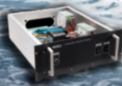 | 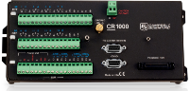 | 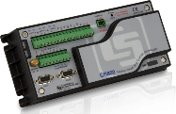 | 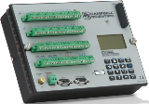 | 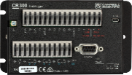
Name | AWS430 [1] | CR1000 [2] | CR800 [3] | CR3000 [4] | CR300 [5]
Overview | Designed to withstand salty and wet conditions, freeze/thaw and can endure vibration and shock. | Rugged, can withstand extreme conditions. Reliable, used in applications all over the world. | Small, research-grade, standalone operations. | Supports complex applications with many sensors, designed for standalone operation in harsh and remote environments | Small, low-cost, fast communication, low power, USB, excellent analog input accuracy/ resolution.
Power | 2.6 Ah / 12 V | 9.6 to 16 Vdc | 9.6 to 16 Vdc | 10 to 16 Vdc | 16 to 32 Vdc for charger input (CHG)
Analog Inputs | - | 16 single-ended or 8 differential | 6 single-ended or 3 differential | 28 single-ended or 14 differential | 6 single-ended or 3 differential
Digital I/O | - | 8 I/Os or 4 RS-232 COM  I/O ports can be paired as transmit and receive for measuring smart serial sensors. | I/Os or 2 RS-232 COM  I/O ports can be paired as transmit and receive for measuring smart serial sensors. | 3 SDM and 8 I/Os or 4 RS-232 COM  I/O ports can be paired as transmit and receive for measuring smart serial sensors. | 7 terminals (C1, C2, P_SW, and SE1 to SE4) configurable for digital input and output. Includes status high/low, pulse width modulation, external interrupt, and communication functions.
Communication Ports | RS-232, RS-485 bus, LAN, ModBus, TCP/IP, and serial | CS I/O  RS-232  Parallel peripheral | CS I/O  RS-232 | CS I/O  RS-232  Parallel peripheral | USB Micro B  RS-232
Battery-backed SRAM for CPU Usage & Final Storage | - | 4 MB | - | - | CPU Drive/program 80 MB serial flash, Data storage 30MB serial flash

Wind speed/wind direction

Part of the criteria for the DAQ system was for it to be able to monitor wind speed and direction. Below is a comparison table containing five possible sensor options for the DAQ system to use.
 | 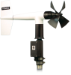 | 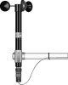 | 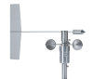 | 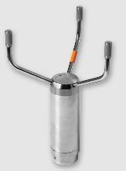 | 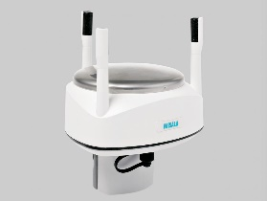
Name | 05103-L [6] | 014A-L [7] | 034B-L [8] | WMT700 [9] | WXT532 [10]
Description | This device is designed for measuring windspeed and direction. It is corrosion resistant. | This device measures windspeed. | Three-cup anemometer and vane into a single package. Measures wind direction and wind speed. | Robust, ultrasonic, measures wind speed and wind direction. | Ultrasonic wind sensor, lightweight, measures wind speed and wind direction.
Starting Threshold | Wind Speed: 1.0 m/s (2.2 mph)  Wind Direction: 1.1 m/s (2.4 mph) at 10° displacement | 0.45 m/s (1.0 mph) | Wind Speed (Anemometer): 0.4 m/s (0.9 mph) | Direction 0.1 m/s (0.2 mph), Speed 0 … 75 m/s (168 mph): ±0.1 m/s (0.2 mph) or 2 % of reading, whichever is greater 75 … 90 m/s (201 mph): ±5 % of reading | starting threshold are virtually zero
Accuracy | Wind Speed: ±0.3 m/s (±0.6 mph) or 1% of reading  Wind Direction: ±3° | 0.11 m/s (0.25 mph) or 1.5% | Wind Speed (Anemometer): ±1.1% of true at > 10.14 m/s (22.7 mph)  Wind Speed (Anemometer): 0.1 m/s (0.25 mph) at < 10.14 m/s (22.7 mph)  Wind Direction (Vane): ±4° | Direction ±2°, Speed 0 … 75 m/s (168 mph): ±0.1 m/s (0.2 mph) or 2 % of reading, whichever is greater 75 … 90 m/s (201 mph): ±5 % of reading | Wind Speed: ±3 % at 10 m/s (22 mph)  Wind Direction: ±3.0° at 10 m/s (22 mph)
Range | Wind Speed: 0 to 100 m/s (0 to 224 mph) | 0 to 45 m/s (0 to 100 mph) | Wind Speed (Anemometer): 0 to 75 m/s (0 to 167 mph) | Wind speed: WMT701: 0 … 40 m/s (89 mph) WMT702: 0 … 65 m/s (145 mph) WMT703: 0 … 75 m/s (168 mph) WMT704: 0 … 90 m/s (201 mph) | Wind Speed: 0 ... 60 m/s (134 mph)
Resolution | Wind Speed: (0.0980 m s-1) / (scan rate in seconds) or (0.2192 mph) / (scan rate in seconds) | - | Wind Direction (Vane): < 5°  Wind Speed (Anemometer): (0.7998 m s–1) / (scan rate in seconds) or (1.789 mph) / (scan rate in seconds) | Direction 0.01°, Speed 0.01 m/s (0.0223 mph) | Wind Speed: 0.1 m/s (km/h, mph, knots)  Wind Direction: 1°
Operating Temperature Range | -50° to +50°C (assuming non-riming conditions) | -50° to +70°C | -30° to +70°C | −55 …+70 °C | -60 … +70 °C

The wind spend and wind direction monitor 05103-L was chosen for the DAQ system. The 05103-L is corrosion resistant. The DAQ system is shore based so the sensor will be exposed to very wet and windy conditions. The corrosion resistant will help the sensor to last longer. Unlike some of the other sensors this sensor monitors both wind speed and wind direction so only one sensor is needed to meat the DAQ requirements. The 05103-L has the largest wind speed sensing range out of the five sensors.

Temperature and Humidity

The weather station that is being designed needs to be able to monitor temperature and humidity. Below is a comparison table of five sensors that are possible options for the DAQ system.
 | 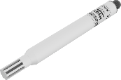 | 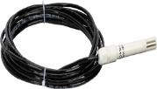 | 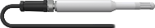 | 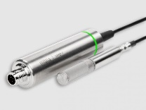 | 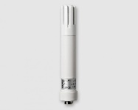
Name | HygroVUE10 [11] | HygroVUE05 [12] | EE181-L [13] | HMP3 [14] | HMP113 [15]
Description | Temperature and humidity elements, digital sensor | Temperature and Relative Humidity Sensor | Temperature and Relative humidity, long term unattended application | General purpose humidity and temperature application with exchangeable sensor | Temperature and humidity prob
Supply Voltage | 7 to 28 Vdc | 7 to 28 Vdc | 7 to 30 Vdc (typically powered by the datalogger’s 12 V supply) | 15 … 30 VDC | 13.5 ... 16.5 VDC
Sensing Element | SHT35 modified by Campbell Scientific | SHT35 derivative (specially coated for reliability) |  | HUMICAPâ R2 sensor | -
Humidity Measurement range | 0 to 100% RH | 0 to 100% RH | 0 to 100% RH (non-condensing) | 0 … 100 %RH | 0 ... 100 %RH
Humidity accuracy | (at 25°C) ±1.5% (over the range 0 to 80% RH)  ±2% (over the range 80 to 100% RH) | (at 25°C) ±1.8% (over the range 0 to 80% RH)  ±3% (over the range 80 to 100% RH) | -40° to +60°C; ± (1.5 + 0.015 • RH reading) % RH | at +23 °C; ±0.8 %RH (0 … 90 %RH) | (incl. Non-Linearity, Hysteresis and Repeatability):
Temperature Measurement Range | -40°C to +70°C | -40 to +70°C | -40° to +60°C | −40 … +120 °C | -40 ... +60 °C
Temperature Accuracy | ±0.2°C (over the range -40 to +70°C)  ±0.1°C (over the range -20 to +60°C) | ±0.4°C (over the range -40 to +70°C)  ±0.3°C (over the range -20 to +60°C) | ±0.2°C (at +23°C) | ±0.1 °C | -40 ... 0 °C, +40 ... +60 °C ±0.4 °C
The HygroVUE10 was chosen as the sensor for the weather station. The temperature and humidity probs all have very similar properties. The HygroVUE10 is the most up to date sensor.

Sunlight Brightness

The weather station needs to be able to monitor sun brightness. Below is a comparison table of potential sun brightness sensors.

 | 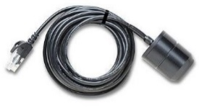 | 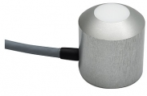 | 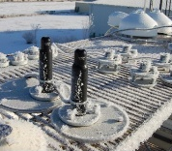 | 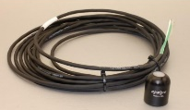 | 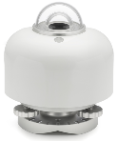
Name | S-LIB-M003 HOBO- Solar Radiation Sensor [16] | SSR1D Solar Radiation Sensor [17] | SP-230 Sunshine Sensor (heated) [18] | SP-212 Apogee Precission Amplified Pyranometer [19] | SR15 Digital [20]
Description | Light Sensor | designed for constant outdoor use, ull sight vision of 180° | eliminating the problem of snow, frost, and dew accumulating on the sensor | Measures solar radiation | General solar resource monitoring
Supply Voltage |  | 3,3-15V DC | 12 VDC with a nominal current draw of 15 mA | 2.5-24 VDC with a nominal current draw of 300 μA
Operating Temperature Range: | -40° to 75°C | -40 …. +65°C | -40 to 70 C, 0 to 100 % relative humidity | -40 to 70 C, 0 to 100 % relative humidity | -40 to +80 °C
Measurement range | 0 to 1280 W/m2 | 0 … 1500 W/m2 |  | up to 1250 W m-2
Resolution | 1.25 W/m2 | 2mV per W/m2 | 0.20 mV per W m-2 | 2.0 mV per W m-2 | 10 x 10-6 V/(W/m2)
Spectral Range | 300 to 1100 nm | 300 – 1000 nm | 360 nm to 1120 nm | 360 nm to 1120 nm | 285 to 3000 x 10-9 m
Accuracy | ±10 W/m2 or ±5%, whichever is greater in sunlight. Additional temperature induced error ±0.38 W/m2 /°C from 25°C | +/- 5% | ± 1% | < 1 % | < 1.8 %

The SSR1D Solar Radiation Sensor was chosen for the sun brightness sensor. This sensor is designed for constant outdoor use, it has a full sight vision of 180° and the largest measurement range out of the five sensors.

Wave Hight

The weather station is marine based and is expected to be able to monitor wave height. Below is a comparison table with five potential sensors.
 |  | 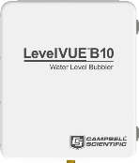 | 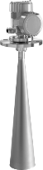 | 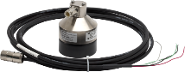 | 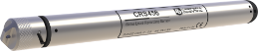
Name | CS451 [21] | LevelVUE™B10 [22] | CS477 [23] | SR50A [24] | CRS456 [25]
Description | Pressure transducer, water level measurements | Water level based on a non-submersible pressure transducer system | Radar ranging sensor, monitors water level, non-contact | Non-contact, snow or water depth. Uses ultrasonic sound | Water level and water temperature sensor, own time clock, memory, battery
Power Requirements | 6 to 18 Vdc | 11.5 to 16.5 V | 9.6 to 16 Vdc | 9 to 18 Vdc | -
Operating Temperature Range | 0° to 60°C | -40° to +60°C | -40° to +80°C | -45° to +50°C | 0° to 60°C
Water-Level Resolution | 0.0035% FS | ±2.1 mm (0.007 ft) for 0 to 15 PSI | 1 mm (0.04 in.) | 0.25 mm (0.01 in.) | 0.0035% FS
Output | SDI-12 (version 1.3) 1200 bps; RS-232 9600 bps | SDI-12 Protocol, SDI-12 Default "M" Measurement Response Time, RS-485 Protocol, RS-485 Baud Rate | SDI-12 | SDI-12 version 1.3, RS-232, RS-485 | micro USB
The CS451 was chosen as it was a contact-based sensor and it was wasn’t an independent device like the CRS456. For the wave height to be measured two of these sensors will be needed. One will measure the average wave height and will be put in a buoyancy float with small holes in it so that it resists the water flow. The second sensor will be in a buoyancy float that doesn’t resist the water flowing in and out of it. The water volume in the second float will fluctuate at the same rate as the wave and that volume of water in the second flat compared to the first float will give the wave height.

GPS Positioning

Below is a comparison table of three GPS models that could be used for monitoring the DAQ’s location.
 | 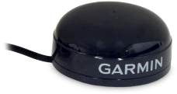 | 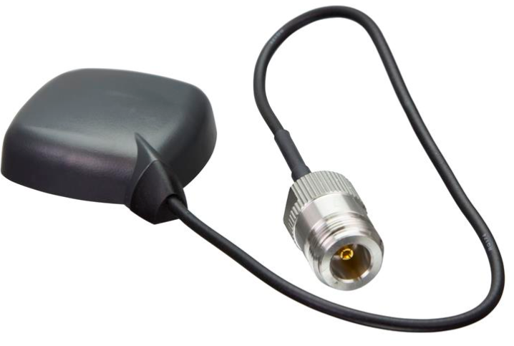 | 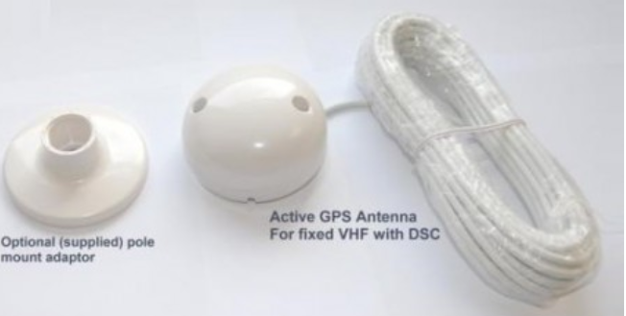
Name | GPS16X-HVS [26] | ANT895-6ML GPS - 6GK5895-6ML00-0AA0 [27] | GPS Receiver Antenna with NMEA 0183 output [28]
Description | GPS, provides positioning, velocity and timing information | GPS antenna is optimally suited for outdoor use | Built-in patch antenna  12 parallel tracking channels  Fast TTFF and low power consumption
6Operating Voltage Range | 8 to 40 Vdc | - | -
Output | PSS, 1 Hz pulse; 1 µs accuracy (Width factory set to 100 ms.) | 0.3 m connection cable with N-female plug | Support RS-232 or RS-422 interface
Velocity Accuracy | 0.1 knot RMS steady state | - | -
Operating Temperature Range | -30° to +80°C | -40-85 °C | -

The GPS16X-HVS was chosen as it had the most available information about it online. The other GPS models had very limited information and had no data sheet.

PIC Peripheral Needs

Now that the sensors have been selected the following table will lay out all the needs of the sensors and the peripherals that will be in the DAQ system that the PIC will need to support. This will give an idea of the PIC specifications.
 | Pins | Type A/D | Resolution | Memory | Clock Speed | Power | Other
Wind speed/wind direction | 1 | Analog | 0 to 224 mph  (three pulses per revolution)  90 Hz (1800 rpm) = 8.8 m/s (19.7 mph) | 10KB readings one week | 1KHz (program reads data every 1second) |  | Measurements are typically processed for output with the Wind Vector instruction  Pulse Counter
Wave Height | 2 | RS232 | 0.0035% FS SDI-12  (version 1.3)  1200 bps; RS-  232 9600 bps | 100KB | 0.1s | 6 to 18 Vdc
Temperature/ Humidity sensor | 1 | Digital | 0.001°C  ±0.1°C (over the range -20 to +60°C) | 170B | 1min | 7 to 28 Vdc | standard M12 connector
Sunlight Brightness | 1 | Analog | Sensitivity 2mV per W/m2  Sensitivity range 300 – 1000 nm | 170B | 1min | 3,3-15V DC,
GPS Positioning | 1 | Digital | 1 Hz pulse; 1 µs accuracy (Width factory set to 100 ms.) | 10KB | 1Hz | 8 to 40 Vdc
Button | 1 | Digital | 0.25 seconds |  | Interrupt | 5V
USB2 | 1 | Digital |  |  | 480Megabits per second | 3.3V
RS232 | 2 | Digital |  | 10KB
SD | 4 | Digital
Total | 10 | 6D, 2A |  | 120KB

PIC Selection

Now that demands of the peripherals have been calculated, it is time to choose a PIC. Below is a table that compares the top pic options. For each category the preferred value has been highlighted in orange.
 | PIC18F2550 [29]  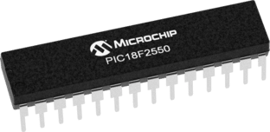 | PIC18F25J50 [30]  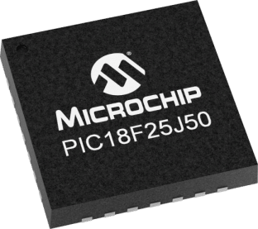 | PIC18F26J53 [31]  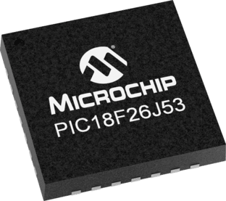 | PIC18F27J53 [32]  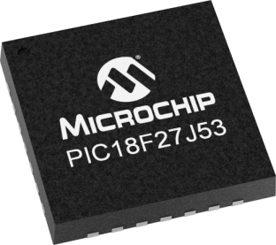 | PIC32MK1024GPD064 [33]  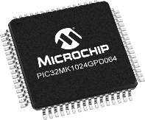
Price $ | 3.44 | 2 | 2.42 | 2.66 | 4.86
CPU Type | 8-bit PIC MCU | 8-bit PIC MCU | 8-bitPIC MCU | 8-bit PIC MCU | 32-Bit MIPS MCU
Program Memory Size (KB) | 32KB | 32KB | 64KB | 128KB | 1024KB
Program Memory Size (Kwords) | 16 | 16 | 32 | 64
SRAM | 2048 | 3800 | 3800 | 3800 | 262144
Emulated EEPROM | 256/HEF | 0/HEF | 0/HEF | 0/HEF | 4096 / True
Pin count | 28 | 28 | 28 | 28 | 64
Internal Oscillator | 8MHz, 32KHz | 8MHz, 32KHz | 8MHz, 32KHz | 8MHz, 32KHz | 8MHz, 32KHz
Max ADC Resolution  (Bits) | 10 | 10 | 12 | 12 | 12
Max ADC Sampling Rate (ksps) | 100 | 100 | 100 | 100 | 500
UART | 1 | 2 | 2 | 2 | 6
USB Modules | 1 | 1 | 1 | 1 | 2
Temp Range | -40 to +85°C | -40 to +85°C | -40 to +85°C | -40 to +85°C | -40 to +125°C
Total No. of Preferred Features | 1 | 3 | 3 | 5 | 5

Above it show that there are two PIC’s with 5 preferred features, PIC18F27J53 and PIC32MK1024GPD064. PIC32MK1024GPD064 is a large high power pic, it give the circlet developer freedom to implement a broad range of feature it they so wished. However this pick has way more capabilities than are needed for this weather station DAQ system, its physically larger so the PCB would need to be larger (which is not cost efficient) and the chip itself costs $4.85. The PIC18F27J53 chip is better well suited for the DAQ systems purposes and it is physically small and costs less than the PIC32MK1024GPD064. For these reasons the PIC18F27J53 will be the main chip.

Circuit design and PCB

The circlet design process used two CAD programs, proteus and Easy-PC. The circuit was designed on proteus first. Below is a screen shot of the Circuit design.
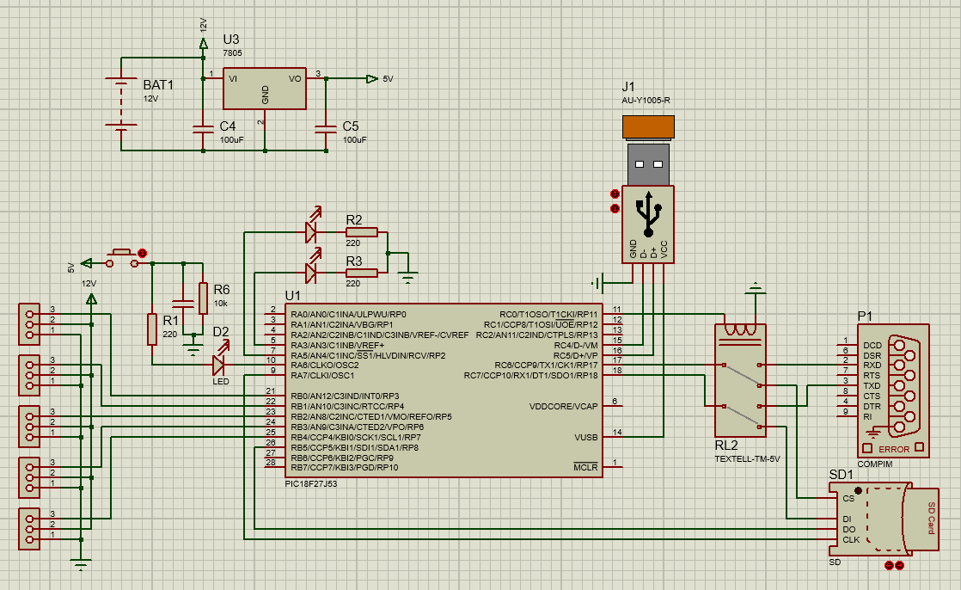
It has five sensor ports. Only four sensor ports are needed as the wave sensor is connected through the RS232 port but an extra one was added as a backup port in case one of the others failed.
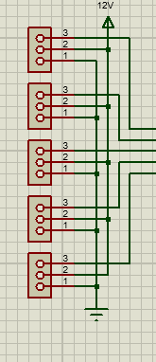
The circuit design also incorporates a low powered relay switch. This relay switch is powered by 5V so can be controlled straight from the PIC. As the PIC only have one set of TX RX ports but both the RS232 and the SD card was wanted in the final DAQ system a relay switch was added to allow both the ports contact with the chip one either one are ever in contact at the same time. This would mean if the PIC wanted to store data onto the SD card then it cannot read the incoming data from the RS232 at the same time. To over come this the sensory data would be stored onto the PIC SRAM and then every cycle the SRAM memory would be copied to the SD card and whipped from the chip.
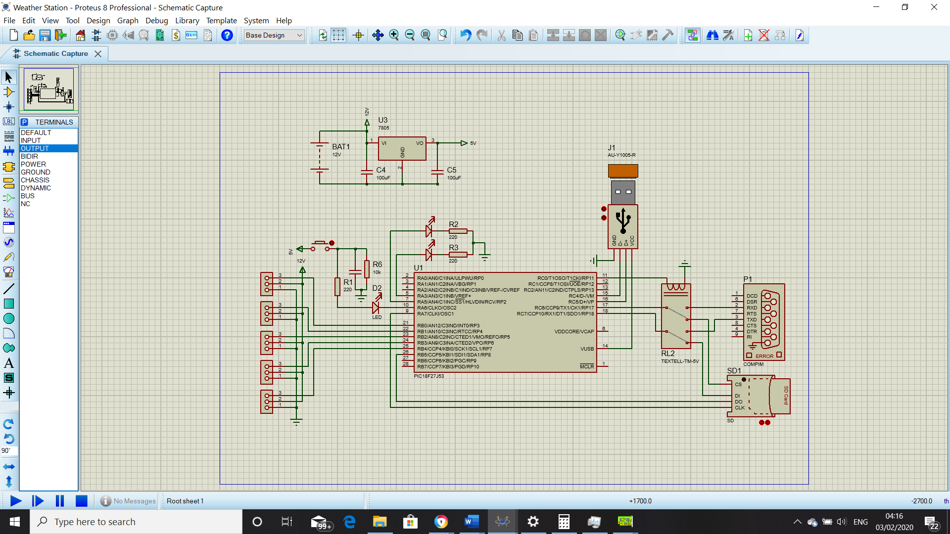

The Circuit is powered of a 12V battery as the sensors need a high voltage to work. The PIC runs of 5V so a step-down voltage module was introduced to supply the PIC.

The circuit has three LED’s. One to show when the button is pressed, one to show when SD card is connected and one to show when the USB is communicating data.

Below is a screen show of the Easy-PC circuit diagram and the PCB board design.
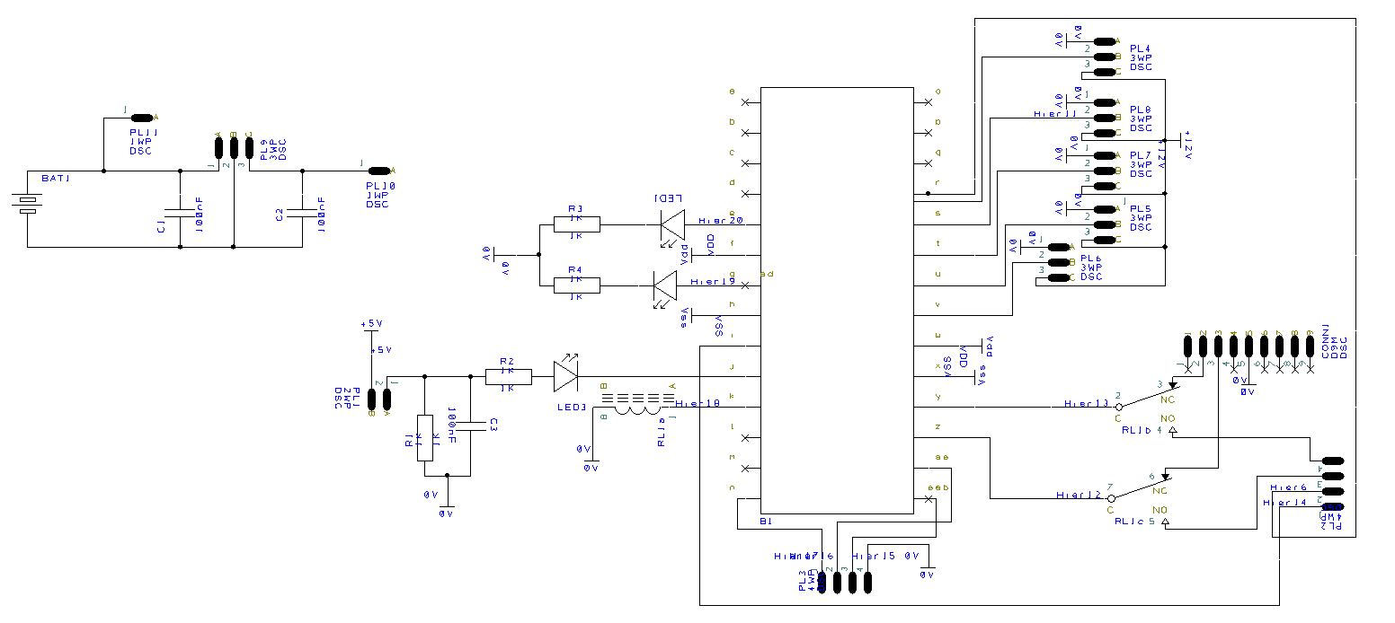
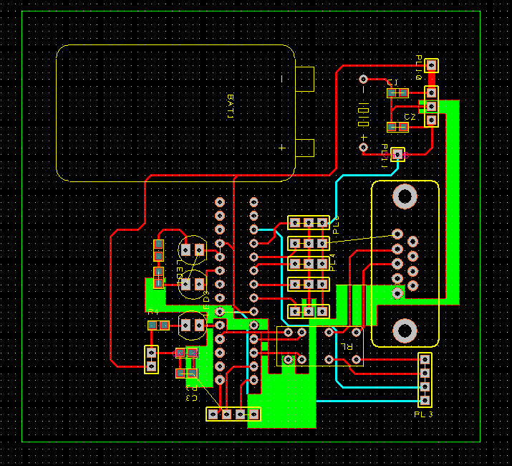

Flowchart

For the programmer to have an understanding of how the circuit is meant to function a block diagram and a flowchart have been made. The Block diagram show a simplified version of the data flow in the circuit were as the flowchart shows how the PIC would process and manage the data flow.

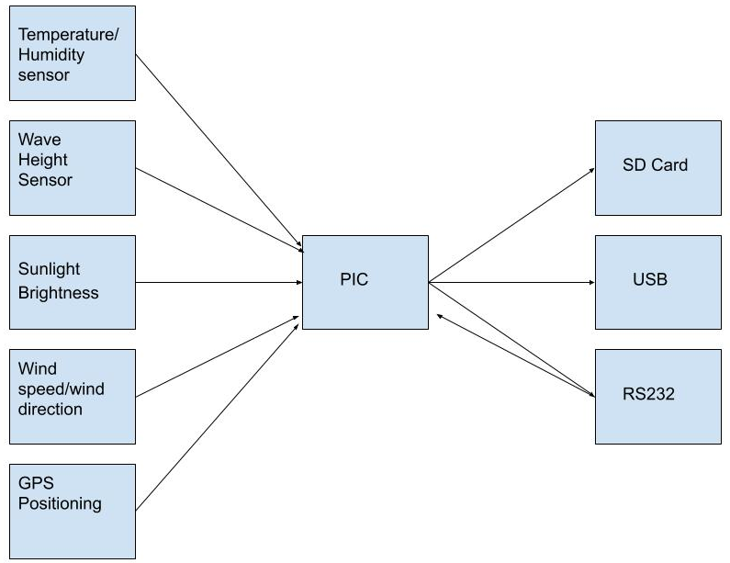
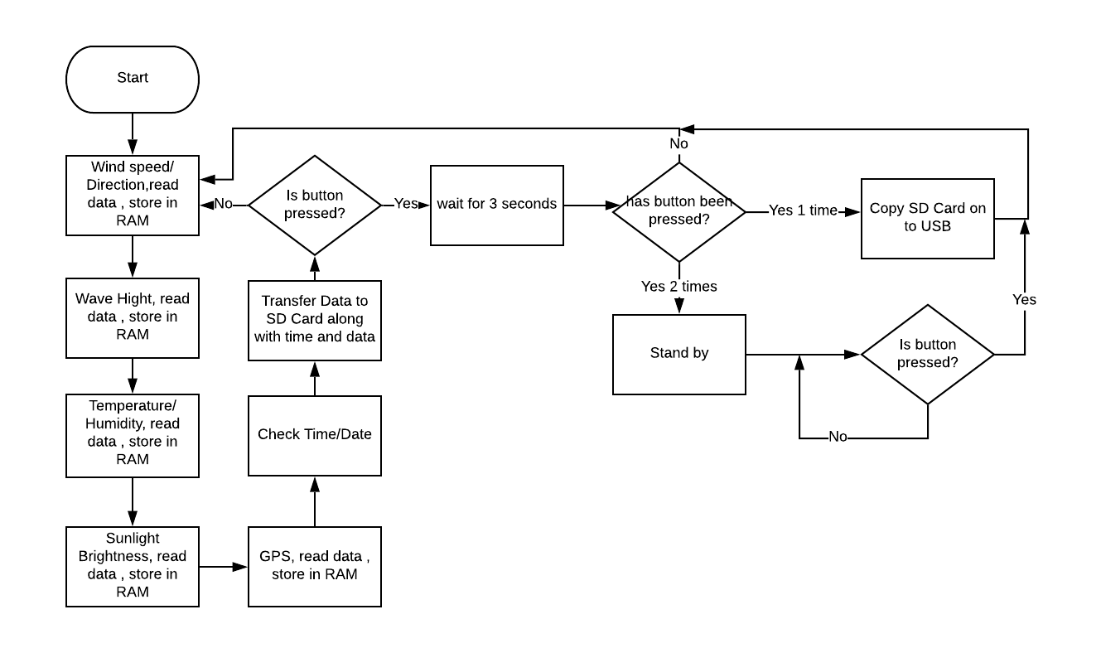

Battery Pack

In order to power the weather system monitor it needs a battery pack. Below are the workings out for the battery’s current supply.
Wind Monitor - Quiescent 50 µA, During Measurement 0.6 mA (takes 0.5 s)
Temperature and Humidity - Quiescent 50 µA, During Measurement 0.6 mA (takes 0.5 s)
Sunlight Brightness - ?
GPS - 65 mA active (@ 12 Vdc)
Wave Hight – Quiescent < 50 µA ,Measurement/Communication 8 mA (1 s measurement), Maximum 40 mA.
General connectors 0.6mA 0.0006
0.6mA 0.0006
0.6mA 0.0006
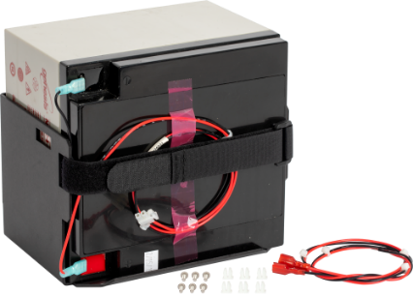
0.6mA 0.0006
(GPS) 65mA 0.065
(RS232) 8mA 0.008
(relay) 30mA 0.03
Button 20 mA 0.02A
Total = 125.4mA
Voltage 12V
Table of Battery Options
Battery Type | Rechargeable
Output Voltage | 12 Vdc
Nominal Rating | 24 Ah
Battery Cables Length | 0.6 m (2 ft)
Dimensions | 21.3 x 17.7 x 13.0 cm (8.4 x 7.0 x 5.1 in.) battery with mounting bracket
Weight | 10.2 kg

Packaging

Below is the package that the DAQ system will be contained in. It’s 245 x 162 x 215mm large so can fit the battery in with the brackets the secure it. The case is waterproof, shockproof and it is resistant to temperatures between -33°C and +90°C.
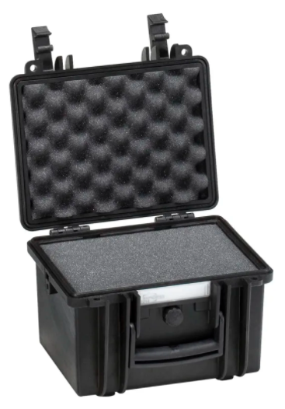

Costings Table

Item | £
Wind speed wind direction | 1510.50
Wave height sensor | Estimate new 400
Temperature and humidity | Estimate 200
Sun brightness Sensor | 175
GPS | 20
Components and PCB (mass manufacture prediction) | Less than 10
PIC | 2.66
Battery | 50
Casing | 60.22
Total | 2428.38

Conclusion and Improvements

The DAQ system that has been designed meets the criteria that was required. There are changes that could be made in an updated version in the future. Those changes consist of more general sensor ports to give the DAQ user more flexibility. The DAQ system would befit from three RS232 ports as quite a few sensors require one. This would again give the user more flexibility with the DAQ system. A later model would benefit from having the RS232 and the SD card totally separate at DAQ system would be able to perform faster and more efficiently. The DAQ system would benefit from the container being specifically designed and made for the DAQ system.

References

[1] Maritime Observation System AWS430, VAISALA, Online (https://www.vaisala.com/en/products/instruments-sensors-and-other-measurement-devices/weather-stations-and-sensors/aws430)
[2] CR1000, Campbell Scientific, Online (https://www.campbellsci.com/cr1000)
[3] CR800, Campbell Scientific, Online(https://www.campbellsci.co.uk/cr800)
[4] CR3000, Campbell Scientific, Online (https://www.campbellsci.co.uk/cr3000)
[5] CR300, Campbell Scientific, Online (https://www.campbellsci.co.uk/cr300)
[6] 05103-L, Campbell Scientific, Online (https://www.campbellsci.com/05103-l)
[7] 014A-L, Campbell Scientific, Online (https://www.campbellsci.com/014a)
[8] 034B-L, Campbell Scientific, Online (https://www.campbellsci.com/034b)
[9] WINDCAP Ultrasonic Wind Sensor WMT700, VAISALA, Online (https://www.vaisala.com/sites/default/files/documents/WMT700_Datasheet_B210917EN.pdf)
[10] WINDCAP Ultrasonic Wind Sensor WXT532, VAISALA, Online (https://www.vaisala.com/sites/default/files/documents/WXT532-Datasheet-B211593EN-B.pdf)
[11] HygroVUE10, Campbell Scientific, Online (https://www.campbellsci.com/hygrovue10)
[12] HygroVUE5, Campbell Scientific, Online (https://www.campbellsci.com/hygrovue5)
[13] EE181-L, Campbell Scientific, Online (https://www.campbellsci.com/ee181-l)
[15] HUMICAP Humidity and Temperature Probe HMP113, VAISALA, Online (https://www.vaisala.com/en/products/instruments-sensors-and-other-measurement-devices/instruments-industrial-measurements/hmp113)
[16] S-LIB-M003 HOBO-Solar Radiation Sensor, Alphaomega Electronics, Online (https://www.alphaomega-electronics.com/en/sensors-probes/134-hobo-solar-radiation-sensor.html)
[17] SSR1D Solar Radiation Sensor, MSI, Online (https://www.measurementsystems.co.uk/sensors_and_meters/meteorological-sensors/ssr1d--solar-radiation-sensor?gclid=Cj0KCQiAsbrxBRDpARIsAAnnz_PrqzDOhlpFCShU7nCqUDBkyRiVugwiz55j28LNpHQfB76vSALnTf4aAiaVEALw_wcB)
[18] SP-230 Sunshine Sensor (heated), Alphaomega Electronics, Online (https://www.alphaomega-electronics.com/en/sensors-probes/1288-sp-230-piranometro-calefactado-para-todas-las-estaciones-del-ano.html)
[19] SP-212 Apogee Precission Amplified Pyranometer, Alphaomega Electronics, Online (https://www.alphaomega-electronics.com/en/sensors-probes/668-sp-212-piranometro-de-precision-apogee-alimentacion-desde-25-vdc.html)
[20] SR15 Digital “First Class” Pyranometers with various outputs, Alphaomega Electronics, Online (https://www.alphaomega-electronics.com/en/sensors-probes/4430-sr15-digital-first-class-pyranometers-with-various-outputs.html)
[21] CS451 Stainless Steel Pressure Transducer, Campbell Scientific, Online (https://www.campbellsci.com/cs451)
[22] LevelVUEB10 Water Level Continuous Flow Bubbler with Integrated Screen, Campbell Scientific, Online (https://www.campbellsci.com/levelvueb10)
[23] CS477-L Radar Water Level Sensor, Campbell Scientific, Online (https://www.campbellsci.com/cs477-radar-water-level)
[24] SR50A-L Sonic Distance Sensor, Campbell Scientific, Online (https://www.campbellsci.com/sr50a)
[25] CRS456 Titanium Stand Alone Pressure Transducer, Campbell Scientific, Online (https://www.campbellsci.com/crs456)
[26] GPS16X-HVS GPS Receiver with Integrated Antenna, Campbell Scientific, Online (https://www.campbellsci.com/gps16x-hvs)
[27] GPS antenna Siemens ANT895-6ML GPS – 6Gk5895-6ML00-0AA0, Automation 24, Online (https://www.automation24.co.uk/gps-antenna-siemens-ant895-6ml-gps-6gk5895-6ml00-0aa0)
[28] GPS Receiver Antenna with NMEA 0183 output, PRSComms, Online (https://www.prscomms.co.uk/webshop/gps-sensors/567-icom-active-gps-antenna.html)
[29] PIC18F2550, Microchip, Online (https://www.microchip.com/wwwproducts/en/PIC18F2550)
[30] PIC18F25J50, Microchip, Online (http://ww1.microchip.com/downloads/en/DeviceDoc/39931d.pdf)
[31] PIC18F26J53, Microchip, Online (http://ww1.microchip.com/downloads/en/DeviceDoc/30009964C.pdf)
[32] PIC18F27J53, Microchip, Online (http://ww1.microchip.com/downloads/en/DeviceDoc/39632e.pdf)
[33] PIC32MK1024GPD064, Microchip, Online (http://ww1.microchip.com/downloads/en/DeviceDoc/PIC32MK_GP_MC_Familly_Datasheet_60001402G.pdf)
[34] GT Line Waterproof Plastic Equipment Case, RS, Online (https://uk.rs-online.com/web/p/flight-cases-equipment-cases/1366428?cm_mmc=UK-PLA-DS3A-_-google-_-PLA_UK_EN_Enclosures+%26+Storage+%26+Material+Handling_Whoop-_-Flight+Cases+%26+Equipment+Cases_Whoop-_-PRODUCT_GROUP&matchtype=&pla-311649107718&s_kwcid=AL!7457!3!413164771568!!!g!311649107718!&gclid=Cj0KCQiA7OnxBRCNARIsAIW53B9G1F6ID4QzV9D3xIe7uF_WFSwBlGrACWVRQaAje0oTNfCkgWFP0nwaAstWEALw_wcB&gclsrc=aw.ds)
[35] R.M. 5103 Wind Monitor Sensor, wind speed and direction, Cole-Parmer, Online (https://www.coleparmer.co.uk/i/r-m-young-5103-wind-monitor-sensor-wind-speed-and-direction/9953618?PubID=UY&persist=true&ip=no&keyword=&gclid=Cj0KCQiA7OnxBRCNARIsAIW53B_dylRPlie-rZxuX9TcUdeCAqj0OdzUZD2LF9EnFVdhzw_UyYYWL10aAtpUEALw_wcB&gclsrc=aw.ds)
[36] CS451 Stainless-Steel Pressure Transducer, Google Shopping, Online (https://www.google.com/search?client=avg&biw=1215&bih=558&tbm=shop&sxsrf=ACYBGNRB0WSJkjhD7e_seWrl_ZnGjeeZ9Q%3A1580960926714&ei=now7XoClK62j1fAPmIiQQA&q=CS451+Stainless-Steel+Pressure+Transducer&oq=CS451+Stainless-Steel+Pressure+Transducer&gs_l=psy-ab-sh.3...679123.680317.0.680817.2.2.0.0.0.0.62.115.2.2.0....0...1c.1.64.psy-ab-sh..0.0.0....0.lDeqJTUsvH8)
[37] Return air humidity sensor, Google Shopping, Online (https://www.google.com/search?q=return+air+humidity+sensor&client=avg&sxsrf=ACYBGNSpndK-T2mjgnSpcAIif2YAJbhKnQ:1580960120130&source=lnms&tbm=shop&sa=X&ved=2ahUKEwjU7PSy_7vnAhXwQhUIHemQB30Q_AUoAXoECA0QAw&biw=1215&bih=558)

