
Report
Effective team building/ Effective teamwork
Elena Todorova (2124115) | Abdi Rahman | Effective Team Working and Communication BMSW4002

CONTENT

Introduction

Overview

Models of Team development

INTRODUCTION
Creating a team and developing it to work efficiently its very responsible and not an easy task. However, there are many models and frameworks to help do this, such as Tuckman’s Model (1965), Wheelan’s Model (1999) and Gersick (1988). On the other hand, Meridith Belbin’s develops the idea of balance of personalities and roles in order teams to succeed is very good as well. Belbin and others argued that ‘’the combination of personalities in a team or the combination of individual team member roles could significantly improve or diminish the ability of a team to complete a particular task” (Morgan, 2017, p207). Effective team produce more efficient workload and greater results in general. Every aspect of creating a team and leading it to become effective team is important and need to be followed if organisation wants to succeed in their common goal. The following report will look the case of Pelsall Hall Care Home. Also, the report will examine the following below points to understand and resolve the issue of how to create effectively working team.

- How to develop an effective team
- The impact of effective teamworking
- The barriers to effective teamworking
- Roles that are needed in effective teams

Understanding the definition and full meaning of what a team is; is very important to make it work. So, what is a team?
- Team is group of people who are working together to achieve common goal.
- Team somebody/something to put two or more things or people together to do something or to achieve a particular effect.
- To act together to achieve something.
Team building task itself is a hard task, as many things need to be taken in consideration and needs to have constant monitoring so that any issues be prevented or resolved. Every team has team leader; the role its crucial to assure the team meets the expectations and performes at its best. Also, resolving issues that may occur in any time. More than clear is that every member of a team its equally important and without them, work can’t be done. No job is less important and less valued.

HOW TO DEVELOP AN EFFECTIVE TEAM
Every team undergoes several development stages. And no team experience is the same as all teams are different. As mentioned above there are few models of team development. In our report examined will be Tuckman model as its more detailed and in-depth model of development that shows all different sides of team development and helps bring better understanding on the subject. As mentioned by Rickards and Moger (2000, 277) ‘’called ‘a simple means of discussing and exploring team dynamics’’. Comprising 5 stages this model describes how teams are formed and leads to better understanding of how teams developed. Wing, Linda S. (2001) give some ideas of how to develop effective team and ideas on how team leader can use different actions and ideas to engage the team effectiveness. Creating safe and diverse working environment is essential, also creating good working practice is positive for the effective team working.
TUCKMAN MODEL

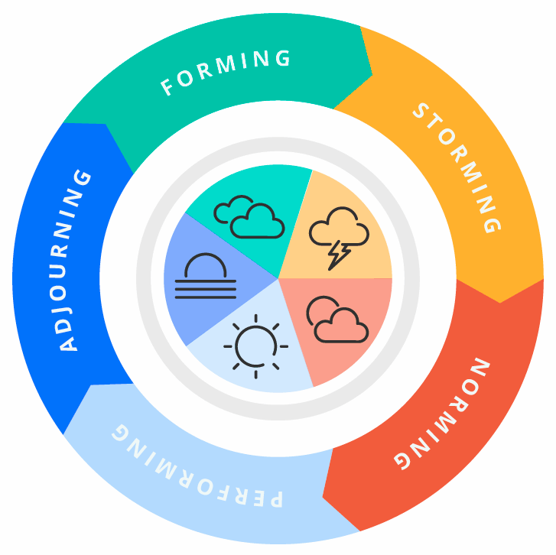

Forming stage
It is a complex mixture of uncertainties and anxiousness; the first stage is where everyone gets introduced and start to get to know each other’s. People trying to fit in and find their place in the new formed team. Everyone is unsure of what the rules are and what’s acceptable, so they all look up to the team leader to lay the ground of what are everyone’s responsibilities, roles and get guidance and reassurance as well. This stage is a bit scary and intense, but as soon as you find your fit and click with the team you start to feel really like part of the team. That is when this stage of development is complete.
Storming Stage
This is the conflict stage- where everyone fights over taking control of the team and finding its place in the hierarchy of the team. People tasting each other and defining the barriers of acceptable behaviour. Sometime teams losing members through this stage.
Norming stage
Developing close relationships and working well together, this stage clears the expected working behaviour and common goal. As well, brings sense of togetherness and identity. Everything is cleared out and members accepting and respecting each other’s opinions.
Performing stage
In this stage the team can work on its own without the constant need or presence of team leader or director. Been flexible and creative taking the work in its own hands. Performance rate should be positive when teamwork is effective and efficient.
Adjourning stage
This is the time for reflecting on the teams work and see how everyone has performed. Transitions are made at some work roles, its like end of ear report been conducted and reflected on.

Impact of effective team working
When effective is mentioned, this means is something positive, and positive is good. The effective team working is vital for the team and for the whole organisation. As more divers the teams are the greater horizon there is, as every member has something to contribute to lead the team on way to success. Van Knippenburg and Schipper (2007) mention that diversity have a positive impact on team as there are many things brought to the table as opinions, experience, knowledge, different perspectives, and vibes which will lead to more informed and better decision making. On other hand, may at some case lead to division between people and cause internal separation to ‘’US’’ and ‘’THEM’’ or bullying. That’s why is important to know what gets team members united and no conflicts occur. Different ideas, experiences, knowledge, culture, vibes of unique individuals all blend in together to create effective team. Companies that understand the importance and implement good working practices in the roots and foundation of their working place are more likely to succeed in having effective team working. Making the workplace nice and welcoming helps the team members, because they feel more positive and ready to conquer daily tasks. On the other hand, rewards, and recognitions when appropriate is another plus, as it’s known that people work more and go the extra mile when feel appreciated and there is reward. But they need to be sincere and personal to make the desire impact. People know when appreciation is sincere and personal, not just whenever or because it must be done. Getting to know your employees is important in finding their likes, abilities and making sure you can support them if needed and helping them grow and parallel with that company crows with its employees. Also, good collaboration is another key factor in effective team working, as by working together and collaborating by technology or face to face teams produce efficient amount of great work and results are at hand. Motivating staff is important as everyone at times need this and recognising everyone’s hard work and effort is essential as every small piece adds to the big picture of effective team. Good team leaders are the spine of the effective teams, as if the leadership is good the performance will be high quality. Rickards Moger (2000) mentions how the creative leadership impact on team effectiveness and the workload produced. Guiding, inspiring, supporting, listening, good speaking skills, understanding, compassion, fairness, and many more are the qualities that team leader should acquire to lead well. By using creative thinking some time team leader helps the team and this is mentioned – ‘’There are circumstances in which the leader should remind the team members of the more general rule of creative thinking- If it worth thinking, it worth saying.’’ (Rickards and Moger, 1999a, p.103)And this is true as some time people have a great idea, but thing is not good enough and don’t share it and loose on it. So creative thinking and thinking outside of the box are verry effective some time. Creating team building exercises or events is good to break the barriers and bring people together, and at the same time they get to know each other; build professional bond and relationships. Also sending team members out of their comfort zone some time is good as they gain experience, ideas and knowledge and come back with new ideas, experiences, and broader views. When there is effective team working in a company or any place the result is that common goal achieved and prosperity of the organisation. Also, the dynamic is visible and no need for further intervention from above. The way the team members are treating each other and the way they collaborate is indicator that team is effective. However, as well the leader of the organisation or a team should use the culture code created by Coyle (2018) to implement effective team working. The code consists of 3 skills. Build safety, as showing the people that you listen to them, and care is important. Also, good leader must be able to show vulnerability and to accept if may be wrong some time as the approach of ‘’I am always right’’ or ‘’ My way or the highway’’ do not go far ahead and problems rise. When there may be bad news as not everything is always perfect teams need to learn to accept and embrace the lows and learn from the mistakes and experience as this happens some time and need to be handled appropriately. The effective teams know how to handle situations like this. Mentioned by Wheelan (2014) there are some advice on how to be a good team member and they are very helpful for whomever struggle. See below:

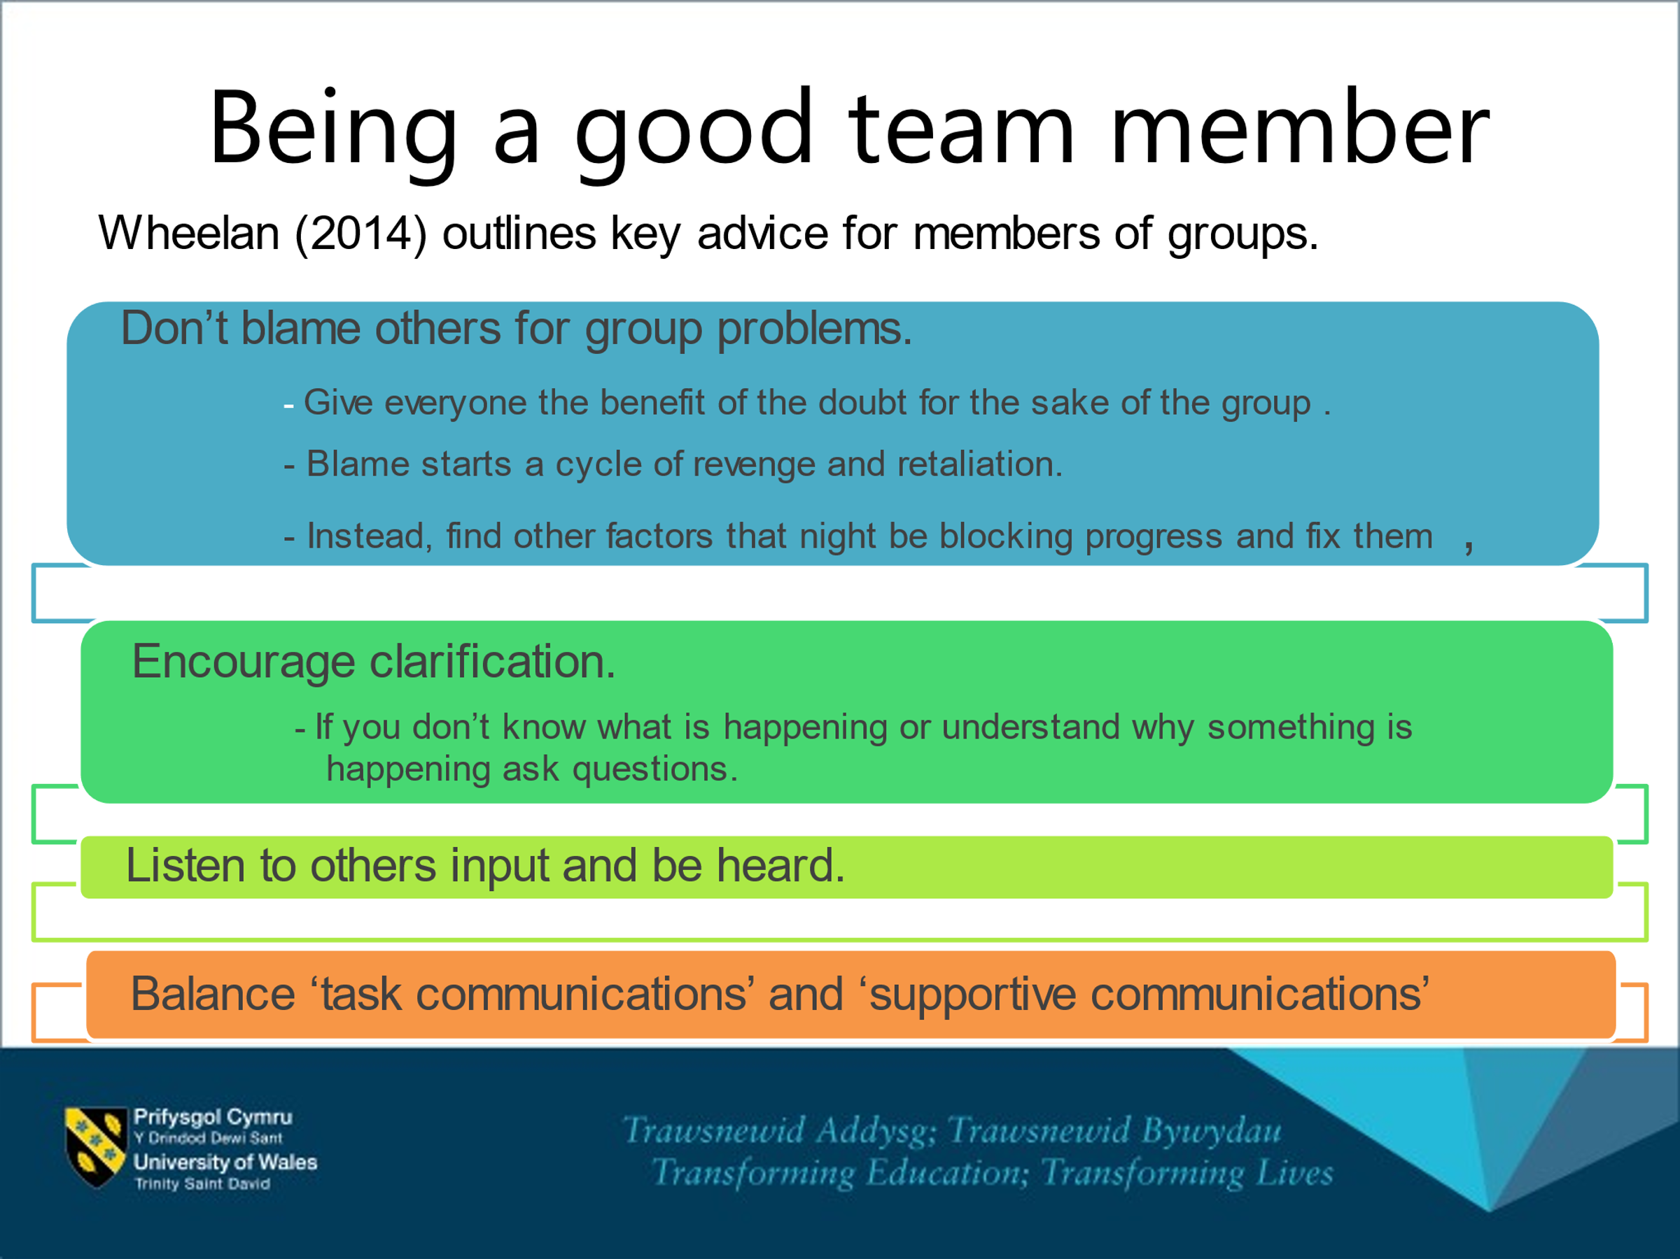

The approach toward people is crucial as people respond to good approach more politely and is more likely they listen and follow what’s requested from them. If the team leader shouts staff or be rude to them, they won’t listen and complete the task as they will be stressed and most likely will lack concentration. As well if there is not clear target or common goal to achieve this may cause confusion and team division or arguments.

Barriers to effective teamworking
There are many things that can eventually become a barrier in effective team working as different characters and personalities are mixed all in one team. Below will list some of the barriers that may occur in team.
- Different believes and point of view
- Language barrier
- Body language
- Communication barrier/IT
- Documentation not handled properly
- Personalities difference
- Lack of listening skills
- Lack of communication skills
- Never admits if wrong
- Commitment issue/Time management issue
- Miscommunication/not having the full picture when dealing with issue
- Collaboration issue
- Bulling
- Discrimination/Excluding

Each of the barriers affects the team in one way or another and preventing it from working cohesively to achieve best results. So as soon and fast these barriers are identified and removed this will be of great help for providing high-quality services. On the other hand, will improve the quality of care and life of residents and staffs working environment.
Team Roles
Everyone has a specific role in a team; and every role is important so the team can work in sync and efficient manner. There for, Belbin idea of team balance of personalities comes handy to be successful. As well, Belbin suggests that, by understanding your role within a particular team, you can develop your strengths and manage your weaknesses as a team member, and so improve how you contribute to the team Every individual has special ability or trade that when combined all together are key to effective team working and lead to achieving their common goal. Some are thinkers, other are action people, others have ability to communicate better and this makes them ‘’people’s person’’. So, if company want to have positive team working and good work environment, they need to learn to implement this in their place. As well, is widely known that happy employees work much better, and more tasks are completed. When hiring people and selecting them in teams, considerations must be made so roles of everyone are evenly distributed and go hand by hand in way of making cohesive teamworking environment. Also, team leader’s role is to be able to recognise person gift and abilities and to make it all work in sync. Good leadership is of great importance as is the pilar of every successful team and aids progress of the whole unit.
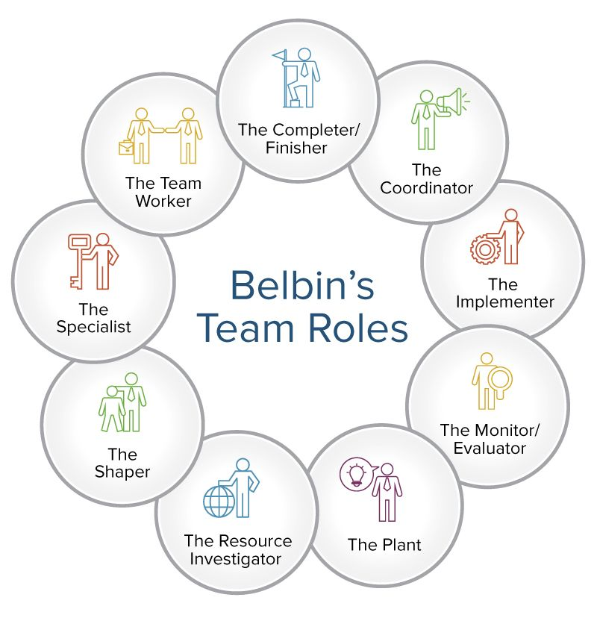

Solution
Gathering all the information and the knowledge gained from the report and the independent research it became clear what organisations and team members need to consider and implement in their work practice if want to achieve effective teamworking. Presented good working practice and rules, also cooperation between everyone, monitoring and resolution to any issues may occur, Also, making sure the team is diverse and full of different people who have roles that blended are the success for effective team. Fast resolving on conflict and monitoring to workload is needed so organisation knows if team is effective.

Reference
- Morgan, P. (2017), The Business Student’s guide to study and employability, London: SAGE
- https://www.oxfordlearnersdictionaries.com/definition/english/team_2
- Rickards, T., and S. Moger. 2000. Creative leadership processes in project team development: An alternative to Tuckman’s stage model. British Journal of Management 11,
- https://www.mindtools.com/pages/article/newLDR_83.htm#:~:text=Belbin%20suggests%20that%2C%20by%20understanding,help%20create%20more%2Dbalanced%20teams.
- Power Point presentation from class
- Van Knippenburg, D. and Schnippers, M.C. (2007) ‘Work Group Diversity’. Annual Review of Psychology, 58, pp.515-541
- Wheelan, S.A., (2016), Creating Effective Teams, 5th edn, London: SAGE
- Coyle, D. (2018), The Culture Code, London: Random House Business

